CHCECE002
Ensure the health and safety of children
Learner Guide



CHCECE002
Ensure the health and safety of children

Table of Contents

Table of Contents 3
Unit Description 4
Performance Criteria 5
Skills and Knowledge 7
Assessment Conditions 9
Housekeeping Items 10
Objectives 10
1. Support each child’s health needs 11
1.1 – Communicate with families about children’s health needs 12
Discuss children’s health needs with families 12
Learning Task One 14
Activity 1A 15
1.2 – Maintain confidentiality in relation to children’s individual health needs 16
Maintaining confidentiality 16
Learning Task Two 18
Activity 1B 19
1.3 – Assist others to implement appropriate practices when administering medication 20
1.4 – Check the written authorisation form to administer medication from the parent or guardian 20
Assist with administering medication 20
Medication form 20
Learning Task Three 23
Activity 1C 24
1.5 – Check the medication does not exceed the use-by date, is supplied in its original packaging and displays the child’s name 25
1.6 – Store medication appropriately 25
Checking medication 25
Learning Task Four 27
Activity 1D 28
2. Provide opportunities to meet each child’s need for sleep, rest and relaxation 29
2.1 – Ensure sleep and rest practices are consistent with approved standards and meet children’s individual needs 30
2.2 – Provide appropriate quiet play activities for children who do not sleep or rest 30
Sleep and rest 30
Safety standards for cots 30
Learning Task Five 34
Activity 2A 35
2.3 – Respect children’s needs for privacy during any toileting and dressing and undressing times 36
2.4 – Ensure children’s and families’ individual clothing needs and preferences are met, to promote children’s comfort, safety and protection within the scope of the service requirements for children’s health and safety 36
Children’s clothing needs 36
Self-help skills 37
Individual preferences 37
Privacy 38
Clothing policies 38
Respect for families 39
Learning Task Six 42
Activity 2B 43
2.5 – Share information about individual children’s rest and sleep with families as appropriate 44
Sharing information with families 44
Childcare practice vs family practice 45
Learning Task Seven 47
Activity 2C 48
3. Implement effective hygiene and health practices 49
3.1 – Consistently implement hygiene practices that reflect advice from relevant health authorities 50
3.2 – Support children to learn personal hygiene practices 50
3.3 – Implement the service health and hygiene policy and procedures consistently 50
Hygiene practices 50
How you can support children to learn personal hygiene practices? 53
Learning Task Eight 55
Activity 3A 56
3.4 – Ensure that service cleanliness is consistently maintained 57
Routine cleaning 57
Learning Task Nine 59
Activity 3B 60
3.5 – Observe and respond to signs of illness and injury in children and systematically record and share this information with families 61
Observing signs of illness 61
Recording illness 61
Learning Task Ten 63
Activity 3C 64
3.6 – Consistently implement the service policies for the exclusion of ill children 65
An exclusion policy 65
Learning Task Eleven 67
Activity 3D 68
3.7 – Discuss health and hygiene issues with children 69
Discussing health and hygiene 69
Learning Task Twelve 71
Activity 3E 72
4. Supervise children to ensure safety 73
4.1 – Supervise children by ensuring all are in sight or hearing distance at all times 74
4.2 – Adjust levels of supervision depending upon the area of the service and the skill, age mix, dynamics and size of the group of children, and the level of risk involved in activities 74
4.3 – Exchange information about supervision with colleagues to ensure adequate supervision at all times 74
Sight and sound supervision 74
Supervising groups 75
Learning Task Thirteen 78
Activity 4A 79
5. Minimise risks 80
5.1 – Assist in the implementation of safety checks and the monitoring of buildings, equipment and the general environment 81
Assist with safety checks 81
Monitor the environment 81
Learning Task Fourteen 84
Activity 5A 85
5.2 – Consistently implement policy and procedures regarding the use and storage and labelling of dangerous products 86
Dangerous products 86
Policies and procedures 86
Learning Task Fifteen 89
Activity 5B 90
5.3 – Follow service procedures for the safe collection of each child, ensuring they are released to authorised people 91
Safe collection of children 91
Learning Task Sixteen 94
Activity 5C 95
5.4 – Assist in the supervision of every person who enters the service premises where children are present 96
Supervise people entering the centre 96
Learning Task Seventeen 98
Activity 5D 99
5.5 – Discuss sun safety with children and implement appropriate measures to protect children from over-exposure to ultraviolet radiation 100
Sun safety 100
Sun Protection Policy 101
Learning Task Eighteen 105
Activity 5E 106
5.6 – Check toys and equipment are safe for children and safe to use in their proposed area 107
5.7 – Remove any hazards immediately or secure the area to prevent children accessing the hazard 107
Maintaining toy and equipment safety 107
What to do if you have a concern? 108
Learning Task Nineteen 111
Activity 5F 112
6. Contribute to the ongoing management of allergies 113
6.1 – Identify and recognise signs, symptoms and key characteristics of allergies and anaphylaxis 114
Allergies and Intolerances 114
The difference between allergies and intolerances 114
Anaphylaxis 115
Signs and Symptoms 116
Management and treatment 116
Learning Task Twenty 118
Activity 6A 119
6.2 – Apply organisational risk-management strategies for children with severe allergies 120
6.3 – Follow organisational policies and legislative requirements in relation to medication for anaphylaxis 120
Risk management 120
Learning Task Twenty-One 122
Activity 6B 123
7. Contribute to the ongoing management of asthma 124
7.1 – Identify signs, symptoms and triggers of asthma 125
What is asthma? 125
Triggers 125
Symptoms 126
Minimising the chances 126
Learning Task Twenty-Two 128
Activity 7A 129
7.2 – Identify children who have an asthma management plan and follow that plan 130
7.3 – Follow organisational policies and legislative requirements in relation to medication for asthma 130
Identify asthmatic children 130
Supporting parents 131
Learning Task Twenty-Three 133
Activity 7B 134
Skills and Knowledge Activity 135
Major Activity – An opportunity to revise the unit 136
References 138

Unit Description

Description
This unit describes the skills and knowledge to ensure the health and safety of children.

This unit applies to educators working in a variety of education and care services.

No licensing, legislative or certification requirements apply to this unit at the time of publication.

Links
Companion volumes are available from the CS&HISC website – http://www.cshisc.com.au/

Performance Criteria
Element | Performance criteria
- Support each child’s health needs | - Communicate with families about children’s health needs  - Maintain confidentiality in relation to children’s individual health needs  - Assist others to implement appropriate practices when administering medication  - Check the written authorisation form to administer medication from the parent or guardian  - Check the medication does not exceed the use-by date, is supplied in its original packaging and displays the child’s name  - Store medication appropriately
- Provide opportunities to meet each child’s need for sleep, rest and relaxation | - Ensure sleep and rest practices are consistent with approved standards and meet children’s individual needs  - Provide appropriate quiet play activities for children who do not sleep or rest  - Respect children’s needs for privacy during any toileting and dressing and undressing times  - Ensure children’s and families’ individual clothing needs and preferences are met, to promote children’s comfort, safety and protection within the scope of the service requirements for children’s health and safety  - Share information about individual children’s rest and sleep with families as appropriate
- Implement effective hygiene and health practices | - Consistently implement hygiene practices that reflect advice from relevant health authorities  - Support children to learn personal hygiene practices  - Implement the service health and hygiene policy and procedures consistently  - Ensure that service cleanliness is consistently maintained  - Observe and respond to signs of illness and injury in children and systematically record and share this information with families  - Consistently implement the service policies for the exclusion of ill children  - Discuss health and hygiene issues with children

- Supervise children to ensure safety | - Supervise children by ensuring all are in sight or hearing distance at all times  - Adjust levels of supervision depending upon the area of the service and the skill, age mix, dynamics and size of the group of children, and the level of risk involved in activities  - Exchange information about supervision with colleagues to ensure adequate supervision at all times
- Minimise risks | - Assist in the implementation of safety checks and the monitoring of buildings, equipment and the general environment  - Consistently implement policy and procedures regarding the use and storage and labelling of dangerous products  - Follow service procedures for the safe collection of each child, ensuring they are released to authorised people  - Assist in the supervision of every person who enters the service premises where children are present  - Discuss sun safety with children and implement appropriate measures to protect children from over-exposure to ultraviolet radiation  - Check toys and equipment are safe for children and safe to use in their proposed area  - Remove any hazards immediately or secure the area to prevent children accessing the hazard
- Contribute to the ongoing management of allergies | - Identify and recognise signs, symptoms and key characteristics of allergies and anaphylaxis  - Apply organisational risk-management strategies for children with severe allergies  - Follow organisational policies and legislative requirements in relation to medication for anaphylaxis
- Contribute to the ongoing management of asthma | - Identify signs, symptoms and triggers of asthma  - Identify children who have an asthma management plan and follow that plan  - Follow organisational policies and legislative requirements in relation to medication for asthma

Skills and Knowledge
Make sure this matches the text on the training.gov.au specs

Foundation Skills

The foundation skills described those required skills (language, literacy and numeracy) that are essential to performance.

- Reading – in order to accurately read and interpret medication packaging and dosage instructions
- Numeracy – in order to correctly calculate medication dosages for common measurements including milligrams (mg) and millilitres (ml)

The remaining foundation skills essential to performance are explicit in the performance criteria of this unit.

Performance Evidence

The candidate must show evidence of the ability to complete tasks outlined in elements and performance criteria of this unit, manage tasks and manage contingencies in the context of the job role. There must be demonstrated evidence that the candidate has completed the following tasks at least once:

- Consistently supported the health needs of the children in the service, including the following activities:
- Contributing to the provision of a clean and safe environment
- Recognising and responding to signs of illness of children, including signs and symptoms of asthma and anaphylaxis
- Reading and interpreting authorisation forms, medication labels, medical management plans and other relevant medical information
- Developing children’s awareness of safety

Knowledge Evidence

The candidate must be able to demonstrate essential knowledge required to effectively do the task outlined in elements and performance criteria of this unit, manage the task and manage contingencies in the context of the work role.
These include knowledge of:

- How to access:
- The National Quality Framework
- The National Quality Standards
- The relevant approved learning framework
- How to navigate through framework and standards documents to find areas relevant to this unit of competency
- How to undertake a risk analysis of toys and equipment
- Potential hazards to children, including medical conditions
- Children’s requirements for sleep and rest
- Environments that promote rest and sleep including light, noise, temperature and ventilation requirements
- Signs, symptoms and key characteristics of allergy/anaphylaxis
- Signs, symptoms and key characteristics of asthma
- How to use an adrenalin auto injector for anaphylaxis
- How children’s oral health impacts on their general health and well-being, including signs of tooth decay
- Safety issues and risk management strategies for children’s health and safety in a variety of contexts
- Basic home fire safety including high-risk groups, behaviour that contributes to fire injury and fatalities, and smoke alarm placement, installation and maintenance
- Organisational standards, policies and procedures.

Assessment Conditions

Skills must be demonstrated in a regulated education and care service.

In addition, simulations and scenarios must be used where the full range of contexts and situations cannot be provided in the workplace or may occur only rarely. These are situations relating to emergency or unplanned procedures where assessment in these circumstances would be unsafe or is impractical.

Simulated assessment environments must simulate the real-life working environment where these skills and knowledge would be performed, with all the relevant equipment and resources of that working environment.
Asthma and anaphylaxis aspects of this unit are best assessed in conjunction with HLTAID004 Provide an emergency first aid response in an education and care setting

Assessment must ensure use of:

- National Quality Framework for Early Childhood Education and Care
- The relevant approved learning framework under the National Quality Framework for Early Childhood Education and Care.

Assessors must satisfy the NVR/AQTF mandatory competency requirements for assessors

Links

Companion volumes are available from the CS&HISC website – http://www.cshisc.com.au/

Housekeeping Items

Your trainer will inform you of the following:
- Where the toilets and fire exits are located, what the emergency procedures are and where the breakout and refreshment areas are.
- Any rules, for example asking that all mobile phones are set to silent and of any security issues they need to be aware of.
- What times the breaks will be held and what the smoking policy is.
- That this is an interactive course and you should ask questions.
- That to get the most out of this workshop, we must all work together, listen to each other, explore new ideas, and make mistakes. After all, that’s how we learn.
- Ground rules for participation:
  - Smile
  - Support and encourage other participants
  - When someone is contributing everyone else is quiet
  - Be patient with others who may not be grasping the ideas
  - Be on time
  - Focus discussion on the topic
  - Speak to the trainer if you have any concerns

Objectives

- Discover how to support each child’s health needs
- Know how to provide opportunities to meet each child’s need for sleep, rest and relaxation
- Learn how to implement effective hygiene and health practices
- Understand how to supervise children to ensure safety
- Develop the skills to minimise risks
- Obtain the skills to contribute to the ongoing management of allergies
- Acquire the skills to contribute to the ongoing management of asthma
- Gain essential skills and knowledge required for this unit

1. Support each child’s health needs

1.1. Communicate with families about children’s health needs
1.2. Maintain confidentiality in relation to children’s individual health needs
1.3. Assist others to implement appropriate practices when administering medication
1.4. Check the written authorisation form to administer medication from the parent or guardian
1.5. Check the medication does not exceed the use-by date, is supplied in its original packaging and displays the child’s name
1.6. Store medication appropriately



1.1 – Communicate with families about children’s health needs

Discuss children’s health needs with families
Parents see early childhood educators as valuable sources of information in all areas of child development, including health. Educators spend a lot of time with and become familiar with the children in their care, and can often see or help identify patterns or problems.
It is important to communicate with families about their child’s health needs at enrolment, when an incident occurs, after a minor or prolonged illness and when parents make a specific request.
Examples of health needs you will need to communicate with families about:
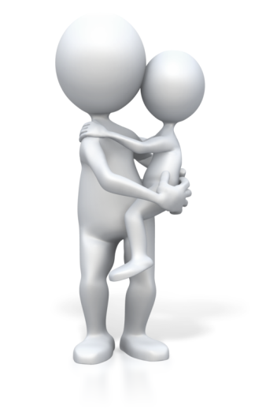
- Illnesses – chronic and occasional
- Nutrition – including general guidelines, detailed information on what the child ate at the centre and ideas for dealing with picky eating or other eating problems at home
- Healthy sleep – toddlers and children in early childhood need 10-12 hours in a 24 hour period, split between night time and naps
- Allergies and food intolerances
- Hydration
- Hygiene
- Doctor visits when children are exhibiting signs of illness.
Communicating with families can occur formally or informally. For example:
- Share daily reports/logs, written or verbal, that include what the child ate, when they slept, and their toileting (when appropriate).
- Informal conversations at pick-up or drop-off times (“She was not sleepy during naptime today and stayed awake, so she may need to get some extra sleep tonight to meet that 10-12 hours guideline,” or “He really enjoyed carrots at lunch, so there’s a vegetable he might be willing to eat at home!”).
- Share articles on health topics, either with individual families as they need arises, or with all the parents in the group.
- Scheduled, one-on-one conferences.
- An email or phone call if there’s something you need to share and you won’t get a chance to talk to the parent in person.

When your relationships with parents are friendly and professional and you routinely communicate positively about all aspects of their child’s day and development, your input about health-related issues is more likely to be appreciated and considered. Remember that while parents often see you as an “expert” in child development, they also come in with their own background and knowledge that should be treated with respect. Parents also really benefit from and respond to your vote of confidence in their abilities. Remember to talk to parents privately when appropriate and don’t discuss one child with another child’s parent.
National Quality Standards
Quality Area and Standards included in this section:

The Early Years Learning Framework
The principles, practices and outcomes included in this section:

Learning Task One
Why is it so important to communicate with families about children’s health needs?

List the different ways and times you can communicate with families about a child.

What should you always take into consideration when you are communicating with families about their children?

Activity 1A


1.2 – Maintain confidentiality in relation to children’s individual health needs


Maintaining confidentiality
Confidentiality around all children’s individual needs is expected of early childhood educators. It safeguards their privacy and promotes trust between families and the centre. When parents trust that sensitive information will be kept private, they are more likely to share it with you, and you are more likely to be able to help.
Things to keep confidential:
- Names of specific children with a diagnosis of a communicable disease. Sometimes you may need to let parents know that their children have been exposed to an illness, but you should not share who has come down with it, or who had it first, or even whether it was a student or staff member.
- Diagnoses of non-communicable diseases or other health issues of any kind.
- Types of medications or dietary restrictions a child has.
Maintaining confidentiality can be challenging and you may experience times when you need to talk with a co-worker or friend about your work. When this happens, you must manage this within your organisation’s documented guidelines and talk with your nominated supervisor. It is not a breach of confidentiality to appropriately discuss children’s health issues with other staff members who work directly with the child.
Just as you have a legal and ethical obligation to maintain children’s confidentiality, you also have an obligation to breach it if you know the law has been, or will be broken.
As a general rule, all information about children should be kept in confidence, with the following exceptions:
- Where a child is in danger of physical or sexual abuse (laws relating to mandatory notification will apply)
- Where a child’s health or safety is in danger
- Where a child’s condition or circumstances create a danger to others
In all of these circumstances, you must report to your nominated supervisor and follow your centres policies and procedures for responding to critical incidents.

Children will share private information about themselves and their friends. If you hear private and personal information being discussed by the children, steer the conversation to something else and then later talk the incident over with the child or their parent. This will help teach the child about “appropriate sharing”.

If a parent comes to you with sensitive information their child has given them, let them know that this is confidential information that you are not able to discuss, but that if there is anything all the parents need to know in order to preserve the safety of their children, you will inform them.
National Quality Standards
Quality Area and Standards included in this section:

The Early Years Learning Framework
The principles, practices and outcomes included in this section:

Learning Task Two
List the times when you are expected to maintain confidentiality at your centre, especially regarding health issues.

What can you do when a child is sharing private information about themselves or their family to another child?

Activity 1B

1.3 – Assist others to implement appropriate practices when administering medication

1.4 – Check the written authorisation form to administer medication from the parent or guardian

Assist with administering medication
Early childhood education educators are responsible for correctly administering medications. Medication can be dangerous if administered incorrectly. Administering medication to children is a task that requires attention to detail, meticulous record keeping, teamwork and common sense.
Examples of medication you are likely to see and help administer:
- Pain-reliever/fever-reducer (usually only for teething, as fever and pain from illness would be cause for exclusion)
- Antibiotics
- Lotions and lip balms (prescription and over-the-counter)
- Medications to manage chronic illnesses
- Adrenaline auto injectors (EpiPens and AnaPens)
- Inhalers
- Occasionally eye-drops, but usually parents will do this at home, as it’s difficult
- Sunscreen (some parents may request/provide a special type for sensitive skin)

Medication form
Parents must complete a Medication Authorisation Form (or similar) for every medicine to be administered to their child. This applies to long and short-term medicines. Your centre will have a form, and you must become familiar with its location, use and storage. When parents fill out the authorisation form, they expect that the directions will be followed.

Medication authorisation forms typically include:
- Child’s full name
- Medication
- Reason for medication
- Dosage amount
- Time to be given
- Date/s to be given
- Side effects and/or anticipated reactions

- GP/Chemist contact
- Special instructions
- Storage requirements
- Parent signature and date
- Area for educators to record how and when the medicine was administered
The (general) procedures for administering medication:
- Keep to the timing schedule
- Give the correct dosage
- Pay attention to guidelines about when and/or what to eat along with the medication
- Check expiration dates each time you administer a medication – do not give expired medication (notify parents immediately)
- Do not give a child’s medication to another child, under any circumstances
- Wash hands before and after administration
- Keep a written record of the administration of medication
- All medication must be checked by two staff members before being administered to children
- The medication record form is to be signed by the person administering the medication and the person who has cross checked that the correct medication and dose has been given to the correct person at the right time.
Medications that are stored at the centre can expire before they are used. Check them frequently to make sure they are not expired when you need them. Review the authorisation forms regularly and ensure that parents complete an updated form for long-term medication every three-months.

National Quality Standards
Quality Area and Standards included in this section:
The Early Years Learning Framework
The principles, practices and outcomes included in this section:

Learning Task Three
What types of medication you are likely to see and help administer at your centre?

What is the general procedure for administering medication at your centre?

Activity 1C

1.5 – Check the medication does not exceed the use-by date, is supplied in its original packaging and displays the child’s name

1.6 – Store medication appropriately

Checking medication
Ingesting the wrong or expired medication or the wrong amount of a medication can have serious health risks. You should only administer medication if it is in its original packaging with the pharmacy label attached. The child’s name must be listed as the prescribed person, along with the dosage to be given. This applies to all medications, regardless of whether they are non-prescribed (such as teething gels, nappy creams, cough medicines etc.) or prescribed (antibiotics etc.).
Children must never be able to access medication on their own. Medications must be stored in a secure area (including refrigerators) that children do not have access to. If medications are stored inappropriately and a child accesses them, that child could be poisoned and the centre would be held responsible.
Store all medications in one locked area, and go through it, checking expiration dates, labels, and names on a periodic schedule, about every two weeks, to make sure that parents are able to get new medication before it is expired. Check the packaging and expiration date of medications each time you administer them.
Educators are responsible for:
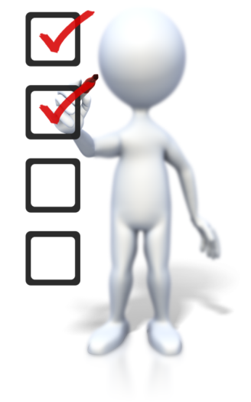
- Clearly explaining to parents the centre’s policy for administering medication, including paracetamol.
- Explaining to parents that the centre is unable to administer medication unless it is in its original container with a pharmacy label attached listing the child as the prescribed person and the dosage to be given.
- Ensuring parents deliver medication to a staff member, so that it can be stored securely (out of children’s access) and at the recommended temperature (e.g. in the fridge or cupboard). Medication must not remain in children’s bags.
- Returning all expired and unused medication to parents for disposal.

National Quality Standards
Quality Area and Standards included in this section:

The Early Years Learning Framework
The principles, practices and outcomes included in this section:

Learning Task Four
Why is it important that medications do not exceed the use-by date, are supplied in their original packaging, display the child’s name and are stored appropriately?

Activity 1D

2. Provide opportunities to meet each child’s need for sleep, rest and relaxation

2.1. Ensure sleep and rest practices are consistent with approved standards and meet children’s individual needs
2.2. Provide appropriate quiet play activities for children who do not sleep or rest
2.3. Respect children’s needs for privacy during any toileting and dressing and undressing times
2.4. Ensure children’s and families’ individual clothing needs and preferences are met, to promote children’s comfort, safety and protection within the scope of the service requirements for children’s health and safety
2.5. Share information about individual children’s rest and sleep with families as appropriate

2.1 – Ensure sleep and rest practices are consistent with approved standards and meet children’s individual needs

2.2 – Provide appropriate quiet play activities for children who do not sleep or rest


Sleep and rest
Physiological needs have to be met in order for children to thrive. One of the most essential needs of early childhood is adequate sleep and rest. You must provide appropriate sleep areas and times in order for children to get the rest they need while in your care.
General sleep standards for children:
- Infants up to one year are able to sleep at-will, throughout the day.
- Infants must be put to sleep on their backs.
- Toddlers transition to one afternoon nap, usually right after lunch.
- The sleeping area should be darkened and white noise or soft music should be playing.
- Mats or cots should be covered with a blanket or sheet and only used for one child in between washes.
- Mats or cots should be adequately spaced (at least 30CM)
- Children should sleep head-to-toe when they are less than a metre apart, to avoid the spread of germs.
- Record the time that children spend sleeping on the daily log.
Each early childhood education centre has their own policies regarding techniques used to promote healthy sleep and rest that follow strict safety standards. Always stay up-to-date with changing policies and procedures and be sure to talk to your nominated supervisor if you have questions or concerns.

Safety standards for cots
All early childhood education and care centres are required to follow the cot and bedding safety standards for Australia. Your specific role in checking to make sure these standards are met will be determined by your nominated supervisor.
In 2005, Australia adopted a mandatory standard for all new and used cots to ensure their safety. It is your responsibility to consult with your lead educator if you have any concerns about the safety of a cot or bedding. It may be your responsibility to perform regular cot checks to make sure they are safe and functioning, as they should.
Australian cot safety standards:
- All cots must comply with the mandatory safety standard based on the Australian standard for household cots AS/NZS 2172.
- Look for the label or sticker that states that the cot complies with the mandatory standard.
- Make sure the mattress base, panels, bars and drop sides are securely attached.
- The mattress must have a snug fit (within 20mm all around).
- The gap between the bars of the cot must be between 50mm and 85mm.
- Make sure there are no spaces between 30mm and 50mm that could trap a child’s arms or legs.
- Check there are no corner posts, bolts or knobs that might catch a child’s clothing.
- Cots should only be used for sleeping, not climbing or playing.
An educator trained in safe sleeping practices must be present at all times when children are sleeping. The educator should remain alert and actively supervise all sleeping children by checking to make sure each child’s head is uncovered and look for any potential issues or concerns.
Sleep and rest practices include:
Infants | - Help them to sleep as needed by rocking, swaddling, singing, bouncing, using a dummy, etc.  - Transition them to their cribs, on their backs.  - Educators must be able to see and hear the children as they sleep.  - When they wake up, they should be taken from their cribs and brought into the ongoing activity (some will need a quiet cuddle as they wake).
Toddlers | - At a specified naptime, instruct them to lie down on their cots or mats with a blanket, a snuggly toy, and a dummy if one is provided and desired by parents.  - Dim the lights and play soft music or white noise.  - Educators may lay down with individual children who need help calming their bodies, and sing, read, rub backs, etc. moving from child to child until all are asleep.  - Offer a quiet activity to children who do not fall asleep or wake before the others.  - Turn lights on and resume normal activity when the nap period is over, usually after 2.5-3 hours.
Pre-school | - Naptime for older children is similar to that of toddlers.  - More children will probably fall asleep without assistance, and they will generally sleep for shorter periods of time.  - Some parents will probably begin to request that their children not nap, or that they be woken up after a shorter nap, in order to maintain consistent bedtimes at home.
Rest is a time when children may sleep or simply spend quiet time on their own. Some children will lie in their cot, hammock or mat without actually sleeping, but they will be getting restorative rest. Spending time without external stimulation (toys, bright lights, loud noises, talking, etc.) provides most children the basis for healthy sleep and rest.
Children who do not sleep should be offered a quiet activity, or if they are still awake more than a half-hour after lying down. It is not appropriate to expect a child to stay quietly on a mat or cot for a long period of time if they are awake.
Not all children are on the same daily schedule, or occasionally a child will have a need for extra sleep due to a circumstance at home. Try to accommodate these needs without disrupting the routine for the other children.
Individual sleep preferences/requirements may also include:
- Some children require special items like particular blankets, stuffed toys, or a dummy to fall and stay asleep.
- Some parents will ask that their child be woken up early or not sleep at all, oftentimes because the child has trouble falling asleep at night.
- Some children will need to have help from an educator to fall asleep, and the type of help preferred (rubbing back, patting, singing, etc.) will differ from child to child.
- Infants are swaddled to sleep, while older children should not be.
- Some children need an especially dark, quiet, or secluded area to sleep. Educators should provide for these needs while still ensuring that all children can be seen and heard.
Important things to consider when providing appropriate sleep and rest opportunities:
- Children may have trouble falling asleep as they make transitions, like ending their use of a dummy or joining a new classroom.
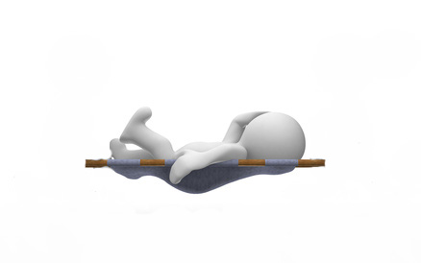
- Room size and furniture arrangement can make it difficult to set up cots in a way that everyone can be seen and has enough space.
- Educators must resist the temptation to leave a child awake on their bed longer than is allowed, in hopes that they will fall asleep.
- Student/educator ratios need to be maintained during nap times.
- It can be tricky to remember special sleeping requests, especially to wake a child early. Teamwork helps, as does writing it down.

National Quality Standards
Quality Area and Standards included in this section:

The Early Years Learning Framework
The principles, practices and outcomes included in this section:

Learning Task Five
What are general sleep standards for children?

Complete the following table outlining sleep and rest practices:
Infants
Toddlers
Pre-school

Activity 2A

2.3 – Respect children’s needs for privacy during any toileting and dressing and undressing times

2.4 – Ensure children’s and families’ individual clothing needs and preferences are met, to promote children’s comfort, safety and protection within the scope of the service requirements for children’s health and safety

Children’s clothing needs
Children should be encouraged to make their own clothing choices and to dress themselves, but they need guidance to make the right choices for their health and wellbeing. Educators need to work with families to help children select appropriate clothing for childcare.
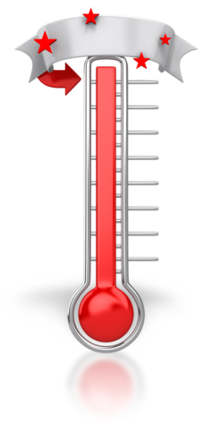
The clothing children wear at childcare influences the quality of their experiences in activities, and provides protection from hazards and the elements. It is important that children’s clothing is safe as well as comfortable.
There are many factors that determine appropriate clothing choices at childcare:
- Temperature
- Sun protection
- Fabric
- Practicality
- Individual preferences.
Temperature
Some children are warm or cool regardless of the climate, but it is important that they are not under or over-dressed. Cotton and other natural, breathable fibres are cooler and more comfortable than synthetic fabrics. Layers are good for fluctuating temperatures and all children should keep a raincoat in their cubby for unexpected showers. Suggest that parents send spare clothes for unexpected weather changes.
Babies and toddlers, who sleep during the day, should be dressed warmly and covered with a blanket or a sheet. Check that sleeping children are warm enough by gently touching their back or tummy, as this will give a better indication of their body temperature than their hands or feet.
Sun Protection
All children in early childhood education and care settings must be dressed appropriately for sun protection. This means that children must wear hats outside, and always wear a t-shirt and sunscreen. Outdoor play is essential to all early education programs and many centres enforce a ‘no hat, no play’ rule that excludes the children without hats from outdoor activities. Inform parents of your sun protection policy and ensure that all children bring a hat and are properly dressed before going outside.

Fabric
Some children are very sensitive to certain fabrics, and some may have an allergic reaction to particular detergents. If you have a child in your care that is pulling or scratching on their clothing, they may be sensitive to the material. Let the parents know and recommend a change in washing detergent and/or clothing.
All clothes that children wear, especially those for sleeping, must be low fire danger. This applies to the clothes children wear, the spare clothing supplied by the centre for accidents and any clothing used for dress up play.
Practicality
Children should come to care prepared to play and learn and that means that their clothing must be suitable for climbing, painting, water play, digging, etc. Clothes must fit properly, but be comfortable and allow for movement so children can participate in all activities. For example, girls who like to wear long dresses and skirts may find it hard to participate in physical activities, or they may trip and fall on playground equipment.

The clothes children wear significantly impact the development of their self-help skills. Shoes and clothing they can put on and take off by themselves builds their confidence and reinforces their desire to master new skills. For example, elastic waist pants are easier to remove for toileting than pants with zippers and buttons.

Self-help skills
Clothing that helps build self-help skills includes:
- Elastic waist pants and skirts
- Slip on or Velcro shoes
- Big button or toggles
- Pull on jumpers.
Encourage parents and caregivers to provide practical clothing that helps their children master self-help skills, such as dressing and toileting independently.
Some children will come to care wearing a special item of clothing they are reluctant to get to dirty or wet. Rather than excluding them from the activity, provide a smock or alternative clothing for certain activities.

Individual preferences
Children will have individual clothing preferences and they should be encouraged to make clothing choices and learn to dress themselves. However, young children will not always make a sensible or safe choice, e.g., refusing to wear a t-shirt on a hot day, wearing cowboy boots for all activities, refusing to wear blue, etc. Educators must respect children’s individual clothing preferences unless there is a health or safety concern. Check with your nominated supervisor or centre’s clothing policy if you are unsure.

Privacy
You must be respectful of children’s privacy regarding dressing, e.g., some children will be more modest than others and want to change in privacy. Try to provide a safe and private dressing area, particularly when children are changing due to a toileting accident.
Other children are more comfortable changing in front of other children or in open spaces. Children tend to strip off their clothes whenever they are hot or bothered by their clothing. Educators can help guide these children to an appropriate location so they can finish changing clothes.
You will be required to help children dress or undress, or wipe themselves after toileting, etc. If these activities are done in appropriately private places, like the bathroom, you are still providing privacy. Sometimes a child will have a strong preference that a certain educator helps them, or specifically that a certain educator does not help them. It’s good to honour that preference. If it feels appropriate, you can do this while still talking calmly and kindly about how all of the educators are “safe people.”
Respecting children’s need for privacy during toileting and dressing times demonstrates and reinforces that their bodies are private, and are not to be shared with others. This understanding will help them when they are in other settings, when safety might be more of an issue.

Clothing policies
A clear policy that outlines appropriate clothing for children in care helps guide educators and parents make informed clothing choices for children. This policy should include details about the clothing that parents are expected to provide for their children and the procedures the educators are required to carry out to enforce the policy. These procedures must be clear to educators and parents to avoid misunderstandings that will impact the children.
The clothing policy will include items such as:
- Appropriate clothing for learning and play
- Dirty and soiled clothing

- Clothing for weather
- Cleanliness
- Spare clothing.
All policies must be current and in line with the following guidelines:
- Sun safety
- Hygiene practices
- Children’s health and safety
- Safe sleeping
- Children’s health and development.

Footwear
Children must have safe, comfortable and properly fitting shoes that they can play in. Thongs, plastic shoes or dress up shoes give little to no protection or support for growing feet. Children need to wear shoes they can run, climb and jump in. Sneakers, with properly fitting cotton socks are the safest choice for childcare.
Special clothes
Some children will want to wear special clothes or accessories to childcare, e.g., a cape, a birthday dress, a costume, etc. When this happens, encourage the child to remove the special item and keep it safe for the rest of the day. Remind them that it will get dirty, may get broken/lost, etc. However, most of the time the child just wants to show off their new or special item.
On some occasions, special clothing items are worn for comfort, such as cape to help the child feel brave. Allow the child to wear the item as they adjust to the childcare environment, and then encourage them to leave it at home once they have settled in and no longer need the extra courage.
Dress-up clothes
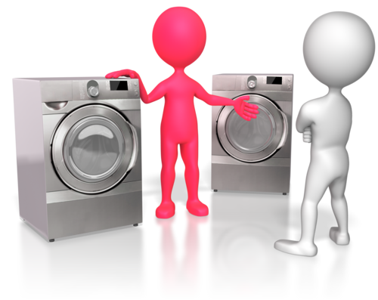
Most centres provide a dress-up area for imaginative play; clothing in this area must also follow the rules for health and safety:
- Dirty or soiled clothing must be cleaned or disposed of
- Broken or ripped items must be replaced to prevent injury
- Necklaces and scarves must be monitored to prevent strangulation
- Shoes should not be too large or too high to prevent tripping.
Educators must supervise children in the dress up area to ensure safe play and to monitor any safety hazards.

Respect for families
Clothing choices can often be based on family preferences, cultural norms or financial circumstances. It is important to be respectful of these issues without making assumptions or judgements about the family.
There are many reasons why children come to care in unsuitable clothing. They may be adjusting to a new climate, have cultural or religious traditions that determine clothing choices or families may simply have different views of appropriate clothing for childcare. Some families may not have the means to provide their children with a variety of appropriate clothing for childcare, or they may not be able to regularly launder their children’s clothing. Be sensitive to this and provide assistance where possible.
Educators must be aware of these issues and demonstrate respect to the family while working with them to ensure their children’s clothing supports positive outcomes while in care.
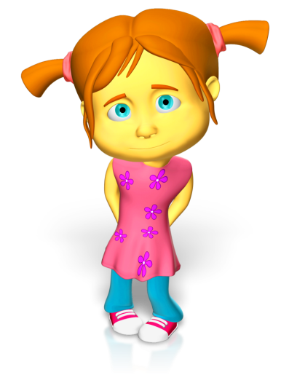
There are several ways to ensure families are informed about appropriate clothing for childcare:
- Give parents/caregivers a copy of the centre’s clothing policy or include it in the parent handbook
- Include parents/caregivers in discussions about children’s clothing
- Include discussions about clothing in the enrolment and orientation process
- Post reminders in the newsletter or on the community noticeboard
- Provide reminders when the seasons change.
Strategies to meet the individual clothing needs and preferences of children include:
- Talk about appropriate clothing for childcare with children
- Talk about the differences in clothing across cultures
- Address any instances of preference, judgement or exclusion based on clothing
- Model appropriate dress (always wear a hat outside, wear safe footwear and avoid jewellery)
- Try to make dressing tasks enjoyable and stress-free
- Make dressing tasks achievable and provide incremental goals
- Supply alternative clothing
- Ask parents to provide clothing that is easy for children to manage
- Respect individual choices without compromising health and safety.
As an educator you must be respectful of family norms around clothing, uphold the centre’s policies and support the individual needs and preferences of the children. Your first priority is to ensure that all children in your care dressed in a manner that maintains their health and safety without disrupting learning.

National Quality Standards
Quality Area and Standards included in this section:

The Early Years Learning Framework
The principles, practices and outcomes included in this section:

Learning Task Six
What are the procedures you must follow during toileting and dressing and undressing times?

How do you ensure children’s and families’ individual clothing needs and preferences are met, to promote children’s comfort, safety and protection within the scope of the service requirements for children’s health and safety?

Activity 2B

2.5 – Share information about individual children’s rest and sleep with families as appropriate

Sharing information with families
Children can spend a large portion of their week in childcare; parents need to know what has happened so that they can adequately provide for needs at home. When you share rest and sleep information with parents they can plan for early bedtimes if a child didn’t sleep, or can be on the lookout for other signs of ill health if a child was extremely tired or slept a lot during the day.
Parents should be encouraged to share sleep and rest information with educators so you can better plan for the child and understand what may be influencing their behaviour during the day.
Sleep and rest information you should share with families:

- The time(s) that the child fell asleep, and time(s) they woke up
- If a child was exceptionally sleepy at any time during the day
- If they fell asleep during a time of day that is not usually spent napping (for children older than a year), for example if they nodded off at the lunch table or during free play time
- Quality of sleep and rest (restless, dreams, etc.)
- Uncharacteristic sleep refusal
- Toileting accidents during sleep (if toilet trained).
About sharing sleep and rest information
Some parents may want you to give them lots of detailed information about their child and others may not need or want information unless it is important that you tell them. Once something becomes a habit, for example, if a preschool-aged child has moved away from napping, you no longer need to tell the parent each day that their child didn’t sleep. If something is out of the ordinary, it’s always appropriate to share it.
If a parent has a special sleep request, such as a desire for their child to be woken up from nap early, it can be hard to always make that happen. This becomes a communication issue, as you don’t want the parent to feel as though their input is not being valued. But it is still important to accurately report what is happening during care. Use visual reminders to wake a child up, ask other educators to help you remember, set a quiet alarm that you will hear, or whatever you need to do to consistently follow through with the request so that you can confidently communicate about it with parents.
It can be hard to keep track of the exact times each child fell asleep. It is okay to make an educated guess, and just focus on increasing accuracy with practices like carrying a pen and a clipboard with the daily records with you as you’re helping children to sleep or as they’re waking up.
At times, families ask child care providers to implement practices that are considered unsafe by the currently accepted childcare practice. For example, a family might ask that you put their 3-month-old to sleep on her stomach because “she sleeps better that way.” This is considered an unsafe method of sleeping for such a young baby, as all babies should be put to sleep on their back to minimize risk of SIDS.

Childcare practice vs family practice
Other times, families use techniques at home that are not necessarily unsafe, but are not accepted childcare practice. For example, some families will let their child cry for extended periods of time in their cot when the child is trying to take a nap. While this practice is a personal choice and decision for each family at home, at early childhood education centres, this practice is not used.
In both of these situations, it is important to approach the family without using judgmental language. You want to listen carefully to the family’s reasoning and then clearly explain the centre’s policies. By providing clear reasons why these policies must be followed, you should avoid most conflicts. Families just want what is best for their children and will usually understand if centre policies do not match their own at home. The key is to be sure you are not making any judgment statements.
These issues may occasionally be a result of working with people from different cultures or backgrounds. It is important to be respectful of all families and the way they view and implement sleep routines. The goal of the centre with regards to sleep is to provide a safe and comfortable rest environment for each child.
Ultimately, educators need to work with each family to make sure their child’s sleeping needs are met in a manner that is suitable to the family, the child and the centre. The communication and conversation should be ongoing in order to take into account a child’s changing sleep patterns as they get older, and any changes at home that may affect rest.

National Quality Standards
Quality Area and Standards included in this section:
The Early Years Learning Framework
The principles, practices and outcomes included in this section:

Learning Task Seven
What sleep and rest information you should share with families?

Why is this important information to share?

Activity 2C

3. Implement effective hygiene and health practices

3.1. Consistently implement hygiene practices that reflect advice from relevant health authorities
3.2. Support children to learn personal hygiene practices
3.3. Implement the service health and hygiene policy and procedures consistently
3.4. Ensure that service cleanliness is consistently maintained
3.5. Observe and respond to signs of illness and injury in children and systematically record and share this information with families
3.6. Consistently implement the service policies for the exclusion of ill children
3.7. Discuss health and hygiene issues with children

3.1 – Consistently implement hygiene practices that reflect advice from relevant health authorities

3.2 – Support children to learn personal hygiene practices

3.3 – Implement the service health and hygiene policy and procedures consistently

Hygiene practices
Hygiene practices reduce the spread of germs and other contagions, which keeps educators, children and families healthy. Consistent implementation of hygiene practices and policies that reflect the advice from relevant health authorities is an expectation of early childhood professionals.
Most early childhood education centres develop their hygiene policies and procedures in consultation with the National Health and Medical Research Council. The Staying Healthy – Preventing infectious diseases in early childhood education and care services (2012, 5th Edition) is a tool to help you limit the spread of illness and disease in your centre.
You can locate this document at: www.nhmrc.gov.au

Hygiene policies and procedures are in place to keep people healthy. If they’re not consistently followed, they will not be effective. Other educators will take your level of commitment to following the policies and procedures as a cue. Your consistent actions will positively influence those of others.
Hygiene and health practices include:
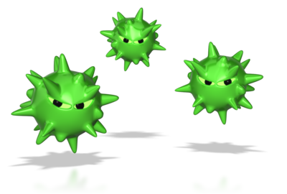
- Washing hands when entering the room, after nappy changing or toileting, after dealing with bodily fluids and when transitioning to and from eating. Educators, children and parents must all follow this practice.
- Timely changing of soiled nappies or clothes
- Use of gloves when dealing with bodily fluids
- Limit sharing of hats, clothing and blankets
- Daily sanitising of toys
- Immediate sanitising of any toy that has been in a child’s mouth
- Regular cleaning of the play areas and entire learning environment
- Exclusion of children (and educators) who are ill
- Follow food safety protocols.

Implementing hygiene practices involves:
Hand washing | - Make sure that parents are aware of the expectation that they and their child wash hands as they enter the centre/room.  - For older children, make sure that the hand washing area is set up so that they can do each of the steps of the process independently when they are individually able (for example, have an easy-to-operate soap pump, make sure paper towels are reachable).  - Post simple visuals of the steps of the hand washing process for children to refer to, and teach them how to use them.  - Make hand washing a consistent part of the routine, and children will begin to do it at appropriate times without needing reminders.
Changing soiled nappies and clothes | - Keep a regular schedule of nappy checks and changes.  - Immediately change any nappies or clothes that you notice are soiled.  - Teach children to tell you when their nappy is wet or dirty. This also helps move them toward learning to use the toilet.
Gloves | - Make sure these are always available in the bathroom, the classroom and in a backpack or first aid kit that you take with you whenever you leave the centre.  - Make sure that children are not able to access them.
Sharing hats, clothing and blankets | - Give children a dedicated space for their belongings (basket, cubby).  - Encourage parents to label their child’s items.  - Work with children to learn the expectations.
Daily sanitation | - Build this into your daily closing procedures.  - Some educators spray everything down with a bleach solution at the end of the day; others use a dishwasher or steam sanitiser.
Immediate sanitation of items that have been in mouths | - When a child is mouthing a toy, watch and be ready to pick it up and set it aside for cleaning when they are finished.  - For older children, you can ask them to set it aside themselves (and, as age-appropriate, teach about keeping toys out of mouths).  - Assign a dedicated bin or area for these dirty toys and wash or sanitise them before they go back into play rotation.  - Depending on the age of your children or the amount of toys in your room, you can either sanitise all of these at the end of the day, or deal with them periodically in small batches so that children can continue playing with them.
Regular cleaning | - Maintain a cleaning schedule that includes floors, surfaces, bathrooms, sinks, doorknobs, etc.  - Most centres will have protocols in place for educators to follow.
Exclusion of sick people | - Consistently follow the procedures put in place by your centre to exclude children who have symptoms of infectious diseases.  - Stay home yourself if you are sick.  - In general, educators and children should not come to the centre if they have a fever, diarrhoea or vomiting, excessive coughing, unexplained rashes, mucus that is not clear, or off-colour eyes or skin.
Food safety | - Follow protocols for refrigeration and storage and do not leave food out for longer than is recommended  - Check foods for expiration dates  - Do not allow children to share food, keep communal utensils out of individual mouths and don’t touch them to individual plates, bowls, cups, or utensils as you serve.  - Always wash hands before serving food.  - Make sure to be familiar with any allergies or parental food preferences in your class.

Make sure that everyone working with children is aware of and committed to following these practices. Consistency is key with all of these practices. Some of them are inconvenient or seem inefficient or hard to keep up, but once they are simply a part of the expected routine, and especially once children and families are also on board, it becomes much easier to stay on top of it all.
A room full of children is often very busy, and it can be hard in the moment to stick with tedious or inconvenient hygiene and health practices. Take the time to set yourself up for success when children are not present or when things are calm, by doing things like stocking gloves and cleaning supplies or getting ahead on cleaning tasks.
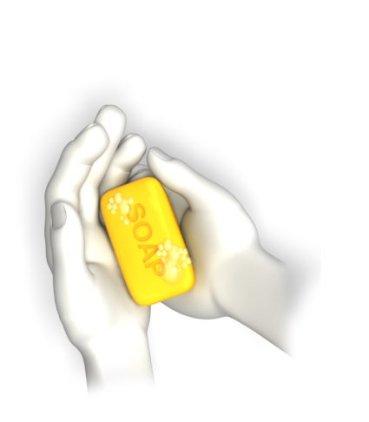
Ask for help and communicate with other educators so you can share the responsibility. Set up regular routines for things like changing nappies or helping children wash their hands, so that no one person is always responsible for it and the expectations are clear.
Early childhood education centres provide children with a great opportunity to learn healthy hygiene practices that they will carry with them throughout life. What you consistently do with and for young children, they are more likely to continue to do for themselves once they are more independent. As you help children do these things when they’re young, you can simultaneously be teaching them how to do it for themselves when they’re older. Oftentimes, when kids reach school age, they are expected to do many of these tasks on their own without guidance or even reminders from adults, so it is important that they are prepared for that.

How you can support children to learn personal hygiene practices?
- Make it possible for them to carry out the practices on their own by placing items where they can reach them, and providing easy-to-use apparatuses, e.g., pump soap, paper towel dispensers, etc.
- Post visual cues for familiar routines and teach children how to refer to them. For example, take a picture of each of the steps of hand washing, and then post them, in sequence, near the sink.
- Allow time for children to try new things on their own. Remain encouraging throughout the process, and be willing to allow them to struggle a bit, as long as they don’t appear to be overly frustrated.
- If you do need to help, do so with positivity and continued encouragement (“You are trying and trying to get the soap out, but it seems stuck. Would you like me to get you started, and then you can do the rest?”)
- Communicate with parents about what their child might be capable of doing independently at home. Share with parents about how you encourage independence at school, and techniques they can try at home if they’re interested.
When children do things on their own, it is often messy and/or time consuming. Learn to expect this, and also, be proactive. For example, don’t ask a toddler to wash his hands by himself if you have ten other children waiting for a turn.
Some children do not want to try things themselves and get upset when they are asked to. Just keep asking positively. Offer the chance with the expectation that the child will accept. Break the task into smaller, more manageable steps; maybe a child doesn’t want to put soap on her own hands, but she will step up to the sink on her own or turn the tap on.
Some children become unwilling to accept any help at all once they get a taste of independence. This can be tricky in the early childhood education setting. Try to get that child started before other children, so they have more time to work on the process.

National Quality Standards
Quality Area and Standards included in this section:

The Early Years Learning Framework
The principles, practices and outcomes included in this section:

Learning Task Eight
What are the basic hygiene and health practices followed at early childhood education centres?

Why is it so important to follow these practices consistently?

How can you support children to learn personal hygiene practices?

Activity 3A

3.4 – Ensure that service cleanliness is consistently maintained

Routine cleaning
Germs are invisible. You may think something is really clean and germ free. However, this may not the case. Bleach and disinfectants will kill most germs, but nothing will kill all of germs. It is essential to keep everything as clean as possible to stop germs from spreading germs and causing illness. All early childhood education and care childcare services must clean their premises on a daily basis and as required throughout the day.
Come up with a cleaning schedule, or follow the policies put in place by the administration to make sure that all areas are routinely cleaned according to standards. Tidy up and clean up messes as they occur whenever possible, and complete routine cleaning projects during naptimes or other downtimes during the day.
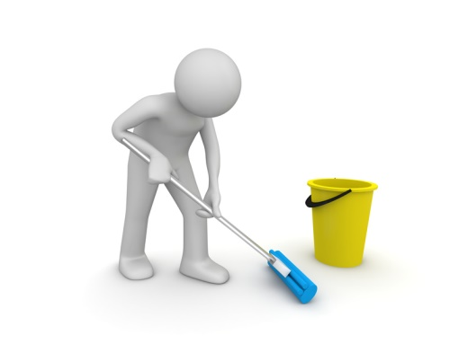
Use detergents and disinfectants to clean away dirt and grime followed by bleach/chlorine solutions to help stop cross contamination. It is recommended that you use warm water when cleaning because this makes it easier to remove dirt from a surface.
Basic steps for effective routine cleaning:
- Use detergent and warm water – follow the manufacturer’s instructions on how much detergent to use.
- Vigorously rub the surface to physically remove germs.
- Rinse the surface with clean water.
- Dry the surface.
- Dispose of cleaning cloths and gloves as specified by your centre.
Bathrooms and toilets should be cleaned every day, and accidents must be cleaned up immediately according to the centres procedures. Nappy change areas must be thoroughly cleaned with detergent and water after each nappy change. Dispose of cleaning cloths or paper towels. Waterproof sheets or changing mats should be laundered at the end of each day and when they are soiled during a change.
Toys must be washed regularly to reduce spread of infection. Wash toys at the end of each day, especially in the baby or toddler room, where most things go into their mouths. Toys can be safely cleaned with warm water and detergent and left to dry in the sun. Wipe visible dirt off books and puzzles and leave them to dry.
Cleaning equipment must be well maintained, cleaned and stored appropriately so it can dry between uses. It is recommended that you use different coloured cleaning cloths for different areas, e.g., green in the classroom, yellow in food preparation areas and blue in the bathroom.

National Quality Standards
Quality Area and Standards included in this section:

Learning Task Nine
What are the basic steps for effective routine cleaning?

List items in a centre that should be washed daily and list items that should be washed weekly.

Activity 3B

3.5 – Observe and respond to signs of illness and injury in children and systematically record and share this information with families

Observing signs of illness
Parents count on educators to keep them informed of the health and wellbeing of their children while they are in care. You must always respond to signs of illness and injury in order to make sure the child receives the proper care and to prevent the spread of infection to others.
Common illness and injury in the early childhood education setting:

- Fever – can be due to illness, ear infection or teething
- Coughs
- Colds, flu, other infectious illnesses
- Rashes
- Allergic reactions
- Bruises and abrasions
- Bites
- Bumps to the head
- Broken bones or sprains.

Recording illness
All illnesses and injuries must be reported to the lead educator and/or your nominated supervisor. Official and accurate records might be required as documentation if a child is seriously injured or becomes ill in your care, and requires medical treatment. Records of illness and injury are usually required by law to be kept on file for several years. Accurate documentation is also needed if you are excluding a child from the program because of an illness.
Recording illness and injury information:
Illness | - The centre should have a specific form to fill out when you are sending a child home due to illness.  - It should have space to record symptoms and to write down the conditions under which the child can return to care.
Injury | - The centre should also have an “accident/incident” form, which allows you to record the date and time of the injury, the nature of the injury and what care the child received.  - These are usually signed by the nominated supervisor and then shared with parents at pick-up time, before being filed.

Any time a child has symptoms of illness, even if they are not severe enough to warrant exclusion from the program, you must inform the parents/caregiver. Call parents immediately for head injuries or injuries you believe might require medical attention. Other injuries can be reported at regular pick-up time. When an injury occurs that leaves a mark, or was traumatic for the child, use your best judgement about when to inform the parents. Talk with your lead educator if you are unsure.
If an injury involved two children (for example, if one child bit another) remember to maintain confidentiality. Each parent should only be told what happened to his or her own child specifically.
National Quality Standards
Quality Area and Standards included in this section:

The Early Years Learning Framework
The principles, practices and outcomes included in this section:

Learning Task Ten
What are you required to do when a child in your care is injured?

What are you required to do when a child in your care becomes ill?

Activity 3C

3.6 – Consistently implement the service policies for the exclusion of ill children

An exclusion policy
Children cannot learn or benefit from being at the centre school when they are ill; they need individual care, which educators in the group care setting cannot properly give. When children and adults come to the centre when they are sick, they spread germs, which results in others also getting sick. Early childhood education and care centres must consistently exclude children who show signs of illness.

An exclusion policy helps to reduce the spread of infectious illnesses. Excluding ill children, educators and other staff is an effective way to limit the spread of infection. The more consistent you are about the exclusion of ill children, the easier it becomes to convince parents to keep their child home or come in to pick them up when they demonstrate symptoms of illness.
Become familiar with the exclusion policy at your centre. Know when to send a child home or advise a parent not to bring them in. For example, if a child has a fever over a specific degree, if they have vomited within 24 hours, or if they have discharge from discoloured eyes, etc. Separate sick children from the group while they are waiting to be picked up. Most centres will remove sick children to the office where an adult can supervise them.
In some cases, the exclusion policy will require that a child have a doctor’s note to return to care. This is usually for things like rashes, where the child can return to care while the symptoms persist as long as a doctor says the rash is not contagious, or in the case of a fever that goes along with teething or an infection that is being treated and is not contagious. Be diligent in asking to see these doctor’s notes before allowing the child to be left in your care.
The exclusion policy and families
Some parents may have a hard time with the exclusion policy; they are busy with work, have other commitments and responsibilities that cause them to occasionally send their sick child to the centre when it isn’t appropriate, or they will be more reluctant to respond to calls asking them to come in and pick up a sick child. Your centre can avoid these problems by providing families with a clear and consistent written policy at enrolment that outlines the exclusion criteria and the minimum exclusion period. Occasionally send out a reminder about the exclusion policy, especially during flu season or of there has been a serious illness in the centre
Ask the lead educator or your nominated supervisor for support in communicating with a parent. Be pleasant, compassionate and still firm when alerting a parent that their child is being excluded. Communicate your concern for the child’s wellbeing foremost. There should be several phone numbers by which to reach the parents or an alternate contact in case of an emergency.
Remember to maintain confidentiality about children’s illnesses. If a child is being excluded, you should not share that information with any other child’s parents. You are expected to notify parents if children have been exposed to an infectious illness, but do not disclose any names or other personal details.

National Quality Standards
Quality Area and Standards included in this section:

The Early Years Learning Framework
The principles, practices and outcomes included in this section:

Learning Task Eleven
Locate the following online PDF to use for this activity. Your centre may have a hard copy you can use).
Staying Healthy – Preventing infectious diseases in early childhood education and care
services (5th edition.)
Look up the recommended minimum exclusion periods. Discuss with a nominated supervisor which exclusions you are most likely to see in your setting. Also, list five “common” illnesses that are not exclusionary and why.

Activity 3D

3.7 – Discuss health and hygiene issues with children

Discussing health and hygiene
When left entirely up to the 3 to 5 year old, hygiene practices can be pretty poor. It is a normal and common trait for children to put fingers in their mouths, up their noses and down their pants. It is up educators to model good hygiene habits and explain why they are important, if you want to encourage children to practise the same.
You will need to assist children where and when needed, and the amount of assistance you provide will depend on their developmental needs and strengths, not their age. For example, a child with a disability may require more help with toileting or nose blowing for a longer period than another child of similar age without a disability. Never belittle a child for their lack of hygiene; always offer encouragement and help in a manner that respects the child’s self-esteem and privacy.
Modelling good hygiene alone is not sufficient to educate children about hygiene and help them adopt appropriate behaviours. Children are more likely to actively participate in health and hygiene practices when they understand the reasons for them. Talk to children about hygiene issues and why they are important, without making them uneasy about germs, illness or their health.
Children learn well from real-life experiences and conversations in context. For example, you can discuss health and hygiene issues with children:
- Casually, in the moment, as you wash hands, or change out of dirty clothes, or wash a dirty toy.
- During one-on-one conversations as you work with a child on a project.
- In small groups, during free play while several children pretend to “do chores” in the Home Living or Dramatic Play area of the classroom.
- As a whole group, as in Circle Time, where you might introduce a hand-washing visual and talk about or practice the steps of the process together.
- In conversation, e.g., if a child asks why they have a stuffy nose, you could introduce the concept of germs and talk about the hygiene practices that help us keep germs out of our bodies.
Educators can build discussions about health and hygiene into the program in the following ways:
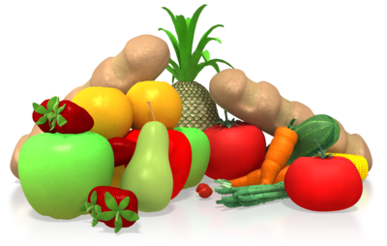
- Conduct lessons about health and hygiene, focus all activities for the week on healthy habits and encourage children to continue at home.
- Provide books about health and hygiene practices and read them with children.
- Talk casually about these topics as they emerge. Expand upon the children’s interest and experiences to deepen learning.
- Make sure that children are routinely engaging in the expected health and hygiene practices and then talk about why they are doing what they are doing.
It is important to remember that the expectations at home may be different than those at the centre. In those cases, it is fine to allow the distinction of doing certain things only at the centre, and then shift the conversation to the reasons why we do these activities.
National Quality Standards
Quality Area and Standards included in this section:

The Early Years Learning Framework
The principles, practices and outcomes included in this section:

Learning Task Twelve
List five important hygiene habits relevant to young children:

List three examples of how you can discuss health and hygiene issues with children:

Activity 3E

4. Supervise children to ensure safety

4.1. Supervise children by ensuring all are in sight or hearing distance at all times
4.2. Adjust levels of supervision depending upon the area of the service and the skill, age mix, dynamics and size of the group of children, and the level of risk involved in activities
4.3. Exchange information about supervision with colleagues to ensure adequate supervision at all times

4.1 – Supervise children by ensuring all are in sight or hearing distance at all times

4.2 – Adjust levels of supervision depending upon the area of the service and the skill, age mix, dynamics and size of the group of children, and the level of risk involved in activities

4.3 – Exchange information about supervision with colleagues to ensure adequate supervision at all times

Sight and sound supervision
Sight and sound supervision ensures that children are being adequately cared for, as it allows educators to respond quickly to both safety needs and opportunities for learning.
Specific examples supervision requirements:
- No child should be left unattended in a room or other area of the school.
- Educators should utilise safety gates and doors to keep children within boundaries.
- Educators should position themselves to make sure that each area of the environment (cubby nooks, bathroom, entry areas) is being supervised by the sight and sound of at least one educator.
- In outdoor play areas, particularly if boundaries are only marked with something like cones or a chalk line, educators should make sure that all children understand these conceptual boundaries, are familiar with the reasons boundaries are important, and are able to control their impulse to cross them.
- Educators should be extra-vigilant to keep eyes on all students during outside play, and take informal roll calls from time to time.
- If there are caves or tunnels or playhouses outside, educators should be positioned so that all children can be seen and heard. Play areas should also be designed with this need in mind.
Educators will adjust their locations or attention in response to factors or circumstances. Some examples include:
- If a child is frequently demonstrating aggressive behaviour toward peers, an educator should stay in close physical proximity to that child in order to help them problem-solve effectively and to avoid injuries to the other children.
- If a group of children notices a bird’s nest on the playground and clusters around it, an educator would approach them to observe, support and expand upon the children’s understandings, and to supervise the activity for safety reasons.

- If older children are riding bikes in the same area as toddlers are playing, educators need to watch the activity closely and give guidance to the children to help keep everyone safe.

Supervising groups
Supervising a group of children to ensure that all are seen and heard can be challenging. This is particularly challenging in the following areas:
- Large spaces
- In spaces with nooks, crannies and places to hide
- In outdoor areas where no physical boundaries like fences or walls are present
- When there is only one educator, even if the child to educator ratio is maintained. If one educator takes a small group to the playground, for example, it may be hard for that educator to keep eyes and ears on every child.
- When educators “bunch up” to talk with each other, as opposed to being spread out around the play area. It can be necessary for an educator to remind their co-workers that they need to be positioned apart from each other.
Early childhood education regulations govern the ratio of children to educators in both home-based and centre-based services. You must learn these ratios, as they are vital in maintaining the safety of the children in care. Centres will have their own procedures and guidelines for discussion and modelling, however basic safety areas will apply to all children in all settings.

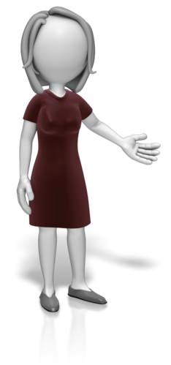
Educators should all be aware of the ratio requirements for their age group, and the way these change when classes combine. Co-workers should share this information with each other when appropriate. In general, the ratio for the youngest child present is the one that must be followed. For example, the ratio for two-year-olds may be 5:1 (meaning that there must be one educator for every five children) while the ratio for three-year-olds changes to 10:1. However, if the two-year-old and three-year-old classes combine for any reason, or even if one two-year-old joins the older class, the 5:1 ratio must be met. (This is a general guideline; your state/territory may have a different set of ratios. If you are unsure about ratios in your centre, talk to your nominated supervisor.)
While children must always be supervised, some activities, circumstances, or groups require heightened levels of attention and involvement. Communication between colleagues ensures that everyone’s knowledge contributes to the level of supervision given to the children. Educators can then work together to meet the supervision requirements.
Educators can pass information to each other in conversation, saying things like, “I am going to stay at this activity table, helping with the scissors and glue. Can you keep an eye on the other areas of the room?” or “Jay seems to be hitting more than usual today. One of us should probably stick nearby. Would you like to take turns with that?”
At different age and skill levels, the same activity will require different levels of supervision. For example, five-year-olds could make a collage fairly independently, while three-year-olds would need an educator to ensure the scissors are used safely and effectively, and that glue goes only on the paper.
A small group of children can often play happily without much active input from an educator, but as the group grows larger, they may begin to need a different type of supervision and educator interaction in order to share space and materials and generally get along.
Age mix, group dynamics and size of the group determine the level of risk involved in activities, and impact supervision levels. For example:
- A variety of age groups may go on a field trip our outdoor outing together, or all ages might be combined in one classroom for part of the day, or the whole day, depending on the type of program. This would require more supervision, because the children are at different skill-levels and may need help from an adult to share space and materials safely and productively. For example, five-year-olds can have difficulty understanding how to play with a two-year-old and may get frustrated that the younger child isn’t “playing by the rules.”
- Some groups are generally more rambunctious, while other groups are generally more interested in quiet play. You can use your understanding of your group as a whole to determine how much support and what types of activities your children need at certain times of the day.
- Whenever children are doing a novel activity, or something that involves some risk, like a cooking project, increased supervision will be necessary.
- In some cases, there will be one or two children in a group that routinely need extra attention from an educator, because of difficult behaviours or other needs. In these cases, it is helpful if the educator can get support from administration to meet the needs of that child without taking away from supervision of the rest of the group.
There are times when adjusting supervision to meet the needs the needs of the children is more challenging:

- Age groups tend to combine at the beginning and end of the day, as well as during outside play times.
- When multiple factors that require increased supervision are happening simultaneously. Planning ahead can help, but when these factors occur, communication with co-workers becomes even more important. Never hesitate to ask for and offer support.
- When staffing is limited, or there are not enough adults present.
It’s important for educators to be flexible and willing to help out with supervision when it is needed. For example:
- Educators may need to postpone bathroom breaks or other breaks until another adult is available to relieve them.
- Some activities simply require too much of an educator’s attention at a given time, and may need to be discarded, or planned for another time when circumstances allow for appropriate supervision.
National Quality Standards
Quality Area and Standards included in this section:

The Early Years Learning Framework
The principles, practices and outcomes included in this section:

Learning Task Thirteen
What is appropriate supervision and how does it vary according to the age/stage of development?

In what situations is it important to exchange information about supervision with colleagues to ensure adequate supervision?

Activity 4A

5. Minimise risks

5.1. Assist in the implementation of safety checks and the monitoring of buildings, equipment and the general environment
5.2. Consistently implement policy and procedures regarding the use and storage and labelling of dangerous products
5.3. Follow service procedures for the safe collection of each child, ensuring they are released to authorised people
5.4. Assist in the supervision of every person who enters the service premises where children are present
5.5. Discuss sun safety with children and implement appropriate measures to protect children from over-exposure to ultraviolet radiation
5.6. Check toys and equipment are safe for children and safe to use in their proposed area
5.7. Remove any hazards immediately or secure the area to prevent children accessing the hazard

5.1 – Assist in the implementation of safety checks and the monitoring of buildings, equipment and the general environment

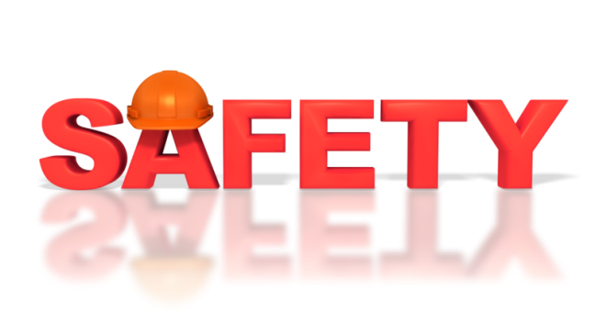
Assist with safety checks
Children depend on the adults who are caring for them for their safety and wellbeing, and parents trust that professionals working with their children will take every precaution in ensuring their health. Safety checks and monitoring will help educators to be proactive and aware of potential dangers. Preventing harm is always preferable to dealing with it after it happens!
Safety checks include:
- Keeping an accurate count of children and double-checking that everyone is present, especially during transitions from one activity or area to the next.
- Routinely checking and stocking your first aid kit to ensure you’ll have what you need in an emergency.
- Building plans for emergency preparedness, talking about them with your co-workers, and practicing them with children. These could include fire and lockdown drills, whistle drills where students come immediately to their educator at the sound of the whistle, and lost child drills.

Monitor the environment
Educators must monitor buildings, equipment and the general environment to ensure children’s safety. This includes:
- Checking outdoor play spaces for safety before the children begin playing.
- Checking toys for broken or damaged pieces which might cut a child or be a choking hazard.
- Checking that toys available to children are age-appropriate, especially in terms of size.
- Keeping doors, gates and fences etc., closed securely so that children stay with educators.
- Ensuring that all possibly hazardous materials, like cleaning supplies, are kept in locked cabinets out of children’s reach.
- Making sure that bathroom garbage cans or nappy bins are kept closed and children cannot access them.
- Using child safety locks on cabinets and bathroom doors when appropriate, and covers for all unused electrical outlets.
- Keeping educators’ items, like handbags or hot drinks, etc., out of the reach of children.
- Checking outdoor play areas for hazards such as any breakages or rough edges on play equipment, animal droppings or sharp implements including needles.
- Keeping rooms such as the kitchen, laundries, office, etc., out of access to children.
It’s a good to get down to the level of the children in your care and explore the room from their perspective to see potential hazards you might otherwise not notice. Use a daily safety checklist to assess the room and outdoor play areas.
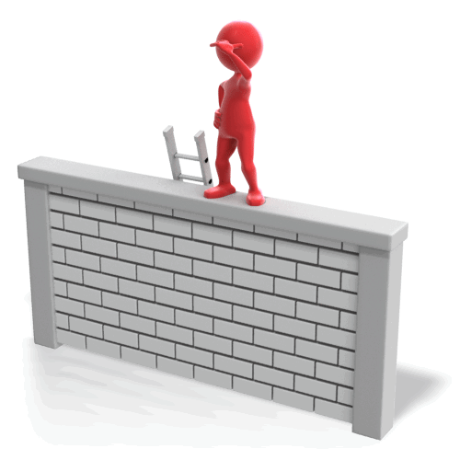
There are some areas of the centre that require more intensive monitoring:
- Playground or outside play spaces
- Walkways outdoors or through the building
- Bathrooms
- Transitions of any kind, especially when you leave one area and go to another.
Be careful to take roll, matching children to their name on your roll sheet, before you leave an area and once you get to your destination. Counting alone is helpful, but it’s possible to count incorrectly, or to have the wrong number of students signed in for the day. When you take the time to account for each child visually, it is less likely that you will mistakenly leave anyone behind.
Work with your teaching team to ensure that every child can be seen and heard by at least one educator as they play. This often means that educators need to “spread out” in an area, rather than standing together.
You may want to set up a schedule for safety checks and maintenance of the centre to ensure that all areas and potential hazards are monitored regularly. Use a daily safety checklist to assess the room and outdoor play areas.

National Quality Standards
Quality Area and Standards included in this section:
The Early Years Learning Framework
The principles, practices and outcomes included in this section:

Learning Task Fourteen
Define and describe safety checks.

List the common areas and equipment etc., where educators need to monitor to ensure children’s safety.

Activity 5A

5.2 – Consistently implement policy and procedures regarding the use and storage and labelling of dangerous products

Dangerous products
Some products that need to be present in the early childhood education and care setting could be harmful if misused, or if accessed by a curious child. Dangerous good and products must be labelled clearly enough that any adult, even one unfamiliar with the centre’s routines, could use them properly.
Dangerous products include:
- Cleaning products, like bleach, glass cleaner, or washing detergent
- Used nappies and wipes

- Tools and toolboxes
- Ladders
- Toxic office supplies, like permanent markers or printer ink cartridges
- Scissors and knives
- Staplers
- Medications, lotions and sunscreen
- Fertiliser for planting projects
- Items that pose a choking hazard to children, especially rubber gloves used for changing nappies.
Policies and procedures have been put in place to maintain safety and consistency when using products that may be dangerous. Consistent implementation of these policies and procedures ensures your health and safety as well as that of the children in your care.

Policies and procedures
General policies and procedures regarding use, storage and labelling of dangerous products:
- Find and familiarise yourself with your centre’s policies and procedures regarding use, storage and labelling of dangerous products.
- Label cleaning products accurately and only use them for their intended purpose.
- Keep medications and chemicals in their original packaging to limit confusion about how and why to use each product.
- Store cleaning supplies, tools, office supplies, medications and other potentially hazardous items in locked storage areas out of the reach of children.
- Follow your centre’s procedures for the storage and administering of children’s medications and lotions, both prescription and over-the-counter.
- Keep bathroom and nappy changing areas clean and neat, ensuring that children do not have access to gloves or soiled items.
- Use ladders and other tools appropriately and return them to storage immediately after use.
- Keep your personal items out of the reach of children.
There are simple ways to consistently implement the centre’s policies and procedures:
- Work together with other educators to share information and support each other to consistently follow the policies and procedures.
- If you notice a hazard left by someone else, do what you can to solve the problem immediately. For example, if another educator leaves a bleach bottle out in order to quickly attend to a crying child, you can help out by putting the bleach bottle away.
- Routinely scan the learning environment classroom, especially from the perspective of your children, to notice and address any hazards.
- Plan ahead when possible so that you are using hazardous products when children are not present, and cleaning up before children arrive/return.
- Invite feedback and reminders from co-workers, and be willing to give them as well.
- Watch for expiration dates on cleaning products and medicines.
- Check storage containers and locks for wear and tear that might limit their effectiveness.
- Review your centre’s policies and procedures on a regular basis to make sure they stay familiar to you.
- Make parents aware of the policies and procedures around medications and lotions.
- Ask parents to be mindful of bringing in hazardous items during drop-off and pick-up, like hot drinks, sharp objects, etc.

Often times you will be called away from what you are doing to attend to a child or talk with a parent. It’s important to make sure you take the time, whenever possible, to quickly put away all hazardous items before you move away from them. If you can’t, for instance if a child has been hurt and needs immediate attention, ask for help from a co-worker.

National Quality Standards
Quality Area and Standards included in this section:

The Early Years Learning Framework
The principles, practices and outcomes included in this section:

Learning Task Fifteen
List all of the potentially dangerous materials located in your room.

How do you ensure children and staff cannot be harmed by these materials?

Provide five examples of ways to consistently implement the centre’s policies and procedures regarding the use and storage and labelling of dangerous products.

Activity 5B

5.3 – Follow service procedures for the safe collection of each child, ensuring they are released to authorised people

Safe collection of children
Children remain an educator’s responsibility until an authorised person picks them up. However, pick-up times can be hectic, so there are procedures are in place to ensure that children do not leave on their own or with anyone other than an authorised person, regardless of the circumstances.

There are times when additional vigilance is required to ensure children are released to authorised people. For example:
- Early pick-ups
- When leaving for a mid-day appointment and coming back later
- Going on excursions
- Any time a child is leaving the centre with a person other than their parent (who is usually known to you)
Procedures regarding safe collection of each child:
- Make sure that parents and educators always check in with each other at pick-up times. Parents should be aware of the expectation that they touch base with their child’s educator before leaving the centre.
- Educators should immediately update their roll sheet, marking the child out.
- Parents should notify the office and the educators if someone else is going to be picking up their child. This person’s name should be on file, and educators must see a photo ID for any unfamiliar person and check it against the list of people authorised for pick-up before releasing the child.
- Children will remain with an educator or administrator or other authorised adult at all times.
- If a parent is late picking up their child, an educator or administrator must wait with that child until an authorised pick-up person arrives.
- Children may be supervised by an authorised chaperone during a field trip, but the educator remains ultimately responsible for the safety and wellbeing of every child.

Tips to consistently implement the service procedures:
- Keep a roll sheet and maintain it throughout the day.
- Communicate and work together with fellow educators, administrators and parents to ensure that children are only released to authorised adults.
- Make sure that every child can be seen and heard by at least one educator or chaperone at all times, so that someone will notice if the child is being picked up or is leaving with an unauthorised party.
Sometimes, in an effort to be polite, educators are tempted to let a child leave with an adult they seem to know. It is still important that you check the ID of anyone you do not know and make sure that they have been properly authorised to pick up before you let the child leave with them. This is important because there may be custody issues or other considerations you do not know about.
Sign children in and out on the roll sheet in a timely manner, and check periodically that it is correct and up to date. Do this especially if you are leaving your room in the care of another educator for a time, because if you have failed to sign out a child who has left, the other educator will expect that child to still be with the group. Alternately, if you did not sign a child in and then you or another educator takes roll using the incorrect roll sheet, that child or another may be accidentally left behind.
Talk to your lead educator or nominated supervisor if you have any concerns or questions about whether a person is authorised to collect a child.

National Quality Standards
Quality Area and Standards included in this section:

The Early Years Learning Framework
The principles, practices and outcomes included in this section:

Learning Task Sixteen
Find and familiarise yourself with your centre’s procedures for the safe collection of each child, ensuring they are released to authorised people. Summarise your findings and create a reference sheet you could post throughout the centre.

Activity 5C

5.4 – Assist in the supervision of every person who enters the service premises where children are present

Supervise people entering the centre
Most people who enter a childcare centre, whether they are family members of students, friends of educators, prospective employees, visiting parents, or people doing some business in the building, are there for a valid reason and will behave safely in the centre. However, it is your job as an educator to make sure these visitors are not posing a threat to the children or interfering with their learning.
It’s also important that these visitors themselves remain safe while on the premises. Your attention can help visitors to feel welcome and comfortable in your centre.

When this is necessary:
- Grandparents come to visit the classroom.
- The neighbourhood librarian comes to read to the children.
- A repairperson comes to work on the plumbing.
- A parent brings along siblings at drop off/pick-up time.
- A person visits the centre to determine whether they’d like to enrol their child.
- Someone wants to know if there is a bathroom they can use. (Sometimes the person will not have appropriate business being in the centre and should be asked to leave.)
You need to be generally aware of what is going on within your environment in order to deal with or prevent any difficulties that may arise. Discuss possible situations with your co-workers and develop plans for what to do in each situation. Remain alert so that you know who is in your classroom at all times.
Familiarise yourself with your centre’s policies and procedures regarding visitors to the centre, and know where to find them if you need to reference them. Most centres will require all visitors sign in and wear a visitor badge that identifies them. The sign in book will record their name, the reason for visiting, the room/areas they are visiting, and time they entered and left the building. Remind your visitors that this procedure must be followed at all times.
All people in the centre should have a valid reason for being there. If they do not, it is okay to ask them to leave and to get support from administration, security or the police as necessary. Let all visitors know if they are engaging in an inappropriate action, like taking pictures of the children, playing roughly or leaving tools within children’s reach. Make sure these visitors know the expectations, and if they are unable to follow them, ask them to leave.

What to do if you have concerns:
- Talk to your fellow educators and administrators
- Direct the visitor to speak to an administrator
- Calmly take the children to a safe or different area while the visitor is present
- Call security or police
Follow your instincts if someone’s presence makes you feel uncomfortable. It is okay to ask a visitor to leave, or to ask for assistance from co-workers or your nominated supervisor.
National Quality Standards
Quality Area and Standards included in this section:

The Early Years Learning Framework
The principles, practices and outcomes included in this section:

Learning Task Seventeen
You are near the front door as someone you do not recognise walks in the centre. She starts rushing past you and you ask for her name. You do not recognise her name and you ask her who she is here to see. She tells you that she has to pick up her niece because her mother has been in an accident. You have an uneasy feeling about the situation and are very concerned. What do you do?

Activity 5D

5.5 – Discuss sun safety with children and implement appropriate measures to protect children from over-exposure to ultraviolet radiation

Sun safety
Educators are responsible for teaching, reinforcing and modelling positive sun protection behaviours. Most early childhood education centres and services promote outdoor play for at least an hour each day and children must be protected from the sun.
Sun protection is essential for safe outdoor play in the early childhood setting because:

- Over-exposure to ultraviolet rays can cause painful sunburns, as well as risks of future illness.
- Too much time in the sun without proper attire and hydration can cause heat stroke and other potentially damaging conditions.
All children in early childhood education and care settings must be dressed appropriately for sun protection. This means that children must wear hats outside, and always wear a t-shirt and sunscreen. Outdoor play is essential to all early education programs and many centres enforce a ‘no hat, no play’ rule that excludes the children without hats from outdoor activities.
Examples of appropriate measures:
- Use of sunhats, sunscreen, and/or loose-fitting clothing that covers the body.
- Application of sunscreen, re-applying throughout the day as necessary. Make sure it has a high enough SPF, and is listed as “broad-spectrum.” Cover any exposed skin, and supervise older children who are applying to themselves.
- Apply the sunscreen 30 minutes before going into the sun.
- Sunscreen shouldn’t be applied to infants under six months, so these children should be kept out of direct sun.
- Limiting time outside or choosing times when the sun is less intense.
- Making sure to offer children lots of water when the weather is warm. Offer several times an hour while outside, rather than waiting for children to ask.
Follow these measures even on overcast or cloudy summer days as the sun’s rays can still pass through.
What to do if a child gets sunburn:
- Give water to drink and apply cool, wet cloths to the area.
- Keep the child out of the sun until it is healed.
- Call the parents to let them know. A doctor should also be notified if an infant or toddler is sunburned.
- Watch for signs of heat stroke (flushed skin, fever, no sweating, confusion, and shock) and call emergency medical services if these occur.
- Watch for signs of heat exhaustion (pale skin, sweating, dizziness, fainting) and call the child’s parents if they occur.
Children who attend an early childhood education and care centre usually do so during peak UV times (10 am and 3pm). Because of this, it is essential that the centre has policies and practices in place to protect the children, and educators focus on teaching children about skin protection.
Educators must discuss sun safety with children any time they are going outside. Children need consistent reminders as to why these measures are important. Some children don’t like putting sunscreen on, or wearing appropriate clothing (hats and t-shirts, etc.), so they may need a little extra encouragement.
Examples of things you can say to children to remind them about sun safety:
- “We are going outside, and it’s very sunny. Let’s put on some sunscreen to keep our skin safe. We don’t want sunburn, because that hurts”.
- “It’s outside time. Everyone get your hats; remember, No Hat – No Play”.
- “Let’s look for some shady spots we can be in if we get too hot”.
- “If you are thirsty, we have your water bottles in our backpack! It’s really important to drink water when the sun is out. It keeps our bodies healthy and feeling good. Come ask me for a drink whenever you want one”.

Sun Protection Policy
All early childhood education services must enforce a comprehensive sun protection policy. This policy describes the centre's commitment to sun safety and outlines responsibilities for educators, staff, families, children and visitors.
A sun protection policy ensures the following:
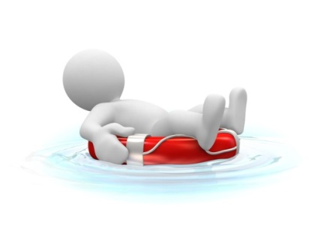
- All children and staff have some UV exposure for vitamin D
- All children and staff use a combination of sun protection measures (sunscreen, hat, appropriate clothing)
- Children learn to be responsible for their own sun protection
- All staff and families are informed of the service’s SunSmart measures
- The service provides a safe outdoor environment with adequate shade
- Sun protection measures are included in planning daily activities.
(Cancer Council Australia, 2012)

Sample SunSmart Policy
Shadybrook Early Childhood Education Centre Sun Protection Policy
Outdoor activities | - Outdoor activities are planned outside peak UV times (before 10 am and after 3pm)
Shade | - All outdoor activities are planned in shaded areas  - Activity areas are moved throughout the day to maximise shade patterns  - Educators assess the availability of shade when planning excursions and all other outdoor activities.  - Children are encouraged to use available areas of shade when outside.  - Children who do not have appropriate hats or outdoor clothing are required to play in the covered area or indoors  - A shade audit is conducted regularly to determine the current availability and quality of shade.  - The centre will provide a portable shade when needed or when holding a special event or excursion.
Clothing | - Children are required to wear loose fitting clothing that covers as much skin as possible.  - Tops that cover the shoulders are required.  - Educators and staff must wear their uniform at all times.  - Children, educators and staff are encouraged to wear close fitting, wrap-around sunglasses that meet the Australian Standard 1067 (Sunglasses: Category 2, 3 or 4) and cover as much of the eye area as possible.
Hats | - All children and educators are required to wear hats that protect their face, neck and ears, i.e. legionnaire, broad-brimmed or bucket hats.  - The centre enforces the 'no hat no play' rule – any child without a hat must remain inside, or undercover during outdoor activities.
Sunscreen | - All children, educators and staff are required to wear SPF 30+ or higher broad spectrum, water resistant sunscreen (provided by the centre)  - Sunscreen must be applied at least 20 minutes before going outdoors and reapplied every two hours if outdoors.  - With parental consent, children with naturally very dark skin are not required to wear sunscreen to help with vitamin D requirements.
Families and visitors | - Families and visitors are required to comply with this policy when attending the centre.  - Special requests/needs regarding the use of sunscreen will be reviewed on a case-by-case basis and in line with this policy.

Education | - The centre incorporates this policy into all curriculum and learning programs  - Sun protection information is shared and made available to families, staff, visitors and community members.  - Educators, parents, staff, visitors and community members are informed of changes to the policy
Policy availability | - This policy is communicated to families, educators, staff and visitors upon arrival to the centre.  - Updates to this policy will communicated to all parties in a timely and efficient manner
Policy review | - This policy will be regularly reviewed and updated according to relevant recognised authorities.

(Adapted from Cancer Council Queensland, 2013)
National Quality Standards
Quality Area and Standards included in this section:

The Early Years Learning Framework
The principles, practices and outcomes included in this section:

Learning Task Eighteen
What are the sun protection guidelines for children according to the recommendations of relevant authorities?

How do you enforce these guidelines at your centre?

What can you personally do to uphold the sun protection guidelines at your centre?

Activity 5E

5.6 – Check toys and equipment are safe for children and safe to use in their proposed area

5.7 – Remove any hazards immediately or secure the area to prevent children accessing the hazard

Maintaining toy and equipment safety
Maintaining the safety of toys and equipment greatly decreases the risk of accidents and injuries, from cuts to choking. Educators should check for broken or loose parts and jagged edges that may scratch or pinch when sanitising and organising toys.
Toys or equipment that can be considered unsafe:
- Toys with moving parts that may come loose
- Wooden or plastic toys that create jagged edges or pinching hazards when broken
- Necklaces or strands of beads that can break apart and become choking hazards
- Art or sensory materials that can spoil (for example, play dough and clay can grow mould even when stored in a closed tub; corn starch and water mixtures can become sour after one day)
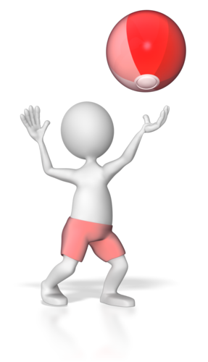
- Toys with paint or varnish that is beginning to peel
- Electronic devices that have not been safety tested (there is usually a safety tag attached – this should not be removed)
- Toys brought from home (they may not pass the safety standards of the centre)
- Toys for older children left in shared areas or brought into younger classrooms
- Toys and equipment that are left outside and exposed to weather
- Classroom supplies meant for educators’ use that may be within reach of children
- Toys that are used roughly, like hammer and peg sets.
Make sure that all dangerous/hazardous items are safely locked away from children. Make sure the areas accessed by children are monitored for sharp objects or broken toys and equipment that may cause injury. Sometimes even if you have explained a hazard to children, they will not respond by staying away. Broken items or hazards that educators are discussing can be novel and exciting to curious children, even if they are unsafe. Remove all broken or hazardous items immediately.

The environment should be checked throughout the day for hazards, including:
- Bodily fluids
- Backed up plumbing
- Broken glass
- Slippery spills of food, paint, sensory materials, etc.
- A broken toy or piece of equipment
- In outside play areas, especially if they are shared with the public, there can be litter, animal waste, etc.
- Equipment for use by adults, like ladders, tools, or cleaning supplies.

Educators should also keep a constant watch for choking hazards. For infant through toddler ages, there are measuring devices available to ensure that toys are large enough to prevent choking. A general rule is that if it fits through a toilet paper tube, it is choke-able.

What to do if you have a concern?
- Remove the toy temporarily from the environment until you can be sure it is safe.
- Ask your nominated supervisor or co-workers for input on the safety of the equipment.
- Research the issue on your own.
- Do not allow a child to play with or use an item if you have doubts about its safety.
- Secure the area.
In some cases, it is necessary for all children to leave the area where a hazard has been identified. For example, if a toilet backs up, children should be removed from the bathroom and kept away from the mess with a closed door or gate.
If possible, remove the hazard to a place where children are not present. For example, if a tricycle has a wobbly wheel that looks like it may fall off, it can be taken from the playground and stored in an appropriate location that is inaccessible to children, until it has been fixed.
For older children, plastic cones can be used to block off certain types of hazards. For example, if animal droppings are found while playing at the park, educators can place cones around the area to remind children to steer clear.
Someone should stay in the area of the hazard until it is dealt with, to warn others that may enter. When this is not possible, use signs to alert others that there is a hazard. For example, if a child vomits and you decide to take the rest of the group outside while waiting for the mess to be dealt with, there should be a staff member on the scene until it is all cleaned up, to make sure no children are brought into the area by someone who is unaware of the situation.
You can apply risk reduction strategies to ensure hazards are prevented and/or addressed in a timely manner. For example:
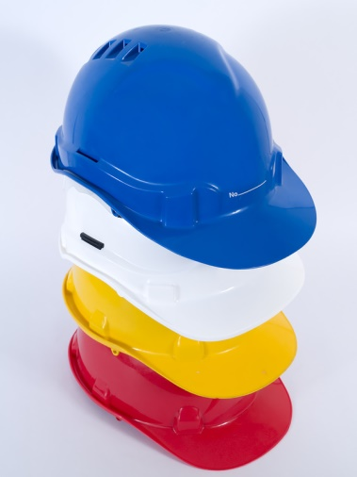
- Gates on stairs
- Covers on electrical sockets
- Removal/locking away of dangerous substances
- Close supervision of any children in kitchens
- Fences and gates, locking mechanisms
- Out of bounds areas
- Vacuuming/sweeping floors to remove small or dangerous objects
- Children being seated and supervised at meal and snack times.
When you discover a hazard, you will often find it necessary to get extra assistance, either from administration or from some other staff member who is not needed to meet the student to educator ratio, in order to secure the area and deal with the hazard while keeping the children safe. Make sure to take the proper precautions to keep yourself safe while taking care of a hazard. Wear gloves to clean up bodily fluids, ask for help in moving heavy equipment.
National Quality Standards
Quality Area and Standards included in this section:

The Early Years Learning Framework
The principles, practices and outcomes included in this section:

Learning Task Nineteen
What risk reduction practices are in place in your workplace?

What are common toy safety issues in your room and how are they handled?

Activity 5F

6. Contribute to the ongoing management of allergies

6.1. Identify and recognise signs, symptoms and key characteristics of allergies and anaphylaxis
6.2. Apply organisational risk-management strategies for children with severe allergies
6.3. Follow organisational policies and legislative requirements in relation to medication for anaphylaxis

6.1 – Identify and recognise signs, symptoms and key characteristics of allergies and anaphylaxis

Allergies and Intolerances
True food allergies are very rare and are usually very serious. Food intolerances are more common.
The following are common signs and symptoms that can be caused by food intolerance:
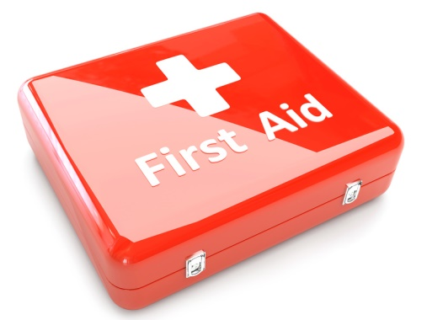
- Watery eyes
- Sneezing/wheezing, or runny nose
- Coughing
- Lethargy and/or headaches
- Behaviour concerns
- Dark circles under the eyes
- Frequent colds and/or middle ear infections
- Intestinal gas
- Frequent skin rashes e.g. hives
- Diarrhoea, stomach pains
These symptoms may also have other causes so it is wise to check with a medical practitioner. It is reported that the following may assist with preventing the development of food allergies and intolerances:
- Breastfeeding for at least the first twelve months
- Introducing solid foods when the child shows definite signs of readiness, which is usually about six months of age
- Making sure the solids introduced are less allergenic e.g. cereal, fruits and vegetables
- Introducing foods one at a time to test for a reaction

The difference between allergies and intolerances
Allergies are triggered by the immune system, while food intolerances are abnormal responses to food that do not involve the immune system. Usually, food allergies are more medically serious and may be life threatening in some cases. People with a food allergy are usually advised to avoid the food altogether. Food intolerances are often managed by lowering the intake of the food that causes the problem.

Occasionally, children have allergic reactions to certain foods that are life threatening, e.g. peanuts. Some early childhood education and care centres have banned all nuts rather than run the risk of a child having a life-threatening reaction (reactions usually include swelling of the face and digestive tract).
It can take weeks and even months to track the exact food to which the child is allergic to or intolerant of, or exactly how much a child can eat of the allergenic food before a reaction occurs. This must always be done in consultation with a doctor or dietician.

Anaphylaxis
Anaphylaxis is the most severe form of allergic reaction and is potentially life threatening. It must be treated as a medical emergency, requiring immediate treatment and urgent medical attention. Anaphylaxis is a generalised allergic reaction, which often involves more than one body system (e.g. skin, respiratory, gastro-intestinal, and cardiovascular). A severe allergic reaction usually occurs within 20 minutes of exposure to the trigger and can rapidly become life threatening.
Common triggers of anaphylaxis include:
Food | Milk, eggs, peanuts, tree nuts, sesame, fish, crustaceans and soy are the most common food triggers, which cause 90% of allergic reactions, however, any food can trigger anaphylaxis. It is important to understand that even trace amounts of food can cause a life-threatening reaction. Some extremely sensitive individuals can react to even the smell of a food.
Insect Venom | Bee, wasp and jumper ant stings are the most common causes of anaphylaxis to insect stings. Ticks and fire ants also cause anaphylaxis in susceptible individuals.
Medication | Medications, both over the counter and prescribed, can cause life-threatening allergic reactions. Individuals can also have anaphylactic reactions to herbal or alternative medicines.
Other | Other triggers such as latex or exercise induced anaphylaxis are less common and occasionally the trigger cannot be identified despite extensive investigation.

Signs and Symptoms
The signs and symptoms of anaphylaxis may occur almost immediately after exposure or within the first 20 minutes after exposure. Rapid onset and development of potentially life threatening symptoms are characteristic markers of anaphylaxis. Allergic symptoms may initially appear mild or moderate but can progress rapidly. The most dangerous allergic reactions involve the respiratory system (breathing) and/or cardiovascular system (heart and blood pressure).
Common Symptoms – mild to moderate allergic reaction:
- Tingling of the mouth
- Hives, welts or body redness
- Swelling of the face, lips, eyes
- Vomiting, abdominal pain
Severe allergic reaction – ANAPHYLAXIS

- Difficulty and/or noisy breathing
- Swelling of the tongue
- Swelling or tightness in the throat
- Difficulty talking or hoarse voice
- Wheeze or persistent cough
- Loss of consciousness and/or collapse
- Pale and floppy (young children)

Management and treatment
Anaphylaxis is a preventable and treatable event. Knowing the triggers is the first step in prevention. Children and educators need to be educated on how to avoid food allergens and/or other triggers. However, because accidental exposure is a reality, children and educators need to be able to recognise symptoms of an anaphylaxis and be prepared to administer adrenaline according to the individuals Anaphylaxis Action Plan.
Research shows that fatalities more often occur away from home and are associated with either not using or a delay in the use of adrenaline. In Australia, adrenaline can be purchased on the PBS in the form of an auto-injector known as the EpiPen®. The EpiPen® auto injector is an intra-muscular injection of adrenaline for the emergency treatment of anaphylactic reactions. It is available in two doses, EpiPen® Jr or EpiPen®.

National Quality Standards
Quality Area and Standards included in this section:

The Early Years Learning Framework
The principles, practices and outcomes included in this section:

Learning Task Twenty
List five common symptoms of a severe allergic reaction.

What is the policy at your centre to avoid cross-contaminating foods?

Activity 6A

6.2 – Apply organisational risk-management strategies for children with severe allergies

6.3 – Follow organisational policies and legislative requirements in relation to medication for anaphylaxis


Risk management
Allergies (especially to nuts) are becoming common enough amongst children that it becomes most effective to ban certain foods or other substances from early childhood education and care centres. Some allergies are severe enough to be life threatening. Proactive risk-management strategies are far less risky and stressful than treating and caring for children who experience severe allergic reactions while at the centre.
Educators must apply risk-management strategies for children with severe allergies. Depending on your centre’s policies and procedures this may include:
- Create a “no nut” policy for the entire centre.
- Make visual alerts for each child with severe allergies, particularly to food. These can include the child’s name, their picture, the days they usually attend care and the foods or substances they are allergic to. These should be posted in a location that is visible to everyone who will work with a child, and should especially be visible during mealtimes. It is helpful to post a copy in the kitchen or food prep area as well.
- Regularly discuss children’s allergies with co-workers to keep the information fresh in everyone’s mind.
- Communicate regularly with parents to ensure that you have up-to-date information on allergies, medications and emergency action plans.
- Be especially attentive, to ensure that not only is the child served the right foods, but that they don’t access foods they are allergic to by sharing with peers, serving themselves from the communal bowl or eating food that has fallen on the table or floor.
- Plan ahead to have alternatives available for foods that a child is allergic to. This is important when preparing regular meals and snacks, as well as when planning to have cupcakes or other foods for birthdays or class parties.
- If you bring in your food for meals, be mindful of allergies in the room. IF you are on a special diet yourself, eat your food outside the classroom, and store it in an area children can’t access.
- Consider allergies when making decisions about having a class pet.
- Encourage educators and parents to limit use of scented products, especially lotions and perfumes.
- Regularly wash blankets and dress-up clothes in a hypoallergenic detergent.
It’s easy to forget and become careless, but it is essential that you do not relax the centre’s policies for responding to severe allergies and administering medication for anaphylaxis. Visual reminders can be extremely helpful with this. You may also need to come up with other safeguards. Maybe one educator who feels confident in their ability to manage allergies takes on the task of serving meals and snacks, or you could make all children a placemat, and then include a visual allergy reminder on the placemats of children with allergies.
Additional care must be taken when:
- Children are eating in a communal way. Prohibit food sharing between children, or eating things found on tables or floors.
- Using non-food materials that may have allergens as ingredients (for example, play dough is generally made with flour, which causes allergic reactions in some children).
- Involving children in cooking projects when the ingredients include allergens.
National Quality Standards
Quality Area and Standards included in this section:

The Early Years Learning Framework
The principles, practices and outcomes included in this section:

Learning Task Twenty-One
What organisational risk-management strategies for children with severe allergies are in place at your centre?

What are your centre’s organisational policies and legislative requirements in relation to medication for anaphylaxis?

Activity 6B

7. Contribute to the ongoing management of asthma

7.1. Identify signs, symptoms and triggers of asthma
7.2. Identify children who have an asthma management plan and follow that plan
7.3. Follow organisational policies and legislative requirements in relation to medication for asthma

7.1 – Identify signs, symptoms and triggers of asthma

What is asthma?
Asthma is the inflammation, tightening and swelling of the airways in the respiratory system, resulting in the obstruction of airflow to and from the lungs. Asthmatics are prone to colds and infections depending on their exposure and susceptibility to triggers.
Symptoms include:
Breathlessness | - Not being able to take in enough air  - Need to breath out and breathe in at the same time  - Causes distress which makes it worse
Wheezing | - High-pitched whistling sound  - Air is being forced through the narrowed airways
Coughing | - Repetitive dry cough or cough with phlegm  - Mostly at night and early morning  - Puts strain on the heart and drives phlegm deeper into the lungs  - The more they cough the more they feel the need to cough again
Chest tightness | - Trapped air in the lungs generates a feeling of over-inflatedness  - Feels like someone is squeezing or sitting on the chest
Tiredness | - Frequent yawning due to interrupted sleep  - Breathlessness reduces sleep quality

Triggers
‘Asthma attack’ is the term used to describe an episode of difficult breathing. There are many different situations that can trigger an asthma attack. A ‘trigger’ is something that makes brings on an asthmatic episode. In most cases, asthma attacks are brought on by a combination of triggers.
Some common trigger factors include:
- Colds
- Exercise
- Changes in the weather
- Pollens and pet dander
- Cigarette smoke
- Perfumes

- House dust mites
- Emotional stress
- Allergies
- Respiratory infections
- Digestive disturbances
- Food colourings and additives.

Symptoms
Asthma attacks can be frightening for the both children and adults. It is essential that all educators who work with children with asthma are aware of the condition and are alert for signs of an attack.
Symptoms of an asthma attack include:
- Wheezing
- Shortness of breath
- Tightness in the chest
- Coughing.

Minimising the chances
While there is no cure for asthma, there are some steps that can minimise the chances of an attack.
- Require that all children and staff was their hands thoroughly and regularly to help minimise exposure to colds and viruses (the most common trigger for asthma attacks).
- Avoid vigorous or long continuous activity when the child is sick. Asthmatic airways are blocked and are super sensitive to physical strain.
- Avoid emotional stress that can bring on excessive crying. Teach relaxation to children with asthma and support them with additional coping skills.
- Provide opportunity for regular daily exercise, rather than intense, one-off games and activities. Regular activity strengthens the lungs over time.
- Reduce exposure to allergens including, airborne allergens such as moulds, pollens, animal dander and dust, and food allergens such as dairy, eggs and wheat.
- Ensure that children drink plenty of water to thin out mucus secretions.
Although there are no activities or sports that children with asthma should avoid, some are more appropriate for children with asthma. Activities that require constant movement with little time for rest, such as running or bike riding, are more likely to bring on an asthma attack. However, with appropriate use of medication and a proper warm up, children with asthma can participate in most activities.
Types of activity recommended for children with asthma:
- Swimming indoors where the air is warm and humid is particularly beneficial as it reduces any irritation that cold, dry air can cause to the airways.
- Fitness classes that allow children to take small breaks between exercises.
- Yoga is highly recommended since it helps children improve their breathing and teaches relaxation.
- Activities with short bursts of effort are great as they allow for rests in activity e.g. sprinting.
National Quality Standards
Quality Area and Standards included in this section:

The Early Years Learning Framework
The principles, practices and outcomes included in this section:

Learning Task Twenty-Two
What are the signs, symptoms and triggers of asthma?

Activity 7A

7.2 – Identify children who have an asthma management plan and follow that plan

7.3 – Follow organisational policies and legislative requirements in relation to medication for asthma

Identify asthmatic children
Children in early childhood and care centres are exposed to multiple germs and allergens that can trigger asthma symptoms. These symptoms can interfere with learning and development. You must work to provide an environment that is sensitive to the asthmatic child, but also supports their learning and socialisation.
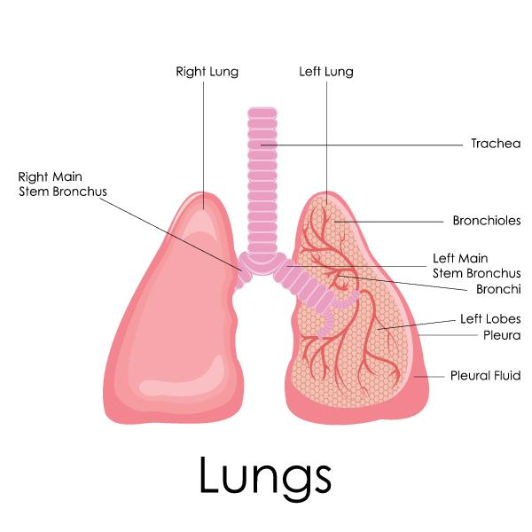
Asthma is a life-threatening condition, and while children are in care, their educators must know how to minimise risks and respond to emergencies. Educators must also be aware of their legal responsibilities, including that children cannot be excluded from activities or the centre because of their asthma or allergies.
Asthmatic children should be actively involved in their own care programs, being made to understand the things that they need to do to minimise the chances of experiencing an attack and knowing what to do when they notice symptoms. Educate the child on how to manage their symptoms in relation to their developmental age e.g., teach them why they must wash their hands, and why they can’t roll around in the grass etc. Be careful not to scare the child or make them feel that cannot participate in group activities. There needs to be a balance between caution and adventure.
Asthma is a condition that can be managed well when management plans are followed. Asthma management plans are developed by a child’s parents and doctors and include the following:
- Information regarding how to reduce the risk of asthma attacks, signs and symptoms of an attack, and protocols to follow if symptoms are occurring.
- Detailed instructions on when and how to administer any asthma medications (rescue inhalers, etc.) Similar to other types of medicine, asthma medications can be harmful or can become less effective when administered improperly.
- Information regarding when to limit physical activity.
- Information regarding dietary restrictions
- Special sleep instructions (put to sleep on sides, propped up with a towel or blanket, etc.)
- Instructions regarding breathing exercises that the child may need to do every day. You must provide opportunity and space for them to do these exercises with respect to their privacy.
- Up-to-date phone numbers that would be needed in case of an emergency.
Children with asthma management plans should be identified to the centre administrators at the time of enrolment. Educators working with the child should be notified, as well as given a copy of the plan and access to necessary medications. Everyone who interacts with children with asthma should be informed about the illness, understand the triggers and symptoms and know how to respond in an emergency.
If asthma management is working well, a child can go months or years without experiencing symptoms, which can mean that educators lose the sense of urgency about the issue over time, and can be surprised and unprepared if it ever comes up. Some asthma symptoms can be similar to symptoms of colds or other respiratory illnesses and if you lack experience with asthma, it can be scary and make you feel very anxious. If you are not sure that symptoms are occurring, don’t hesitate to contact the parent by phone immediately.
It can be useful for the child’s regular educator to post a visual alert in a space that any relief or visiting educators can see. This sign could have the child’s name and picture, the days that they are usually in care, and the information that they have asthma. This is similar to the visual alert used for children with severe allergies.

Supporting parents
It is normal for parents to worry about the health of their children, particularly when they have a child with asthma. However, it is important to remember that providing children with opportunities for exercise and active play benefits their health in many ways including a reduction in asthma symptoms and attacks.
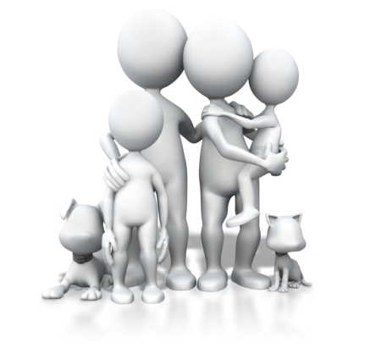
- Include parents in creating a management plan and try to incorporate their requests as best you can without impacting the other children.
- Recommend that parents have their child tested for common allergens and work together to limit the child’s exposure to these allergens at home and at the centre.
- Keep a food diary of everything the child eats in care and share with parents.
- Identify a core team in your centre to work with children with asthma and their parents (nominated supervisor, lead educators and yourself).
- Help parents remember to keep information up-to-date and medications current.
- Recommend that parents store more than one rescue inhaler at the centre to make sure there is always one available. For example, one could stay in the medication cupboard and another could be stored in the backpack/first aid kit that goes with the class on excursions or walks outside.

National Quality Standards
Quality Area and Standards included in this section:

The Early Years Learning Framework
The principles, practices and outcomes included in this section:

Learning Task Twenty-Three
How do you identify the children at your centre who have an asthma management plan?

What information is usually included in an asthma management plan?

Name two common medications used for asthma.

Activity 7B

Skills and Knowledge Activity

Nearly there...

Major Activity – An opportunity to revise the unit

At the end of your Learner Workbook, you will find an activity titled ‘Major Activity’. This is an opportunity to revise the entire unit and allows your trainer to check your knowledge and understanding of what you have covered. It should take between and 1-2 hours to complete and your trainer will let you know whether they wish for you to complete it in your own time or during session. Once this is completed, you will have finished this unit and be ready to move onto the next, well done!

Congratulations!
You have now finished the unit ‘Ensure the health and safety of children'.


References

These suggested references are for further reading and do not necessarily represent the contents of this Learner Guide.

Cancer Council Queensland 2014, Early Childhood Centre SunSmart Policy Guidelines, Cancer Council Queensland, Fortitude Valley, Qld, viewed 27 February 2014, http://www.cancer.org.au/preventing-cancer/sun-protection/sunsmart-schools/

NHMRC National Health and Medical Research Council 2012, Staying Healthy – Preventing infectious disease in early childhood education and care services 5th edition, Commonwealth of Australia, NHMRC National Health and Medical Research Council, viewed 31 July 2014, http://www.nhmrc.gov.au/_files_nhmrc/publications/attachments/ch55_staying_healthy_childcare_5th_edition_0.pdf

