CPCCBC4014A
Prepare simple building sketches and drawings

THEORY EXAM INSTRUCTIONS

- This exam will occur under standard assessment conditions.
  - An oral examination may be allowed under certain circumstances.
Answers will be documented and FT003 (Oral examination declaration form) must be completed.
- Participants must provide enough detail in their responses to demonstrate their knowledge and skills.
- Please fill in the details below, providing your name, signature and date of assessment.
  - Your signature acknowledges that this is your own work.
- If a participant initially answers a question incorrectly but modifies their response, they must follow the instructions below:
  - If a participant changes their response in writing, they must put their initials next to the written change.
  - If a participant changes their response verbally, this must be noted on the exam paper by the assessor.

Participant name | Anna-Marie Dorin
Participant signature | 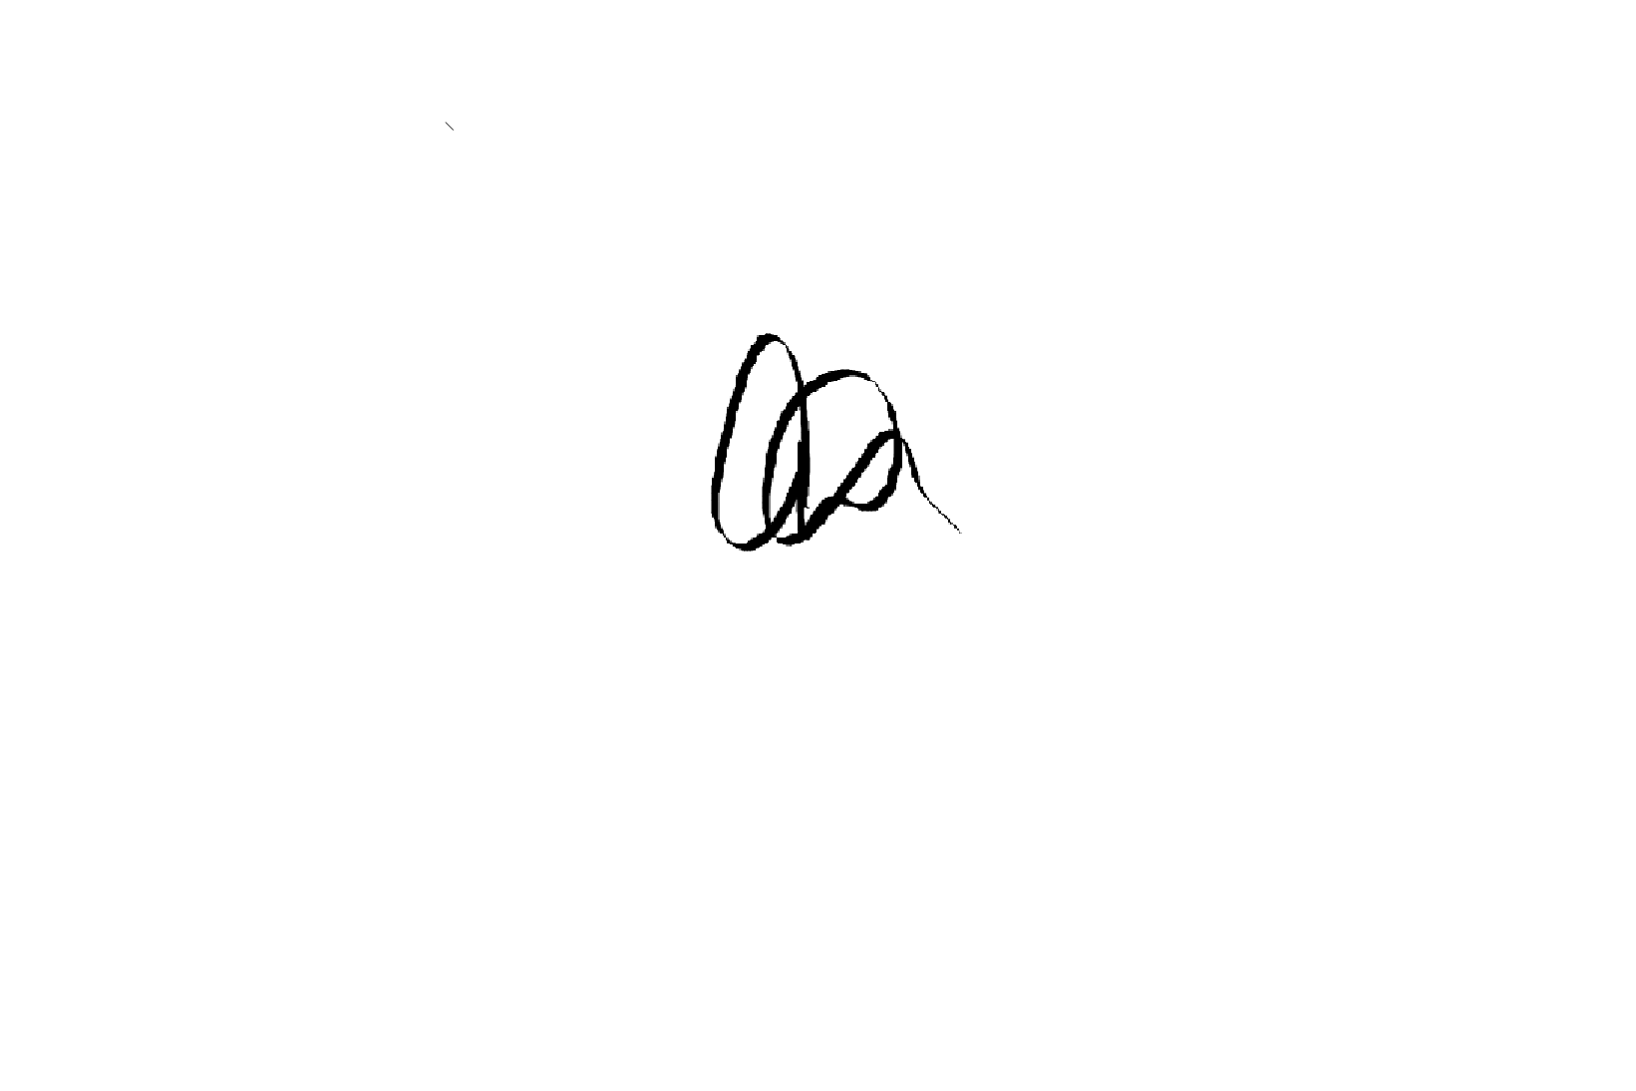

Assessor name | Brett Stower
Assessor signature | 

Date | 22/05/2019

Number of questions | Number of questions answered correctly | Satisfactory?
23 |  | Yes | No
Assessor Comments
- Identify three (3) two-dimensional drawings/sketches that may be used to clarify or communicate ideas to clients or other parties. For each drawing/sketch, identify four (4) key features that may be shown.

Answer | Drawing/sketch type | Key features
 | Schematic sketches | These form an important part of this process as they are a quick way of getting thoughts onto paper and planning any special or critical areas.
 | Floor plan | Shows the layout/arrangement of rooms and other parts of a house interior
 | Sectional views | A view of the house or structure after it has been cut vertically at some point to show the detail of structural parts and how they are to be built or assembled.

- Name two (2) advantages of a three-dimensional sketch/drawing.

Answer | 3D drawings provide a more realistic picture of a space of the drawing.  It can give a realistic impression of the volume or space of the drawing.

- Name one (1) individual you might contact to establish the scope and standard of the job being undertaken.

Answer | Client

- You need to inspect the relevant area to take measurements for your drawings/sketches. Identify two (2) safety requirements you would need to observe on site.

Answer | SWMS  PPE

- Identify two (2) types of tools/equipment you would use when inspecting the area to take measurements.

Answer | Measuring Wheel  Gradient/Digital Level

- Identify two (2) types of tools/equipment you might need when completing sketches/drawings.

Answer | Digital Camera  Writing/Sketching equipment ie pencil/paper etc

- What action should be taken if any of the tools/equipment identified in Q5. and Q6. are found to be defective? Tick your response.

Answer | Choice | Possible Answers
 |  | Report, Record
 |  | Stop, Report, Record
 | x | Stop, Tag, Report, Record
 |  | Stop, Fix, Report, Record

- True or False (Tick your response): It is best practice to double check measurements before recording them.

Answer | x | True
 |  | False

- Explain the purpose of the scale on sketches/drawings.

Answer | You need to have an understanding of the sketch/drawing so you can clarify/communicate ideas, capture design concepts, make estimates and show measurements.

- You have measured a wall that is 2.4m high. Using a scale of 1:100, what size will this be drawn? Provide your answer in mm. Show your workings.

Answer | 2.4m to mm = 2.4 x 1000 = 2400mm  Scale 1:100

- Explain the purpose of a key or legend on sketches/drawings.

Answer | To be able to identify what is needed/required for the sketch/drawing ie, orientation symbols, lines, electrical distribution etc.

- Which of the following are true about drawing contours?
Tick all that apply.

Answer | Choice | Possible Answers
 | x | Equally spaced contour lines indicate uniform slope
 |  | Closely spaced contour lines indicate flat surface
 | x | Closely spaced contour lines indicate steep ground
 | x | Concentric closed contours with decreasing values toward the centre indicate a pond
 |  | Concentric closed contours with decreasing values toward the centre indicate a hill

- Identify the Volume and Parts of the NCC that relate to metal sheet roof cladding for Classes 1 and 10, and Classes 2 to 9.

Answer | Classes 1 and 10 | Classes 2 to 9
 | Volume 2 Parts 3.5.1.0 and 3.5.50 | Volume 1, Parts B1.4 and F1.5

- Which Australian Standard is referenced in the NCC with regards to the requirements for the design and installation of metal sheet roof cladding?

Answer | AS 1562

- Sketch the following standard design symbols.

Answer | Item | Sketch
 | Compass (North) | 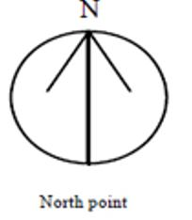
 | Sink with one bowl | 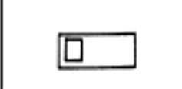
 | Stairs | 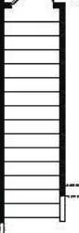
 | Toilet | 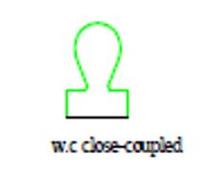

- Explain the meaning of the abbreviations in the table below.

Answer | Abbreviation | Meaning
 | BK | Brick
 | CBD / CPD | Cupboard
 | DP | Down Pipe
 | INSUL | Insulation
 | KIT | Kitchen
 | MSB | Main Switch Board
 | PBD | Plaster Board
 | RWT | Rain Water Tank
 | SHR | Shower
 | TEL | Telephone
 | WC | Water Closet

- True or False (Tick your response): The dashed/chain lines on the section view shown below represent the portions that have been in contact with the cutting plane.



Source: https://www.mcvts.net/cms/lib/NJ01911694/Centricity/Domain/131/Section_Views.pdf

Answer | x | True
 |  | False

- Explain the use of hatching lines for sectional drawings.

Answer | The hatching lines represent the material type in contact with the cutting plane, as illustrated by the key/legend.

- True or False (Tick your response): In an offset sectional drawing, the cutting plane does not travel in a straight line.

Answer | x | True
 |  | False

- Which of the following information should be included in the title block for a sketch/drawing? Tick all that apply.

Answer | Choice | Possible Answers
 | x | Client details
 | x | Contact details for person who prepared drawings
 | x | Date drawing was completed
 | x | Drawing number
 | x | Drawing title
 | x | Job number
 | x | Project name and address
 | x | Revisions / Amendments (if applicable)
 | x | Scale

- True or False (Tick your response): Amendments usually have to be signed or initialled by both the builder and the client to show they both agree.

Answer | x | True
 |  | False

- Explain why it is good practice to have a single repository for sketches/drawings.

Answer | It is important to have a central location where documents are stored to ensure there is a reference point to check that the sketches/drawings being used are the most current.

- Name the Regulation and identify the section that outlines the requirement for structure designers to produce a safety report.
Briefly describe the requirements.

Answer | Section of Act | Requirements
 | SafeWork 2017  Act 2011 No 10 | An Act to secure the health, safety and welfare of persons at work; to repeal the Occupational Health and Safety Act 2000; and for other purposes.

