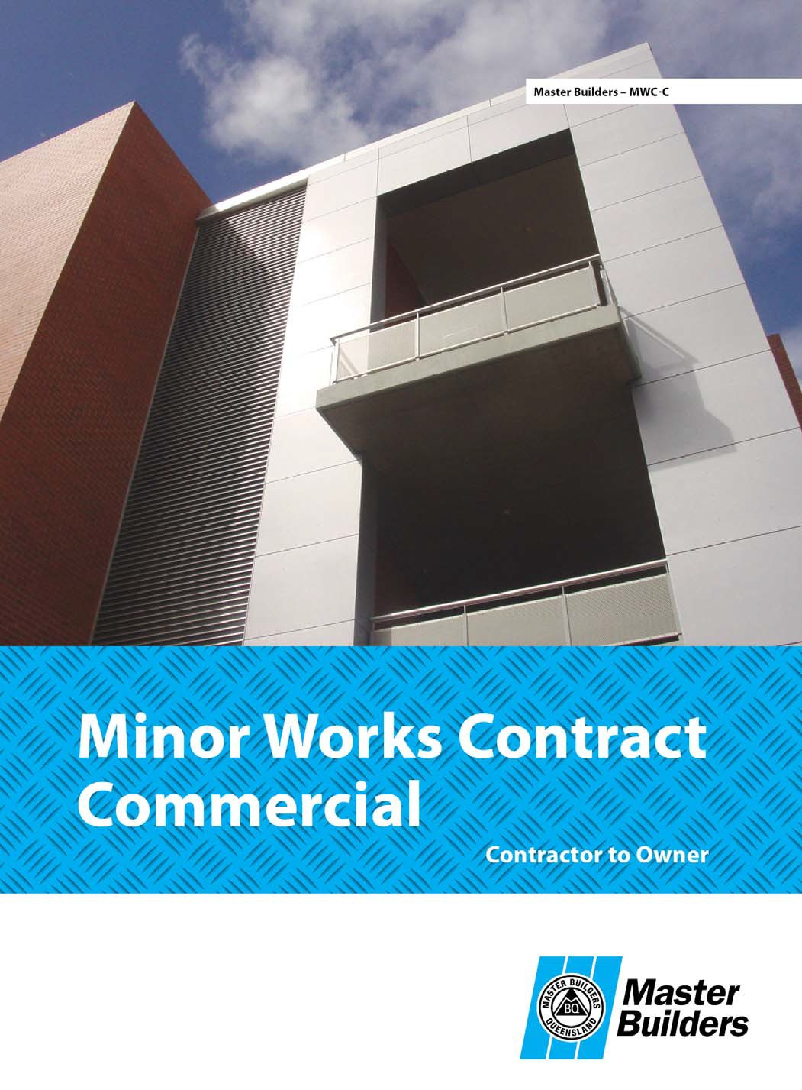


Commercial Minor Works Contract

Version: MWC-C v04-2014

Item 1 - Owner
Name 1
Real-Built Developments Pty Ltd
69 146 462 497
2 Calypso Drive, Gold Coast QLD 4216
07 5597 3167
admin@real-builtdev.com.au

Name 2 Trading as ABN
Address Phone 1
Phone 2 Email Fax

Item 2 - Contractor
Name

Trading as

Address ABN
QBCC licence number Phone 1
Phone 2 Email Fax
Is the contractor a member of Master Builders QLD?

Alder Constructions Pty Ltd ATF Alder Family Trust
As shown on the QBCC licence card

PO Box 1531 Oxenford QLD 4210
31 106 657 470
1066 730
07 5514 4900
mail@aldercon.com.au
07 5556 0845
Yes No

NOTE: If the Contractor named in this Contract is not a Master Builders Queensland member, then:
- no support will be provided to either party named in the Contract;
- there will be no access to the Master Builders Queensland Holding Account; and
- there will be no service offered for disputes between parties.

Clause 1(a)

Brief description of the Works
House Extension – extra bedroom with ensuite
60 Curassick Street, Merrimac QLD 4226
Lot 3
RP 9763
Gold Coast City Council

Site address Lot no.
on RP

Local authority

Clause 1(b)
Contract Sum (GST inclusive) Contact sum (in words)
$ 89,500
including GST

Clause 3
Date for Commencement
4/09/2020

Clause 4
Party responsible for additional costs of any Contractor Owner
Latent Conditions (if nothing stated, the Owner)

Latent Condition margin
20%

(if nothing stated, 20%)

Clause 6(a)
Payment claims to be made Weekly Fortnightly Monthly

and submitted on the
day of the 25th (or next business day)

Clause 6(c)
Time for payment

30 Days EOM
(if nothing stated, 5 Business Days)

Clause 6(e)

Interest on overdue amounts

10 %
(minimum interest as per Clause 6(e))

Clause 7(c)

Prime Cost Item and Provisional Sum margin

20%
(if nothing stated, 20%)

Clause 10

Date for Practical Completion Stage
21/01/2021

Clause 11
Defect Liability Period
12 months

(if nothing stated, 6 months)

Clause 12

Liquidated Damages
$ Nil /Day

Clause 15
Special conditions

Agreement
The parties agree that the Contractor is to carry out and complete the Works at the Site in exchange for the Contract Sum and in accordance with the terms and conditions of this Contract.
/ /

Signed (Contractor): Date:

Signed (Owner): Date:
/ /

Signed (Owner): Date:
/ /

Commercial Minor Works Contract - General Conditions (MWC-C 04-2014)
- WORKS & CONTRACT SUM
  - The Contractor must carry out and complete the Works in a proper and tradespersonlike manner, in accordance with the Contract Documents and using materials that are suitable, new and free of defects. Unless otherwise agreed, the Contractor must supply everything necessary to carry out the Works.
  - The Owner must pay the Contract Sum to the Contractor in the manner and at the times stated in the Contract.

COMPLIANCE WITH STATUTES
The Contractor must comply with all Statutory Requirements relating to the Works and unless otherwise agreed, obtain all consents, approvals and permits necessary for the carrying out of the Works.

COMMENCEMENT
  - The Owner must give the Contractor possession of the Site by the Date for Commencement.
  - The Contractor must commence the Works by the Date for Commencement or within 14 days after receiving all necessary consents, approvals and permits to carry out the Works, whichever is later.

SITE CONDITIONS
  - On becoming aware of the existence of a Latent Condition, the Contractor must promptly give the Owner a written notice containing details of the Latent Condition, including the Contractor’s estimate of any work (including plans and designs) and the cost required to overcome the Latent Condition.
  - On giving the Owner a notice under Clause 4(a):
    - the Works are deemed to have been varied to include the work required to overcome the Latent Condition; and
    - unless otherwise stated in the Contract, the cost to the Contractor, together with the Contractor’s Margin applied to that total cost,is to be added to the Contract Sum and included by the Contractor in the next Payment Claim.

INSURANCE
  - The Contractor must effect and maintain the following insurance policies:
    - Work Cover or any other insurance required by law;
    - in respect of third party personal injury or property damage, public liability insurance:
      - in the joint names of the Owner and the Contractor;
      - for an amount not less than $5 million per occurrence;
      - the policy must include a waiver by the insurer of its subrogation rights against any of the co-insured and operate as if each of the co-insured is deemed to be the subject of a separate policy of insurance (subject always to the overall sum insured not being increased thereby).
  - If the Works comprise of the alteration, addition or repair of an existing building, the Owner must effect and maintain a policy of insurance over any existing building affected by the Works and their contents:
    - for an amount not less than their full replacement value; and
    - covering against any loss or damage.
  - Where requested in writing by the other party, a party liable to insure must provide satisfactory evidence as to the existence, maintenance and terms of any insurance policy.

PAYMENT
  - The Contractor shall submit Payment Claims to the Owner by the following reference dates:
    - the times stated in the Schedule (or, if any time stated in the Schedule is not a Business Day, the next Business Day);
    - or the last Business Day of each month; whichever is the earlier.
  - A Payment Claim shall set out:
    - details of:
      - the work carried out by the Contractor to which the Payment Claim relates;
      - the amount that the Contractor claims for payment by the Owner for that work; and
      - any other amount arising out of or in connection with the Contract that the Contractor claims for payment by the Owner; and
    - the total amount that the Contractor claims for payment by the Owner.
  - On the submission of a Payment Claim under Clause 6(a), the Owner shall:
    - pay to the Contractor the total amount of the Payment Claim by the time stated in the Schedule for payment or the date 15
Business Days after the Submission Date, whichever is the earlier; or
    - if the Owner disputes all or any part of the total amount of the Payment Claim:
      - give the Contractor a written notice setting out the amount in dispute and details of the dispute by the time stated in the Schedule for payment or the date 10 Business Days after the Submission Date, whichever is the earlier; and
      - pay to the Contractor the amount of the Payment Claim that is not disputed by the Owner by the time stated in the Schedule for payment or the date 15 Business Days after the Submission Date, whichever is the earlier.
  - If the Owner fails to give the Contractor a notice under Clause 6(c)(ii)(A) by the time required under Clause 6(c)(ii)(A), the Owner shall pay to the Contractor, under Clause 6(c)(i), the total amount of the Payment Claim without any deduction.
  - the Owner shall pay interest, calculated on a daily basis, to the Contractor on any overdue amount under this Clause, including any part of the amount of a Payment Claim wrongly withheld by the Owner up to and including the date on which the overdue amount is paid by the Owner at the rate stated in the Schedule or the rate comprising the annual rate, as published from time to time by the Reserve Bank of Australia for 90 day bills plus 10%, whichever is the higher.
  - A payment made by the Owner under Clause 6 is payment on account only.

PRIME COST ITEMS & PROVISIONAL SUMS
  - Where a Prime Cost Item or Provisional Sum is included in the Contract, the Owner must give the Contractor all necessary directions and instructions regarding the selection and supply of materials, goods or work comprising the Prime Cost Item or Provisional Sum in sufficient time to ensure that the progress of the Works is not delayed.
  - If the actual cost to the Contractor in performing the work or supplying the item comprising the Prime Cost Item or Provisional Sum is less than that estimated and included in the Contract Sum, the difference is to be deducted from the Contract Sum and allowed for by the Contractor in the next Payment Claim.
  - If the actual cost to the Contractor in performing the work or supplying the item comprising the Prime Cost Item or Provisional Sum is greater than the estimated amount, the difference, together with the Contractor’s Margin applied to the difference is to be added to the Contract Sum and included by the Contractor in the next Payment Claim.

VARIATIONS
  - The Contractor must not vary the Works or omit any part of the Works, except in accordance with the Contract.
  - The parties may agree to a Variation of the Works, provided that the agreement must be put in written form by the Contractor:
    - if the Variation requires additional work to be carried out, before the Variation is carried out by the Contractor; or
    - if the Variation is an omission from the Works, within the shortest practicable time.
  - The parties written agreement to vary the Works must:
    - state the scope of work the subject of the Variation;
    - state the price of the Variation or how the price of the Variation is to be calculated; and
    - be signed by the Owner and the Contractor.
  - The Contract Sum is to be adjusted by the price of a Variation and the adjustment is to be included by the Contractor in the next Payment Claim.

EXTENSION OF TIME
  - The Contractor is entitled to an extension of the Date for Practical Completion Stage if the progress of the Works is delayed as a result of any of the following:
    - Variations to the Works;
    - Obtaining the signed agreement of the Owner to a Variation to the Works;
    - Inclement weather or conditions resulting from inclement weather;
    - Claims or proceedings being taken, or threatened to be taken, by third parties;
    - Disputes with adjoining or neighbouring owners or occupiers;
    - A strike, lockout, civil commotion or industrial action affecting:
- any persons carrying out the Works; or
- the manufacture or supply of materials to be used in the Works;
    - A shortage, or delay in the delivery, of materials to be used in the Works; or (viii)Any other matter, cause or thing beyond the control of the Contractor.
  - The Contractor must, within a reasonable time of the delay concluding, give the Owner a notice in writing setting out:
    - the reason for the delay;
    - the period during which the carrying out of the Works was delayed; and
    - the extended Date for Practical Completion Stage.
  - Where a delay is a result of any of the causes listed in Clause 9(a):
    - the Contractor is entitled to be paid by the Owner for any increase in the cost of carrying out the Works, including supervision and off-site costs, arising directly or indirectly out of the delay; and
    - the cost to the Contractor is to be added to the Contract Sum and included by the Contractor in the next Payment Claim.

PRACTICAL COMPLETION STAGE
  - The Contractor must ensure that the Works reach Practical Completion Stage by the Date for Practical Completion Stage.
  - After reaching Practical Completion Stage, the Contractor is to give the Owner possession of the Site and the Works on payment of all monies due to the Contractor, including payment of all outstanding Payment Claims.
  - If the Owner, for any reason takes possession of, occupies or uses the Works, or any part of the Works, prior to the Contractor giving the Owner possession under Clause 10(b) or without the written consent of the Contractor, the Works are deemed to have reached Practical Completion Stage on that date and the Owner is deemed to have accepted that the Works have been completed in accordance with Clause 1(a).

DEFECTS LIABILITY PERIOD
The Contractor must, at its own cost, rectify any part of the Works that is faulty or defective, and remove and replace any materials not in accordance with this Contract as directed in writing by the Owner after Practical Completion Stage and before the expiration of the Defects Liability Period.

LIQUIDATED DAMAGES
If the Contractor fails to bring the Works to Practical Completion Stage by the Date for Practical Completion Stage, the Contractor shall pay liquidated damages to the Owner at the rate specified in the Contract for the period during which the Works are not at Practical Completion Stage.

DISPUTE RESOLUTION
  - If either party has any difference of dispute in connection with, or arising out of, the Contract, that party must give the other party a written notice of dispute adequately identifying and providing details of the dispute.
  - Notwithstanding the existence of a dispute, the parties must, subject to the Contract, continue to perform the Contract.
  - A dispute may be referred to the Master Builders for conciliation at any time by either party, provided that one of the parties is a member of the Master Builders.
  - If conciliation under Clause 13(c) does not take place or conciliation fails to resolve the dispute, then a minor commercial building dispute where the claim and/or counter claim is less than $50,000 may be referred to the Queensland Civil and Administrative Tribunal (QCAT) for resolution.

DEFINITIONS
In this Contract, unless the context otherwise requires:
Business Day - has the meaning given in Section 36 of the Acts Interpretation Act 1954 (QLD) but does not include 27, 28, 29, 30 or 31 December of any year.
Contract Sum - means the amount payable to the Contractor by the Owner under the Contract as adjusted in accordance with the Contract and includes GST.
Latent Condition - means any physical condition on or below the site, or the area surrounding the site, which differs materially from the physical conditions which could reasonably have been expected by the Contractor at the time the Contract was entered into.
Practical Completion Stage - means the stage when the Works are complete except for minor defects or omissions that do not prevent the Works from being capable of being used for their intended purpose.
Start Date - means the date the Contractor physically commences the Works on the Site.
Submissions Date - means the date on which the Contractor submits (as the case may be) the Payment Claim.

SPECIAL CONDITIONS
If applicable, the Special Conditions attached shall take effect as express terms of the contract. Special conditions prevail over these general conditions to the extent of any inconsistency.

