
AHCLSC309
Install water features

Copyright © 2021 CSTC Pty Ltd

All rights reserved. No part of the contents of this publication may be reproduced or used in any form or by any means – graphic, electronic, or mechanical including photocopying, digitising, recording, or information storage-and-retrieval systems – without the written permission of CSTC Pty Ltd.
ASSESSMENT FOR AHCLSC309

Student name | Kelly Thorpe
Date of assessment submission | Click here to enter a date.

Trainer/Assessor’s name
Date of assessment marking | Click here to enter a date.
Outcome for unit | ☐ Competent  ☐ Not Yet Competent

TASK INSTRUCTIONS

- As part of the assessment for this unit of competency, you are required to complete a series of activities.
  - Some of these activities will require you to provide a response within this document, others will require you to gather evidence to demonstrate your knowledge and skills.
- At all times, the responses in your assessment must reference Australian (Queensland or Federal) documentation, including legislation, regulations, codes of practice, standards and guidance publications.

ACTIVITIES

Draw a simple concept plan for a proposed landscape design which includes a water feature.

Response
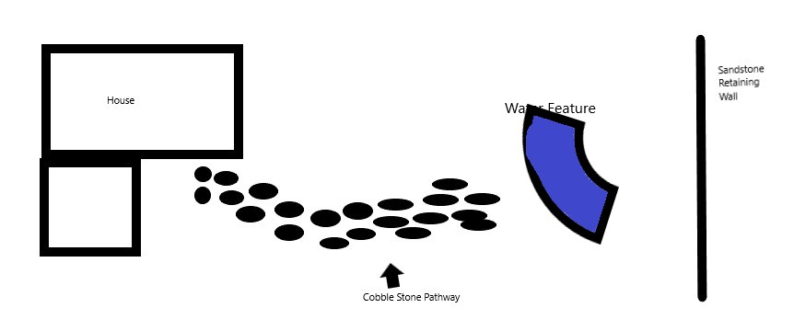

Outcome for Activity 1 | ☐ Satisfactory  ☐ Not satisfactory
Trainer/Assessor comments

Identify/list the detail on the landscape plan shown.

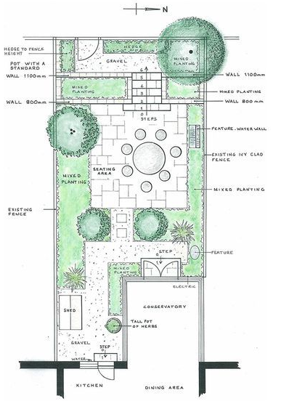

Response
Title
Property address
Date
Plan identification number
Version and amendment table
Name and contact details of designer
North blocks
Scale
Plan size
Property boundaries, fence, retaining walls
Existing buildings
Contours, drainage lines
Existing trees (including species, height)’
Services (overhead and underground)
Proposed buildings, gardens and structures
Materials to be used in proposed structures

Outcome for Activity 2 | ☐ Satisfactory  ☐ Not satisfactory
Trainer/Assessor comments

List the materials required to complete the water feature in the construction plan shown.

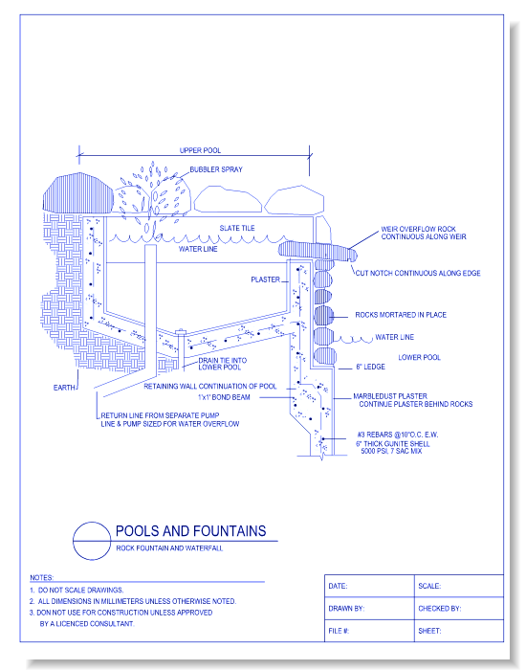

Response
Slate tiles, rock, plaster, pumps/pipes, granite shell

Outcome for Activity 3 | ☐ Satisfactory  ☐ Not satisfactory
Trainer/Assessor comments

Have team members take photos and videos of your involvement with water features.

Identify each photo / video with a letter label and describe each photo / video in the table below. Submit the photo / video files along with this workbook.

Advantages
A
B
C
D
E
F
G
H
I
J
K
L
M
N
O
P
Q
R
S
T
U
V
W
X
Y
Z

Outcome for Activity 4 | ☐ Satisfactory  ☐ Not satisfactory
Trainer/Assessor comments

