CHCECE025
Embed sustainable practices in service operations
Learner Guide


Table of Contents

Unit of Competency 4
Application 4
Performance Criteria 5
Foundation Skills 6
Assessment Requirements 7
An introduction to the National Quality Framework (NQF) 9
1. Develop a sustainability management plan 12
1.1 – Identify aspects of sustainability in the service 13
The importance of sustainability 14
Identify current sustainable practices within the service 14
What can you do without? 15
Activity 1A 17
1.2 – Consider areas of potential change in all aspects of the service’s delivery and environments 18
Improving practices for service delivery 18
The outdoor environment 19
The indoor environment 20
Activity 1B 21
1.3 – Ensure that nature, waste, energy and toxins have been considered 22
Exploring nature 22
How about energy? 22
Waste products 22
Toxins in the environment 23
Activity 1C 25
1.4 – Identify areas where change can be instigated to enhance environmental sustainability and increase children’s connection with nature, in consultation with children 26
Helping children to connect with nature 26
Include the thoughts of children 26
Activity 1D 29
1.5 – Develop strategies to address these areas of change in consultation with children 30
1.6 – Implement strategies and evaluate outcomes 30
Develop strategies with the children 30
Use your strategies 31
Evaluate the success of the strategies 31
Activity 1E 33
2. Support children to develop an understanding and respect for the natural environment 34
2.1 – Provide children with a wide range of natural and recycled materials in their indoor and outdoor environments 35
Use natural and recycled materials for the service’s needs 35
Use recycled items for sustainability 36
Activity 2A 37
2.2 – Create opportunities to discuss with children the natural environment and the interdependence between people, plants, animals and the land 38
Talk about geography and the environment 38
Living with and off the land 38
Give back to the land 39
Activity 2B 40
2.3 – Role-model respect, care and appreciation for the natural and constructed environments 41
2.4 – Share information and provide children with access to resources about the environment and the impact of human activities on environments 41
Be a good role model for others 41
Our impact on the environment 41
Activity 2C 43
2.5 – Create spaces that promote the development of life skills, such as growing and preparing food, waste reduction and recycling 44
Cultivation 44
Food from the plant to the table 45
Improvements to areas of waste 45
Create definite spaces for activities 45
Activity 2D 47
2.6 – Encourage children to exchange thoughts and ideas about sustainable practice through intentional teaching, learning experiences and projects 48
Learn about sustainability 48
Introduce fun projects for the children 49
Activity 2E 50
2.7 – Explore ethical dilemmas of waste disposal for sustainability with all stakeholders 51
Discuss waste management with the stakeholders 51
How can the service’s waste be managed better? 52
Activity 2F 53
3. Support others in implementing sustainable practice 54
3.1 – Encourage children to participate in sustainable practice discussions and learning experiences 55
3.2 – Engage with adults and children to encourage their participation in the service’s sustainable practices 55
Encourage others to participate in sustainable practices 55
Engage with the community 55
Activity 3A 57
4. Embed sustainability into service policies and procedures 58
4.1 – Review the service philosophy, policies and procedures in relation to sustainable practice 59
4.2 – Identify areas of potential change in the service philosophy, policies and procedures 59
A service philosophy 59
Make a review 59
Identify areas of change 60
Activity 4A 61
4.3 – Discuss with stakeholders any identified areas of potential change 62
4.4 – Finalise changes after agreement with appropriate stakeholders 62
Discuss any potential changes with stakeholders 62
Agree and finalise the changes to be made 63
Activity 4B 64
Summative Assessments 65
References 66

Unit of Competency

Application

This unit describes the skills and knowledge required to support children to connect with and contribute to their world and embed sustainable practice into service operations.

This unit applies to work across a range of education and care service services.

The skills in this unit must be applied in accordance with Commonwealth and State/Territory legislation, Australian/New Zealand standards and industry codes of practice.

Unit Mapping Information

No equivalent unit.

Pre-requisite Unit

None stated.

Unit Sector

None stated.

Performance Criteria
Element  Elements describe the essential outcomes. | Performance Criteria  Performance criteria describe the performance needed to demonstrate achievement of the element.
- Develop a sustainability management plan | - Identify aspects of sustainability in the service  - Consider areas of potential change in all aspects of the service’s delivery and environments  - Ensure that nature, waste, energy and toxins have been considered  - Identify areas where change can be instigated to enhance environmental sustainability and increase children’s connection with nature, in consultation with children  - Develop strategies to address these areas of change in consultation with children  - Implement strategies and evaluate outcomes
- Support children to develop an understanding and respect for the natural environment | - Provide children with a wide range of natural and recycled materials in their indoor and outdoor environments  - Create opportunities to discuss with children the natural environment and the interdependence between people, plants, animals and the land  - Role-model respect, care and appreciation for the natural and constructed environments  - Share information and provide children with access to resources about the environment and the impact of human activities on environments  - Create spaces that promote the development of life skills, such as growing and preparing food, waste reduction and recycling  - Encourage children to exchange thoughts and ideas about sustainable practice through intentional teaching, learning experiences and projects  - Explore ethical dilemmas of waste disposal for sustainability with all stakeholders
- Support others in implementing sustainable practice | - Encourage children to participate in sustainable practice discussions and learning experiences  - Engage with adults and children to encourage their participation in the service’s sustainable practices
- Embed sustainability into service policies and procedures | - Review the service philosophy, policies and procedures in relation to sustainable practice  - Identify areas of potential change in the service philosophy, policies and procedures  - Discuss with stakeholders any identified areas of potential change  - Finalise changes after agreement with appropriate stakeholders

Foundation Skills
The Foundation Skills describe those required skills (language, literacy, numeracy and employment skills) that are essential to performance.

Foundation skills essential to performance are explicit in the performance criteria of this unit of competency.

Assessment Requirements
Performance Evidence

The candidate must show evidence of the ability to complete tasks outlined in elements and performance criteria of this unit, manage tasks and manage contingencies in the context of the job role. There must be demonstrated evidence that the candidate has completed the following tasks at least once:

- Supported sustainable practices within at least one education and care service, including:
- undertaking an analysis of the environmental sustainability of the workplace
- identifying and supporting potential for workplace change to enhance environmental sustainability
- supporting children to develop respect for the natural environment
- designing, implementing and reviewing a program to enhance environmental sustainability in the child care workplace
- using a variety of strategies to involve colleagues, children, families and the broader community in participating in and evaluating a program to enhance environmental sustainability.

Knowledge Evidence

The candidate must be able to demonstrate essential knowledge required to effectively do the task outlined in elements and performance criteria of this unit, manage the task and manage contingencies in the context of the work role. These include knowledge of:

- How to access:
- the National Quality Framework
- the National Quality Standards
- the relevant approved learning framework
- How to navigate through framework and standards documents to find areas relevant to this unit of competency
- Importance of community as a source of knowledge, skills and values, including:
- barriers and drivers for behavioural change
- strategies to increase children’s experiences and understanding of animals and the natural environment
- impact of key global issues, such as climate change, ozone layer effects, greenhouse effect, earth resources and biodiversity
- Qualitative and quantitative evaluation processes for sustainability program
- Sustainable practices and sustainable strategies
- Cleaning and maintenance, and building, equipment and associated resources
- Organisation standards, policies and procedures.

Assessment Conditions

Skills must be demonstrated in a regulated education and care service.

In addition, simulations and scenarios must be used where the full range of contexts and situations cannot be provided in the workplace or may occur only rarely. These are situations relating to emergency or unplanned procedures where assessment in these circumstances would be unsafe or is impractical.

Simulated assessment environments must simulate the real-life working environment where these skills and knowledge would be performed, with all the relevant equipment and resources of that working environment.

Assessment must ensure use of:

- National Quality Framework for Early Childhood Education and Care
- The relevant approved learning framework under the National Quality Framework for Early Childhood Education and Care.

Assessors must satisfy the Standards for Registered Training Organisations (RTOs) 2015/AQTF mandatory competency requirements for assessors.

Links

Companion volumes are available from the CS&HISC website - http://www.cshisc.com.au/

Companion Volume implementation guides are found in VETNet - https://vetnet.education.gov.au/Pages/TrainingDocs.aspx?q=5e0c25cc-3d9d-4b43-80d3-bd22cc4f1e53

An introduction to the National Quality Framework (NQF)
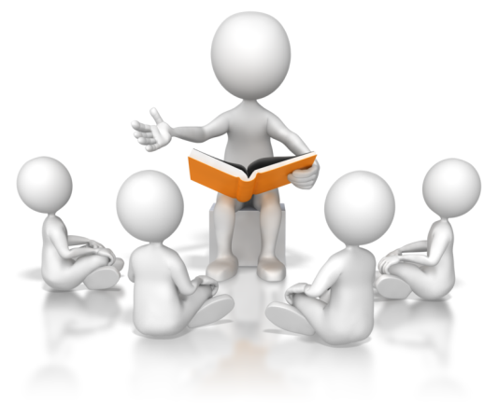
The National Quality Framework (NQF) was established in 2012 by the government as a measure to raise the quality and standards of early childhood education and care across the whole of the Commonwealth by introducing consistency in the regulation and assessment of Australian education and care services. This is overseen by the Australian Children’s Education and Care Quality Authority (ACECQA), in conjunction with the individual state and territory regulatory bodies.
The NQF applies to most of the following services:
- Long day care
- Family day care
- Preschool/kindergarten
- Outside school hours care.
The need for a national approach is to ensure that all children in the early stages of childhood access quality education and care in their formative years in order to give them the best possible start in development and learning. Research shows that the higher the quality of education and care in these early years, the higher the quality of health, educational attainment, and employment in later life.
Note: the NQF applies to children from birth to thirteen years of age.
It aims to raise the quality of education and care services by:
- Changes in educator-to-child ratios – as of 1 January 2016, some states and territories have seen changes in their ratios, depending on the type of service and age group of children. Educator-to-child ratios have already been put in place for Tasmania and Western Australia and these remain unchanged. Information on ratios can be accessed at the following website link, ‘Improved educator to child ratios’ at ACECQA: http://www.acecqa.gov.au/Improved-educator-to-child-ratios
- Improved educator qualifications – the NQF has established minimum qualification requirement which is approved by ACECQA. If a qualification is not on ACECQA’s list of approved educator qualifications, it is possible to have this assessed with ACECQA to determine if this is deemed equivalent. Information on educator qualifications can be found at the following website link, ‘Qualifications’ at ACECQA: http://www.acecqa.gov.au/educators-and-providers1/qualifications
- Provision of information on educators, providers and services in the national registers – this service is updated weekly and enables access to find approved education and care services, and certified supervisors. This can be found at the following website link, ‘National Registers’ at ACECQA: http://acecqa.gov.au/national-registers
- Support for learning through approved learning frameworks – these are designed to assist the role of educators in providing for learning and development needs of children. The following are the two nationally approved learning frameworks:
- ‘Belonging, Being and Becoming’: the early years learning framework for Australia
- ‘My Time, Our Place’: the framework for school age care in Australia.
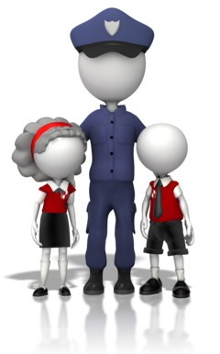
There also exist jurisdictional approved learning frameworks for Victoria (the Victorian Early Years Learning and Development Framework) and Western Australia (the Curriculum Framework for Kindergarten to Year 10). Information on learning frameworks can be accessed at the following website link, ‘Approved Learning Frameworks’ at ACECQA: http://www.acecqa.gov.au/national-quality-framework/national-law-and-regulations/approved-early-learning-frameworks.
The NQF includes the following aspects:
- The National Law and National Regulations
- The National Quality Standard (NQS)
- National learning frameworks
- Assessment and quality rating process.
National Quality Standard (NQS)
The NQS is the benchmark for quality in early years’ education and child care provision. The plan is that every early years’ education and care service throughout Australia will be assessed against this standard and rated accordingly. The ratings will then be placed on a national register that can be viewed by all.
Each provider will be assessed in seven different areas and also given an overall rating.
The seven quality areas of assessment are:
- Educational program and practice
- Children’s health and safety
- Physical environment
- Staffing arrangements
- Relationships with children
- Collaborative partnerships with families and communities
- Governance and leadership.

Each quality area will be rated with one of the five following levels defined by the NQS:
- Excellent rating – awarded by ACECQA
- Exceeding National Quality Standard
- Meeting National Quality Standard
- Working Towards National Quality Standard
- Significant Improvement Required.
All information on the National Quality Framework (NQF) has been accessed and taken or modified from the Australian Children’s Education and Care Quality Authority (ACECQA) website: http://www.acecqa.gov.au/national-quality-framework/explaining-the-national-quality-framework
More information on the NQF will be covered in the relevant unit sections of this unit, as applicable to the performance criteria.
(All of the above website links have been accessed on 05.02.2018.)
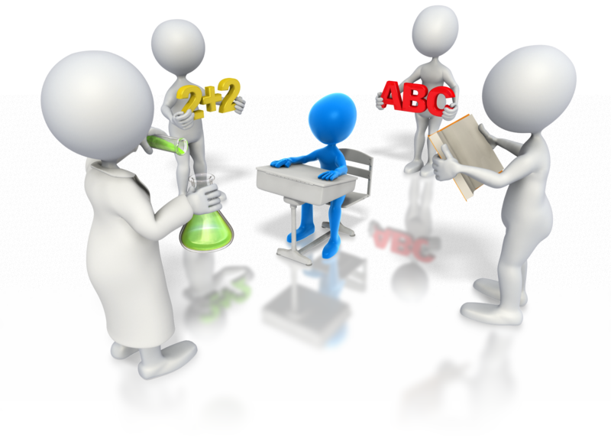

1. Develop a sustainability management plan
1.1. Identify aspects of sustainability in the service
1.2. Consider areas of potential change in all aspects of the service’s delivery and environments
1.3. Ensure that nature, waste, energy and toxins have been considered
1.4. Identify areas where change can be instigated to enhance environmental sustainability and increase children’s connection with nature, in consultation with children
1.5. Develop strategies to address these areas of change in consultation with children
1.6. Implement strategies and evaluate outcomes


1.1 – Identify aspects of sustainability in the service
By the end of this chapter, the learner should be able to:
- Identify Quality Area 3 of the NQS
- Determine the two aspects of sustainability that apply to services
- Identify sustainable practices currently in operation at their service (or example service).
The National Quality Standards, within the National Quality Framework for early years education and care services (as mentioned at the start of this unit), includes a standard on the physical environment within its seven quality areas.
Quality Area 3 – Physical environment:
Standard 3.1 – The design of the facilities is appropriate for the operation of a service
Element 3.1.1  Outdoor and indoor spaces, buildings, fixtures and fittings are suitable for their purpose, including supporting the access of every child. | Element 3.1.2  Premises, furniture and equipment are safe, clean and well maintained.

Sourced from ‘Quality Area 3 – Physical environment’ ACECQA: http://www.acecqa.gov.au/Physical-environment (access date: 06.02.2018).
The learning outcomes (as shown in the approved learning frameworks from ACECQA) also state the following learning outcome:
- Learning outcome 2: Children are connected with and contribute to their world.
Specifically, ‘Belonging, Being and Becoming: The Early Years Learning Framework for Australia’ provides the following guidance.
‘Children become socially responsible and show respect for the environment’, this includes:
- Children should be encouraged to:
- demonstrate an increasing knowledge of, and respect for natural and constructed environments
- explore, infer, predict and hypothesise in order to develop an increased understanding of the interdependence between land, people, plants and animals
- explore relationships with other living and non-living things and observe, notice and respond to change
- develop an awareness of the impact of human activity on environments and the interdependence of living things

- Educators’ can:
- Model respect, care and appreciation for the natural environment
- find ways of enabling children to care for and learn from the land
- share information and provide children with access to resources about the environment and the impact of human activities on environments
- embed sustainability in daily routines and practices.
Information on learning outcome 2 has been sourced from page 29 in the ‘Belonging, Being and Becoming: The Early Years Learning Framework for Australia’ publication from ACECQA: http://files.acecqa.gov.au/files/National-Quality-Framework-Resources-Kit/belonging_being_and_becoming_the_early_years_learning_framework_for_australia.pdf (access date: 17.05.2017).

The importance of sustainability
Environmental sustainability is important for all people, wherever they may come from. To successfully live with the environment, a respect for the surrounding natural resources should be given. Our natural habitat and wildlife should be preserved and nurtured for all to enjoy, and for the generations to come. Educating children about our environment and on how to interact with it will help create the correct awareness and respect for life.
Self-sustaining is also another aspect of sustainability that should be considered within the early year’s education and care service. Services should look to meet and maintain their needs for the now and for the future to establish an excellence of service that can be enjoyed by many. A service should look to sustain equitable practices that impact positively and provide the best start in life for young children.

Identify current sustainable practices within the service
Look to the current sustainable practices that your service may already undertake. It is helpful to make a ‘sustainability audit’ to correctly ascertain what parts of the service are, and are not, following acceptable sustainable practices. From this point, you are then able to understand how well the service is performing.
You may want to look at:
- Energy efficiency, such as:
- the policy for turning lights on/off
- unplugging appliances when not being used (do not use standby mode)
- draught-proofing doors and windows
- checking that doors and windows are closed when/if using air conditioning or heating

- Water usage, for example:
- ensuring taps do not drip and are turned off correctly after use
- using a grey water system for watering plants
- Waste products, such as:
- paper towels and tissues
- food waste/food packaging
- assessing broken items, and items/equipment that can only be used once
- Practices that the children may undertake, such as:
  - looking after equipment/toys used within the service
  - picking up items of rubbish and placing in the appropriate bins
  - getting to know the community by participating in group outings.
Compile a list of the recognised sustainable practices already performed and use this to determine any areas that could be improved upon.

What can you do without?
Within the service, look at the type of resources that you use and determine if any could be minimised or exchanged to more environmentally aware ones. For example, if your service uses chemical cleaners, can you minimise the selection of cleaners, or use more environmentally-friendly versions?
If your service uses paper hand towels, you may want to consider a policy that ensures sensible usage, such as one paper towel used each time. You could also consider using cotton towels instead, or maybe just in certain areas of the service, depending upon your usage requirements.
Note: it is good practice to use individual fabric towels only once before discarding. Your service will need to have plenty of hand towels so there are enough in circulation. This allows for frequent washing of fabric towels on a hot wash cycle, which is required to eliminate the possibility of bacteria and germs.
Achieving a balance

In the example of hand towels, look at the service’s usage needs. It may make better sense to change to fabric towels to minimise paper waste, but you don’t want to be constantly washing half-loads of towels each day without considering the impact this will have on your water usage.
Ensure that enough towels are available so a full wash can be performed less often and water is not wasted. This is where a balance should be considered with the needs of the service. Is it more ecologically sound to use paper towels or fabric towels for your service? The whole environmental footprint should be considered when making a decision.
This may also impact on other environmentally sustainable changes that you are considering. Each service may have different requirements and this should be addressed before making changes.
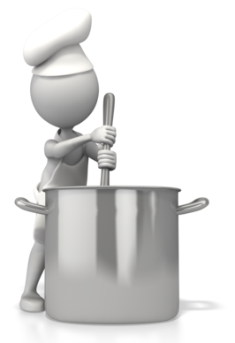
Do you:
- Use air conditioning or heating at your service?
- Prepare/cook food on site?
- Have a vegetable/flower garden?
- Have an outside water play area?
Look at the specific areas where you can improve upon your sustainable practices. By doing this, you will be creating an environmentally aware service with practices that you can role model to the children and the children’s families.


Activity 1A

1.2 – Consider areas of potential change in all aspects of the service’s delivery and environments
By the end of this chapter, the learner should be able to:
- Identify where changes to improve sustainability can be made
- Recognise the improvements that could be made to increase sustainability within the identified areas.
When looking to make changes for sustainability, make small changes that don’t overwhelm.
Small changes are easier to make and integrate into your current practices and will still have a positive impact on the service. Implementing and maintaining small changes will provide a platform for making further or larger changes that you may consider in the future.

Improving practices for service delivery
Within the service, identify areas that could be more sustainable. Look at what you may use and order on a regular basis and seek to identify items that support sustainability.
Items that may be ordered for use within the service may include:
- Food items:
  - food sourced from local suppliers
  - fresh food with minimal packaging
  - ordering non-perishables in bulk.
- Service equipment:
  - paper, pencils, paints, etc. Look at ordering recycled paper and non-toxic paint
  - chairs/furniture items made from natural materials, and items that are built to last
- Cleaning materials:
  - try using fewer chemical cleaners and look at more environmentally sustainable methods such as steam cleaning
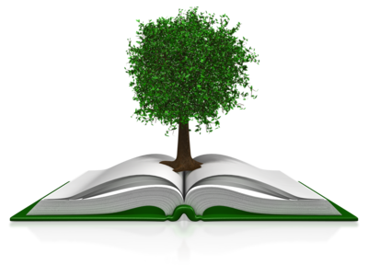
  - use quality, reusable cloths instead of disposable wipes.
Look at sustainability within learning
Use natural materials/fibres and recyclables that could be used and adapted, for example, in crafts and arts activities. Ask families to bring items that are usually discarded, such as cardboard boxes, empty bottles and cartons, and use these in activities.

Plan experiences with sustainability in mind; read stories that have environmental themes, sing songs and rhymes about the natural environment and about caring for others. Introduce themes of sustainability that can help children to understand the world around them and where everyday objects that we use, come from.

The outdoor environment
Your service may have an outside area large enough for a playground and garden, or it may have a small yard. Whatever the size of your outside space, it is an opportunity to show the children how to live side-by-side with nature and the environment.
Your service may consider the following:
Create a garden | Plant flowers, natural habitat plants, herbs or vegetables. If the outside area is small, use plant pots and tubs to cultivate.
Create a worm farm or compost waste | Put appropriate food scraps to one side and use these to keep a worm farm or for composting. This will help children to learn about a natural decomposition cycle that is environmentally friendly.
Observe nature and local wildlife | Take the time to look at the wildlife near to you, or visit a local park/wildlife area. You could encourage activities such as drawing or painting what can be seen outside, or have a checklist of flora and fauna that the children can look to identify.
Create an area for a pet | Having a pet at the service is a great opportunity to educate children on care for animals and as a conduit to wildlife. Show the children how to look after the pet and provide for its needs and encourage active participation.

Teaching about sun safety (SunSmart program)
Sunscreen should be applied for outdoor activities and parents are encouraged to apply sunscreen to their child before arrival to the service. It is sensible for children to wear a hat and clothing that covers the trunk, tops of arms and tops of legs. Some items of outdoor clothing also include UV protection, check the labelling/manufacturer for full details on the protection that these specific clothing items provide.
From September to April (and when the UV index is at 3 or above), all children should wear sunscreen to protect exposed areas of skin and sun hats to protect their head, faces and necks. Outdoor activities should be more carefully monitored and controlled with regards to sun exposure, and time should be limited for safety. Make sure children stay hydrated and drink enough water during hot weather periods.
Information on SunSmart programs can be found at ‘SunSmart schools and early childhood programs’ from Cancer Council Australia: http://www.cancer.org.au/preventing-cancer/sun-protection/sunsmart-hools/ (access date: 17.05.2017).

The indoor environment
Inside the service, include practices that the children can participate in each day. Encourage the development of good habits with the environment and self-sufficient practices. Make this fun for children, for example, place colourful signs and pictures with positive environmental messages around the centre as a reminder.
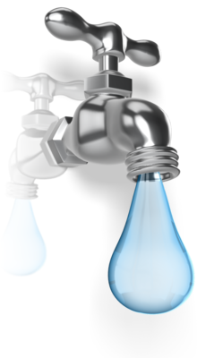
You could also group the children into teams and assign a responsibility to them, for example, collecting and disposing of rubbish or recycling into the correct bins. After a short period of time, change the type of rubbish or recycling for each team so they can familiarise themselves with all types.
Encourage the children to:
- Reuse items
- Recycle items
- Place recycling and rubbish in the correct bins
- Look after equipment/items that they use
- Use half-flush on toilets
- Turn off taps after using them
- Turn on/off lights (e.g., provide longer pull cords for children to reach).
Referencing learning outcome 2 (as mentioned in section 1.1 of this unit), model sustainability through leading by example; this applies to children and staff. Children learn through observation and by copying the adults in their surroundings. Provide consistent approaches and help instil good habits.
Establish a display area for objects that the children may like to bring in. You could theme the displays so that a range of environmental and sustainable issues could be looked at and included in learning opportunities.
Example themes may include:
- The natural world
- Colours that are seen in the bush habitat
- Items that can be recycled
- Different materials, for example, objects made from wood, plastic or metals.

Activity 1B

1.3 – Ensure that nature, waste, energy and toxins have been considered
By the end of this chapter, the learner should be able to:
- Recognise how services can be considerate to the natural environment
- Identify sources of toxins and toxicants that may exist at a service.

Exploring nature
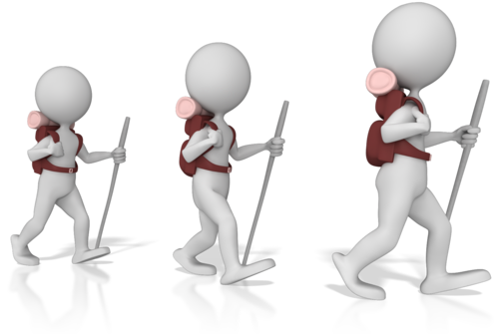
Nature should be a place of enjoyment and learning for all. When going outdoors, you should ensure that the correct protection from the weather and environment is taken.
As mentioned in section 1.2 of this unit, always protect yourself and the children from sun exposure – wear a hat that provides protection for the head, face and neck, and apply sunscreen. Wear appropriate clothing to protect from the sun. Make sure comfortable footwear is worn and is appropriate for the terrain you are walking on.
If outdoors during the cooler or wetter months of the year, make sure that the children have items of clothing to keep them both warm and dry. Choose activities appropriate to the seasons.
Consider nature
If your service needs to make changes to its operations, building(s) or surroundings, make sure that the impact to nature is included in the decisions that are made. Look at ways to eliminate/minimise the negative effects to the environment. Be aware of the natural habit and how to co-exist with it, for example, use eco-friendly materials in any constructions or alterations and create eco-environments for wildlife within the garden or surroundings of the service. You can use natural light indoors as much as possible and minimise the use of air conditioning units by taking activities outside or opening doors and windows.

How about energy?
Your service can improve energy efficiency in easy ways:
- Turning off computers, printers and equipment after use, or at the end of the day, or when not in use
- Using natural light and ventilation when possible
- Consolidating laundry washing loads – name tag sheets so they can be used by the same children again and batch washing to avoid washing the same items each day
- Using a clothes line to dry washing rather than an automatic dryer.

Waste products
Consider the amount of waste your service may produce and how effective current methods of disposal are. Can waste be reduced, or can more items be recycled? Check the systems that you have in place for your waste disposal and see if improvements could be made. Look to using less disposable goods and instead, use items that are made of natural materials and fibres, and items that are more durable.

Toxins in the environment
Toxin or toxicant?
A toxin is defined as an organic poison (produced by plants and animals) which can make you very sick and be of a serious nature. Toxin is also used to describe other poisonous substances known as toxicants. Toxicants are found within man-made products which are known to be harmful to humans (such as chemical cleaners). Avoid exposure to all dangerous substances and potential sources of toxins or toxicants.
Toxins in plants
Toxins are commonly found in plants. When outdoors look to identify any potential sources of toxins. Point out the harmful plants to the children and ensure that they stay away from these. Keep a list and pictures of the poisonous plants or trees found in your area. If you are unsure on a particular plant or tree, keep away from it and try to identify it later to determine if it is a source of risk.
Poisonous plants include:
- Black bean or Moreton Bay chestnut (Queensland and New South Wales) – between March and May, the seeds within the large seed pods appear and should not be ingested.
- Strychnine tree – this tree produces small orange-coloured fruits with poisonous seeds that are neurotoxic if ingested, the tree’s blossom and bark can also be poisonous.
- Angel’s trumpets – a common garden plant, not native to Australia and is a medium-sized shrub or tree with thin trunks and flowers that are large and can be in red, white, orange or pink. The leaves and seeds are highly toxic and should not be ingested.
- Oleander – another common garden plant that can cause mild irritation to the skin if touched and can be fatal if any part is ingested. Burning oleander can produce toxic fumes that should not be breathed in or used on barbeques.
- Milky mangrove (Western Australia, Queensland and New South Wales) – the milky sap of this plant can cause temporary blindness if it comes into contact with the eyes and also skin irritation and blistering.
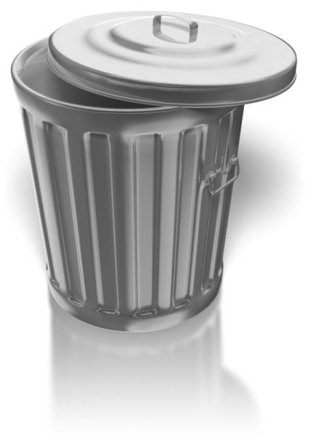
Bio-toxins found in wildlife
In the outdoors, be aware of the wildlife around that may also be a potential threat to humans. Take care to avoid the known spiders, snakes, and any other animals or insects that may cause a toxic reaction if contact is made with them.
Toxins in food
Toxins may also come from food products and care should be taken to store, prepare, cook and use all food appropriately. Ensure that hygiene is of a high standard and all correct food and hygiene practices are followed. Do not leave food out and make sure that all children wash their hands when coming into contact with food. Do not leave food standing and make sure waste food products are removed and disposed of appropriately and that all counters, tables and areas where food items have been, are cleaned and sanitised thoroughly.
Toxicants
Keep all chemical products away from children and the areas that they use. When using chemicals, make sure these are stored safely and used appropriately. Be mindful of what man-made additives are put into the cleaners and even into the food products, which you may use. Items that we use daily can include substances that are a potential source of harm – for example, detergents, cosmetics and fumes created by cigarettes or motor vehicles.
Sources of toxicants may include:
- Detergents
- Chemical cleaners
- Air fresheners
- Food additives and preservatives
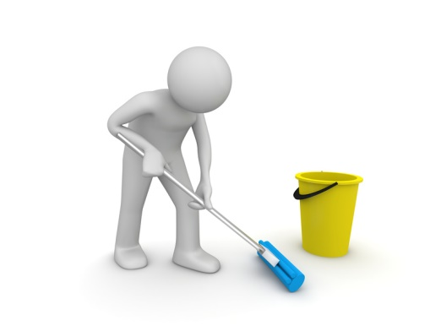
- Pesticides, herbicides and fertilisers
- Solvents
- Plastics
- Cigarettes.

Activity 1C

1.4 – Identify areas where change can be instigated to enhance environmental sustainability and increase children’s connection with nature, in consultation with children
By the end of this chapter, the learner should be able to:
- Determine how to instigate environmental sustainability
- Identify how children can connect with nature
- Recognise how children can be consulted on making changes to enhance environmental sustainability
- Determine how to encourage children to increase their connection with nature.

Helping children to connect with nature
Look at learning experiences which include the environment and natural wildlife, and build upon children’s awareness of their surroundings. You can encourage children to interact with nature to understand more about it and the many differences that exist and make up the natural world.
Explore the relationships between nature and the ecosystems that support life; this will help children to make a connection between our own interactions and impacts on nature.
Children can connect with nature through:
- Outdoor play
- Outdoor learning activities
- Caring for nature, for example, planting seedlings in the service’s garden.
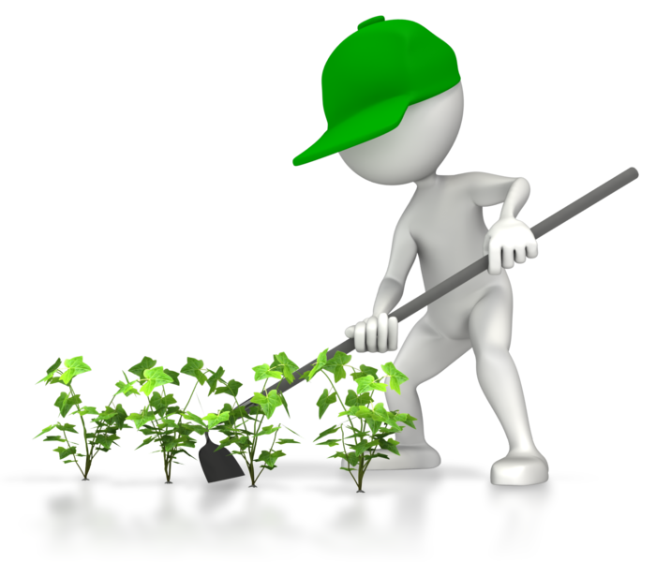
Show the children ways that they can interact with the environment, plant seeds, watch the growth cycle and observe the changes in nature. Create a wild garden or a bush garden, if you have the space, and encourage wildlife to visit. By creating different areas, you can show the children how the different environments support different wildlife.
If you have a pet area, take turns with the children to care and tend for the pet(s) you have. Develop an interest and a caring approach to the environment, to help children connect with and appreciate nature.

Include the thoughts of children
Create learning experiences that encourage the children to think about nature and how they can help nurture and protect it. As well as participating in sustainable acts within the service, such as placing waste items in the correct bins and looking after equipment and toys, engage the children in discussions about the environment. Ask the children about their environment and what they know. Look to expand their thoughts and encourage them to participate in sustainable thinking so they can contribute suggestions and ideas on how the environment can be looked after.
Produce a display within the service of the ideas that the children have contributed with for environmental sustainability. By producing a visual display, you can affirm to the children that their ideas are important for the environment.
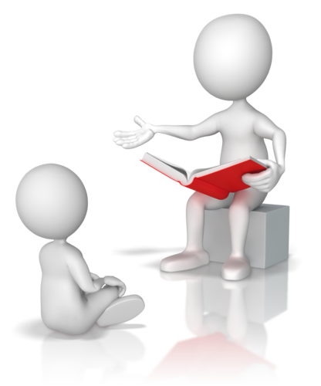
Example topics that you can discuss with the children:
- Recycling – how items can be reused
- Which animals live in your habitat
- What animals need in order to survive in their environment
- What we need to exist in the environment
- Use of resources – turning off lights and taps and highlighting the value of our resources
- How we can do things differently – look at alternatives for environmental sustainability.
Look to include ideas from the children. Encourage them to talk to their families about the environment and invite families to the service to see and discuss practices that may be of interest to them.
Show the children different environments
Take the children out into the community and show them other sites, such as parks, conservation centres and local community facilities, such as a recycling centre. Make visits interesting and fun so that the children can relate to their experiences. If visiting a park, look to identifying local wildlife or birds, or if visiting a recycling centre, ask the children to identify different objects that they see. Try to make visits interactive to improve opportunities for learning.
Environments include:
Land – characteristics include: | - Mountains  - Fields and pastures  - Desert  - Rivers and streams
Marine – characteristics include | - Sea water  - Sand  - Coral  - Fish and other marine life

Forest – characteristics include | - Trees  - Ferns and plants  - Wildlife  - Rocks
Urban – characteristics include | - Buildings  - Streets and roads  - Cars and motor vehicles  - People

Activity 1D

1.5 – Develop strategies to address these areas of change in consultation with children

1.6 – Implement strategies and evaluate outcomes
By the end of this chapter, the learner should be able to:
- Identify what is required to formulate strategies for sustainability
- Determine strategies that can be used within the service to promote sustainability
- Recognise how to implement strategies
- Identify how to assess strategies.
Once you have put together your sustainability management plan, you will then be in a better position to look at the specific strategies you may want to use for creating a more sustainable service.
Your sustainability management plan may include:
- Your policy
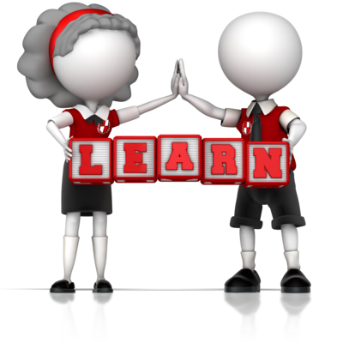
- The targets and aims for sustainability
- Re-examination of purchasing practices
- A recycling and waste management program
- Educating about our environment and the practices that have an effect upon it
- Working with the community to communicate and educate on environmental sustainability.

Develop strategies with the children
Strategies will help you and the service to plan for opportunities to achieve sustainability while maintaining focus on the areas that you want to improve upon. Identify the strategies that will help you the best and include the children in your development of the strategies to encourage their participation.
Strategies for sustainability may include:
- Lead by example – follow sustainable practices at the service and within the community.
- Professional development for staff on sustainability – if any staff need additional training, provide the means for them to learn and understand the issues.
- Reuse – where possible, reuse items within the service, for example, use both sides of the paper when drawing or for activities, and use old plastic bottles, buttons and scraps of paper in crafts.
- Recycle – collect items for recycling, for example, paper, plastic and metal. If the service has a pet, you could also shred paper for bedding.
- Connecting with the natural world – take learning outside into the environment, for example, create a vegetable garden or get to know different animals by visiting an animal farm or zoo.
- Including parents and families – take the time to invite participation by families in activities that promote sustainability.
- Inform about sustainable issues – place notices and diagrams around the service to remind about sustainable practices, such as turning off lights, and also as a way of providing information about sustainable issues, for example, greenhouse gas emissions.
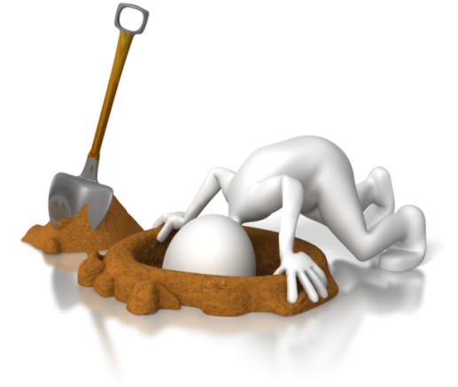
- Learning about sustainability – arrange learning experiences that can be used to discuss sustainability, for example, reading books that cover environmental issues such as energy or different habitats.
- Conservation projects – participate in conservation projects with the community, such as picking up litter or a community garden.
Once the strategies have been identified, assess the potential impact of each, against the outcomes that you want to achieve.
A combination of strategies will work better for achieving sustainability.

Use your strategies
Implement your strategies for sustainability within the service and check the effectiveness of each. Allow time to ensure that the strategies are embedded into the practices of the service and are being used by all involved.

Evaluate the success of the strategies
Check how the strategies are working; have you achieved the results you were hoping for? If you have made positive progress by implementing the strategies, identify the successful elements. However small the progress may be, know that it is going in the right direction and look to promote improved practices within your strategies further.
If the results have not been as good as expected, look at the parts that have not worked well, look at why they have not worked and adjust the strategies to compensate for this. Work with the strategies again and check/monitor these to see if the improvements made have a more positive effect.
You may need to:
- Improve on information about sustainable issues
- Provide clearer signs for recycling bins
- Provide better equipment/resources, for example, gardening equipment for children
- Look at community projects that the service can be involved in.

Activity 1E

2. Support children to develop an understanding and respect for the natural environment
2.1. Provide children with a wide range of natural and recycled materials in their indoor and outdoor environments
2.2. Create opportunities to discuss with children the natural environment and the interdependence between people, plants, animals and the land
2.3. Role-model respect, care and appreciation for the natural and constructed environments
2.4. Share information and provide children with access to resources about the environment and the impact of human activities on environments
2.5. Create spaces that promote the development of life skills, such as growing and preparing food, waste reduction and recycling
2.6. Encourage children to exchange thoughts and ideas about sustainable practice through intentional teaching, learning experiences and projects
2.7. Explore ethical dilemmas of waste disposal for sustainability with all stakeholders

2.1 – Provide children with a wide range of natural and recycled materials in their indoor and outdoor environments
By the end of this chapter, the learner should be able to:
- Identify natural materials that can be provided for children in service environments
- Identify recycled materials that can be provided for children in service environments.

Use natural and recycled materials for the service’s needs
Use natural and recycled materials as much as possible within the environments of the service for displays and for the children to interact with, in activities and learning. You could construct an inside habitat area with logs, rocks and sand and other natural objects to provide a focus on nature. By using items that you find in the natural environment, you can create awareness of the wonderful things that nature provides when the conditions are right for growth.
Outside, use natural materials for seating and play areas, wicker or wood seats and benches with cushions. Use bark or cork surfaces to provide textures and to differentiate areas outside. When participating in play use sand and water and provide activity areas that are constructed from wood and other natural or recycled materials.
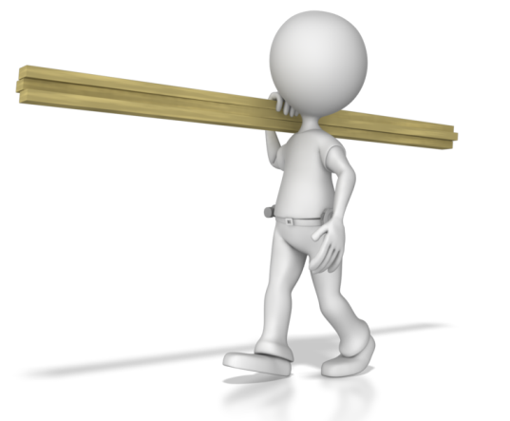
Natural materials may include:
- Wood – logs, tree cookies (small pieces of branches cut into cookie shapes) twigs, bark and also items made from wood, such as tables, chairs and shelves
- Plants – use indoor plants to add colour and balance to the inside environment while outside select a range of plants that represent the natural habitat and also for cultivating flowers or vegetables
- Shells – these can be used to learn about the marine environment and also for activities such as for matching and sorting play
- Rocks/stones – use in displays and for counting activities
- Leaves – can be used to identify plants and trees, and for displays or for use in collages and crafts
- Wool/natural fabrics – use natural fibres for soft toys, dolls clothes, and soft furnishings such as blankets and cushions.

Use recycled items for sustainability
A recycled item can be anything that is no longer needed, and no longer serves its original purpose. With imagination, a lot of items can be adapted and reused within crafts, activities and displays.
Show children that you can make use out of the things that are around you and that new is not always better. You may also find that second-hand shops or organisations are a great way to source items that can be used in play and learning activities and this could be another area to explore when making purchasing requirements for curriculum needs.
You could use recycled items in both indoor and outdoor areas. Use discarded containers and objects as planters or for use in outside activities.
Recycled items may include:
- Paper
- Wrapping paper and decorations such as ribbon and bows
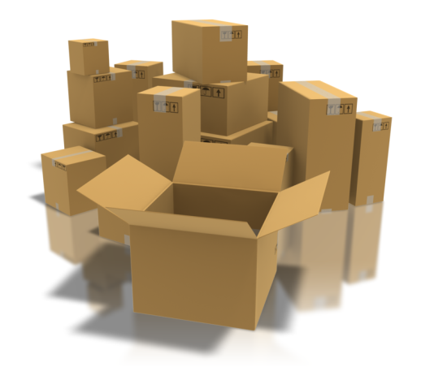
- Plastic bottles/cartons/containers
- Glass jars/bottles
- Discarded magazine and catalogues
- Boxes
- Old CDs/DVDs
- Broken toys/toy parts.

Activity 2A

2.2 – Create opportunities to discuss with children the natural environment and the interdependence between people, plants, animals and the land
By the end of this chapter, the learner should be able to:
- Determine how to introduce discussions on the environment and interdependence between people, plants, animals and the land.

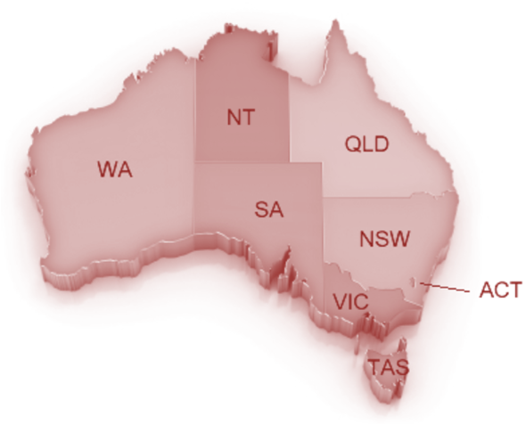
Talk about geography and the environment
Provide a learning experience where you discuss the environment and its many climates. Look at the different areas within Australia and at the range of wildlife that also lives there. Australia has much unique flora and fauna that should be protected and preserved for the generations to come.
Discuss the weather patterns; for example, show how the rain cycle occurs and use diagrams to help explain this. Look at how the weather cycles are continually operating and at how the environment responds to, and is influenced by, these cycles.
The different climates include:
- Equatorial – found at the most northernmost tips of the Northern Territory and Queensland
- Tropical – found across the Northern top of Western Australia, Northern Territory and Queensland
- Sub-tropical – found down the east coast of Queensland and parts of New South Wales, and along the southwest coast of Western Australia
- Dessert – found across central areas of Western Australia, Northern Territory, west Queensland, South Australia and the northwest of North South Wales
- Grassland – found around the desert areas in all territories except ACT and Tasmania
- Temperate – found in the southern area of Western Australia and South Australia, most of Victoria and parts of the east coast of New South Wales, and all of Tasmania.

Living with and off the land
Make opportunities to discuss the ways in which humans, animals and plants are dependent upon the natural environment for their needs. This can be a fun and informative learning experience that shows the marvellous ways in which nature provides for us. In turn, you can discuss ways in which we can also support the environment and give back to it, to replenish the resources that we use.

Examples of nature providing includes:
- Farming the land for crops – show how farmers tend the land and also care for it by putting nutrients back into the soil
- Fishing in the sea – discuss the marine environment and sustainable fishing (talk about the eco-system that is not normally seen)
- Rain providing water for our needs – raise awareness to Australia’s dry climate and how we can manage and protect water resources
- Animals that live off the land – how animals graze and hunt for their survival.
By discussing and showing examples of interdependence you can show the importance of being kind to the environment and encourage all to follow sustainable practices.
See examples of living off the land
Visit a bushcraft and survival centre/park if able to, and look at the ways that it is possible to live off the land. There are many important life skills that can be learned and these show the importance of using just what you need in order to maintain a sustainable supply of resources. Bushcraft teaches us to respect the land and to allow nature the time to replenish its stocks.
Encourage the children to experience these skills first-hand with a centre or park, and to have a different kind of learning experience.

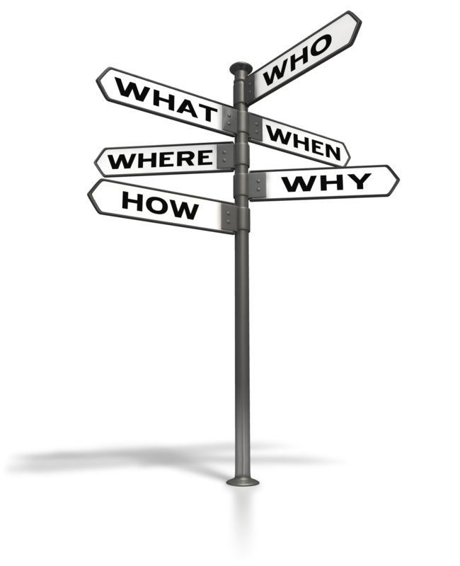
Give back to the land
If the service has a garden, encourage the children to participate in growing vegetables and show the complete cycle of ‘seedling to plate’. By involving children in the care and nurture of the vegetables, they can see the amazing transformation and the way that nature does provide for us. This will help reinforce sustainable learning practices and by replanting more vegetables after using, you can show how the life cycle works.
Go out into the community and become involved in any replanting initiatives to rejuvenate the environment, this will help show the children that urbanisation can impact negatively on the natural environment but with thought and care, both can co-exist.

Activity 2B

2.3 – Role-model respect, care and appreciation for the natural and constructed environments

2.4 – Share information and provide children with access to resources about the environment and the impact of human activities on environments
By the end of this chapter, the learner should be able to:
- Identify how to be a good role-model to others
- Recognise what children can achieve when provided with information and resources on the environment and the impact of human activities on environments.


Be a good role model for others
Show respect for others and the environment at all times. Set good examples of behaviour and show care and appreciation for all types of environments. Children will watch and follow the standards set by the staff and service, along with their own parents and family members. They will absorb attitudes and habits, both consciously and unconsciously, and setting the right example is important for shaping caring individuals who are conscious of the world around them.
Make sure that the sustainable practices in place at the service are always followed. For example, if the recycling paper bin is full, do not throw the paper in the general waste bin – take the time to empty the recycling paper bin so it can be used for its intended purpose.
Always:
- Treat all others with respect
- Take time to appreciate your surroundings
- Take care of your surroundings and environment
- Look to sustainable practices above all others
- Speak to parents and families and invite them to visit and join in with activities at the service
- Speak kindly and take the time to explain issues of sustainability and environmental sustainability with others including the children.

Our impact on the environment
Find out information about the environment and how human activities have an effect upon it. What are the cause and effects of using the earth’s resources? Look at the different types of resources that we use, such as metals, minerals, fossil fuels, water, the land. Mining and using such resources strips the earth of its properties and these cannot be replaced as quickly as we are using them. Research the impact of this and ensure the information comes from reliable sources that provide real facts.
Information can be:
- Quantitative – information sourced from verifiable facts and figures
- Qualitative – information based on narrative descriptions and characteristics.
Share this information with the service, the children and the families of the children. Construct learning experiences that can show cause and effect in simple terms.
Be aware that children should be encouraged to follow good practices and should not be overloaded with information that is gloomy. Provide resources for them to explore environmental themes such as books, pictures and short films. Make it fun and inspiring so children can make positive decisions on choosing sustainable options.
Human impact on the environment includes:
- Deforestation – causing land erosion, changes to the natural environment/loss of habitats for wildlife, greenhouse gases (trees absorb carbon emissions)
- Land clearing for urban development – causing loss of biodiversity and habitats, and increased water usage and infrastructure for a larger human population
- The introduction of non-indigenous species – this has proven to have had an adverse effect on the natural landscape, and when successful, the new species can take over and threaten indigenous species. For example, the introduction of rabbits to Australia and the negative effects made to other mammals competing for habitat and food
- Depletion of the ozone layer – due to emissions from gases produced by manufactured goods such as refrigerators, air conditioners and aerosols
- Energy use – using fossil fuels contributes to greenhouse gases and climate change
- Pesticides – using chemicals on the land can lead to chemical run-off into the sea and pollution effecting marine life.
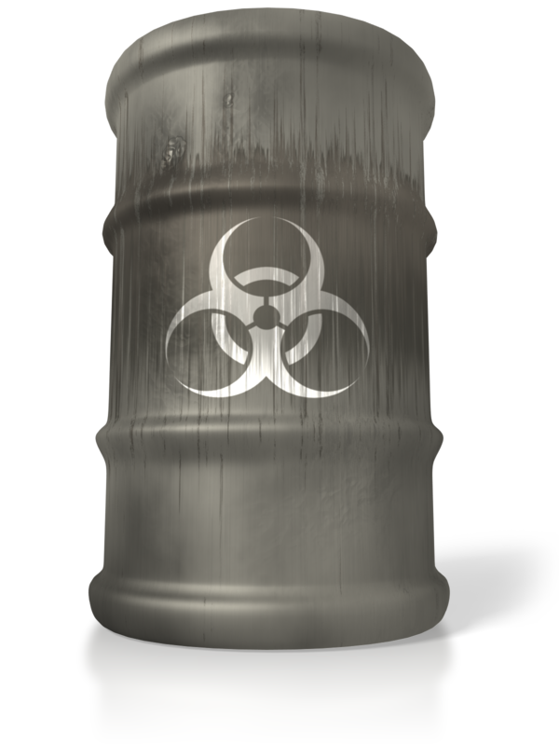

Activity 2C

2.5 – Create spaces that promote the development of life skills, such as growing and preparing food, waste reduction and recycling
By the end of this chapter, the learner should be able to:
- Identify learning spaces
- Recognise how these spaces provide opportunities for children to learn and develop life skills
- Determine how children use spaces.

Cultivation
Involve the children in being responsible for their environment, look at developing spaces within the service environment to teach life skills.
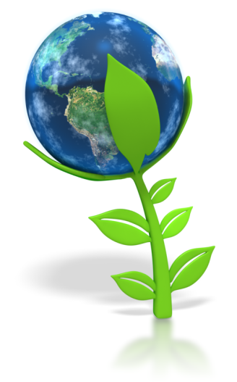
As mentioned previously in section 2.2 of this unit, create a garden for growing vegetables and herbs for food. Teach the children about the different types of food plants and about the parts of the plants that we can and can’t eat. Let them see how the plants develop, grow and become ready to harvest. Let them share the experience of taking care of and watering the vegetables and herbs.
Plants include:
- Cacti
- Vegetables
- Herbs
- Flowers
- Shrubs and bushes
- Trees.
Grow flowers to show how plants transform and develop into many different forms. Look at the beauty and colours that they produce and discuss how different flowers and plants have different life cycles. Some will flower just one season before their life cycle ends, while others can take years to develop and mature and will continually produce flowers, fruits and seeds each season.
The basic plant types include:
- Annuals – lifecycle occurs within one season and will need replacing
- Biennials – lifecycle occurs over two years (the flowers and seeds are usually produced in the second year)
- Perennials – the lifecycle lasts longer than two years and the plant or tree can flower and produce fruit and seeds many times over.
Look at the different needs of the plants; some will need lots of water while others will survive on much less water. Check the positioning of plants is correct; i.e., in full sunshine, partial sunshine or shade. Establish the correct environment for the plants in your garden and outdoor areas. The same will be needed for any indoor plants that you may have – make sure that they are watered and positioned as to the requirements of the plant.

Food from the plant to the table
Once the vegetables and herbs have been picked and prepared for use in the kitchen, you can create a simple learning experience for the children by showing them how the food they have grown has been prepared and used in the food they eat.
Being mindful of hygiene requirements and health and safety, you could involve the children in preparing simple snacks with the vegetables they have grown, such as carrot sticks and a healthy dip. Show them how to wash carrots and how they will appear on the plate.

Improvements to areas of waste
Ensure that the area for your waste and recycling is clearly laid out and that each bin is marked for the relevant type of waste that should go in there. You could colour-code the bins to make it easier for the children to understand and use, or place the bins in different areas to help them locate the appropriate bin. For example, recycling paper could be in one area, while food scraps will be close to the kitchen. Help create appropriate spaces that work for your service.
Improve on the amount of waste created

There may be ways that your service can reduce the amount of rubbish and waste that is generated each day. Place trays or storage boxes within designated spaces to collect and store items that could be used in activities and crafts.
You could keep:
- Paper that has been used on one side so that the second side can be used
- Old scraps of paper for paper maché crafts
- Broken items/spare pieces/oddments.
Ask the children’s parents and families if they can bring unwanted items in for activities, such as spare wrapping paper, old buttons and used packaging. This will provide a variety of materials for art and crafts.

Create definite spaces for activities
Within the service, create specific inside and outside areas for the children to use in learning and play activities. Avoid reworking areas each time activities need to change; creating spaces encourages children to become familiar with their surroundings and helps them to feel safe. Having set areas will promote a sense of ownership by the children which will encourage them to use these spaces. It helps them to develop a sense of belonging and being in their environment, which in turn helps them to become confident learners (as advocated in the Early Years Learning Framework for Australia, ‘Belonging, Being and Becoming’).
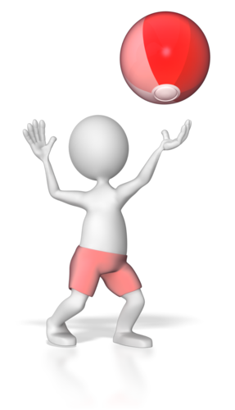
Creating specific spaces enables children to engage in different types of activities, choosing and using equipment and resources that support this.
You should look at the overall space you have for your group and at how you can use this to create activity spaces and play areas. There should be clear pathways and boundaries for each area so children know where they are and what they can do in each one. Spaces can be used to determine different themes and moods which promote the experiences you want to provide. Children will respond to colours, objects, the arrangement of space, etc., and this can be used to provide guidance on how they should use the particular space.
You should avoid working in small groups around the edge/perimeter of inside spaces as the activities and children may overlap into one another. This can cause disturbances with children and learning experiences.

Activity 2D

2.6 – Encourage children to exchange thoughts and ideas about sustainable practice through intentional teaching, learning experiences and projects
By the end of this chapter, the learner should be able to:
- Identify how to encourage children to engage in sustainable practices
- Determine if encouraging children is through intentional teaching, learning experiences and/or projects.

Learn about sustainability
Through the learning experiences and activities that are carried out, stimulate the children to think about how they can use sustainable practices. Ask them to voice their thoughts and encourage a discussion on every-day subjects that they have experience of.
Your discussions could include:
- How the children travel to the service – if they are close enough to walk to the service, do they? If a parent of family member drives them; discuss whether public transport is possible or introduce the idea of car sharing as a concept for sustainable travel.
- Pets that the children may look after at home – talk about the different pets that the children and their families may have and how they need to be cared for.
- How rubbish is disposed of at home – do the children’s families recycle or compost? Discuss the different lifestyles that the children may experience and compare this to the service environment.
- Upcycling items/revamping items no longer used – discuss how objects can be made-over and reused, such as furniture and household items.
- Passing unwanted items on to others – rather than throwing unwanted or unused items away, discuss how these could be given or sold on to others who may be able to make use of them. Are there any second-hand outlets/shops in your area or local community projects that could benefit from this?

Use intentional teaching
Plan and consider the points that you want to teach to the children and use these in structured learning activities.
You could create simple quizzes that are fun and formulate group games that introduce themes of sustainability. For example, a game on the theme of energy; you could gather the children in a circle and each child could be an object and the game would be to guess whether each one needs an energy source to make it work, and if so, what it would be.
Use additional resource items to help embed learning and to provide a point of reference. Use short films and display posters to highlight relevant points and create mini experiments and use practical examples to help with learning experiences.

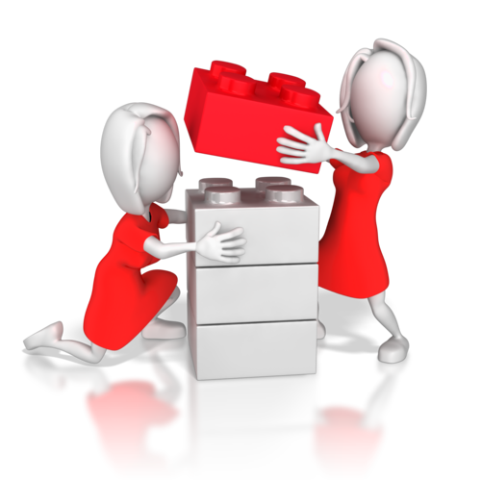
Introduce fun projects for the children
Create a project around the subject of sustainability that the children can work on over time. For example, ask them to collect pictures and photos from magazines on sources of energy or on different habitats.
You could encourage parents and families to participate with their children in the project. They could help their child put together a scrapbook of collected images, home-made crafts and arts, all on themes of sustainability. They could also help their child to produce comments and annotations.
Build a model
Ask the children to make a model on an environmental subject such as’ what is at the beach’. This could be made with the help of parents out of any materials or objects that have been discarded. Put these on display at the service, or at the local community centre or library.
Introduce a sustainability program
Your service could introduce a sustainability program that could involve the children and their families participating in scheduled events at the service. You could focus this on themes such as gardening and healthy eating or on specific sustainable learning activities within the community.

Activity 2E

2.7 – Explore ethical dilemmas of waste disposal for sustainability with all stakeholders
By the end of this chapter, the learner should be able to:
- Identify the stakeholders for discussing ethical dilemmas of waste disposal
- Determine current ethical dilemmas in waste disposal
- Identify points for further exploration on the ways that waste can be sustainably managed at a service.

Discuss waste management with the stakeholders
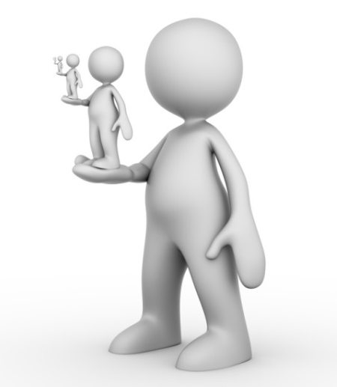
At your service look at the ethical dilemmas for waste disposal and discuss the ways in which waste can be managed. Include all stakeholders in your meetings and discussions so a variety of opinions can be gathered and looked at. Stakeholders are any persons that have an interest or concern in the service.
Stakeholders may include:
- Service organisation
- Service management
- Service staff
- Kitchen staff
- Cleaning staff/company
- Parents and families.
Your discussions may cover a range of topics on current practices used, the amount of waste generated at the service and the ways these are managed. It is important for the environment to consider options for minimising waste within the daily practices at the service.
Current ethical dilemmas in waste management
The majority of waste in Australia that cannot be recycled or reused is put into landfill sites. This causes environmental issues with air, water and land quality. Landfill gases (mainly methane) contribute to global warming when released into the air. When waste decomposes, the gases are released not only upwards but also through the soil, further aided by water that may flow through the landfill site. This causes further pollution into the surrounding land, which in turn affects wildlife habitats and biodiversity.

How can the service’s waste be managed better?
In order to minimise waste generated at the service, look at the areas that would benefit from sustainable practices.
Look at:
- Using reusable cloth nappies instead of disposable nappies (or use more eco-friendly versions)
- Using less disposable items, such as wet wipes
- Using and cooking only the amount of food that you need to use for that day
- Feeding scraps of food to pets, or composting/using a worm farm for food scraps
- Reusing items as much as possible
- Improving current recycling practices
- Education for better waste management practices.
Discuss the improvements that could be introduced to make the service more environmentally sustainable and to improve waste management. Contact any relevant waste management organisations for further information so you have all the facts to hand.
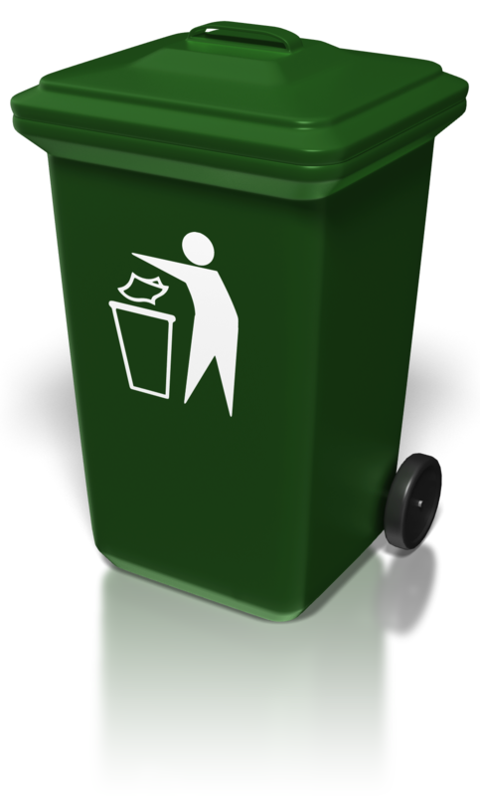
Reach an agreement with the stakeholders for implementing more sustainable practices. By including stakeholders in the decision-making process, you can better encourage all persons to work together to use more sustainable methods to the benefit of the environment.

Activity 2F

3. Support others in implementing sustainable practice
3.1. Encourage children to participate in sustainable practice discussions and learning experiences
3.2. Engage with adults and children to encourage their participation in the service’s sustainable practices

3.1 – Encourage children to participate in sustainable practice discussions and learning experiences

3.2 – Engage with adults and children to encourage their participation in the service’s sustainable practices
By the end of this chapter, the learner should be able to:
- Determine methods to encourage children’s participation in sustainable practice discussions and learning experiences
- Identify how to support others to be more sustainable
- Recognise how to engage with children and adults on sustainable practices.

Encourage others to participate in sustainable practices
Involve the children in areas of sustainability for the service and also within their own environment; encourage them to participate in learning experiences and discussions. Use a variety of topics that relate to sustainable issues and enable the children to have open and frank discussions without judgement. This will help them to understand the importance of sustainability.
Involve parents and families
To encourage parents and families to work together with their children on sustainability, you should look to guide and support them with knowledge and through the practices used at the service. Show them how these practices work and how they can make positive changes in their own homes and environment. Encourage them to continue making sustainable choices with their children at home.
You can support others by:
- Talking about sustainable options
- Showing examples of sustainable practices
- Joining together to form sustainable ideas and practices that all can use
- Making it a part of everyday life

- Providing enriching learning experiences to improve knowledge and inspire better practices for all.

Engage with the community
Look to share information and examples of sustainability with the whole community. Advertise the policies and practices that have been implemented to show that being green can help make a difference.
You should also look at examples of good environmental practices that are already being carried out within the community as these can inspire and provide further sources for new ideas. Visit sites that have implemented practices and been through changes that are similar to the needs of the service.
Go out and join in community projects on sustainability. You could also start your own community projects if none exist.

Show that it is important to provide a more environmentally sustainable community for the present, and for the generations to come. Set good examples and show how improvements can make a difference, however small they may seem.

Activity 3A

4. Embed sustainability into service policies and procedures
4.1. Review the service philosophy, policies and procedures in relation to sustainable practice
4.2. Identify areas of potential change in the service philosophy, policies and procedures
4.3. Discuss with stakeholders any identified areas of potential change
4.4. Finalise changes after agreement with appropriate stakeholders

4.1 – Review the service philosophy, policies and procedures in relation to sustainable practice

4.2 – Identify areas of potential change in the service philosophy, policies and procedures
By the end of this chapter, the learner should be able to:
- Determine factors for the review of sustainable practices
- Recognise areas of potential change in service philosophy, policies and procedures.

A service philosophy
A philosophy describes the values and beliefs which will lay the foundation for the policies developed and used on a daily basis.
Once you have identified and implemented additional sustainable practices at your service, look to include these new practices within your philosophy, policies and procedures.

Make a review
To conduct a review, you will need to identify the factors that need to be addressed. Does service philosophy correctly reflect the sustainable practices that you do? If not, revise this to include the values that are important. The service philosophy sets the tone for your practices and it may be the first introduction that a parent/family has when considering your service for the care of their child.

You should also check the service’s policies and procedures to ensure that these also support the principles and practices of your service. Do these include guidance and interpretation of the sustainable practices that your service now performs?
Look at the National Quality Framework and the seven quality areas of the National Quality Standards to ensure your philosophy, policies and procedures accurately reflect these too. You can also assess the relevant learning framework to ensure your sustainable practices are aligned to this.
Service philosophy may include:
- Information about the service
- Aims of the service
- Strategies used for everyday practices
- Responsibilities of the service and others.
Policies are the ethical, legal and industry guidance and rules for conducting business. Procedures will provide clear steps and actions for carrying out these policies; they exist to help the service and staff to follow correct practices and to provide consistency and quality in work.
Organisational standards are those standards that are recognised at industry level as being best practice; they provide the benchmarks for working efficiently and effectively.

Identify areas of change
Once you have reviewed your documentation, look at the elements and areas that you may need to make changes to.

Areas of potential change may include:
- Changes to policy on waste management
- Changes to purchasing requirements and strategies
- Changes to parent/ family activities and sustainable programs
- Changes to learning experiences, for example, ensuring that excursions to places of sustainable interest are made
- Changes to energy use within the service.
Legislation that may impact on child care/education and sustainable practices include:
- Education and care Services National Regulations – this supports the National Quality Framework in the following ways:
  - “the National Quality Standard (schedule 1)
  - application processes for provider approval and service approval
  - setting out the rating scale
  - the process for the rating and assessment of services against the National Quality Standard
  - minimum requirements relating to the operation of education and care services organised around each of the seven quality areas
  - staffing arrangements and qualifications
  - fees for a range of transactions
  - jurisdiction-specific provisions”
(Source, ‘National Regulations’, Australian Children’s Education and Care Quality Authority (ACECQA): http://www.acecqa.gov.au/national-regulations access date: 06.02.2018)
- Environmental Protection and Biodiversity Conservation Act 1999 and Environmental Protection and Biodiversity Conservation Regulations 2000 – environmental legislation for protecting Australia’s habitats, wildlife and heritage, allowing the states and territories to be responsible for issues of state and local significance.

Activity 4A

4.3 – Discuss with stakeholders any identified areas of potential change

4.4 – Finalise changes after agreement with appropriate stakeholders
By the end of this chapter, the learner should be able to:
- Determine the need to discuss making changes with relevant stakeholders
- Identify how to finalise making changes after obtaining agreement.

Discuss any potential changes with stakeholders
Meet with stakeholders and discuss the suggested changes and improvements to sustainable practices within the service’s operations. Let them know that in light of these changes, the philosophy, policies and procedures of the service may also need to be amended to reflect these new practices.
Make a presentation
Present to the stakeholders how the changes to sustainable practices were made. Recap how these were identified as important and also how they were made achievable.
Explain the strategies that were used to implement the new practices and how the service worked together with the children and parents/families to do this. Provide information on the outcomes, the successes and any problems encountered, and how strategies evolved and were changed to accommodate the changes.
Compile the relevant facts and information on the outcomes so that the achievements can be measured (quantitative research) and highlight case studies where sustainable practices have been experienced first-hand (qualitative research) to gain a full understanding of the changes.
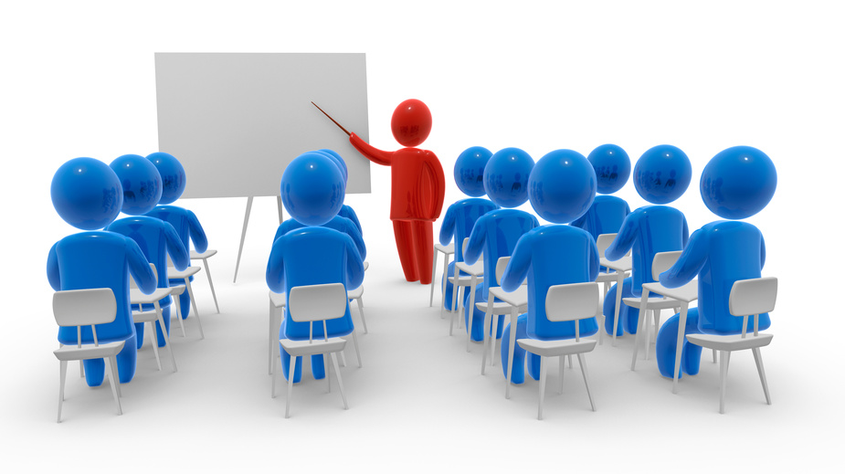

Agree and finalise the changes to be made
Before changes can be made, you will need to discuss with all the relevant stakeholders what the proposed changes are and whether these should be made. Confirm the changes with the stakeholders, so that the agreements you need have been gained.

Finalise the agreed changes and amend/change the service’s philosophy, policies and procedures as necessary.
Let others know the changes
Make sure that once these changes have been made that all staff, and any other people who need to know, have been told. If staff at the service need to familiarise themselves with any areas, allow them the time to do this so that the service can maintain good sustainable practices within its operations. Update all relevant documentation within the service to reflect the changes made and make this available to parents and families for their information.
Finalising changes will include:
- Obtaining confirmations and any necessary signatures or sign-offs on agreements for changes
- Revising and updating service documentation to reflect the changes
- Informing staff of the changes
- Assisting staff to adopt the changes and to follow revised/new policies and procedures
- Making the appropriate changes within the service environment
- Communicating changes to families, children and any other relevant stakeholders.

Activity 4B

Summative Assessments
At the end of your Learner Workbook, you will find the Summative Assessments.
This includes:
- Skills Activity
- Knowledge Activity
- Performance Activity.
This holistically assesses your understanding and application of the skills, knowledge and performance requirements for this unit. Once this is completed, you will have finished this unit and be ready to move onto the next one – well done!

References

These suggested references are for further reading and do not necessarily represent the contents of this unit.
Websites
Information on educator ratios can be accessed at ‘Improved educator to child ratios’ from ACECQA: http://www.acecqa.gov.au/Improved-educator-to-child-ratios
Information on educator qualifications can be found at ‘Qualifications’ from ACECQA: http://www.acecqa.gov.au/educators-and-providers1/qualifications
Information on educators, providers and services in the national registers can be found at ‘National Registers’ from ACECQA: http://acecqa.gov.au/national-registers
Information on learning frameworks can be accessed at ‘Approved Learning Frameworks’ from ACECQA: http://www.acecqa.gov.au/national-quality-framework/national-law-and-regulations/approved-early-learning-frameworks
Information on the National Quality Framework (NQF) can be found at the ACECQA website: http://www.acecqa.gov.au/national-quality-framework/explaining-the-national-quality-framework
Information on Quality Area 3 sourced at ‘Quality Area 3 – Physical environment’ from ACECQA: http://www.acecqa.gov.au/Physical-environment
Information on learning outcome 2 has been sourced from page 29 in the ‘Belonging, Being and Becoming: The Early Years Learning Framework for Australia’ publication from ACECQA: http://files.acecqa.gov.au/files/National-Quality-Framework-Resources-Kit/belonging_being_and_becoming_the_early_years_learning_framework_for_australia.pdf
Information on SunSmart programs can be found at ‘SunSmart schools and early childhood programs’ from Cancer Council Australia: http://www.cancer.org.au/preventing-cancer/sun-protection/sunsmart-hools/
Information on the Education and care Services National Regulations and NQF sourced at ‘National Regulations’ from ACECQA: http://www.acecqa.gov.au/national-regulations
The Australian Association for Environmental Education: http://www.aaee.org.au/about/
Publications
‘Belonging, Being and Becoming: The Early Years Learning Framework for Australia’ from ACECQA: http://files.acecqa.gov.au/files/National-Quality-Framework-Resources-Kit/belonging_being_and_becoming_the_early_years_learning_framework_for_australia.pdf
‘My Time, Our Place: Framework for School Age Care in Australia’ from ACECQA: http://files.acecqa.gov.au/files/National-Quality-Framework-Resources-Kit/my_time_our_place_framework_for_school_age_care_in_australia.pdf
‘Guide to the Education and Care Services National Law and the Education and Care Services National Regulations 2011’ from ACECQA: http://files.acecqa.gov.au/files/National-Quality-Framework-Resources-Kit/NQF-Resource-02-Guide-to-ECS-Law-Regs.pdf

All references accessed on and correct as of 17.05.2017, unless other otherwise stated.

