BSBWHS414
Contribute to WHS risk management
ASSESSMENT SUMMARY

The assessment activities for BSBWHS414 Contribute to WHS risk management cover all aspects of the unit of competency required. To demonstrate competence in this unit, a participant must undertake all tasks and complete them satisfactorily and consistently. For Apprentices and Trainees, this includes employer completion of the Employer Record Book (ERB).

Participants must read all the information given before starting any assessment task. The assessment tasks are intended to be equitable, fair and flexible. If a participant has any questions or requires alternative arrangements to be made such requests should be directed to their Trainer/Assessor, who should note such arrangements in the ‘Assessor Comments’ on the affected assessment. If a participant feels they are not yet ready to be assessed, they should discuss their options with their Trainer/Assessor.

To satisfactorily complete the assessment, the participant is required to answer all questions correctly and demonstrate their skills to industry standards. If a participant does not answer some questions or perform some tasks, they will be deemed ‘Not Satisfactory’ for the task and ‘Not Yet Competent’ for the unit of competency. The Trainer/Assessor is able to provide the participant with additional information on interpreting the assessment outcomes and provide guidance on the participant’s options. Should a participant still be deemed ‘Not Satisfactory’ they will have the opportunity to undertake a supplementary assessment or appeal the result.

By signing the cover page for each assessment item, the participant acknowledges they understand the assessment instructions and requirements and consent to being assessed. The participant also verifies and assures the RTO that the work submitted is their own work.

Participant Name | Amanda Griffith

Task | Assessment Results
Workbook | Satisfactory | Not Yet Satisfactory
Quiz | Satisfactory | Not Yet Satisfactory
Practical Assessment | Satisfactory | Not Yet Satisfactory
Outcome for Unit of Competency | Competent | Not Yet Competent

Assessor Name
Assessor Signature | 
Unit Competence Determination Date | Click here to enter a date.

BSBWHS414
Contribute to WHS risk management

WORKBOOK INSTRUCTIONS

- This workbook will occur under standard assessment conditions.
  - An oral assessment may be allowed under certain circumstances, whereby the Participant’s answers will be documented by a party other than the Participant. This must be acknowledged in writing (e.g. FT001 and Assessor Comments)
- Participants must provide enough detail in their responses to demonstrate their knowledge and skills.
- Please fill in the details below, providing your name, signature and date of assessment.
  - Your signature acknowledges that this is your own work.
- Assessors are to complete marking in pen of a different colour to the Participant.
- If a Participant initially answers a question incorrectly but modifies their response, they must follow the instructions below:
  - If a Participant changes their response in writing, they must put their initials next to the written change.
  - If a Participant changes their response verbally, this must be noted on the document by the assessor.

Participant name | Amanda Griffith
Participant signature | 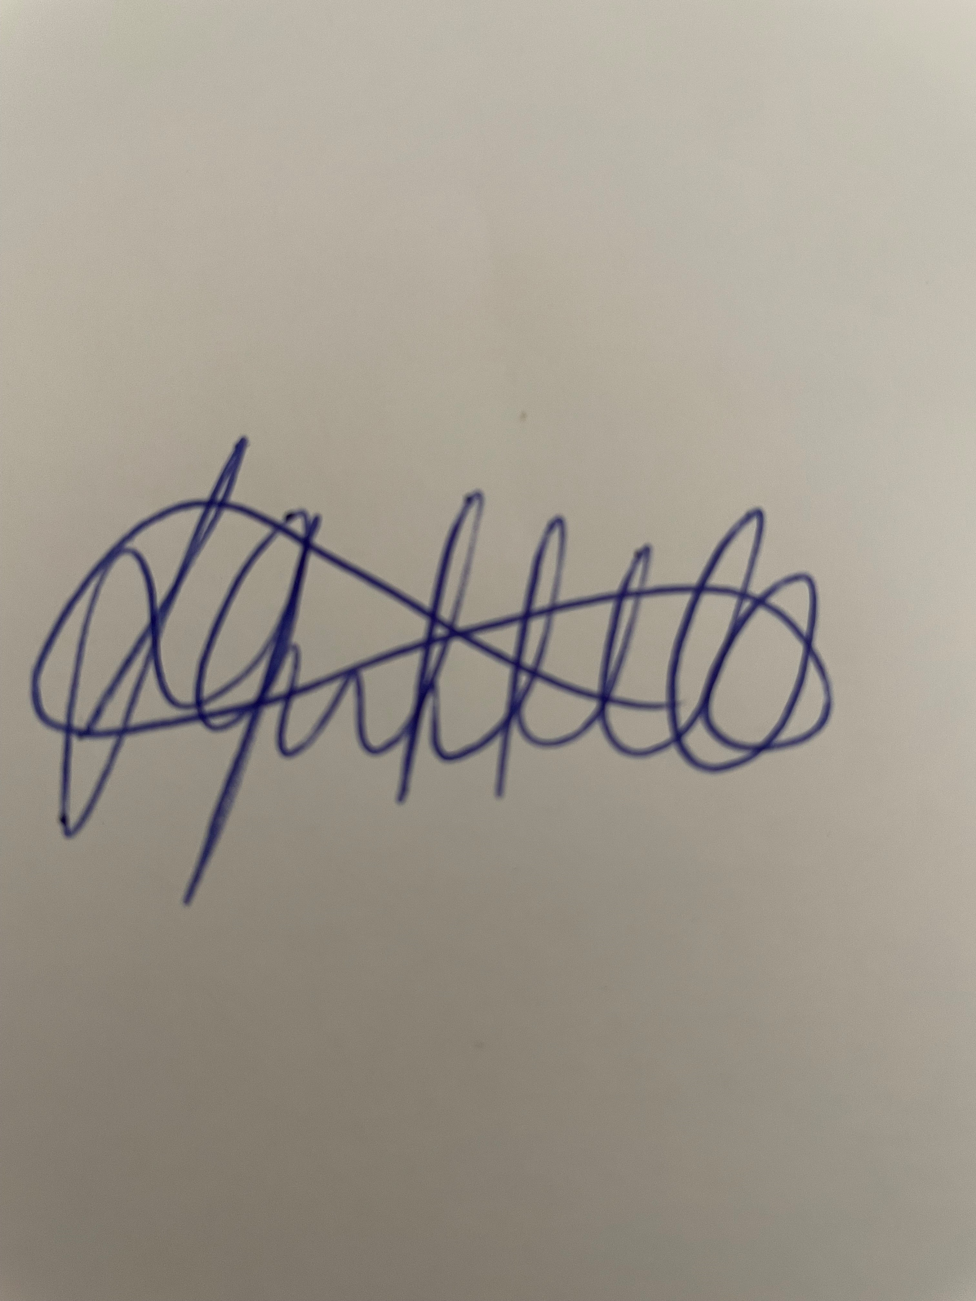
Date | 13/02/2023

Assessor name
Assessor signature
Date | Click here to enter a date.

Number of activities | Number of activities answered correctly | Task outcome (Tick)
4 |  | Satisfactory | Not Yet Satisfactory

ASSESSOR Comments
NOTE

At times, you will be provided with a specific business context to which you must respond, otherwise it is anticipated that you will use a workplace of your choosing (your own, or hypothetical) to provide the context to the task.

At all times, the responses in your assessment must reference Australian (Queensland or Federal) documentation, including legislation, regulations, codes of practice, standards and guidance publications.

For the following activities, name a workplace that you wish to examine.

Name of workplace | Griffith Graphics Pty Ltd

Identify the duty holders and their range of duties regarding hazard identification, risk assessment and risk control activities by explaining the requirements found in:
- WHS Acts
- WHS Regulations
- Codes of practice
- Guidelines

Explain how you comply with the requirements of these documents.

Hazard identification
WHS Acts
-the likelihood of the hazard or the risk concerned occurring; and
-the degree of harm that might result from the hazard or the risk; and
-what the person concerned knows, or ought reasonable to know, and
the hazard or the risks; and
ways of eliminating or minimising the risk; and
-the availability and suitability of ways to eliminate or minimise the risk; and
-after assessing the extent of the risk and the available ways of eliminating or minimising the risk, the cost associate with available ways of eliminating or minimising the risk, including whether the cost is grossly disproportionate to the risk.

WHS Regulations
A duty holder, in managing risks to health and safety, must identify reasonably foreseeable hazards that could give rise to risks to health and safety.
Codes of practice
A PCBU must eliminate risks in the workplace, or if that is not reasonably practicable, minimise the risks so far as is reasonably practicable.
Identifying hazards in the workplace involves finding things and situation that could potentially cause harm to people.
Guidelines
Providing and maintaining a work environment that is safe and without risks to health, including the entering the exiting of the workplace through Hazard Identification.
How you comply
Regular inspections at Griffith Graphics will be conducted to observe job tasks and to assess if any unsafe work practices exist, as well as the general state of housekeeping and cleanliness.

Risk assessment
WHS Acts
A duty imposed on a person to ensure health and safety requires the person:
-To eliminate risks to health and safety, so far as is reasonable practicable; and
-If it is not reasonably practicable to eliminate risk to health and safety, to minimise those risk so far as is reasonable practicable.
WHS Regulations
A duty holder, in managing risks to health and safety, must -
-eliminate risks to health and safety so far as is reasonably practicable; and
-if it is not reasonable practicable to eliminate risks to health and safety - minimise those risks so far as is reasonably practicable.
Codes of practice
A risk assessment involves considering what could happen if someone is exposed to a hazard and the likelihood of it happening. A risk assessment can help you, as a PCBU, to determine:
-how severe a risk is
-whether any existing control measures are effective
-what action you should take to control the risk
-how urgently the action needs to be taken
Guidelines
Providing workers with information, instruction, training or supervision needed for them to work safely and without risks to their health.
How you comply
Risk assessments are carried out prior to works and this helps us determine how severe the risks are, whether or not the existing control measures are effective and what action should be taken to control the risk at what level of urgency.

Risk control
WHS Acts
That the health of workers and the conditions at the workplace are monitored for the purpose of preventing illness or injury of workers arising from the conduct of the business or undertaking.
WHS Regulations
A duty holder who implements a control measure to eliminate or minimise risks to health and safety must ensure that the control measure is, and is maintained so that it remains, effective, including by ensuring that the control measure is and remains -
-fit for purpose; and
-suitable for the nature and duration of the work; and
-installed, set up and used correctly.
Codes of practice
In deciding how to control risks; as a PCBU, you must consult your workers and their representatives who will be directly affected by this decision. Their experience will help you choose appropriate control measures and their involvement will increase the level of acceptance of any changes that may be needed to the way they do their job.
Guidelines
Monitoring the health of their workers and the condition of the workplace under their management and control to prevent injury or fillness.
How you comply
Griffith Graphics consults with workers and representatives in helping to choose appropriate control measures and to ensure a safer workplace for everyone.

Satisfactory Outcome

Explain the requirements of your organisation regarding hazard identification, risk assessment and risk control activities by identifying the requirements found in:
- WHS policy
- WHS procedure
- WHS process
- WHS system

Explain how you comply with the requirements of these documents.

Hazard identification
WHS policy
Every worker of Griffith Graphics is responsible for identifying hazards in the workplace while conduction your job role which is why we are proactive in educating our workers on all aspects of work health and safety.
WHS procedure
Identifying hazards involves finding things and situations that could potentially cause harm to people. Hazards generally arise from aspects of work and their interaction.
WHS process
Some hazards can be part of the work process, such as mechanical hazards, noise or toxic properties of substances while other hazards may result from equipment or machine failures and misuse, chemical spills and structural failures.
WHS system
Each of these hazards need to be identified and eliminated if possible, or at least managed.
How you comply
A General Audit Checklist is conducted and Hazard Register is used to describe the hazard, location, priority of risk level, risk control measures and extra controls needed.

Risk assessment
WHS policy
Griffith Graphics carry out risk assessments which involve considering what could happen if someone is exposed to a hazard and the likelihood of it happening.
WHS procedure
A risk assessment can be undertaken with varying degrees of detail depending on the type of hazards or can be as simple as a discussion with our workers and details recorded.
WHS process
A risk assessment will be carried out when:
There is uncertainty about how a hazard may result in injury or illness.
The work activity involves a number of different hazards and there is a lack of understanding about how the hazards may interact with each other to produce new or greater risks.
Changes at the workplace occur that may impact on the effectiveness of control measures.
WHS system
The risk assessment needs to be identified and risk control measures put in place.
How you comply
A Risk Register is used to describe the risk description, location, risk level, risk control measures, date by which controls to be implemented, person responsible for implementation and date controls are due for review.

Risk control
WHS policy
As part of our risk management approach here, we endeavour to do everything that is reasonably practicable to either eliminate or at the very least control the risks and minimise them to a workable manner as far as is reasonably practicable.
WHS procedure
Griffith Graphics consult with workers and representatives in helping choose appropriate control measures to ensure a safer workplace for everyone.
WHS process
Griffith Graphics management with consider various control options and choose the control that most effectively eliminates the hazard or minimises the risk in the appropriate circumstances.
WHS system
Here at Griffith graphics, we will ensure that the ways of controlling risks are ranked from the highest level of protection and reliability to the lowest. This ranking is the hierarchy of risk control.
How you comply
A Risk Register is used to describe the risk description, location, risk level, risk control measures, date by which controls to be implemented, person responsible for implementation and date controls are due for review.

Satisfactory Outcome

In meeting the legal and organisational requirements noted in Activities 1 and 2, identify two (2) hazards that may occur in your workplace. For each hazard identified, find information to explain:
- The nature and scope of the hazard
- The range of harms caused by the hazard and how they are caused
- The techniques, tools and processes used to identify each hazard
- Select tools appropriate for the workplace and identify different tools for each hazard
- Describe how you contribute to applying these selected techniques, tools and processes and document the results
- Determine the level of risk for the hazard within your workplace
- How you advise others of this information
- Identify the individuals and parties who should be notified (i.e. because they are at risk or are required to implement controls)
- Consider how best to addresses peoples’ range of abilities and backgrounds
- Be sure to also consider the timeframes in which you should advise others
- Risk controls that may be implemented to address the hazard and risk assessment results
- Consider the hierarchy of control and any legal requirements
- Offer at least two (2) risk controls and justify why one (1) is more appropriate than the other
- Explain the timeframes in which these risk control options should be implemented

Name of Hazard 1
Workplace Housekeeping
Nature and scope of hazard
Poor housekeeping can cause, slips, trips, falls and exposure to chemicals if they’re not stored properly.
The range of harms caused and how they are caused
Slip, trip and fall hazards - When objects, materials, tools and equipment are not properly stored workers are bound to trip over them.
Strain hazards - When heavy objects or awkward objects are placed on the floor and needs to be picked up by a worker, it creates a risk for injury.
Laceration hazards – When items are not properly stored, this creates a huge risk of laceration injuries. Sharp tools can easily cut through a glove or clothing and injure a worker.

Techniques, tools and processes to identify hazard
Regular inspections are conducted through the workshop to monitor housekeeping.
Safe work procedures are put into place to ensure housekeeping is meet and tools are stored correctly.
Before workers begin work at Griffith Graphics, they are given a general safety induction which explains the housekeeping of where tools are stored, keeping the workshop clean and maintaining clear entry and exit points. The workers also have tool inductions which shows them where the tools are stored, how they are used, cleaned and then returned.
Determine the level of risk
If these hazards are not controlled the hazards are of a high level. When the hazards are controlled they are of a moderate level as there is room for human error.
How you advise others about hazards, harms and associated risk
By documenting it in a Hazard Register and meeting with workers and representatives to discuss risk control measures.
Risk controls
Work plans must include waste control and this must be ensured by the work procedures.
This control should be implemented ASAP before any future works is conducted.
This control is the most appropriate as it deals with each project individually.

Monitor workplaces to make sure all specified procedures are being followed and to ensure that controls are functioning correctly.
This control should be implemented ASAP.

Name of Hazard 2
Ergonomics
Nature and scope of hazard
Ergonomic hazards are physical factors in the environment that may cause musculoskeletal injuries.
The range of harms caused and how they are caused
Areas of concern for ergonomic hazards include:
Strain and sprains – monitor glare and height
Musculoskeletal injuries – workstation design and height
Techniques, tools and processes to identify hazard
Regular inspection and maintenance of office equipment .
Engineering improvements including rearranging, modifying, redesigning or replacing tools.

Determine the level of risk
Once these levels are monitored it is a low risk.
How you advise others about hazards, harms and associated risk
By documenting it in a Hazard Register and meeting with workers and representatives to discuss risk control measures.
Risk controls
Keyboard, mouse and work surface at your elbow height.
Position monitor directly in front of you.
Monitor and work surface free from glare.
Take postural breaks every 30 minutes.
Take regular eye breaks from looking at your monitor.

Satisfactory Outcome

For the two (2) risks (and associated risk controls) identified in Activity 3:
- Explain how you would contribute to developing and implementing a risk control plan to meet your legal and organisational obligations
- Describe the process you would undertake to evaluate the risk controls that had been implemented

Hazard/Risk 1
Develop and implement risk control plan
Effective controls protect workers from workplace hazards which: help avoid injuries, illnesses and incidents, minimise or eliminate safety and health risks and helps provide workers with safe and healthful working conditions.
- Involve workers with consultation.
- Identify and evaluate options for controlling hazards, using a hierarchy of controls.
- Use a hazard control plan to guide the selection and implementation of controls, and implement controls according to the plan.
- Develop plans with measures to protect workers during emergencies.
- Evaluate the effectiveness of existing controls to determine whether they continue to provide protection.

Evaluation of risk control
Conduct regular inspections to confirm that engineering controls are operating as designed.
Evaluate control measures to determine if they are effective or need to be modified. Involve workers in the evaluation of the controls.
Confirm that work practices, administrative controls and personal protective equipment use policies are being followed.
Conduct routine preventative maintenance of equipment, facilities, and controls to help prevent incidents due to equipment failure.

Hazard/Risk 2
Develop and implement risk control plan
Effective controls protect workers from workplace hazards which: help avoid injuries, illnesses and incidents, minimise or eliminate safety and health risks and helps provide workers with safe and healthful working conditions.
- Involve workers with consultation.
- Identify and evaluate options for controlling hazards, using a hierarchy of controls.
- Use a hazard control plan to guide the selection and implementation of controls, and implement controls according to the plan.
- Develop plans with measures to protect workers during emergencies.
- Evaluate the effectiveness of existing controls to determine whether they continue to provide protection.

Evaluation of risk control
Conduct regular inspections to confirm that engineering controls are operating as designed.
Evaluate control measures to determine if they are effective or need to be modified. Involve workers in the evaluation of the controls.
Confirm that work practices, administrative controls and personal protective equipment use policies are being followed.
Conduct routine preventative maintenance of equipment, facilities, and controls to help prevent incidents due to equipment failure.

Satisfactory Outcome

BSBWHS414
Contribute to WHS risk management

QUIZ INSTRUCTIONS

- This quiz will occur under standard assessment conditions.
  - An oral assessment may be allowed under certain circumstances, whereby the Participant’s answers will be documented by a party other than the Participant. This must be acknowledged in writing (e.g. FT001 and Assessor Comments)
- Participants must provide enough detail in their responses to demonstrate their knowledge and skills.
- Please fill in the details below, providing your name, signature and date of assessment.
  - Your signature acknowledges that this is your own work.
- Assessors are to complete marking in pen of a different colour to the Participant.
- If a Participant initially answers a question incorrectly but modifies their response, they must follow the instructions below:
  - If a Participant changes their response in writing, they must put their initials next to the written change.
  - If a Participant changes their response verbally, this must be noted on the document by the assessor.

Participant name | Amanda Griffith
Participant signature
Date | 13/02/2023

Assessor name
Assessor signature
Date | Click here to enter a date.

Number of questions | Number of questions answered correctly | Task outcome (Tick)
6 |  | Satisfactory | Not Yet Satisfactory

ASSESSOR Comments
- Match the terms and definitions by writing the appropriate letter next to each number in the centre column.

Answer | Terms |  |  | Definitions
 |  | Hazard | 1 - C |  | Taking action to eliminate health and safety risks
 |  | Risk | 2 - B |  | The possibility that harm might occur when exposed to a hazard
 |  | Risk control | 3 - A |  | A situation or thing that has the potential to harm a person

- Which of the following can be causes of workplace hazards?
Tick all that apply.

Answer | Choice | Possible Answers
 |  | Noise
 |  | Physical layout of the workplace
 |  | Temperature
 |  | Stress

- Which of the following individuals and parties may require information about workplace hazards? Tick all that apply.

Answer | Choice | Possible Answers
 |  | Health and Safety Committees (HSCs)
 |  | All members of the public
 |  | Contractors
 |  | Workers
 |  | Managers
 |  | Technical specialists who can assist with determining control measures

- Which of the following are appropriate techniques, tools and processes for identifying hazards and risks? Tick all that apply.

Answer | Choice | Possible Answers
 |  | Workplace inspections
 |  | Compensation claim information
 |  | Safe Work Method Statements
 |  | Information issued by WHS regulators

- True or False (Tick your response): Risk control options can come from both internal sources (e.g. policies and procedures) and external sources (e.g. codes of practice and standards).

Answer |  | True
 |  | False

- Which of the following should be considered when developing a risk control plan? Tick all that apply.

Answer | Choice | Possible Answers
 |  | How and when controls will be implemented
 |  | Evaluation processes for implemented controls
 |  | Consultation with individuals and parties
 |  | Responsibilities for implementation

BSBWHS414
Contribute to WHS risk management

PRACTICAL ASSESSMENT INSTRUCTIONS

- The following practical assessment will require the Participant to complete work related activities.
- The Assessor will conduct observations of the Participant’s work to determine whether they display sufficient practical skills and knowledge.
- Please fill in the details below – providing your name, signature and date of assessment.
  - The Participant’s signature acknowledges that the Assessor provided clear instructions and the Participant understood what was required to complete this assessment.
- The Assessor may substitute a Practical Task with an alternate task of equal value.
  - Alternate tasks must be fully documented by the assessor in the Assessor Comments area.

Participant name | Amanda Griffith
Participant signature
Date | 13/02/2023

Assessor name
Assessor signature
Date | Click here to enter a date.

Task | Task outcome (Tick)
Task | Satisfactory | Not Yet Satisfactory
Task 1

Assessor Comments
BSBWHS414
Contribute to WHS risk management

Practical Task 1
Description of task:
The participant is to identify two (2) different WHS hazards, assess and control the risk relating to those identified hazards. For each hazard, the participant is required to:
- Apply legal and organisational requirements when selecting and applying techniques, tools and processes for hazard identification, risk assessment and risk control
- Document the processes undertaken in the form of a presentation, for delivery to workers, contract workers, managers and PCBU (e.g. PowerPoint presentation slides with accompanying face-to-face delivery or real-time video, as arranged with your assessor)
- Identify the responsibilities of your audience with regards to their legal duties in controlling the identified risks

The participant is to submit the following evidence with this Practical Assessment sheet. There should be two (2) of each of the following documents submitted (i.e. one for each hazard):
- Workplace checklists for monitoring effectiveness of risk control measures
- Presentation materials with included graphics (e.g. PowerPoint)

The assessor is to provide detailed comments on the tasks completed by the participant. Detail should be recorded in the Assessor’s Comments (e.g. questions asked by assessor during presentation).
Resources required:
Computer.
Assessment of task
Name of participant: | Amanda Griffith
Name of assessor:
Location:
Date:
When completing the task, did the participant: |  | Tick if satisfactorily completed.  Provide comments if left unticked.
1 Hazard identification
- Confirm and apply legal and organisational requirements with regards to hazard identification.
- Select and apply hazard identification tools and techniques.
- Analyse information and data to determine each hazard’s nature and scope.
2 Risk assessment
- Confirm and apply legal and organisational requirements with regards to risk assessment.
- Analyse information and data when conducting risk assessments.
- Select and apply tools, techniques and processes to assess risk – determining those affected, as well as the nature, severity and likelihood of potential harm.
3 Risk management and controls
- Confirm and apply legal and organisational requirements with regards to risk controls.
- Analyse information and data when identifying, evaluating and selecting risk control options.
- Identify potential risk controls according to the hierarchy of control and evaluate most appropriate options for action.
- For each hazard, develop a checklist to enable evaluation of effectiveness of risk controls.
4 Presenting findings
- Develop and deliver presentation (in person/via live stream video).
- Review processes undertaken, including:
- Tools used for hazard identification, risk assessment and risk control processes
- Hazard identification results – including two (2) workplace hazards and the harms they may cause
- Risk assessment results – including those affected and the nature, severity and likelihood of potential harm
- Risk management plan – including the selected risk controls and activities requiring joint responsibility and accountability (considering time and resource constraints)
- Identify duty holders and their roles and responsibilities according to risk management requirements including:
- Explaining legal and organisational requirements
- Identifying requirements to ensure effectiveness of risk controls
- Outline plan for monitoring effectiveness of risk controls (i.e. using checklist)
The Participant’s performance was: Satisfactory Not Satisfactory

