CPCCBC4002A
Manage occupational health and safety in the building and construction workplace
ASSESSMENT SUMMARY

The assessment activities for CPCCBC4002A Manage occupational health and safety in the building and construction workplace cover all aspects of the unit of competency required. To demonstrate competence in this unit, a participant must undertake all tasks and complete them satisfactorily and consistently. For Apprentices and Trainees, this includes employer completion of the Employer Record Book (ERB).

Participants must read all the information given before starting any assessment task. The assessment tasks are intended to be equitable, fair and flexible. If a participant has any questions or requires alternative arrangements to be made such requests should be directed to their Trainer/Assessor, who should note such arrangements in the ‘Assessor Comments’ on the affected assessment. If a participant feels they are not yet ready to be assessed, they should discuss their options with their Trainer/Assessor.

To satisfactorily complete the assessment, the participant is required to answer all questions correctly and demonstrate their skills to industry standards. If a participant does not answer some questions or perform some tasks, they will be deemed ‘Not Satisfactory’ for the task and ‘Not Yet Competent’ for the unit of competency. The Trainer/Assessor is able to provide the participant with additional information on interpreting the assessment outcomes and provide guidance on the participant’s options. Should a participant still be deemed ‘Not Satisfactory’ they will have the opportunity to undertake a supplementary assessment or appeal the result.

By signing the cover page for each assessment item, the participant acknowledges they understand the assessment instructions and requirements and consent to being assessed. The participant also verifies and assures the RTO that the work submitted is their own work.

Participant Name | Morgan Chambers

Task | Assessment Results
Theory Exam | Satisfactory | Not Yet Satisfactory
Practical Assessment | Satisfactory | Not Yet Satisfactory
Outcome for Unit of Competency | Competent | Not Yet Competent

Assessor Name
Assessor Signature | 
Unit Competence Determination Date | Click here to enter a date.

CPCCBC4002A
Manage occupational health and safety in the building and construction workplace

THEORY EXAM INSTRUCTIONS

- This exam will occur under standard assessment conditions.
  - An oral examination may be allowed under certain circumstances, whereby the Participant’s answers will be documented by a party other than the Participant. This must be acknowledged in writing (e.g. FT001 and Assessor Comments)
- Participants must provide enough detail in their responses to demonstrate their knowledge and skills.
- Please fill in the details below, providing your name, signature and date of assessment.
  - Your signature acknowledges that this is your own work.
- Assessors are to complete marking in pen of a different colour to the Participant.
- If a Participant initially answers a question incorrectly but modifies their response, they must follow the instructions below:
  - If a Participant changes their response in writing, they must put their initials next to the written change.
  - If a Participant changes their response verbally, this must be noted on the exam paper by the assessor.

Participant name | Morgan Chambers
Participant signature | 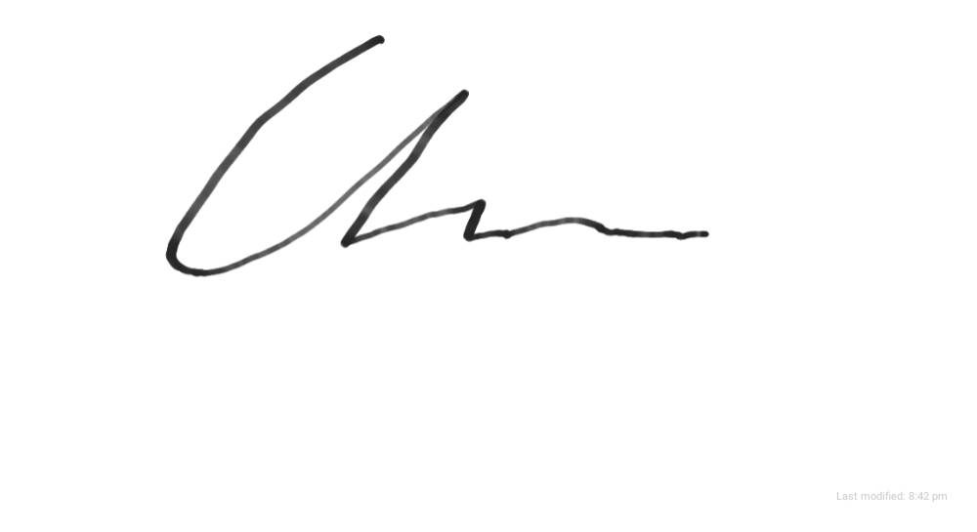
Date | 8/04/2020

Assessor name
Assessor signature
Date | Click here to enter a date.

Number of questions | Number of questions answered correctly | Task outcome (Tick)
28 |  | Satisfactory | Not Yet Satisfactory
Assessor Comments
- For each of the common building and construction jobs listed below, identify one (1) hazard specific to that job.

Answer | Job | Risks
 | Construction equipment use (e.g. power tools, concrete mixers) | Electrocution
 | High risk construction equipment use (e.g. lasers, EPT) | Damage to eyes
 | Crane use | contact with people or plant
 | Demolition | Hazardous materials
 | Formwork | Cuts, slips, trips, falls
 | Scaffolding use | Unstable ground, contact with plant
 | Work at heights | Falling from height
 | Welding | burns

- Using the risk table below, determine the level of risk for each of the hazards identified in Q1. Identify how each risk level was determined, by identifying the likelihood and consequences of each hazard.
Matrix | A:  Death or permanent disability | B:  Serious injury | C:  Lost time injury | D:  Casualty Treatment | E:  First Aid
1: Very Likely | E | E | H | H | M
2: Likely | E | H | H | M | M
3: Possible | H | H | M | M | L
4: Unlikely | H | M | M | L | L
5: Very Unlikely | M | M | L | L | L

E: Extreme | H: High | M: Medium | L: Low

Answer | Job | Level of risk
 | Construction equipment use (e.g. power tools, concrete mixers) | H
 | High risk construction equipment use (e.g. lasers, EPT) | M
 | Crane use | H
 | Demolition | M
 | Formwork | M
 | Scaffolding use | M
 | Work at heights | H
 | Welding | H

- Identify an appropriate control measure for each of the hazards identified in Q1.

Answer | Job | Control measure
 | Construction equipment use (e.g. power tools, concrete mixers) | Isolated power source, insulated equipment
 | High risk construction equipment use (e.g. lasers, EPT) | PPE
 | Crane use | Spotter, exclusion zone
 | Demolition | PPE
 | Formwork | Improved manual handling, team lifting
 | Scaffolding use | Exclusion zones
 | Work at heights | harness
 | Welding | PPE

- True or False (Tick your response): Risk control options can come from both internal sources (e.g. policies and procedures) and external sources (e.g. codes and standards).

Answer |  | True
 |  | False

- Name two (2) workplace personnel you may speak to for safety advice.

Answer | Supervisor, site safety officer

- Referring to the WHS Regulations, explain how the following documents contribute towards identifying hazards and risks in the workplace.

Answer | Document | Description
 | Safe Work Method Statements | The primary purpose of a SWMS is to help supervisors, workers and any other persons at the workplace to understand the requirements that have been established to carry out the high risk construction work in a safe and healthy manner.
 | Site Safety Plan / WHS Management Plan | The purpose of a Site Safety Plan is to outline policies and practices in respect of Occupational Health and Safety in the building and construction industry.

- Identify two (2) advisory standards you might refer to safely undertake building and construction work and briefly summarise their requirements.

Answer | Standard name | Requirements
 | Part 5 WHSA 2011 (QLD) | deals with consultation, representation and participation within the workplace
 | Work health and safety consoltation, co-operation and co-ordination code of practice 2011 | This code of practice provides practical guidance to persons conducting a business or undertaking  on how to effectively consult with workers who carry out work for the business or undertaking and  who are (or are likely to be) directly affected by a health and safety matter. It includes information  on mechanisms to facilitate worker participation and representation.

Building and construction industry contracts require building legislation and the National Construction Code to be observed. Refer to these documents when responding to Q8. to Q10.

- Identify the requirements in the National Construction Code Volume 1 with regards to air pressurisation for fire-isolated exits. Identify the relevant section of the Code and the Australian Standard referenced.

Answer | Code section(s) | Requirements and Standards
 | D1.7section D part 2 | the exit must be pressurised in accordance with AS 1668.1.

- Identify the requirements in the National Construction Code Volume 2 with regards to smoke alarms. Identify the relevant section of the Code and the Australian Standard referenced.

Answer | Code section(s) | Requirements and Standards
 | Part 3.7.5.2 | comply with AS 3786, except that in a Class 10a private garage where the use of the area is likely to result in smoke alarms causing spurious signals, any other alarm deemed suitable in accordance with AS 1670.1 may be installed provided that smoke alarms complying with AS 3786 are installed elsewhere in the Class 1 building; and be powered from the consumer mains source where a consumer mains source is supplied to the building; and be interconnected where there is more than one alarm

- Name the building legislation (Act and Regulations) that apply within your jurisdiction.

Answer | Queensland building and construction commission Act 1991

- Which of the following should be considered when developing a risk control plan? Tick all that apply.

Answer | Choice | Possible Answers
 |  | How and when controls will be implemented
 |  | Evaluation processes for implemented controls
 |  | Consultation with individuals and parties
 |  | Responsibilities for implementation

- True or False (Tick your response): If control measures do not adequately control risks, they must be revised.

Answer |  | True
 |  | False

- Which of the following are appropriate techniques, tools and processes for identifying hazards and risks? Tick all that apply.

Answer | Choice | Possible Answers
 |  | Workplace inspections
 |  | Compensation claim information
 |  | Safe Work Method Statements
 |  | Information issued by WHS regulators

- Which of the following can be used to assist with workplace inspections? Tick all that apply.

Answer | Choice | Possible Answers
 |  | Hazard and risk checklists
 |  | Job Safety Analysis (JSA)
 |  | Manifests and registers
 |  | Surveys
 |  | Workplace walk-through

- Which of the following are limitations of using a generic hazard/risk assessment checklist? Tick all that apply.

Answer | Choice | Possible Answers
 |  | Specifics of the workplace are not considered
 |  | Not all checklist points will be applicable
 |  | Such checklists/processes must be completed on a computer
 |  | You always have to purchase these checklists

- Identify the applicable WHS Act in your jurisdiction. Identify its requirements for PCBUs with regards to identifying hazards and risks.

Answer | Act name and section(s) | Requirements
 | Work health and safety act 2011 | The WHS Act places the primary health and safety duty on a person conducting a business or undertaking (PCBU). The PCBU must ensure, so far as is reasonably practicable, the health and safety of workers at the workplace. Duties are also placed on officers of a PCBU, workers and other persons at a workplace.

- Identify the applicable WHS Regulation in your jurisdiction. Identify its requirements for PCBUs with regards to identifying hazards and risks.

Answer | Regulation name and section(s) | Requirements
 | Work health band safety regulation 2011 | The Work Health and Safety (WHS) laws require a person conducting a business or undertaking (PCBU) to ensure, so far as is reasonably practicable, the health and safety of their workers while at work in the business or undertaking.

- Identify a relevant policy in your organisation with regards to identifying hazards and risks and briefly describe its requirements.

Answer | Policy name | Requirements
 | Company policy | Company policy and procedures are basically set in place to establish the rules of conduct within an organization, outlining the responsibilities of both employees and employers. Company policy and procedures aim to protect the rights of workers as well as the business interests of employers.

- Identify the statutory requirements in your jurisdiction with regards to the completion of inspection reports.

Answer | Legislation name and section(s) | Requirements

- Which of the following individuals and parties may require information about workplace hazards and proposed risk controls?
Tick all that apply.

Answer | Choice | Possible Answers
 |  | Health and Safety Committees
 |  | PCBU
 |  | All members of the public
 |  | Workers

- Identify the requirements in the Code of Practice with regards to consulting parties when managing risks.

Answer | Legislation name and section(s) | Requirements
 | Work health and safety consultation, co-operation and co-ordination code of practice 2011 | Section 49: A person conducting a business or undertaking must consult with workers when:  • identifying hazards and assessing risks arising from the work carried out or to be carried out  • making decisions about ways to eliminate or minimise those risks  • making decisions about the adequacy of facilities for the welfare of workers  • proposing changes that may affect the health or safety of your workers  • making decisions about procedures for consulting with workers; resolving health or safety  issues; monitoring health of your workers; monitoring the conditions at the workplace and  providing information and training for your workers.

- Identify the requirements in the Code of Practice with regards to consulting parties when developing procedures for communicating WHS policy and practice requirements.

Answer | Legislation name and section(s) | Requirements

- Name three (3) parties who should consult to determine effective strategies for communicating WHS policy and practice.

Answer | Managers, supervisors and employees

- Name two (2) communication strategies that may be used in the building and construction industry.

Answer | Issued site specific instruction or signage  Verbal communication

- Name two (2) education programs that may be implemented in the building and construction industry.

Answer | General and site specific induction training  Other forms of specialist and targeted training

- Fill in the blanks for the statement below:
The ‘How to manage work health and safety risks Code of Practice 2011’ identifies that control measures are more effective when ______________________ is provided and when workers are _____________________.
consulted
training

Answer

- Explain why it is important to review the effectiveness of communications and educational programs.

Answer | After you have established appropriate education and training programs for staff, it is important to review them. Should communications and/or training have taken place, yet WHS hazards/risks are unaffected (i.e. not reduce in likelihood of occurrence), then they must be reviewed

- List three (3) methods for reviewing the effectiveness of communication and educational programs.

Answer | Evaluating training programs for effectiveness  Ensuring employees have an adequate understanding  Conducting post training surveys

CPCCBC4002A
Manage occupational health and safety in the building and construction workplace

PRACTICAL ASSESSMENT INSTRUCTIONS

- The following practical assessment will require the Participant to complete work related activities.
- The Assessor will conduct observations of the Participant’s work to determine whether they display sufficient practical skills and knowledge.
- Please fill in the details below – providing your name, signature and date of assessment.
  - The Participant’s signature acknowledges that the Assessor provided clear instructions and the Participant understood what was required to complete this assessment.
- The Assessor may substitute a Practical Task with an alternate task of equal value.
  - Alternate tasks must be fully documented by the assessor in the Assessor Comments area.

Participant name | Morgan Chambers
Participant signature
Date | 8/04/2020

Assessor name
Assessor signature
Date | Click here to enter a date.

Task | Task outcome (Tick)
Task | Satisfactory | Not Yet Satisfactory
Task 1 (Occasion 1)
Task 1 (Occasion 2)

Assessor Comments
CPCCBC4002A
Manage occupational health and safety in the building and construction workplace

Practical Task 1 (2X)
Description of task:
On two (2) occasions, a suitable observer is to verify the participant’s ability to conduct and report on a WHS risk analysis, including workplace inspection.

The participant is to gather evidence of how they have completed each component of the Practical Task, which is to be submitted with this Practical Assessment sheet.

Evidence to be submitted may include:
- A copy of a Site Specific Safety Plan or Construction Safety Plan, including:
- Copies of Risk Assessments completed on a project
- Copies of Safety Work Method Statements used on a project
- A copy a workplace safety inspection checklist that has been used on a project

The observer is to provide detailed comments on the tasks completed by the participant. The assessor is to verify the observer’s comments in the Assessor Comments section, and provide the Practical Assessment outcome on the front cover of this document.
Resources required:
Computer.
Assessment of task
Name of participant:
Name of observer:
Role of observer
(Confirm suitability to sign)
Email address of observer
Signature of observer:
Date: | Click here to enter a date.
When completing the task, did the participant: |  | Tick if satisfactorily completed.  Provide comments if left unticked.
 |  | 1st  Occasion | 2nd  Occasion
- Conduct a workplace inspection to evaluate construction site safety for the range of occupations in the workplace according to WHS legislation and company policies, including:
- Identifying construction hazards and potential risk areas
- Identifying and prioritising hazards
- Identifying and prioritising risks
- Seek expert advice as appropriate, including:
- Advice from workplace personnel regarding the application of building codes and standards
- Consulting with relevant parties regarding compliance with statutory requirements (including SWMS and site safety plans)
- Consulting with appropriate personnel to determine effective strategies for communicating WHS policy.
- Complete an inspection report in accordance with best practice and statutory obligations: including:
- Recommendations from findings
- Required approaches to remediation
- Implement agreed control measures in conjunction with relevant workplace personnel, implementing negotiation and conflict resolution skills, as necessary.
- Monitor and review control measures, updating records with findings
- Establish communication strategies and educational programs specific to the building and construction industry in accordance with statutory requirements and best practice.
- Review the effectiveness of communication and educational programs, updating records with findings.
- Effectively communicate using the following methods:
- Verbally using language/concepts appropriate to cultural differences
- Non-verbal communication
The Participant’s performance was: Satisfactory Not Satisfactory

observer Comments

