CHCECE017
Foster the holistic development and wellbeing of the child in early childhood
Learner Workbook



Table of Contents

Table of Contents 1
Candidate Details 3
Assessment – CHCECE017: Foster the holistic development and wellbeing of the child in early childhood 3
Competency Record to be completed by Assessor 4
Observation/Demonstration 5
Activities 6
Activity 1A 6
Activity 1B 7
Activity 1C 8
Activity 2A 9
Activity 2B 10
Activity 2C 11
Activity 2D 12
Activity 2E 13
Activity 2F 14
Activity 2G 15
Activity 3A 16
Activity 3B 18
Activity 3C 19
Activity 3D 20
Activity 3E 21
Activity 4A 22
Activity 4B 23
Activity 4C 24
Activity 4D 25
Activity 4E 26
Activity 4F 27
Activity 4G 29
Activity 5A 30
Activity 5B 31
Activity 5C 32
Activity 5D 33
Activity 5E 34
Activity 6A 35
Activity 6B 36
Activity 6C 37
Activity 6D 38
Activity 6E 39
Activity 6F 40
Activity 6G 41
Activity 6H 42
Activity 6I 43
Activity 6J 44
Activity 6K 45
Skills and Knowledge Activity 46
Major Activity 48

Candidate Details

Assessment – CHCECE017: Foster the holistic development and wellbeing of the child in early childhood
Please complete the following activities and hand in to your trainer for marking. This forms part of your assessment for CHCECE017: Foster the holistic development and wellbeing of the child in early childhood.
Name: Jessica McCrystal
Address: 25 Oliphant street murarrie
Email: mccrystal.jess@gmail.com
Employer: _____________________________________________________________
Declaration
I declare that no part of this assessment has been copied from another person’s work with the exception of where I have listed or referenced documents or work and that no part of this assessment has been written for me by another person.
Signed: ____________________________________________________________
Date: ____________________________________________________________
If activities have been completed as part of a small group or in pairs, details of the learners involved should be provided below:
This activity workbook has been completed by the following persons and we acknowledge that it was a fair team effort where everyone contributed equally to the work completed. We declare that no part of this assessment has been copied from another person’s work with the exception of where we have listed or referenced documents or work and that no part of this assessment has been written for us by another person.
Learner 1: ____________________________________________________________
Signed: ____________________________________________________________
Learner 2: ____________________________________________________________
Signed: ____________________________________________________________
Learner 3: ____________________________________________________________
Signed: ____________________________________________________________

Competency Record to be completed by Assessor
Learner Name: _______________________________________________________
Date of Assessment: _______________________________________________________
The learner has been assessed as competent in the elements and performance criteria and the evidence has been presented as:
Assessor Initials
Authentic
Valid
Reliable
Current
Sufficient

Learner is deemed: COMPETENT NOT YET COMPETENT (Please circle)

If not yet competent, date for re-assessment: ____________________________________

Comments from Trainer / Assessor:
__________________________________________________________________________________________________________________________________________________________________________________________________________________________________________________________________________________________________________________________________________________________________________________________________________________________
Assessor Signature: ________________________________________________________

Observation/Demonstration

Throughout this unit, you will be expected to show your competency of the elements through observations or demonstrations. Your instructor will have a list of demonstrations you must complete or tasks to be observed. The observations and demonstrations will be completed as well as the activities found in this workbook. An explanation of demonstrations and observations:
Demonstration is off-the-job
A demonstration will require:
- Performing a skill or task that is asked of you
- Undertaking a simulation exercise
Observation is on-the-job
The observation will usually require:
- Performing a work based skill or task
- Interaction with colleagues and/or customers
Your instructor will inform you of which one of the above they would like you to do. The demonstration/observation will cover one of the unit’s elements.
The observation/demonstration will take place either in the workplace or the training environment, depending on the task to be undertaken and whether it is an observation or demonstration. Your instructor will ensure you are provided with the correct equipment and/or materials to complete the task. They will also inform you of how long you have to complete the task.
You should be able to demonstrate you can:
- Foster physical development
- Foster social development
- Foster emotional development
- Foster cognitive development
- Foster communication development
- Foster an environment for holistic learning and development
You should also demonstrate the following skills:
- Oral Communication – in order to facilitate collaborative discussions with children, families and other educators.
- Reading – in order to access and apply relevant pedagogical principles from an approved learning framework.
Activities

Activity 1A
Estimated Time | 20 Minutes
Objective | To provide you with an opportunity to assess and monitor children’s physical skills and development.
Activity | Define fine motor movements.  Fine motor movements are small, more precise movements and can be split into two categories:  - Fine manipulative skills – are those physical skills that are needed for writing, threading or doing puzzles e.g. the pincer grip.  - Fine motor skills – these are small movements that involve using hands and wrists e.g. turning a handle.  Define gross motor movements.  Gross motor movements are large and can also be split into two categories:  - Gross motor skills – these movements use an entire limb e.g. catch a ball  - Locomotive skills – these movements are broader still and help children to walk, run and jump.  When movements require more than one skill, a child will need to be able to co-ordinate. Give three different types of co-ordinating skills and activities that would require each.  - Hand-eye co-ordination (where eyes guide hands)  - Foot- eye co-ordination (where eyes guide feet)  - Balance (involves development of central nervous system so that you know to adjust your position).  What should you look out for when observing the physical development of a child?  Things to look out for when observing a physical activity include:  - Whether they are using right or left hand  - How confident they are with the task  - If they ask or look around for help.

Activity 1B
Estimated Time | 30 Minutes
Objective | To provide you with an opportunity to plan and provide appropriate experiences and opportunities to foster each child’s fine and gross motor skills, and fundamental movement skills through play.
Activity | Create or use a timetable plan of activities for an age group that you are familiar with. Ensure each child has opportunities to use fundamental movement and fine and gross motor movement skills.  How does this timetable help to ensure all children, no matter what session they are in, get the opportunity to practice each physical skill set?  They are ensured because there is more than one physical skill set. So they will get a go at every activity that is set on the timetable.
  Time | Fine-motor and manipulative |  | Gross-motor | Fundamental movement
  9:00-9:30 | Indoor free play |  | Indoor free play | Indoor free play
  9:30-9:45 |  |  | Circle time – rolling ball game
  9:45-10:00 |  |  | Songs with actions | Songs with actions
  10:15-10:45 | Snack |  | Snack
  10:45-11:00 | Modelling clay with cutters
  11:00-11:30 | Small world toys:  - Trains  - Cars  - Playsets | Small world toys:  - Trains  - Cars  - Playsets
  11:30-12:30 |  | Outside play |  | Outside play:
  12:30-1:00 | Lunch | Lunch
  1:00-1:30 | Outside or free play | Outside or free play |  | Outside or free play
  1:30-1:45 | Story time  (turning the pages) | Story time  (Hands up to answer and ask questions)
  1:45-2:00 | Mathematics activities:  - Puzzles  - Threading beads  - Sorting buttons  - Blocks
  2:00-2:15 |  | Dancing games or Simon says |  | Dancing games or Simon says
  2:15-2:45 | Small world toys:  - Trains  - Cars  - Playsets | Small world toys:  - Trains  - Cars  - Playsets
  2:45-3:15 | Indoor free play | Indoor free play |  | Indoor free play
  3:15-3:30 | Snack | Snack
  3:30-3:45 |  | Parachute game |  | Parachute game
  3:45-4:00 | Arts and crafts  - Paints  - Chalks  - Stamps  - Sticking  - Cutting
  4:00-5:00 | Outside play or free play | Outside play or free play |  | Outside play or free play

Activity 1C
Estimated Time | 15 Minutes
Objective | To provide you with an opportunity to plan and provide experiences which challenge the physical skills and abilities of children and promote physical fitness.
Activity | What can you do to encourage children to get physically active? (Think about games that you can play and equipment that you can set up).  - Obstacle course with beams and tunnels will encourage children to crawl and balance  - Follow my leader can get children running jumping, twirling, hopping etc.  - Playing music will encourage children to dance  - Balloons, streamers and balls encourage activity  - Trampolines  - Chasing games e.g. tag  - Hide and seek.  What are the benefits of being active?  The benefits of being active include:  - ‘Help achieve and maintain a healthy weight  - Build strong bones and muscles  - Improve balance, movement and co-ordination skills  - Promote social skills through interactions with people  - Support brain development  - Encourage self-confidence’

Activity 2A
Estimated Time | 20 Minutes
Objective | To provide you with an opportunity to assess and monitor children’s social skills and development.
Activity | Provide an overview of Erick Erikson’s psychosocial stages (1902-1994).  Stages of development include:  - 0-1  - 2-3  - 4-5  - 6-12  - 13-18  - 19-25  - 26-40  - 41 and over  What does this mean for childcare workers?  - Babies – need their needs met consistently e.g. interaction, smiling, gentle touch, feeding when hungry, nappy changing when dirty, burping after feeds etc.  - 2-3 – need encouragement and kind words ‘well done’ or ‘you can do it’ and should not be made to feel guilty e.g. when they have a toileting accident  - 4-5 – need to feel independent and able to make plans. They will need their own space to play, encourage free play time, leave children to have a go before offering any help but ensure that they have boundaries.

Activity 2B
Estimated Time | 20 Minutes
Objective | To provide you with an opportunity to plan and provide opportunities for different forms of social interaction between children during play with respect for each child’s interests, goals and development stage
Activity | What are the different types of social interaction?  - Greetings e.g. hello, hi, morning  - Goodbyes e.g. goodbye, bye, see you soon  - Manners e.g. please, thank you, pardon, excuse me  - Socially accepted behaviour e.g. waiting patiently, table manners, covering mouth when coughing.  How can you encourage each of the above types of social interaction?  You should plan for different forms of social interaction. This means creating the opportunity for different social experiences. Many of these experiences will occur naturally in general day-to-day activities – for example, when you greet or say goodbyes to primary care givers and children. You should make the time to say hello and goodbye to each child.  Certain games will reinforce greetings and goodbyes – for example, imaginative play, songs such as hello or welcome songs (of which there are many versions). These songs include greetings and introductions such as ‘welcome’, ‘hello’, ‘how are you?’ and sometimes encourage children to go around the group and sing each other’s names.  Mealtimes are a good time to consciously reinforce manners and patience. Children should be encouraged to wait patiently and say ‘please’ and ‘thank you’ if they are able. This is also the case when sharing toys. Children should be encouraged to say ‘please’ and ‘thank you’, wait their turn and share toys and resources.  Socially accepted behaviour should be encouraged as well – – for example, being kind to others, sharing and what not to do. For example, a child that has thrown food on the floor should be asked why they did, they should also be told why they should not do certain things e.g. that create a mess, you are supposed to eat it, you will be hungry later etc. Pointing out the mess that they made is a good way to draw the attention to younger children, but you should be aware that babies will make a mess and do not have the cognitive skills to understand right and wrong, manners etc.

Activity 2C
Estimated Time | 20 Minutes
Objective | To provide you with an opportunity to create opportunities for children to participate in meaningful ways in group discussions and shared decision-making.
Activity | Give examples of three ideas for encouraging group discussions.  - Sit down in a circle and open a topic of discussion e.g. families, pets, weather etc. Ask children to talk to each other about the topic.  - Set up equipment that will lead to the need to share – – for example, a tub of crayons in the middle of a table with four chairs  - Be a good role model – join in with activities and demonstrate polite conversation e.g. ‘please may I have the orange crayon when you have finished James?’  Give examples of three ideas for encouraging shared-decision making.  - Ask a group of children what story they would like (give them a choice of two or three)  - Ensure children have the opportunity each day to choose their own activities ‘free play’.  - Share decisions about the menu at the setting (ensuring that you incorporate healthy foods)  Give children choices such as  - where to sit  - who to play with  - what type of juice they would like  - topics they would like to cover.

Activity 2D
Estimated Time | 20 Minutes
Objective | To provide you with an opportunity to structure experiences in a way that promotes cooperation and conflict resolution.
Activity | What elements to an apology should you teach children about?  - Make eye contact  - Say the name of the child they are apologising to  - Say sorry  - Say why they are sorry.  Example: ‘Jessica I am sorry I pushed you’.  Give an example of a time when you have predicted conflict between children and intervened to avoid it.  When my little nephew is nagging for a toy but the other child doesn’t want to then I step in and get him his favourite toy and send him off away from the child for a while.  Give an example of a time when you have promoted cooperation between children.  Ideas for structuring experiences to promote cooperation:  - Construction activities can be good for cooperation, as children can build a tower or train track together.  - Pretend play is good for role playing polite conversations e.g. shopkeepers  - Puppets and puppet shows can demonstrate cooperation to children and they can use them for role play as well  - Reward children who are behaving appropriately e.g. letting them choose an activity, going first on an activity etc.

Activity 2E
Estimated Time | 15 Minutes
Objective | To provide you with an opportunity to promote a sense of community within the service.
Activity | What do you do in your setting to promote a sense of community within the service?  The setting can encourage this feeling of belonging in a variety of ways:  - Meet and greet all primary care givers and children  - Have an open door policy where care givers feel they can talk to childcare workers at any time  - Communication books/scrapbooks are good for communicating with primary care givers and are a chance for the children to show what they have been doing with photographs and children’s work  - By providing a positive atmosphere where all children feel valued  - Inviting family members/guardians in to the setting to share a story or their experiences, celebrate a festival etc.  - Be inclusive – ensure that you have a wide range of materials that all children can relate to and/or use e.g. books from all cultures, demographics etc.  - Take trips around the local community, visiting shops, parks and libraries is a good way to build up a sense of the wider community that the setting is a part of  - Praising children for achievements, cooperation and kindness or mood e.g. happiness  - Having an area where children’s work is put on display. Every child should have a turn where something they have created is displayed.  - Children’s drawings that are not displayed or not put in scrapbooks can be sent home for care givers.  - Asking children their opinions – for example, about where to hang pictures, topics they would like to learn about etc.  - Having mission and vision statements and goals for behaviour can help children to feel part of a group with the same values.

Activity 2F
Estimated Time | 30 Minutes
Objective | To provide you with an opportunity to arrange the environment to encourage interactions between children as well as accommodating a child’s need for privacy, solitude or quiet.
Activity | Draw a diagram that represents the layout of your setting. How does it encourage interactions between children as well as accommodating a child’s need for privacy, solitude or quiet?  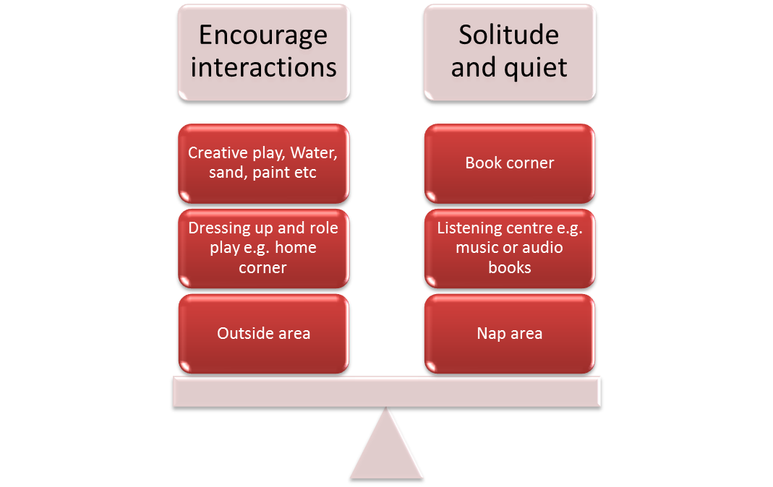

Activity 2G
Estimated Time | 20 Minutes
Objective | To provide you with an opportunity to provide opportunities for children to investigate ethical issues relevant to their lives and their communities.
Activity | What are ethical issues?  Ethical issues are issues to do with morals and include a few different areas.  Ethical issues may include:  - What is right and wrong  - Our responsibilities and rights  - Our decisions and reactions.  How can you get children to think about their behaviour?  One of the most important things a childcare worker can do is to get children to think about their behaviour; asking them why.  For example:  - Why they reacted as they did?  - Why should we do this?  - Is this good or bad?  - Is this right or wrong?  - How would this make you feel?  What is your setting’s values system?  Incorporating a values system, that children can understand, into experiences can help to guide them and develop a sense of morality.  For example, these sets of values are easy to understand:  - We are kind to each other  - We look after toys  - We are helpful  - We try our best.

Activity 3A
Estimated Time | 30 Minutes
Objective | To provide you with an opportunity to assess and monitor children’s emotional development.
Activity | What is emotional development?  Emotional development is about how we manage our feelings of frustration, joy, anger, sadness, jealousy etc. It can also relate to how we see ourselves and how secure we feel in our surroundings.  Complete the table to demonstrate your understanding of how you can assess self-concept development.  What contributes to self-esteem and how can we assess it?  We use the following assess ourselves:  - Direct experience  - The perceived importance of the skill or characteristic  - Judgements and labels given by others.
  Stages of self-concept development | How you can assess it
  Babies begin to understand around 2or 3 months old that they are separate from their care givers. | They may cry when their carer leaves the room.
  At 9-12 months babies recognise that objects have permanence (they are there even if the baby cannot see them) | You can test this by showing the baby an object e.g. a ball or teddy and then put it under a blanket; if they understand that the object is still there they will look for it under the blanket.
  At 21 months children can recognise themselves in a mirror | Put a sticker or draw a spot on a child’s forehead and ask them to look in the mirror – a child who recognises themselves will touch their forehead (a child who does not will reach for the mirror)
  2 years children begin to understand gender and know that they have a name | You can ask the child ‘are you a boy or a girl?’ or ‘What is your name?’
  2 ½ and above enjoy imaginative play and try on different roles | You might observe children dressing up, pretending to be mummies and daddies, superheros or bad guys.

Activity 3B
Estimated Time | 20 Minutes
Objective | To provide you with an opportunity to create opportunities for children to experience individual strengths and successes during play.
Activity | Rachael is left-handed; she is struggling to use the scissors. Everyone else can use the scissors without problems ‘I can’t do it’ she says, I’m not very good at this’.  What should you do?  - You should check if there are left-handed scissors available  - Ask her if she would like to try the left-handed scissors out  - Praise her for trying and encourage her to continue.  How can you empower all children through their environment?  Creating an environment where children are able to do things for themselves. This means having facilities such as sinks, toilets, tables and chairs at a comfortable height, and providing stools where this is not possible. Toys should be provided in an accessible way e.g. book slings to display books, pots for crayons, boxes, chests or open storage for larger items.

Activity 3C
Estimated Time | 20 Minutes
Objective | To provide you with an opportunity to plan and provide opportunities through play that challenge children’s emerging skills and capabilities.
Activity | Provide three examples of children’s current or emerging skills – for each, note what area the skill is in and what you can do to challenge the skill.
  Current or emerging skills | Skill area | What could you do to challenge this?
  Nine month old baby can sit and reach for toys. | Physical skills – gross motor | You could occasionally put toys slightly out of reach to develop this skill. Reaching is the stage before being able to crawl or shuffle so can promote physical development.
  Two year old child is self-aware, he knows his name and how old he is. | Emotional development | Could ask him questions about himself and his family – e.g. do you have any pets at home, talk about genders etc.
  Three year old child is confident putting together 12-piece puzzles on own. | Cognitive skills | Provide three year old child with twenty piece puzzle and sit close by to offer any support if needed.

Activity 3D
Estimated Time | 20 Minutes
Objective | To provide you with an opportunity to provide opportunities for children to engage independently with tasks and create opportunities for children to explore self-image and identity through play.
Activity | How can you provide opportunities for children to engage independently with tasks?  To engage children independently you can:  Provide free play time where children choose their own activities  Set up computers  Provide children with:  - a reading area  - colouring books and crayons  - jigsaw puzzles  - string and beads  Learn when to interact and when to not.  How do children explore their self-identity?  How you can create opportunities for children to explore self-image and identity through play depends on the age of the child.  Babies may like to:  - Suck their fingers and toes  - Look in mirrors  - Play peek-a-boo  - Look at friendly faces  Toddlers may like to:  - Try on roles through imaginative play and dressing up – themed areas can add another dimension to this e.g. a castle area.  - Developing ability to cope with emotions e.g. anger, jealousy, joy etc. through physical activity, manipulation of toys, banging of drums, sand, moulding clay etc.  - Come to terms with hopes and fears e.g. through acting out of scenes that fill child with wonder or fear.

Activity 3E
Estimated Time | 15 Minutes
Objective | To provide you with an opportunity to provide opportunities for children to release feelings and express emotions through suitable experiences.
Activity | What sorts of emotions are common in young children?  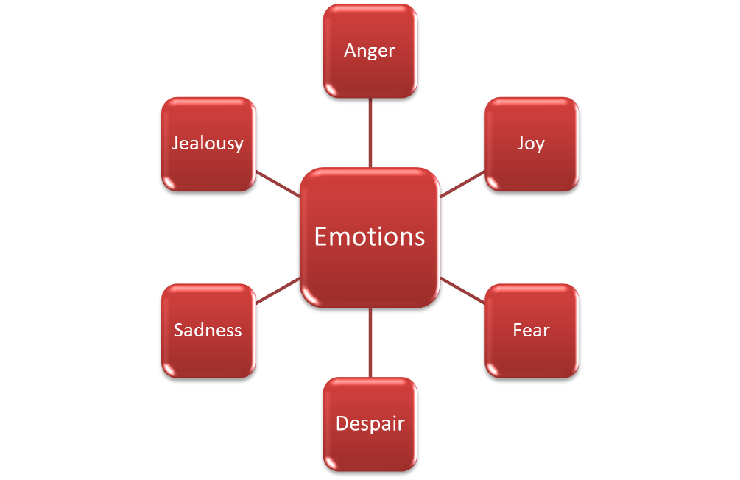  Name three different ways that children can release emotions through play. Give examples with your answer.  Feelings and emotions can be released through:  Physical activity such as:  - Running  - Dancing  - Riding a trike  - Trampolines  Imaginary play:  - Dolls  - Dressing up  - Small world play  Sensory play such as:  - Water  - Sand  - Dough/clay  - Music.

Activity 4A
Estimated Time | 30 Minutes
Objective | To provide you with an opportunity to Assess and monitor children’s cognitive skills and development.
Activity | What does cognitive development rely on/what do we need in order to be able to learn?  Cognitive development is how children learn and think about their environment. Cognitive development relies on memory, perception and concentration.  In order to learn we need:  - Memory, either short term for following instructions (a skill that needs to be developed in childhood), or long term for retaining information.  - Perception for learning about our environment – we need to use our sense to give a fuller picture of the world around us.  - Concentration for focusing on information – without concentration we would be constantly distracted by our environment e.g. lights, sounds, smells etc.  Choose two cognitive theories to describe in detail below.  Pavlov (1849-1936) devised thee theory of classical conditioning  Pavlov noticed he could influence his dogs’ behaviour through associations. He began to ring a bell just before he fed his dogs and noticed that they salivated before the food was given – associating the bell with food.  People can also draw associations – for example, if you are sick after you have eaten a lot of chocolate, you might associate being sick with chocolate and go off it.  Piaget (18896-1980)  Jean Piaget realised that children’s cognitive development followed a logical pattern involving schemas – schemas are conclusions we draw about the world around us based on our own experiences. A popular schema could be that all children live with their parents. Piaget thought that children could adapt their schemas when they came across new experiences.  There are two ways to do this, through:  Assimilation – where an existing schema fits a different situation. For example, putting on shorts is similar to putting on trousers.  Accommodation – where there is a realisation that an existing schema does not fit and the child has to change it. For example, a child believes that all other children live with both parents until this is challenged when they stay at a friend’s house; the friend lives with grandparents.  Piaget also named four stages of conceptual development that children went through.  Stages of conceptual development are:  Object permanence – babies believe that if an object or a person is not in sight it, or they do not exist (at around eight months, babies understand that objects have permanence)  Egocentrism – children under the age of six are self-centred and cannot see things from other people’s perspectives e.g. if you sat opposite a child and asked them what you could see, they would tell you what they could see.  Animism – animals and objects have the ability to feel.  Conservation – if a material changes its form other elements would still be the same. There are three tests for this (volume, mass and number).

Activity 4B
Estimated Time | 30 Minutes
Objective | To provide you with an opportunity to engineer and provide opportunities for children to participate in science, mathematics and technology experiences.
Activity | What activities can you provide for children to participate in science?  Activities that can provide opportunities to participate in science include:  - Baking  - Sensory activities with different textures e.g. a sensory basket with foil, feathers, teddy, crinkly material, rattles etc.  - Painting e.g. mixing colours  - Sticking and crafting  - Racing e.g. marble run  - Water table/play  - Clay and modelling  - Tin can phone  - Create a rain maker (e.g. with a tube and rice)  - Growing plants  - Felt scenes e.g. underwater, at the beach, at the park, inside a house etc.  What activities can you provide for children to participate in mathematics?  Activities that can provide opportunities to participate in mathematics include:  - Singing songs about numbers  - Reading books with numbers and repetition  - Playing with abacuses  - Comparing size activities e.g. big and small  - Puzzles  - Construction toys e.g. blocks, Duplo etc.  - Board games that involve counting spaces or rolling dice.  What activities can you provide for children to participate in technology?  Activities that can provide opportunities to participate in technology include:  - Using computer equipment to:  - Make pictures, draw shapes  - Help children to write using writing applications  - Provide children with literacy or numeracy games  - Print work and certificates for children.  - Use television equipment to watch suitable videos relating to curriculum topics e.g. learning about animals, numbers, phonics etc.  - Use cameras to:  - Take photographs of their environment – take the lead and become self-aware  - Edit photographs – some children’s cameras have editing tools designed for children where you can change hairstyles etc.  - Use stereos/radios to:  - Support singing and dancing activities  - Record and playback voices/alter sounds of voices.  - Play with robots.

Activity 4C
Estimated Time | 15 Minutes
Objective | To provide you with an opportunity to plan and provide opportunities through play for children to experience the consequences of their choices, actions and ideas.
Activity | Why should children experience the consequences of their choices, actions and ideas?  Consequences are something that children need to be aware of so that they can make informed decisions and learn to regulate their own behaviour. Children in the childcare setting will only just be learning about how actions and choices can have consequences, both positive and negative.  How can you plan, and provide opportunities through play, for children to experience the consequences of their choices, actions and ideas?  For example, through:  - Cause and effect activities and toys:  - Water/sand wheels  - Pop-up toys (where you twist, press or bang to make a toy pop up).  - Making marks on paper with crayon, paints etc.  - Bubbles (blowing creates bubbles)  - Ramps for cars or marbles.  - Let children experience the natural consequences of their choices:  - If they refuse to wear a coat, the natural consequence would be they get cold  - If they refuse to eat, the natural consequence would be they get hungry.  - Socialisation with others including group activities where they can put forward ideas. The consequences may be making people laugh, having people listen to you and ask questions and receiving praise.

Activity 4D
Estimated Time | 20 Minutes
Objective | To provide you with an opportunity to creates with appropriate levels of challenge where children are encouraged to explore, experiment and take appropriate risks in their learning.
Activity | What are risks, what are the thought processes involved and why is it good for children to take certain risks?  There are aspects of a child’s day that will involve risk taking. Some risks are good for children to take – for example, answering a question. There is a risk with answering a question that you might get it wrong, but it is good as it allows self-expression and encourages thinking skills.  The thought processes involved in risk taking:  - Risk identification – physical, social, emotional, cognitive  - Weigh negatives against positives of taking the risk  - Think through actions needed to take risk  - Evaluate whether it was successful or not.  How can you encourage children to take risks in their learning?  To encourage children to take risks staff should:  - Be prepared to answer children’s questions (if you do not know the answer you should try to find out).  - Allow children to play with items in ways that they were not designed/intended e.g. a stick could be a wand  - Encourage a relaxed eating environment where babies can explore food and try not to worry about the mess.  - Encourage children to ask and answer questions.

Activity 4E
Estimated Time | 20 Minutes
Objective | To provide you with an opportunity to build opportunities for involvement in experiences that support the investigation of ideas, complex concepts and thinking, reasoning and hypothesizing.
Activity | How can you build opportunities for involvement in experiences that support the investigation of ideas?  Other ideas for investigating ideas:  - Challenge children to create something – for example, with wooden blocks, stickle bricks, Duplo etc.  - Ask children to find something (e.g. a house) from anywhere in the room – children can then pick out things e.g. toy houses, play house, pictures of houses, books with a house on etc.  - Challenge children to ‘move like a…e.g. snake, car, tree etc.’  What key concepts do children need to learn?  Key concepts include:  - Time  - Space  - Colour  - Number  - Mass  - Temperature  - Opposites  - Length and height  - Volume and capacity  - Shape  - Pattern  - Speed  - Symbolic representation e.g. words.  How can you encourage children to develop reasoning and hypothesising skills?  To encourage children to develop hypothesising and reasoning skills, you can ask questions to get them to think more carefully about their experiences. Certain questions can be framed to try and help children to predict what happens next – for example, make an observation such as ‘there are black clouds in the sky’ and then ask children to predict what could happen e.g. it might rain. Asking questions about the day is also good practice and can help children think about routines and changes to them.

Activity 4F
Estimated Time | 30 Minutes
Objective | To provide you with an opportunity to provide opportunities through play for children to explore concept development and make opportunities for children to both construct and take apart, as a strategy for learning.
Activity | What are concepts and what are their functions?  Concepts provide a way of categorising and organising experiences; without them it would be difficult to retain and learn anything. From the moment we are born we begin to categorise – the sound of people’s voices, people’s faces, colours etc.  Concepts also have the following functions:  - Identifying objects  - Forming analogies  - Making inferences  - Building on knowledge.  What toys can help concept development?  There are a variety of toys that can help concept development including:  - Matching and pairing games:  - Pairs  - Snap  - Spot the difference  - Puzzles:  - Wooden peg puzzles  - Six piece/nine piece/twelve piece puzzles  - 3D Puzzles  - Buzz wire puzzle  - Memory games:  - Heads shoulders knees and toes (with mime)  - Pairs  - Take one away games (where you hide items under a blanket and take one away. The children then have to guess what you have taken)  - Threading beads/sewing activities  - Construction toys:  - Building bricks  - Duplo  - Lego  - Train track sets  - Sorting toys:  - Shape sorters  - Buttons, wool or beads to sort by colour  - Simon says  - Sensory bag.  How can you encourage children to take part?  - You could encourage the child to take part in skipping by:  - Holding a skipping rope out for her to jump over first  - Next, swinging it around for her to jump over (can do this with another staff member), stopping at her feet to make it easy  - Then swinging it a bit higher and/or faster  - Handing her the skipping rope to practice skipping  - Praising children for the effort and progress they make.

Activity 4G
Estimated Time | 30 Minutes
Objective | To provide you with an opportunity to provide children with a wide range of everyday materials that they can use to create patterns and to sort, categorise, order and compare.
Activity | What materials can you use for creating patterns?  Materials for creating patterns  Materials for creating patterns can involve the use of items like wood, pasta, coins, leaves and sponges together with paint, wax crayons or glue to make a pattern that reflects different textures.  For example:  - You can use materials with paint like stamps to make imprints on paper  - You can rub wax crayons over materials with different textures  - You can stick items together to make patterns.  What materials can you use for sorting and categorising?  You can sort and categorise materials according to their properties such as:  - What they are made of e.g. wooden, metal, plastic etc.  - What they feel like e.g. rough, smooth, wet, dry etc.  - What colour they are e.g. brown, white, silver etc.  - What shape they are e.g. circle, square, rectangle etc.  - What function they have e.g. feeding us, holding things together (e.g. buttons, zips and Velcro), money/currency, natural occurring materials e.g. leaves.  Any material can be sorted and categorised if put together with a range of other materials – for example, pasta and a yellow plate are both yellow and dry. Shell pasta and a shell are both shell shapes.  What materials can you use for ordering and comparing?  Think about using:  - Tissue paper  - Foam  - Coloured foil  - Cotton wool  - Card  - Shells  - Sand  - Leaves  - Textiles e.g. cotton, wool polyester etc.

Activity 5A
Estimated Time | 20 Minutes
Objective | To provide you with an opportunity to assess and monitor children’s language skills and development.
Activity | In what ways can people communicate?  There are many different ways that we communicate with each other including:  - Speech  - Writing or drawing  - Body language  - Gestures  - Sign language.  What is the difference between linguistic and pre-linguistic stage of language development?  Why might language delay occur in children?  Language delay can occur for a variety of reasons in children – for example:  - Learning difficulties  - Physical conditions  - Hearing difficulties  - Shyness  - Lack of stimulation  - If the child is learning more than one language.
  Pre-linguistic stage
  0-3 months | - Cries to have needs met  - Recognises tones of voices  - Makes cooing sounds  - Smiles at people  - By the end of this stage they can be calmed by main carer’s voice.
  3-6 months | - Still cries but is calmed more easily  - Begins to babble ‘e.g. da da’  - Laughs and makes squealing sounds
  6-12 months | - Lots of babbling making repetitive sing-song sounds  - Babbling starts to reflect the language of those around them  - Asks for things through gestures e.g. pointing  - Enjoys games e.g. Peekaboo  - At the end of this stage a baby will understand around seventeen words
  Linguistic stage
  12-18 months | - Baby will say first words (at first will only be recognisable to main carers)  - One word can mean many things – for example, ‘dummy’ may mean they want a dummy, have lost their dummy or do not want their dummy any more.  - Babies will use around ten words that are understood by main carers
  18-24 months | - Can put two words together e.g. ‘Hello Mama’  - Vocabulary increases rapidly around ten to thirty words a month  - At the end of this stage children will be using around 200 words
  2-3 years | - Can use plurals and past tense but sometimes makes errors (due to reasoning) e.g. ‘catched’, ‘mouses’  - Uses questions ‘where dog?’  - Uses negatives ‘no teddy’
  3-4 years | - Imitates adult speech patterns e.g. ‘he fell over, didn’t he?’  - Strangers can understand language now  - Uses sentences of four or more words  - Still make errors  - Have a large vocabulary – know animal names, body parts etc.  - Likes to ask questions e.g. ‘why are we going to the shops?’  - Recites and understands nursery rhymes
  4-8 years | - Enjoy using language and make less mistakes  - Enjoy hearing jokes and telling them  - Understands that you can write words down  - By five vocabulary has expanded to around 5000 words  - By eight children are fluent in speaking and reading, and are working on their writing skills

Activity 5B
Estimated Time | 15 Minutes
Objective | To provide you with an opportunity to plan and provide developmentally appropriate experiences and opportunities to foster language and literacy development through play.
Activity | What activities can you think of that would help to expand vocabulary in children?  Turn-taking and waiting games  - Roll a ball around the group and children have to say something about themselves  - Take turns to copy an action either ‘follow my leader’ in a line or in a circle  - Pass the parcel or beanbag  - Take turns to construct or add something to a picture  - Ready, steady go games that delay gratification – children have to wait for the word ‘go’ from the early years worker to knock sand castle down, release cars, have a running race etc.  Songs, rhyming and sounds  - Sing nursery rhymes and songs with children – you can also pause for certain words for the children to fill in  - Create rhyming bags with pictures of objects that rhyme e.g. cat and mat  - Talk about sounds you can hear with children  - Use pictures or toy animals and put them in the middle of a group of children, make an animal noise and ask children to choose the animal or do the action that goes with it  - Make a beat for children to follow by clapping – you can also use a two or three different sounds or musical instruments e.g. shakers, whistles, drums etc.  Stories  You should read to children both in a one-to-one scenario and in a group. When reading stories to children, you should try to engage them as effectively as possible. Young children will enjoy listening to the rise and fall of your voice, looking at the pictures and turning the pages. Older children will enjoy pointing things out, predicting the story and asking questions about it. It is a good idea to read stories to children that relate to a topic that you are covering as this helps children to get the most out of storytelling. For example, they may retain the vocabulary used or understanding about a particular concept if it is covered through a range of activities.  What else should you take into account when planning experiences?
  Age | Experiences and opportunities
  0-6 months | One-to-one communication through running commentaries, repetition, expressive faces and good eye contact
  6-12 months | Point things out to children to increase vocabulary  Sing nursery rhymes and read stories  When children point to things – state what they are or pick them up for the child to get a better look  Continue running commentary
  12-24 months | Move down to child’s level to make eye-contact, listen, nod along and be interested in what children are saying  Sing nursery rhymes with actions and read stories  Continue running commentary
  2-4 years | Do not rush child or ignore them  Do not override their decisions – – for example, if they have asked you to read the story again (because they enjoy repetition)  Do not correct children in grammatical errors – instead use the correct language in your answer – for example, a child says ‘I catched the ball’, you could say ‘you caught the ball did you? Well done!’  Encourage group play through playsets, trains, dressing up and home areas  Continue with songs, actions and stories – can begin to incorporate phonics and learning about letters e.g. alphabet puzzles, posters, songs, stories
  4-8 years | Child may lead conversations  Adult can ask open questions to extend conversations  Children’s vocabulary surpasses their understanding – they may use words that they do not understand e.g. out of context  Plan activities that help with listening and following instructions  Encourage children to read on their own – but still have a time when you read to them e.g. as a group.

Activity 5C
Estimated Time | 15 Minutes
Objective | To provide you with an opportunity to create opportunities for children to listen and respond to language.
Activity | Why is listening important?  Listening is an integral part of communication. Children need to be able to listen so that they can respond to someone appropriately. Responding to people appropriately shows that you are keen to know what they are saying and improves relationships, helping you to retain friends. It is also vital for retaining information and learning new things.  Draw a spider diagram to show how you can listen actively.  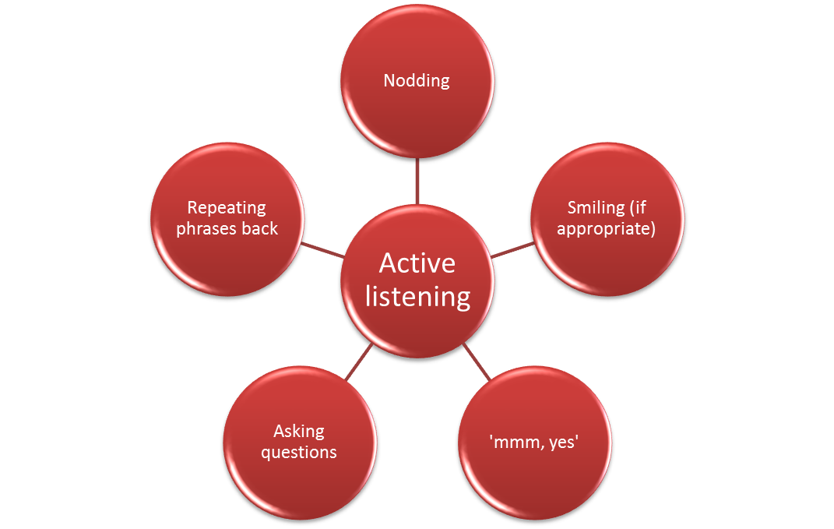

Activity 5D
Estimated Time | 15 Minutes
Objective | To provide you with an opportunity to value the child’s linguistic heritage and encourage the use and acquisition of home languages.
Activity | How can you encourage the use and acquisition of home languages? Provide a range of ideas.  Ideas to encourage use and acquisition of home languages:  - Employ someone with the same first language to come in and talk with the child  - Organise after-school sessions where the child can learn to read and write in home/first language  - Ask family members to come in and talk about their culture  - Celebrate any significant festivals or holidays with all the children in the setting  - Have a themed area dedicated to the different cultures of children in the setting  - Display information bilingually and translate brochures  - Learn greetings in the children’s home language  - Create scrapbooks/developmental progress books with pictures and captions written in both English and home language  - Promote multi-cultural awareness and set up an ethos  - Provide toys and resources that reflect a diversity:  - Books in different languages  - Puzzles and pictures should reflect various lifestyles and backgrounds  - Plants and herbs that you grow together should be diverse in representation e.g. Vietnamese mint, Bamboo, Native Australian plants, Oregano, Lavender etc.  - Sing songs and have music and instruments that are associated with a variety of backgrounds e.g. drums, didgeridoos, keyboards, tambourines, guitars, recorders etc.  - Encourage families to talk to children in their home language and reassure them that the setting will be able to develop the English.  - Respect families and their backgrounds by asking them about how their family life and routine e.g. child’s sleeping patterns, toys they have at home/what the child likes to play with, feeding, toileting and behaviour management.

Activity 5E
Estimated Time | 30 Minutes
Objective | To provide you with an opportunity to provide opportunities for children to engage with familiar and unfamiliar culturally constructed text, create a literacy-enriched environment including displaying home languages and Standard Australian English and provide resources that encourage children to experiment with images and print.
Activity | How can you ensure that children have opportunities to engage with familiar and unfamiliar culturally constructed text?  Things to try:  - Ensure book corner is stocked with lots of culturally familiar and unfamiliar texts  - Listen to audio stories of different cultures  - Ask relatives to come in and tell a story  How does your setting create a literacy-enriched environment?  Creating literacy filled environments:  - Indigenous stories  - Atlases  - Globes  - Poster maps  - Dolls and characters that represent various cultures and communities  - Flag matching games or puzzles  - Alphabet and number frieze  - Musical instruments  - Different ways to move to music e.g. dancing, yoga etc.  - Artwork from different cultures.  How can you encourage children to experiment with images and print?  Thing to try:  - Using paint to create prints:  Finger, hand and foot printing  Printing with a variety of different objects  - Using computers to design pictures and print them  - Creating collages of different materials:  Tissue paper  Magazines  Card  Foil.

Activity 6A
Estimated Time | 20 Minutes
Objective | To provide you with an opportunity to support and initiate inquiry processes, try new ideas and take on challenges and provide resources and materials that offer challenge, intrigue and surprise.
Activity | How can you support and initiate inquiry processes?  To support and initiate inquiry processes, you can:  - Be a good role model – make comments about your environment ‘I wonder…’  - Plan activities around the interests of children  - When asked a question – ask children what their thoughts are before answering in a clear and simple way appropriate to child’s age  - Use the library to explore books  - Ask open ended questions that allow children to think on their own  - Encourage children to ask each other questions e.g. about their families  - Create an environment that promotes curiosity e.g. soft play area, climbing areas, colourful displays, wall mirrors, accessible toys and materials.  What resources do you use at your setting to challenge, intrigue and surprise?  Challenge:  - Baby gyms  - Swings, slides climbing frames and tunnels  - Hopscotch  - Bean bags  - Puzzles  - Beads  Intrigue:  - Books with flaps  - Books with textures  - Natural materials e.g. sand, water, shells etc.  - Displays covering topics discussed  - Putty and clay  - Cornflour and water experiment  Surprise:  Jack in the box  Pop-up books  Peek-a-boo games  Hide and seek  Changing words in songs/silly rhymes  Jokes/joke books.

Activity 6B
Estimated Time | 15 Minutes
Objective | To provide you with an opportunity to assist to promote children’s sense of belonging and connectedness.
Activity | In what ways can you promote children’s sense of belonging and connectedness?  You can help to promote a sense of belonging and connectedness in the following ways:  - Make the surroundings welcoming  - Host events for families to attend such as festival days, charity fund raisers, sports days etc.  - Have an open door policy where parents/carers can ask questions or voice concerns  - Create a newsletter to inform parents of topics that will be covered  - Collaborate with families:  - To create an ongoing discussion of their child’s progress  - To involve parents or guardians with policy creation.  - Provide information on community events and support for families  - Cover topics such as:  - Families  - Culture  - Geography  - Ask children what they like so that you can engage with their interests  - Build a bond with families:  - Meet and greet families with a smile  - Tell them about the child’s day at pick-up  - Encourage families to get involved with the setting

Activity 6C
Estimated Time | 15 Minutes
Objective | To provide you with an opportunity to engage children in sustained shared conversations to extend their thinking.
Activity | What are sustained shared conversations?  Sustained shared conversations are conversations that take place with one or more child that extend thinking surrounding a topic. The topic could have been introduced by an educator or a child.  How can you engage in sustained shared conversations?  There are many ways that you can engage in sustained shared conversations – for example:  - Listen and watch carefully to what the child is saying and doing  - Show genuine interest through body language e.g. smiling, nodding and eye contact  - Invite children to elaborate on their ideas e.g. ‘This is interesting, could you tell me more?’  - Repeating/clarifying what children have said ‘so you mean…’  - Sharing own experiences e.g. ‘I like to…’  - Suggesting options e.g. ‘how about we do it like this’  - Reminding children to do things e.g. ‘don’t forget to wash your hands before you eat’  - Speculating e.g. ‘Do you think those ducks might like some cake?’  - Offer different perspectives ‘Maybe….’  - Use encouragement to promote thinking e.g. ‘Very good Ethan, you have found the square, now where are you going to put the circle?’

Activity 6D
Estimated Time | 15 Minutes
Objective | To provide you with an opportunity to provide the opportunity for scaffolding learning and development.
Activity | What is scaffolding?  Scaffolding is a process where an early educator is able to encourage a child to think about their knowledge about a topic and from there, build on this knowledge to expand areas of thinking, provide links and solve problems. Activities or tasks are supported by an educator at first, but the educator’s role decreases gradually as the learner becomes more competent.  Give an example of when you have put scaffolding into practice.  Educator: ‘See if you can find a piece that goes here’ (educator points to a gap in the puzzle)  Alex: (He looks for the piece, picks up one that does not fit and tries to slot it in, he puts it down)  Educator: ‘Try looking over here’ (educator points to four pieces in a group)  Alex: Smiles as he finds the piece and slots it in ‘yes I found it!’

Activity 6E
Estimated Time | 20 Minutes
Objective | To provide you with an opportunity to assist children to see their mistakes as opportunities to learn and grow.
Activity | How can you help children to learn from mistakes?  Help children to learn from mistakes by:  Show children that you like them whether they make mistakes or not  Help children to overcome mistakes on their own and learn from them  Tell children of times you have made mistakes and what you did to resolve them  Encourage children to own up to mistakes and not to blame tools or other people  - Praise children for their efforts and when they admit mistakes  - Encourage children to apologise if their mistakes have hurt other people and be a good role model – apologise if your mistakes have hurt other people.  - Do not focus on past mistakes or other times when the same mistake has occurred – focus on the here and now.  How can you help children to self-reflect?  When children are a bit older they may be able to self-reflect. Some educators ask children to use emoticons or colours to show how they think they did – for example, smiley face, straight face, sad face or red, yellow and green.  - Smiley faces or green mean ‘I can do it’  - Straight faces or yellow means ‘I need some more practice’  - Sad faces or red means ‘I need more help/I didn’t understand’.

Activity 6F
Estimated Time | 15 Minutes
Objective | To provide you with an opportunity to facilitate families’ diverse contributions to the learning community.
Activity | What sort of contributions can families make?  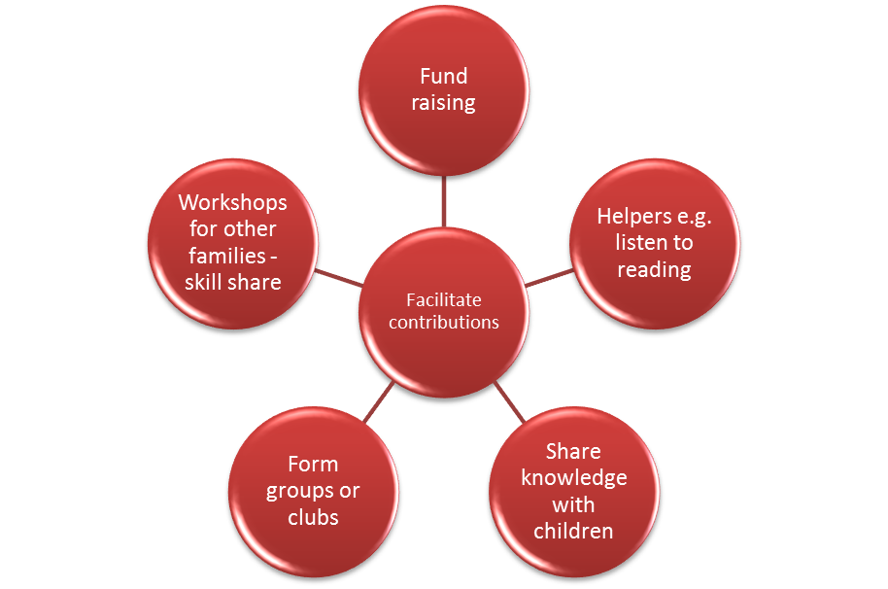  Why might parents find it difficult to contribute?  Sometimes, it can be difficult for family members to get involved with the setting – they may not have time, they may have language barriers, lack in self-esteem or be intimidated by the setting. It is vital that you do not pressure parents or families who may find it difficult to contribute, the last thing you want is to make families feel guilty or stressed about contributing.  What methods can you use to communicate with families?  Methods of communicating with families about opportunities to contribute:  - Face-to-face – at the beginning or end of the day  - Newsletters  - Notice boards  - Letters to parents  - Parent days  - Information days  - Home books  - Activity slips.

Activity 6G
Estimated Time | 15 Minutes
Objective | To provide you with an opportunity to share information with colleagues about child development and wellbeing.
Activity | What are the three elements that a good working relationship is based on and how can you gain them?  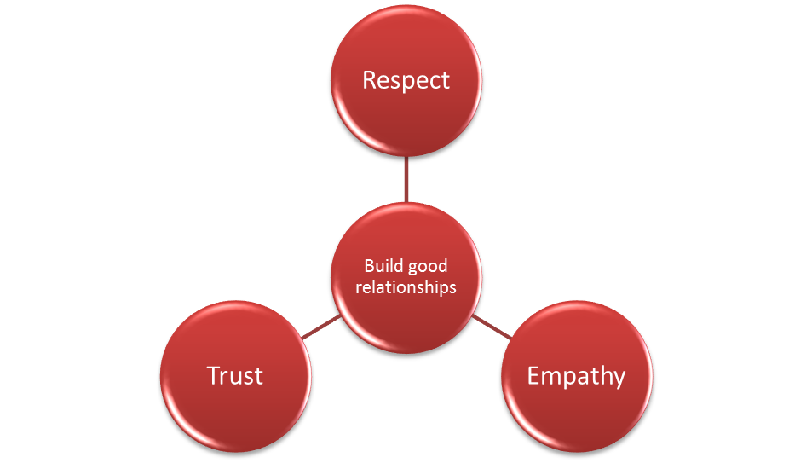  What tips can you give for communicating through writing?  Written communication should:  - Be clear and concise  - Be accurate and include only facts (not opinions)  - Contain all relevant information (should not be missing relevant information)  - Contain only abbreviations that all staff are familiar with  - Check spelling and punctuation as errors could lead to confusion.

Activity 6H
Estimated Time | 15 Minutes
Objective | To provide you with an opportunity to create learning environments where children are able to immerse themselves in self-directed play.
Activity | Who is Friedrich Froebel and who did he inspired or influenced by him and how?  Friedrich Froebel (1782-1852)  Friedrich Froebel developed the first kindergarten in 1840. He believed in a child-centred approach to learning and education where each child is valued for their uniqueness. He believed in imaginative play that involved indoor and outdoor activities. This was somewhat of a revolution at a time where children were thought of as miniature adults to be moulded into citizens as quickly as possible.  Froebel observed that children could understand an object could signify something else – for example, a box could become a spaceship, a house, a car etc. He thought that this creativity was when children learned the most and was integral to their development.

Activity 6I
Estimated Time | 20 Minutes
Objective | To provide you with an opportunity to recognise spontaneous teachable moments as they occur and use them to build on children’s learning and ensure a balance between child-initiated and educator-supported learning.
Activity | Give an example of when you have recognised a spontaneous teachable moment and have used it to build on a child’s learning.  Example:  When looking at frogspawn in the pond Edward says ‘I am looking at the eyes’. This is an opportunity for an educator to tell Edward the name of what he is looking at. An educator could say ‘yes they do look like eyes. It is called frogspawn’.  You may then go on to talk about what frog spawn is ‘The frogs make it. There are frog babies inside. When the babies come out they are called tadpoles.  What is the difference between adult-led and child-led activities?  Adult-led activities are activities that have been pre-planned as part of the curriculum and follow strict rules  Child-led activities are activities that children will engage in without adult rules; they usually involve imaginative scenarios.

Activity 6J
Estimated Time | 30 Minutes
Objective | To provide you with an opportunity to provide learning environments with appropriate levels of challenge where children are encouraged to explore, experiment and take risks in their learning.
Activity | What is a good learning environment and what can a setting do to create it?  In general the setting should have:  - Toys and activities readily accessible  - Themed areas for imaginative play  - Eye-catching displays that support topics  - Toys and activities for various abilities  - Resources for finding out information e.g. books, technology.  How can you encourage babies to experiment and explore?  Ideas for encouraging babies to explore:  - Putting objects within the reach of a baby and supporting them so they can reach for them  - Count during routines such as ‘1, 2, 3’ before taking off a jumper  - Encourage older babies to pretend and join in with their games e.g. pouring pretend tea, giving voices to toys, cooking things in the play oven etc.  - Ensure any children that you have in your care with hearing impairments can see what you are doing and can see your face when you talk  - Encourage visually impaired babies using touch and sound  - Use blankets to gently roll babies with movement difficulties over.  How can you encourage toddlers to experiment and explore:  Ideas for encouraging toddlers to explore:  - Take toddlers on trips – for example, a trip to a farm yard, a ride on the bus or train, a walk in the park or forest/woods, feed the ducks by a river, have a splash in puddles.  - Talk about the places you go, what you saw and enjoyed etc.  - Learn about people and what they do e.g. the jobs they do e.g. teachers, librarians, hairdressers, bus drivers, doctors, firefighters etc.  - Experiment with shapes e.g. pointing out shapes and putting them together to make pictures  - Experiment with colours e.g. mixing colours to create new ones.  - When drawing encourage children to think about how they can achieve different effects e.g. ‘what could we use to make a fluffy rabbit tail?’ or ‘what colour would you like to paint the sky?’  - Explore change such as weather, life-cycles, melting ice, growth e.g. of plants; you can do this by observation or creating a record – for example, through taking photographs at regular intervals (e.g. of a seed, plant emerging and growing bigger).  How can you encourage young children to experiment and explore?  Encouraging children to experiment and explore is about encouraging them to think about things in more detail or look at things differently. We can help children to experiment and explore in many ways.

Activity 6K
Estimated Time | 15 Minutes
Objective | To provide you with an opportunity to facilitate team collaboration of assessments and evaluation in relation to child development and wellbeing.
Activity | Make a list if all the colleagues that you may need to work with in the setting and in partnership.  Colleagues working with you at the setting:  - Nursery nurses  - Supervisors or managers  - Teachers  Colleagues working in partnership:  - Counsellor  - Social worker  - Safeguarding officer  - Behavioural support worker  - Speech therapists  - Doctors  - Child psychiatrists  - Educational psychologists  - Play therapists.  Do you use templates to collaborate with colleagues? If so please attach or describe a template below.  You play an integral part of assessing a child’s development and wellbeing. You may use templates that help to communicate information in a structured and consistent way. These templates will act as a guide to see if you need any more information.

Area of development | Information | Learning outcome met | Learning outcome NOT met
Strengths
Interests
Relationships
Learning | Physical development and wellbeing
Learning | Cognitive development
Learning | Emotional intelligence
Learning | Spiritual, moral and cultural awareness and development
Learning | Behaviour for learning
Learning | Attitude towards learning
Learning outcome | Major issue | Suggested method of support
Children have a strong sense of identity
Children are connected with and contribute to their world
Children have a strong sense of wellbeing
Children are confident and involved learners
Children are effective communicators

Skills and Knowledge Activity
Estimated Time | 45 Minutes
Objective | To provide you with an opportunity to demonstrate your knowledge of the foundation skills, knowledge evidence and performance evidence.
Activity | Complete the following individually and attach your completed work to your workbook.  The answers to the following questions will enable you to demonstrate your knowledge of:  - Oral Communication – in order to facilitate collaborative discussions with children, families and other educators.  - Reading – in order to access and apply relevant pedagogical principles from an approved learning framework.  - How to access:  - The national quality framework  - The national quality standards  - The relevant approved learning framework  - How to navigate through framework and standards documents to find areas relevant to this unit of competency  - Relevant aspects of theories of children’s emotional and psychological development as they apply to the educator’s role  - Links between social, physical, psychological and cognitive development  - In-depth knowledge of a range of developmental theories for children between birth and 5 years of age  - Contextual factors which influence the children’s emotional and psychological development  - Factors which enhance the development of self-esteem and self-identity  - Core principles of child development and associated developmental tasks  - Organisational standards, policies and procedures.  Answer each question in as much detail as possible, considering your organisational requirements for each one.  - Give examples of antenatal, perinatal and postnatal issues that can impact on physical development of children.  - Choose one of the following age groups and state the milestones you can measure.  - 0-1  - 1-2  - 2-3  - 3-4  - 4-6  - How can you best communicate with parents/carers?  - What is attachment theory and what does this mean for childcare settings?  - Why is talking about emotions important?  - What activities can encourage children’s understanding of materials and their properties?  - Give at least three examples of turn taking games and three examples of songs rhyming and sound games you can play with children to help them with language skills.  - What games can you play to encourage listening?  - How can you share books with children to encourage literacy development and an enjoyment of literature?  - What is a holistic approach and why is it important?  - How can you help children to try new ideas and take on new challenges?  - What are your organisation’s policies on information sharing?  - What are the two nationally approved learning frameworks?  - What are the quality standards and the levels that your organisation will be assessed on?

Major Activity
Estimated Time | 240 Hours (as outlined in the unit of competency)
Objective | To provide you with an opportunity to demonstrate your knowledge of the entire unit.
Activity | This is a major activity – your instructor will let you know whether you will complete it during class or in your own time.  Attach your completed answers to the workbook.  You must individually, answer the following questions in full to show your competency of each element:  - Foster physical development  - Foster social development  - Foster emotional development  - Foster cognitive development  - Foster communication development  - Foster an environment for holistic learning and development  - Portfolio – using between three children as case studies, devise a short term plan (e.g. a day or a week) that enables you to assess, plan and provide opportunities for physical, social, emotional, cognitive and communication development. (Please note that the three children that you choose can be used more than once).  You should provide a portfolio of work with your observations, plans and progress of the children.

