CPCCBC4004A
Identify and produce estimated costs for building and construction projects

THEORY EXAM INSTRUCTIONS

- This exam will occur under standard assessment conditions.
  - An oral examination may be allowed under certain circumstances.
Answers will be documented and FT003 (Oral examination declaration form) must be completed.
- Participants must provide enough detail in their responses to demonstrate their knowledge and skills.
- Please fill in the details below, providing your name, signature and date of assessment.
  - Your signature acknowledges that this is your own work.
- If a participant initially answers a question incorrectly but modifies their response, they must follow the instructions below:
  - If a participant changes their response in writing, they must put their initials next to the written change.
  - If a participant changes their response verbally, this must be noted on the exam paper by the assessor.

Participant name | Emma Carew
Participant signature | 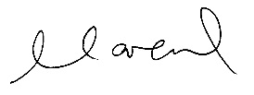

Assessor name
Assessor signature | 

Date | 21/05/2018

Number of questions | Number of questions answered correctly | Satisfactory?
24 |  | Yes | No

Assessor Comments
- What is the critical aspect of identifying and interpreting plans, drawings and specifications for a building project?

Answer | To show all parties involved in a building project the proposed structure and what it will look like when completed.

- What is the purpose for date stamping of plans, drawings and specifications?

Answer | To make sure the most current versions are up to date and previous versions are superseded.

- Nominate at least six (6) people and/or entities that would use plans drawings and specifications on a building project.

Answer | - The Client  - Local Council  - Builders  - Subcontractors – Carpenters, Bricklayers, Concretors, Painters  - Engineers  - Various Authorities – Energex, Unitywater

- Plans and drawings usually hold many and varied features.
Name some of the types of drawings and details you would expect to see on plans and drawings for a building project.

Answer | - Location plan  - Site of Block Plan  - Floor Plan  - Elevations  - Sections

- It is necessary to acquire all building plans and specifications at the beginning of the negotiation period so we know all building project details prior to commencing work (including dimensions, construction materials, door and window schedules, masonry control joint locations and smoke alarm locations).
What else would be expected to be provided?

Answer | - Architectural plans and elevations  - Building specification  - Footing construction report and foundation soil assessment  - Roof truss computations  - Energy efficiency report

- Drawings are usually arranged in the approximate order of construction. What might a set of drawings consist of?

Answer | - Civil Drawings  - Structural Drawings  - Architectural Drawings  - Electrical Drawings  - Mechanical Drawings  - Plumbing / Hydraulic Drawings

- Explain how to access the Building Code of Australia (BCA) and its relevance to estimating costs for building and construction projects.

Answer | To Building Code of Australia (BCA) is Volume One and Two of the NCC  www.abcb.gov.au  Can view NCC 2016 Complete Series at no charge.  The Code is a uniform set of technical provisions for building work and plumbing and drainage installations throughout Australia.  The relevance to estimating is that a builder has to build to the regulations, codes and standards set which firstly starts at the estimating process, if this estimate is incorrect then this will affect the whole project.  Relevanc

- Explain how to access the Plumbing Code of Australia (BCA) and its relevance to estimating costs for building and construction projects.

Answer | The Plumbing Code of Australia (PCA) is Volume Three of the NCC  www.abcb.gov.au  Can view NCC 2016 Complete Series at no charge.  The Code is a uniform set of technical provisions for building work and plumbing and drainage installations throughout Australia.  The relevance to estimating is that a builder has to build to the regulations, codes and standards set which firstly starts at the estimating process, if this estimate is incorrect then this will affect the whole project.

- Explain how to access Australian Standards and their relevance to estimating costs for building and construction projects.

Answer | The company I work for has a membership through Sai Global that allows us to view the ABCB Codes + Standards in the same location.  www.bca.saiglobal.com  The Australian Standards set out the specifications and procedures designed to ensure products, services and systems are safe, reliable and consistently perform the way they are intended to. They estimate a minimum set of requirements which define quality and safety criteria.  The relevance to estimating is that a builder has to build to the regulations, codes and standards set which firstly starts at the estimating process, if this estimate is incorrect then this will affect the whole project.

- Identify two (2) standards that would be relevant to the industry sector.

Answer | AS 1670 - Fire detection, warning, control and intercom systems  AS1670.1:2015 – Fire  AS1670.3:2004 – Fire alarm monitoring  AS1670.4:2015 – Emergency warning and intercom systems  AS/NZ 3500 - Plumbing and drainage  AS/NZS 3500.1:2015 – Water services  AS/NZS 3500.2:2015 – Sanitary plumbing and drainage  AS/NZS 3500.3:2015 – Stormwater drainage  AS/NZS 3500.4:2003/2015 – Heated water services  AS/NZS 3500.5:2012 – Housing installations

- Explain the impact of WorkCover requirements on costs to the project.

Answer | WorkCover costs should be included into the cost of a project, this ensures that the company can recover the overheads. WorkCover is considered a direct job cost (labour) which are costs that are incurred with the actual construction.

- Explain the impact of Environmental Protection Agency requirements on costs to the project.

Answer | Environmental related costs will be incurred on a project, such as seeking approvals, waste management fees and third party water monitoring costs,

- Calculate and cost the lineal timber order for 93 x 19 DAR Meranti and allow 5% wastage. The cost per lineal metre is $6.40.
The requirements are: 22 @ 2400; 30 @ 3600; 10 @ 4800; 12 @ 1880
Show your calculations.

Answer | A timber order for 93 x 19 DAR Meranti  22 x 2.4m = 52.8m  30 x 3.6m = 108m  10 x 4.8m = 48m  12 x 1.88m = 22.6m  Sub Total = 231.4m  Plus 5% waste – 11.6  Total = 243m x $6.40 = $1555.20

- A building floor plan measures 24000 x 14000 and the specification states the sheet flooring is 3.6 x 0.9 x 19mm Yellow TERMIFLOR T&G H2 at $58.38 per sheet.
Calculate the area of floor sheeting required when an allowance of 2% is made for waste and cutting. Determine the number of sheets to order to the nearest whole sheet and calculate the cost for the flooring.
Show your calculations.

Answer | Area of flooring = 342.7m2  24.0 x 14.0 = 336m2  Plus 2% waste = 6.7m2  Total area of floor sheeting required is: 342.7m2  Number of sheets to order = 106  3.6 x 0.9 = 3.24m2  342.7m2 / 3.24m2 = 106 Sheets  Cost for flooring = 106 x $58.38 = $6,188.28

- If a solid cavity brick wall is to be built 23000mm long and 2400mm high (no windows and no doors), how many bricks would be required if the number of bricks per square metre is 50? Show your calculations.

Answer | 23m x 2.4m = 55.2m2  55.2m2 x 50 Bricks / m2 = 2760 Bricks

- You are a QBCC licensed plasterer and a client (Owner Builder) Davey Jones-Locker of 100 Reef Avenue, Brisbane, Queensland wants you to quote for plastering an internal wall of his house build and has described to you the following information over the phone:
The Client tells you the Council approved plans and drawings state the finished ceiling height from the top of slab floor is 2400mm. There is one external solid timber door (D4) is 2340 x 870 x 35 in this wall and no other openings. The length of this house end wall is 11 metres.

The house is of brick veneer construction and includes a 50mm cavity and the load bearing external framing is 70 x 45 MGP12 (a Boral product “Pineguard Blue”). The bricks are standard bricks 230 x 76 x 100mm. (L x H x W).

The Client tells you that the door is positioned 2100mm from an internal corner (RHS in aerial view) and as seen from inside the house looking out. The specification and drawings state 10mm regular internal plasterboard. You know from experience regular plasterboard is supplied in the following sizes lengths 6M, 4.8M, 4.2M, 3.6M, 3M, 2.7M and 2.4M with recessed edge and widths of 1200mm and 1350mm.

The Client wants a quote to fix and finish this internal wall with plasterboard.

Your labour and on-costs are charged at $51.50 an hour per tradesman plus materials including sheets, fixing, finishing and sanding. You estimate ancillaries including stud glue, screws, base coat, top and finish coats at $315.00 and that there is two (2) days’ work.
Your business works a 38 hour week you allow workers a 15 minute morning tea break and half hour for lunch. You will need two (2) tradesmen first day and one (1) tradesman second day including materials and equipment supply, fixing, finishing and sanding.
You are to research or acquire plasterboard sheet prices and attach this price list to your email. You are not required to supply or fix cornice.
Sketch the wall in Plan View (not to scale), dimension it with relevant measurements, and position the door on the right side of your plan view sketch and then calculate the plasterboard required and approximate waste expressed as a percentage (%) for internally lining this wall.
Estimate the cost of the job, including supplying plasterboard materials fixing setting, finishing and sanding plus labour. Then write a covering email to be sent to the client. You must show your methods for calculating cost of sheets, waste, plus fixing, setting, finishing and sanding.
Attach your quote, sketch, calculations and pricing list and email this to your Trainer/Assessor (details provided by them).

DRAFT AREA

18th May 2018

Davey Jones-Locker
100 Reef Avenue
Brisbane QLD. 4002

To Mr Jones-Locker,

QUOTE: 100 REEF AVENUE BRISBANE QLD. 4002

EC Plastering is pleased to provide the following quote for the supply, fix and finish of the internal wall at your property for the figure of $2,437.00.

This quote is as per the Council approved plans and drawings provided.

The following items have been included in the above quotation figure:
- All supervision, site allowances and construction insurance
- All materials and labour

The following items have been excluded from the above tender figure:
- Painting of the wall

Please contact me should you require any further assistance.

Yours faithfully

EC Plastering
Emma Carew

Labour | 2 Tradesmen 1st day  1 Tradesman 2nd Day | 24 | Hours | $ 51.50 | $ 1,236.00
Materials | Plasterboard Sheets
 | 6000 x 1200 x 10mm | 2 | Item | 37 | $ 74.00
 | 2700 x 1200 x 10mm | 2 | Item | 24 | $ 48.00
 | 2400 x 1200 x 10mm | 2 | Item | 22 | $ 44.00
Materials | Fixing, Finishing, Sanding | 24 | m2 | 30 | $ 720.00
Ancillaries | Stud glue, screws, base, top & finish coats |  |  |  | $ 315.00
 | Total |  |  |  | $ 2,437.00

DRAFT AREA

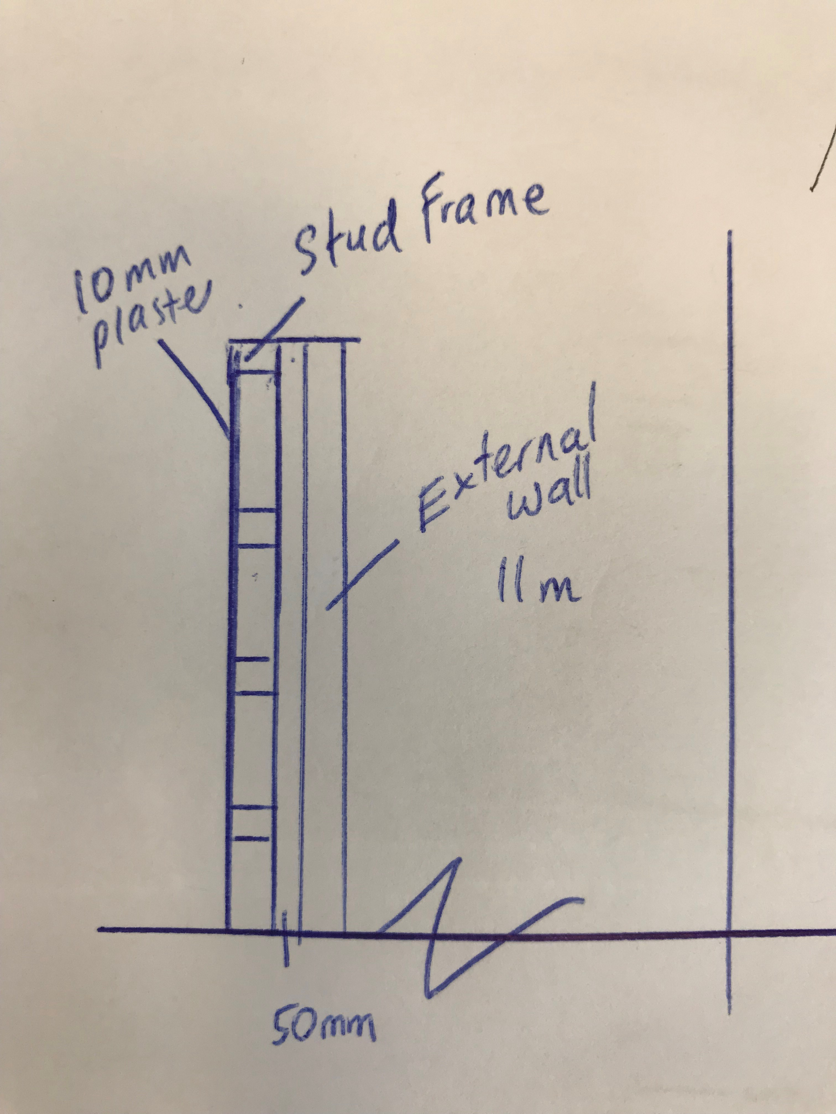

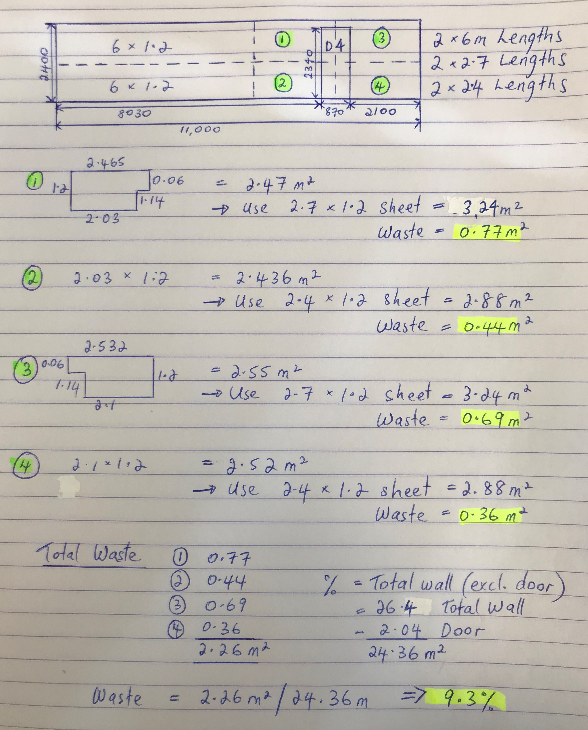

Answer

- There are many different ways of estimating project costs. You can use your past experience, or ‘square metre’ rates but if you are unfamiliar with estimating and pricing then you should resort to the materials and labour method of costing using an item-by-item approach which is considered as the best industry approach to estimating.
What are at least three of the nominated methods for estimating?

Answer | - Costing by Area  - Costing by Material and Labour  - Costing by a costing guide or estimating manual

- Name some of the circumstances to consider in relation to labour adjustment factors when estimating a project for construction.

Answer | - Add 25% - 50% for work done following a major flood, fire, earthquake where skilled tradesmen are not readily available. Material costs may also be higher after a major disaster.  - Add 5%-50% for tradesmen with below average skills  - Deduct 10% when the work is in a large open area with excellent access and good light.  - Add 15%-25% for work on a ladder or a scaffold, in a crawl space, in a congested area or remote from the material storage point  - Deduct 10%-20% when an identical task is repeated many times for several days at the same time  - Add 10%-35% for demanding specs, rigid inspections, unreliable suppliers, a difficult owner or an inexperienced architect.

- If a bricklayer lays 600 bricks in an eight (8) hour day, what is the average number of bricks laid per hour by the bricklayer?
Tick your response.

Answer | Choice | Possible Answers
 | ☐ | 65
 | ☐ | 70
 | ☐ | 55
 | ☐ | 90
 | ☒ | 75
 | ☐ | 105
 | ☐ | 85

- What and where are some of the potential sources you could go to in choosing your suppliers for goods and services?

Answer | - Online  - Yellow Pages  - Attending industry events and exhibitions  - Use your networks

- What are some of the primary (key) factors for choosing your suppliers?

Answer | Request written quotations and samples of the items you need, then compare their service to see which suppliers are best fit for your business.

- What are some of the ways you could communicate with your suppliers for gaining quotes?

Answer | - Email / website online request  - Telephone request  - Verbal request  - Written request  - Fax request – although not very popular now

- Explain the concept of a ‘Labour Only’ quote?

Answer | Labour only quote means that materials are not included.

You will be provided an allocated period by your instructor to complete this task.
You may use appropriate costing software programs in completing this task.

- Referring to the supplied set of house plans, you must do the following scheduling and costing:

- Identify and nominate a supplier/s and schedule the materials and cost the internal and external timber wall framing.
- Identify and nominate a supplier/s and schedule the materials and cost the foundations and lower floor concrete slab including the schedule and costing for reinforcement.
- Identify and nominate a supplier/s and schedule the materials and cost for the sub floor framing and the flooring for the upper floor plan.
- Calculate the architrave and skirting required for the fit out of the upper floor only in lineal metres.
- Calculate the wet area tiles for the upper floor only which are client chosen for both floors and walls with the wall tiles 250 x 100 and floor tiles 300 x 300.
- Estimate the labour only cost to tile all the wet areas only in the home. The tiler charges labour only $44.00 per square metre.
- Determine the roofing material and number of square metres of it that are required.
- Complete the aluminium windows and doors schedule and other external doors schedule for the lower floor only.
- Complete a full internal doors schedule for the lower floor only.
N.B. Assume all doors are flush panel 2040mm in height and 35mm thick.
- Estimate the labour only cost for hanging all doors on the lower floor – if a tradesman takes 2 hours to jamb an opening, hang the door, fit the door furniture, door stops, architrave and fit a door-open-restraint. The hourly rate is $27.80 plus 20% on costs.

Answer | Please refer to attached Excel spreadsheet – Q24. Lot 6 Pender Street

Answer

