BSBSMB406A
Manage small business finances

THEORY EXAM INSTRUCTIONS

- This exam will occur under standard assessment conditions.
  - An oral examination may be allowed under certain circumstances.
Answers will be documented and FT003 (Oral examination declaration form) must be completed.
- Participants must provide enough detail in their responses to demonstrate their knowledge and skills.
- Please fill in the details below, providing your name, signature and date of assessment.
  - Your signature acknowledges that this is your own work.
- If a participant initially answers a question incorrectly but modifies their response, they must follow the instructions below:
  - If a participant changes their response in writing, they must put their initials next to the written change.
  - If a participant changes their response verbally, this must be noted on the exam paper by the assessor.

Participant name | Albert Hart
Participant signature | 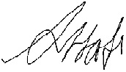

Assessor name
Assessor signature | 

Date | 16/04/2019

Number of questions | Number of questions answered correctly | Satisfactory?
45 |  | Yes | No
ASSESSOR Comments
- What does a financial plan enable you to do in your business?

Answer | A financial plan will enable me to measure the success of the business including profitability, and make decisions to control the business finance in order to grow the business. It will also enable me to forecast the profitability, financial needs and financial viability.

- List five (5) types of financial information you might need to profitably operate and extend your business in accordance with the business plan.

Answer | - Asset Registers  - Business Activity Statements  - Cash Flow Forecasts  - Financial Budgets  - Ratios

- Match the following specialists and the services they can provide to a business by writing the appropriate letter next to each number in the centre column.

Answer | Specialist |  | Answers | Services
 | 1 | Accountant | 1 - D | A | Provides assistance and direction across a variety of business areas, working closely with management.
 | 2 | Broker | 2 - C | B | Works with clients to determine their borrowing needs and ability, selects a loan suited to their circumstances.
 | 3 | Financial advisor | 3 - B | C | Provides advice and services in the form of investment and capital raising advice, insurance and income protection.
 | 4 | Legal advisor | 4 - E | D | Keeps financial records for a business, traditionally in the form of ledgers and journals.
 | 5 | Mentor | 5 - A | E | Can draft contract, provide advice of regulatory issues or protection of intellectual property.

- Briefly explain how personal net worth calculated. Give an example.

Answer | Personal net worth is calculated by subtracting the liabilities from assets:  Assets – Liabilities = personal net worth  Example:  House ($300,000) + Car ($30,000) + Savings ($10,000) – Mortgage ($150,000) – Credit Card ($2,500) – Personal Loan ($3,000) = Personal Net Worthn ($184,000)

- Identify the information required when calculating a budget.

Answer | The time frame of the budget, fixed costs, variable costs and expected income.

- Explain the process for preparing a cash flow forecast.

Answer | To prepare a cash flow forecast you use the following formula:  Starting Cash + Cash In – Cash Out = Ending Cash

- True or False (Tick your response): Cash flow forecasts are usually carried out at least once during a twelve month period.

Answer |  | True
 |  | False

- Refer to the anticipated figures in the table below to calculate the break even sales amount. Determine whether this business is viable.

Total sales | $180,000
Fixed costs | $ 64,800
Variable costs | $ 78,300
Total costs | $143,100

Answer | The break even can be determined by using the following formula  Break Even Sales = Fixed Costs___  Contributed Margin  Contributed Margin = Total Sales and Variable Costs  Total Sales  Contributed Margin = 1.435 (($180,000 + $78,300) / $180,000)  Break Even Sales = $45,157 ($78,300 / 1.435)  This business is viable as the anticipated sales $180,000 exceeds the breakeven point of $45,157

- Refer to the anticipated figures in the table below to calculate the break even sales amount. Determine whether this business is viable.

Total sales | $ 800,000
Fixed costs | $ 559,800
Variable costs | $ 243,300
Total costs | $ 803,100

Answer | The break even can be determined by using the following formula  Break Even Sales = Fixed Costs___  Contributed Margin  Contributed Margin = Total Sales and Variable Costs  Total Sales  Contributed Margin = 1.304 (($800,000 + $243,300) / $800,000)  Break Even Sales = $429,294 ($559,800 / 1.304)  This business is viable as the anticipated sales of $800,000 exceeds the breakeven point of $429,294

- The cost of goods sold (COGS) is the total expense associated with the goods sold in a reporting period.
James has a business selling books on eBay. An inventory count at the beginning of November shows that he has $50,000 worth of inventory on hand. Over the month, he purchases another $14,000 worth of books. His inventory count at the end of November shows that he has $22,000 of inventory on hand.
Using the calculation for COGS (Beginning Inventory + Purchases - Ending Inventory = Cost of Goods Sold) determine the cost of goods sold for James’ business.

Answer | COGS = $42,000 ($50,000 + $14000 - $22,000)

- Identify the three (3) main methods of pricing products/services by writing the appropriate letter next to each number in the centre column.

Answer | Structure |  | Answers | Taxation requirements
 | 1 | Competition-based pricing | 1 - C | A | Adding together direct costs, indirect costs, profit margin and market price.
 | 2 | Cost-based pricing | 2 - A | B | Consider how much customers are prepared to pay.
 | 3 | Demand-based pricing | 3 - B | C | Charging a price as per market price.

- Name three (3) individuals/parties who should receive financial budgets/projections.
Answer | Banks  Creditors  Investors

- Provide three (3) reasons why you may need to raise business capital.
Answer | To start a business (to finance assets, staff and materials)  Invest in new technology to increase production capacity  Developing and marketing new product ideas

- Which of the following could be a potential financial backer?
Tick all that apply.

Answer | Choice | Possible Answers
 |  | Banks
 |  | Family and friends
 |  | Private investors
 |  | Shareholders

- Which of the following are relevant when negotiating, securing and managing business capital? Tick all that apply.

Answer | Choice | Possible Answers
 |  | Contingency plans
 |  | Necessary experience
 |  | Tested business model
 |  | Tested marketing approach

- True or False (Tick your response): Tax obligations will differ depending on your business structure.

Answer |  | True
 |  | False

- Identify two (2) strategies that could be implemented to make sure your taxation liabilities are met when they are due.
Answer | PAYG Instalments  Regular and Accurate accounting procedures

- Tax obligations will differ, depending on the business’s structure. Match the structures and their taxation requirements by writing the appropriate letter next to each number in the centre column.

Answer | Structure |  | Answers | Taxation requirements
 | 1 | Company | 1 - B | A | Declare business income (or loss) in their personal income tax return and pay tax at individual tax rates.
 | 2 | Partnership | 2 - C | B | A separate legal entity with its own income tax liability. No tax-free threshold.
 | 3 | Sole Trader | 3 - A | C | Must lodge a tax return, but doesn’t pay tax. Those involved pay tax on their share of the income according to individual tax rates.
 | 4 | Trust | 4 - D | D | Holds income for the benefit of others. Generally has no tax liability where the whole of the net income is distributed to adult resident beneficiaries. Each beneficiary pays tax on their share of the income according to individual tax rates.

- What is a credit policy? Identify three (3) points that may be included in a credit policy.
Answer | A credit policy is an arrangement made with customers which enables them purchase goods on credit meaning that they receive the goods straightaway but have to pay for them at a later date as set out in the credit policy. 3 Points that may be included in a credit policy are:  Payment Options  Payment terms (when and how)  Debt collection  Credit limits

- Explain how a credit policy can maximise cash flow.
Answer | A credit policy can increase cash flow by encouraging customers to increase their spending with the business. However to achieve optimum cash flow a stringent credit policy needs to be put in place to ensure that credit limits are adhered to, payments are made in full and on time so that the business can pay bills as they fall due.

- Describe one (1) method you may use to address debtors in default.
Answer | To address debtors in default you may engage a debt collector to take reasonable steps to secure the payment from consumers of businesses that are legally bound to pay owed moneys

- What purpose do Key Performance Indicators (KPIs) play in managing and monitoring a business?
Answer | KPIs enable management to monitor the financial performance and progress of a business. KPIs are predetermined measurements that reflect the critical success factors of a company.

- True or False (Tick your response): Financial plans, strategies and objectives develop over time, so it is inappropriate to continue reporting on the same KPIs as in previous periods.

Answer |  | True
 |  | False

- Explain the seven (7) general characteristics of an effective KPI.
Answer | Characteristic | Explanation
 | Non-Financial | Non-financial measures, not expressed in dollars
 | Timely | Measured Frequently
 | Management Focus | Acted upon by management
 | Simplicity | All staff understand the KPI and what corrective action is required
 | Team Orientated | Responsibility can be assigned to a team who work closely together
 | Significant Impact | Has a noteworthy effect on the business’s outcomes
 | Encourage Appropriate Action | Has been tested to ensure it has a positive impact on performance

- Why should you consult with relevant stakeholders when developing financial procedures?
Answer | Consultation with relevant stakeholders in critical when developing financial procedures to ensure that the procedures are relevant and understood

- Explain how you should communicate financial procedures to facilitate implementation of the business plan.
Answer | Procedures should be communicated in writing and be made readily available to all. Training should be provided on the procedures as required.

- True or False (Tick your response): The best way to maintain control of your business is to continuously monitor its financial performance targets.

Answer |  | True
 |  | False

- Identify four (4) points that a financial report should be able to address.
Answer | Is the business making a profit or suffering a loss? If so, how much?  How do assets stack up against liabilities  Where did the business get its capital and is it making good use of the money?  What’s the cash flow from the profit or loss for the period?

Refer to the following financial report to respond to Q29. to Q31.

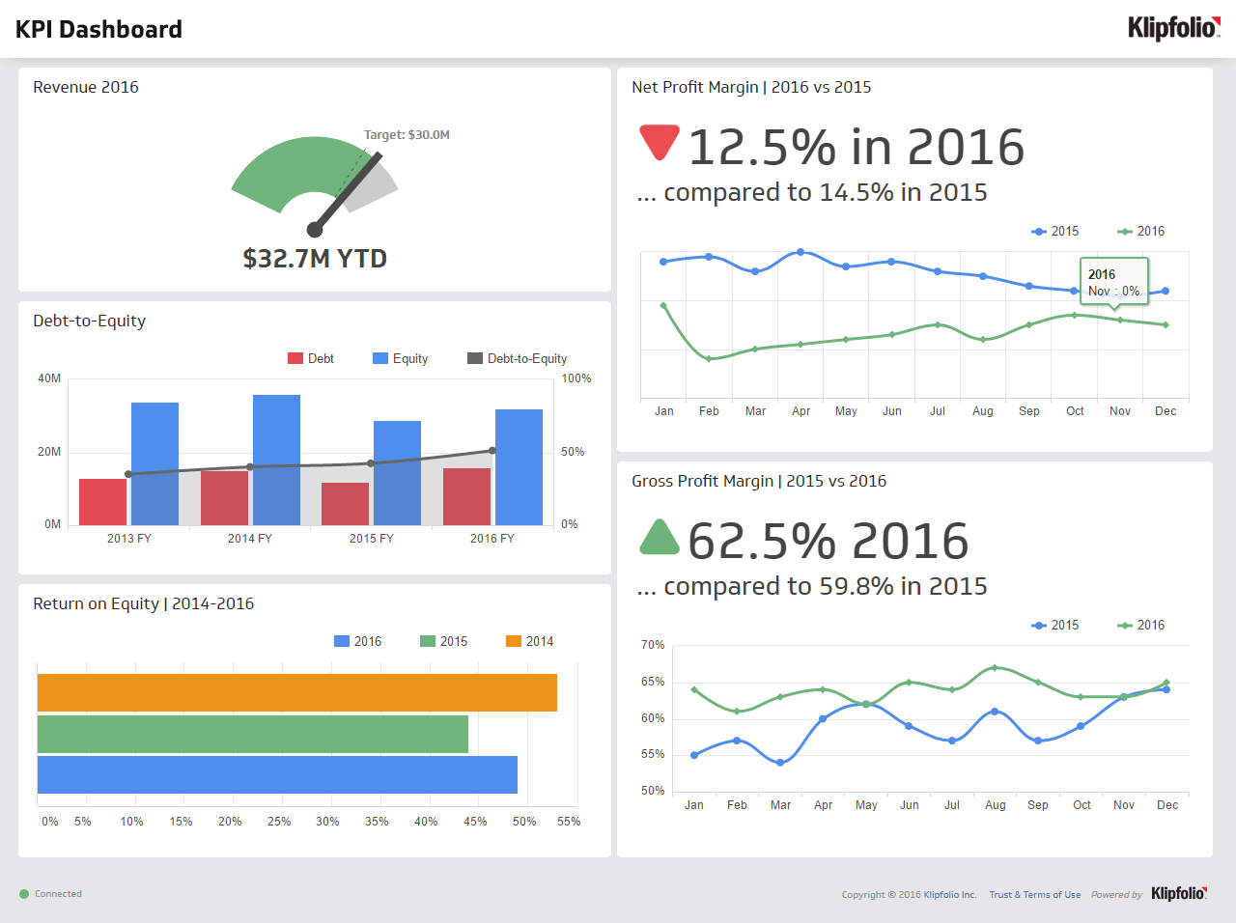
Source: https://www.klipfolio.com/resources/dashboard-examples/executive/kpi-dashboard

- True or False (Tick your response): The target revenue in 2016 was met.
Answer |  | True
 |  | False

- True or False (Tick your response): The gross profit margin for 2016 is better than 2015.
Answer |  | True
 |  | False

- True or False (Tick your response): The net profit margin for 2016 is better than 2015.
Answer |  | True
 |  | False

- How is gross profit determined for a profit and loss statement?
Answer | Gross profit is determined by subtracting costs of goods sold (COGS) from total sales  Gross Profit = Total Sales - COGS

- Name six (6) expenses considered in a profit and loss statement.
Answer | Accountant Fees  Advertising and Marketing  Bank Fees and Charges (Including Credit Cards)  Bank Interest  Utilities (Electricity, Water, Gas, Telephones)  Property Fees (Lease/Loan Payments, Rent, Rates)

- How is net profit calculated on a profit and loss statement?
Answer | Net Profit is calculated by subtracting total expenses from gross profit  Net Profit = Gross Profit – Total Expenses

- Name two (2) current assets and two (2) fixed assets that would be considered when compiling a balance sheet.
Answer | Asset | Examples
 | Current | Inventory, Cash
 | Fixed | Building / Property, Vehicles

- Name two (2) long-term liabilities and two (2) short-term liabilities that would be considered when compiling a balance sheet.
Answer | Liability | Examples
 | Long-term | Loans, Hire-Purchase Liabilities
 | Short-term | Credit Cards Payable, Accounts Payable

- How are net assets calculated on a balance sheet?
Answer | Net assets are calculated by subtracting total liabilities from total assets  Net Assets = Total Assets – Total Liabilities

- True or False (Tick your response): You may be legally obligated to perform an annual stocktake based on the stock and size of your business.
Answer |  | True
 |  | False

- You should be able to track in item in your stock by which of the following details? Tick all that apply.

Answer | Choice | Possible Answers
 |  | Applicable tax
 |  | Cost
 |  | Point-of-sale details
 |  | Quantity
 |  | Selling price
 |  | Source of supply
 |  | Stock number
 |  | Stored location
 |  | Unique item number

- Describe the effects that marketing strategies can have on the financial plan.
Answer | A good marketing plan and strategy can will help reach the target audience and boost your customer base. This will ultimately increase sales and up the bottom line and therefore affect the financial plan. Similarly, a poor marketing strategy could have a negative effect on the financial plan as sales could drop. The financial plan may have to be reviewed if sales don’t reach the anticipated level due to a poor marketing strategy.

- Describe the effects that operational strategies can have on the financial plan.
Answer | Operations play a huge role in the overall performance of a business. The operations are responsible for product management, supply chain, inventory, forecasting, scheduling, quality and facilities planning and management. If the operations are not conducted in an efficient way this then will impact the financial plan in a negative way. The financial plan may need to be reviewed if this is the case. On the other hand, efficient operations can have a positive effect on the financial plan.

- There are some common financial ratios used which allow the financial position of a business to be compared over time. Three (3) of these are working capital, current ratio and quick ratio (or acid test ratio).
The equations and explanations for these follow in the table below:
Financial ratio | How to calculate It | What it tells you
Working Capital | = Current Assets - Current Liabilities | An indicator of whether the company will be able to meet its current obligations (i.e. pay its bills & meet its payroll, make a loan, etc.) If a company has current assets exactly equal to current liabilities. The greater the amount of working capital the more likely it will be able to make its payment on time
Current Asset Ratio | = Current Assets ÷ Current Liabilities | This tells you the relationship of current assets to current liabilities. A ratio of 3:1 is better than 2:1. A 1:1 ratio means there is no working capital
Quick Asset Ratio  (Acid Test) | = (Cash + Temp. Investments + Accounts Receivable) ÷ Current Liabilities : 1 | This ratio is similar to the Current Asset Ratio except that Inventory, Supplies and Prepaid Expenses are excluded. This indicates the relationship between the amount of assets that can be quickly turned to cash versus the amount of liabilities
Using the example company balance sheet on the following page, determine:
- Working Capital
- Current Asset Ratio
- Quick Asset Ratio (Acid Test)

Answer | Item | Calculations
 | Working Capital | Working Capital = $28,000 ($89,000 - $61,000)
 | Current Asset Ratio | Current Asset Ration = 1.46 ($89,000 ÷ $61,000)
 | Acid Test | Acid Test = 0.86:1 ($2,100 + $10,000 + $40,500 ÷ $61,000)

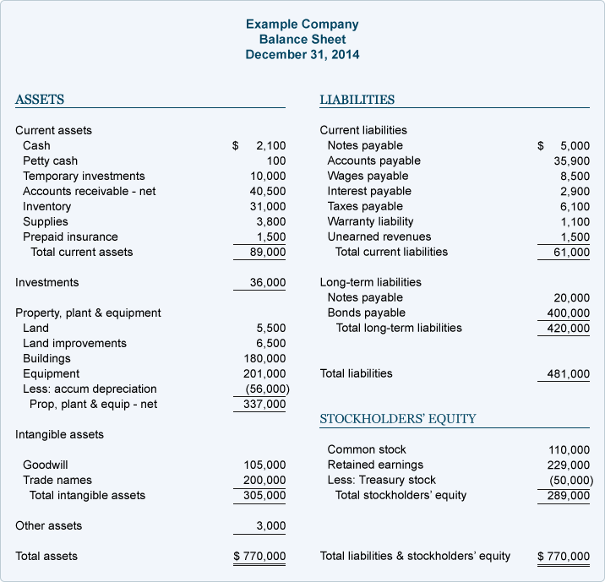

- Name and describe the two (2) types of benchmarks provided by the Australian Tax Office.
Answer | Benchmark | Explanation
 | Performance Benchmark | Financial ranges for your industry to help you work out how you compare to other businesses in your industry and if you need to make any improvements. Two types of performance benchmarks include Income Tax and Activity Statement
 | Input Benchmark | These show an expected range of income for tradespeople based on the labour and materials they use to undertake domestic projects.

- True or False (Tick your response): Comparing your ratios to the benchmark will give you a better idea of how your business is tracking and whether change might be required.

Answer |  | True
 |  | False

- Provide two (2) reasons that might cause you to alter your financial plan.
Answer | Change in Market  Change in Customers

