BSBLDR414
Lead team effectiveness

ASSESSMENT SUMMARY

The assessment activities for BSBLDR414 Lead team effectiveness cover all aspects of the unit of competency. For Apprentices/Trainees, this includes supervisor completion of the Apprentice/Trainee Record (ATR).

Participants must read all the information given before starting any assessment task. The assessment tasks are intended to be fair, flexible, valid and reliable. If a Participant has any questions or requires alternative arrangements to be made such requests should be directed to their Trainer/Assessor, who should note such arrangements in the ‘Assessor Comments’ on the affected assessment. If a Participant feels they are not yet ready to be assessed, they should discuss their options with their Trainer/Assessor.

To satisfactorily complete the assessment, the Participant is required to answer all questions correctly and demonstrate their skills to industry standards. If a Participant does not answer all questions or perform all tasks, they will be deemed ‘Not Satisfactory’ for the task and ‘Not Yet Competent’ for the unit of competency.

The Trainer/Assessor can provide the Participant with additional information on interpreting the assessment outcomes and guide the Participant’s options. If a Participant is still deemed ‘Not Satisfactory’ they will have the opportunity to undertake a supplementary assessment or appeal the result as per the process in the Student Handbook.

By signing below, the Participant acknowledges:
- They understand the assessment instructions and requirements, and consent to being assessed.
- The work submitted is to be their own work – with the work of/with others needing to be clearly acknowledged and documented.
- They consent to any photo/video recording of their work that occurs during assessment.

Participant name | Mohsin Ali Ch.
Participant signature | 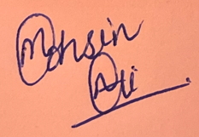

Pre-requisite unit(s) to be achieved and authenticated prior to undertaking assessment
Not applicable

Task | Date completed | Assessment Results
Theory Exam | Select Date. | Satisfactory | Not Satisfactory
Practical Assessment | Select Date. | Satisfactory | Not Satisfactory
Outcome for BSBLDR414 | Select Date. | Competent | Not Yet Competent

Evidence requirements checklist (ticked by assessor and evidence supplied to RTO)
Theory Exam | Practical Assessment  Team development plan

Assessor Name
Assessor Signature | 

BSBLDR414
Lead team effectiveness

THEORY EXAM

Participant name | Mohsin Ali Ch.

FOR THE PARTICIPANT
Instructions
- You will complete written questions as outlined on the following pages. You must attempt all questions and provide enough detail in your responses to demonstrate your knowledge.
- It is anticipated that you should complete this assessment within two (2) hours, but additional time may be allowed upon negotiation with the Assessor.
- You must complete all questions unassisted by the Assessor or other personnel but may refer to reference material as needed. All questions must be answered correctly for a ‘Satisfactory’ assessment outcome to be awarded.
  - An oral examination may be allowed under certain circumstances, whereby your answers will be documented by another party.
  - Any written questions that are incomplete, or not answered satisfactorily will need to be completed again after further training support.
    - If you answer a question incorrectly but modify your response, put your initials next to the written change (or the Assessor must initial a verbal change).
Resources required
Pen

FOR THE ASSESSOR
Instructions
- Where oral examination has occurred, ensure that this is acknowledged in writing (e.g. FT001 and Assessor Comments)
- All questions must be satisfactorily demonstrated by the Participant for a Satisfactory determination (indicated by an Assessor tick to the right of the question).
- Assessors are to complete marking in pen of a different colour to the Participant.
- If the Participant verbally modifies their response, write in the modified response verbatim and put your initials next to the written change.

ASSESSOR COMMENTS
As necessary, outline:
- Details on reattempts, alternative arrangements or reasonable adjustments made.
- Where a Participant is deemed ‘Not Satisfactory’, provide recommendations for future training.

- Identify a team that may exist in the workplace. Consider the purpose of the team, its goals and objectives. Name and describe the roles and responsibilities for at least three (3) team members. Finally, identify at least one (1) method that will assist with monitoring progress towards the team goals.

Answer | Point | Detail
 | Team purpose | Team: Services  The purpose of services team is to deliver the construction of all services required in the building as per the design approved for the project i-e Electrical, Mechanical, Fire, Hydraulics. Making sure that all these necessary services are properly installed and functional.
 | Goals and objectives | Short term | - Establish clear communication between all trades to facilitate coordination between all team members.  - Close coordination with other construction teams for integration and installation of all services.
 | Goals and objectives | Long term | - Develop plans to provide temp services in the future areas that would be handed over from structures to install permanent services.  - Enhance safety measures and emergency response protocols for all systems taking part in construction to ensure the wellbeing of all the staff.
 | Team members | Role | Description | Responsibilities
 | Team members | 1 | Senior Project Engineer | - Lead the services team and oversee planning, installation and maintenance of services.  - Managing the contractors work, progress claims and claim variations.  - Coordinate with subcontractors to to ensure the timely installation with in the forecasted budget.
 | Team members | 2 | Project Engineer | - Supervise the installation of all the services installed and making sure the proper design implemented and are compliant with industry Australian standards.  - Coordinate with structural and fitouts team to integrate services infrastructure into the construction design.  - Planning of the future services works in the areas available and set target date to close out those works.
 | Team members | 3 | Site Engineer | - Managing work conducted by onsite subcontractors and implementing prompt and safe corrective action on site where required.  - Assist Senior Project Engineer with development of short and long term construction planning and programming.  - Review and assess subcontractor variation claims  .
 | Progress monitoring | Services team should hold weekly meetings to review the progress of construction activities. The progress can be tracked by setting up different trackers in excel and update the trackers on weekly basis which will help navigate the team in achieving the major milestones in efficient way. Ahex can also be used to track the progress of subcontractors on the field , which can be effective to do the variation claims if for some reason subcontractors on site cannot meet the target date.

- True or False (Tick your response): A team leader is more of a mentor than overseer who checks work.

Answer |  | True
 |  | False

- Match the leadership styles and definitions by writing the appropriate letter next to each number in the centre column.

Answer | Style |  |  | Definition
 | 1 | Authoritarian | 1 - L | A | Leaders who let the team function without much interference
 | 2 | Democratic | 2 - A | B | Leaders who fully control their team
 | 3 | Laissiz-Faire | 3 - D | C | Leaders who try to include everyone in the decision-making process

- Identify two (2) benefits and two (2) drawbacks of transactional leadership.

Answer | Benefits | Drawbacks
 | Clearly defined short and long term goals. | Little room for flexibility or adaptability.
 | Streamlined, efficient chain of command. | Personal initiative is not rewarded or valued.

- Which of the following are characteristics of transformational leaderships? Tick all that apply.

Answer | Choice | Possible Answers
 |  | The leader acts as a role model to employees
 |  | Close, consistent focus on the company vision
 |  | A high value on interpersonal relationships
 |  | Inspiration as a tool to motivate employees

- Why is it important for team leaders to include team members in the planning process?

Answer | Having various skilled team members in the planning allows for improved practices such as:  Innovation – Application of better solutions to meet requirements.  Productivity – Improved output of work through streamlining processes.

- For each of the listed activities in the table below, identify two (2) methods that team leaders can use to involve team members.

Answer | Activity | Method/s to involve team members
 | Goal setting | - Set clear, identifiable and achievable goals.  - Monitor a team’s progress towards the goal.  - Provide encouragement, promoting creative and innovating approaches to problem-solving.
 | Decision making | - By organising team and individual activities.  - To improve productivity, a manger should not be consulted each time a decision is to be made.
 | Work allocation | - Try to allocate work according to skills and abilities to get the most out of team members.  - Ensure that work is fairly delegated to avoid resentment between group members.

- True or False (Tick your response): Diverse teams produce more creative results than teams in which members are less diverse.

Answer |  | True
 |  | False

- Provide two (2) examples of how the knowledge, skills and background of team members can enhance team practices.

Answer | - Communication and negotiation skills(e.g. dealing with different language/accent or client perspective)  - Problem-solving and critical thinking abilities demonstrated by those who have learned from previous experiences or cultural values.

- Provide two (2) reasons that responsibilities must be carefully delegated within the work team.

Answer | - To avoid resentment between team members.  - To maintain group dynamics  - To get most out of team members.

- Describe what innovation brings to the workplace. Provide one (1) example of innovative practice.

Answer | Innovation brings several benefits to the workplace i-e Improved efficiency, cost reduction, enhanced employee engagement, competitiveness.  Example:  Using Building Information Modelling (BIM) for coordination and project planning that enables different teams to create 3D models including architectural, structural , electrical, mechanical and plumbing. This technology shows better visualisation which allows for better coordination, detailed analysis of projects elements reducing conflicts and hence improving efficiency. :

- Describe (3) methods that may be used to measure a team’s innovation.

Answer | - Speed to market.  - Number of unsuccessful projects.  - Customer satisfaction with new projects.

- Explain how encouraging team members to assist each other in undertaking their roles and responsibilities can improve productivity.

Answer | 1 It reduces the workload when team members assist each other. It ensures task completion in timely manner.  2 Team members assisting each other can streamline the task leading to increased efficiency among the team.

- Describe (3) methods that may be used to measure a team’s productivity.

Answer | A team’s productivity can be measured in different ways, such as  - Achievement of objectives (i-e meeting set objectives)  - Measuring quantitative productivity ( i-e how many parts, applications, products or calls processed perday, hour or month.)  - Measuring profit (i-e Tracking revenue)

- Which of the following are likely outcomes from involving team members in all aspects of a job? Tick all that apply.

Answer | Choice | Possible Answers
 |  | Causes members to resent the team
 |  | Makes the work more meaningful
 |  | Improves self-esteem of team members
 |  | Improves team morale
 |  | Team members take more responsibility for their individual work

- Explain how providing feedback to team members can encourage and motivate team members – building trust and positive working relationships.

Answer | Team leader must ensure that providing feedback is managed carefully.  Putting plans into place to correct poor results.  Feedback should be given constructively.  These ways of providing feedback to team members can build trust and positive working relationships and enhance accountability.

- Identify one (1) issue, concern or problem that may be identified by team members. Describe the signs that you would recognise to identify the issue and how the matter could be resolved by internal team negotiation.

Answer |  | Response
 | Issue, problem, or concern | Disrespect within team
 | Signs | Issue raised by team members
 | Solution via negotiation | Counselling offered internally or externally  One-on-one discussions.

- Identify one (1) issue, concern or problem that would need to be resolved by an external party. Describe the signs that you would recognise to identify the issue and who the matter should be referred to.

Answer |  | Response
 | Issue, problem, or concern | Underperformance
 | Signs | Deadlines not being met.
 | Solution via negotiation | Review and amend work plan.  Impacts of external problems flagged with management.

- Identify three (3) ways that the team leader can serve as a role model to, and motivate, the team.

Answer | - Providing information and guidance on matters overarching the day-to-day operations of the team.  - Providing assistance where the team is having difficulties and cannot resolve matters internally.  - Team leader should communicate information from management to the team and vice versa.

- For each of the following areas, provide one (1) example of how the team leader’s contributions to the work team can enhance the organisation’s image:
- Internally, within the work team and the organisation
- Externally, with clients/customers

Answer | Question | Response
 | Within the work team and organisation | The team leader is a key link between the team and management. He must always maintain open communication with management.  For example: Having meeting with management, delivering regular reports)
 | With clients and customers | By actively seeking feedback from clients/customers and incorporating their input into team processes and deliverables.  By ensuring transparent communication and proactive updates with clients throughout the project.

- Provide three (3) communication methods that a team leader may encourage the team to use, and situations that each communication method would be suitable for.

Answer | Method | Suitability
 | Meetings | For discussing complex topics, decisions making, facilitating real time communication , address challenges.
 | Interviews | Interviews are a good source to gather in depth knowledge insights from individual team members.  With interviews, team leader can assess the career aspirations of team member, gather feedback on team processes, identify area of improvement.
 | Brainstorming sessions | Brainstorming sessions encourage open discussions, creativity and divergent thinking among team members.  Suitable for problem solving, strategic planning etc.

- Identify two (2) ways that the team leader can establish open communication with management.

Answer | - Having meeting with management, delivering regular reports).  - Both good and bad news must be reported – problems will not be avoided by only reporting good news

- Identify two (2) issues, concerns and problems that may be raised by the team to management.

Answer | - Disrespect with in the team.  - If team requires additional training

- Identify two (2) issues, concerns and problems related to the team that may be raised by management back to the team.

Answer | Underperformance  Poor communication.

- Describe one (1) situation where the team leader may have to negotiate with management on behalf of the team.

Answer | If the team requires additional training to complete their job, management may need to provide opportunities for professional development

Refer to the extract below from an Escalation Policy and Procedure to respond to Q26. to Q28.

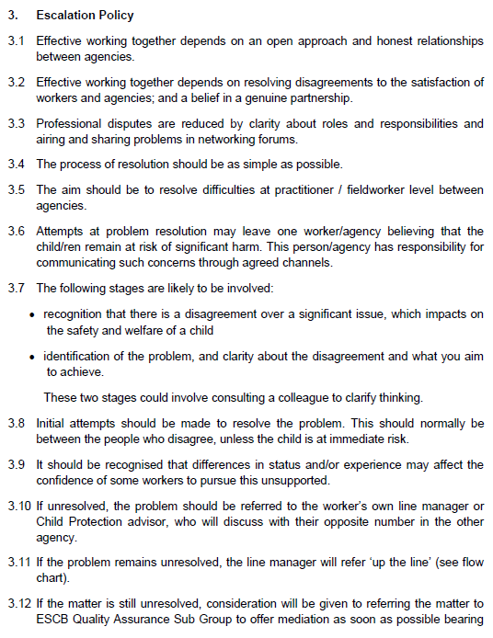
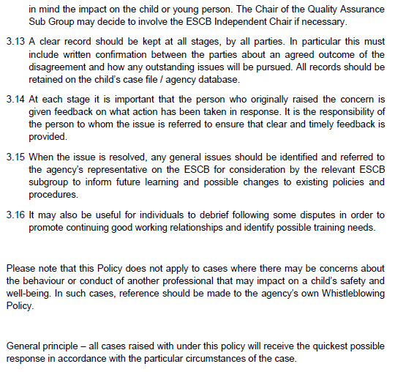
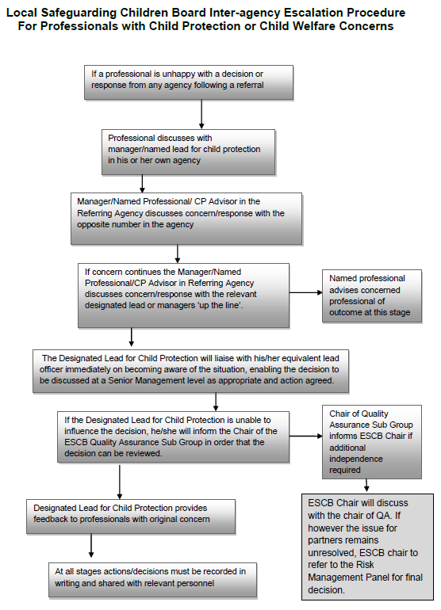

- Order the following steps from 1 to 5 to identify the correct order of issue escalation where a problem is unresolved.

Answer | Step Number | Steps
 | 1 | The people who disagree should make the initial attempts to resolve the problem
 | 5 | When the issue is resolved, any general issues should be identified and referred back to the agency’s representative to inform future learning and possible changes to existing policies and procedures
 | 3 | If the problem remains unresolved, line manager will refer ‘up the line’
 | 4 | If the matter is still unresolved, the matter may be referred to the Quality Assurance Sub Group to offer mediation
 | 2 | If unresolved, the problem should be referred to the worker’s own line manager

- True or False (Tick your response): It is the goal for all cases raised under this policy to receive the quickest possible response.

Answer |  | True
 |  | False

- If the ESCB Chair cannot resolve the issue, which body can make the final decision?

Answer | Risk Management Panel

BSBLDR414
Lead team effectiveness

PRACTICAL ASSESSMENT

Participant name | Mohsin Ali Ch

FOR THE PARTICIPANT
Instructions
- The tasks outlined on the following pages will require performance of normal workplace activities, as a result of a structured activity set by an Observer in the workplace or a simulated activity set by your Assessor/Observer.
- The timeframe for these tasks will be established by your Assessor/Observer, in consideration of location conditions and industry requirements.
- You must complete all tasks unassisted by the Assessor or other personnel, unless the steps note this assistance.
- You must attempt all tasks (and itemised steps) for a ‘Satisfactory’ assessment outcome to be awarded.
  - For any observation conducted that is incomplete, or without satisfactory performance, the observation will need to be completed again after further training support.

FOR THE ASSESSOR/OBSERVER
Instructions
- The following observation record should be used to judge and record your observations of the Participant as they complete the task(s) set. You must record your observations of the Participant’s performance.
  - For each occasion, indicate the task performed and whether it was a simulation or workplace-based task.
    - Any simulated assessment must ensure the Participant still performs under workplace conditions which reflect industry standards.
  - In the comments, provide clear detail regarding the task that the Participant was required to do (e.g. PPE used, materials handled, attachments connected, plant types).
- All steps must be satisfactorily demonstrated by the Participant for a ‘Satisfactory’ determination (indicated by an Assessor tick to the right of each itemised step, or an Observer tick to the right of each itemised step, and confirmation by an Assessor in the Assessor Comments).
  - Where you have determined that one or more task steps have not been satisfactorily demonstrated, provide the Participant with additional support and outline details of such assistance in the Assessor/Observer Comments. Allow the Participant two (2) further opportunities to demonstrate the task again to allow an opportunity for a ‘Satisfactory’ assessment outcome to be achieved.
  - If after three (3) attempts the Assessor determines that the Participant cannot demonstrate the required steps, a ‘Not Satisfactory’ outcome is to be determined.

TASK OUTCOME
Task | Date | Task Type (Tick) | Location | Task outcome (Tick)
 |  |  |  | Satisfactory | Not Satisfactory
Task 1 | 19/04/2024 | Workplace  Simulation | Boggo Road Station

ASSESSOR COMMENTS
As necessary, outline:
- Details on reattempts, alternative arrangements or reasonable adjustments made.
- Where a Participant is deemed ‘Not Satisfactory’, provide recommendations for future training.
Not applicable, no reattempts required.

ASSESSOR COMMENTS: PRACTICAL TASK 1
Individual student (as named on cover page)
Multiple students [ All from Attendance Report, Specific students involved – identify students]
Task | Provide detail
1.B. | Feedback provided to team members:  Mohsin was able to provide clear feedback to team members as required to improve their involvement and their outputs.
1.C. | Support offered to identify and resolve problems, issues and concerns:  Continued regular check-ins and team meetings to ensure any issues faced by the team were raised and addressed, and encouraged the team members to identify ways to improve the program and safety on the project.
1.D. | Issues passed from management to the team and vice versa:  Effective at raising the issues up to the project manager, following up the resolution, and feeding back to the rest of the team.

BSBLDR414
Lead team effectiveness

Practical Task 1
Description of task:
A suitable observer is to verify the participant’s ability to lead team effectiveness, including:
- Leading and consulting with the team to develop a team development plan that addresses –
  - Team cohesion
  - Innovation and productivity measures
  - Issues management and actions
- Communicating with team members and management to –
  - Consult, encourage, support and provide feedback to the team
  - Model team leadership behaviours and approaches
  - Resolve problems

The Observer is to provide detailed comments on the tasks completed by the Participant (on the Observer Comments, overleaf). The Assessor is to verify the Observer’s comments, noting their findings in the Assessor Comments (on the back of the Practical Assessment cover page) and provide the assessment outcome.
Resources required:
Team Development Plan Template
Observer details
Name of observer: | Matthew Groves
Role of observer  (Confirm suitability to sign) | Project Engineer
Email address of observer | Matthew.Groves@cbgujv.com.au
Signature of observer: | 
Date: | 19/04/2024

When completing the task, did the Participant: | Tick if satisfactorily completed.  Provide comments if left unticked.
- Lead and consult with the team to establish and document a team development plan, incorporating:
- Team purpose, roles, responsibilities, goals, objectives and plans
- Consideration of organisational goals, objectives and plans
- Team cohesion
- Innovation and productivity measures
- Issues management and actions
- Lead team to develop cohesion, including:
- Providing opportunities for input of team members into planning, decision making and operational aspects
- Encouraging and supporting team members to take responsibility for own work and to assist each other
- Providing feedback to team members to encourage, value and reward individual and team efforts and contributions
- Participate in and facilitate work team, including:
- Leading and supporting team members in meeting expected outcomes
- Actively encouraging team members to participate in and take responsibility for team activities and communication processes
- Giving the team support to identify and resolve problems, issues and concerns
- Acting as a role model to enhance the organisation’s image for work team, clients and customers
- In line with organisational escalation policies and procedures, maintain open communication by passing information from management to the team and vice versa (including issues, concerns and problems).

OBSERVER COMMENTS
Mohsin has demonstrated a solid understanding of effective team leadership practices and processes across all aspects of team building and cohesion, driving the objectives of the project and the organisation, and managing issues that may arise in the team either internally or externally. He has applied the aspects of the team development plan throughout the process of a subproject on the site from the planning phase through the delivery of the subproject, which included some issues arising within the immediate team as well as the managed subcontractor.

TEAM DEVELOPMENT PLAN

DATE OF EFFECT
Start | 5/03/2024 |  | End |  | 10/04/2025
GOALS, PLANS AND OBJECTIVES
Outline the team’s purpose, goals, and objectives. Identify how this fits within the organisation’s goals, objectives and plans.
Team Development Plan for Services Team:
- Purpose:
The purpose of services team in construction is to deliver construction projects in an efficient and safe manners, meeting client expectation and adhering to Australian standards and regulations.
- Goals:
-Completion of project within set time and budget.
-Maintain high standards of quality and safety throughout the project execution.
-Improve processes and techniques in various departments of construction to enhance efficiency and productivity.
-Develop a skilled and motivated team capable of delivering excellence in construction services.
- Objectives:
-Minimizing delays and cost overruns along with the timely delivery of project within the budget.
-Adherence to the safety protocols to prevent on site accidents hence ensuring secure working environment.
-Meet or exceed client expectations in terms of implantation of design and quality of products and equipment used.
-Maintain healthy communication with client to address any concerns and change in scope.
-To develop the skillset of relative team/employees, invest in training and development programs to tackle complex challenges that might arise during construction task completion.
Alignment of team’s purpose, goals and objectives with organizational purpose, goals and objectives:
- Team’s purpose goals align with the organizational goals in such a way that it aligns with the delivering of construction services and design solutions to the client.
- By focusing on project completion in timely manner and client satisfaction.
- Efficiency in managing project budget and resources, minimizing risks and maintaining safety and quality.
- In terms of objectives, it complements the organization’s objectives of personal and organizational growth, profitability, sustainability.
- Our service’s team plan of workforce development through new innovation and continuous improvement supports the organizational strategic plans for innovation, competitiveness and talent acquisition.
- In order to stay ahead of market trends, invest in technology, employee training, team building exercises are good ways to maintain competitiveness within the team and in industry.

OBJECTIVES FOR TEAM
Objective |  | Work process |  | Responsible employee |  | Start date | End date
Team cohesion |  | Organising team building activities, communication links between the team, collaboration initiatives to enhance team work. |  | Project Manager |  | 5/04/2024 | 6/08/2024
Innovation |  | Identification of opportunities for implementation of new construction techniques, upto date with latest technologies and familiarise with team, sustainable practices to drive innovation. |  | Project Engineer/Coordinator |  | 15/04/2024 | 24/01/2025
Productivity |  | Managing contractors, sub contractors on site, Resources allocation, Implement performance metrics |  | Senior Project Engineer |  | 8/04/2024 | 1/04/2025
Issues management |  | Establish protocols for identifying and resolving issues that arise during project execution. Rectifying issues between management and employees. |  | Site Manager/Project Manger |  | 4/04/2024 | 5/04/2025
REVIEWING AND ASSESSMENT METHODS
How will you track the plan’s implementation, the team’s progress (e.g. through team meetings, reports)?
One-on-One Check-ins:
Conduct regular one-on-one meetings with team members to provide individual support and guidance.
Project Management tools:
Use of project management tools or software to track the progress, milestones. Aphex and Microsoft project etc.
Assign responsibilities and monitor task completion to ensure accountability. Kanban Flow and Air table are the tools that can be used for this purpose.

Regular team meetings:
Conduct regular team meetings to check the status of ongoing and soon to be commenced works on site and plan the work, discuss challenges and updates on progress towards objectives.
ADDITIONAL SUPPORT
Is there any additional support needed to reach the desired goals (e.g. courses, classes, resources).
Access to resources and tools:
Ensure that team has access to necessary tools and resources required to perform their tasks efficiently i-e construction software, equipment, safety gear etc.
Training and development program:
For services, provide training or organise workshops to focus on areas such as project management, construction procedures, safety workshops etc.
Mentorship:
Provide team members with experienced coaches and mentors who has vast industry experience and can provide guidance, support and practical insights. Fostering this culture of knowledge sharing from senior members to junior colleagues will facilitate skill transfer.

EXPECTED OUTCOME
Team leader’s expectations on the outcome based on the data.
The team leader’s expectations on the basis of implementation of team development plan are as:
Improved team cohesion by increased collaboration and mutual support among team members resulting in enhanced productivity and job satisfaction.
Enhanced innovation due to adoption of new techniques and introducing new technologies and sustainable practices leads to improved problem-solving capabilities and culture of creativity hence creating differentiation in marketplace.
Improved productivity by task management , resource allocation and optimizing construction processes resulting in increased efficiency, client satisfaction, improved profitability and various other business opportunities.

OUTCOME IF GOALS AND OBJECTIVES ARE NOT MET
Identify the consequences and further steps if the team fails to satisfy the standards set by the plan.
- Project delays and cost overruns:

Consequences: Failure to meet productivity resulting in project delays and cost overruns which can lead to dissatisfaction among the clients.
Further steps: Identify the root cause of delays. Revise project schedules, reallocate resources to mitigate further impacts.

- Safety Incidents and Compliance Issues:

Consequences: Inadequate management issues related to safety may lead to accidents, penalties and reputational damage to organization.
Further Steps: Regular safety walks to ensure every thing is compliant and upto the industry standards e.g egress lighting, scaffolds etc. Provide additional training and resources to adhere safety and to prevent future incidents.

- Decreased team morale and cohesion:

Consequences: Increased conflicts and reduced productivity could be a reason of decreased team morale.
Further Steps: Implement team building activities, conflict resolution training, and leadership development programs to address underlying issues and build team morale.

