BSBLDR414
Lead team effectiveness

ASSESSMENT SUMMARY

The assessment activities for BSBLDR414 Lead team effectiveness cover all aspects of the unit of competency. For Apprentices/Trainees, this includes supervisor completion of the Apprentice/Trainee Record (ATR).

Participants must read all the information given before starting any assessment task. The assessment tasks are intended to be fair, flexible, valid and reliable. If a Participant has any questions or requires alternative arrangements to be made such requests should be directed to their Trainer/Assessor, who should note such arrangements in the ‘Assessor Comments’ on the affected assessment. If a Participant feels they are not yet ready to be assessed, they should discuss their options with their Trainer/Assessor.

To satisfactorily complete the assessment, the Participant is required to answer all questions correctly and demonstrate their skills to industry standards. If a Participant does not answer all questions or perform all tasks, they will be deemed ‘Not Satisfactory’ for the task and ‘Not Yet Competent’ for the unit of competency.

The Trainer/Assessor can provide the Participant with additional information on interpreting the assessment outcomes and guide the Participant’s options. If a Participant is still deemed ‘Not Satisfactory’ they will have the opportunity to undertake a supplementary assessment or appeal the result as per the process in the Student Handbook.

By signing below, the Participant acknowledges:
- They understand the assessment instructions and requirements, and consent to being assessed.
- The work submitted is to be their own work – with the work of/with others needing to be clearly acknowledged and documented.
- They consent to any photo/video recording of their work that occurs during assessment.

Participant name | Alison Radford
Participant signature | 

Pre-requisite unit(s) to be achieved and authenticated prior to undertaking assessment
Not applicable

Task | Date completed | Assessment Results
Theory Exam | Select Date. | Satisfactory | Not Satisfactory
Practical Assessment | Select Date. | Satisfactory | Not Satisfactory
Outcome for BSBLDR414 | Select Date. | Competent | Not Yet Competent

Evidence requirements checklist (ticked by assessor and evidence supplied to RTO)
Theory Exam | Practical Assessment  Team development plan

Assessor Name
Assessor Signature

BSBLDR414
Lead team effectiveness

THEORY EXAM

Participant name | Alison Radford

FOR THE PARTICIPANT
Instructions
- You will complete written questions as outlined on the following pages. You must attempt all questions and provide enough detail in your responses to demonstrate your knowledge.
- It is anticipated that you should complete this assessment within two (2) hours, but additional time may be allowed upon negotiation with the Assessor.
- You must complete all questions unassisted by the Assessor or other personnel but may refer to reference material as needed. All questions must be answered correctly for a ‘Satisfactory’ assessment outcome to be awarded.
  - An oral examination may be allowed under certain circumstances, whereby your answers will be documented by another party.
  - Any written questions that are incomplete, or not answered satisfactorily will need to be completed again after further training support.
    - If you answer a question incorrectly but modify your response, put your initials next to the written change (or the Assessor must initial a verbal change).
Resources required
Pen

FOR THE ASSESSOR
Instructions
- Where oral examination has occurred, ensure that this is acknowledged in writing (e.g. FT001 and Assessor Comments)
- All questions must be satisfactorily demonstrated by the Participant for a Satisfactory determination (indicated by an Assessor tick to the right of the question).
- Assessors are to complete marking in pen of a different colour to the Participant.
- If the Participant verbally modifies their response, write in the modified response verbatim and put your initials next to the written change.

ASSESSOR COMMENTS
As necessary, outline:
- Details on reattempts, alternative arrangements or reasonable adjustments made.
- Where a Participant is deemed ‘Not Satisfactory’, provide recommendations for future training.

- Identify a team that may exist in the workplace. Consider the purpose of the team, its goals and objectives. Name and describe the roles and responsibilities for at least three (3) team members. Finally, identify at least one (1) method that will assist with monitoring progress towards the team goals.

Answer | Point | Detail
 | Team purpose | Hazardous Chemicals Management Team  Ensure workplace safety by effectively identifying, storing and disposing of hazardous chemicals, complying with workplace health and safety regulations
 | Goals and objectives | Short term | Conduct risk assessments of hazardous chemicals, implement controls to reduce risks in the workplace and educate of the safe handling procedures.
 | Goals and objectives | Long term | Maintain compliance with the regulations, laws and GMRs, reduce workplace incidents relating to hazardous chemicals and create a safety focused culture in the workplace.
 | Team members | Role | Description | Responsibilities
 | Team members | 1 | Health and Safety Officer | Conduct risk assessments  Ensure SDS are present and up to date  Ensures proper labelling of chemicals and workers are trained
 | Team members | 2 | Workplace HSR | Conducts inspections  Reports hazards and incidents  Ensures all teams receive training and instruction
 | Team members | 3 | Site Manager | Ensures resources for safety measures  Implements safety procedures  Ensures compliance with the regulations
 | Progress monitoring | Regular safety audits and inspections assist with compliance, identify areas of improvement and ensure control measures are effectively implemented.

- True or False (Tick your response): A team leader is more of a mentor than overseer who checks work.

Answer |  | True
 |  | False

- Match the leadership styles and definitions by writing the appropriate letter next to each number in the centre column.

Answer | Style |  |  | Definition
 | 1 | Authoritarian | 1 - B | A | Leaders who let the team function without much interference
 | 2 | Democratic | 2 - C | B | Leaders who fully control their team
 | 3 | Laissiz-Faire | 3 - A | C | Leaders who try to include everyone in the decision-making process

- Identify two (2) benefits and two (2) drawbacks of transactional leadership.

Answer | Benefits | Drawbacks
 | Clearly defined short- and long-term goals | Little room for flexibility
 | Streamlined and efficient chain of command | Employees feel like followers rather than innovators or leaders

- Which of the following are characteristics of transformational leaderships? Tick all that apply.

Answer | Choice | Possible Answers
 |  | The leader acts as a role model to employees
 |  | Close, consistent focus on the company vision
 |  | A high value on interpersonal relationships
 |  | Inspiration as a tool to motivate employees

- Why is it important for team leaders to include team members in the planning process?

Answer | This can encourage collaboration and team members feeling more invested in goals. They gain a variety of skills and knowledge from diverse perspectives. Can assist with communication, ensuring understanding from all parties. Can boost morale and improve problem solving and team efficiency.

- For each of the listed activities in the table below, identify two (2) methods that team leaders can use to involve team members.

Answer | Activity | Method/s to involve team members
 | Goal setting | Ensure the goal is attainable and achievable and address any barriers/challenges. Ensure the goal is specific enough and identify strategies to achieve the goal.
 | Decision making | Team meeting and brainstorming sessions, surveys, feedback forms, suggestion boxes etc
 | Work allocation | Try to allocate work according to skills and ability. Ensure the work is fairly delegated to avoid resentment between group members.

- True or False (Tick your response): Diverse teams produce more creative results than teams in which members are less diverse.

Answer |  | True
 |  | False

- Provide two (2) examples of how the knowledge, skills and background of team members can enhance team practices.

Answer | Benefits the team in productivity, performance and quality of work.  Communication skills, problem solving and critical thinking abilities are demonstrated by those who have learned from previous experience.

- Provide two (2) reasons that responsibilities must be carefully delegated within the work team.

Answer | By delegating dependant on skill sets, you can get much more out of team members.  Ensure the work is fairly delegated to avoid resentment between group members.

- Describe what innovation brings to the workplace. Provide one (1) example of innovative practice.

Answer | Innovation increases efficiency and productivity, assists in problem solving, can set companies apart from others and gives higher employee engagement and satisfaction.  An example of innovative practice could be how we have transformed workplaces into work from home or remote from office roles. Using technology to communicate such as teams’ meetings etc

- Describe (3) methods that may be used to measure a team’s innovation.

Answer | Number of new ideas proposed – Track the ideas and document.  Proportion of ideas selected for implementation – You can determine the percentage that are successfully implemented.  Customer satisfaction – This can be tracked by surveys, online reviews/ feedback etc

- Explain how encouraging team members to assist each other in undertaking their roles and responsibilities can improve productivity.

Answer | This can create a positive work environment  Tasks can be completed faster and efficiently  Each team member can assist and/or learn from each other improving skills and knowledge.  Can help with problem solving  Boosts morale and team engagement

- Describe (3) methods that may be used to measure a team’s productivity.

Answer | Achievement of objectives i.e. Meeting set objectives  Measuring quantative productivity i.e. How many parts, applications, products or calls processed per hr, day, or month.  Measuring profit i.e. Tracking revenue

- Which of the following are likely outcomes from involving team members in all aspects of a job? Tick all that apply.

Answer | Choice | Possible Answers
 |  | Causes members to resent the team
 |  | Makes the work more meaningful
 |  | Improves self-esteem of team members
 |  | Improves team morale
 |  | Team members take more responsibility for their individual work

- Explain how providing feedback to team members can encourage and motivate team members – building trust and positive working relationships.

Answer | It shows that both the team and individual efforts are valued.  A valued team will remain inspired to keep working towards its goals – as well as remain focused, energetic and cohesive in its actions.

- Identify one (1) issue, concern or problem that may be identified by team members. Describe the signs that you would recognise to identify the issue and how the matter could be resolved by internal team negotiation.

Answer |  | Response
 | Issue, problem, or concern | Uneven workload or task distribution
 | Signs | Decreased productivity, errors. Giving more tasks to one person than others can lead to stress and burnout, team conflicts, missed deadlines etc
 | Solution via negotiation | Hold a meeting with an open forum, review current task allocation, collaborate with the team to negotiate a fairer workload, monitor progress and follow up

- Identify one (1) issue, concern or problem that would need to be resolved by an external party. Describe the signs that you would recognise to identify the issue and who the matter should be referred to.

Answer |  | Response
 | Issue, problem, or concern | Workplace bullying and harassment
 | Signs | Absenteeism, low morale, decline in performance. Complaints from one or more employees, stress, anxiety, withdrawal from team activities
 | Solution via negotiation | Refer to the HR department who can investigate, offer mediation and make sure appropriate action is taken

- Identify three (3) ways that the team leader can serve as a role model to, and motivate, the team.

Answer | Using effective communication.  Recognising the needs of team members  Setting goals and motivating the team by providing encouragement

- For each of the following areas, provide one (1) example of how the team leader’s contributions to the work team can enhance the organisation’s image:
- Internally, within the work team and the organisation
- Externally, with clients/customers

Answer | Question | Response
 | Within the work team and organisation | Team members feel valued and supported. Creates a positive, trusting culture leading to improved job satisfaction. Higher productivity and less turnover
 | With clients and customers | A positive workplace culture spreads, giving the company a great reputation.  A better interaction with other departments, clients and customers.

- Provide three (3) communication methods that a team leader may encourage the team to use, and situations that each communication method would be suitable for.

Answer | Method | Suitability
 | Team meetings | Discussing updates, goals and strategies.  Encouraging collaboration and brainstorming within the team.  Addressing any issues that require feedback or team input.
 | Email | Sharing policies, announcements and important documents. Communicating with external parties. Providing detailed instructions or follow up summaries after a meeting.
 | Messages, Whatsapp | Quick informal updates, requests. Sending out reminders. Encourages real time collaboration amongst a broad team remotely

- Identify two (2) ways that the team leader can establish open communication with management.

Answer | Meeting with management delivering regular reports.  Always maintaining open communication providing honest reports.

- Identify two (2) issues, concerns and problems that may be raised by the team to management.

Answer | Workplace conflict due to miscommunication or interpersonal conflicts.  Lack of training or resources to do their job.

- Identify two (2) issues, concerns and problems related to the team that may be raised by management back to the team.

Answer | Missing deadlines and poor performance.  Workplace changes creating resistance by the team.

- Describe one (1) situation where the team leader may have to negotiate with management on behalf of the team.

Answer | Underperformance – The team leader may need to guide the team to enable it to work as a more effective unit. The team leader may be required to negotiate the level of performance expected if it is too high.

Refer to the extract below from an Escalation Policy and Procedure to respond to Q26. to Q28.

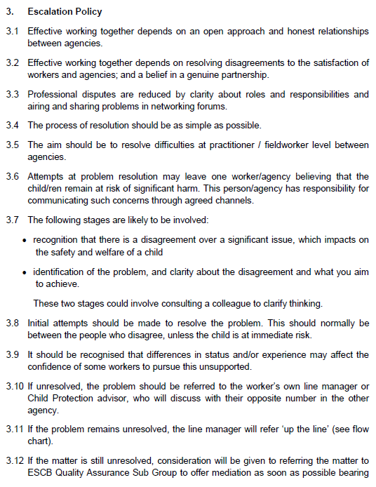
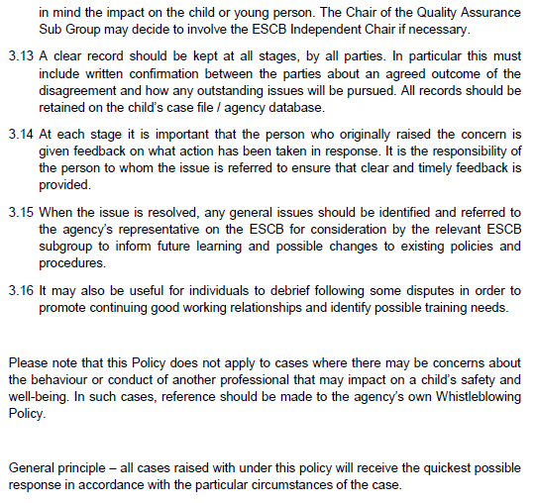
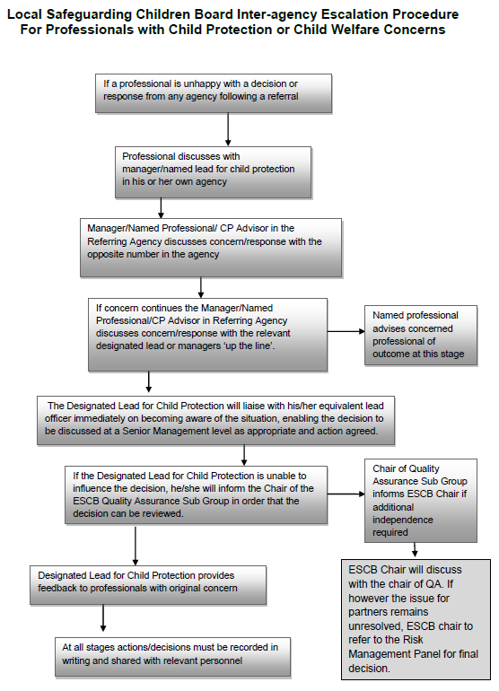

- Order the following steps from 1 to 5 to identify the correct order of issue escalation where a problem is unresolved.

Answer | Step Number | Steps
 | 1 | The people who disagree should make the initial attempts to resolve the problem
 | 5 | When the issue is resolved, any general issues should be identified and referred back to the agency’s representative to inform future learning and possible changes to existing policies and procedures
 | 3 | If the problem remains unresolved, line manager will refer ‘up the line’
 | 4 | If the matter is still unresolved, the matter may be referred to the Quality Assurance Sub Group to offer mediation
 | 2 | If unresolved, the problem should be referred to the worker’s own line manager

- True or False (Tick your response): It is the goal for all cases raised under this policy to receive the quickest possible response.

Answer |  | True
 |  | False

- If the ESCB Chair cannot resolve the issue, which body can make the final decision?

Answer | Risk Management Panel

BSBLDR414
Lead team effectiveness

PRACTICAL ASSESSMENT

Participant name | Alison Radford

FOR THE PARTICIPANT
Instructions
- The tasks outlined on the following pages will require performance of normal workplace activities, as a result of a structured activity set by an Observer in the workplace or a simulated activity set by your Assessor/Observer.
- The timeframe for these tasks will be established by your Assessor/Observer, in consideration of location conditions and industry requirements.
- You must complete all tasks unassisted by the Assessor or other personnel, unless the steps note this assistance.
- You must attempt all tasks (and itemised steps) for a ‘Satisfactory’ assessment outcome to be awarded.
  - For any observation conducted that is incomplete, or without satisfactory performance, the observation will need to be completed again after further training support.

FOR THE ASSESSOR/OBSERVER
Instructions
- The following observation record should be used to judge and record your observations of the Participant as they complete the task(s) set. You must record your observations of the Participant’s performance.
  - For each occasion, indicate the task performed and whether it was a simulation or workplace-based task.
    - Any simulated assessment must ensure the Participant still performs under workplace conditions which reflect industry standards.
  - In the comments, provide clear detail regarding the task that the Participant was required to do (e.g. PPE used, materials handled, attachments connected, plant types).
- All steps must be satisfactorily demonstrated by the Participant for a ‘Satisfactory’ determination (indicated by an Assessor tick to the right of each itemised step, or an Observer tick to the right of each itemised step, and confirmation by an Assessor in the Assessor Comments).
  - Where you have determined that one or more task steps have not been satisfactorily demonstrated, provide the Participant with additional support and outline details of such assistance in the Assessor/Observer Comments. Allow the Participant two (2) further opportunities to demonstrate the task again to allow an opportunity for a ‘Satisfactory’ assessment outcome to be achieved.
  - If after three (3) attempts the Assessor determines that the Participant cannot demonstrate the required steps, a ‘Not Satisfactory’ outcome is to be determined.

TASK OUTCOME
Task | Date | Task Type (Tick) | Location | Task outcome (Tick)
 |  |  |  | Satisfactory | Not Satisfactory
Task 1 | 10/04/2025 | Workplace  Simulation | Lendlease ITB Project

ASSESSOR COMMENTS
As necessary, outline:
- Details on reattempts, alternative arrangements or reasonable adjustments made.
- Where a Participant is deemed ‘Not Satisfactory’, provide recommendations for future training.

ASSESSOR COMMENTS: PRACTICAL TASK 1
Individual student (as named on cover page)
Multiple students [ All from Attendance Report, Specific students involved – identify students]
Task | Provide detail
1.B. | Feedback provided to team members:
1.C. | Support offered to identify and resolve problems, issues and concerns:
1.D. | Issues passed from management to the team and vice versa:

BSBLDR414
Lead team effectiveness

Practical Task 1
Description of task:
A suitable observer is to verify the participant’s ability to lead team effectiveness, including:
- Leading and consulting with the team to develop a team development plan that addresses –
  - Team cohesion
  - Innovation and productivity measures
  - Issues management and actions
- Communicating with team members and management to –
  - Consult, encourage, support and provide feedback to the team
  - Model team leadership behaviours and approaches
  - Resolve problems

The Observer is to provide detailed comments on the tasks completed by the Participant (on the Observer Comments, overleaf). The Assessor is to verify the Observer’s comments, noting their findings in the Assessor Comments (on the back of the Practical Assessment cover page) and provide the assessment outcome.
Resources required:
Team Development Plan Template
Observer details
Name of observer: | Rod Mills
Role of observer  (Confirm suitability to sign) | EHS Coordinator Lendlease ITB BAC Project
Email address of observer | rodney.mills@lendlease.com
Signature of observer: | 
Date: | 15/04/2025

When completing the task, did the Participant: | Tick if satisfactorily completed.  Provide comments if left unticked.
- Lead and consult with the team to establish and document a team development plan, incorporating:
- Team purpose, roles, responsibilities, goals, objectives and plans
- Consideration of organisational goals, objectives and plans
- Team cohesion
- Innovation and productivity measures
- Issues management and actions
- Lead team to develop cohesion, including:
- Providing opportunities for input of team members into planning, decision making and operational aspects
- Encouraging and supporting team members to take responsibility for own work and to assist each other
- Providing feedback to team members to encourage, value and reward individual and team efforts and contributions
- Participate in and facilitate work team, including:
- Leading and supporting team members in meeting expected outcomes
- Actively encouraging team members to participate in and take responsibility for team activities and communication processes
- Giving the team support to identify and resolve problems, issues and concerns
- Acting as a role model to enhance the organisation’s image for work team, clients and customers
- In line with organisational escalation policies and procedures, maintain open communication by passing information from management to the team and vice versa (including issues, concerns and problems).

OBSERVER COMMENTS
Alison demonstrated good leadership and communication skills in this team task. Using the development plan template, she openly addressed the key areas and collaborated well to develop the plan.

Alison outlined the need to identify the team’s strength and weaknesses, ensuring the team can recognise how they best contribute, and encouraged input from all to ensure the plan was inclusive and cohesive.

Through this brainstorming session, the team was encouraged to communicate their ideas openly so they could outline any foreseeable issues, encourage new ideas and make decisions.

Within the process, Alison facilitated clear reporting and resolution steps to assist with communication back to the work groups and management.

Alison is very approachable, listens and responds well to team input. She creates great morale amongst the team, is approachable and remains calm. This attitude assisted in the session when any issues were raised and enabled the team to speak freely. Should the outcomes and goals not be met, the team was comfortable creating strategies cohesively to overcome these issues.

Overall, Alison led the team effectively and considered all aspects from the business, Lendlease to the subcontractors, work groups and importantly our EHS commitment to a safe workplace.

TEAM DEVELOPMENT PLAN

DATE OF EFFECT
Start | 15/04/2025 |  | End |  | 15/07/2025
GOALS, PLANS AND OBJECTIVES
Outline the team’s purpose, goals, and objectives. Identify how this fits within the organisation’s goals, objectives and plans.
Strengthen safety culture through regular safety walks and meetings. Increase hazard awareness, improve communication around safety encouraging reporting and solutions. This supports Lendlease GMRs and the site “WILL REMAIN INCIDENT FREE” workplace vision and improve EHS practices.
OBJECTIVES FOR TEAM
Objective |  | Work process |  | Responsible employee |  | Start date | End date
Team cohesion |  | Involve all in walks |  | Hemi LL Delegate |  | 15/04/2025 | 15/07/2025
Innovation |  | Encourage suggestions |  | Alison LL HSR |  | 15/04/2025 | 15/07/2025
Productivity |  | Track completion of corrective actions |  | Rod Safety Coordinator |  | 15/04/2025 | 15/07/2025
Issues management |  | Follow up on unresolved hazards |  | Rod Safety Coordinator |  | 15/04/2025 | 15/07/2025
REVIEWING AND ASSESSMENT METHODS
How will you track the plan’s implementation, the team’s progress (e.g. through team meetings, reports)?
Weekly toolbox, fortnightly meetings with minutes and follow-ups, audit outcomes and completion review every three months.
ADDITIONAL SUPPORT
Is there any additional support needed to reach the desired goals (e.g. courses, classes, resources).
Refresher training on risk and hazard identification, HSR training, ensure all subcontractors have HSR representation.
EXPECTED OUTCOME
Team leader’s expectations on the outcome based on the data.
All to be involved with the safety process, improved rates of hazard identification, a stronger safety culture.
OUTCOME IF GOALS AND OBJECTIVES ARE NOT MET
Identify the consequences and further steps if the team fails to satisfy the standards set by the plan.
Additional training, re-allocation of roles and responsibilities if safety standards and participation in engagement are not being met.

