INVOICe
DATE  19/01/2020 | INVOICE NO  000432 | Tommy’s Tiling  17 Burke Street  Coorparoo 4151  0423582011  admin@tommystiling.com.au
INVOICE TO
Pelican Constructions
90 Holland Road
Holland Park
0418626049
admin@pelicanconstructions.com.au

Job |  | Payment Terms |  | Due date
5 Wylma Street Holland Park | Full amount |  | 2 weeks from invoice

Quantity | Description | Unit Price | Line Total

34.5 square metres | Living area floor tiles | $40/square metre | $1380
36.4 square metres | Bathroom 1 floor and wall tiles | $40/square metre | $1456
32 square metres | Bathroom 2 floor and wall tiles | $40/square metre | $1280
60 square metres | Outdoor alfresco floor tiles | $40/square metre | $2400
Subtotal | $6,516.00
GST | $651.60
Total | $7,167.60

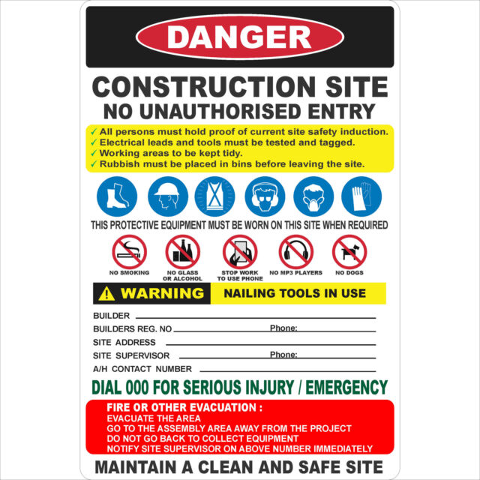

PELICAN CONSTRUCTIONS
837261 (07) 3288 2198
5 WYLMA STREET HOLLAND PARK
MATT CUMISKEY 0418 626 049
0418 626 049

Work health and safety policy

Pelican Constructions is committed to providing and maintaining a safe and healthy workplace for all workers (including contractors and volunteers) as well as clients, visitors and members of the public. Hazards and risks to health and safety will be eliminated or minimised, as far as is reasonably practicable.

The responsibility for managing health and safety ultimately rests with the person in control of the business or undertaking (PCBU), directors and management. Workers also have important responsibilities for health and safety in the workplace.

We are committed to complying with the Work Health and Safety Act 2011, the Work Health and Safety Regulation 2011, codes of practice and other safety guidance material.

Management will:
- Ensure the business complies with all legislation relating to health and safety
- Eliminate or minimise all workplace hazards and risks as far as is reasonably practicable
- Provide information, instruction and training to enable all workers to work safely
- Supervise workers to ensure work activities are performed safely
- Consult with and involve workers on matters relating to health, safety and wellbeing
- Provide appropriate safety equipment and personal protective equipment
- Provide a suitable injury management and return to work program

Workers will:
- Take reasonable care for their own health and safety
- Follow safe work procedures, instructions and rules
- Participate in safety training
- Report health and safety hazards
- Report all injuries and incidents
- Use safety equipment and personal protective equipment as instructed
- Work in accordance with Safe Word Method Statements (SWMS)

Our goal is to provide a safe and healthy work environment that is free from workplace injury and illness. This will only be achieved through the participation, co-operation and commitment of everyone in the workplace.

Name: | Matt Cumiskey | Position: | Owner
Signature: | 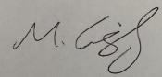 | Date: | 13/05/2008
Review date: | 10/01/2020
Hi Jim,

It is with great pleasure that I am sending this email to let you know that your application for the carpenter role with Pelican Constructions has been successful. We are very excited to have you joining our team and get started next Monday (3rd February 2020). Until then here are some links to some websites which refer to safety, anti-discrimination and equal opportunity employment information which we take very seriously at Pelican Constructions.

www.pelicanconstructions.com.au/aboutus/whspolicy

https://www.legislation.qld.gov.au/view/pdf/inforce/current/act-1991-085

If you could also please fill out an employee details form from the link below:

www.pelicanconstructions.com.au/aboutus/employeedetailsform

Please bring this with you next Monday and we will sort out all other paper work including signing you onto our SWMS and doing a site induction. Can’t wait to have you on board with us to help Pelican Constructions give our clients the best possible build with high quality workmanship.

Regards
Matt Cumiskey
Owner – Pelican Constructions
0418 626 049

