Jeremy Tydd
CPCCBC4007 Plan building or construction work

Construction plans.
Construction planning is the process of figuring out the most efficient and cost-effective method of arriving at a satisfactory construction project. The construction project plan is a roadmap that guides the project from conception to completion.

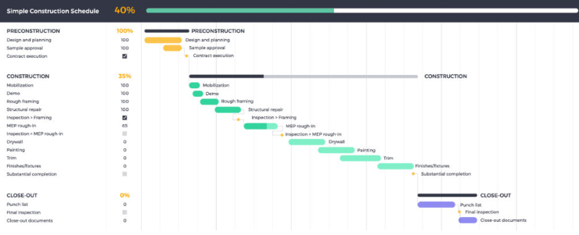

Preconstruction Site inspection
- Location & Boundaries:
Verify the exact location and boundaries of the project site against plans and permits. Check for any encroachments or conflicting structures.
- Topography & Drainage:
Assess the terrain, slope, and existing drainage patterns. Identify potential issues like flooding, erosion, or water accumulation.
- Soil Conditions:
Note soil type, stability, and any potential issues like soft soil, unstable slopes, or presence of hazardous materials.
- Utilities:
Identify and map existing utilities like electrical, gas, water, and communication lines. Ensure they are accessible and protected during construction.
- Environmental Considerations:
Note any environmental sensitivities like wetlands, endangered species habitats, or historical sites. Ensure compliance with environmental regulations.
2. Safety & Hazard Assessment:
- Access & Traffic:
Evaluate access routes for workers, equipment, and materials. Ensure safe and clear traffic routes, and proper signage.
- Site Security:
Check for adequate fencing, gates, and security measures to prevent unauthorized access and protect the site.
- Potential Hazards:
Identify potential hazards like unstable ground, hazardous materials, electrical hazards, and falling objects. Document and address any potential risks.
- Emergency Preparedness:
Ensure fire extinguishers, first-aid kits, and emergency communication systems are readily available and in good working order.
3. Compliance & Documentation:
- Permits & Licenses:
Verify all required permits and licenses are in place for the project.
- Contract Documents:
Review all contract documents, including plans, specifications, and schedules. Ensure everyone is aware of their responsibilities.
- Safety Regulations:
Ensure compliance with all relevant safety regulations and industry standards.
- Record Keeping:
Maintain a detailed record of the inspection findings, including photos, notes, and recommendations.
4. Other Important Considerations:
- Site Layout:
Plan and mark out the site layout, including staging areas, storage locations, and work zones.
- Storage & Material Handling:
Ensure adequate storage for materials and equipment, and implement safe material handling procedures.
- Welfare Facilities:
Verify the availability and cleanliness of restrooms, water coolers, and break areas for workers.
- Equipment & Tools:
Check the condition and functionality of any equipment or tools required for construction.

WHS policies and procedures

- Risk Assessment and Management:
Identify potential hazards and implement controls to minimize risks.
- Safe Work Method Statements (SWMS):
Develop and implement SWMS for high-risk tasks, ensuring safe working practices.
- Emergency Preparedness and Response:
Establish procedures for handling emergencies, including fire, medical incidents, and evacuations.
- Personal Protective Equipment (PPE):
Ensure that appropriate PPE is provided and used by all workers, such as hard hats, safety boots, and high-visibility clothing.
- Training and Education:
Provide comprehensive WHS training to all employees and contractors, including specific training for high-risk tasks.
- Communication and Consultation:
Establish clear communication channels for reporting hazards, incidents, and safety concerns.
- Reporting and Investigation:
Implement procedures for reporting accidents and incidents and investigating the root causes to prevent future occurrences.
- Compliance with Regulations:
Ensure that all WHS policies and procedures comply with relevant laws and regulations, such as the Work Health and Safety Act.
- Site-Specific Rules:
Develop and enforce site-specific rules that address unique hazards and risks associated with the construction project.
Specific WHS Requirements for Construction Work:
- Working at Heights:
Implement fall protection measures, such as guardrails, safety nets, and personal fall arrest systems.
- Electrical Work:
Ensure that all electrical work is performed by qualified electricians and that proper safety precautions are taken.
- Confined Spaces:
Establish safe work procedures for entering and working in confined spaces, such as trenches and underground structures.
- Handling Hazardous Substances:
Implement procedures for storing, handling, and disposing of hazardous chemicals and materials.
- Traffic Management:
Develop a traffic management plan to ensure the safe movement of vehicles and pedestrians on the construction site.
- First Aid and Emergency Response:
Ensure that adequate first aid supplies and personnel are available, and that emergency response procedures are in place.

