CPCCBC4001A
Apply building codes and standards to the construction process for low rise building projects

PRACTICAL ASSESSMENT INSTRUCTIONS

- The following practical assessment will require the participant to complete work related activities.
- Observations will be conducted of the participant’s work to determine whether they display sufficient practical skills and knowledge.
- Please fill in the details below, providing your name, signature and date of assessment.
  - Your signature acknowledges that the assessor provided clear instructions and the participant understood what was required to complete this assessment.
- The assessor may substitute a Practical Task with another task of equal value.
  - Alternate tasks must be fully documented by the assessor.

Participant name | Alexander Butler
Participant signature | 

Assessor name
Assessor signature | 

Date | Click here to enter a date.

Number of tasks | Number of tasks completed | Satisfactory?
1 (2X) |  | Yes | No

Assessor Comments
CPCCBC4001A
Apply building codes and standards to the construction process for low rise building projects

Practical Task 1 (2X)
Description of task:
On two (2) occasions, a suitable observer is to verify the participant’s ability to access, interpret and apply relevant building codes and standards.
- Occasion 1: Construction classified as Class 1 and 10 construction
- Occasion 2: Construction classified in Classes 2 to 9 with a gross floor area not exceeding 2000 square metres, not including Type A or Type B construction

These tasks may be simulated or real. The participant is to gather evidence of how they have completed each component of the Practical Task, which is to be submitted with this Practical Assessment sheet. The observer is to provide detailed comments on the tasks completed by the participant. The assessor is to verify the observer’s comments in the Assessor Comments section, and provide the Practical Assessment outcome on the front cover of this document.
Resources required:
Drawings and specifications, National Construction Code, Australian Standards, Relevant legislation.
Assessment of task
Name of participant: | Alexander Butler
Name of observer: | Conan Butler
Role of observer  (Confirm suitability to sign) | Operations manager
Email address of observer | conan@eastcoastconcrete.com.au
Signature of observer: | 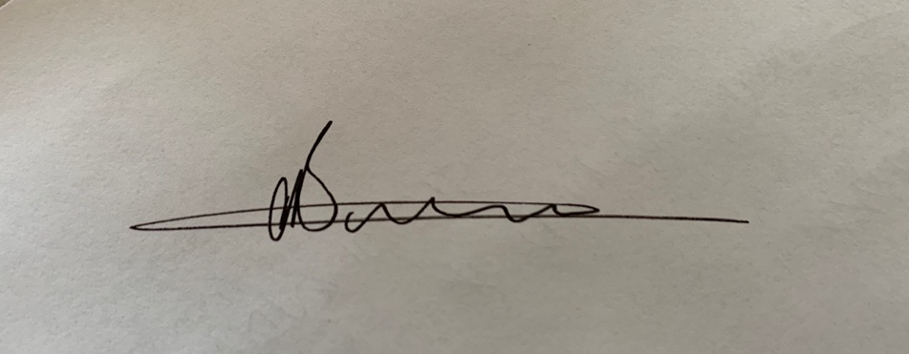
Date: | 13/09/2019
When completing the task, did the participant: |  | Tick if satisfactorily completed.  Provide comments if left unticked.
 |  | 1st  Occasion | 2nd  Occasion
1 Access and interpret codes and standards
- Identify relevant performance requirements from the National Construction Code that apply to individual projects described as low rise.
- Determine requirements of relevant National Construction Code deemed-to-satisfy (DTS) provisions.
- Access and interpret requirements of relevant Australian standards referenced in the National Construction Code.
2 Classify buildings
- Determine the nature of building according to its use and arrangement.
- Apply National Construction Code criteria to determine the defined classification.
- Identify and interpret National Construction Code requirements for multiple classification.
3 Solutions for compliance
- Determine range of criteria to ensure that construction methods comply with National Construction Code performance requirements.
- In accordance with company policy and procedures, discuss and propose alternative solutions to a design or construction problem that complied with National Construction Code requirements, considering basic design principles and the behaviour of materials and structures under stress, strain, compression, bending or combined actions.
- Identify and document performance-based solutions in accordance with National Construction Code requirements.
- Analyse and apply assessment methods referenced in the National Construction Code to determine whether a building solution complied with performance requirements or DTS provision.
- Identify and complete relevant documentation in accordance with National Construction Code requirements.
- Effectively communicate using the following methods:
- Language/concepts appropriate to cultural differences
- Non-verbal communication
4 Fire protection requirements
- Identify and apply passive and active fire control elements for low rise buildings, as required by the National Construction Code and other legislation (including WHS requirements).
- Determine level of fire resistance required for the construction of various low rise buildings.
- Check existing buildings for compliance with passive and active fire protection requirements, in accordance with National Construction Code requirements.
The participant’s performance was: Satisfactory Not Satisfactory

observer Comments
Alex successfully demonstrated that he could utilise his knowledge of the NCC.

