BSBITU302
Create electronic presentations
Learner Workbook



Table of Contents

Table of Contents 2
Candidate Details 3
Assessment – BSBITU302: Create electronic presentations 3
Competency Record to be completed by Assessor 4
Observation/Demonstration 5
Activities 6
Activity 1A 6
Activity 1B 7
Activity 2A 8
Activity 3A 11
Activity 3B 12
Activity 3C 13
Skills and Knowledge Activity 15
Major Activity 16

Candidate Details

Assessment – BSBITU302: Create electronic presentations
Please complete the following activities and hand in to your trainer for marking. This forms part of your assessment for BSBITU302: Create electronic presentations.
Name: Zoe Lwin
Address: 79 Waterview Avenue, Wynnum, 4178
Email: zoejade_98@hotmail.com
Employer: Lwins Cleaning
Declaration
I declare that no part of this assessment has been copied from another person’s work with the exception of where I have listed or referenced documents or work and that no part of this assessment has been written for me by another person.
Signed: ____________________________________________________________
Date: ____________________________________________________________
If activities have been completed as part of a small group or in pairs, details of the learners involved should be provided below;
This activity workbook has been completed by the following persons and we acknowledge that it was a fair team effort where everyone contributed equally to the work completed. We declare that no part of this assessment has been copied from another person’s work with the exception of where we have listed or referenced documents or work and that no part of this assessment has been written for us by another person.
Learner 1: ____________________________________________________________
Signed: ____________________________________________________________
Learner 2: ____________________________________________________________
Signed: ____________________________________________________________
Learner 3: ____________________________________________________________
Signed: ____________________________________________________________

Competency Record to be completed by Assessor
Learner Name: _______________________________________________________
Date of Assessment: _______________________________________________________
The learner has been assessed as competent in the elements and performance criteria and the evidence has been presented as;
Assessor Initials
Authentic
Valid
Reliable
Current
Sufficient

Learner is deemed: COMPETENT NOT YET COMPETENT (Please circle)

If not yet competent, date for re-assessment: ____________________________________

Comments from Trainer/Assessor:
__________________________________________________________________________________________________________________________________________________________________________________________________________________________________________________________________________________________________________________________________________________________________________________________________________________________
Assessor Signature: ________________________________________________________

Observation/Demonstration

Throughout this unit, you will be expected to show your competency of the elements through observations or demonstrations. Your instructor will have a list of demonstrations you must complete or tasks to be observed. The observations and demonstrations will be completed as well as the activities found in this workbook. An explanation of demonstrations and observations:
Demonstration is off-the-job
A demonstration will require:
- Performing a skill or task that is asked of you
- Undertaking a simulation exercise
Observation is on-the-job
The observation will usually require:
- Performing a work based skill or task
- Interaction with colleagues and/or customers
Your instructor will inform you of which one of the above they would like you to do. The demonstration/observation will cover one of the unit’s elements.
The observation/demonstration will take place either in the workplace or the training environment, depending on the task to be undertaken and whether it is an observation or demonstration. Your instructor will ensure you are provided with the correct equipment and/or materials to complete the task. They will also inform you of how long you have to complete the task.
You should be able to demonstrate you can:
- Prepare to create presentation
- Create presentation
- Finalise presentation
You should also demonstrate the following skills:
- Reading
- Writing
- Oral communication
- Navigate the world of work
- Interact with others
- Get the work done
Activities

Activity 1A
Estimated Time | 30 Minutes
Objective | To provide you with an opportunity to organise personal work environment in accordance with ergonomic requirements.
Activity | Take time to review the Australian Standard AS 3590 as it relates to workplace ergonomic requirements  Australian Standard AS 3590  SCOPE. This Standard specifies performance requirements for visual display units (VDUs) incorporating cathode-ray tubes. The Standard does not apply to CAD units or to test equipment. This Standard sets out guidelines for the evaluation, design, setting-up, and selection of furniture for desk-top, screen-based workstations in offices. The guidelines are aimed at selection of furniture and equipment that will suit particular screen-based tasks and encourage appropriate posture in screen-based equipment (SBE) operators. This Standard does not apply to special cases such as schools, where the height of counters, for example, might vary from those given. The Standard does not include requirements for wheelchair access.
  Comments
  Ergonomic Requirements:
  - Avoiding screen radiation
  - Chair, seat and back adjustment
  - Document holder
  - Footrest
  - Keyboard and mouse position
  - Lighting
  - Noise minimisation
  - Posture
  - Screen position
  - Workstation height and layout
  - Assessments of ergonomic conditions handled through Human resources dept. (HR) to evaluate risk as part of Workplace health and Safety (WHS).
  - Employers responsibility to provide a safe workplace
  - Supervisors, managers and team leaders are often designated WHS officers – responsibilities include hazard and accident reporting, safe work instructions, emergency procedures, supply of protective equipment etc.
  - Workplace Policy requirements: maintain clean, uncluttered work areas, carry out procedures safely and efficiently

Activity 1B
Estimated Time | 40 Minutes
Objective | To provide you with an opportunity to determine purpose, audience and mode of presentation in consultation with content author or presenter; identify presentation requirements in terms of supporting documents and equipment; and apply work organisation strategies and energy and resource conservation techniques to plan work activities.
Activity | Workplace Activity
  Detail from your workplace experience or discuss with the instructor alternative references, the practical examples of the following four elements discussed in this session.
  - How does your workplace organise personal work environment in accordance with ergonomic requirements?
  The location of furniture in the room, the layout of desk equipment, posture and environment can all personalised to ensure ergonomic requirements are met. As per organisational requirements, it is important that regular short breaks are taken and that the workload of each operator is controlled.
  - Detail your experiences in consultation with staff when researching content for a presentation or detail your workplace support in this area?
  Content authors are people who contribute to the content of a subject and/or have skills in assisting with designing a purpose, audience profile and mode of presentation. Within my role, I have had to consult with various personnel such as supervisors and team leaders, to acquire and research content for a presentation.
  - What levels of supporting documents, transparencies and equipment does your workplace provide?
  Various types of supporting documents and equipment are provided to meet presentation requirements. Organisational technology allows for delivery methods such as verbal, video, audio and visual presentation as well as scripts and story boards.
  - Detail the strategies and energy and resource conservation techniques provided in your workplace?
  In order to conserve energy and resources in the workplace, strategies are in place to ensure appropriate planning is carried out prior to completing a task or creating a presentation. This maximises efficiency and helps to save time and resources. Other strategies which are in place to improve quality of work include exercise breaks, rest periods and mixing up activates.

Activity 2A
Estimated Time | 30 Minutes
Objective | To provide you with an opportunity to create presentation.
Activity | Detail the actions and processes for a PowerPoint presentation used recently, currently or in the past in your workplace and address the elements listed in the activity below.
  Workplace Activity
  Establish your workplace designated timelines first!
  Designated time lines may include:
  - Organisational timeline e.g. conference deadline requirements
  - Timeline agreed with internal or external client
  - Timeline agreed with supervisor or person requiring presentation
  The first things to consider when preparing to create electronic presentations are timelines and planning. Establishing a timeline may involve consultation with a supervisor or external personal. Once a deadline is set, various stages of the task can be planned accordingly. Excel spreadsheets and charts can be used to help stay on track.
  Then, detail your findings for each step, how it was/can be achieved and maintain the agreed designated timelines.
  - Design slides, notes and handout masters and any task requirements in relation to image and preferred style
  After establishing a timeline for the completion of the task, think about the image and preferred style of the presentation with regard to organisational task requirements. Organisation requirements may include a company logo & colour scheme, company name, time, date, occasion, corporate image, music, company video clip etc. It is important to ensure the design doesn’t include distractions such as heavy colour, irrelevant information, overly busy background, overuse of sound or too many words per slide.
  Obviously, when designing a presentation, consideration must also be given to the purpose and intended audience.
  - Meet any identified presentation requirements using software functions for consistency of design and layout
  Software functions that can be used to enhance a presentation include backgrounds, colour schemes, templates, handout master, importing outlines, images and graphics, notes master, place holders and slide master. If manipulated appropriately, theses can be used to meet presentation requirements and improve consistency of design and layout.
  - Balance presentation features for visual impact and emphasis
  The basic components within a presentation need to be well balanced to create visual impact and emphasis. It is important for each slide to appear professional, which does not necessarily mean ‘fancy’. To be professional, the visual features need to be neat and organised, with appropriate emphasis given. Accurate spelling and grammar within a presentation are vital.
  - Detail any advanced software features used to streamline and customise the presentation for different audiences
  Advanced features that can be found using alternative software applications, can be used to fine tune a presentation and customise it to suit a purpose or audience. These features allow you to create a custom slide show, or perform on-the-spot customisation. One advantage of this is the flexibility to hide or skips slides if they don’t seem useful to a particular audience. Some examples of advanced software within PowerPoint include;
  - Animations and transitions
  - Photos, graphics, clip art
  - Custom shows
  - Sound, music, narration
  - YouTube videos and movies

Activity 3A
Estimated Time | 30 Minutes
Objective | To provide you with an opportunity to use manuals, user documentation and online help to overcome problems with design and production.
Activity
  Workplace Activity
  In groups of three or as directed by the instructor, discuss and detail the various advantages and disadvantages you have experienced in your workplace with accessing and using various types of user manuals, user documentation or online help to overcome workplace problems with design and production of a presentation using PowerPoint. Refer to the examples in the notes for a cross reference in similar or new issues.
  User manuals for software applications are designed to help the user overcome problems and act as a useful learning tool in understanding a program. Manuals may be found online, on your computer, websites, hard copy within box or folder, or on a CD or DVD. The applicability/helpfulness of a user manual will often depend on the skills and attitude of the user. While user manuals can be an advantage when problems arise, they do have drawbacks. At times, considerable time and effort may be required by the user, as manuals can be difficult to navigate and understand. Also, the terminology and instructions used within various help files and user guides may not be consistent, therefore, it may be necessary to first learn how a specific software relates to the manual.
  The quality of user documentation can be assessed by considering:
  - Does the documentation reflect the technical architecture of the product?
  - Does it contain understandable lists of errors and production hints?
  - How efficient is the integration of online documentation with the software?
  - Does it include clear instructions which address users directly?

Activity 3B
Estimated Time | Approx 1 Hour – Depending on how many groups there are
Objective | To provide you with an opportunity to check presentation for spelling and consistency in presentation features and style, in accordance with task requirements.
Activity | The five minute presentation  Either singularly or in groups, as determined by the instructor, allocate sufficient preparation time to prepare, and then present a 5 minute PowerPoint presentation.
  TIPS
  - Although your material may be limited for a five minute presentation, you still need to do sufficient research to understand your topic and extract the theme and objective.
  - Draw on your workplace experiences or current issues for examples.
  - Narrow down your topic to one core concept.
  - Allow some time to practice.
  - Five minutes is short, so if appropriate, lead with a compelling or controversial topic.
  - For a 5 minute presentation do not overload with lots of facts, figures and statistics or you will run out of time and will quickly lose your audience.
  (This is a practical function using both the requirements of your 5 minute presentation and the practical use of a variety of print needs, as per the examples below)
  Presentation materials may/can include:
  - Handouts
  - Outlines
  - Overhead transparencies
  - Paper printouts of presentation/slide show
  - Speaker notes
  - 35 mm slides (not applicable)
  - Website documents
  
  - Refer to attached PowerPoint Presentation
  
  
  
  
  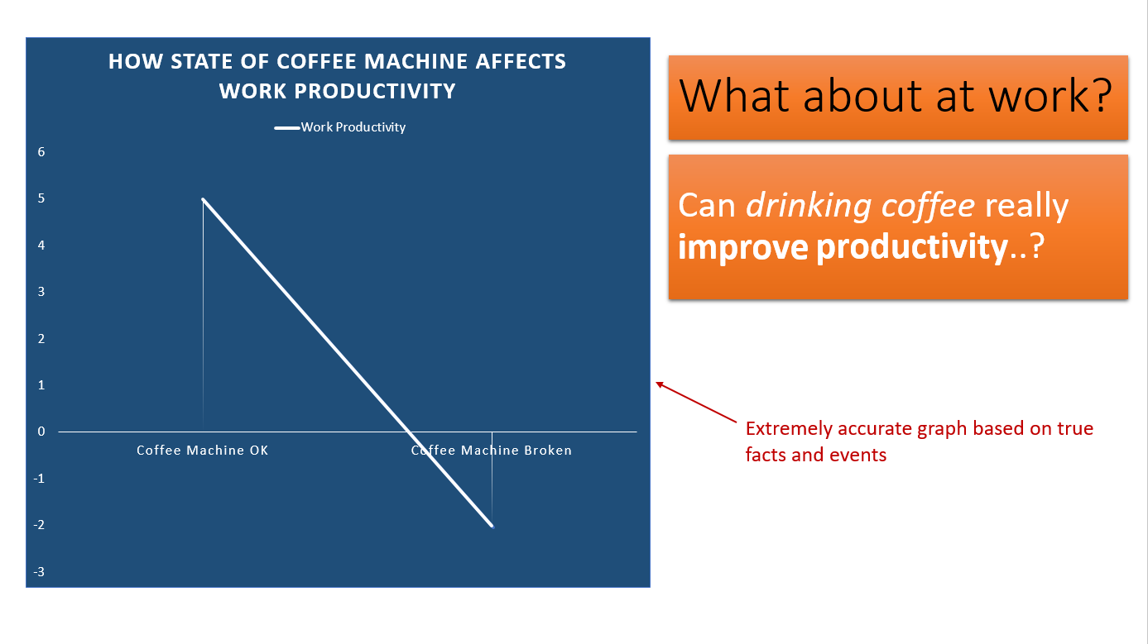
  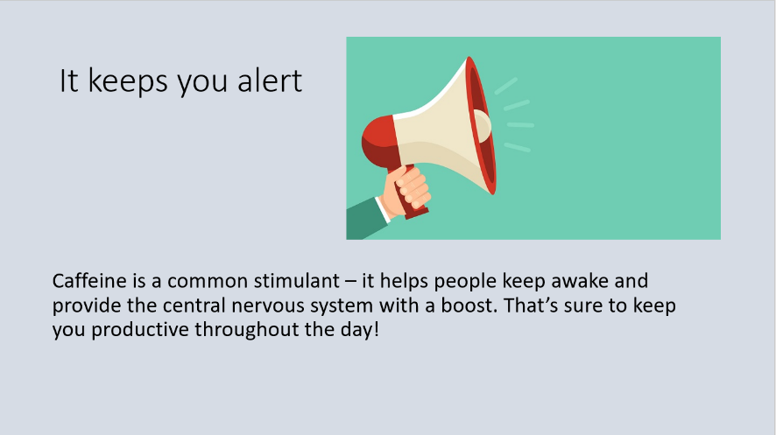
  
  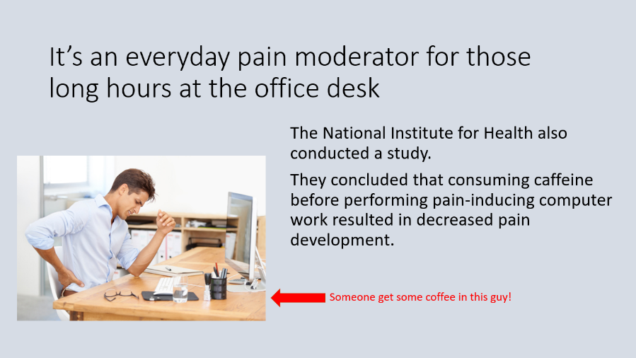
  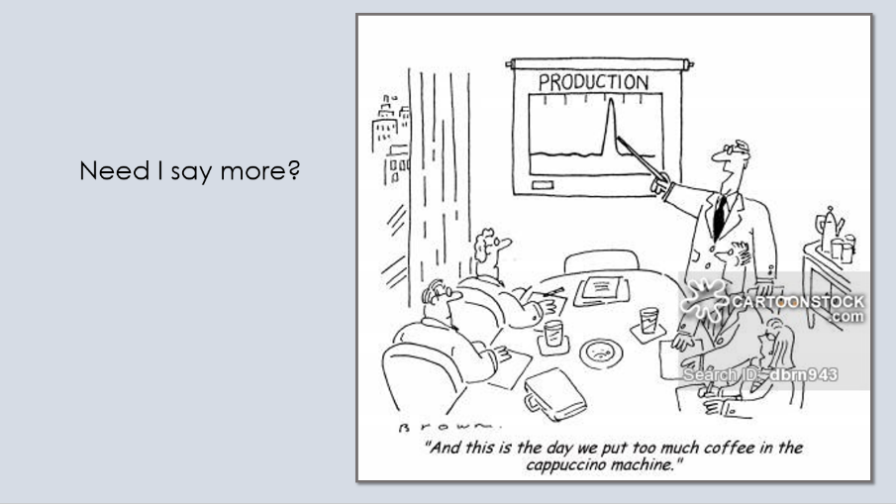
  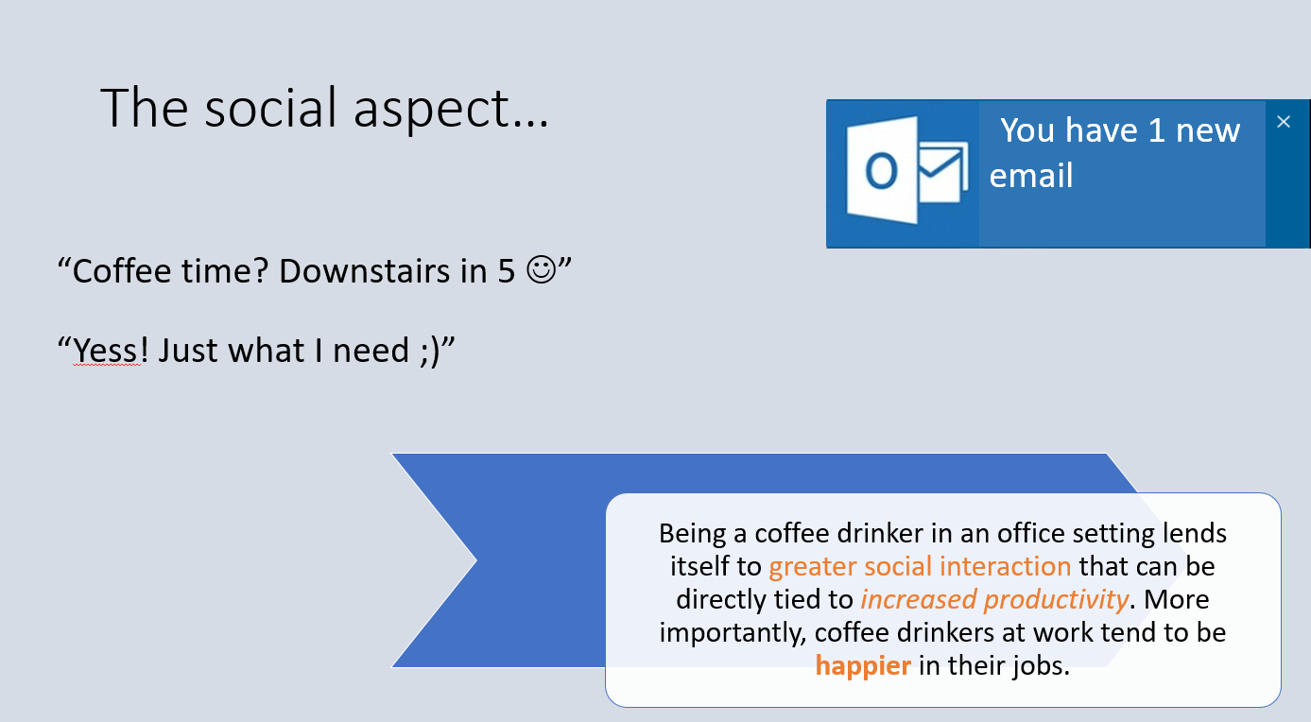
  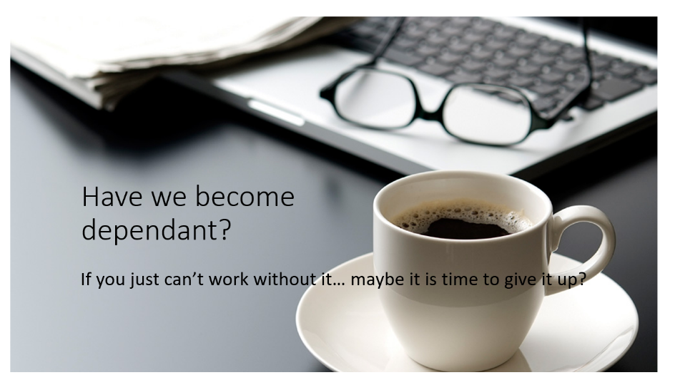
  
  

Activity 3C
Estimated Time | 30 Minutes
Objective | To provide you with an opportunity to print presentation materials in accordance with presenter or audience requirements; and store presentation, in accordance with organisational requirements and exit application without information loss or damage.
Activity | Detail your workplace experience on the suggested examples and areas to note for storing presentations.  Be prepared to discuss these with the class.
  Storing presentations | My workplace experience
  Authorised access | A system of maintaining authorised access when storing presentations ensures that confidentiality and privacy requirements are upheld.
  Filing locations | To keep an organised filing system, filing locations need to allow presentations to be easily located and accessed later on. Folders and files need to be sorted logically using appropriate file names.
  Organisational policy for backing up files | To avoid loss or damage to files, it is beneficial to make backups onto hard drives, thumb drives, CD-ROM, and other devices. This ensures important files and data are stored in more than one location.
  Organisational policy for filing hard copies | Within my organisation, hard copies have become less important as they take up a lot of space and presentations can be more easily stores and accessed electronically.
  Security | It is important to ensure that policies and procedures are in place to support the security of digital records. This way, all employees are following a common policy and security protocol.
  Storage in folders or sub-folders | A system of appropriately names folders and sub-folders helps to keep files well organised and easy to locate.
  Storage on disk drives, USB, CD-ROM, backup tapes, server | Some older forms of storage are vulnerable to obsolesce. Over time, storage devices such as CD-ROM and backup tapes have been replaced more up to date technological systems.

Skills and Knowledge Activity
Estimated Time | 1 Hour
Objective | To provide you with an opportunity to demonstrate your knowledge of the foundation skills, knowledge evidence and performance evidence.
Activity | Complete the following individually and attach your completed work to your workbook.  The answers to the following questions will enable you to demonstrate your knowledge of:  - Reading  - Writing  - Oral communication  - Navigate the world of work  - Interact with others  - Get the work done  - Key provisions of relevant legislation, standards and codes that affect aspects of business operations  - How design features affect the readability and appearance of electronic presentations  Answer each question in as much detail as possible, considering your organisational requirements for each one.  - Where would you find information about legislation and policies your organisation adheres to regarding presentations?  Written organisational policies regarding electronic presentations such as task requirements, storing presentations and ergonomic guidelines are stored in electronic computer files. Hard copies of these policies and procedures can also be located in the office filing system under the category of internal workplace information. Other information and requirements may be transmitted verbally through consultation with team leaders and supervisors.  - In your current role, how would you clarify the requirements of documents?  Within my role, I would clarify the requirements of documents by reviewing organisational and legislative policies. When creating presentations, I would also consult with various content authors to ensure all facts and details meet organisational standards. Consultation with supervisors and team leaders can also be helpful in this matter.  - Why are a diverse range of keyboard skills, advanced software and design features useful when creating presentations?  A diverse range of keyboard skills and knowledge of advanced software allows you to manipulate design features to enhance a presentation which helps the audience to gain an increased understanding of key concepts and ideas. Having the skill and knowledge to customise a presentation, enhance text and objects, work with other applications and manage slide shows etc. provides added versatility when designing presentations.  - In your current organisation, why are literacy skills an important aspect of creating and finalising presentations?  When finalising a presentation, it is important to be able to check the document for spelling and grammatical errors. Identifying and removing mistakes contributes to the overall professionalism of the presentation.  - How can processes you use within your organisation be flexible and interchangeable?  The processes used within my organisation allow for flexibility and individuality as each staff member developing presentations has the freedom to personalise and customise the document depending on their own ability to use the software, as well as the purpose and intended audience.

Major Activity
Estimated Time | 2 Hours
Objective | To provide you with an opportunity to demonstrate your knowledge of the entire unit.
Activity | This is a major activity – your instructor will let you know whether you will complete it during class or in your own time.  Attach your completed answers to the workbook.  You must individually, answer the following questions in full to show your competency of each element:  - Prepare to create presentation  - Create presentation  - Finalise presentation  - What ergonomic factors must be taken into account in your current role when organising your work environment?  Within my workplace, ergonomic factors such as avoiding screen radiation, chair, seat and back adjustment, lighting, noise minimisation and posture when working must be taken into consideration. As per organisational requirements, it is important that regular short breaks are taken and that the workload of each operator is controlled.  - In your current role how would you complete the following:  - Determine the purpose and audience of a presentation.  To determine the purpose and intended audience of a presentation, a checklist of your design can be completed in association with a content author or presenter. This would help to identify what is the central idea and most important information, and what other information is necessary to include.  - Identify required supporting documents of the presentation.  Depending on the purpose, intended audience and method of presentation, supporting documents may include handouts, outlines, overhead transparencies, paper printouts of presentation/slide show, speaker notes and website documents.  - Your organisation’s strategies for energy conservation relating to planning work activities.  In order to conserve energy and resources in the workplace, strategies are in place to ensure appropriate planning is carried out prior to completing a task or creating a presentation. This maximises efficiency and helps to save time and resources. Other methods of conserving energy include using power-save options for equipment.  - Create a five page presentation that you could be asked to create in your current role, keeping in mind the following:  - Organisation and task requirements.  - Software functions to maintain a uniform appearance between slides  - How can the presentation be altered to suit a different audience?  - See attached PowerPoint Presentation      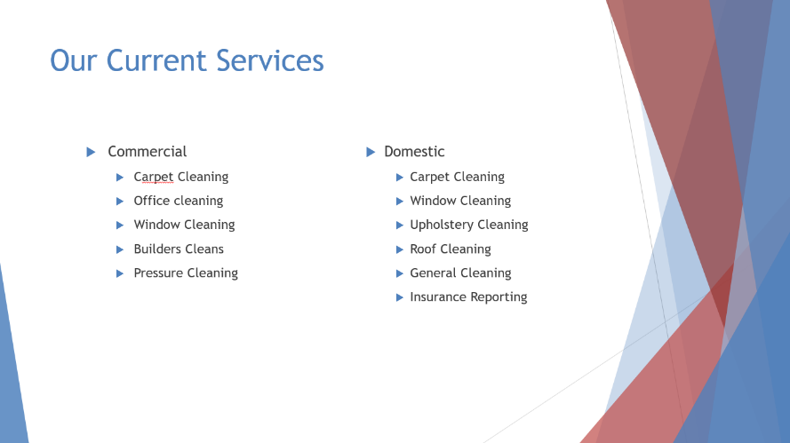  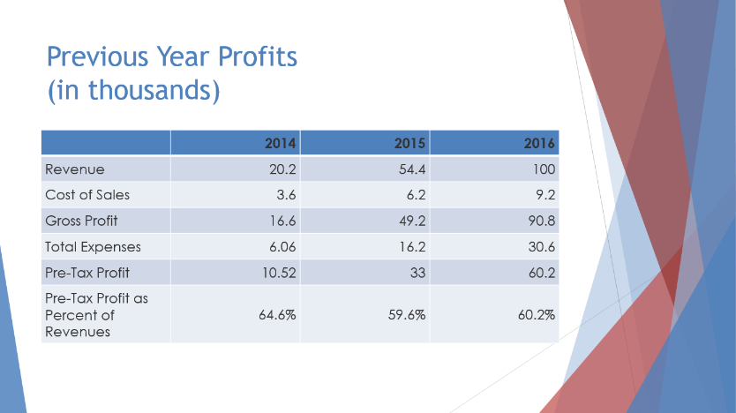  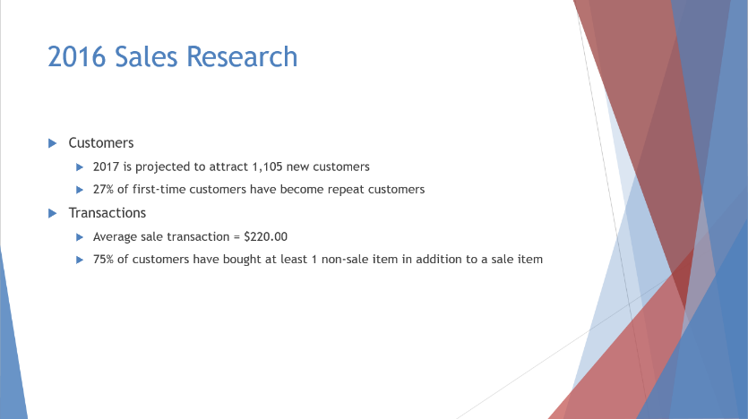  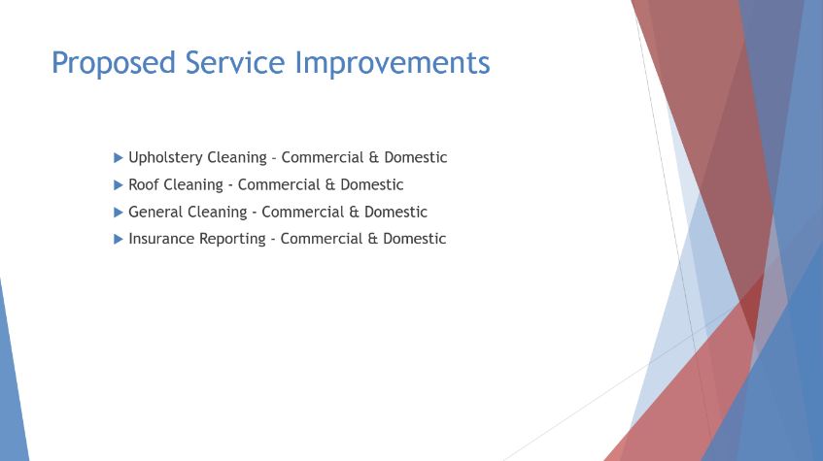  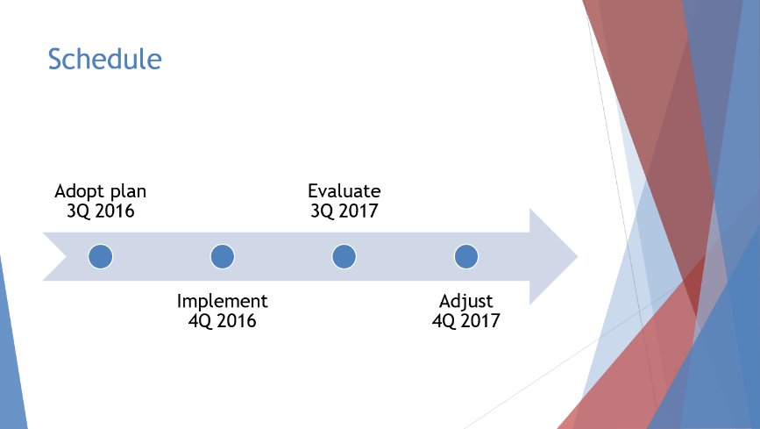    - What help is available or any problems you may encounter with presentation software?  When problems are encountered with presentation software, various forms of user manuals, user documentation and online help can assist in overcoming these. These manuals may be found online, on your computer, in hard copy or on a CD/DVD. External or inhouse help desks are also available to provide assistance.  - Using the presentation created in question three, complete the following:  - Proofread the document, correcting any errors you find.  Proofreading the presentation thoroughly allows you to correct errors in order to achieve a high level of professionalism. The presentation from question 3 has been checked for correct spelling and grammar, as well as consistency in presentation and design features.  - Print the presentation adhering to your organisation’s requirements.  Depending on the purpose of a document, an organisation may require printing in various forms. The above presentation has been printed to a pdf and saved on the computer as per organisational requirements.  - How would your organisation expect you to store the document?  It is important to ensure that the storage of presentations meets organisational requirements regarding authorised access, filing locations, security and file backups so that documents are not lost, corrupted or compromised. The presentation has been named and stored systematically within computer folders and sub-folders, and backed up onto an external drive.

