

CPCCBC4026
Arrange building applications and approvals
STUDENT PACK
Version Control
Unit code | Document version | Release date | Comments/actions
CPCCBC4026 | 10.1 | 30/05/2022 | First edition
CPCCBC4026 | 10.2 | 30/11/2022 | Minor amendments

Copyright
Copyright ©2021 by CAQA Resources.
Copyright protects this material. No part of this publication may be reproduced, distributed, or transmitted in any form or by any means, including photocopying, recording, or other electronic or mechanical methods, without the prior written permission of the publisher, except in the case of brief quotations embodied in critical reviews and certain other non-commercial uses permitted by Copyright Act 1968 (Cth). For permission requests, write to the publisher, addressed “Attention: Permissions Coordinator,” at the address below.
Enquiries should be addressed to:
CAQA Resources
2/10 Lawn Ct
Craigieburn, Victoria – 3064
Australia
www.caqaresources.com.au
Disclaimer
Although the author and publisher have made every effort to ensure that the information in this book was correct at press time, the author and publisher do not assume and hereby disclaim any liability to any party for any direct, indirect, incidental, or consequential loss, damage, or disruption caused by errors or omissions, whether such errors or omissions result from negligence, accident, or any other cause. Data and case study examples are intended to be fictional. Any resemblance to real persons or organisations is coincidental.
If you believe that information of any kind in this publication is an infringement of copyright, in material in which you either own copyright or are authorised to exercise the rights of a copyright owner, and then please advise us by contacting CAQA Resources, 2/10 Lawn Ct, Craigieburn, Victoria - 3064 or email copyright@careercalling.com.au.
Acknowledgement

This remains the property of CAQA Resources, a Career Calling initiative.

Student Pack

What is the purpose of this document?
The Student Pack is the document you, the student, needs to complete to demonstrate competency. This document includes the context and conditions of your assessment, the tasks to be completed by you and an outline of the evidence to be gathered.

The information includes the following:

- Information related to the unit of competency
- Guidelines and instructions to complete each task and activity

Link to other unit documents

- The Student Pack is a document for students to complete to demonstrate their competency. This document includes context and conditions of assessment, tasks to be administered to the student, and an outline of the evidence to be gathered from the student.
- The Unit Mapping is a document that contains information and comprehensive mapping with the training package requirements.

Student and trainer details
Student details
Full name: | Anya Eden English
Student ID: | 13784668
Contact number: | 0478944719
Email address: | anya@cogentscaffolding.com.au
Trainer details
Full name:

Qualification and unit of competency
Qualification/Course/Program Details
Code:
Name:
Unit of competency
Code: | CPCCBC4026
Name: | Arrange building applications and approvals
Releases: | 1.0
Release date: | 27/Nov/2020

Assessment Submission Method
☐ By hand to trainer/assessor ☐ By email to trainer/assessor
☒ Online submission via Learning Management System (LMS)
☐ Any other method _________________________________________________
(Please describe here)

Student declaration
- I have read and understood the information in the Unit Requirements prior to commencing this Student Pack
- I certify that the work submitted for this assessment pack is my own. I have clearly referenced any sources used in my submission. I understand that a false declaration is a form of malpractice;
- I have kept a copy of this Student Pack and all relevant notes, attachments, and reference material that I used in the production of this Student Pack;
- For the purposes of assessment, I give the trainer/assessor permission to:

  - Reproduce this assessment and provide a copy to another member of staff; and

  - Take steps to authenticate the assessment, including communicating a copy of this assessment to a plagiarism checking service (which may retain a copy of the assessment on its database for future plagiarism checking).

Student signature: ________________________________

Date: __09__/_05____/_2023_____________

Assessment Plan

The student must be assessed as satisfactory in each of the following assessment methods in order to demonstrate competence in a variety of ways.
Evidence number/ Task number | Assessment method/ Type of evidence/ Task name |  | Sufficient evidence recorded/Outcome
Assessment task 1 | Knowledge Test (KT) |  | S / NS (First Attempt)  S / NS (Second Attempt)
Assessment task 2 | Skill Test (ST) |  | S / NS (First Attempt)  S / NS (Second Attempt)
Assessment task 3 | Skill Test (ST) |  | S / NS (First Attempt)  S / NS (Second Attempt)
Outcome | C ☐ NYC ☐ | Date assessed: | Trainer signature:

Completion of the Assessment Plan

Your trainer is required to fill out the Assessment Plan Outcome records above, when:
- You have completed and submitted all the requirements for the assessment tasks for this cluster or unit of competency.
- Your work has been reviewed and assessed by your trainer/assessor.
- You have been assessed as either satisfactory or unsatisfactory for each assessment task within the unit of competency.
- You have been provided with relevant and detailed feedback.
Every assessment has a “Feedback to Student” section used to record the following information. Your trainer/assessor must also ensure that all sections are filled in appropriately, such as:
- Result of Assessment (satisfactory or unsatisfactory)
- Student name, signature and date
- Assessor name, signature and date
- Relevant and detailed feedback

Pre-Assessment Checklist: Task 1 - Knowledge Test
The purpose of this checklist
The pre-assessment checklist helps students determine if they are ready for assessment. The trainer/assessor must review the checklist with the student before the student attempts the assessment task. If any items of the checklist are incomplete or not clear to the student, the trainer/assessor must provide relevant information to the student to ensure they understand the requirements of the assessment task. The student must ensure they are ready for the assessment task before undertaking it.
Section 1: Information for Students
☒ Make sure you have completed the necessary prior learning before attempting this assessment.
☒ Make sure you understand what evidence is required to be collected and how.
☒ Make sure you know your rights and the Complaints and Appeal process.
☒ Make sure you discuss any special needs or reasonable adjustments to be considered during the assessment (refer to the Reasonable Adjustments Strategy Matrix - Appendix A and negotiate these with your trainer/assessor).
☒ Make sure that you have access to a computer and the internet (if you prefer to type the answers).
☒ Make sure that you have all the required resources needed to complete this assessment task.
☒ The due date of this assessment task is in accordance with your timetable.
☒ In exceptional (compelling and compassionate) circumstances, an extension to submit an assessment can be granted by the trainer/assessor. Evidence of the compelling and compassionate circumstances must be provided together with your request for an extension to submit your assessment work.
☒ The request for an extension to submit your assessment work must be made before the due date.
Section 2: Reasonable adjustments
I confirm that I have reviewed the Reasonable Adjustments guidelines and criteria as provided in Appendix A and attached relevant evidence as required and select the correct checkbox.
☐ I do require reasonable adjustment
☒ I do not require reasonable adjustment
Declaration (Student to complete)
☒ I confirm that the purpose and procedure of this assessment task has been clearly explained to me.
☒ I confirm that I have been consulted about any special needs I might have in relation to the assessment process.
☒ I confirm that the criteria used for this assessment has been discussed with me, as have the consequences and possible outcomes of this assessment.
☒ I confirm I have accessed and understand the assessment information as provided in the Training Organisation’s Student Handbook.
☒ I confirm I have been given fair notice of the date, time, venue and/or other arrangements for this assessment.
☒ I confirm that I am ready for assessment.

Student Name: __Anya English _____________________

Student Signature: ___________________________________

Assessment method-based instructions and guidelines: Knowledge Test
Assessment type

- Written Questions

Instructions provided to the student:

Assessment task description:

- This is the first assessment task you must successfully complete to be deemed competent in this unit of competency.
- The Knowledge Test is comprised of six (6) written questions
- You must respond to all questions and submit them to your Trainer/Assessor.
- You must answer all questions to the required level, e.g. provide an answer within the required word limit, to be deemed satisfactory in this task
Applicable conditions:

- All knowledge tests are untimed and are conducted as open book assessment (this means you can refer to your textbook during the test).
- You must read and respond to all questions.
- You may handwrite/use a computer to answer the questions.
- You must complete the task independently.
- No marks or grades are allocated for this assessment task. The outcome of the task will be Satisfactory or Not Satisfactory.
- As you complete this assessment task, you are predominately demonstrating your written skills and knowledge to your trainer/assessor.
Resubmissions and reattempts:

- Where a student’s answers are deemed not satisfactory after the first attempt, a resubmission attempt will be allowed.
- The student may speak to their trainer/assessor if they have any difficulty in completing this task and require reasonable adjustments.
- For more information, please refer to the Training Organisation’s Student Handbook.
Location:

- This assessment task may be completed in:

☐ a classroom
☐ learning management system (i.e. Moodle),
☐ workplace,
☐ or an independent learning environment.
Instructions for answering the written questions:

- Complete a written assessment consisting of a series of questions.
- You will be required to answer all the questions correctly.
- Do not start answering questions without understanding what is required. Read the questions carefully and critically analyse them for a few seconds; this will help you to identify what information is needed in the answer.
- Your answers must demonstrate an understanding and application of the relevant concepts and critical thinking.
- Be concise, to the point and write answers within the word-limit given to each question. Do not provide irrelevant information. Remember, quantity is not quality.
- You must write your responses in your own words.
- Use non-discriminatory language. The language used should not devalue, demean, or exclude individuals or groups based on attributes such as gender, disability, culture, race, religion, sexual preference or age. Gender-inclusive language should be used.
- When you quote, paraphrase, summarise or copy information from other sources to write your answers or research your work, always acknowledge the source.
Purpose of the assessment

This assessment task is designed to evaluate student’s knowledge essential to arrange building applications and approvals in a range of contexts and industry settings and knowledge regarding the following:
- Knowledge of the relevant government building legislation, codes and standards
- Knowledge of the plans, specifications and contracts
- Knowledge of the local authority building application processes:
- full approval
- staged approval
- development applications
- sustainability requirements
- fees and levies
- complaints and appeals
- Knowledge of the documentation requirements of building approval submissions:
- design briefs
- specialist's reports
- working drawings, plans, details and specifications
- Knowledge of the organisational quality assurance processes and practices:
- authorities and approval delegations
- document control
- Knowledge of the specialist services for certification of documentation:
- building surveyors, quantity surveyors and site surveyors
- geotechnical and environmental specialists
- structural, mechanical and electrical engineers.
Task instructions
- This is an individual assessment.
- To ensure your responses are satisfactory, consult a range of learning resources and other information such as handouts, textbooks, learner resources etc.
- To be assessed as Satisfactory in this assessment task, all questions must be answered correctly.

Assessment Task 1: Knowledge Test
Provide your response to each question in the box below.

Q1: | Answer the following questions regarding relevant government building legislation, codes and standards.  - Discuss the government building legislation relevant to building applications and approvals. Write your answer in 100-150 words.  - Discuss the government building codes and standards relevant to building applications and approvals. Write your answer in 100-150 words. | Satisfactory response
Q1: |  | Yes ☐ | No ☐
1.1. The government building legislation relevant to building applications and approvals include The Building Act 2011. The Building Act 2011 is the main legislation relevant to building applications and approvals in Australia as it governs the approval process. It also governs the registration of building service providers including building surveyors, and complaint resolution. An example is that the Building Act 2011 states that a Certificate of design compliance must be approved in an approved format and must include a statement from the building surveyor that the designs and specifications are compliant with building standards and if built will be safe.

1.2. The relevant government building codes and standards to building applications and approvals include The National Code of Conduct and The Building Code of Australia. The B.C.A. sets out technical provisions for the design and construction of buildings as well as other structures in Australia. The National Code of Conduct sets out the standard design of aspects of a building through a deemed to satisfy or a performance solution or both. These codes and standards are relevant to the applications and approvals for building because in order to apply and be approved for building work, the design and construction must be safe as consistent throughout all buildings.
Q2: | Answer the following questions regarding plans, specifications and contracts.  2.1. What are construction contracts? Write your answer in 100-150 words. | Satisfactory response
Q2: |  | Yes ☐ | No ☐
2.1. A construction contract is a legally binding documents that binds two parties, for example a builder and a client to a set out of roles that both agree on in order to complete the construction or building work. A contract is typically based on documented policies and conditions that specifies vital information including scope of work, risks, responsibilities and legal rights of the contractor and the owner. There are a few types of construction contracts including but not limited to, like subcontract, lump-sum contract. All types of contracts have to be signed by both parties before any works can begin.
Q3: | Answer the following questions regarding local authority building application processes:  3.1 Discuss the following local authority building application processes:  - full approval  - staged approval  - development applications  - sustainability requirements  - fees and levies  Write your answer in 100-200 words for each part.  3.2 List the organisations where you can make a complaint and appeal about building and construction projects. Write your answer in 100-200 words. | Satisfactory response
Q3: |  | Yes ☐ | No ☐
3.1.
a) Full approval in terms of following the local authority building application process, is getting approval from local authorities of the layout plan before any construction work can begin. This is for both residential and commercial buildings. In the application, there should be two copies of the plans that include the floor plans, elevations and sections, with a scale no less than 1:100, which may be accompanied by supporting calculations. The Full approvals are typically for larger newer builds that must include the appropriate charge that is required and the location or block plan that should be a scale of 1:1, 250.

b) A staged approval is when the applicant, normally the owner, submits the various building consent applications for the different stages of that buildings proposed construction work. A staged approval could be typically used for a multi-story buildings such as apartment buildings with multiple units or development blocks, because these builds or projects are typically built in stages. It is best to used staged approval for these types of projects to ensure each stage is complaint and safe and nothing is missed, being that these builds are so big. These staged approvals are very thorough as the scope of each component for the building are very well defined.

c) A development application also know as DA, is a request for consent that is typically formal, to execute the proposed building/development. The type of development could include, but not limited to changing the use of the land, subdividing land, performing building work or landscaping and cannot begin until the local council has approved the application. There are typically 4 stages; stage one – determine what type of project you are working on, this could be a commercial or residential building, demolition etc. Stage two is determining the type of evaluation that is required while stage three is deciding what kind of evaluation is required. Stage four, the Local Government Area will issue a decision notice, then development work may begin.

d) Sustainability requirements include, using sustainable building materials, using prefabricated material and discarding the construction waste responsibly. The first step is determining and using sustainable building materials, for example, concrete is surprisingly not environmentally friendly. Using prefabricated materials entails that materials such as doors, walls panels, floor panels, stairs, windows, walls and roof trusses are created in a controlled environment. This method is a low-cost and environmentally friendly way of producing building materials as well as they can be transported and assembled on the job site. Discarding the construction waste responsibly is another strategy that needs to be considered in order to have sustainability. Waste could include roofing, lumber, drywall, concrete, gravel, wiring, ductwork and glass and metal parts.

e) Fees and levies are applied for acting as a general contractor or construction manager to construct improvements, supervise and coordinate projects. These sort of fees are widely known as a Construction Fee as they provide improvements, supervise or coordinate construction projects. The Australian Parliament has put a levy on building and construction work that costs over $25, 000 (including G.S.T.) in Australia. This levy goes into a fund that is managed by the Long Service Corporation, which then distributes long-service payments to the building and construction workers. Another type of fee or other remuneration, known as Construction fee, refers to providing major repairs or rehabilitation on a property.

3.2. There are a few places where you can submit a complaint or appeal, for example your local council, your relevant building surveyor (R.B.S) or WorkSafe. Submitting a complaint or appeal can be for many reason, like things going wring during the construction of your project, and misunderstanding between plumber, contractual disputes or work that does not comply with the building codes. Your local council can help with planning or urgent safety issues relating to building work. The relevant building surveyor are best with helping to ensure plans and the building work are compliant with building laws and regulations. While, WorkSafe is best with helping with concerns about unsafe building sites.

Q4: | Answer the following questions regarding documentation requirements of building approval submissions:  4.1. Discuss the following documentation requirements of building approval submissions:  - design briefs  - specialist's reports  - working drawings  - plans  - details  - Specifications  Write your answer in 50-100 words for each part.  4.2. What are the steps of documentation approval for the building and construction project? Write your answer in 100-200 words.  4.3. Explain the purpose of the following working drawings and plans in 40-80 words each.  - Site Plan  - Cross Section  - Elevation  Write your answer in 50-100 words for each part. | Satisfactory response
Q4: |  | Yes ☐ | No ☐
4.1.
a) A design brief documentation is classes in project management with details of the design of a project. Fortunately, there is no standard to follow with what should be included in a design brief but some of the common points that may be included are the design project overview and scope, timelines, information about the target audience and budget.

b) A specialist’s report that is usually needed for a initial valuation or survey is done by a specialist contractor. A specialist contractor caries out activities in the development of building and construction that required specialist construction knowledge and skill. The specialists reports are usually entails specific issues including damp, drainage or structural as well as on occasion more specific issues including wall ties, tree risks, asbestos or environmental hazards.

c) Working drawings are used to provide dimensional and graphical information that can be used by a contractor to construct the works or for suppliers to fabricate the works components and assemble or install components. Working drawings may include but not limited to the following; title blocks, dimensions, notation and symbols.

d) Plans are working drawings that contain information about the construction work in order for the contractor or supplier to fabricate, assemble and install instalments. Types of plans include architectural, structural, civil mechanical or electrical and can be presented in a site map, floor plans, sectional views or elevations, which all have a specific purpose when needing to see different aspects of a building.

e) details or detailed drawings are vital when needing to see a close up of a certain aspect of a drawing. They depict precise descriptions of the drawings dimensions and shape. They may include title blocks and symbols to simplify and make easier to comprehend. For example, structural steel drawing, which shows the location of each structural steel material used in the building.

f) Specifications are the written descriptions, instructions and information about the plans for the building or project, that aren’t typically included in the drawings themselves. This is for the builder, contractor or worker to better find information on what they are building. Specifications are vital because they entail how a building is to be constructed or developed.

4.2.
There are 4 steps of documentation approval for a building project. Step 1 – Design Documents, Step 2- Development Application (D.A.), Step 3 Construction Documents and Step 4 construction certificate (C.C.). During the Design documents process, the concept drawings are created and reviewed by the client with their feedback to then be developed into more detailed drawings. Once these drawings are finalised and there has been an assessment to see if it meets the required energy efficient criteria, then it is time to prepare the development application which requires a quite in depth level of detail in order for the local council to approve. A D.A. is the approval of the design of the structure, however does not permit the commencement of the construction of the project as the council does not consider the building construction, fire safety and structural support of the structure. Once the designs have been approved, the development of construction documents can begin. These documents include the method of construction, the structural system, the wall, floor and roof materials and etc. Thes also include site plans, elevation and section, details and specifications. The last step is getting the construction certificate, only then can construction work begin.

4.3.
a) Site plan also called site map is a drawing that details the overall layout of the building site and structure. The site map must show all utility connections including the drainage and sewer lines, water supply, electricity and communications cables and outdoor lighting. It demonstrates the boundaries and access points of the site as well as any significant surrounding structures.

b) A cross section or a sectional view is a drawings that demonstrates the inside of a structure if it was cut in half by an imaginary line. Its main purpose is to view the dimensions and thicknesses of the structural components and to show the sill height, lintel height and floor height.

c) An elevation drawings depicts the side views of the structure including the front, back and sides. The main purpose of elevations is to demonstrate the finished appearance of the specific side of the building as well as to provide information about the vertical heights.
Q5: | Discuss what should be included in organisational quality assurance processes and practices for the following:  - authorities and approval delegations  - document control  Write your answer in 150-200 words for each part. | Satisfactory response
Q5: |  | Yes ☐ | No ☐
a) In organisational quality assurance it is most common for a organisation to have a group of primarily responsible and having a Quality Manager. A Quality Manager is responsible for ensuring that products and processes meet predetermined standards, with the authority to do whatever is necessary in assuring that this is achieved. Approval Delegation is a feature on Service Manager 9.51 that allows users to delegate their approval authority to another qualified operator. This allows the operator to use the Approval Delegation Wizard to delegate their approvals. There are a few options available in the wizard; assign all approvals to another competent person, assign approvals for a specific application and delegate approvals from a starting date to a finishing date. This software is an example of what should be included in quality assurance to ensure a organisation is following the processes and practices during the complete cycle of a construction of a structure.

b) Document control is key for an organisations quality assurance to ensure that the company is following all processes and practices. Version data is an example of how to control documents to ensure that documents are not out of date. It is quite crucial to ensure that the set of drawings or specifications that you are working with are not out of date as it could lead to waste of time and material. Applications such as PlanGrid allow documents to be automatically tracking version data. This ensures that everyone, including designers and architects are on the same page when working and ensure that they can compare changes to previous revisions. Central and single source is another example of how to document control. This allows the company to find documents easily when they are a centralised source for storage and document control. These two examples of document controls should be included in organisational quality assurance processes and practices to ensure that everyone is on the same page and documents don’t start to go missing and the organisation begins to become unorganised.

Q6: | Explain the purpose of the following specialist services for certification of documentation:  - building surveyors, quantity surveyors and site surveyors  - geotechnical and environmental specialists  - structural, mechanical and electrical engineers  Write your answer in 150-200 words for each part. | Satisfactory response
Q6: |  | Yes ☐ | No ☐
a) The purpose of a building surveyor is to ensure that the design if a new building meets the applicable building standards, that the structure was built following the specified plans and specifications, that the existing buildings meet applicable building standards that the building in its current form is safe to occupy and use in the manner proposed. On the other hand, quantity surveyors give advice on financial and contractual issues that are about the project as well as prepare the quantities bills and perform other financial and material support required. Their main purpose is the financial and material advice they are able to provide. Site surveyors take precise measurements to determine the boundary lines and prepare construction sites to avoid legal disputes. Their main purpose is to provide information about the shape and contour of the Earth’s surface for the purpose of engineering, mapping and construction projects. Although the three have different jobs they all provide the same purpose which is to ensure that the structure and area is safe and to ensure that the building and site has the right certification documents to comply with legislations.

b)
The geotechnical engineer will collect soil samples and determines the stress-bearing tasks, with identifying if there are any of the following problems; failure to load problems, deformation problems and flow problems. If one of these problems were to occur, it could be solved by using experimental modelling, theoretical modelling or experience. Although the geotechnical engineers purpose is to investigate the subsurface of the project area, the environmental specialists purpose is to inspect the sites locations and environmental impact. They make recommendations for the design, implementation and modification of government or commercial environmental operations to ensure that the construction is site meets all the compliance of all environmental regulations and standards. With these people documenting this important information and ensuring that designs and specifications comply with the soil and environmental issues mean that the project structure is safe and compliant to build and use. Without this certification, the construction of the site could become dangerous, or add to the destruction of the environment.

c) A structural engineer should be hire to look at your plans and specifications before you begin building your structure, not after, to ensure that the framing plans, member sizes, beams and column support roof framing sizes and support and foundation are complaint and safe. They are hired when sketching the plans begin. Their main purpose of structural engineers is designing and constructing safe structures and ensuring that they stand through elements that they are exposed to. However, mechanical engineers are concerned with the study, design, development, construction and testing of mechanical and thermal sensors and devices. This includes tools, engines and machines. On the other hand, electrical engineers are concerned with developing cost estimates for materials and labour, estimate manpower and timelines to provide project managers with necessary information about contractor bids to keep the project on budget. They are also concerned with the designing, developing and maintaining the electrical systems in the structure ensuring they are safe and compliant.

Assessment Results Sheet
Outcome | Outcome (make sure to tick the correct checkbox):  Satisfactory (S) ☐ or Not Satisfactory (NS) ☐  Date: _______(day)/ _______(month)/ _______(year)  Feedback:  Outcome (please make sure to tick the correct checkbox):  Satisfactory (S) ☐ or Not Satisfactory (NS) ☐  Date: _______(day)/ _______(month)/ _______(year)  Feedback:
  First attempt:
  Second attempt:
Student Declaration | - I declare that the answers I have provided are my own work. Where I have accessed information from other sources, I have provided references and/or links to my sources.  - I have kept a copy of all relevant notes and reference material that I used as part of my submission.  - I have provided references for all sources where the information is not my own. I understand the consequences of falsifying documentation and plagiarism. I understand how the assessment is structured. I accept that the work I submit may be subject to verification to establish that it is my own.  - I understand that if I disagree with the assessment outcome, I can appeal the assessment process, and either re-submit additional evidence undertake gap training and or have my submission re-assessed.  - All appeal options have been explained to me.
Student Signature
Date | 09/05/2023
Trainer/Assessor Name
Trainer/Assessor Declaration | I hold:  ☐ Vocational competencies at least to the level being delivered  ☐ Current relevant industry skills  ☐ Current knowledge and skills in VET, and undertake  ☐ Ongoing professional development in VET  I declare that I have conducted an assessment of this student’s submission. The assessment tasks were deemed current, sufficient, valid and reliable. I declare that I have conducted a fair, valid, reliable, and flexible assessment. I have provided feedback to the student.
Trainer/Assessor Signature
Date
Office Use Only | The outcome of this assessment has been entered into the Student Management System  on _________________ (insert date)  by (insert Name) __________________________________

Pre-Assessment Checklist: Task 2 – Skill Test
The purpose of this checklist
The pre-assessment checklist helps students determine if they are ready for assessment. The trainer/assessor must review the checklist with the student before the student attempts the assessment task. If any items of the checklist are incomplete or not clear to the student, the trainer/assessor must provide relevant information to the student to ensure they understand the requirements of the assessment task. The student must ensure they are ready for the assessment task before undertaking it.
Section 1: Information for Students
☒ Make sure you have completed the necessary prior learning before attempting this assessment.
☒ Make sure you understand what evidence is required to be collected and how.
☒ Make sure you know your rights and the Complaints and Appeal process.
☒ Make sure you discuss any special needs or reasonable adjustments to be considered during the assessment (refer to the Reasonable Adjustments Strategy Matrix and negotiate these with your trainer/assessor).
☒ Make sure that you have access to a computer and the internet (if you prefer to type the answers).
☒ Make sure that you have all the required resources needed to complete this Assessment Task (AT).
☒ The due date of this assessment task is in accordance with your timetable.
☒ In exceptional (compelling and compassionate) circumstances, an extension to submit an assessment can be granted by the trainer/assessor. Evidence of the compelling and compassionate circumstances must be provided together with your request for an extension to submit your assessment work.
☒ The request for an extension to submit your assessment work must be made before the due date.
Section 2: Reasonable adjustments
I confirm that I have reviewed the Reasonable Adjustments guidelines and criteria as provided in Appendix A and attached relevant evidence as required and select the correct checkbox.
☐ I do require reasonable adjustment
☒ I do not require reasonable adjustment
Declaration (Student to complete)
☒ I confirm that the purpose and procedures of this assessment task has been clearly explained to me.
☒ I confirm that I have been consulted about any special needs I might have in relation to the assessment process.
☒ I confirm that the criteria used for this assessment has been discussed with me, as have the consequences and possible outcomes of this assessment.
☒ I confirm I have accessed and understand the assessment information as provided in the Training Organisation’s Student Handbook.
☒ I confirm I have been given fair notice of the date, time, venue and/or other arrangements for this assessment.
☒ I confirm that I am ready for assessment.
Student Name: ____Anya English ______________
Student Signature: ___________________________________

Assessment method-based instructions and guidelines: Skill Test
Assessment type

- Skill Test - Arrange building applications and approvals

Instructions provided to the student:

Assessment task description:

- This is the second assessment task you must successfully complete to be deemed competent in this unit of competency.
- This assessment task is a Skills Test.
  - This assessment task consists of three (3) practical demonstration activities.
      - Activity 1: Develop and review a submission plan.
      - Activity 2: Prepare and lodge application.
      - Activity 3: Manage application process.
- You must attempt all activities of the project for your trainer/assessor to assess your competence in this assessment task.
Applicable conditions:

- This skill test is untimed and is conducted as an open book assessment (this means you are able to refer to your textbook or other learner materials during the test).
- You will be assessed independently on this assessment task.
- No marks or grades are allocated for this assessment task. The outcome of the task will be Satisfactory or Not Satisfactory.
- As you complete this assessment task, you are predominately demonstrating your skills, techniques and knowledge to your trainer/assessor.
- Your trainer/assessor may ask you relevant questions during this assessment task
Resubmissions and reattempts:

- Where a student’s answers are deemed not satisfactory after the first attempt, a resubmission attempt will be allowed.
- The student may speak to their trainer/assessor if they have any difficulty in completing this task and require reasonable adjustments.
- For more information, please refer to the Training Organisation’s Student Handbook.
Location:

- This assessment task may be completed in:

☐ a classroom
☐ learning management system (i.e. Moodle),
☐ workplace,
☐ or an independent learning environment.
Purpose of the assessment

The purpose of this assessment task is to assess the student’s knowledge and skills essential to arrange building applications and approvals in a range of contexts and industry settings.
- Skills to identify the project stages that require approvals and create a submission plan.
- Skills to determine the level and type of information and documentation required for each approval stage.
- Skills to consult with outside experts to help with document certification.
- Skills to examine the submission plan to ensure that all client needs are addressed and met.
- Skills to prepare documentation and supporting information to ensure compliance with the building approval authority's requirements.
- Skills to adopt strategies to minimise the application's impact on stakeholders while maintaining their support.
- Skills to submit the application and any supporting documentation with approval authority.
- Skills to notify the appropriate person of the need to pay fees by the due dates and terms.
- Skills to ensure continued progress, seek confirmation of application status at appropriate intervals.
- Skills to assess the status of building approvals and notify stakeholders.
- Skills to examine minor changes to see how they affect the project.
- Skills to analyse the best course of action for maintaining project continuity in the face of rejected submissions, resubmissions, or appeals.
- Skills to use digital tools and devices to communicate and collaborate effectively with others.
- Skills to use equipment and programs to access and extract information and develop relevant documentation.
- Skills to Liaise with clients, stakeholders, specialists and approval authorities to negotiate amendments, confirm requirements and share information.
Task instructions
- This is an individual assessment.
- The purpose of this assessment task is to prepare and submit building applications to appropriate authorities for approval and manage the submission through to its final approval.
- The student must asess the NCC codes for relevant class of the building to perform the activities specified in the assessment task.
- The student will be required to communicate effectively with clients, building professionals and planning officers.
- The student must supervise the various aspects of the construction.
- The trainer/assessor must assess the performance as per the performance criteria and checklist provided.

Assessment Task 2: Skills Test
Skills Test:
This assessment task requires the student to prepare, submit and manage a Residential building and construction application for approval. This includes:
- Developing a submission plan that includes the following:
  - stages and dates for submission of applications
  - forms, documents and supporting evidence required to be submitted
  - application fees, charges and costs.
- Preparing and lodging application.
- Managing application process.
This assessment task will be performed on a Residential building.
Note: The above specifications for the building are compulsory to meet the requirements of the National Construction Code (NCC).
During the completion of this assessment task, you will be required to communicate effectively with clients, building professionals and planning officers.
To arrange building applications and approvals, you are required to complete the following activities:
- Activity 1: Develop and review a submission plan.
- Activity 2: Prepare and lodge application.
- Activity 3: Manage application process.

Instructions for trainer/assessor:
- The trainer/assessor must arrange a worksite for the student to carry out the specified project.
- The workplace must be:
  - An actual workplace
  - A close simulation of the workplace environment provided that simulated or project-based assessment techniques replicate construction workplace conditions, materials, activities, responsibilities and procedures
Note: The requirements for a simulated workplace environment are given below.
- The structure must be a Residential building.
- The role of the Supervisor (trainer/assessor) is to allocate the tasks, activities and responsibilities that you will be required to undertake to complete these assessments.
- The worksite must meet the requirements given in the ‘Simulated workplace environment requirements’ section given below.
- The trainer/assessor must ensure that if the assessment task is to be conducted in a simulated environment, it must replicate workplace conditions, materials and equipment, interactions with others and workplace irregularities and meets industry standards for safety and environmental practices.
Instructions for the student:
- The student will be required to bring all necessary PPEs required to complete this activity.
- The student must follow the instructions provided by the Supervisor.
- The student must complete the activities specified.

Simulated workplace environment requirements
The student is required to have access to a workplace or a close simulation of the workplace environment to replicate construction workplace conditions and standards, materials, activities, responsibilities, procedures, safety requirements and environmental considerations to each student.
Further, the training organisation must ensure the construction site must meet the requirements given in the table below.
The training organisation must ensure that the student has access to the following:
- WHS legislation and regulations
  - Model WHS Act (Provide along with this assessment task)
  - Model WHS Regulations (Provide along with this assessment task)
- Current building and construction codes and standards
  - https://www.abcb.gov.au/
  - https://ncc.abcb.gov.au/editions/2019-a1/ncc-2019-volume-one-amendment-1/contents-and-introduction/introduction-ncc-volume
  - https://ncc.abcb.gov.au/editions/2019-a1/ncc-2019-volume-two-amendment-1/contents-and-introduction/copyright-and-licence
  - https://ncc.abcb.gov.au/editions/2019-a1/ncc-2019-volume-three-amendment-1/contents-and-introduction/introduction-ncc
- NCC Volume 1 – Volume 3 (Provided along with this assessment)
- Organisational quality policies and procedures
- Workplace safety requirements
- Project plans and specifications
- Manufacturer specifications and installation instructions
- Local authority building approval processes and application forms
- Sufficient materials and equipment to facilitate arrange building applications and approvals
- Business equipment and technology, applications and software.

The worksite must have realistic tasks or simulated tasks, relevant specifications and work instructions, standard work practices, safety requirements and environmental constraints.
The site and its surroundings are accessible and clear of hazards, so far as reasonably practicable.
The site must have realistic workplace conditions, standards, materials, activities, responsibilities, procedures, safety requirements, and environmental considerations.
An experienced employee is available to provide adequate guidance and supervision to less experienced employees.
The students have the clothing and footwear required. In addition, the clothing and footwear are in good condition and suitable for the task.

Workplace Scenario
You are working as a project manager in a construction company. Your organisation has received a project to construct a residential house.
As a project manager, you must prepare and submit building applications to appropriate authorities for approval and manage the submission through to its final approval.
This includes:
- Developing a submission plan that includes the following:
  - stages and dates for submission of applications
  - forms, documents and supporting evidence required to be submitted
  - application fees, charges and costs.
- Preparing and lodging application.
- Managing application process.
Task requirements:
To prepare and submit building applications to appropriate authorities for approval and manage the submission through to its final approval, you will be required to demonstrate your skills and knowledge in the following areas:
- Identify the project stages that require approvals and create a submission plan.
- Determine the level and type of information and documentation required for each approval stage.
- Consult with outside experts to help with document certification.
- Examine the submission plan to ensure that all client needs are addressed and met.
- Prepare documentation and supporting information to ensure compliance with the building approval authority's requirements.
- Adopt strategies to minimise the application's impact on stakeholders while maintaining their support.
- Submit the application and any supporting documentation with approval authority.
- Notify the appropriate person of the need to pay fees by the due dates and terms.
- To ensure continued progress, seek confirmation of application status at appropriate intervals.
- Assess the status of building approvals and notify stakeholders.
- Examine minor changes to see how they affect the project.
- Analyse the best course of action for maintaining project continuity in the face of rejected submissions, resubmissions, or appeals.
- Use digital tools and devices to communicate and collaborate effectively with others.
- Use equipment and programs to access and extract information and develop relevant documentation.
- Liaise with clients, stakeholders, specialists and approval authorities to negotiate amendments, confirm requirements and share information.
Roles and responsibilities (Supervisor):
The Supervisor must:
- Ensure that the student is clear about the task requirements.
- Supervise the student performing the task.
- Observe them against the observation checklist provided after each activity.

Skills Test:
This assessment task requires the student to prepare, submit and manage a Residential building and construction application for approval. This includes:
- Developing a submission plan that includes the following:
  - stages and dates for submission of applications
  - forms, documents and supporting evidence required to be submitted
  - application fees, charges and costs.
- Preparing and lodging application.
- Managing application process.
This assessment task will be performed on a Residential building.
Note: The above specifications for the building are compulsory to meet the requirements of the National Construction Code (NCC).
During the completion of this assessment task, you will be required to communicate effectively with clients, building professionals and planning officers.
To arrange building applications and approvals, you are required to complete the following activities:
- Activity 1: Develop and review a submission plan.
- Activity 2: Prepare and lodge application.
- Activity 3: Manage application process.

Activity 1: Develop and review a submission plan – Residential building.
This activity requires you to Develop and review a submission plan – Residential building.
To complete this activity, you are required to:
- Complete the steps given in the ‘Checklist 1’ provided.
- Access and interpret NCC codes and relevant Australian Standards referenced in the NCC.
- Complete Template 1 & 2.
While completing each step, you must place a tick mark against each step given in the checklist once completed.
Instructions for trainer/assessor:
- The student should access to the following documents:
  - Project plans and specifications.
  - Material specifications
  - NCC Vol 1- Vol 3 (Provided along with this assessment)
  - Model WHS Law and regulations (Provided along with this assessment)
  - Environmental requirements and sustainability principles
  - Manufacturer’s materials and product specifications and installation instructions for building materials in the project specifications
  - Project plans, design brief, working drawings and specifications.
  - Manufacturer specifications and installation instructions
  - Local authority building approval processes and application forms
  - Sufficient materials and equipment to facilitate arrange building applications and approvals
Instructions for the student:
- The student must:
  - Identify the project stages that require approvals and create a submission plan.
  - Consult with outside experts to help with document certification.
  - Examine the submission plan to ensure that all client needs are addressed and met.
After completing this task, submit the following to your assessor:
- A completed Checklist 1 and Template 1 & 2,
- A completed Performance Criteria/Checklist – Activity 1 & 2
- Copies of any emails/screenshots used to communicate with outside experts to assist with document certification
- Copies of the construction project documents you sourced in completion of this activity.

Checklist 1: Develop and review a submission plan.
Steps | Tick mark, once completed
Step 1: Identify the project stages that require approvals and create a submission plan.  - Identify the project stages that require approval from local authority and dates for submission.  - Consult local authorities to confirm requirements.  - Document the identified stages and dates for submission of applications using Submission Plan (Template 1).  - Determine the level and type of information and documentation required for each approval stage.  - Analyse the outcomes of Step 1 to identify the project stages that require approval.  - Determine the level and type of information and documentation required for each approval stage and document using Submission Plan (Template 1).  - Determine the following and document using Submission Plan (Template 1).  - forms, documents and supporting evidence required to be submitted  - application fees, charges and costs. | 
Step 2: Consult with outside experts to help with document certification.
- Use digital tools and devices to communicate and collaborate effectively with others.
- Consult with building professionals and planning officers to help with document certification.
Note: Candidate must provide evidence of using digital tools and devices to communicate with outside experts (e.g. screenshots and/or emails)
Step 3: Examine the submission plan to ensure that all client needs are addressed and met.
- Identify the client needs and document using Template 2.
- Review submission plan to ensure client needs are addressed and met.
- Document the outcomes of review conducted using Template 2.

Template 1: Submission plan
Submission plan (300-400 words)
Identified stages and dates for submission of applications | Stage One: Planning Permit – Consult with a town planner/Brisbane city council to identify if town planning is required for this project. If required, apply for planning permit. 18/4/23-2/5/23 ( Two Weeks)  Stage Two: Plan the design and what is required to obtain a Building approval and/or building permit. Apply a quote from a building surveyor and submit all required documentation. 19/4/23-26/4/23 (One week)  Stage Three: Pre-lodgment meeting with council duty officer for general questions before submitting lodgment 27/4/23 (One Day)  Stage Four: Submit Lodgment for Building Approval and wait for approval 28/4/23-12/5/23 (Four Weeks)  Stage Five: Apply for a Commencement Notice 13/5/23 (Two Weeks)  Stage Six: Once approved for commencement, may start work. 27/5/23
Level and type of information and documentation required for each approval stage | Stage One Documentation: Preliminary building design plans and proof of the landowner has been notified of the development plans. A detailed description of building proposal.  Stage Two Documentation: Building plans, builders contact, details and insurance, approved architectural drawings, compliance certificates, design compliance, building compliance, property information, planning information from council, soil report and re established survey.  Stage Three: all previous documentation  Stage Four: All previous documentation  Stage Five: A commencement notice form
Forms, documents and supporting evidence required to be submitted | Building plan  Proof that the landowner has been notified of development plans  Design Brief  Evidence of Approval from the government or the Executive Director, Public Health that the construction of any apparatus for the treatment of sewage may proceed other wise the person that install or constructs this commits an offense (Health Act 1911 Part IV Division 4)  A aquatic facility other than approved from the Chief Health Officer must not be constructed. Proof of Approval from Chief Health Officer to be able to construct, alter or extend a aquatic facility.
Application fees, charges and costs | Compliance Fees:  Building Class 1 Inspection - $250  Swimming Pool Inspection - $250  Building Approvals Lodgment Fees:  Electronic Lodgment - $184  Assessment Planning Fees  Deemed-to-satisfy - $218  Building Fees: $1608  Building Assessment Class 1 - $468
Insert evidence of using digital tools and devices to communicate with outside experts (e.g. screenshots and/or emails) here…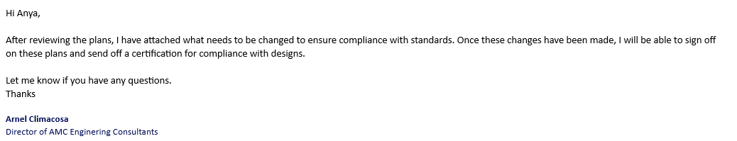
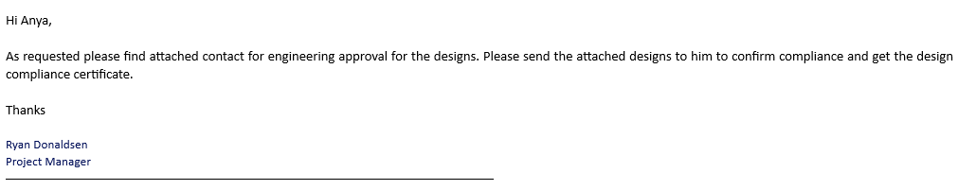
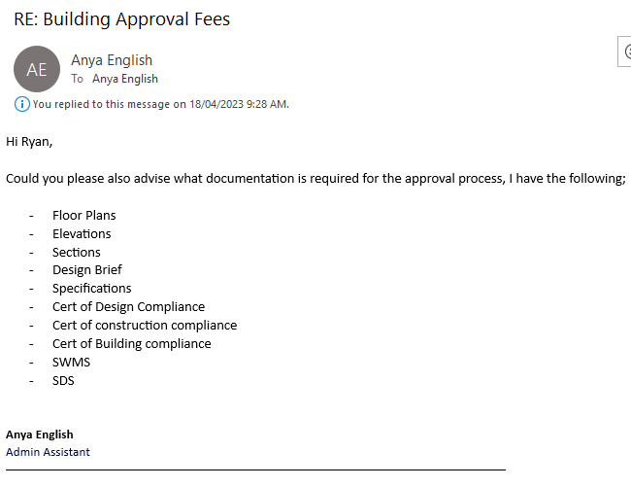
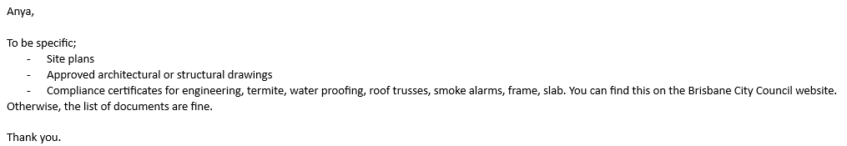
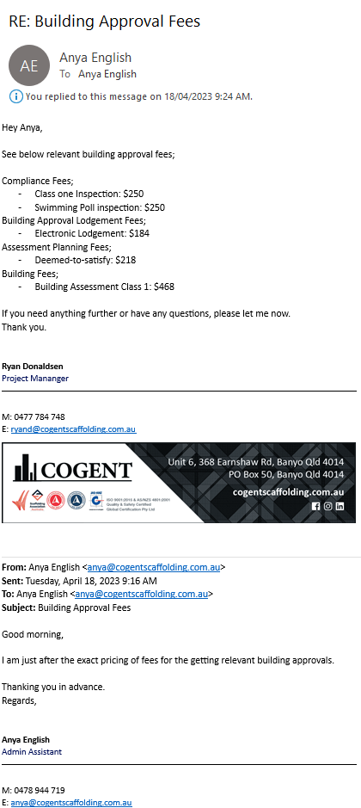
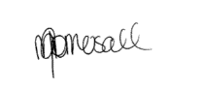
Sign off:
Date: 10/05/2023

Template 2: Review of the submission plan conducted
Review of the submission plan conducted (200-300 words)
Client needs | - The clients wants to ensure that the build is done safely and that everything in compliant with standards, and has certificates for everything. The client intends to sell after extension so everything must be in writing to ensure an easy sell for the client.  - Work to be done effectively and safely, however also done in a timely manner. The client is on a bit of a time crunch and wants the build done as soon as timely possible.  - Easy invoicing and easy to understand the invoicing. Wants everything broken into items on the invoice to understand what is being charged and why.  - The client has had pervious mishaps with other builders and created a bad relationship, resulting in client not trusting builders. Wants everything communicated and easy to understand.  - Wants complete copy of designs and specifications, with engineer approval  - Wants to witness building permit  - Will not sign commencement notice until everything is received and completely satisfied with all documentation.
Outcomes of review conducted | A spreadsheet of what is being paid to the client so the client understands what is being paid and why.  Ensure everything is communicated and that we are on top of everything to ensure the client trusts us. This is a good opportunity to build a relationship with a client that could tell people that we are the only builder he trusts.  Needs to be directed to the workers that customer service is to be on point  We hire other trades that have good customer service and good quality of work. Their work reflects our work.  Supervisors must be vigilant to ensure that works is done correctly and safely. They need to communicate as soon as possible if something goes wrong to ensure a quick and safe fix to the problem  Weekly inspections and checks are to be done and sent to the client.
Sign off:

Date: 10/05/2023

Performance Criteria/Performance Checklist: Activity 1
This task must address the following performance criteria/ performance checklist.
To be assessed as satisfactory (S) in this assessment task, the participant needs to demonstrate competency in the following critical aspects of evidence | S | N/S | Trainer/Assessor to complete  (Comment and feedback to students)
Identified the project stages that require approvals and create a submission plan.
- Identified the project stages that require approval from local authority and dates for submission.
- Consulted local authorities to confirm requirements.
- Documented the identified stages and dates for submission of applications using Submission Plan.
- Determined the level and type of information and documentation required for each approval stage.
  - Analysed the outcomes of Step 1 to identify the project stages that require approval.
  - Determined the level and type of information and documentation required for each approval stage and document using Submission Plan.
- Determined the following and document using Submission Plan.
  - forms, documents and supporting evidence required to be submitted
  - application fees, charges and costs.
Consulted with outside experts to help with document certification.
- Consult with building professionals and planning officers to help with document certification.
Note: Candidate must provide evidence of consulting with outside experts to help with document certification (e.g. screenshots and/or emails)
Examined the submission plan to ensure that all client needs are addressed and met.
- Identified the client needs and document using Template 2.
- Reviewed submission plan to ensure client needs are addressed and met.
- Documented the outcomes of review conducted using Template 2.
Used equipment and programs to access and extract information and developed relevant documentation.
The student’s performance was: | - Not satisfactory  - Satisfactory
Feedback to student:

Student signature
Trainer/Assessor signature

Activity 2: Prepare and lodge application.
This activity requires you to prepare and lodge application for the residential project.
To complete this activity, you are required to:
- Complete the steps given in the ‘Checklist 2’ provided.
- Access and interpret NCC codes and relevant Australian Standards referenced in the NCC.
- Complete Template 3.
While completing each step, you must place a tick mark against each step given in the checklist once completed.
The student should have access to the following documents:
- Project plans and specifications.
- Material specifications
- NCC Vol 1- Vol 3 (Provided along with this assessment)
- Model WHS Law and regulations (Provided along with this assessment)
- Environmental requirements and sustainability principles
- Manufacturer’s materials and product specifications and installation instructions for building materials in the project specifications
- Project plans, design brief, working drawings and specifications.
- Manufacturer specifications and installation instructions
- Local authority building approval processes and application forms
- Sufficient materials and equipment to facilitate arrange building applications and approvals
Instructions for the student:
- The student must:
  - Prepare documentation and supporting information to ensure compliance with the building approval authority's requirements.
  - Adopt strategies to minimise the application's impact on stakeholders while maintaining their support.
  - Submit the application and any supporting documentation with approval authority.
  - Notify the client of the need to pay fees by the due dates and terms.
After completing this task, submit the following to your assessor:
- A completed Checklist 2 and Template 3,
- A completed Performance Criteria/Checklist – Activity 2
- Email evidence of them submitting the documentation and supporting information to the relevant supervisor for review
- Screenshot/email evidence of implementing strategies to minimise the impact on stakeholders (this can be simulated with their supervisor).
- Screenshot/email evidence of submitting the application and supporting documentation with approval authority to Supervisor.
- Email confirmation (can be simulated with supervisor) that the relevant person has been notified of any payment due dates and terms and conditions of the construction project.

Checklist 2: Prepare and lodge application.
Steps | Tick mark, once completed
Step 1: Prepare documentation and supporting information to ensure compliance with the building approval authority's requirements.
- Determine the documentation and supporting information required to ensure compliance with the building approval authority's requirements and document using Template 3.
- Submit the documentation and supporting information prepared to the supervisor assigned via e-mail.
- Provide the email response from your Supervisor which confirms that the documentation and supporting information meet the requirements of the building approval authority.
Note: Candidate must provide email evidence of them submitting the documentation and supporting information to the relevant supervisor for review (include the email response from their supervisor).
Step 2: Adopt strategies to minimise the application's impact on stakeholders while maintaining their support.
- Analyse the impact of application on stakeholders and document using Template 3.
- Implement strategies to minimise impact on stakeholders and maintain their support for the application.
- Further, document the strategies adopted to minimise the application’s impact on stakeholders using Template 3.
Note: Candidate must provide screenshot/email evidence of implementing strategies to minimise the impact on stakeholders (this can be simulated with their supervisor).
Step 3: Submit the application and any supporting documentation with approval authority.
- Prepare the application and any supporting documentation that is required to be submitted.
- Submit the application and any supporting documentation with approval authority to Supervisor via e-mail.
Note: Candidate must provide screenshot/email evidence of submitting the application and supporting documentation with the relevant approval authority.
Step 4: Notify the relevant person of the need to pay fees by the due dates and terms.
- Document the due dates and terms notified to the client using Template 3.
Note: Candidate must provide email evidence that the relevant person (this can be simulated with their supervisor) has been notified of any payment due dates and terms and conditions.

Template 3: Prepare and lodge application
Coordinate and manage the site assessment and job set-up for a large, high-rise, or complex building project (300 - 400 words)
Documentation and supporting information required to ensure compliance with the building approval authority's requirements | Documents and supporting information required are Plans/Drawings and Specifications. Including Architectural, Site Plans, Elevations and Sections. Including relevant Drawing Title, drawing number, drawing completion date, site addressed and Engineer approval. Project Summary, Schedule of documents that comprise plans/drawings and specifications, development statement, site and location plans, performance solution information.
Insert email evidence of them submitting the documentation and supporting information to the relevant supervisor for review (include the email response from their supervisor) here…
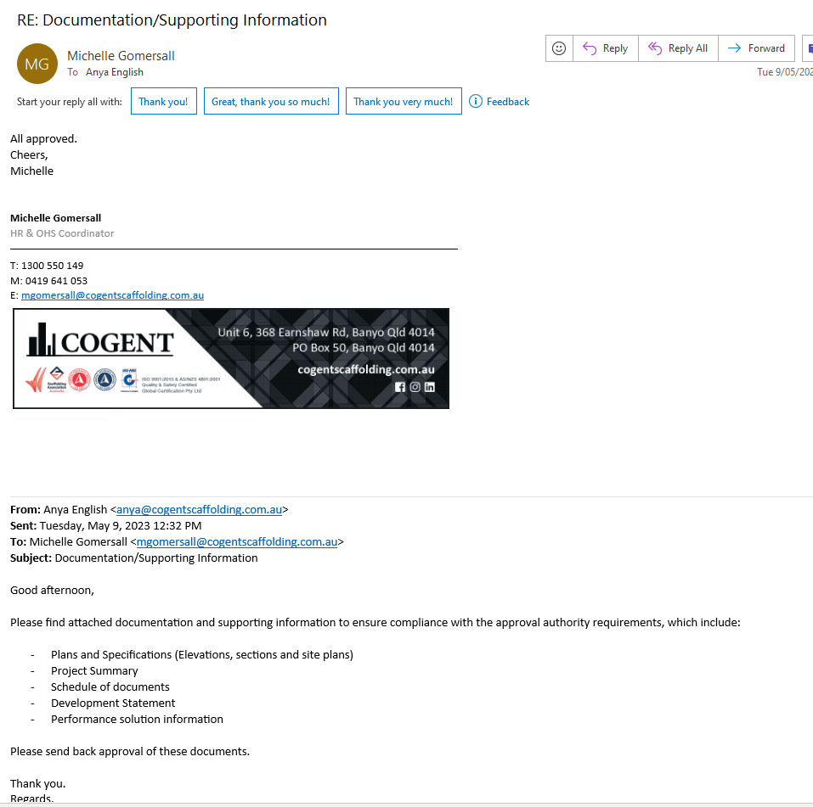
Impact of application on stakeholders | Employees – The employees may be waiting on work and casuals may not get much work during the weeks waiting on approval. This could cause lack of trust from employees and lead to employees leaving and find work elsewhere.  Clients – Client waiting on approvals and getting impatient on long waiting approval times. This may cause a negative impact on customer feedback and reviews, meaning no returning work.  Suppliers – Suppliers may not hold stock for our company if we are waiting too long on approvals, causing delays.  Investors – Not applicable for this project.
Strategies adopted to minimise the application’s impact on stakeholders | Employees – Planning also includes the thought of having work/projects elsewhere to cover the couple of weeks waiting for approval. Communicate to the employees to ensure that they are aware that there is work coming up, however there may be a delay in beginning. This will ensure trust of the employees and hopefully keeping them as workers.  Client – ensure a open communication with the client of what stages we are at with approvals and planning to maintain trust and so that the client is aware of what is happening. This will minimise impatience and negative feedback.  Supplies – Ensure communication with suppliers on estimated time we are in need of supply to maintain trust and stock.
Insert screenshot/email evidence of implementing strategies to minimise the impact on stakeholders (this can be simulated with their supervisor) here…
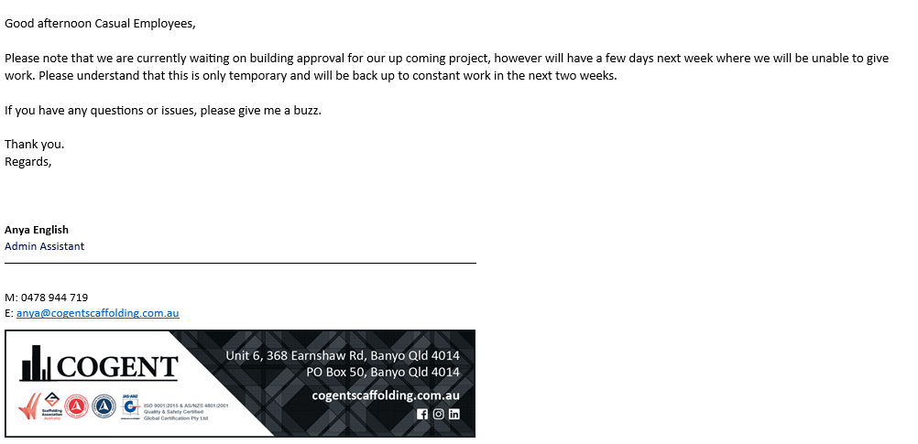
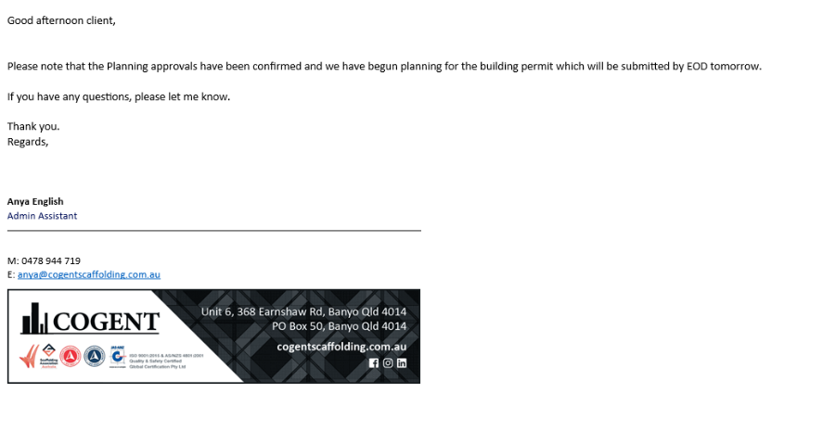
Insert screenshot/email evidence of submitting the application and supporting documentation with the relevant approval authority here…
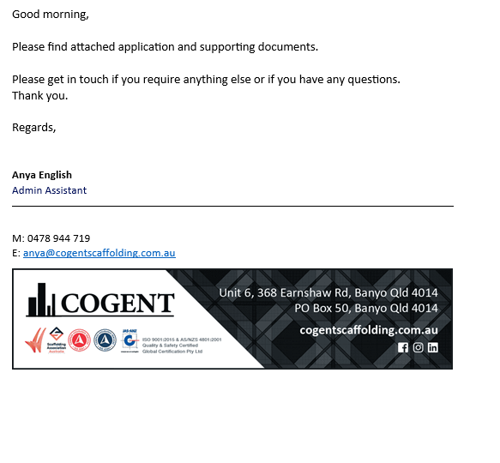
Due dates and terms notified to the client | Planning Fees – Payment Due on the 5th of April (If applicable) Client will be notified if Planning Fees are required and once submitted, and once again once approved or denied.  Building Approvals and Permit payment due on the 9th of April 2023, this will be notified to client once paid and submitted, and once again once approved/denied.  Building Fees – Will be due on the 23rd of April 2023. This gives enough time if the planning and building approval is denied and there is need for a resubmission. The client will be notified of updates.  Building Inspection – Will be due on the 30th of April 2023. This is done early so ensure no delays in booking inspection. This will be notified to the client that the inspection has been booked ready for when the build is complete.
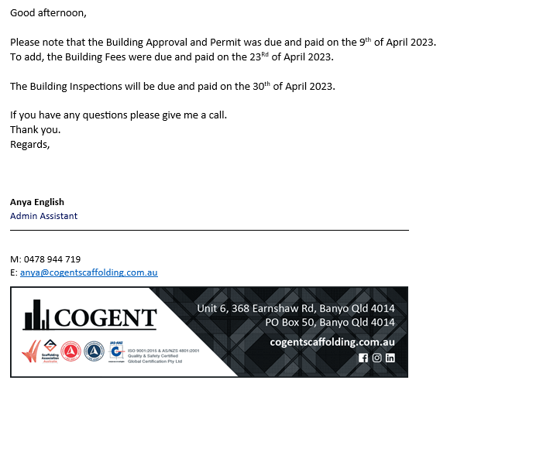
Insert email evidence that the relevant person (this can be simulated with their supervisor) has been notified of any payment due dates and terms and conditions here…
Sign off:
Date:10/05/2023

Performance Criteria/Performance Checklist: Activity 2
This task must address the following performance criteria/ performance checklist.
To be assessed as satisfactory (S) in this assessment task, the participant needs to demonstrate competency in the following critical aspects of evidence | S | N/S | Trainer/Assessor to complete  (Comment and feedback to students)
Prepared documentation and supporting information to ensure compliance with the building approval authority's requirements.
- Determined the documentation and supporting information required to ensure compliance with the building approval authority's requirements.
- Submitted the documentation and supporting information prepared to the supervisor assigned via e-mail.
- Ensured that the documentation and supporting information meet the requirements of the building approval authority.
Note: Candidate must provide email evidence of them submitting the documentation and supporting information to the relevant supervisor for review (include the email response from their supervisor).
Adopted strategies to minimise the application's impact on stakeholders while maintaining their support.
- Analysed the impact of application on stakeholders.
- Implemented strategies to minimise impact on stakeholders and maintain their support for the application.
Note: Candidate must provide screenshot/email evidence of implementing strategies to minimise the impact on stakeholders (this can be simulated with their supervisor).
Submitted the application and any supporting documentation with approval authority.
- Prepared the application and any supporting documentation that is required to be submitted.
- Submitted the application and any supporting documentation with approval authority to Supervisor via e-mail.
Note: Candidate must provide screenshot/email evidence of submitting the application and supporting documentation with the relevant approval authority.
Notified the client of the need to pay fees by the due dates and terms.
Note: Candidate must provide email evidence that the relevant person (this can be simulated with their supervisor) has been notified of any payment due dates and terms and conditions.
Used equipment and programs to access and extract information and developed relevant documentation.
The student’s performance was: | - Not satisfactory  - Satisfactory
Feedback to student:

Student signature | 
Trainer/Assessor signature

Activity 3: Manage application process.
This activity requires you to manage application process.
To complete this activity, you are required to:
- Complete the steps given in the ‘Checklist 3’ provided.
- Access and interpret NCC codes and relevant Australian Standards referenced in the NCC.
- Complete Template 4.
While completing each step, you must place a tick mark against each step given in the checklist once completed.
The student should have access to the following documents:
- Project plans and specifications.
- Material specifications
- NCC Vol 1- Vol 3 (Provided along with this assessment)
- Model WHS Law and regulations (Provided along with this assessment)
- Environmental requirements and sustainability principles
- Manufacturer’s materials and product specifications and installation instructions for building materials in the project specifications
- Project plans, design brief, working drawings and specifications.
- Manufacturer specifications and installation instructions
- Local authority building approval processes and application forms
- Sufficient materials and equipment to facilitate arrange building applications and approvals
Instructions for the student:
- The student must:
  - Ensure continued progress, seeking confirmation of application status at appropriate intervals.
  - Assess the status of building approvals and notify stakeholders.
  - Examine minor changes to see how they affect the project.
  - Analyse the best course of action for maintaining project continuity in the face of rejected submissions.
After completing this task, submit the following to your assessor:
- A completed Checklist 3 and Template 4,
- A completed Performance Criteria/Checklist – Activity 3
- Email evidence that the stakeholders (this can be simulated with your supervisor) are notified on the building approvals and status of building approvals.
- Email confirmation (can be simulated with supervisor) that all signed documents have been sent to the appropriate person for verification, so that the project can move onto the next stage.
- Copies of the signed construction project documents you sourced in completion of this activity.

Checklist 3: Manage application process.
Steps | Tick mark, once completed
Step 1: To ensure continued progress, seek confirmation of application status at appropriate intervals.
- Document the application status at least three (3) different intervals using Template 4.
Step 2: Assess the status of building approvals and notify stakeholders.
- Identify the relevant stakeholders that need to be notified of the status of the building approval.
- Assess building approval progress.
- Email evidence that the stakeholders (this can be simulated with your supervisor) are notified on the building approvals and status of building approvals.
Step 3: Examine minor changes to see how they affect the project.
- Document the minor amendments examined and how they affect the project using Template 4.
Step 4: Analyse the best course of action for maintaining project continuity in the face of rejected submissions.
- Assume, that the submission has been rejected.
- Analyse rejected submission to determine likely success of an appeal or a resubmission.
- In Template 4, discuss how you would address a rejected submission to ensure that the project can continue.

Template 4: Manage application process.
Manage application process. (300-400 words)
Application status at least three (3) different intervals | Application status one – on the 9th of April once the payment for building approval and permit has been completed. Ensure that this is completed and that the planning approvals have been paid. Confirm that planning has begun for the project and has an effective progress on it. Planning has begun and has been notified to the client.  Application Status two – 19th of April find confirmation on whether or not the building approvals and permits have been approved and the progress on the planning stage. Planning is just waiting on approval for engineers and documentation is through its final draft stages ready for submission. Approval on building permit.  Application status three – 25th of April 2023, confirmation for approvals for building and confirmation that the planning is complete and can submit for approval to begin construction work. We can now begin booking for inspections for after build is complete.
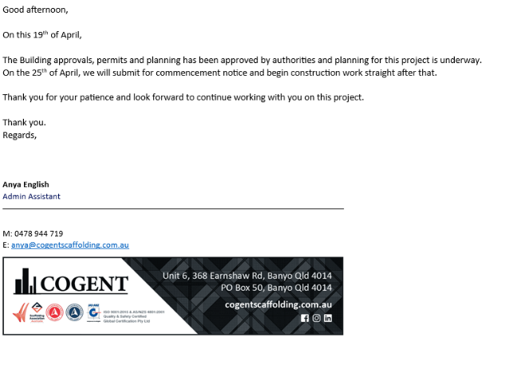
Insert email evidence that the stakeholders (this can be simulated with your supervisor) are notified on the building approvals and status of building approvals here…
Minor amendments examined | Changed the scaffold designs as there was not enough gear to allow for perimeter all the way around.
Discuss how you would address a rejected submission to ensure that the project can continue. | If a submission was rejected, first notify the relevant people on the rejection with the reasoning for rejection.  Then plan a meeting with relevant people to discuss solution and how we will timely fix this for a resubmission.  Once fixed, review one last time to ensure approvals.
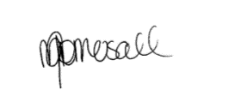
Sign off:
Date:10/05/2023
Performance Criteria/Performance Checklist: Activity 3
This task must address the following performance criteria/ performance checklist.
To be assessed as satisfactory (S) in this assessment task, the participant needs to demonstrate competency in the following critical aspects of evidence | S | N/S | Trainer/Assessor to complete  (Comment and feedback to students)
To ensure continued progress, sought confirmation of application status at appropriate intervals.
- Document the application status at least three (3) different intervals using Template 4.
Assessed the status of building approvals and notify stakeholders.
- Identified the relevant stakeholders that need to be notified of the status of the building approval.
- Assessed building approval progress.
- Email evidence that the stakeholders (this can be simulated with your supervisor) are notified on the building approvals and status of building approvals.
Examined minor changes to see how they affect the project.
- Document the minor amendments examined and how they affect the project using Template 4.
Analysed the best course of action for maintaining project continuity in the face of rejected submissions.
- Assume, that the submission has been rejected.
- Analysed rejected submission to determine likely success of an appeal or a resubmission.
- In Template 4, discuss how you would address a rejected submission to ensure that the project can continue.
The student’s performance was: | - Not satisfactory  - Satisfactory
Feedback to student:

Student signature
Trainer/Assessor signature

Pre-Assessment Checklist: Task 3 – Skill Test
The purpose of this checklist
The pre-assessment checklist helps students determine if they are ready for assessment. The trainer/assessor must review the checklist with the student before the student attempts the assessment task. If any items of the checklist are incomplete or not clear to the student, the trainer/assessor must provide relevant information to the student to ensure they understand the requirements of the assessment task. The student must ensure they are ready for the assessment task before undertaking it.
Section 1: Information for Students
☒ Make sure you have completed the necessary prior learning before attempting this assessment.
☒ Make sure you understand what evidence is required to be collected and how.
☒ Make sure you know your rights and the Complaints and Appeal process.
☒ Make sure you discuss any special needs or reasonable adjustments to be considered during the assessment (refer to the Reasonable Adjustments Strategy Matrix and negotiate these with your trainer/assessor).
☒ Make sure that you have access to a computer and the internet (if you prefer to type the answers).
☒ Make sure that you have all the required resources needed to complete this Assessment Task (AT).
☒ The due date of this assessment task is in accordance with your timetable.
☒ In exceptional (compelling and compassionate) circumstances, an extension to submit an assessment can be granted by the trainer/assessor. Evidence of the compelling and compassionate circumstances must be provided together with your request for an extension to submit your assessment work.
☒ The request for an extension to submit your assessment work must be made before the due date.
Section 2: Reasonable adjustments
I confirm that I have reviewed the Reasonable Adjustments guidelines and criteria as provided in Appendix A and attached relevant evidence as required and select the correct checkbox.
☐ I do require reasonable adjustment
☒ I do not require reasonable adjustment
Declaration (Student to complete)
☒ I confirm that the purpose and procedures of this assessment task has been clearly explained to me.
☒ I confirm that I have been consulted about any special needs I might have in relation to the assessment process.
☒ I confirm that the criteria used for this assessment has been discussed with me, as have the consequences and possible outcomes of this assessment.
☒ I confirm I have accessed and understand the assessment information as provided in the Training Organisation’s Student Handbook.
☒ I confirm I have been given fair notice of the date, time, venue and/or other arrangements for this assessment.
☒ I confirm that I am ready for assessment.

Student Name: ______Anya English________________

Student Signature: ___________________________________

Assessment method-based instructions and guidelines: Skill Test
Assessment type

- Skill Test - Arrange building applications and approvals
Instructions provided to the student:

Assessment task description:

- This is the third assessment task you must successfully complete to be deemed competent in this unit of competency.
- This assessment task is a Skills Test.
  - This assessment task consists of three (3) practical demonstration activities.
      - Activity 1: Develop and review a submission plan.
      - Activity 2: Prepare and lodge application.
      - Activity 3: Manage application process.
- You must attempt all activities of the project for your trainer/assessor to assess your competence in this assessment task.
Applicable conditions:

- This skill test is untimed and is conducted as an open book assessment (this means you are able to refer to your textbook or other learner materials during the test).
- You will be assessed independently on this assessment task.
- No marks or grades are allocated for this assessment task. The outcome of the task will be Satisfactory or Not Satisfactory.
- As you complete this assessment task, you are predominately demonstrating your skills, techniques and knowledge to your trainer/assessor.
- Your trainer/assessor may ask you relevant questions during this assessment task
Resubmissions and reattempts:

- Where a student’s answers are deemed not satisfactory after the first attempt, a resubmission attempt will be allowed.
- The student may speak to their trainer/assessor if they have any difficulty in completing this task and require reasonable adjustments.
- For more information, please refer to the Student Handbook.
Location:

- This assessment task may be completed in:

☐ a classroom
☐ learning management system (i.e. Moodle),
☒ workplace,
☐ or an independent learning environment.
Purpose of the assessment

The purpose of this assessment task is to assess the student’s knowledge and skills essential to arrange building applications and approvals in a range of contexts and industry settings.
- Skills to identify the project stages that require approvals and create a submission plan.
- Skills to determine the level and type of information and documentation required for each approval stage.
- Skills to consult with outside experts to help with document certification.
- Skills to examine the submission plan to ensure that all client needs are addressed and met.
- Skills to prepare documentation and supporting information to ensure compliance with the building approval authority's requirements.
- Skills to adopt strategies to minimise the application's impact on stakeholders while maintaining their support.
- Skills to submit the application and any supporting documentation with approval authority.
- Skills to notify the appropriate person of the need to pay fees by the due dates and terms.
- Skills to ensure continued progress, seek confirmation of application status at appropriate intervals.
- Skills to assess the status of building approvals and notify stakeholders.
- Skills to examine minor changes to see how they affect the project.
- Skills to analyse the best course of action for maintaining project continuity in the face of rejected submissions, resubmissions, or appeals.
- Skills to use digital tools and devices to communicate and collaborate effectively with others.
- Skills to use equipment and programs to access and extract information and develop relevant documentation.
- Skills to Liaise with clients, stakeholders, specialists and approval authorities to negotiate amendments, confirm requirements and share information.
Task instructions
- This is an individual assessment.
- The purpose of this assessment task is to prepare and submit building applications to appropriate authorities for approval and manage the submission through to its final approval.
- The student must asess the NCC codes for relevant class of the building to perform the activities specified in the assessment task.
- The student will be required to communicate effectively with clients, building professionals and planning officers.
- The student must supervise the various aspects of the construction.
- The trainer/assessor must assess the performance as per the performance criteria and checklist provided.

Assessment Task 3: Skills Test
Skills Test:
This assessment task requires the student to prepare, submit and manage a Commercial building and construction application for approval. This includes:
- Developing a submission plan that includes the following:
  - stages and dates for submission of applications
  - forms, documents and supporting evidence required to be submitted
  - application fees, charges and costs.
- Preparing and lodging application.
- Managing application process.
This assessment task will be performed for a Commercial building.
Note: The above specifications for the building are compulsory to meet the requirements of the National Construction Code (NCC).
During the completion of this assessment task, you will be required to communicate effectively with clients, building professionals and planning officers.
To arrange building applications and approvals, you are required to complete the following activities:
- Activity 1: Develop and review a submission plan.
- Activity 2: Prepare and lodge application.
- Activity 3: Manage application process.
Instructions for trainer/assessor:
- The workplace must be:
  - An actual workplace
  - A close simulation of the workplace environment provided that simulated or project-based assessment techniques replicate construction workplace conditions, materials, activities, responsibilities and procedures
Note: The requirements for a simulated workplace environment are given below.
- The structure must be a Commercial building.
- The role of the Supervisor (trainer/assessor) is to allocate the tasks, activities and responsibilities that you will be required to undertake to complete these assessments.
- The worksite must meet the requirements given in the ‘Simulated workplace environment requirements’ section given below.
- The trainer/assessor must ensure that if the assessment task is to be conducted in a simulated environment, it must replicate workplace conditions, materials and equipment, interactions with others and workplace irregularities and meets industry standards for safety and environmental practices.
Instructions for the student:
- The student will be required to bring all necessary PPEs required to complete this activity.
- The student must follow the instructions provided by the Supervisor.
- The student must complete the activities specified.

Simulated workplace environment requirements
The student is required to have access to a workplace or a close simulation of the workplace environment to replicate construction workplace conditions and standards, materials, activities, responsibilities, procedures, safety requirements and environmental considerations to each student.
Further, the training organisation must ensure the construction site must meet the requirements given in the table below.
The training organisation must ensure that the student has access to the following:
- WHS legislation and regulations
  - Model WHS Act (Provide along with this assessment task)
  - Model WHS Regulations (Provide along with this assessment task)
- Current building and construction codes and standards
  - https://www.abcb.gov.au/
  - https://ncc.abcb.gov.au/editions/2019-a1/ncc-2019-volume-one-amendment-1/contents-and-introduction/introduction-ncc-volume
  - https://ncc.abcb.gov.au/editions/2019-a1/ncc-2019-volume-two-amendment-1/contents-and-introduction/copyright-and-licence
  - https://ncc.abcb.gov.au/editions/2019-a1/ncc-2019-volume-three-amendment-1/contents-and-introduction/introduction-ncc
- NCC Volume 1 – Volume 3 (Provided along with this assessment)
- Organisational quality policies and procedures
- Workplace safety requirements
- Project plans and specifications
- Manufacturer specifications and installation instructions
- Local authority building approval processes and application forms
- Sufficient materials and equipment to facilitate arrange building applications and approvals
- Business equipment and technology, applications and software.

The worksite must have realistic tasks or simulated tasks, relevant specifications and work instructions, standard work practices, safety requirements and environmental constraints.
The site and its surroundings are accessible and clear of hazards, so far as reasonably practicable.
The site must have realistic workplace conditions, standards, materials, activities, responsibilities, procedures, safety requirements, and environmental considerations.
An experienced employee is available to provide adequate guidance and supervision to less experienced employees.
The students have the clothing and footwear required. In addition, the clothing and footwear are in good condition and suitable for the task.

Workplace Scenario
You are working as a project manager in a construction company. Your organisation has received a project to construct a commercial building.
As a project manager, you must prepare and submit building applications to appropriate authorities for approval and manage the submission through to its final approval.
This includes:
- Developing a submission plan that includes the following:
  - stages and dates for submission of applications
  - forms, documents and supporting evidence required to be submitted
  - application fees, charges and costs.
- Preparing and lodging application.
- Managing application process.
Task requirements:
To prepare and submit building applications to appropriate authorities for approval and manage the submission through to its final approval, you will be required to demonstrate your skills and knowledge in the following areas:
- Identify the project stages that require approvals and create a submission plan.
- Determine the level and type of information and documentation required for each approval stage.
- Consult with outside experts to help with document certification.
- Examine the submission plan to ensure that all client needs are addressed and met.
- Prepare documentation and supporting information to ensure compliance with the building approval authority's requirements.
- Adopt strategies to minimise the application's impact on stakeholders while maintaining their support.
- Submit the application and any supporting documentation with approval authority.
- Notify the appropriate person of the need to pay fees by the due dates and terms.
- To ensure continued progress, seek confirmation of application status at appropriate intervals.
- Assess the status of building approvals and notify stakeholders.
- Examine minor changes to see how they affect the project.
- Analyse the best course of action for maintaining project continuity in the face of rejected submissions, resubmissions, or appeals.
- Use digital tools and devices to communicate and collaborate effectively with others.
- Use equipment and programs to access and extract information and develop relevant documentation.
- Liaise with clients, stakeholders, specialists and approval authorities to negotiate amendments, confirm requirements and share information.
Roles and responsibilities (Supervisor):
The Supervisor must:
- Ensure that the student is clear about the task requirements.
- Supervise the student performing the task.
- Observe them against the observation checklist provided after each activity.

Skills Test:
This assessment task requires the student to prepare, submit and manage a Commercial building and construction application for approval. This includes:
- Developing a submission plan that includes the following:
  - stages and dates for submission of applications
  - forms, documents and supporting evidence required to be submitted
  - application fees, charges and costs.
- Preparing and lodging application.
- Managing application process.
This assessment task will be performed on a Commercial building.
Note: The above specifications for the building are compulsory to meet the requirements of the National Construction Code (NCC).
During the completion of this assessment task, you will be required to communicate effectively with clients, building professionals and planning officers.
To arrange building applications and approvals, you are required to complete the following activities:
- Activity 1: Develop and review a submission plan.
- Activity 2: Prepare and lodge application.
- Activity 3: Manage application process.

Activity 1: Develop and review a submission plan – Commercial building.
This activity requires you to Develop and review a submission plan – Commercial building.
To complete this activity, you are required to:
- Complete the steps given in the ‘Checklist 1’ provided.
- Access and interpret NCC codes and relevant Australian Standards referenced in the NCC.
- Complete Template 1 & 2.
While completing each step, you must place a tick mark against each step given in the checklist once completed.
Instructions for trainer/assessor:
- The student should have access to the following documents:
  - Project plans and specifications.
  - Material specifications
  - NCC Vol 1- Vol 3 (Provided along with this assessment)
  - Model WHS Law and regulations (Provided along with this assessment)
  - Environmental requirements and sustainability principles
  - Manufacturer’s materials and product specifications and installation instructions for building materials in the project specifications
  - Project plans, design brief, working drawings and specifications.
  - Manufacturer specifications and installation instructions
  - Local authority building approval processes and application forms
  - Sufficient materials and equipment to facilitate arrange building applications and approvals
Instructions for the student:
- The student must:
  - Identify the project stages that require approvals and create a submission plan.
  - Consult with outside experts to help with document certification.
  - Examine the submission plan to ensure that all client needs are addressed and met.
After completing this task, submit the following to your assessor:
- A completed Checklist and Template 1 & 2,
- A completed Performance Criteria/Checklist – Activity 1 & 2
- Copies of any emails/screenshots used to communicate with outside experts to assist with document certification
- Copies of the construction project documents you sourced in completion of this activity.

Checklist 1: Develop and review a submission plan.
Steps | Tick mark, once completed
Step 1: Identify the project stages that require approvals and create a submission plan.
- Identify the project stages that require approval from local authority and dates for submission.
- Consult local authorities to confirm requirements.
- Document the identified stages and dates for submission of applications using Submmission Plan (Template 1).
- Determine the level and type of information and documentation required for each approval stage.
  - Analyse the outcomes of Step 1 to identify the project stages that require approval.
  - Determine the level and type of information and documentation required for each approval stage and document using Submmission Plan (Template 1).
- Determine the following and document using Submmission Plan (Template 1).
  - forms, documents and supporting evidence required to be submitted
  - application fees, charges and costs.
Step 2: Consult with outside experts to help with document certification.
- Use digital tools and devices to communicate and collaborate effectively with others.
- Consult with building professionals and planning officers to help with document certification.
Note: Candidate must provide evidence of using digital tools and devices to communicate with outside experts (e.g. screenshots and/or emails)
Step 3: Examine the submission plan to ensure that all client needs are addressed and met.
- Identify the client needs and document using Template 2.
- Review submission plan to ensure client needs are addressed and met.
- Document the outcomes of review conducted using Template 2.

Template 1: Submission plan
Submission plan (300-400 words)
Identified stages and dates for submission of applications | Stage One: Consult with a town planner to confirm whether or not a planning permit is required. Obtain all relevant documentation for town planner and apply for planning permit. 3rd of April –  12th of April (One week)  Stage Two: Begin planning the design and what is required for a safe and complaint build. 2 weeks 4th of April – 19th of April to gather all relevant information and documentation for a building approval and building permit as well as pay any fees required and ensure that all plans and documents comply with relevant codes and standards.  Stage three: Prolongment meeting with council 21st of April  Stage four: Apply and obtain a commencement notice once obtained a building approval and permit. 24th April – 2nd of May.  Stage Five: Once obtained a commencement notice, begin construction work. 4th of May.
Level and type of information and documentation required for each approval stage | Stage One: Designs, Planning report and shadow diagrams  Stage Two:  Design – comply with building codes plans and specifications  Development statement and location plans  Performance solution information  Stage Three: Nominate builder, design certificate, preliminary inspection plan and general arrangement drawings  Stage four: all previous approved documents and information  Stage five: all inspections and certificated for the building inspector.
Forms, documents and supporting evidence required to be submitted | Plans including architectural floor plans, elevations and sections  Specifications  Design briefs  Working drawings  Detail drawings  Certificate of design compliance  Certificate of construction compliance  Certificate of building compliance  SWMS  SDS
Application fees, charges and costs | Building Application Lodgment Fees:  Electronic Lodgment: $184  Building Permit:  $446.54  Assessment – Planning Fee:  Deemed to Satisfy: $218  Full planning and development certificate (full search)  $6784
Insert evidence of using digital tools and devices to communicate with outside experts (e.g. screenshots and/or emails) here…

Sign off:
Date: 10/05/2023
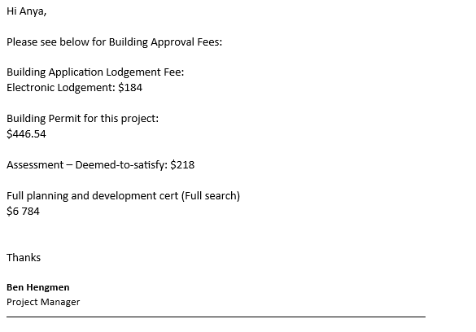

Template 2: Review of the submission plan conducted
Review of the submission plan conducted (200-300 words)
Client needs | A complete copy of all drawings with engineering approvals.  All approved permits and approvals sent via email  Constant updates of the drawings with approval from client.  Constant updates of specifications with approval from client.  Proof of everything complying with standards.  Wants to have a copy of all legislation and codes that we must comply with to ensure that the design is compliant and safe.  Must be aware of all stakeholders involved, to ensure that we are capable of completing the build.
Outcomes of review conducted | Proof of all approvals, permits and licenses, with written approval – email of client happy with outcomes..  We will have weekly check ins with the client via email for up dates of planning stages, and status on building approvals, as well as constant updates of important status changes.  Fortnightly Zoom calls for verbal checks in to see the stages of planning and status on building approvals.  Email a copy of all relevant building legislation and codes and detail how we will comply with the important information.  Ensure that we answer any questions the client has about any of the legislation.  Weekly inspection and checks emailed to client to prove continuous compliance with the build.  Ensure all subcontractors hired are aware that inspections and checks must be done to prove compliance and safety.
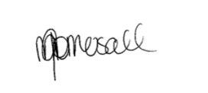
Sign off:
Date: 10/05/2023

Performance Criteria/Performance Checklist: Activity 1
This task must address the following performance criteria/ performance checklist.
To be assessed as satisfactory (S) in this assessment task, the participant needs to demonstrate competency in the following critical aspects of evidence | S | N/S | Trainer/Assessor to complete  (Comment and feedback to students)
Identified the project stages that require approvals and create a submission plan.
- Identified the project stages that require approval from local authority and dates for submission.
- Consulted local authorities to confirm requirements.
- Documented the identified stages and dates for submission of applications using Submmission Plan.
- Determined the level and type of information and documentation required for each approval stage.
  - Analysed the outcomes of Step 1 to identify the project stages that require approval.
  - Determined the level and type of information and documentation required for each approval stage and document using Submmission Plan.
- Determined the following and document using Submmission Plan.
  - forms, documents and supporting evidence required to be submitted
  - application fees, charges and costs.
Consulted with outside experts to help with document certification.
- Consult with building professionals and planning officers to help with document certification.
Note: Candidate must provide evidence of consulting with outside experts to help with document certification (e.g. screenshots and/or emails)
Examined the submission plan to ensure that all client needs are addressed and met.  - Identified the client needs and document using Template 2.  - Reviewed submission plan to ensure client needs are addressed and met.  - Documented the outcomes of review conducted using Template 2. | - v
Used equipment and programs to access and extract information and developed relevant documentation.
The student’s performance was: | - Not satisfactory  - Satisfactory
Feedback to student:

Student signature
Trainer/Assessor signature

Activity 2: Prepare and lodge application.
This activity requires you to prepare and lodge application for a Commercial building.
To complete this activity, you are required to:
- Complete the steps given in the ‘Checklist 2’ provided.
- Access and interpret NCC codes and relevant Australian Standards referenced in the NCC.
- Complete Template 2.
While completing each step, you must place a tick mark against each step given in the checklist once completed.
The student should have access to the following documents:
- Project plans and specifications.
- Material specifications
- NCC Vol 1- Vol 3 (Provided along with this assessment)
- Model WHS Law and regulations (Provided along with this assessment)
- Environmental requirements and sustainability principles
- Manufacturer’s materials and product specifications and installation instructions for building materials in the project specifications
- Project plans, design brief, working drawings and specifications.
- Manufacturer specifications and installation instructions
- Local authority building approval processes and application forms
- Sufficient materials and equipment to facilitate arrange building applications and approvals
Instructions for the student:
- The student must:
  - Prepare documentation and supporting information to ensure compliance with the building approval authority's requirements.
  - Adopt strategies to minimise the application's impact on stakeholders while maintaining their support.
  - Submit the application and any supporting documentation with approval authority.
  - Notify the client of the need to pay fees by the due dates and terms.
After completing this task, submit the following to your assessor:
- A completed Checklist 2 and Template 3,
- A completed (by observer) Performance Criteria/Checklist – Activity 2
- Copies of any screenshot/email evidence of submitting the application and supporting documentation with approval authority to Supervisor.
- Email confirmation (can be simulated with supervisor) that the client has been notified of any payment due dates and terms and conditions of the construction project.

Checklist 2: Prepare and lodge application.
Steps | Tick mark, once completed
Step 1: Prepare documentation and supporting information to ensure compliance with the building approval authority's requirements.
- Determine the documentation and supporting information required to ensure compliance with the building approval authority's requirements and document using Template 3.
- Submit the documentation and supporting information prepared to the supervisor assigned via e-mail.
- Provide the email response from your Supervisor which confirms that the documentation and supporting information meet the requirements of the building approval authority.
Note: Candidate must provide email evidence of them submitting the documentation and supporting information to the relevant supervisor for review (include the email response from their supervisor).
Step 2: Adopt strategies to minimise the application's impact on stakeholders while maintaining their support.
- Analyse the impact of application on stakeholders and document using Template 3.
- Implement strategies to minimise impact on stakeholders and maintain their support for the application.
- Further, document the strategies adopted to minimise the application’s impact on stakeholders using Template 3.
Note: Candidate must provide screenshot/email evidence of implementing strategies to minimise the impact on stakeholders (this can be simulated with their supervisor).
Step 3: Submit the application and any supporting documentation with approval authority.
- Prepare the application and any supporting documentation that is required to be submitted.
- Submit the application and any supporting documentation with approval authority to Supervisor via e-mail.
Note: Candidate must provide screenshot/email evidence of submitting the application and supporting documentation with the relevant approval authority.
Step 4: Notify the relevant person of the need to pay fees by the due dates and terms.
- Document the due dates and terms notified to the client using Template 3.
Note: Candidate must provide email evidence that the relevant person (this can be simulated with their supervisor) has been notified of any payment due dates and terms and conditions.

Template 3: Prepare and lodge application
Coordinate and manage the site assessment and job set-up for a large, high-rise, or complex building project (300 - 400 words)
Documentation and supporting information required to ensure compliance with the building approval authority's requirements | Plans/drawing and specifications including relevant information e.g. sections/elevations, drawing numbers, location, site address  Project Summary  Schedule of documents that of which include the plans/drawings and specifications  Development statement, site and location plans which detail the condition of the site  Performance solution information with evidence of performance solutions used in the planning and building of this structure.
Insert email evidence of them submitting the documentation and supporting information to the relevant supervisor for review (include the email response from their supervisor) here…
Impact of application on stakeholders | Employees – Minimal impact as the are many other projects that will hold the employees while waiting for approval and construction. Worst case, a few casuals might miss a few days work.  Client – waiting on approval may cause impatience and the client may get frustrated with a negative impact on reviews. This may lead to the client not wanting to work with our company again.  Suppliers – Suppliers may not hold stock for our company if we are waiting too long on approvals, causing delays.  Investors – They may not feel confident about investing into the construction of the building and with lack of communication and progress, may pull out of investing. This could cause the project to not go ahead.
Strategies adopted to minimise the application’s impact on stakeholders | Employees – Ensuring that it is planned that there are other projects still up and running while we wait for this project to begin. Communicate with casuals that there may be a few days where there will be no work to maintain trust and hopefully they might go find work elsewhere in the meantime.  Client – Communicate with client of dates and approvals to maintain trust and to get them to understand that we are moving at a timely manner, however just waiting upon approval.  Supplies – Ensure communication with suppliers on estimated time we are in need of supply to maintain trust and stock  Investors – Maintain communication with investors of progress and communicate the benefits of working and investing into this project.
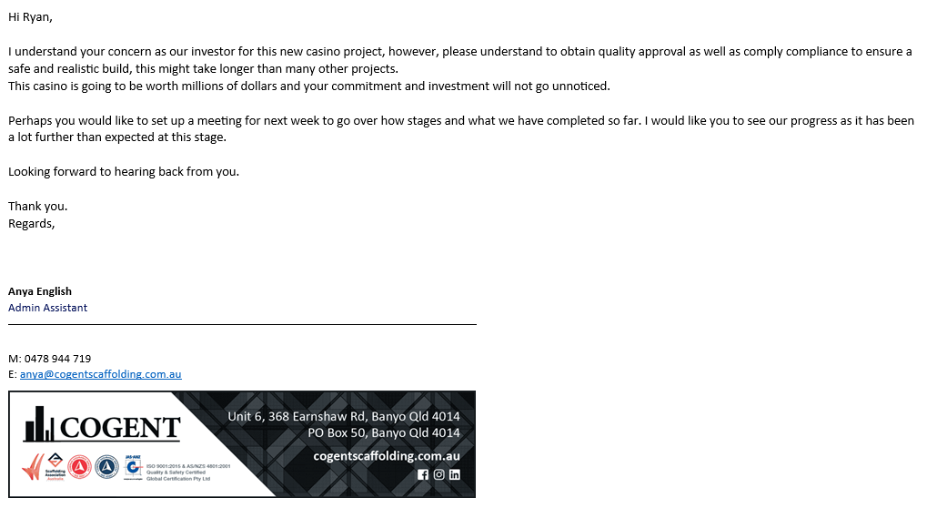
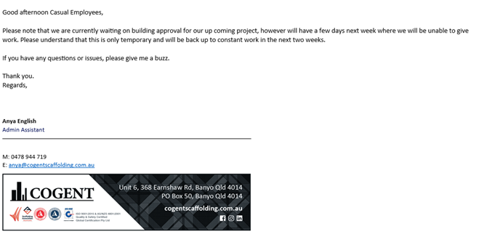
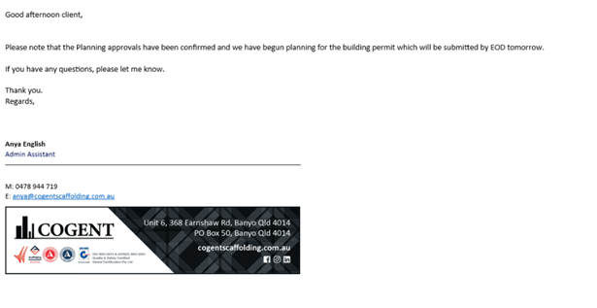
Insert screenshot/email evidence of implementing strategies to minimise the impact on stakeholders (this can be simulated with their supervisor) here…
Insert screenshot/email evidence of submitting the application and supporting documentation with the relevant approval authority here…
Due dates and terms notified to the client | Planning Fee – 3rd April 2023. Communicate with the client when payment has been made, and when planning has been approved and planning has begun.  Building Approval and Permit – 12Th April 2023 Communicate with client when the permit and approval fees have been paid and when approval has been sent  Building Fees. – 21st April 2023. Communicate with client when building fees have been paid.  Building Inspection 30th April 2023. Communicate when the building inspections have been booked and for when.
Insert email evidence that the relevant person (this can be simulated with their supervisor) has been notified of any payment due dates and terms and conditions here…

Date: 10/05/2023

Performance Criteria/Performance Checklist: Activity 2
This task must address the following performance criteria/ performance checklist.
To be assessed as satisfactory (S) in this assessment task, the participant needs to demonstrate competency in the following critical aspects of evidence | S | N/S | Trainer/Assessor to complete  (Comment and feedback to students)
Prepared documentation and supporting information to ensure compliance with the building approval authority's requirements.
- Determined the documentation and supporting information required to ensure compliance with the building approval authority's requirements.
- Submitted the documentation and supporting information prepared to the supervisor assigned via e-mail.
- Ensured that the documentation and supporting information meet the requirements of the building approval authority.
Note: Candidate must provide email evidence of them submitting the documentation and supporting information to the relevant supervisor for review (include the email response from their supervisor).
Adopted strategies to minimise the application's impact on stakeholders while maintaining their support.
- Analysed the impact of application on stakeholders.
- Implemented strategies to minimise impact on stakeholders and maintain their support for the application.
Note: Candidate must provide screenshot/email evidence of implementing strategies to minimise the impact on stakeholders (this can be simulated with their supervisor).
Submitted the application and any supporting documentation with approval authority.
- Prepared the application and any supporting documentation that is required to be submitted.
- Submitted the application and any supporting documentation with approval authority to Supervisor via e-mail.
Note: Candidate must provide screenshot/email evidence of submitting the application and supporting documentation with the relevant approval authority.
Notified the client of the need to pay fees by the due dates and terms.
Note: Candidate must provide email evidence that the relevant person (this can be simulated with their supervisor) has been notified of any payment due dates and terms and conditions.
Used equipment and programs to access and extract information and developed relevant documentation.
The student’s performance was: | - Not satisfactory  - Satisfactory
Feedback to student:

Student signature
Trainer/Assessor signature
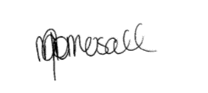

Activity 3: Manage application process – Commercial building.
This activity requires you to manage application process – Commercial building.
To complete this activity, you are required to:
- Complete the steps given in the ‘Checklist 3’ provided.
- Access and interpret NCC codes and relevant Australian Standards referenced in the NCC.
- Complete Template 3.
While completing each step, you must place a tick mark against each step given in the checklist once completed.
The student should have access to the following documents:
- Project plans and specifications.
- Material specifications
- NCC Vol 1- Vol 3 (Provided along with this assessment)
- Model WHS Law and regulations (Provided along with this assessment)
- Environmental requirements and sustainability principles
- Manufacturer’s materials and product specifications and installation instructions for building materials in the project specifications
- Project plans, design brief, working drawings and specifications.
- Manufacturer specifications and installation instructions
- Local authority building approval processes and application forms
- Sufficient materials and equipment to facilitate arrange building applications and approvals
Instructions for the student:
- The student must:
  - Ensure continued progress, seek confirmation of application status at appropriate intervals.
  - Assess the status of building approvals and notify stakeholders.
  - Examine minor changes to see how they affect the project.
  - Analyse the best course of action for maintaining project continuity in the face of rejected submissions.
After completing this task, submit the following to your assessor:
- A completed Checklist 3 and Template 4,
- A completed Performance Criteria/Checklist – Activity 3
- Email confirmation (can be simulated with supervisor) that all signed documents have been sent to the appropriate person for verification, so that the project can move onto the next stage.
- Copies of the signed construction project documents you sourced in completion of this activity.

Checklist 3: Manage application process.
Steps | Tick mark, once completed
Step 1: To ensure continued progress, seek confirmation of application status at appropriate intervals.
- Document the application status at least three (3) different intervals using Template 4.
Step 2: Assess the status of building approvals and notify stakeholders.
- Identify the relevant stakeholders that need to be notified of the status of the building approval.
- Assess building approval progress.
- Email evidence that the stakeholders (this can be simulated with your supervisor) are notified on the building approvals and status of building approvals.
Step 3: Examine minor changes to see how they affect the project.
- Document the minor amendments examined and how they affect the project using Template 4.
Step 4: Analyse the best course of action for maintaining project continuity in the face of rejected submissions.
- Assume, that the submission has been rejected.
- Analyse rejected submission to determine likely success of an appeal or a resubmission.
- In Template 4, discuss how you would address a rejected submission to ensure that the project can continue.

Template 4: Manage application process.
Manage application process. (300-400 words)
Application status at least three (3) different intervals | Application status one – on the 9th of April once the payment for building approval and permit has been completed. Ensure that this is completed and that the planning approvals have been paid. Confirm that planning has begun for the project and has an effective progress on it. Planning has begun and has been notified to the client.  Application Status two – 19th of April find confirmation on whether or not the building approvals and permits have been approved and the progress on the planning stage. Planning is just waiting on approval for engineers and documentation is through its final draft stages ready for submission. Approval on building permit.  Application status three – 25th of April 2023, confirmation for approvals for building and confirmation that the planning is complete and can submit for approval to begin construction work. We can now begin booking for inspections for after build is complete.
Insert email evidence that the stakeholders (this can be simulated with your supervisor) are notified on the building approvals and status of building approvals here…
Minor amendments examined | Specification amendments. Some material changes die to client not liking them, supplier not being able to supply materials including a type of door as the approval stage is taking too long.
Discuss how you would address a rejected submission to ensure that the project can continue. | If a submission was rejected, first notify the relevant people on the rejection with the reasoning for rejection.  Then plan a meeting with relevant people to discuss solution and how we will timely fix this for a resubmission.  Once fixed, review one last time to ensure approvals
Sign off:

Date:10/05/2023
Performance Criteria/Performance Checklist: Activity 3
This task must address the following performance criteria/ performance checklist.
To be assessed as satisfactory (S) in this assessment task, the participant needs to demonstrate competency in the following critical aspects of evidence | S | N/S | Trainer/Assessor to complete  (Comment and feedback to students)
To ensure continued progress, sought confirmation of application status at appropriate intervals.
- Document the application status at least three (3) different intervals using Template 4.
Assessed the status of building approvals and notify stakeholders.
- Identified the relevant stakeholders that need to be notified of the status of the building approval.
- Assessed building approval progress.
- Email evidence that the stakeholders (this can be simulated with your supervisor) are notified on the building approvals and status of building approvals.
Examined minor changes to see how they affect the project.
- Document the minor amendments examined and how they affect the project using Template 4.
Analysed the best course of action for maintaining project continuity in the face of rejected submissions.
- Assume, that the submission has been rejected.
- Analysed rejected submission to determine likely success of an appeal or a resubmission.
- In Template 4, discuss how you would address a rejected submission to ensure that the project can continue.
The student’s performance was: | - Not satisfactory  - Satisfactory
Feedback to student:

Student signature
Trainer/Assessor signature

Assessment Results Sheet
Outcome | Outcome (make sure to tick the correct checkbox):  Satisfactory (S) ☐ or Not Satisfactory (NS) ☐  Date: _______(day)/ _______(month)/ ____________(year)  Feedback:  Outcome (make sure to tick the correct checkbox):  Satisfactory (S) ☐ or Not Satisfactory (NS) ☐  Date: _______(day)/ _______(month)/ ____________(year)  Feedback:
  First attempt:
  Second attempt:
Student Declaration | - I declare that the answers I have provided are my own work. Where I have accessed information from other sources, I have provided references and or links to my sources.  - I have kept a copy of all relevant notes and reference material that I used as part of my submission.  - I have provided references for all sources where the information is not my own. I understand the consequences of falsifying documentation and plagiarism. I understand how the assessment is structured. I accept that the work I submit may be subject to verification to establish that it is my own.  - I understand that if I disagree with the assessment outcome, I can appeal the assessment process, and either re-submit additional evidence undertake gap training and or have my submission re-assessed.  - All appeal options have been explained to me.
Student Signature
Date | 10/05/2023
Trainer/Assessor Name
Trainer/Assessor Declaration | I hold:  ☐ Vocational competencies at least to the level being delivered  ☐ Current relevant industry skills  ☐ Current knowledge and skills in VET, and undertake  ☐ Ongoing professional development in VET  I declare that I have conducted an assessment of this student’s submission. The assessment tasks were deemed current, sufficient, valid and reliable. I declare that I have conducted a fair, valid, reliable, and flexible assessment. I have provided feedback to the student.
Trainer/Assessor Signature | 
Date | 10/05/2023
Office Use Only | The outcome of the assessment has been entered into the Student Management System  on _________________ (insert date)  by (insert Name) __________________________________

Appendix A: Reasonable Adjustments
Write (task name and number) where reasonable adjustments have been applied:

Reasonable Adjustments

- Students with carer responsibilities, cultural or religious obligations, English as an additional language, disability etc. can request for reasonable adjustments.
- Please note, academic standards of the unit/course will not be lowered to accommodate the needs of any student, but there is a requirement to be flexible about the way in which it is delivered or assessed.
- The Disability Standards for Education requires institutions to take reasonable steps to enable the student with a disability to participate in education on the same basis as a student without a disability.
- The trainer/assessor must complete the section below “Reasonable Adjustment Strategies Matrix” to ensure the explanation and correct strategy have been recorded and implemented.
- The trainer/assessor must notify the administration/compliance and quality assurance department for any reasonable adjustments made.
- All evidence and supplementary documentation must be submitted with the assessment pack to the administration/compliance and quality assurance department.
Reasonable Adjustment Strategies Matrix (Trainer/Assessor to complete)

Category | Possible Issue | Reasonable Adjustment Strategy  (select as applicable)
LLN | Speaking  Reading  Writing  Confidence | Verbal assessment  Presentations  Demonstration of a skill  Use of diagrams  Use of supporting documents such as wordlists
Non-English Speaking Background | Speaking  Reading  Writing  Cultural background  Confidence | Discuss with the student and supervisor (if applicable) whether language, literacy and numeracy are likely to impact on the assessment process  Use methods that do not require a higher level of language or literacy than is required to perform the job role  Use short sentences that do not contain large amounts of information  Clarify information by rephrasing, confirm understanding  Read any printed information to the student  Use graphics, pictures and colour coding instead of, or to support, text  Offer to write down, or have someone else write, oral responses given by the student  Ensure that the time available to complete the assessment, while meeting enterprise requirements, takes account of the student’s needs
Indigenous | Knowledge and understanding  Flexibility  Services  Inappropriate training and assessment | Culturally appropriate training  Explore understanding of concepts and practical application through oral assessment  Flexible delivery  Using group rather than individual assessments  Assessment through completion of practical tasks in the field after demonstration of skills and knowledge.
Age | Educational background  Limited study skills | Make sure font size is not too small  Trainer/Assessor should refer to the student’s experience  Ensure that the time available to complete the assessment takes account of the student’s needs  Provision of information or course materials in an accessible format.  Changes in teaching practices, e.g. wearing an FM microphone to enable a student to hear lectures  Supply of specialised equipment or services, e.g. a note-taker for a student who cannot write  Changes in lecture schedules and arrangements, e.g. relocating classes to an accessible venue  Changes to course design, e.g. substituting an assessment task  Modifications to the physical environment, e.g. installing lever taps, building ramps, installing a lift
Educational background | Reading  Writing  Numeracy  Limited study skills and/or learning strategies | Discuss with the Student previous learning experience  Ensure learning and assessment methods meet the student’s individual need
Disability | Speaking  Reading  Writing  Numeracy  Limited study skills and/or learning strategies | Identify the issues  Create a climate of support  Ensure access to support that the student has agreed to  Appropriately structure the assessment  Provide information or course materials in an accessible format, e.g. a textbook in braille  Changes in teaching practices, e.g. wearing an FM microphone to enable a student to hear lectures  Supply of specialised equipment or services, e.g. a note-taker for a student who cannot write  Changes in lecture schedules and arrangements, e.g. relocating classes to an accessible venue  Changes to course design, e.g. substituting an assessment task  Modifications to the physical environment, e.g. installing lever taps, building ramps, installing a lift
Explanation of reasonable adjustments strategy used

Trainer/Assessor Name | Michelle Gomersall
Trainer/Assessor Declaration | I declare that I have attached all relevant evidence to provide reasonable adjustment. The training package guidelines and criteria have not been compromised in the process of providing reasonable adjustment to the student. I declare that I have conducted a fair, valid, reliable, and flexible assessment. I have provided explanation of reasonable adjustments strategy used, as required.
Trainer/Assessor Signature
Date | 10/05/2023

Appendix B: Third-Party Verification Log
Third-Party Verification Log
Instructions for the Assessor:
You are required to contact all third-party personnel involved in the candidate’s assessment to verify the candidate’s performance and evidence submissions and to confirm with them whether the candidate’s evidence submissions are true and accurate.
Complete this Third-Party Verification Log to document your completion of this process. When completing this log, provide all of the following required information for each third-party personnel:
- Name of third-party personnel contacted
- Relevant qualifications and/or experience of Third-party personnel contacted
- Role in the candidate’s assessment (e.g. workplace supervisor, observer, or candidate)
- Contact details (phone number or email address)
- Date contacted
You must also confirm that third-party personnel have verified the candidate’s evidence submissions are true and accurate.

Contact No.1
Name and job title of Third-party Contacted | Gavin Keeffe Project Manager /Site Assist
Relevant Qualifications/experience of Third-party | Cert IV Project Management
Role in the Candidate’s Assessment | Contact Details  (Phone number or email address) | Date contacted | Third-Party verifies evidence submissions of the candidate are true and accurate?
Observer | 0402 610 115  Gavin@cogentscaffolding.com.au | 10/05/2023 | Yes  No  Assessor’s Notes

Contact No.2
Name and job title of Third-party Contacted
Relevant Qualifications/experience of Third-party
Role in the Candidate’s Assessment | Contact Details  (Phone number or email address) | Date contacted | Third-Party verifies evidence submissions of the candidate are true and accurate?
Yes No
Assessor’s Notes

Contact No.3
Name and job title of Third-party Contacted
Relevant Qualifications/experience of Third-party
Role in the Candidate’s Assessment | Contact Details  (Phone number or email address) | Date contacted | Third-Party verifies evidence submissions of the candidate are true and accurate?
Yes No
Assessor’s Notes

Assessor Declaration
I declare that the information recorded in this Third-Party Verification Log is true and accurate.
Assessor’s name | Assessor’s signature
Date signed | Assessor’s signature
End of Third-Party Verification Log (For the Assessor’s Use Only)

