
BSBRSK401 Identify risk and apply risk management processes

HLTWHS001 Participate in workplace health and safety

SISXFAC001 Maintain equipment for activities

Copyright © 2018 CSTC Pty Ltd

All rights reserved. No part of the contents of this publication may be reproduced or used in any form or by any means – graphic, electronic, or mechanical including photocopying, digitising, recording, or information storage-and-retrieval systems – without the written permission of CSTC Pty Ltd.
ASSESSMENT FOR BSBRSK401, HLTWHS001 & SISXFAC001
Student name | Isaac Pavlou
Date of assessment submission | 16/10/2018

Trainer/Assessor’s name
Date of assessment marking | Click here to enter a date.
Outcome for units | ☐ Competent  ☐ Not Yet Competent

TASK INSTRUCTIONS

- The assessment for these units of competency consists of the following:
  - Case studies: You are required to provide written responses to a series of case study scenarios to demonstrate your knowledge and skills.
  - Practical tasks: You will be required to put your knowledge and skills into practice, through observed tasks and work experience.
- At times, you will be provided with a specific context to which you must respond, otherwise it is anticipated that you will use a scenario of your choosing to provide context to the task.

CASE STUDIES

Examine the picture below.
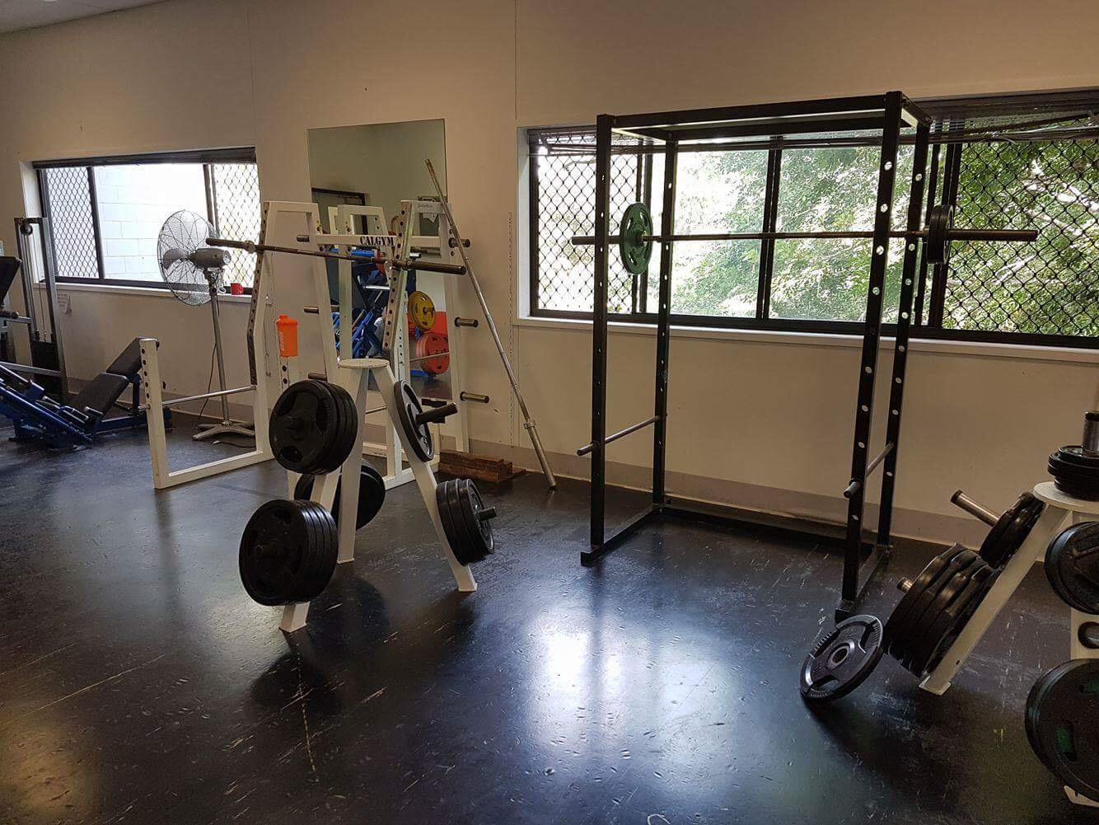

- Identify five (5) hazards present in the picture, completing a risk analysis for each.
- Rank the hazards from 1 to 5 (1 = most serious; 5 = least serious).

EXAMPLE HAZARD
Describe hazard
Dumbbells left on gym floor
Possible consequence(s)
- Trip and fall
- Possible bruising, broken bones, graze, cuts
Control measure(s)
- Erect signs around the gym
- Remind patrons to return weights
- Workers should consistently check gym floor
Determine the level of risk
Matrix | A:  Death or permanent disability | B:  Serious injury | C:  Lost time injury | D:  Casualty Treatment | E:  First Aid
1: Very Likely | E | E | H | H | M
2: Likely | E | H | H | M | M
3: Possible | H | H | M | M | L
4: Unlikely | H | M | M | L | L
5: Very Unlikely | M | M | L | L | L

E: Extreme | H: High | M: Medium | L: Low

Consequence rating: Serious injury (B)
Likelihood rating: Possible (3)
Level of risk: High (H)

HAZARD 1
Describe hazard
Barbell is hanging on an uneven angle
Possible consequence(s)
Fall off
Bruising, grazing, potential broken bones
Control measure(s)
Remind patrons to place equipment back correctly
Determine the level of risk
Matrix | A:  Death or permanent disability | B:  Serious injury | C:  Lost time injury | D:  Casualty Treatment | E:  First Aid
1: Very Likely | E | E | H | H | M
2: Likely | E | H | H | M | M
3: Possible | H | H | M | M | L
4: Unlikely | H | M | M | L | L
5: Very Unlikely | M | M | L | L | L

E: Extreme | H: High | M: Medium | L: Low

Consequence rating: Serious Injury (B)
Likelihood rating: Likely (2)
Level of risk: High

HAZARD 2
Describe hazard
Unequal weights hanging on the squat barbell
Possible consequence(s)
Fall to one side
Bruising, potential broken bones
Control measure(s)
Place signs around gym

Determine the level of risk
Matrix | A:  Death or permanent disability | B:  Serious injury | C:  Lost time injury | D:  Casualty Treatment | E:  First Aid
1: Very Likely | E | E | H | H | M
2: Likely | E | H | H | M | M
3: Possible | H | H | M | M | L
4: Unlikely | H | M | M | L | L
5: Very Unlikely | M | M | L | L | L

E: Extreme | H: High | M: Medium | L: Low

Consequence rating: Serious Injury (B)
Likelihood rating: Unlikely (4)
Level of risk: Medium

HAZARD 3
Describe hazard
Barbell leaning on weight rack
Possible consequence(s)
Slip to the side and fall
Bruising, grazing
Control measure(s)
Place signs around the gym
Remind patrons to place equipment back correctly
Determine the level of risk
Matrix | A:  Death or permanent disability | B:  Serious injury | C:  Lost time injury | D:  Casualty Treatment | E:  First Aid
1: Very Likely | E | E | H | H | M
2: Likely | E | H | H | M | M
3: Possible | H | H | M | M | L
4: Unlikely | H | M | M | L | L
5: Very Unlikely | M | M | L | L | L

E: Extreme | H: High | M: Medium | L: Low

Consequence rating: serious Injury (B)
Likelihood rating: Likely (2)
Level of risk: High

HAZARD 4
Describe hazard
Cord for the fan is out in the open
Possible consequence(s)
Trip and fall
Bruising, grazing, cuts, potential broken bones
Control measure(s)
Place cord out of harm’s way (E.g. tap cord to wall or wrap cord up behind it)
Determine the level of risk
Matrix | A:  Death or permanent disability | B:  Serious injury | C:  Lost time injury | D:  Casualty Treatment | E:  First Aid
1: Very Likely | E | E | H | H | M
2: Likely | E | H | H | M | M
3: Possible | H | H | M | M | L
4: Unlikely | H | M | M | L | L
5: Very Unlikely | M | M | L | L | L

E: Extreme | H: High | M: Medium | L: Low

Consequence rating: First Aid (E)
Likelihood rating: Possible (3)
Level of risk: low

HAZARD 5
Describe hazard
Squat supporters are too low
Possible consequence(s)
Squat bar will crush someone
Bruising, fractures, broken bones
Control measure(s)
Place signs around the gym
Remind patrons to use support bars correctly
Determine the level of risk
Matrix | A:  Death or permanent disability | B:  Serious injury | C:  Lost time injury | D:  Casualty Treatment | E:  First Aid
1: Very Likely | E | E | H | H | M
2: Likely | E | H | H | M | M
3: Possible | H | H | M | M | L
4: Unlikely | H | M | M | L | L
5: Very Unlikely | M | M | L | L | L

E: Extreme | H: High | M: Medium | L: Low

Consequence rating: Serious Injury (B)
Likelihood rating: Very Likely (1)
Level of risk: Extreme

RANK HAZARDS (1 = most serious; 5 = least serious)
Hazard 1 | Squat supporters too low
Hazard 2 | Barbell is leaning on weight rack
Hazard 3 | Barbell hanging on uneven angle
Hazard 4 | Unequal weights on squat bar
Hazard 5 | Cord for fan is out in the open

Outcome for Case Study 1 | ☐ Satisfactory  ☐ Not satisfactory
Trainer/Assessor comments

It is important to maintain items in the gym environment to maintain a safe environment.
  - Create a maintenance schedule for four (4) items regularly seen in a gym environment – one from each of the following categories:
- Gym floor
- Resistance training equipment item
- Cardiovascular machine
- Gym environment
Include daily, weekly and monthly functions, as well as maintenance/repair procedures that may only take place a limited number of times per year.
  - Locate two (2) instruction booklets for common items in a gym. Within each booklet, identify two (2) points with regards to safety and minimising risk for gym patrons.
  - What should an employee do if they cannot repair a piece of gym equipment?
- Who should they report the matter to?
  - Identify three (3) pieces of equipment that are essential to the safety of patrons in an emergency situation.
- For each equipment item, describe the procedures required to check the currency of their servicing history.

Example:
Name equipment item |  | Lat pulldown
Maintenance requirements
Daily | Weekly |  | Monthly | 6+ months | Other
- Check cleanliness  - Ensure security of safety clips  - Wipe down with anti-bacterial | - Ensure pin is safely secured to stack  - Check seats for tearing |  | - Check plate stack for smooth function  - Check smooth rotation of pulleys  - Check cable for signs of fraying | - Check pulleys and cables for major wear and tear | Nil

ITEM 1: GYM FLOOR ITEM
Name equipment item |  | Mats
Maintenance requirements
Daily | Weekly |  | Monthly | 6+ months | Other
Check cleanliness  Wipe down with anti-bacterial | Check for tearing |  | Check for signs of wear and tear | Nil | Nil

ITEM 2: RESISTANCE TRAINING EQUIPMENT ITEM
Name equipment item |  | Chest Delt Flyes
Maintenance requirements
Daily | Weekly |  | Monthly | 6+ months | Other
Ensure security of safety clips  Wipe down with anti-bacterial | Pin is safely secured to stack  Check seats for tearing |  | Check plate stack for smooth function  Check for signs of fraying | Check cables for wear and tear | Nil

ITEM 3: CARDIOVASCULAR MACHINE
Name equipment item |  | Treadmill
Maintenance requirements
Daily | Weekly |  | Monthly | 6+ months | Other
Check cleanliness  Wipe down with anti-bacterial | Buttons and reception check |  | Check for smooth function | Check reception for smooth and clear function | Nil

ITEM 4: GYM ENVIRONMENT ITEM
Name equipment item |  | Fans
Maintenance requirements
Daily | Weekly |  | Monthly | 6+ months | Other
Wipe down for dust | Switch and rotation is functioning correctly |  | Wires aren’t torn or broken | Connection and static is running smoothly | Nil

INSTRUCTION BOOKLET 1
Name equipment item | Belts
Instruction booklet requirements | Inspect all belts for proper tension and any non-uniformity, wear or damage along their entire length
Instruction booklet requirements | Replace at least once a year

INSTRUCTION BOOKLET 2
Name equipment item | Cables
Instruction booklet requirements | Run your fingers on the cable
Instruction booklet requirements | Pay particular attention to bends in the cable and attachment points

Code of Practice name | Work Health and Safety Act 2011
Requirements | How to achieve the standards required under the Act
Requirements | Effective ways to identify and manage risks.

EMERGENCY EQUIPMENT 1
Name equipment item | Cervical Collar
Checking servicing currency | Once every month

EMERGENCY EQUIPMENT 2
Name equipment item | Defibrillator
Checking servicing currency | Once every month

EMERGENCY EQUIPMENT 3
Name equipment item | Tourniquets
Checking servicing currency | Once a week

Outcome for Case Study 2 | ☐ Satisfactory  ☐ Not satisfactory
Trainer/Assessor comments

You have received the following the following client complaint via email:

To whom it may concern,

During the last few sessions at the gym, I have noticed a worrying trend. Of an afternoon, the area around the drink tap is becoming increasingly flooded; it is creating a slippery surface that I have very nearly fallen on at least three times. This leaking tap is a health hazard!

The gym floor workers have acknowledged my complaints, however they are yet to rectify the situation. I fear the next time I go to the gym could result in serious injury. It is disappointing that so far my complaints have fallen on deaf ears. I do not want to go to another gym, but if I continue to feel unheard and unsafe I will begin to look at your competitors.

Please tell me what you are going to do about this.

Regards,
Jim Patron

Respond to this client complaint. Ensure your response meets the following requirements:
- Shows empathy
- Acknowledges recording of the incident
- Discusses the duty of care
- Identifies the relevant chain of command in the resolution and reporting process
- Provides a resolution, including an improvement of organisational policies and procedures to minimise the likelihood of this occurring again

Your response
To Jim patron,
I am sorry to hear that your complaints have gone unheard of this long. I am really sorry about the situation. This is not what our gym is dedicated to as we have a duty of care to help keep our clients safe, secure and happy. We will fix this shortly. Before we call someone to find out what is causing this problem, we will place a wet floor sign around the area and try and figure out what is causing the problem. We will notify you as soon as this occurs. I am really sorry this hasn’t been dealt with earlier.

Kind regards, Isaac

Outcome for Case Study 3 | ☐ Satisfactory  ☐ Not satisfactory
Trainer/Assessor comments

Consider your safety requirements in a gym environment.
  - Describe ways that the following signs could be used in a gym:
- Dangerous goods classification
- Emergency equipment
- Personal Protective Equipment (PPE)
- Hazard
  - Outline the legal requirements with regards to safety
- Identify the legislation that outlines the safety requirements for a gym
- Identify two (2) legal requirements outlined under safety legislation/regulations
- Identify the regulatory authority who would check that legal requirements are being met
  - In situations where an employee cannot repair a piece of gym equipment, who should they refer the repair task to?
  - What role do clients and staff have in reducing or preventing the spread of infectious diseases?
- How can a gym regulate these practices?
  - What reporting processes can be put in place to ensure injuries are appropriately reported?
  - Describe how an employee may reflect on their own levels of stress and fatigue. Who should employees report to?
  - Explain the best process for undertaking hazardous manual tasks.

Safety signs
Showcase what is permitted and what isn’t permitted, clearly stating hazardous objects. (E.g. no weapons) Showcase where the closet emergency equipment is and how to use it. Showcase what the PPE is, where it is and how to use it. A hazard sign should showcase what a hazard is (E.g. electricity or water) and what to do to avoid it.
Legal requirements
Employers manage and conduct their work activities in such a manner as to ensure the safety, health and welfare of employees. That a risk assessment is carried out by the employer or person in control of the place of work. Transport hazards that exist in the workplace must be assessed as part of this risk assessment and appropriate steps taken to eliminate or reduce any risks found.
Referring repair tasks
Either a manager or an employer that is on shift. In the meantime, a ‘DO NOT USE’ will be placed on the broken equipment.
Infectious diseases
Place a sign on the front door of the gym that states rules about being hygienic (E.g. must bring a towel) Supply commercial-grade anti-bacterial bottles all around the gym with a sign stating: Please wipe down all equipment.
Reporting processes
Either telling an employee the injury report face-to-face or have hazard logs across the store that are checked every hour.
Stress and fatigue
To deal with stress and fatigue, employees can stop exercising/working, sit down, drink plenty of water, and relax muscles. If they want to refer to someone, they can refer to their local GP.
Hazardous manual tasks
Isolating the area, ensure it’s not dangerous to whoever is dealing with it, remove any equipment that is damaged/faulty, clean area, and quarantine the area until the hazard is fully dispersed.

Outcome for Case Study 4 | ☐ Satisfactory  ☐ Not satisfactory
Trainer/Assessor comments

PRACTICAL TASKS

You are required to have a suitable observer verify your ability to complete the following tasks. These tasks may be simulated or real.

TASKS | VERIFIED
- Conduct a safety inspection of your work area, completing a risk register:  - Identify hazards and associated risks (including hazardous manual tasks)  - Consult with relevant stakeholders to analyse and evaluate risks  - Identify and evaluate control measures  - Develop and implement treatment plans for your area of responsibility  - Report hazards as per workplace procedures  - Refer hazards that are beyond your own area of responsibility  - Maintain risk management documentation  [Evidence: Risk Register] | ☐
- Respond to a (simulated) fire emergency/drill:  - Provide information needs to emergency response personnel during reporting, arrival and in response to emergency  - Checking and accounting for people during an evacuation  - Debriefing with an appropriate person, as per workplace procedures, to identify personal levels of stress and fatigue | ☐
- Over five (5) service periods, safely conduct six (6) of the following minor maintenance tasks on equipment (i.e. equipment used within the facility, participant/client-specific equipment, emergency equipment, large items requiring lifting and assembly):  - Cleaning  - Lubrication  - Reinflating  - Checking for damage  - Restocking or refilling  - Repairing  - Calibration  - Storage (ensuring entry and exit in the case of an emergency situation)  - Completing maintenance records and forms (e.g. logbook) | ☐

Outcome for Practical Tasks | ☐ Satisfactory  ☐ Not satisfactory
Trainer/Assessor comments

