BSBINM301
Organise workplace information
Learner Workbook



Table of Contents

Table of Contents 1
Candidate Details 2
Assessment – BSBINM301: Organise workplace information 2
Competency Record to be completed by Assessor 3
Observation/Demonstration 4
Activities 5
Activity 1A 5
Activity 1B 6
Activity 1C 8
Activity 2A 9
Activity 2B 10
Activity 2C 10
Activity 2D 12
Activity 2E 13
Activity 3A 14
Activity 3B 15
Skills and Knowledge Activity 16
Major Activity 17

Candidate Details

Assessment – BSBINM301: Organise workplace information
Please complete the following activities and hand in to your trainer for marking. This forms part of your assessment for BSBINM301: Organise workplace information.
Name: Zoe Lwin
Address: 79 Waterview Avenue, Wynnum, 4178
Email: zoejade_98@hotmail.com
Employer: Lwins Cleaning
Declaration
I declare that no part of this assessment has been copied from another person’s work with the exception of where I have listed or referenced documents or work and that no part of this assessment has been written for me by another person.
Signed: ____________________________________________________________
Date: ____________________________________________________________
If activities have been completed as part of a small group or in pairs, details of the learners involved should be provided below:
This activity workbook has been completed by the following persons and we acknowledge that it was a fair team effort where everyone contributed equally to the work completed. We declare that no part of this assessment has been copied from another person’s work with the exception of where we have listed or referenced documents or work and that no part of this assessment has been written for us by another person.
Learner 1: ____________________________________________________________
Signed: ____________________________________________________________
Learner 2: ____________________________________________________________
Signed: ____________________________________________________________
Learner 3: ____________________________________________________________
Signed: ____________________________________________________________

Competency Record to be completed by Assessor
Learner Name: _______________________________________________________
Date of Assessment: _______________________________________________________
The learner has been assessed as competent in the elements and performance criteria and the evidence has been presented as:
Assessor Initials
Authentic
Valid
Reliable
Current
Sufficient

Learner is deemed: COMPETENT NOT YET COMPETENT (Please circle)

If not yet competent, date for re-assessment: ____________________________________

Comments from Trainer / Assessor:
__________________________________________________________________________________________________________________________________________________________________________________________________________________________________________________________________________________________________________________________________________________________________________________________________________________________
Assessor Signature: ________________________________________________________

Observation/Demonstration

Throughout this unit, you will be expected to show your competency of the elements through observations or demonstrations. Your instructor will have a list of demonstrations you must complete or tasks to be observed. The observations and demonstrations will be completed as well as the activities found in this workbook. An explanation of demonstrations and observations:
Demonstration is off-the-job
A demonstration will require:
- Performing a skill or task that is asked of you
- Undertaking a simulation exercise
Observation is on-the-job
The observation will usually require:
- Performing a work based skill or task
- Interaction with colleagues and/or customers
Your instructor will inform you of which one of the above they would like you to do. The demonstration/observation will cover one of the unit’s elements.
The observation/demonstration will take place either in the workplace or the training environment, depending on the task to be undertaken and whether it is an observation or demonstration. Your instructor will ensure you are provided with the correct equipment and/or materials to complete the task. They will also inform you of how long you have to complete the task.
You should be able to demonstrate you can:
- Collect and assess information
- Organise information
- Review information needs
You should also demonstrate the following skills:
- Reading
- Writing
- Oral communication
- Navigate the world of work
- Interact with others
- Get the work done

Activities

Activity 1A
Estimated Time | 30 Minutes
Objective | To provide you with an opportunity to access product and service information in accordance with organisational requirements.
Activity | Identify three common ways to access information within your place of work, and state the common process for doing so, including any organisational requirements that govern the process.
  Method (i.e. computer databases) | Process | Organisational requirements
  Computer files/databases – letters, memos and other documents such as past work schedules, financial reports etc. | Search pc files  Locate relevant business folders  (Folders are systematically ordered and filed on pc to make them easy to locate.) | Organisational code of conduct.  Security and confidentiality requirements  Need to follow correct protocols involved in updating computer files.  Managing accountability – dates and user names.
  Correspondence – emails, letters from suppliers/clients, faxes, memos, etc. | Relevant files may be located on the computer or within paper filing system. Access information needed, make copies if necessary and return files to place/refile in another location. | Organisational code of conduct.  Security and confidentiality requirements
  Forms – insurance, membership, subscription details etc. | Information may need to be updated/adjusted.  Relevant files may be located on the computer or within paper filing system. Access information needed, make copies if necessary and return files to place/refile in another location. | Procedures for updating records  Organisational code of conduct.  Security and confidentiality requirements

Activity 1B
Estimated Time | 30 Minutes
Objective | To provide you with an opportunity to ensure methods of collecting information are reliable and make efficient use of available time and resources and to assess information for clarity, accuracy, currency and relevance to intended tasks.
Activity | Consider the ways of collecting information in your organisation.  Make notes on:  - The reliability of this method  - Does the value of the information warrant the time spent collecting it?  - Do you have the necessary resources to collect information in this way?  Some methods of collecting information within my organisation include; consultation with colleagues/customers, observation and listening, accessing previous file records, checking others research and findings, personal investigation and research etc. To increase the reliability of the information gathered, it is a good idea to access at least three different sources. Repeating the procedure and achieving the same results is a good indication that the method is trustworthy and consistent. To ensure efficiency when collecting information, it may be helpful to consult with others and ask for assistance from a designated member of staff. This also strengthens the credibility of results.  Once you have collected information in this way, how would you ensure that the information is clear, accurate and relevant to the task? How would you analyse the information? Make notes under the following bullet points.  The value of the information collected can be determined by its clarity, accuracy and relevance.  - Clarity  - The information needs to be concise and understandable.  - Accuracy  - It must also be factual; accompanied by sufficient references and justification to ensure its accuracy.  - Relevance  - Useful information must relate to the situation at hand and provide relevant facts and solutions.  - Analysis  Effective analysis can be achieved by representing or mapping out the data in various formats through the use of charts, tables and graphs etc. This allows you to systematically analyse the information and easily identify trends and relationships in order to make appropriate conclusions and recommendations.

Activity 1C
Estimated Time | 45 Minutes
Objective | To provide you with an opportunity to use interpersonal skills to access relevant information from teams and individuals.
Activity | Workplace activity:  In groups of up to five, take turns to lead a group discussion on an aspect of your business or organisation, including the main topic or type of information that is accessed, organised and assessed within the workplace. This could be any topic as long as it applies to your situation. The key element is to display a variety of interpersonal skills in front of each other.  Example: Type of information being accessed – information regarding workplace improvements over the past year.  After individually analysing the information gathered on this topic, it can be discussed with colleagues, clients and others to gain further knowledge. Some of the interpersonal skills that can be used when doing this include; consultation methods which involve accessing information through collaboration, networking, confirming understanding by seeking feedback, summarising/paraphrasing (enables you to be concise and to isolate the most important features of a correspondence) and using appropriate body language. Some examples of positive body language include and upright, confident posture, eye contact, smiling and an open body position which shows that you are welcoming.

Activity 2A
Estimated Time | 40 Minutes
Objective | To provide you with an opportunity to organise information in a format suitable for analysis, interpretation and dissemination in accordance with organisational requirements.
Activity | How do the following formats aid effective organisation of information?
  Organisational feature | How does it aid organisation of information?
  Headers and footers | These can be used to signpost the document, outline its purpose or formalise the document
  Graphics and pictures | Images help the reader easily interpret the information and improve its conciseness. They are very descriptive and often convey information more effectively.
  Symbols | Using symbols can draw the reader’s attention to certain features of a document or report to make communication of ideas clearer.
  Legends | These help you interpret data by providing further information alongside a chart or table.
  Software applications | Depending on the type of organisation, there are various applications with can help to organise and set out information in a desired format such as graphs and charts. Some programs include Microsoft word, excel and PowerPoint.
  Tables and charts | Tables and charts are a good way to display data and make it easier to interpret. They are also very versatile in the type of information which can be represented.
  Add another of your own:  Fonts and sizing. | Helps to emphasise certain points and draw attention to important features of a document. Good way to make information easy to follow. Words and phrases in italics/bold letters stand out more.

Activity 2B
Estimated Time | 30 Minutes
Objective | To provide you with an opportunity to use appropriate technology/systems to maintain information in accordance with organisational requirements.
Activity | Choose a technological item, and one of the systems mentioned in the learner guide, to identify how they help maintain information. Refer to organisational requirements in your explanations.  Technological item (e.g. photocopier, intranet, fax machine etc.)  Email – this technology item is an effective knowledge management system. It allows for efficient communication and file sharing between parties, letting you share and retrieve organisational knowledge. Using this resource in a safe and appropriate manner within the workplace often involves the use of information protocols, encryption and authentication measures.  System (information, knowledge or record management)  An Information Management System (IMS) defines software which is used in the storage, organisation and collection of data. This might include an electronic or physical filing system.

Activity 2C
Estimated Time | 30 Minutes
Objective | To provide you with an opportunity to collate information and materials and communicate to relevant designated persons.
Activity | What is the purpose of collating information? Draw upon your own experiences in the workplace and how you communicated the information to designated persons.  In a business setting, collating information involves bringing documentation together from a range of sources to compare, arrange and organise this data.  Depending on your role within the workplace and level of authority, you may need to collate data such as sales records and appropriately format this data (putting it into the relevant system), before communicating it to designated personnel, such as clients, colleagues, committee members, external agencies, statutory bodies or supervisors.  One part of my role involves collating client data such as outstanding accounts, and overdue invoices, and communicating this data to my supervisor for further action. To do so involves accessing emailed, posted and online information to locate pending and past payments, process these by allocating them to the relevant clients and then collating this data using electronic systems to produce a report.

Activity 2D
Estimated Time | 45 Minutes
Objective | To provide you with an opportunity to identify difficulties organising and accessing information and solve collaboratively with individuals and team members.
Activity | List the possible difficulties that you could come across, in relation to organising information. Offer potential solutions to these situations including the individuals or team members that you may need to collaborate with.
  Difficulty | How you could resolve this issue and who you may call upon to solve the issue
  Lost information | May be the result of a lack of organisation and systematic data filing. May need to obtain the lost documentation from the original source and develop a more organised system. Allocate personnel to take on this role.
  Security measures can restrict access to data when it is shared across organisations. In addition to this, computer systems may be incompatible across locations therefore restricting the sharing of information | This may involve adjusting access settings. If you are not competent using applications, it is best to ask a supervisor or someone with the skills and knowledge to help.
  Too complex & too much data  Some information management systems can fail because they are too complex and it can be too difficult to get results and converting the data can be difficult. When a large businesses processes lots of information, any additional tasks can overload the system. | The ideal situation is to be able to interpret data with ease and efficiency. Solving collaboratively is the best way to achieve results when problems arise.

Activity 2E
Estimated Time | 30 Minutes
Objective | To provide you with an opportunity to update and store information in accordance with organisational requirements and systems.
Activity | Provide an example of a storage system within your organisation, identifying what types of information you may store and how this adheres to organisational requirements.  Within my organisation, central filing systems are employed to store electronic and paper documents.  Manual information storage includes:  - Folders (ring binders, lever arch files)  - Shelving  - Filing cabinets  - Full length secure storage units.  Electronic storage includes;  - Databases  - Emails  - Computer files  - Cloud storage systems.  The information stored in these systems include correspondence, insurance forms, historical data, employee information, financial records etc.

Activity 3A
Estimated Time | 45 Minutes
Objective | To provide you with an opportunity to actively seek feedback on clarity, accuracy and sufficiency of information to ensure relevance of information and system and to review the contribution of information to decision making and implement appropriate modifications to collection processes.
Activity | Demonstrate your knowledge of feedback opportunities by giving examples and answering the following questions in the table.
  Method of giving feedback | What are the advantages of this method? | How may this inform decision making?
  Comments from clients and colleagues | When colleagues are specific, this type of feedback gives accurate insights into business performance. It also allows you to identify like-minded responses and improve the clarity of information gathered. | Gaining feedback allows you to identify alternative decisions and select the best option.  These methods involve dealing with clients and colleagues as well as emailing, researching and organising information which helps to make well-informed, accurate decisions based on the information presented.
  Customer satisfaction questionnaires | Understanding the views of your customers helps to gauge the success of your business, and allows you to gain an external perspective. Responses may highlight unknown issues.
  Quality assurance data | This is often a non-biased way to realise improvements needed within the organisation.

Activity 3B
Estimated Time | 40 Minutes
Objective | To provide you with an opportunity to identify future information needs and incorporate modifications to collection processes and to document future information needs and incorporate in modifications to reporting processes.
Activity | You may discover that further action is needed to improve business protocol. This could occur in a variety of situations and is dependent on your organisation.  Consider the following issues:  - Information management (i.e. you may need to provide more information as a business in order to improve and be a more serious competitor).  - IT system needs. There may be additional systems brought in that require training and management of more resources.  - Business requirements, such as legislative changes.  Consider one of the above issues, depending on your own experience, and answer the following:  - What type of information do you need to collect?  IT System needs. More technology in a workplace can often make tasks easier and more efficient, reducing stress, while they can also increase standardisation and repetition of procedures. Identifying specific needs regarding IT systems is the first step in collecting data. This is, first analyse the current state of your computer systems. Are your current systems too complex/simple? Do they have the capacity to be used to accomplish necessary tasks in the workplace? You may need to research how systems can be improved and collate data to find the best options.  - Where would you access this information?  This information might be accessed through reviewing current systems, personal research (eg online, computer databases etc), through collaboration with colleagues, clients and external bodies, or through feedback.  - How would you document these needs if they became apparent for future improvements?  To document these needs for future reference or to discuss improvements, you would need to:  - Outline views and knowledge about the current state and needs of systems.  - Document findings of research.  - Collate all data – present in an appropriate form using images, graphs, tables etc where necessary.  - Identify trends and make comparisons.  - Present ideas and potential solutions.  An information needs analysis can also help identify where to take future action by showing and comparing past and present needs.

Skills and Knowledge Activity
Estimated Time | 2 Hours
Objective | To provide you with an opportunity to demonstrate your knowledge of the foundation skills, knowledge evidence and performance evidence.
Activity | Complete the following individually and attach your completed work to your workbook.  The answers to the following questions will enable you to demonstrate your knowledge of:  - Reading  - Writing  - Oral communication  - Navigate the world of work  - Interact with others  - Get the work done  - Legislation and regulations affecting the gathering, organising and distribution of workplace information  - Methods for checking validity of information and its sources  - Organisational recordkeeping and filing systems, security procedures and safe recording practices  - Workplace policies and procedures relating to workplace information.  Imagine you are going to conduct a seminar for your colleagues, based around organising workplace information. It is your job to provide an in-depth presentation based on the skills needed to organise workplace information effectively. It will combine all the skills and knowledge you have learnt from this unit. You will need to take your colleagues through the processes of accessing, collecting, organising and reviewing information.  In order to give a credible presentation, you will need to provide resources to help knowledge, such as copies of information sources (databases, records etc.) and you will need to show briefly how to conduct some of the key activities. Remember to refer to legislation where necessary and consider your communication skills.  Plan a PowerPoint presentation (using this application or something of the equivalent) and any required resources to support your presentation.  How to organise workplace information effectively  Accessing Workplace Information  Methods Where can information be found?  There are various methods of locating information within the workplace.  After considering what type of information you require and where it may be stored, these methods can be used to pinpoint what you are looking for. Some of these include;  - Searching pc files on computer databases  - Accessing correspondence such as emails, letters, faxes, memos etc. (these may be in paper of electronic format)  - Retrieving forms, outlining details of things like insurance, memberships, subscriptions etc.  It is important to keep in mind organisation as codes of conduct, security and confidentiality protocols etc when accessing this information.  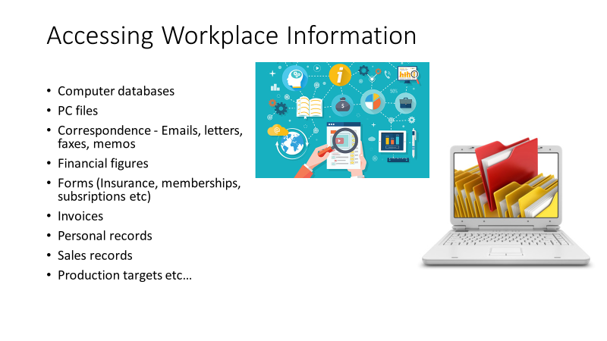  Analysis  After accessing various sources to find the necessary information, the next step is to analyse its relevance and reliability before conclusions/decisions can be made.  The value of the information can be determined by considering its  - Clarity  - Accuracy  - Relevance  Reliability can be increased by accessing information from at least three different sources. It is a good indication that your method is trustworthy and consistent if repeating the procedure gleans the same results.  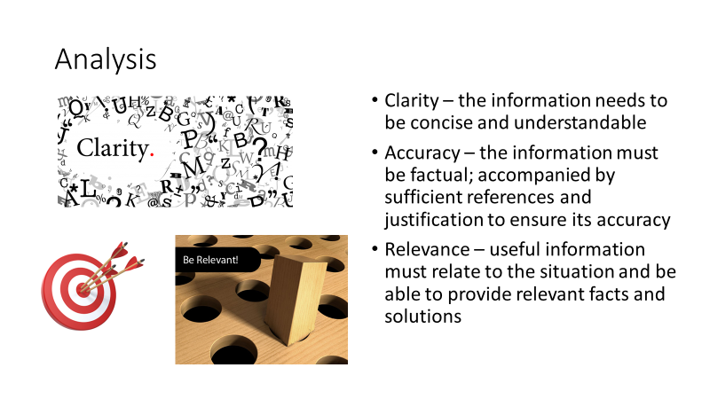  Drawing Conclusions & Presenting the Information  A further analysis of the results will allow you to draw conclusions from the information. Developing graphs and charts is an excellent form of systematic analysis as it allows you to identify relationships and trends within the data so that appropriate, accurate decisions can be made.  After you have organised your information to an appropriate format, consider some ways to make your presentation even more effective.  Formats which can improve the way information is presented include:  - Headers and footers  - Graphics and pictures  - Symbols  - Legends  - Software applications  - Tables and charts  - Fonts and sizing etc  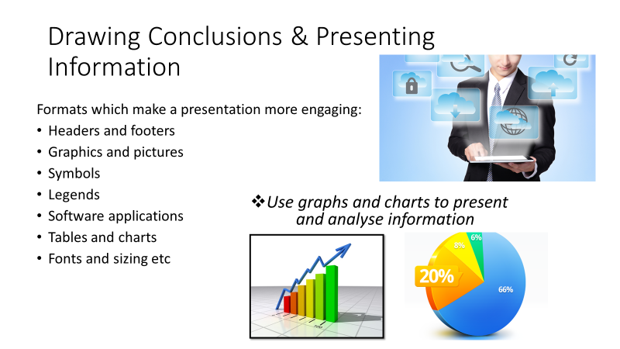  Storing & Sharing: Communicate the Information  There are various Information Management Systems (IMS) and technological items which allow for information to be collated and stored effectively, so it can then be shared with others or accessed at a later date. Email is one excellent example of this.  Sharing, discussing information, and seeking feedback from colleagues, clients and others is a great way to gain further knowledge, therefore it is important to know how to do this effectively. Improving your interpersonal skills will help with effective and meaningful consultation, collaboration and networking with others.  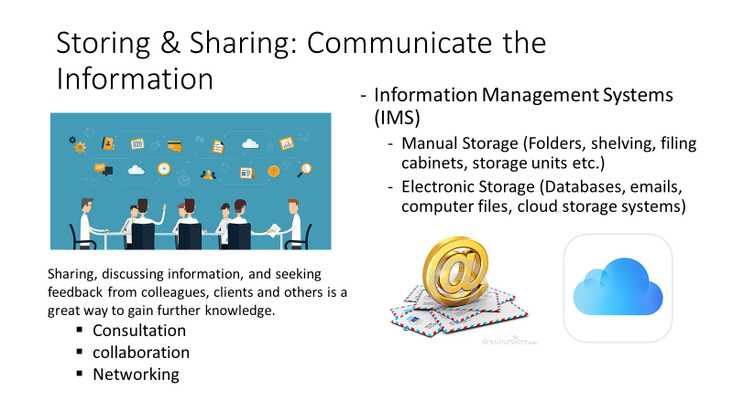  One way to display a variety of interpersonal skills involves using appropriate body language such as upright, confident posture, eye contact, smiling and an open body position.  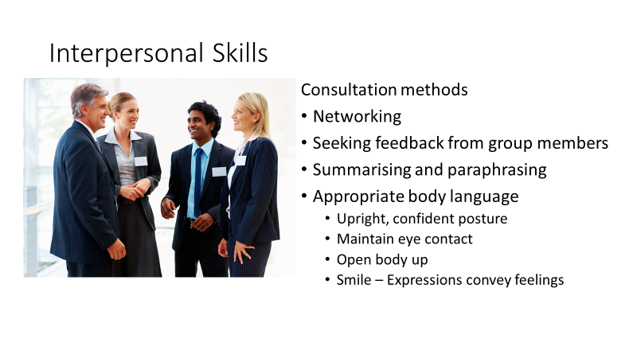

Major Activity
Estimated Time | 1 Hour
Objective | To provide you with an opportunity to demonstrate your knowledge of the entire unit.
Activity | This is a major activity – your instructor will let you know whether you will complete it during class or in your own time.  Attach your completed answers to the workbook.  You must individually, answer the following questions in full to show your competency of each element:  - Collect and assess information  - Organise information  - Review information needs  Answer each question in as much detail as possible, considering your organisational requirements for each one.  - What kinds of information sources are available to access information?  Information can be gathered from various sources within the workplace. Some of these include:  - Computer databases (customer records, item inventory)  - Computer files (letters, memos, filed documents)  - Correspondence (Faxes, memos, letters, emails)  - Financial figures  - Forms (insurance, memberships, subscriptions)  - Personal and business records (salary rates, monthly forecasts, targets achieved etc.)  - What is the purpose of organisational requirements, in relation to accessing information?  Organisational restrictions, protocols and codes of conduct relating to accessing information are in place to maintain security and confidentiality within the workplace, manage accountability and ensure records are updated correctly.  - What factors should you consider, to ensure that methods of collecting information are reliable?  To ensure that your methods of collecting information are reliable, it is important to gather information from credible sources, using a variety of methods to do so. Checking information multiple times and asking others to check the information is another way to ensure its reliability.  - What are the advantages of improving your interpersonal skills in order to access relevant information from teams and individuals?  Improving interpersonal skills can allow us to network and consult with others effectively which can improve work relationships and ensure that communication is calm and efficient. This helps to gain effective feedback and ideas from others.  - Describe the process of analysing, interpreting and disseminating information.  The process of analysing, interpreting and disseminating information relates to the way in which information is processed, understood and shared, once it is organised into an appropriate format.  - Analysis  Inspect information to make conclusions, draw comparisons or complete a given task.  Ensure the accuracy of information using appropriate software.  - Interpretation  Consider the reliability and relevance of your information, ensuring the data is not misleading.  Think about what might be the most appropriate format to present the information in order to make your interpretation clear to your audience.  - Dissemination  Consider the audience you want to reach and how you will share the information on larger scale so as to positively promote your business.  (Eg. Sales report, presentation, meeting, seminar etc.)  - How can the effective use of appropriate technology/systems help to maintain information?  Using various technological systems to store data can be an efficient way to manage, maintain and keep information up to date. Appropriate use of these systems can make it very easy to locate information quickly. Answering machines, computers, email, fax machines and the internet are some good examples of technology that can be used in this way.  - Describe some common difficulties organising and accessing information and how you have overcome these.  When information storage systems, physical or technological, are not properly maintained, it can mean that information gets lost or overlooked. This can happen when these systems are not updated regularly. At times, unfiled information may build up which can cause issues for others trying to access the information. To overcome this, it is important to keep systems up to date, and ensure that those using these systems are properly trained.  - Explain some key factors of effective collaboration.  Effective collaboration can improve business protocol in various ways. Some key steps to achieving this when working collaboratively are:  - Sharing perspectives  - Clearly defining issues  - Identifying interests  - Generating and evaluating options  - Developing a fair standard  - How do you, or those with the responsibility, maintain up to date information and store the documentation? Explain the process and any particular systems in place.  Processes of storing and maintaining information are most efficient when they are kept simple. One method of information storage that is used within my organisation is a filing cabinet. This is a central system where all business records are stored. A well organised filing cabinet allows you to systematically sort and categorise documents, so they can be easily accessed.  - Identify a time when you have actively sought feedback. What was the method used and how did this enable you to provide more relevant information?  Writing job reports is one task which requires me to seek feedback when organising information. After individually analysing and collating a given set of data, and formulating a report, I must seek feedback from my supervisor to ensure all the relevant information has been included.  - Building on your previous answer, how did this inform future decisions?  Continually gaining feedback helps to further knowledge on a topic, allowing you to more accurately interpret information in the future.  - Describe a time when information resources were particularly helpful in improving performance management. It could be internal information, networking, and the influence of legislation or other factors.  There are various information resources from which to gain performance knowledge. These may include internal information such as sales reports or customer feedback. Communicating with customers, formally of informally has been an effective way to gain insight into areas that can improve customer satisfaction.

