CPCCBC4018
Apply site surveys and set-out procedures to building and construction projects

ASSESSMENT SUMMARY

The assessment activities for CPCCBC4018 Apply site surveys and set-out procedures to building and construction projects cover all aspects of the unit of competency. For Apprentices/Trainees, this includes supervisor completion of the Apprentice/Trainee Record (ATR).

Participants must read all the information given before starting any assessment task. The assessment tasks are intended to be fair, flexible, valid and reliable. If a Participant has any questions or requires alternative arrangements to be made such requests should be directed to their Trainer/Assessor, who should note such arrangements in the ‘Assessor Comments’ on the affected assessment. If a Participant feels they are not yet ready to be assessed, they should discuss their options with their Trainer/Assessor.

To satisfactorily complete the assessment, the Participant is required to answer all questions correctly and demonstrate their skills to industry standards. If a Participant does not answer all questions or perform all tasks, they will be deemed ‘Not Satisfactory’ for the task and ‘Not Yet Competent’ for the unit of competency.

The Trainer/Assessor can provide the Participant with additional information on interpreting the assessment outcomes and guide the Participant’s options. If a Participant is still deemed ‘Not Satisfactory’ they will have the opportunity to undertake a supplementary assessment or appeal the result as per the process in the Student Handbook.

By signing below, the Participant acknowledges:
- They understand the assessment instructions and requirements, and consent to being assessed.
- The work submitted is to be their own work – with the work of/with others needing to be clearly acknowledged and documented.
- They consent to any photo/video recording of their work that occurs during assessment.

Participant name | Dawei Yang
Participant signature | 

Pre-requisite unit(s) to be achieved and authenticated prior to undertaking assessment
Not applicable

Task | Date completed | Assessment Results
Theory Exam | Select Date. | Satisfactory | Not Satisfactory
Workbook | Select Date. | Satisfactory | Not Satisfactory
Practical Assessment | Select Date. | Satisfactory | Not Satisfactory
Outcome for CPCCBC4018 | Select Date. | Competent | Not Yet Competent

Evidence requirements checklist (ticked by assessor and evidence supplied to RTO)
Theory Exam  Workbook | Practical Assessment  Booking sheet  Topographic contour plan from grid lines  Calculations sheets

Assessor name
Assessor signature | 

CPCCBC4018
Apply site surveys and set-out procedures to building and construction projects

THEORY EXAM

Participant name | Dawei Yang

FOR THE PARTICIPANT
Instructions
- You will complete written questions as outlined on the following pages. You must attempt all questions and provide enough detail in your responses to demonstrate your knowledge.
- It is anticipated that you should complete this assessment within two (2) hours, but additional time may be allowed upon negotiation with the Assessor.
- You must complete all questions unassisted by the Assessor or other personnel but may refer to reference material as needed. All questions must be answered correctly for a ‘Satisfactory’ assessment outcome to be awarded.
  - An oral examination may be allowed under certain circumstances, whereby your answers will be documented by another party.
  - Any written questions that are incomplete, or not answered satisfactorily will need to be completed again after further training support.
    - If you answer a question incorrectly but modify your response, put your initials next to the written change (or the Assessor must initial a verbal change).
Resources required
Pen

FOR THE ASSESSOR
Instructions
- Where oral examination has occurred, ensure that this is acknowledged in writing (e.g. FT001 and Assessor Comments)
- All questions must be satisfactorily demonstrated by the Participant for a Satisfactory determination (indicated by an Assessor tick to the right of the question).
- Assessors are to complete marking in pen of a different colour to the Participant.
- If the Participant verbally modifies their response, write in the modified response verbatim and put your initials next to the written change.

ASSESSOR COMMENTS
As necessary, outline:
- Details on reattempts, alternative arrangements or reasonable adjustments made.
- Where a Participant is deemed ‘Not Satisfactory’, provide recommendations for future training.

- Explain why we should determine the orientation of the building according to the plans.

Answer | This orientation lets you consistently harness daylight and control glare along the long faces of the building. It also lets you minimize glare from the rising or setting sun.

- Discuss the information you can source from the specifications.

Answer | Building codes and project refers to  Colour selection  Contract requirement  Material and labour schedules  Materials specification  Plans,sketches and drawings  Statements and requirements

- The construction project must comply with the National Construction Code (NCC). What does this mean.

Answer | The National Construction Code (NCC) sets out the requirements for the design and construction of a building in Australia, including plumbing and drainage. It sets the minimum required level for the safety, health, amenity, accessibility and sustainability of certain buildings.

- Describe the principles of establishing control during set-out surveys.

Answer | This surveying principle involves laying down an overall system of stations whose positions are fixed to a fairly high degree of accuracy as control, and then the survey of details between the control points may be added on the frame by less elaborate methods.

- What is linear measurement in surveying?

Answer | Linear measurement in surveying is the determination of the distance between two points on the surface of the earth is one of the basic operations of surveying

- Provide two (2) examples of surveying that uses linear measurements.

Answer  1.  2. | ▪  chain surveying  traverse surveying, and other types of surveying

- Listed below are principles of linear measurement for small surveys. Briefly explain what each principle means.

Answer | Principle | Explanation
 | Working from whole to the part | Treat the area as a whole, then break it down into several triangles rather than the reverse.
 | Form well-conditioned triangles | Form angles preferably between 30° and 120°. Aim for equilateral figures, based on at least one long backbone line.
 | Economy of lines | Use as few measured lines as necessary, while avoiding obstacles and steep slopes, but using sufficient check lines to minimise errors.

- Listed below are two (2) methods of linear measurements. Briefly explain each.

Answer | Type of linear measurement | Explanation
 | Direct method | In this method, the distance is measured during the actual fieldwork using a chain or a measuring tape.
 | Optical method | In this method, the distance is computed indirectly using the tacheometer.

- What is horizontal angular measurement in surveying?

Answer | A horizontal angle is measured in horizontal plane and a vertical angle is measured in vertical plane. Horizontal angles are the basic measurements performed to determine the bearings and azimuths.

- Why are the linear and angular measurements necessary in surveying?

Answer | Surveyors are concerned about measuring both horizontal and vertical distances. And while many angles are read, surveyors need to determine the length of at least one line to supplement them at specific locating points. This is the purpose of linear surveying

- Why is it relevant to have knowledge of geometry when conducting surveying activities?

Answer | Geometry is a branch of mathematics that studies the shapes, positions, and dimensions of objects. Surveyors measure distances, angles, and directions between points by using geometric principles of measurements.

- Why is it relevant to have knowledge of trigonometry when conducting surveying activities?

Answer | The sine quadrant includes grid lines of the trigonometric functions, from which solutions and readings can be achieved. The sine quadrant is a mathematical instrument that solves trigonometric calculations.

- What components are needed when using an optical level and how are these used?

Answer | precision telescope with crosshairs and Stadia marks

- What is the difference between a dumpy level and a theodolite?

Answer | A Dumpy level uses a telescope whose movement along its horizontal plane is restricted and is fixed to its support. A bubble tube is affixed on top of the telescope to indicate a surface’s level.A tilting level consists of a telescope which allows horizontal rotation, as well as tilting of about four degrees in its vertical plane

- Describe a two-peg test.

Answer | To apply the two-peg test, you must establish two points on level instrument ground approximately 50 metres apart. Set the level halfway between the two points of the instrument.  From the level instrument, take the two staff readings. If the line of sight does not coincide with the line of collimation, an error would occur.  The amount is okay if the gap in height is the same. If it is not, the level device needs to be serviced. The example given below shows that the level instrument has an error because there is a height difference of 0.272 between Peg A and Peg B.

- Discuss benefits of using electronic distance measuring (EDM) equipment.

Answer | The EDM is able to measure the azimuth (angle from north) and elevation of a point. The comparison of the returning signal to that emitted by the EDM allows the unit to determine the distance between the unit and the target surface

- Identify one operational and one functional feature for each of the levelling and surveying devices listed below.

Answer | Device | Operational features | Levelling features
 | Laser level: manual-levelling laser | operator to manually level the unit by turning the thumbs screws and getting the unit levelled by looking at the bubble vials | The v-groove shape of the device fits contours of pipe and conduits.
 | Laser level: dot laser levels | establish plumb lines or right angles by projecting laser dots vertically, horizontally, or at right angles | transfer a point from the floor to the ceiling and establish a level plane.

- Describe features of the water level.

Answer | The measured distance to the water surface at a particular time and date, relative to a reference point.

- You are responsible for checking levels in an excavation.
From the drawings for the job you know the floor level is RL 12.000. The floor of the excavation is level (0% grade).
You find a peg, which identifies the RL as 14.50.
The plane of collimation measures 0.65m above the peg.
On what level would you set the receiver on the stave to achieve the desired FL of the excavation? Show your calculations.

Answer | 14.5-0.65=13.85

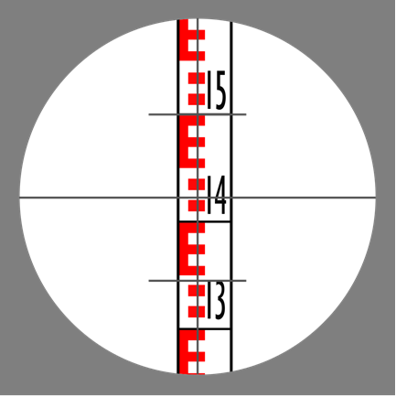
- Using the picture above, what distance is the staff from the instrument? Show workings.

Answer | 14

- Discuss errors in measured distances due to site characteristics and measurement methods.

Answer | ▪slopes  ▪wind  ▪vegetation  ▪other impediments

- Discuss the purpose of setting out gridlines for the construction project.

Answer | The grid lines allow the reader to make references in terms of position or location of various elements in the project A surveyor would then set out grid lines on the construction site. The surveyor will acquire a survey plan that indicates the true coordinate control points near the construction site and then transfer and establish new control points if necessary. From these control points, grid lines can then be established in the construction site..

- Discuss situations where you need to draw up a contour plan.

Answer | When constructing a building on a sloping block, it may be necessary to cut and fill the block so that you have a level surface to build on.

- When do you draw longitudinal sections from RLs.

Answer | Drainage plan

- How do you determine the tolerances when determining levels and clearances from given grades for underground pipework?

Answer | You will set out a grid on a sloping block to work out the cut and fill volumes. You will also take levels at each intersection of the grid and note these. Finally, you will determine the cut and fill line for the block and then calculate the volume to cut from the block and the volume needed for fill. You will show how you arrived at these calculation

- How do you calculate elevation slope as a decimal or a percentage?

Answer | Angles specify the angle in degrees for the pipework. The most common ways to express grades are in the last 2: percentages and ratios.

- How do you calculate elevation slope in degrees?

Answer | Grade as an angle = arctan(rise/run)

CPCCBC4018
Apply site surveys and set-out procedures to building and construction projects

WORKBOOK

Participant name | Dawei Yang

FOR THE PARTICIPANT
Instructions
- You will complete written activities as outlined on the following pages. You must attempt all questions and provide enough detail in your responses to demonstrate your knowledge.
- The timeframe for these tasks will be established by your Assessor or Training Plan, but additional time may be allowed upon negotiation with the Assessor.
- You must complete all questions unassisted by the Assessor or other personnel but may refer to reference material as needed. All questions must be answered correctly for a ‘Satisfactory’ assessment outcome to be awarded.
  - An oral examination may be allowed under certain circumstances, whereby your answers will be documented by another party.
  - Any written questions that are incomplete, or not answered satisfactorily will need to be completed again after further training support.
    - If you answer a question incorrectly but modify your response, put your initials next to the written change (or the Assessor must initial a verbal change).
Resources required
Pen

FOR THE ASSESSOR
Instructions
- Where oral examination has occurred, ensure that this is acknowledged in writing (e.g. FT001 and Assessor Comments)
- All questions must be satisfactorily demonstrated by the Participant for a Satisfactory determination (indicated by an Assessor tick to the right of the question).
- Assessors are to complete marking in pen of a different colour to the Participant.
- If the Participant verbally modifies their response, write in the modified response verbatim and put your initials next to the written change.

ASSESSOR COMMENTS
As necessary, outline:
- Details on reattempts, alternative arrangements or reasonable adjustments made.
- Where a Participant is deemed ‘Not Satisfactory’, provide recommendations for future training.

NOTE

At times, you will be provided with a specific context to which you must respond, otherwise it is anticipated that you will use a workplace of your choosing (your own, or hypothetical) to provide the context to the task.

At all times, the responses in your assessment must reference Australian (Queensland or Federal) documentation, including legislation, regulations, codes of practice, standards and guidance publications.

Access and review the working drawings and specifications contained in the project plan below:
Case Study: Curtin, Australian Capital Territory

Answer the following questions:
- What is the size of the land?
- What is the size of the house, excluding the garage and laundry?
- How many bedrooms does the house have on the ground floor?
- Based on the working drawings, in which cardinal direction is the terrace oriented?
- What was used to replace bricks that were removed?

- What is the size of the land?
825m2
- What is the size of the house, excluding the garage and laundry?
185m2
- How many bedrooms does the house have on the ground floor?
2 bedrooms
- Based on the working drawings, in which cardinal direction is the terrace oriented?
east
- What was used to replace bricks that were removed?
timber weatherboards

Satisfactory Outcome

Review the plans and elevations linked below and answer the questions that follow.

YourHome Design For Place - 3BR + Study All plans and elevations

For the purpose of this assessment, this case study scenario is based in your state/territory.
- What is the building classification for this project?
- In which volume of the NCC 2019 can you find the building codes and standards for this building classification?
- What climate zone is applicable to your work area according to the NCC? Specify your state/territory for your assessor’s reference.
- List state/territory laws used in your state/territory as reference in determining the additions to these building codes.

- What is the building classification for this project?
Class one
- In which volume of the NCC 2019 can you find the building codes and standards for this building classification?
Volume Two
- What climate zone is applicable to your work area according to the NCC? Specify your state/territory for your assessor’s reference.
Climate zone 2
- List state/territory laws used in your state/territory as reference in determining the additions to these building codes.
QLD code of practice

Satisfactory Outcome

Determine the value of x in each of the following trigonometric problems. Calculators are permitted.

- Answer: 7772*tag24=7772x0.4452=3460.09
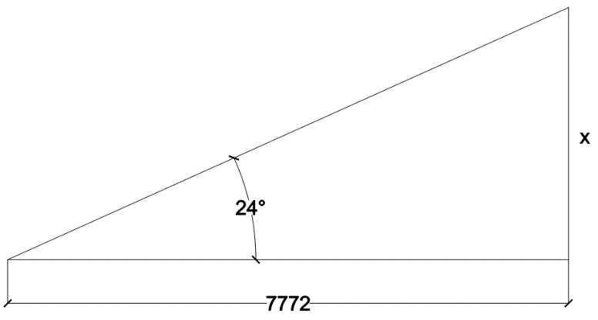
- Answer: 2673/sin19=2673x0.3255=870.06
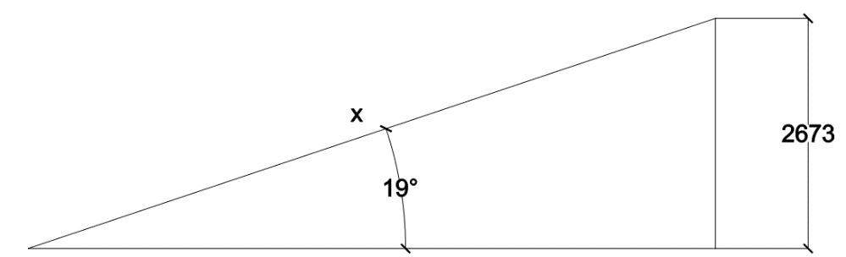
- Answer: 6484*cos27=6484x0.8910=5777.28
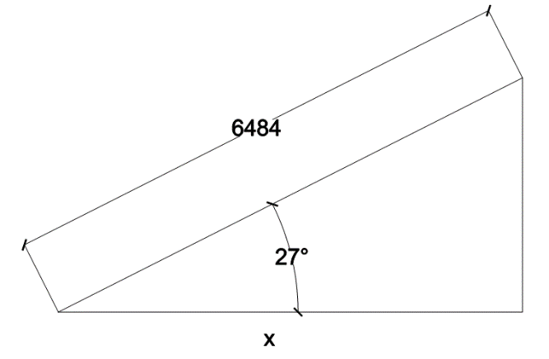

Satisfactory Outcome

Show all working out and calculations.
fff
- Using the grid pattern below, complete the table to calculate how much soil is needed to be removed from the highlighted section of the grid (represents the intended building) to a given RL of 11.000. Grid measurements = 5m x 5m. (first row has been completed for you)
- Suggest a new RL for the site that will require no spoil removal, only cut and fill.

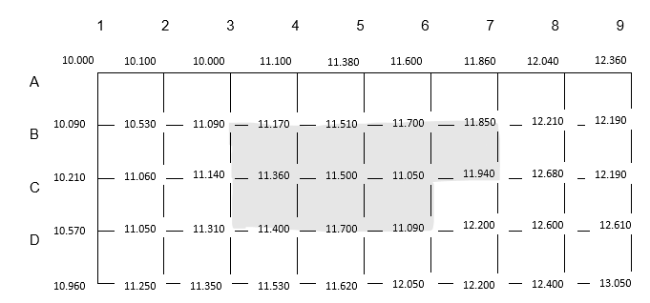

Volume of excavation- Grid method |  | Formation level RL | RL =11.000
Ground level | Corner Height “H” | No. of Squares occurring “N” | Product H & N
B3 | 11.009 -11.000 = 0.090 | 1 | 0.090
B4 | 11.170-11.000=0.170 |  | 0.170
B5 | 11.510-11.000=0.510 |  | 0.510
B6 | 11.700-11.000=0.700 |  | 0.700
B7 | 11.850-11.000=0.850 |  | 0.850
C3 | 11.140-11.000=0.140 |  | 0.140
C4 | 11.360-11.000=0.360 |  | 0.360
C5 | 11.500-11.000=0.500 |  | 0.500
C6 | 11.050-11.000=0.050 |  | 0.050
C7 | 11.940-11.000=0.940 |  | 0.940
D3 | 11.310-11.000=0.310 |  | 0.310
D4 | 11.400-11.000=0.400 |  | 0.400
D5 | 11.700-11.000=0.700 |  | 0.700
D6 | 11.090-11.000=0.090 |  | 0.090
Volume = | Grid x Grid x Total Product ÷ 4
- Calculate how much soil is needed to be removed from the highlighted section of the grid (represents the intended building) to a given RL of 11.000. Original grid measurements = 5m x 5m.
Celler 1: (0.090+0.170+0.140+0.360)/4=0.385
Celler 2: (0.510+0.700+0.500+0.050)/4=0.440
Celler 3: (0.170+0.360+0.510+0.500)/4=0.408
Celler 4: (0.700+0.050+0.850+0.940)/4=0.365
Celler 5: (0.140+0.310+0.360+0.400)/4=0.300
Celler 6: (0.360+0.040+0.500+0.700)/4=0.400
Celler 7: (0.500+0.700+0.050+0.090)/4=0.335

Average removal : 0.385+0.440+0.408+0.365+0.300+0.400+0.335=2.633
Amount removal : 2.633*25 =65.825m

- Suggest a new RL for the site that will require no spoil removal, only cut and fill.
RL of 12.000

Satisfactory Outcome

CPCCBC4018
Apply site surveys and set-out procedures to building and construction projects

PRACTICAL ASSESSMENT

Participant name | Dawei Yang

FOR THE PARTICIPANT
Instructions
- The tasks outlined on the following pages will require performance of normal workplace activities, as a result of a structured activity set by an Observer in the workplace or a simulated activity set by your Assessor/Observer.
- The timeframe for these tasks will be established by your Assessor/Observer, in consideration of location conditions and industry requirements.
- You must complete all tasks unassisted by the Assessor or other personnel, unless the steps note this assistance.
- You must attempt all tasks (and itemised steps) for a ‘Satisfactory’ assessment outcome to be awarded.
  - For any observation conducted that is incomplete, or without satisfactory performance, the observation will need to be completed again after further training support.

FOR THE ASSESSOR/OBSERVER
Instructions
- The following observation record should be used to judge and record your observations of the Participant as they complete the task(s) set. You must record your observations of the Participant’s performance.
  - For each occasion, indicate the task performed and whether it was a simulation or workplace-based task.
    - Any simulated assessment must ensure the Participant still performs under workplace conditions which reflect industry standards.
  - In the comments, provide clear detail regarding the task that the Participant was required to do (e.g. PPE used, materials handled, attachments connected, plant types).
- All steps must be satisfactorily demonstrated by the Participant for a ‘Satisfactory’ determination (indicated by an Assessor tick to the right of each itemised step, or an Observer tick to the right of each itemised step, and confirmation by an Assessor in the Assessor Comments).
  - Where you have determined that one or more task steps have not been satisfactorily demonstrated, provide the Participant with additional support and outline details of such assistance in the Assessor/Observer Comments. Allow the Participant two (2) further opportunities to demonstrate the task again to allow an opportunity for a ‘Satisfactory’ assessment outcome to be achieved.
  - If after three (3) attempts the Assessor determines that the Participant cannot demonstrate the required steps, a ‘Not Satisfactory’ outcome is to be determined.

TASK OUTCOME
Task | Date | Task Type (Tick) | Location | Task outcome (Tick)
 |  |  |  | Satisfactory | Not Satisfactory
Task 1 (Occasion 1) | Select Date. | Workplace  Simulation

ASSESSOR COMMENTS: GENERAL
As necessary, outline:
- Details on reattempts, alternative arrangements or reasonable adjustments made.
- Where a Participant is deemed ‘Not Satisfactory’, provide recommendations for future training.

ASSESSOR COMMENTS: PRACTICAL TASK 1: OCCASION 1
Individual student (as named on cover page)
Multiple students [ All from Attendance Report, Specific students involved – identify students]
Task | Provide detail
1.1A. | Specify how participant identified current plans:  Check for arithmetic
1.1B. | Specify() surveying device collected and operated:  þ Electronic distance measuring (EDM) equipment Laser level: manual-levelling laser  þ Laser level: dot laser level Optical (Dumpy) level Water level Theodolite Other (please specify):
1.1B. | Specify() levelling device collected and operated:  þ Electronic distance measuring (EDM) equipment Laser level: manual-levelling laser  þ Laser level: dot laser level Optical (Dumpy) level Water level Theodolite Other (please specify):
1.1D. 1.1E. 1.1F. | Specify site RL calculations were made:  Height of the instrument method
1.1G. | Specify errors explained due to site characteristics:  Plants and objectives
1.1H. | Specify() digital tools operated to communicate with others:  þ Mobile phone þ UHF/ 2-way PC via intranet PC or mobile for email  Other (please specify):
1.3A. 1.3B. 1.3C. 1.3D. 1.3E. | Specify drainage and pipeline situations where calculations were made to determine grades.  Grade as an angle = arctan(rise/run)
CPCCBC4018
Apply site surveys and set-out procedures to building and construction projects

Practical Task 1
Description of task:
This assessment applies to National Construction Code (NCC) classifications:
- Residential - Class 1 and 10 buildings, maximum two storeys
- Commercial - Class 2 to 9, Type C only constructions

The participant must demonstrate the skills and knowledge to correctly apply site surveys and set-out procedures to a residential or commercial building on site. Demonstration must include:
- Prepare for and conduct site set-out.
  - Locate, read and adhere to the current plans and site set-out procedures.
  - Select and operate one surveying and one levelling device in accordance with SOPs (copy of booking sheet required as evidence).
  - Check accuracy of instrument by conducting a ‘two peg test’.
  - Carry out reduction in a closed level run by rise and fall method (copy of booking sheet required as evidence).
  - Carry out reduction in a closed level run by height of plane collimation (HPC) method (copy of booking sheet required as evidence).
  - Calculate accurate staff readings to enable a specific reduced level (RL) set-out.
  - Identify and explain errors in measured distances due to site characteristics and measurement methods.
  - Use digital tools to communicate with others.
- Develop a contour grid.
  - Determine set-out grid and levels.
  - Prepare a topographic contour plan from grid levels to specified tolerances and stated contour intervals (copy required as evidence).
  - Determine surface area being levelled and calculate cut and fill volumes.
  - Calculate and record trigonometric and geometric calculations commonly used with grid lines, off sets and right-angle triangles without error (copy of calculations required as evidence).
  - Calculate cut and fill quantities including: (copy of calculations required as evidence).
    - area and volume of land to be levelled.
    - area of land to be filled.
    - volume of fill required.
- Determine grades and levels
  - Draw longitudinal sections from RLs.
  - Determine levels and clearances from given grades and distances to specified tolerances.
  - Express calculation angles, percentages and run ratios in grades.
  - Determine calculations for batter levels from grades and distances.
  - Construct longitudinal sections and determine associated grades and levels in typical drainage and pipeline situations.

These tasks may be simulated or real. The Participant is to gather evidence of how they have completed each component of the Practical Task, which is to be submitted with this Practical Assessment sheet. The Observer is to provide detailed comments on the tasks completed by the Participant (on the Observer Comments, overleaf). The Assessor is to verify the Observer’s comments, noting their findings in the Assessor Comments (on the back of the Practical Assessment cover page) and provide the assessment outcome.

Resources required:
Work site, plans, procedures, one surveying device, one levelling device, access to computer and software, booking sheet, grid paper, pencil, calculator, communication equipment.
Observer details
Name of observer: | Steve Zhu
Role of observer  (Confirm suitability to sign) | Builder
Email address of observer | steve.zhu.au@hotmail.com
Signature of observer: | 
Date: | 21/09/2023

When completing the task, did the Participant: | Tick if satisfactorily completed.  Provide comments if left unticked.
1 Prepare for and conduct site set-out.
- Locate, read and adhere to the current plans and site set-out procedures. | þ
- Select and operate one surveying and one levelling device in accordance with SOPs (copy of booking sheet required as evidence). | þ
- Check accuracy of instrument by conducting a ‘two peg test’. | þ
- Carry out reduction in a closed level run by rise and fall method (copy of booking sheet required as evidence). | þ
- Carry out reduction in a closed level run by height of plane collimation (HPC) method (copy of booking sheet required as evidence). | þ
- Calculate accurate staff readings to enable a specific reduced level (RL) set-out. | þ
- Identify and explain errors in measured distances due to site characteristics and measurement methods. | þ
- Use digital tools to communicate with others. | þ
- Use equipment software to collect information and develop relevant documentation. | þ
2 Develop a contour grid.
- Determine set-out grid and levels. | þ
- Prepare a topographic contour plan from grid levels to specified tolerances and stated contour intervals (copy required as evidence). | þ
- Determine surface area being levelled and calculate cut and fill volumes. | þ
- Calculate and record trigonometric and geometric calculations commonly used with grid lines, off sets and right-angle triangles without error (copy of calculations required as evidence). | þ
- Calculate cut and fill quantities including:.(copy of calculations required as evidence).  - area and volume of land to be levelled.  - area of land to be filled and volume of fill required. | þ
3 Determine grades and levels.
- Draw longitudinal sections from RLs. | þ
- Determine levels and clearances from given grades and distances to specified tolerances. | þ
- Express calculation angles, percentages and run ratios in grades (copy of calculations required as evidence). | þ
- Determine calculations for batter levels from grades and distances (copy of calculations required as evidence). | þ
- Construct longitudinal sections and determine associated grades and levels in typical drainage and pipeline situations. | þ

Observer comments:

