Workplace Assessment 2.1 – Assessor’s Checklist
(This form is for the assessor’s use only)

Purpose
This Assessor’s Checklist lists the practical skills that the candidate must demonstrate/perform while completing Workplace Assessment 2.1.
This form is to be completed by the candidate’s assessor to document their assessment of the candidate’s performance in Workplace Assessment 2.1.

Task Overview
For this task, the candidate is required to consult with workers to evaluate the effectiveness of existing hazard control measures on the building and construction project.
In this task, the candidate will be assessed in their:
- Practical knowledge of consultations with site workers
- Practical skills relevant to consulting with site workers

Instructions to the Assessor

During the assessment
- For each practical skill listed in this Assessor’s Checklist:
  - Tick YES if you confirm you have assessed the candidate demonstrate/perform the practical skill.
  - Tick NO if you have not assessed the candidate demonstrate/perform the practical skill.
- If you ticked YES, provide the date when you assessed the candidate demonstrate the skill.
- Write specific comments on the candidate’s performance in each criterion. Your feedback/insights will help address any area/s for improvement.

After the assessment
- Complete all parts of the Assessor’s Checklist, including the Assessor Declaration on the last page of this form. Your signature must be handwritten.

Candidate Details
Candidate name | Dawei Yang

Assessor Details
Candidate is assessed by | Yanzhong Zhu

Context of the Assessment
Workplace/organisation | Dawn construction
Resources required for the assessment | - Building and construction project  - Access to personnel working on the building and construction project  - Opportunities to consult with workers to evaluate the effectiveness of existing hazard control measures on the building and construction project  - Policies and procedures relevant to internal consultation  - Digital devices, applications, or software that can be used to communicate on the project site, such as, but not limited to:  - Laptop or desktop computer  - Mobile phone

Assessor’s Checklist
During the consultation: | YES/NO | Assessor’s comments
- The candidate consults with all personnel directly affected by existing control measures on the building and construction project. | YES NO
- The candidate ensures all relevant personnel are aware of the consultation.
- The candidate asks personnel directly affected by existing control measures:
- If the control measure protects them from risks posed by the relevant hazard. | YES NO
- If the control measure has made it more difficult for them to perform their job. | YES NO
- If the control measure is still working properly or needs to be replaced. | YES NO
- If the control measure has led to any new problems that were not there before. | YES NO
- If they have suggestions for a better control measure option. | YES NO
- The candidate gives the personnel they consulted with the opportunity to speak.
- The candidate takes notes on the feedback they gathered from personnel. | YES NO
- The candidate shares their consultation notes with all relevant personnel. | YES NO

Assessor Declaration
By signing here, I confirm that I have assessed the candidate, whose name appears above, consult with workers to evaluate the effectiveness of existing hazard control measures on the building and construction project.
I confirm that the information recorded on this Assessor’s Checklist is true and accurately reflects the candidate’s performance during their completion of the workplace task.
Assessor’s signature | 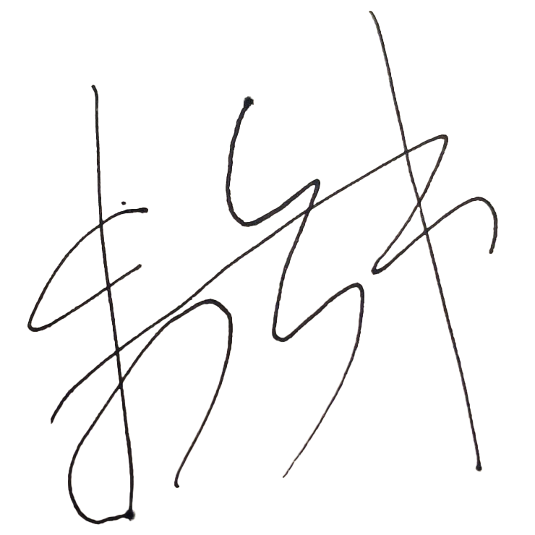
Assessor’s name | Steve Zhu
Date signed | 16/05/2023
End of Workplace Assessment – Assessor’s Checklist

