CPCCBC4012B
Read and interpret plans and specifications

THEORY EXAM INSTRUCTIONS

- This exam will occur under standard assessment conditions.
  - An oral examination may be allowed under certain circumstances.
Answers will be documented and FT003 (Oral examination declaration form) must be completed.
- Participants must provide enough detail in their responses to demonstrate their knowledge and skills.
- Please fill in the details below, providing your name, signature and date of assessment.
  - Your signature acknowledges that this is your own work.
- If a participant initially answers a question incorrectly but modifies their response, they must follow the instructions below:
  - If a participant changes their response in writing, they must put their initials next to the written change.
  - If a participant changes their response verbally, this must be noted on the exam paper by the assessor.

Participant name | Gavin Wong
Participant signature | 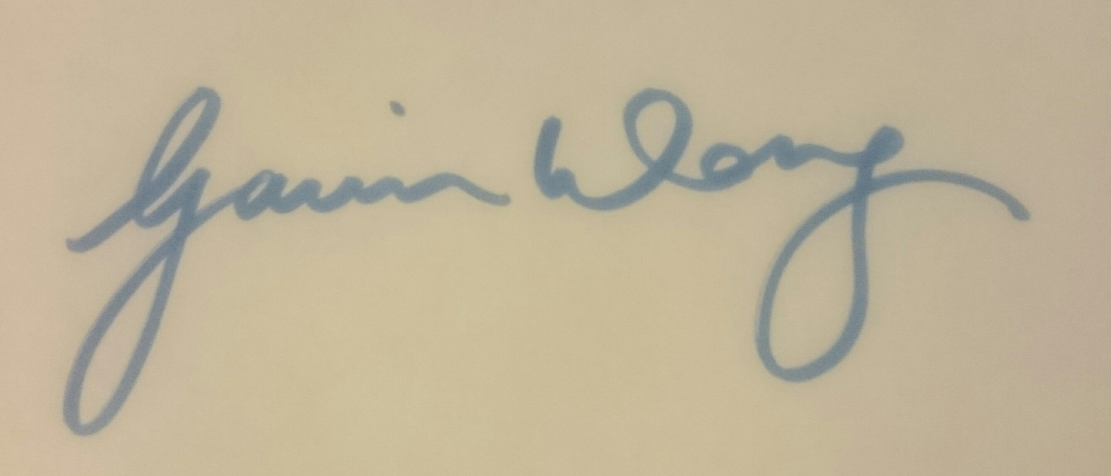

Assessor name
Assessor signature | 

Date | 28/06/2018

Number of questions | Number of questions answered correctly | Satisfactory?
77 |  | Yes | No
Assessor Comments
- What does the term ‘plan’ mean when referencing plans and drawings for construction purposes?

Answer | All of the drawing required to construct a building. Plans show the layout or arrangement of rooms and other part of a building

- Name the people and organisations who will have an interest in plans and drawings for a construction project.

Answer | - the client and lending body  - local council  - supply authorities  - Electrical, gas and cable supply companies  - builders and sub-contractors wanting to quote  - engineers  - Sub-contractors  - real estate agents  - neighbours  - kitchen manufacturers  - landscapers  - various material or product suppliers  - environmental agencies  - mechanical service installers

- What will plans show to the interested parties?

Answer | Plans show all people interested in the proposed structure what it will look like when completed, and how it will be constructed.  Plans generally show:  - the location of various features on the site and illustrate details about the building e.g. construction details for specific trades people  - the height, position and bulk of the building so that council can determine compliance to its codes.  - allow builders and trades people to prepare written quotations. Remember written quotations (quotes) or contracts should only relate to approved building plans. An estimate should be given prior to council approval.  - provide the surveyor with the details ‘to set out’  - illustrate to trades people the structure to be built

- What types of plans is it necessary to be familiar with for building and construction projects?

Answer | Types of plans include:  - Block plans  - Site plans  - Floor plans  - Basic floor plan  - General arrangement plans  - Elevations  - Estate road layout

- All plans and drawings give a compass direction.
Which compass direction is always shown and on which drawings is it likely to be found?

Answer | North  - Key plans  - Site plans  - Block plans  - Floor plans

- What does a location plan contain?

Answer | A location plan details the:  - lot number/s  - deposit plan numbers  - north point  - Scale (usually 1:5,000)

- What does a site or block plan contain?

Answer | A Site or Block Plan is usually drawn at 1:500 and gives the following information:  - A datum - reference height to other site levels  - Building orientation to north point

- What features would you expect to look for and find on plans and drawings for a construction project?

Answer | Key features of a Site or Block Plan  - A datum - reference height to other site levels  - Building orientation to north point  - Outline of site boundaries showing location of proposed building and existing dwellings  - Plan page number, client name, project address, scale, reference numbers and dates  - Major geological and topographical features (trees and vegetation)  - Contours and slopes – 500mm intervals  - Depths where they may occur  - Distance from the boundaries to the building foot print  - Driveways, stormwater drainage, easements and right of carriage  - Soil and surface water drains, pipe sizes  - Service runs from the house to mains - utility services location (sewer, water, gas, electricity)  - New levels on the site in connection with the new house  - Paving  - Retaining walls  Key Features of Plans  - the location of various features on the site and illustrate details about the building e.g. construction details for specific trades people  - the height, position and bulk of the building so that council can determine compliance to its codes.  - allow builders and trades people to prepare written quotations. Remember written quotations (quotes) or contracts should only relate to approved building plans. An estimate should be given prior to council approval.  - provide the surveyor with the details ‘to set out’  - illustrate to trades people the structure to be built  Key Features of Elevations  An elevation is a view you see when standing in front of that wall. It may be multi-storey or single-storey, usually drawn to a scale of 1:100.  Most councils require an elevation from each side of the proposed development and the view is indicated by north, south, east or west - e.g. If the wall is on the west side of the house, it is the west elevation.  Elevations indicate:  - finish to external walls and  - size of windows, doors and balconies  Key Features of Sections  - height of building  - position of piers, beams, openings  - floor to ceiling heights  - distance between finished floor and existing or proposed ground levels  - construction details  - scales same as plan

- What do floor plans identify?

Answer | Sample floor plan for a single-family detached home  In architecture and building engineering, a floor plan is a drawing to scale, showing a view from above, of the relationships between rooms, spaces, traffic patterns, and other physical features at one level of a structure.  Dimensions are usually drawn between the walls to specify room sizes and wall lengths. Floor plans may also include details of fixtures like sinks, water heaters, furnaces, etc. Floor plans may include notes for construction to specify finishes, construction methods, or symbols for electrical items.  It is also called a plan which is a measured plane typically projected at the floor height of 4 ft (1.2 m), as opposed to an elevation which is a measured plane projected from the side of a building, along its height, or a section or cross section where a building, is cut along an axis to reveal the interior structure.

- What are elevation views? What do they provide to the plan reader?

Answer | An elevation is a view you see when standing in front of that wall. It may be multi-storey or single-storey, usually drawn to a scale of 1:100.  Most councils require an elevation from each side of the proposed development and the view is indicated by north, south, east or west - e.g. If the wall is on the west side of the house, it is the west elevation.  Elevations indicate:  - finish to external walls and  - size of windows, doors and balconies

- What is a section?

Answer | A section is a vertical view (slice) through the building. The direction of section lines or arrows is usually shown on the plan to help interpret the sectional view.

- What are detailed drawings?

Answer | a drawing, at relatively large scale, of a part of a building, machine, etc., with dimensions or other information for use in construction

- What are specifications?

Answer | Specifications set out the minimum standards or codes necessary to obtain relevant sizes for all structural components and provide details of building materials and fittings, such as:  - windows, frame material and type of glass  - doors, size, material and the swing on the door  - Finishes/colours to walls, floors and ceilings  - door types and models of locks, latches, hinges, push plates and pull handles

- What information will you find in a title block to a drawing?

Answer | A title block is a template for a sheet and generally includes a border for the page and information about the design firm, such as its name, address, and logo. The title block can also display information about the project, client, and individual sheets, including issue dates and revision information.

- What is the significance of the Australian Architectural Standards?

Answer | The Australian Architectural Standards details the symbols that must be used in drawings

- What will you find in the Waste Management Plans & Site Management plans?

Answer | A waste management plan provides an optimal approach to the management of the new facility's rubbish, looking after the environment and the health of those who come in contact with it and aiming to manage the waste in an efficient, effective and safe manner.  - An overall SMP, often used by clients to map out the whole of the project from initial business goals to evaluation after delivery  - A SMP detailing building task schedules and costs, frequently prepared by the contractor, with detailed information on how the construction work itself is to be accomplished  - A SMP addressing the impact of the construction project on the area around it, where the plan layout and content may follow a fixed format defined by the municipality concerned.

- What is a landscape plan?

Answer | A landscape plan is like a floor plan for an outdoor area. Like a floor plan, a landscape design creates a visual representation of a site using scaled dimensions. Landscape plans include natural elements like flowers, trees, and grass as well as man-made elements such as lawn furniture, fountains, and sheds.

- What is the purpose of a shadow diagram? Who primarily would seek one?

Answer | A shadow diagram allows us to view and calculate the amount of shadow cast by the proposed development. ... The Shadow Diagram must distinguish the extent of shadows cast by existing and proposed buildings, including buildings on adjoining land and vegetation where relevant.  Council primarily seek them

- What is a bracing schedule?

Answer | A bracing schedule give the amount and type of bracing required in a building

- What must we do with plans and drawings in our on-site environments? How often should plans and drawings be viewed on site?

Answer | Plans must be check onsite constantly to ensure compliance with the design and specifications. Before any work is started, before each new task or section of work, constantly during the process and upon completion the plans and drawings must be consulted.

- Explain the meaning of the abbreviations in the table below.

Answer | Abbreviation | Meaning
 | ACRYL | acrylic
 | AS | Australian Standards
 | ASSD | Assumed Data
 | B | Basin
 | BN | Bull Nose
 | BTH | Bath
 | BWK | Brickwork
 | CB | Concrete Block
 | CF | Concrete Floor
 | CG | Clear Glass
 | CJ | Ceiling Joist
 | CORR | Corrugated
 | CWT | Cold water tank
 | DG | Double Glazing
 | DH | Double Hung
 | DPC | Damp Proof Course
 | DSB | Distribution Switch board
 | DW | Dishwasher
 | EJ | Expansion Joint
 | FPBD | Fibrous Plasterboard
 | FFL | Finished Floor Level
 | FHR | Fire Hose Reel
 | GPO | General Purpose Outlet
 | HBD | Hardboard
 | HTR | Heater
 | HWD | Hardwood

- Why and when would you use presentation drawings?

Answer | Presentation drawings are drawings used to convey basic design concepts from a design team to the client of other persons.  Presentation drawings are a very important part of public hearings and design reviews as a structure is studied by government and private agencies to determine its impact on the community.  In residential architecture, presentation drawings are frequently used to show compliance with review board standards and to help advertise existing stock plans.

- Service drawings provide information about a variety of different components and equipment. In order to identify individual items, it is usual to give them a reference number on drawings such as services layout drawings and location plans.
What details might we expect to see from service drawings?

Answer | Service drawings provide information about a variety of different components and equipment. In order to identify individual items, it is usual to give them a reference number on drawings such as services layout drawings and location plans.

- What are working drawings? What do they record?

Answer | A working drawing is a blue print which is complete with enough plan and section views (including dimensions, details and notes) to enable the depicted items construction without additional information.  Working drawings:  - record or explain the appearance and construction of an existing building or sketch  - are used as preliminary construction plans to clarify on-site details not made clear by other drawings

- What is an isometric view?

Answer | View in isometric projection Isometric project is a method of showing three faces of an object on one drawing. ‘Isometric’ means equal measure - that is the three lines defining the three faces or planes produce three equal angles using vertical lines, and horizontal lines at 30 degrees to the horizontal.

- Sketch a concrete block in isometric view.

Answer

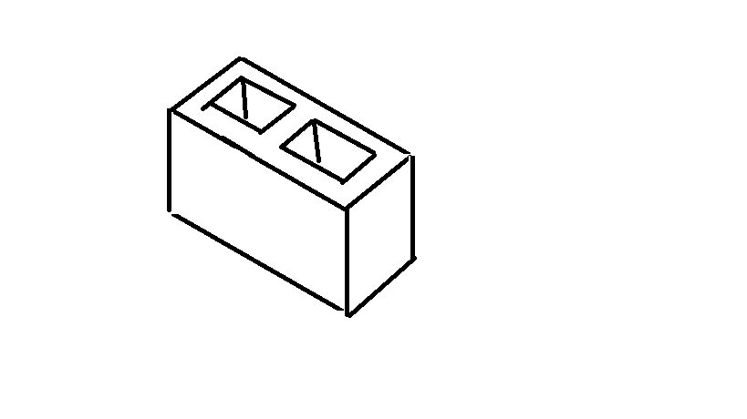

- What is the purpose of perspective projection and representation in drawing of architectural buildings and edifices?

Answer | A perspective is a view that is normally seen by the eye or camera, and is the most realistic form of pictorial. All parallel lines converge at infinite vanishing points as they receded from the observer.  There are three basic types of perspectives: one-point (one vanishing point), two-point (two vanishing points) and three-point.(three perspective points as all sides of the object are at an angle with the picture frame.

- What is a topographical survey?

Answer | - Topographical surveys: including laser scanning or Lidar provides a robust method for surveying areas to set out the exact position of a proposed structure ensuring the construction is done within the legal boundary preventing any future disputes.

- What is an ecological survey?

Answer | - Ecological surveys: identify the habitats and/or species that exist within an area at the time of the survey. Most development proposals will have the potential to impact on the local biodiversity of the development site either through the direct loss of habitats, the reduction in the value of the habitat or the ability of the habitat to support the species that depend on them. Early identification of any ecological constraints ensures that development proposals are not delayed and appropriate mitigation or compensation is incorporated into the design phase.

- What is significant to keep in mind when developing the Schedule of Quantities (also known as a Bill of Quantities)?

Answer | The quantities provided in a bill of quantities usually differ from the quantities actually encountered.

- What should be applied in consideration of stress, load and bearing calculations in the design, the drawings and the building of a structure?

Answer | All building code requirements and calculations for stress and load bearing need to be identified and complied with.

- What is a prime cost (PC) item? Give an example.

Answer | A PC item is:  - an amount of money included in a contract sum to purchase a specified item such as tiles, taps, doors or bathroom fittings  - An agreed estimated amount is included at contract signing but the specific products are not selected until a later stage  - Under the Home Building Contracts Act (1991) a builder must estimate the cost of such items at or above the lowest amount these items could reasonably cost  For example if a client selects a more expensive door than allowed by the PC item, say a $500 door compared with a $440 PC amount, a variation will be required to cover the additional $60. If the PC item varies, so will the final contract sum.

- What is a provisional sum (PS) item? Give an example.

Answer | A provisional sum is:  - an amount of money included in contract sum to cover work and/or materials, not detailed when entering the contract  - typically builders will include a PS for site work costs  - The builder is legally required to take reasonable steps to ensure an accurate site works cost estimate but unforeseen events mean that the provisional sum is exceeded which is added to the contract sum  For example a building site may seem sandy and clean with minimal siteworks required, however, there may be large limestone rocks/tree trunks concealed below the surface which only emerge once siteworks commence, causing cost overrun.

- Suggest when you would need to provide ‘additional’ plans.
Give some examples of such plans.

Answer | Additional plans may be required for variations  All plans pertinent to the variation/s must be amended

- How do you identify and record customer variations?

Answer | Variations are recorded in a variations register

- When reading and interpreting (or amending) variations project specifications, what documentation should you also refer to?

Answer | Should also refer to the plans, contract documents, engineering details, building permits, other permits and legal forms

- So you don’t end up in a dispute what strategies can you employ with your customer/client/home owners?

Answer | Always put in in writing  Changes to terms, including costs, must be dated and signed by all parties to the contract  Submit an extension of time for significant changes that will affect the construction time  Variation payments should be made in accordance with time stated in the variation document

- Name each of the drawing symbol images shown in the table below.

Answer | Name | Image
 | Cavity brick | 
 | Brick veneer | 
 | Internal wall | 
 | Window in single skin walll | 
 | Window with sill | 
 | Single swing door | 
 | Double swing door | 
 | Sliding door into a pocket | 
 | Sliding door exposed on wall face | 
 |  | 

- Draw symbols for the following items.

Answer | Item | Drawing
 | Basin | 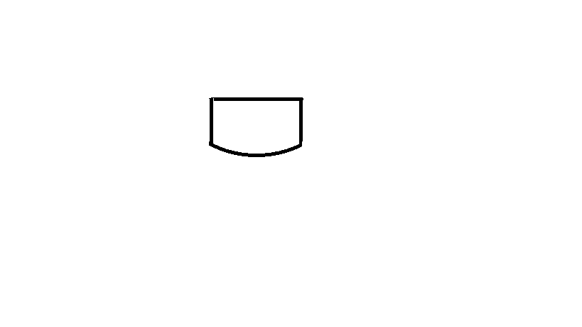
 | Bidet | 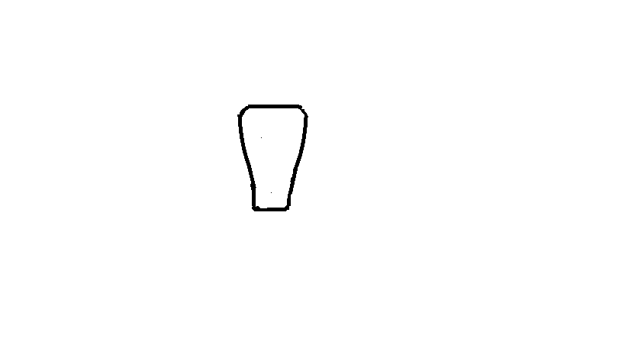
 | Bath | 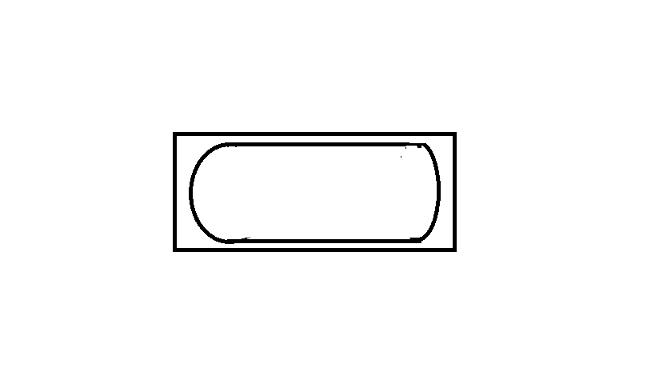
 | Drinking fountain | 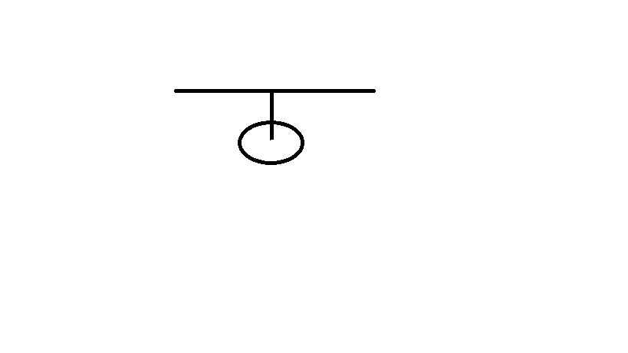
 | Sink: Single bowl | 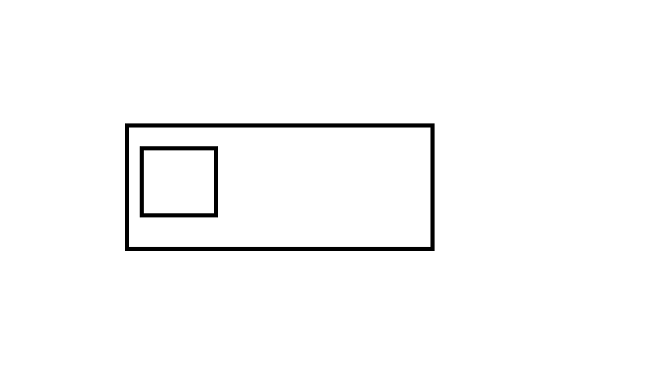
 | Sink: Double bowl | 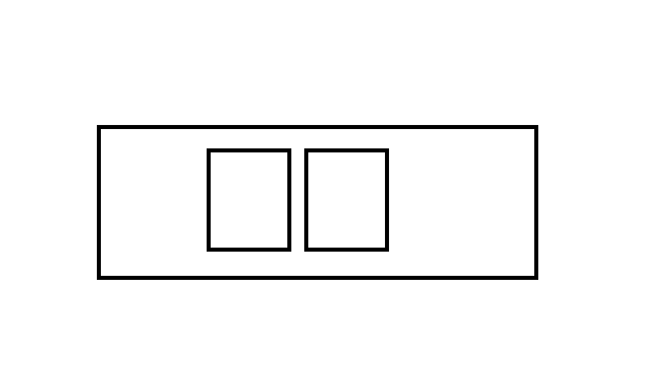
 | Tub: Double | 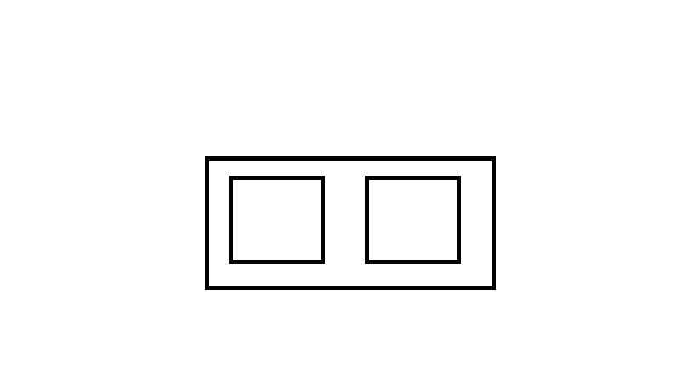
 | Tub: Single | 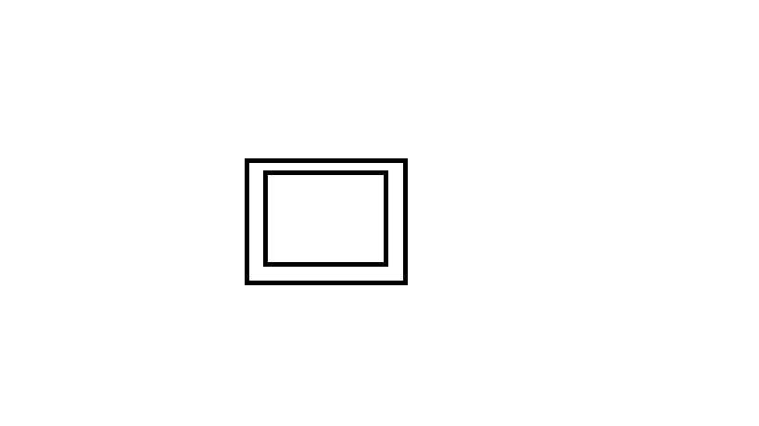
 | Drinking trough | 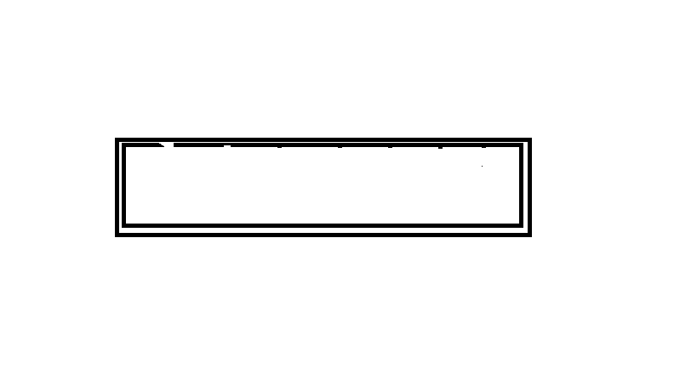
 | Hotplates | 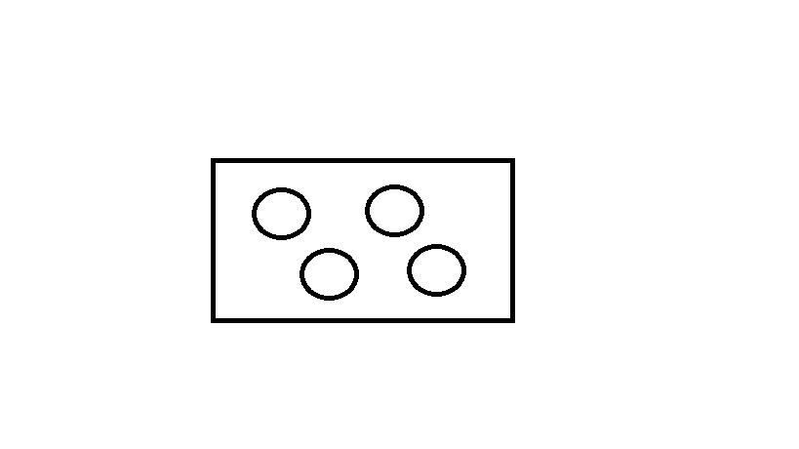
 | Shower | 
 | Shower bath | 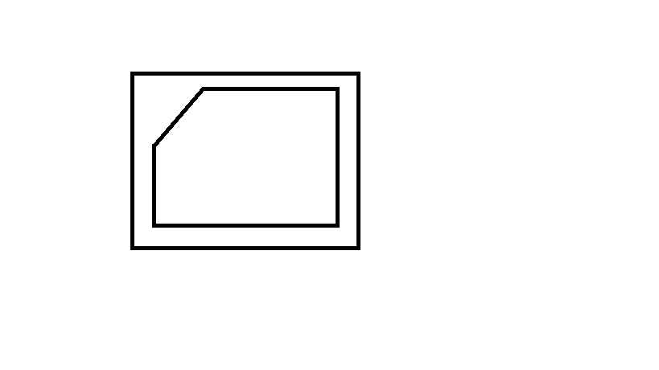
 | Urinal stall | 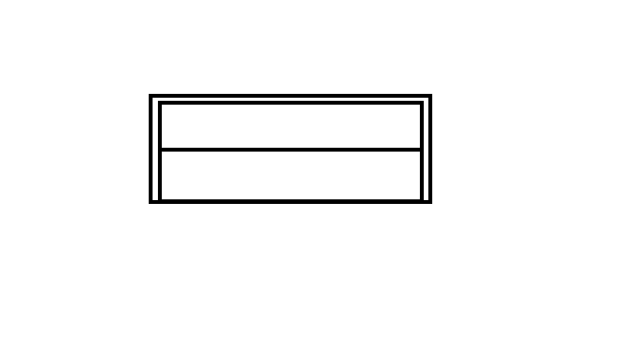
 | Vanity basin | 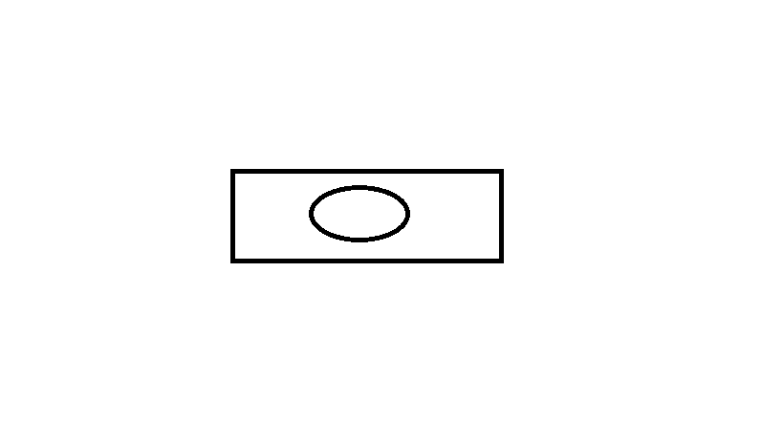
 | Water Closet (Toilet) | 

- Draw the following window symbols in elevation.

Answer | Item | Drawing
 | Hinged at side | 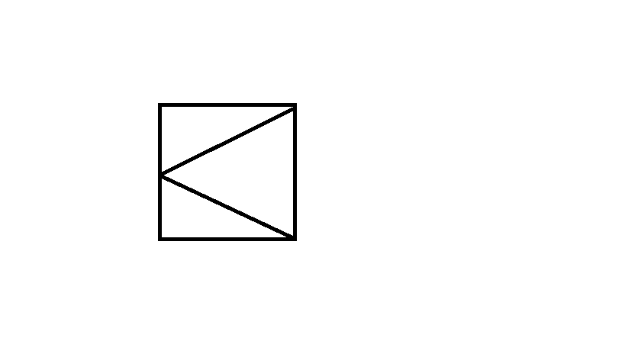
 | Hinged at top | 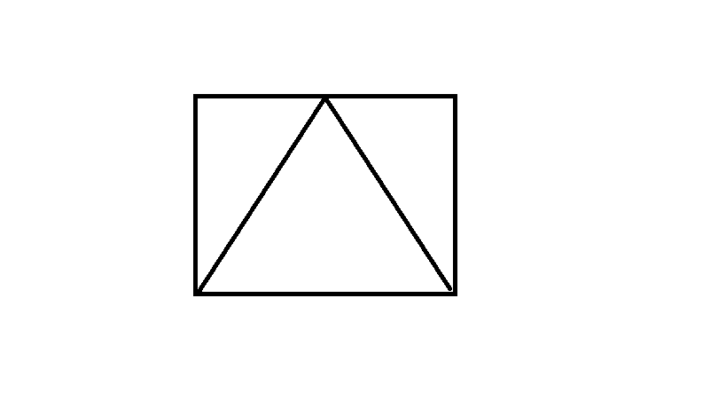
 | Sliding horizontally | 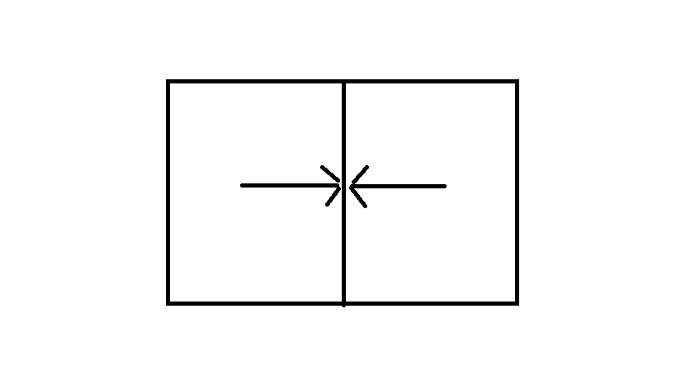
 | Fixed | 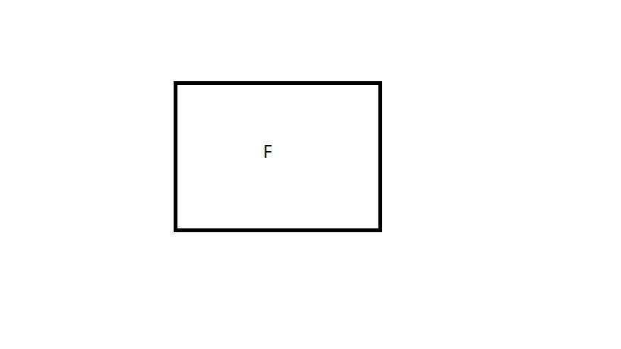

- Draw symbols for the following items.

Answer | Item | Drawing
 | Brickwork | 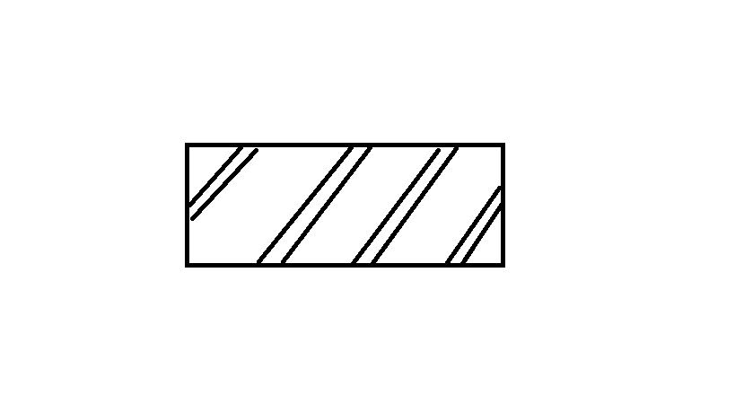
 | Blockwork | 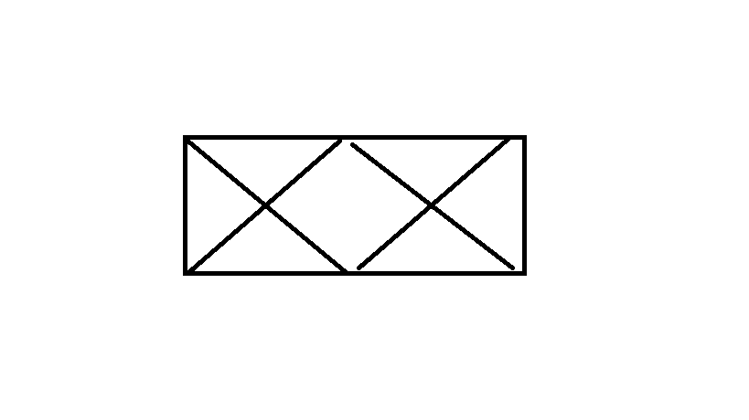
 | Concrete | 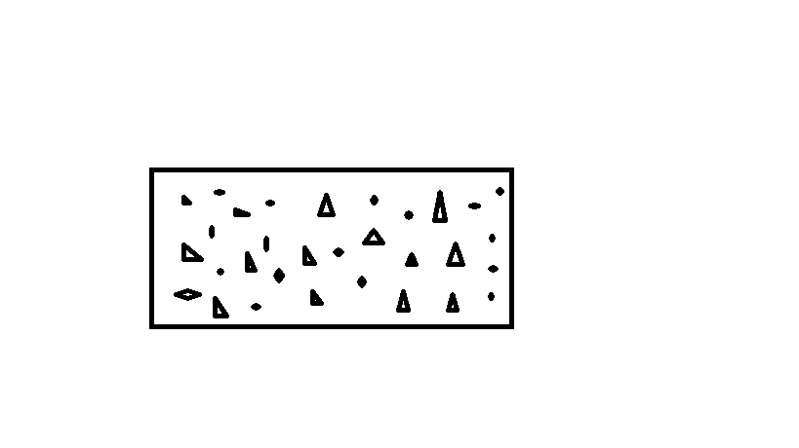
 | Plaster/Render | 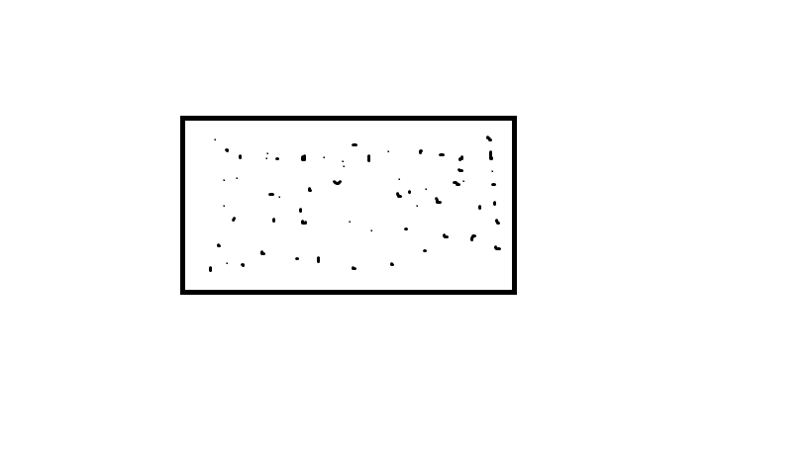

- Provide a description of the residence shown in the plan drawing below.

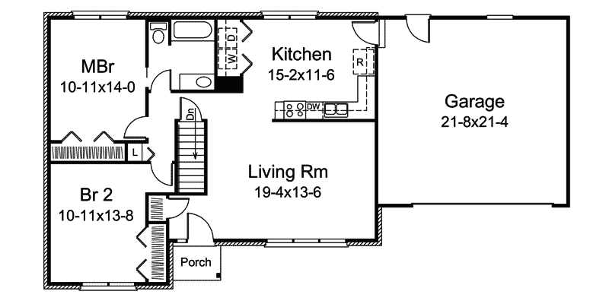

Answer | 2 bedrooms with built ins, main bedroom with shared ensuite, double lock up garage, kitchen with hide-away laundry, living room and basement.

Refer to the sectional drawing below to respond to Q43. to Q63.


- Give a brief description about the building from the detail available in the sectional drawing.

Answer | Four bedrooms, bathroom, Family room with verandahs

- Who is the client?

Answer | H&M Smith

- Where is this project to be built?

Answer | Lot 16 Glenvalley Road Richmond

- What are the contact details for the draftsman?

Answer | DJA

- What sheet number is this drawing?

Answer | Sheet 5 of 7

- What timber is required for loading and non-load bearing walls?

Answer | Wall plates load bearing – F5 45x90  Wall plated non-load bearing – F5 35x90  Common Studs – F5 90x35  Jamb Studs (900 max spacing) lower floor – F5 90x45  Jamb Studs (1800 max spacing) lower floor – F5 90x70  Jamb Studs (2700 max spacing) lower floor – F5 90x90  Jamb Studs (up to 900 spacing) upper floor – F5 90x45  Jamb Studs (up to 1800spacing) upper floor – F5 90x70  Noggings (1350 max spacing) – F5 35x70  Lintels (up to 1500) lower floor – F17 90x45  Lintels (up to 1900) lower floor – F17 140x45  Lintels (up to 1500) upper floor – F17 90x45  Lintels (up to 2000) upper floor – F17 120x45  Lintels (up to 2900) – F17 190x45

- What spacing is recommended for common studs?

Answer | 600 max spacing

- What type of roof truss is to be installed?

Answer | GAngnail roof trusses

- What centres are the trusses positioned at?

Answer | At 900 max spacing

- What size are the veranda posts?

Answer | 90x90

- What timber species are the veranda posts to come from?

Answer | DAR OREGON

- What pitch is the roof?

Answer | 30 degrees

- What size are the noggings and at what spacing?

Answer | 35x70 at 1350 max spacing

- What size are the ceiling joists?

Answer | Intermediate ceiling joists at 450 spacing  Floor joist HJ 240 at 450 spacing

- What timber is used for roof battens and what spacing?

Answer | 35x70 FG pine battens at 900 spacing

- What thickness is the plasterboard sheeting?

Answer | 10mm

- What type of flooring is to be installed?

Answer | 15mm plywood flooring

- What is the roof cladding material?

Answer | Colorbond corrugated metal roofing

- Where will you find information about the footings?

Answer | Refer to engineers drawing for all footing details

- What do the letters DAR refer when timber ordering?

Answer | Dressed all Round

- Explain 240 x 63 LVL. What does it refer to on the section?

Answer | Laminated Veneer Lumbar and it refer to the starting joists on the verandah

Refer to the drawing overleaf to respond to Q64. to Q75.

- What is the number of the drawing?

Answer | 2

- What is the Job Number?

Answer | 00R-112

- What is the scale of the drawing?

Answer | 1:100

- What does the drawing show?

Answer | Four elevations (East, West, North and South) and a Section

- Which view shows the front of the house?

Answer | East

- How many motor vehicles can be parked in the garage?

Answer | 2

- What are the window and doors made from?

Answer | Aluminium framed windows  Timber doors

- What is the size of the eaves?

Answer | 450mm

- What are the eaves lined with?

Answer | Hardiflex

- What type of roof structure is the roof built from?

Answer | Timber framed roof trusses at 600 centres

- What is the roof cladding materials made from?

Answer | Concrete roof tiles

- What is the roof pitch?

Answer | 22.5 degrees



- You have spoken with a client on the phone and they are seeking to make amendments to some plans. They wish to add two more bedrooms to extend their home from the current four bedrooms to six bedrooms.
The two new bedrooms are to both have ensuites (including single shower in each, double bowl vanity unit and under cupboard and toilet) with walk in robes, including the extension of the existing hallway with built-ins for the existing Bed 1 and Bed 2. The Family Room is to be extended to the rear wall in line with kitchen rear wall.
The client has faxed through the image below. Re-sketch and redesign the drawing and add the two new bedrooms along with extended hallway, ensuites, walk-in robes and the Family Room extension for consideration by the client.
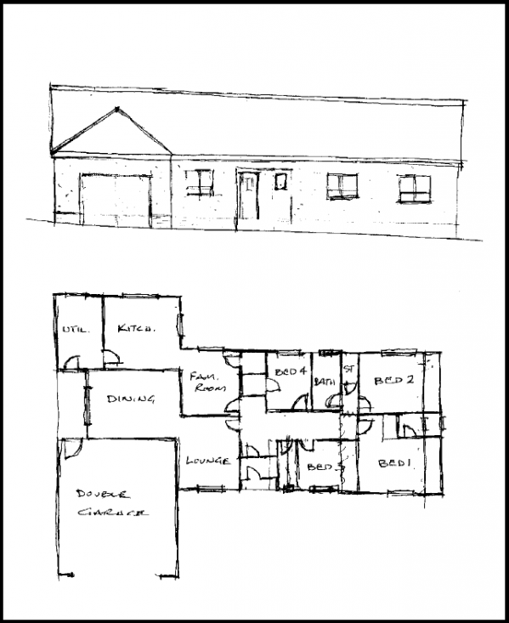
SKETCH
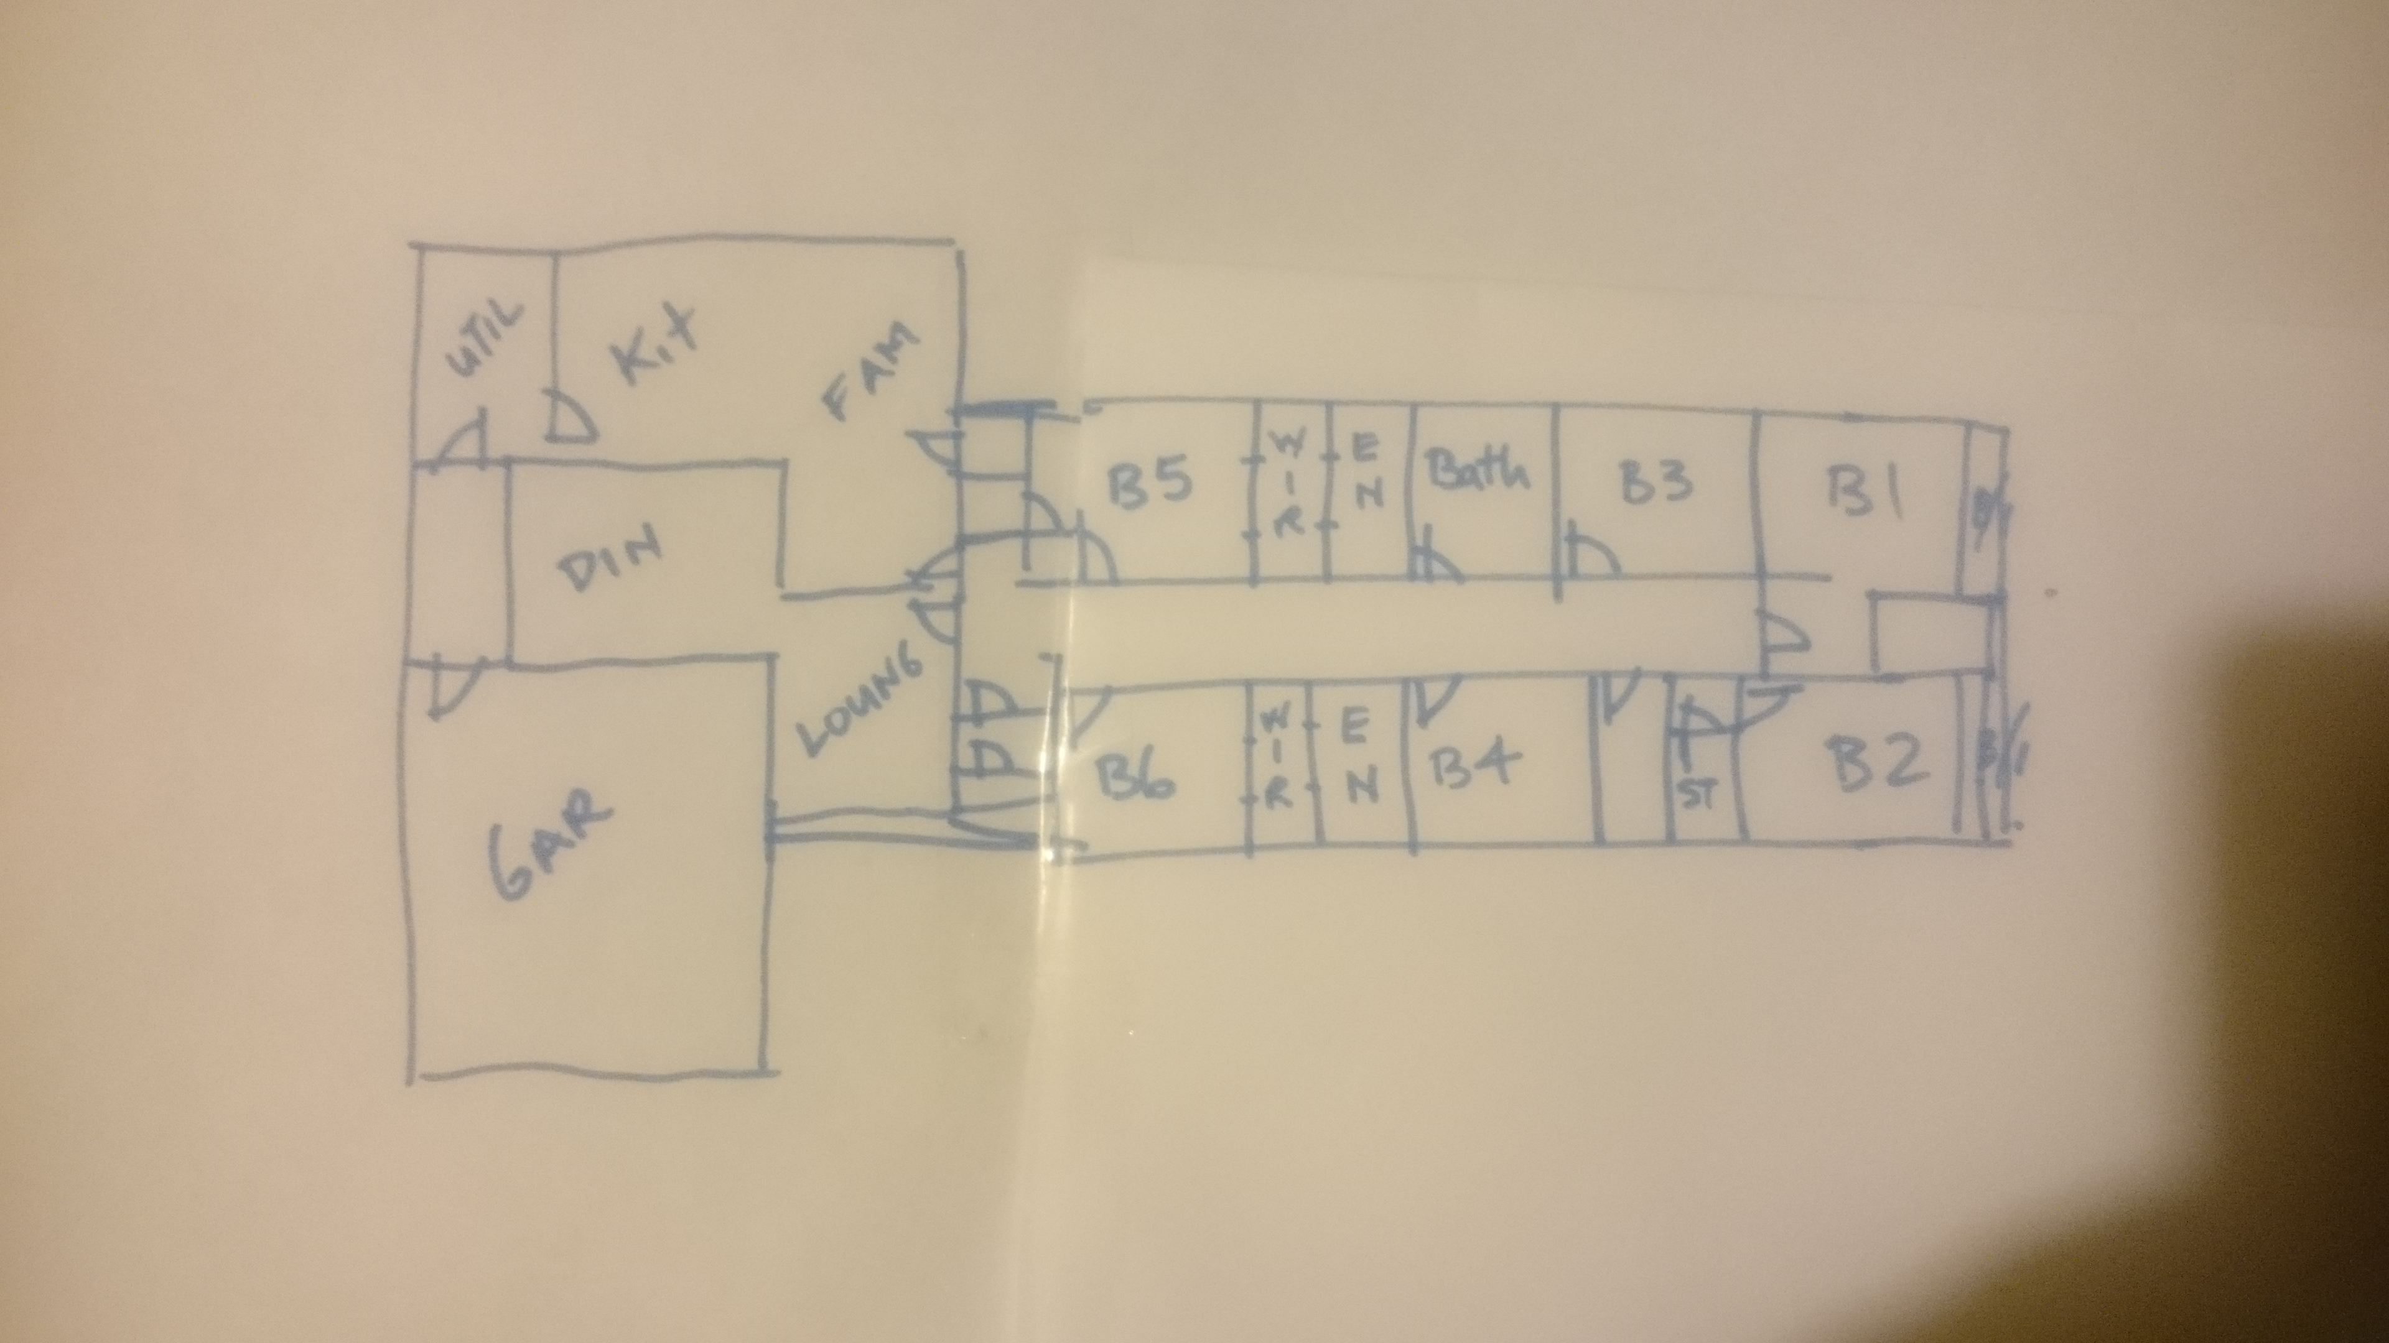

Answer

- Referring to Q76. compose an email to the client, providing an estimate of the additional labour hours/costs and material quantities/costs that have resulted from the their request.

Answer | Dear client,  The two extra bedroom and walk in robes will be an increase of around 15 percent in labour and material quantities and the two extra ensuites will add another 8 percent in extra labour, materials and fixtures. The extension to the Family room will add an extra $10,000 to the price and the built in in Bedrooms 1 and 2 will be around $2500 each.

