
BSBWHS503 Contribute to the systematic management of WHS risk

BSBWHS504 Manage WHS risks

Copyright © 2020 CSTC Pty Ltd

All rights reserved. No part of the contents of this publication may be reproduced or used in any form or by any means – graphic, electronic, or mechanical including photocopying, digitising, recording, or information storage-and-retrieval systems – without the written permission of CSTC Pty Ltd.
ASSESSMENT FOR BSBWHS503 & BSBWHS504

Student name | Nartika Thompson
Date of assessment submission | Click here to enter a date.

Trainer/Assessor’s name
Date of assessment marking | Click here to enter a date.
Outcome for units | ☐ Competent  ☐ Not Yet Competent

TASK INSTRUCTIONS

- The assessment for these units of competency consists of the following:
  - A series of activities: Some of these activities will require you to provide a response within this document, others will require you to gather evidence to demonstrate your knowledge and skills (overview below)
  - Quiz: You will be required to complete a series of questions to demonstrate your knowledge and skills.
  - Practical task: You will be required to have an observer attest to your knowledge and skills and sign a report to this effect.
- At times, you will be provided with a specific business context to which you must respond, otherwise it is anticipated that you will use a workplace of your choosing (your own, or hypothetical) to provide the context to the task.
- At all times, the responses in your assessment must reference Australian (Queensland or Federal) documentation, including legislation, regulations, codes of practice, standards and guidance publications.

ACTIVITY OVERVIEW | REQUIRED FOR SUBMISSION
- Risk management requirements | - Workbook response (below)
- Identify/assess hazards and risks | - Workbook response (below)
- Implementation of risk controls | - Workbook response (below)
- Effectiveness of risk controls | - Workbook response (below)

ACTIVITIES

For the following activities, name a workplace that you wish to examine.

Name of workplace | Wagner Investments (current workplace)

Identify duty holders’ obligations regarding risk management (including PCBUs and workers) by explaining the requirements found in:
- WHS Acts
- WHS Regulations
- Safe Work Australia model Code of Practice: How to Manage Work Health and Safety Risks
- Standards
- Guidance material
- Organisational policies
- Organisational procedures
- Organisational processes

Example:
Name and location of Legislation (Commonwealth or State)
Work Health and Safety Act 2011 (Qld) found at www.legislation.qld.gov.au
Relevant excerpt/requirement for chosen workplace
Section 19: A person conducting a business or undertaking must ensure, so far as is reasonably practicable, the health and safety of workers.

Name and location of Legislation (Commonwealth or State)
Work Health and Safety Act 2011 (Qld) found at https://www.legislation.qld.gov.au/view/html/inforce/current/act-2011-018
Relevant excerpt/requirement for chosen workplace
Section 17 outlines the duty imposed on a person to ensure health and safety requires the person:
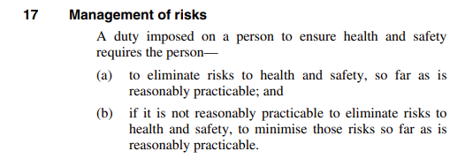

Name and location of Regulation
Work Health and Safety Regulation 2011 (Qld) found at https://www.legislation.qld.gov.au/view/html/inforce/current/sl-2011-0240
Relevant excerpt/requirement for chosen workplace
Section 35: a duty holder, in managing risks to health and safety must
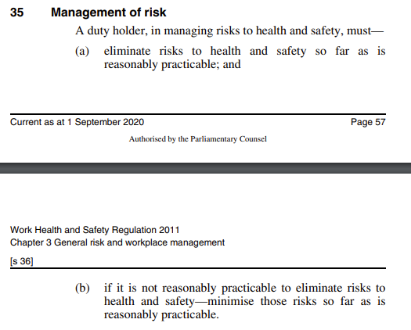

Name and location of Code of Practice
Safe Work Australia model Code of Practice: How to Manage Work Health and Safety Risks found at: https://www.safeworkaustralia.gov.au/system/files/documents/1702/how_to_manage_whs_risks.pdf

Relevant excerpt/requirement for chosen workplace
Section 1.1 outlines the responsibilities of PCBU & Officers

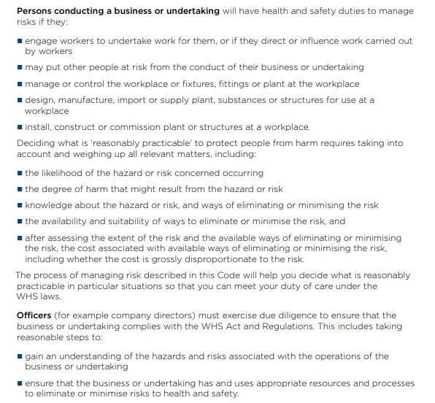
.

Name and location of Standard
ISO45001:2018 outlines the PCBU responsibility to communicate with workers, and he requirements that need to be considered.
Found at: https://infostore.saiglobal.com/en-au/standards/ISO-45001-2018-608884_SAIG_ISO_ISO_1396069/
Relevant excerpt/requirement for chosen workplace
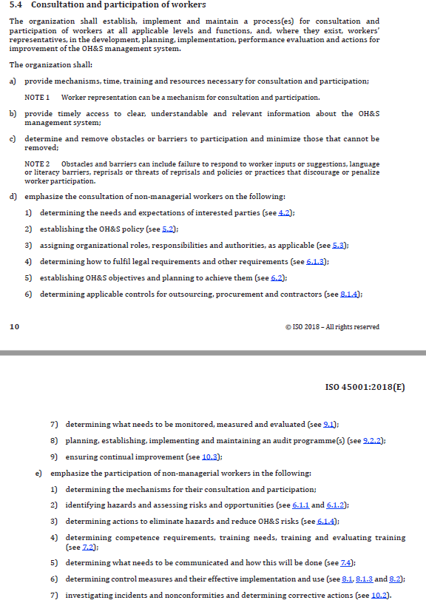

Name and location of Guidance material
Workplace traffic management guidance material
Found at: https://www.safeworkaustralia.gov.au/doc/workplace-traffic-management-guidance-material
Relevant excerpt/requirement for chosen workplace
This material offers guidance for traffic management, and outlines the responsibilities that are applied to the PCBU, in particular, the responsibility to minimise risk as much as reasonably practicable.

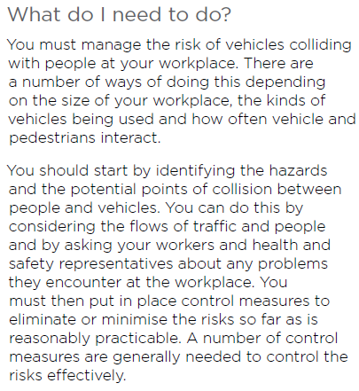

Name and location of Organisational policies
P-IMS-001 Safety, Environment and Quality Policy
https://wagnersltd.sharepoint.com/sites/GreenTree/Documents/IMS%207IntPub/SOP-IMS-004%20Risk%20Management.docx

Relevant excerpt/requirement for chosen workplace
The Wagners Safety, Environment, and Quality Policy outlines that the items raised in the policy apply to all workers, and reiterates the PCBU responsibility to provide a safe place of work.

Name and location of Organisational procedures
SOP-IMS-004 Risk Management
https://wagnersltd.sharepoint.com/sites/GreenTree/Documents/IMS%207IntPub/SOP-IMS-004%20Risk%20Management.docx

Relevant excerpt/requirement for chosen workplace
The below excerpt of section 3.5 of the Standard Operating Procedure outlines workers responsibility to assess risk by completing hazard identification risk assessments.
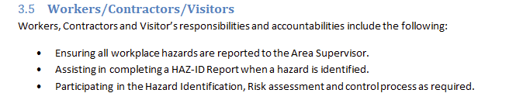

Name and location of Organisational processes
SWMS-CO-001 Use of Block Moulds
https://wagnersltd.sharepoint.com/sites/GreenTree/Documents/CO%206User/SWMS-CO-001%20Use%20of%20Block%20Moulds.docx?d=w54975229d70c4e7299c62ae120fbfb60
Relevant excerpt/requirement for chosen workplace
The below snipping from the SWMS outlines workers duty to assess risk as part of the Take 5 process risk controls before undertaking the works.

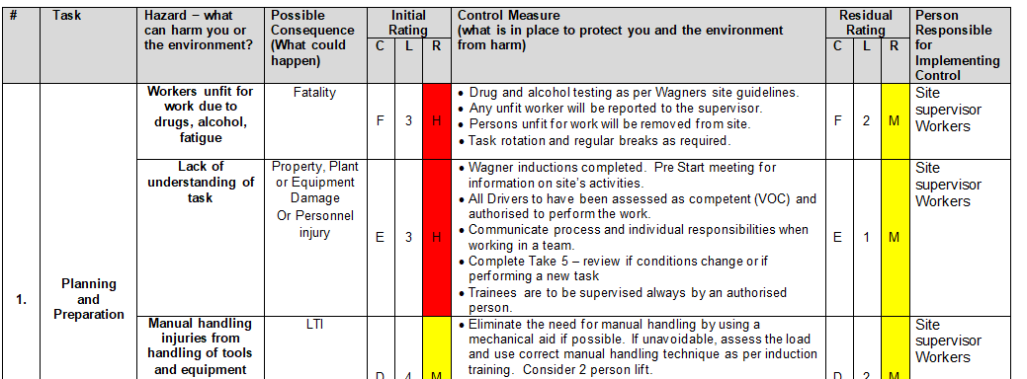

Outcome for Activity 1 | ☐ Satisfactory  ☐ Not satisfactory
Trainer/Assessor comments

Identify two (2) hazards (one chemical, one causing occupational disease) that may occur in your workplace. For each hazard identified, find information to explain:
- The nature and scope of the hazard, including the incidents/injuries it can cause
- Determine the level of risk for the hazard within your workplace
- Determine the application and limitations of each of the following techniques, tools and processes in identifying and controlling your nominated hazard (and associated risk):
- Hazard/risk checklists
- Hazard hunts
- Job safety analysis (JSA)
- Manifest/register (e.g. dangerous hoods, hazardous chemicals and plant)
- Safe work method statement (SWMS)
- Surveys (e.g. questionnaires, interviews)
- Workplace inspections and walk-throughs
- Name and justify at least two (2) risk controls that may be implemented to address the hazard and risk assessment results
- Explain which of these risk control options would be the most suitable

Name hazard resulting from chemicals
Eye, respiratory and skin irritation from Diesel
Nature and scope of hazard
Nature: Biochemical – Naturally produced chemical
Scope: All workforce – all will be exposed during normal operations, inclusive of administrative staff

Source of information (e.g. website address):
https://www.who.int/ipcs/emergencies/diesel.pdf
Determine the level of risk
Matrix | A:  Death or permanent disability | B:  Serious injury | C:  Lost time injury | D:  Casualty Treatment | E:  First Aid
1: Very Likely | E | E | H | H | M
2: Likely | E | H | H | M | M
3: Possible | H | H | M | M | L
4: Unlikely | H | M | M | L | L
5: Very Unlikely | M | M | L | L | L

E: Extreme | H: High | M: Medium | L: Low

Level of risk: Initial E-3

Techniques, tools and processes to identify hazard/risk
Describe application or limitations for each of the following in identifying the hazard/risk:
- Hazard/risk checklists: A hazard checklist or Loss Prevention Inspection may be used to identify controls that are not being met to the required standard.
- Hazard hunts: Hazard hunts may assist to identify areas that may encounter higher levels of exposure to chemical and determine where or when further controls may be required.
- Job safety analysis (JSA): A JSA may assist to identify roles that will encounter the use of diesel
- Manifest/register (e.g. dangerous hoods, hazardous chemicals and plant): A chemical manifest/register will assist in identifying where the chemical is kept and will be a useful tool during emergency situations
- Safe work method statement (SWMS): A SWMS for the refuelling of plant and equipment assists in identifying risks and control measures
- Surveys (e.g. questionnaires, interviews): A survey will not be a useful tool to control this hazard
- Workplace inspections and walk-throughs: Workplace inspections and walk-throughs may assist to identify areas where there is a high potential for spill (e.g. decanting areas)
Risk controls
PPE – Availability of respirators and gloves in decanting areas, availability of eye-wash stations
Administrative – Refuelling of plant and equipment SWMS & training
Engineering – Bunded storage vessels and decanting areas with nearby access to spill kits
Substitution – Purchase plant that does not require diesel to operate

Source of information (e.g. website address):
https://www.coshnetwork.org/node/358

Name hazard causing occupational disease
Respirable Silica Dust Exposure - Silicosis
Nature and scope of hazard
Nature: Biochemical - Silica dust is naturally occurring resource that creates a biochemical respirable hazard
Scope: Operators and maintenance staff involved in Quarrying operations are at highest risk in the company

Source of information (e.g. website address):
https://www.worksafe.qld.gov.au/__data/assets/pdf_file/0008/83186/silica_managing_workplace.pdf
Determine the level of risk
Matrix | A:  Death or permanent disability | B:  Serious injury | C:  Lost time injury | D:  Casualty Treatment | E:  First Aid
1: Very Likely | E | E | H | H | M
2: Likely | E | H | H | M | M
3: Possible | H | H | M | M | L
4: Unlikely | H | M | M | L | L
5: Very Unlikely | M | M | L | L | L

E: Extreme | H: High | M: Medium | L: Low

Level of risk: Initial: A-2

Techniques, tools and processes to identify hazard/risk
Describe application or limitations for each of the following in identifying the hazard/risk:
- Hazard/risk checklists: Hazard checklist can assist to identify if testing for Respirable Crystalline Silica testing is required on site
- Hazard hunts: Hazard hunts may alert workers and members of management as to how much dust is produced (e.g. through observation, accumulation etc) and may prompt seeking information or testing
- Job safety analysis (JSA): A JSA should identify this as a risk when prompted on sites that produce products containing Respirable Crystalline Silica
- Manifest/register (e.g. dangerous hoods, hazardous chemicals and plant): A site risk register should identify this as a prompt
- Safe work method statement (SWMS): A SWMS will be beneficial in identifying the control measures that must be in place for a specific task/activity to prevent exposure to Respirable Crystalline Silica
- Surveys (e.g. questionnaires, interviews): Occupational dust monitoring surveys will assist in determining the exposure levels of workers, and assist in determining what control measures are to be implemented.
- Workplace inspections and walk-throughs: Workplace inspections and walk-throughs by members of management is beneficial to determine if workers are following their duty to comply with control measures and if the control measure are effective
Risk controls
PPE control – Masks & Respirators
Administrate Control – Training and information, testing
Engineering Control – Watering systems

Source of information (e.g. website address):
https://www.worksafe.qld.gov.au/construction/workplace-hazards/silica-exposure-a-serious-risk-for-construction-workers

Outcome for Activity 2 | ☐ Satisfactory  ☐ Not satisfactory
Trainer/Assessor comments

Referring to the hazards identified in Activity 2, consider the implementation of the proposed control measures.
- What impact will the organisation’s WHS management system (WHSMS) have on the implementation process?
- Explain which individuals/parties need to be consulted when determining the suitability of the proposed risk controls.
- Describe the formal/informal communication and consultation processes used when addressing these individuals/parties
- Outline how both risk controls will be implemented in the form of an action plan
- Identify resourcing requirements, allocate roles and responsibilities, and training needs required for implementation
- Prioritise tasks and specify timelines for implementation
- How will the risk control processes be recorded?
- How will the organisation’s WHS information system (WHSIS) influence this?

Impact of WHMS
The WHS management system will provide processes that aim to ensure that risks are identified, and that compliance is maintained. The WHS management system will detail how these risks are assessed and documented and who is responsible and accountable for this. This will ensure there is a systematic approach that doesn’t rely on the knowledge on limited individuals.
Consulting individuals/parties
Individuals and parties that need to be consulted when determining the suitability of proposed risk controls are workers involved in the tasks where the hazards and risks are prevalent, as these changes will affect their responsibilities and impact on their duties to maintain their own health and safety. Members of management will need to be consulted in order to understand risks, obligations, and costs associated. If there were any Health and Safety Representatives or a Health and Safety Committee, they shall also be consulted with the proposed actions.

Generally, communication will start as informal as someone raising points of concern or improvement through general conversation. These may then be made formal through the use of email and meeting minutes.
Action plan
Diesel action plan:
- Site management is to provide PPE to the site for decanting operations within 3 business days.
- Safety Advisors are to consult with site management and workers regarding the development of SWMS. SWMS are to be completed within one week and read and signed by all site members.
- Site management is to ensure the implementation of decanting bays and available pumps is to be made available within 2 weeks. The eye wash stations are to be plumbed within this time also.
- An opportunity for improvement is to be raised in the management system regarding the purchasing of plant that does not require the use of diesel is to be completed by COB by the Safety Advisor. This opportunity is to be assigned to the Procurement Manager for review and assessment.

Respirable Crystalline Silica Action plan:
Resourcing requirements include;
- Water suppression systems require to be plumbed and operational within 2 weeks. This is a high priority task, and is to be overseen & managed by the site supervisor. The site supervisor may seek assistance of upper management as required.
- PPE is to be sourced and obtained. This is required to be completed within 3 weeks, to ensure PPE is on site prior to delivery of training in action 3.
- Training development and delivery of use of PPE must be delivered to all site staff within one month. This is the responsibility of Safety department.

Recording risk control process
These controls will be recorded in the SWMS, site dust management plan, and site risk register. These controls are subject to review and it is the responsibility of site and the relevant Safety Advisor to ensure these are monitored, reviewed and maintained as necessary.

Outcome for Activity 3 | ☐ Satisfactory  ☐ Not satisfactory
Trainer/Assessor comments

Referring to the hazards identified in Activity 2, consider the effectiveness of the proposed control measures.
- Identify factors that may impact on the effectiveness of the risk controls and how they might be addressed. Consider the impact of:
- Workers with specific needs and limitations (e.g. cultural background and diversity, low language, literacy and numeracy levels)
- Structure and organisation of the workforce (i.e. part time vs casual vs contract workers; shift rosters; geographical location)
- Workplace culture relating to gender and alcohol/drug use
- How will you monitor and review the success of each risk control?
- What impact will the organisation’s WHSMS have on this process?
- Identify the criteria used for the evaluation (i.e. positive performance indicators).

Factors impacting on risk management
The effective implementation of these risk controls may be impacted by cultural, organisation structure, workplace psyche, and literacy factors.

Due to the culturally diverse nature of the company, there are some employees that may identify to have religious or cultural reasons to have a beard. This will interfere with the effectiveness of masks and respirators.

As sites are segregated and often work in staggered shifts, communication and training regarding these risks and control measures will have to be monitored to ensure all that are affected are advised.

The majority of the workforce is male, and stereotypically, are not open regarding health issues they may be experiencing. There may also be some bullying within the workplace toward those that choose to wear a mask as a control when it is not mandated.

Due to the literacy and comprehension issues that some of the workforce displays, some workers will have to be explained the new control measures one-on-one.
Monitoring
By logging these risks in the management system, stakeholders will be prompted to ensure that these are monitored and reviewed as required.

To monitor the effectiveness of these controls, data relating to first aid caused by contact with chemical can be reviewed.

Recording and monitoring of Lost Time Injuries due to Respirable Crystalline Silica can be used as a leading indicator to determine the effectiveness of the proposed controls. Review of results from health reviews regarding exposure levels will also provide an indicator to determine effectiveness of controls.

Outcome for Activity 4 | ☐ Satisfactory  ☐ Not satisfactory
Trainer/Assessor comments

QUIZ

QUESTIONS | CORRECT
- A systematic approach to managing WHS risk in the workplace involves: Assessment of hazards/risks, consultation with workers, development and implementation of risk controls by PCBU, and review of risk controls.  ☒ True  ☐ False | ☐
- Which of the following may impact on WHS risk and the management of WHS? Select all that apply.  ☐ Consultation meetings being too long and boring  ☒ Language, literacy and numeracy levels of the workforce  ☒ Workplace culture  ☒ Having separate work sites | ☐
- Which of the following can be used for identifying and controlling WHS hazards and risks? Select all that apply.  ☒ Hazard and risk checklists  ☒ Hazard hunts  ☒ Job safety analysis  ☒ Manifests and registers  ☒ Safe work method statements  ☒ Surveys  ☒ Workplace inspections and walk-throughs  ☒ WHS management system  ☒ WHS information system | ☐
- Which of the following are limitations of using a generic hazard/risk assessment checklists and risk ranking processes? Select all that apply.  ☒ Specifics of the workplace are not considered  ☒ Not all checklist points will be applicable  ☐ Such checklists/processes must be completed on a computer  ☐ You always have to purchase these checklists | ☐
- Match the following terms and definitions by placing the corresponding term number next to each definition. | ☐
  Label | Term |  | Label  (1 – 5) | Definition
  1 | Causation |  | 3 | The action of stopping something from happening.
  2 | Hazard |  | 5 | That which is seen as the natural result of action/inaction.
  3 | Prevention |  | 4 | A measure of the possibility of harm, considering seriousness of injury and likeliness of occurrence.
  4 | Risk |  | 2 | Something which has the potential to harm people.
  5 | Foreseeability |  | 1 | The relationship between conduct and the resulting effect (e.g. injury)

Outcome for Quiz | ☐ Satisfactory  ☐ Not satisfactory
Trainer/Assessor comments

PRACTICAL TASK

You are required to have a suitable observer verify your ability to complete the following tasks. These tasks may be simulated (using the handout provided) or real.

TASKS |  | VERIFIED
- In a small group, show leadership while conducting a safety audit of the work area.  - Check quantities and suitability of emergency equipment |  | ☒
- Document potential emergencies and their causes in a risk register, identifying:  - Possible injuries/damage  - Required control measures (referring to legislation, standards and considering requirements of organisation’s WHSMS and WHSIS)  - Risk assessment results |  | ☒
- Electronically and orally present findings to appropriate persons (e.g. PCBU, Trainer/Assessor). As part of the presentation:  - Identify factors that will impact on WHS risk management  - Explain how control measures will be monitored and reviewed for effectiveness (using positive performance indicators), and in accordance with WHSMS |  | ☒
Name of observer | Hugh Stone
Role of observer  (Confirm their suitability to sign) | ☐ Trainer/Assessor  ☒ Other (specify): Wagners Head of Safety, Environment & Quality
Phone number of observer | 0419 009 173
Email address of observer | hugh.stone@wagner.com.au
Signature of observer | 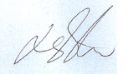
Date | 1/10/2020
Comments | Nartika routinely participates in audits and site inspections to check and verify adequate management and control of site hazards and risks, including those that could trigger emergency response. These audits are captured and documented in our information management system after consultations and presentation of the findings to site managers and action owners.

Outcome for Practical Task | ☐ Satisfactory  ☐ Not satisfactory
Trainer/Assessor comments

