EMAIL SENT TO CLIENT REQUESTING VARIATION APROVAL

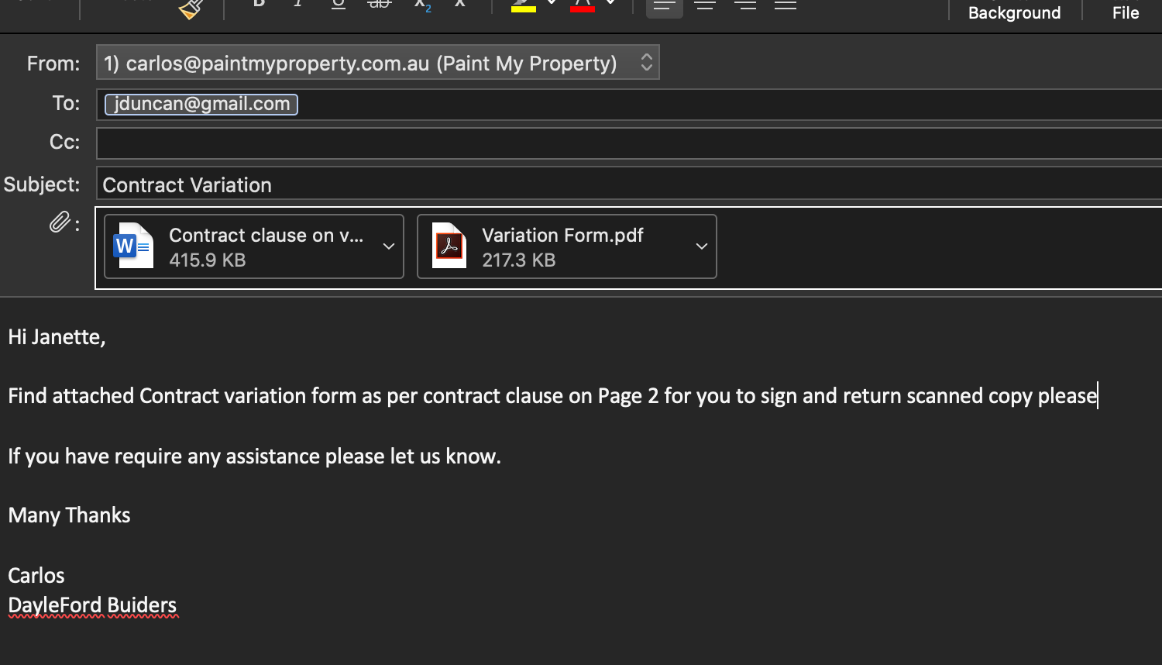

EMAIL RECEIVED BY CLIENT ACCEPTING THE VARIATION



