
AHCLSC304
Erect timber structures and features

Copyright © 2021 CSTC Pty Ltd

All rights reserved. No part of the contents of this publication may be reproduced or used in any form or by any means – graphic, electronic, or mechanical including photocopying, digitising, recording, or information storage-and-retrieval systems – without the written permission of CSTC Pty Ltd.
ASSESSMENT FOR AHCLSC304

Student name | Nick Hollowood
Date of assessment submission | Click here to enter a date.

Trainer/Assessor’s name
Date of assessment marking | Click here to enter a date.
Outcome for unit | ☐ Competent  ☐ Not Yet Competent

TASK INSTRUCTIONS

- As part of the assessment for this unit of competency, you are required to complete a series of activities.
  - Some of these activities will require you to provide a response within this document, others will require you to gather evidence to demonstrate your knowledge and skills.
- At all times, the responses in your assessment must reference Australian (Queensland or Federal) documentation, including legislation, regulations, codes of practice, standards and guidance publications.

ACTIVITIES

Draw a simple concept plan for a proposed landscape design which includes timber structures/features.

Response
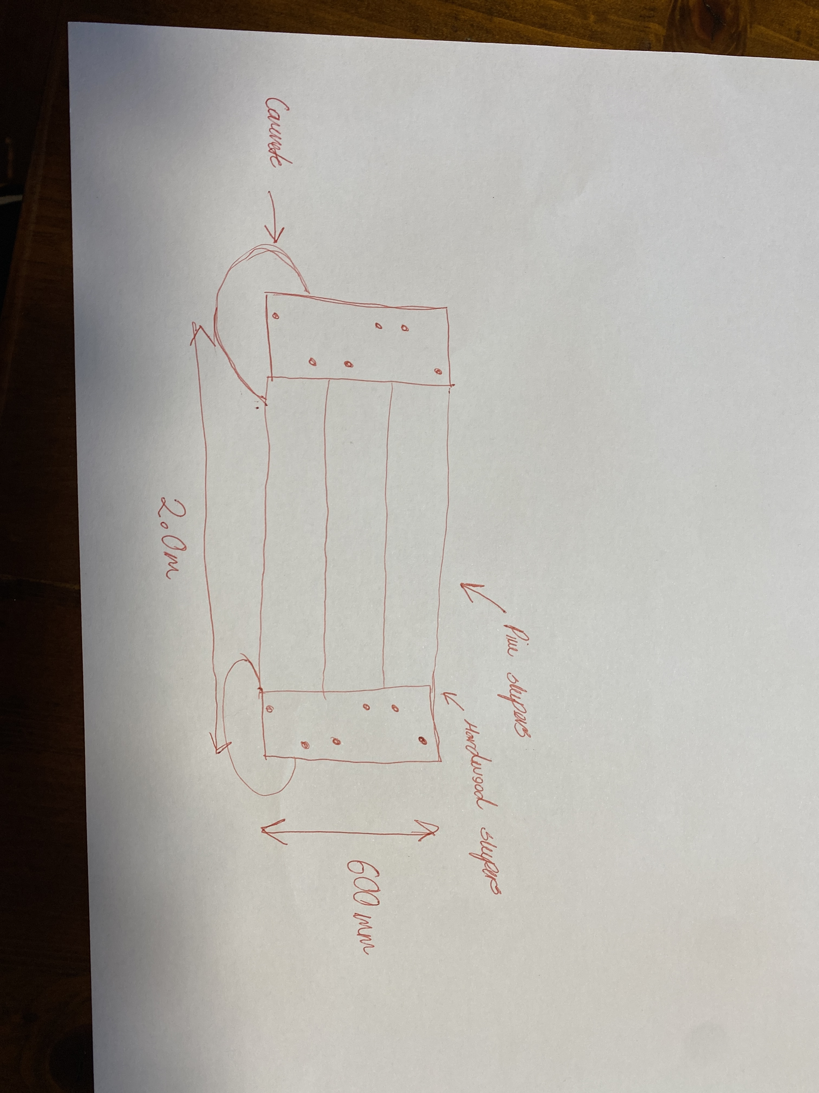

Outcome for Activity 1 | ☐ Satisfactory  ☐ Not satisfactory
Trainer/Assessor comments

Identify/list the detail on the landscape plan shown.

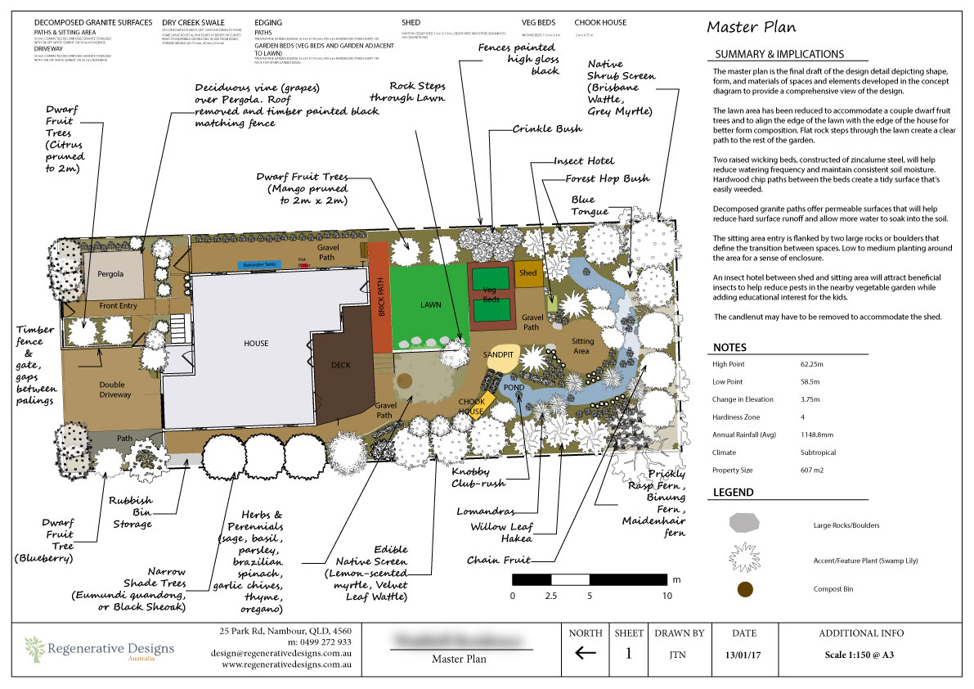

Response
Plants, compose bins, gravel areas, turf areas, pond, hardscape features

Outcome for Activity 2 | ☐ Satisfactory  ☐ Not satisfactory
Trainer/Assessor comments

List the materials required to complete the timber structures in the construction plans shown.

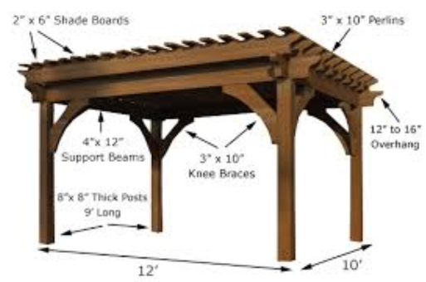

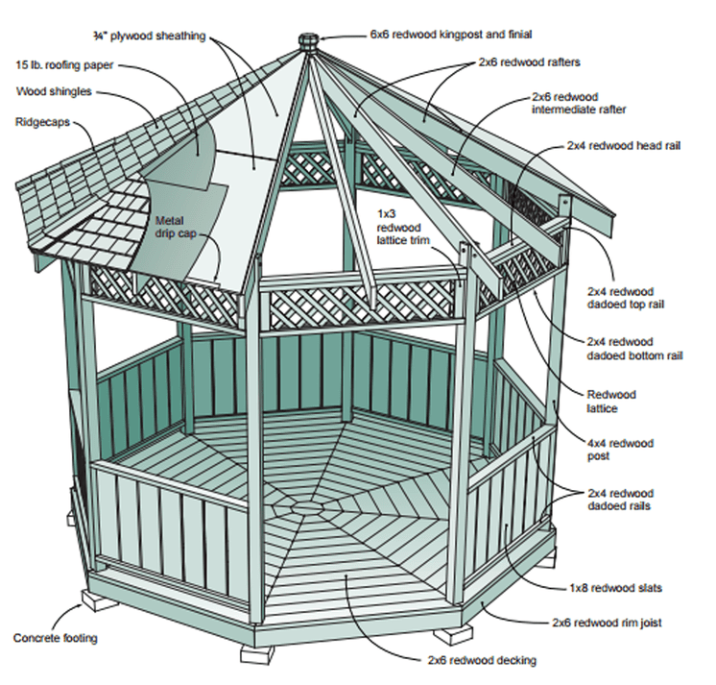

Response
Plywood sheeting, redwood kingpost and finial, roofing paper, wood shingles, ridgecaps, redwood rafters, redwood immediate rafter, redwood head rail, metal drip cap, redwood lattice trim, redwood dadoed bottom rail, redwood dadoed top rail, redwood lattice, reddwod post, redwood dadoed rails, redwood stats, redwood rim joist, redwood decking, concrete footing.

Outcome for Activity 3 | ☐ Satisfactory  ☐ Not satisfactory
Trainer/Assessor comments

Research and identify the difference between treated and untreated timbers.

Response
The difference between the two is that pressure treated lumber will resist the elements better than untreated due to chemical preservatives added, and so will maintain its integrity in conditions that would cause normal wood to rot.

Outcome for Activity 4 | ☐ Satisfactory  ☐ Not satisfactory
Trainer/Assessor comments

Have team members take photos and videos of your involvement with timber structures and features.

Identify each photo / video with a letter label and describe each photo / video in the table below. Submit the photo / video files along with this workbook.

Advantages
A
B
C
D
E
F
G
H
I
J
K
L
M
N
O
P
Q
R
S
T
U
V
W
X
Y
Z

Outcome for Activity 5 | ☐ Satisfactory  ☐ Not satisfactory
Trainer/Assessor comments

