CPCCBC4012B
Read and interpret plans and specifications

THEORY EXAM INSTRUCTIONS

- This exam will occur under standard assessment conditions.
  - An oral examination may be allowed under certain circumstances.
Answers will be documented and FT003 (Oral examination declaration form) must be completed.
- Participants must provide enough detail in their responses to demonstrate their knowledge and skills.
- Please fill in the details below, providing your name, signature and date of assessment.
  - Your signature acknowledges that this is your own work.
- If a participant initially answers a question incorrectly but modifies their response, they must follow the instructions below:
  - If a participant changes their response in writing, they must put their initials next to the written change.
  - If a participant changes their response verbally, this must be noted on the exam paper by the assessor.

Participant name | Test Student
Participant signature | 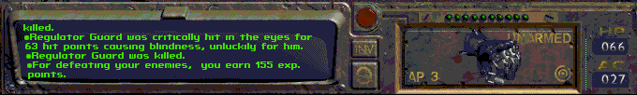

Assessor name | Mel Dobbs
Assessor signature | 

Date | 17/11/2017

Number of questions | Number of questions answered correctly | Satisfactory?
77 |  | Yes | No
Assessor Comments
- What does the term ‘plan’ mean when referencing plans and drawings for construction purposes?

Answer | I’ve totally completed this whole assessment. Did I pass? Thanks.

- Name the people and organisations who will have an interest in plans and drawings for a construction project.

Answer

- What will plans show to the interested parties?

Answer

- What types of plans is it necessary to be familiar with for building and construction projects?

Answer

- All plans and drawings give a compass direction.
Which compass direction is always shown and on which drawings is it likely to be found?

Answer

- What does a location plan contain?

Answer

- What does a site or block plan contain?

Answer

- What features would you expect to look for and find on plans and drawings for a construction project?

Answer

- What do floor plans identify?

Answer

- What are elevation views? What do they provide to the plan reader?

Answer

- What is a section?

Answer

- What are detailed drawings?

Answer

- What are specifications?

Answer

- What information will you find in a title block to a drawing?

Answer

- What is the significance of the Australian Architectural Standards?

Answer

- What will you find in the Waste Management Plans & Site Management plans?

Answer

- What is a landscape plan?

Answer

- What is the purpose of a shadow diagram? Who primarily would seek one?

Answer

- What is a bracing schedule?

Answer

- What must we do with plans and drawings in our on-site environments? How often should plans and drawings be viewed on site?

Answer

- Explain the meaning of the abbreviations in the table below.

Answer | Abbreviation | Meaning
 | ACRYL
 | AS
 | ASSD
 | B
 | BN
 | BTH
 | BWK
 | CB
 | CF
 | CG
 | CJ
 | CORR
 | CWT
 | DG
 | DH
 | DPC
 | DSB
 | DW
 | EJ
 | FPBD
 | FFL
 | FHR
 | GPO
 | HBD
 | HTR
 | HWD

- Why and when would you use presentation drawings?

Answer

- Service drawings provide information about a variety of different components and equipment. In order to identify individual items, it is usual to give them a reference number on drawings such as services layout drawings and location plans.
What details might we expect to see from service drawings?

Answer

- What are working drawings? What do they record?

Answer

- What is an isometric view?

Answer

- Sketch a concrete block in isometric view.

Answer

- What is the purpose of perspective projection and representation in drawing of architectural buildings and edifices?

Answer

- What is a topographical survey?

Answer

- What is an ecological survey?

Answer

- What is significant to keep in mind when developing the Schedule of Quantities (also known as a Bill of Quantities)?

Answer

- What should be applied in consideration of stress, load and bearing calculations in the design, the drawings and the building of a structure?

Answer

- What is a prime cost (PC) item? Give an example.

Answer

- What is a provisional sum (PS) item? Give an example.

Answer

- Suggest when you would need to provide ‘additional’ plans.
Give some examples of such plans.

Answer

- How do you identify and record customer variations?

Answer

- When reading and interpreting (or amending) variations project specifications, what documentation should you also refer to?

Answer

- So you don’t end up in a dispute what strategies can you employ with your customer/client/home owners?

Answer

- Name each of the drawing symbol images shown in the table below.

Answer | Name | Image
 |  | 
 |  | 
 |  | 
 |  | 
 |  | 
 |  | 
 |  | 
 |  | 
 |  | 
 |  | 

- Draw symbols for the following items.

Answer | Item | Drawing
 | Basin
 | Bidet
 | Bath
 | Drinking fountain
 | Sink: Single bowl
 | Sink: Double bowl
 | Tub: Double
 | Tub: Single
 | Drinking trough
 | Hotplates
 | Shower
 | Shower bath
 | Urinal stall
 | Vanity basin
 | Water Closet (Toilet)

- Draw the following window symbols in elevation.

Answer | Item | Drawing
 | Hinged at side
 | Hinged at top
 | Sliding horizontally
 | Fixed

- Draw symbols for the following items.

Answer | Item | Drawing
 | Brickwork
 | Blockwork
 | Concrete
 | Plaster/Render

- Provide a description of the residence shown in the plan drawing below.

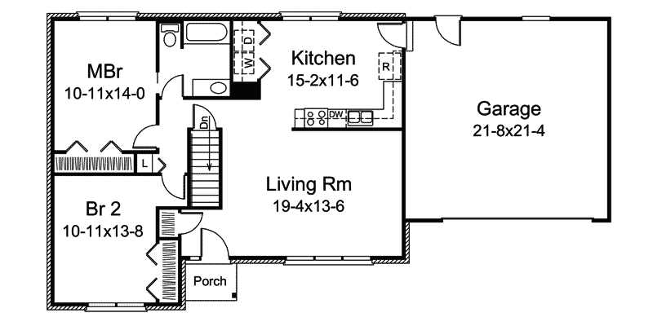

Answer

Refer to the sectional drawing below to respond to Q43. to Q63.


- Give a brief description about the building from the detail available in the sectional drawing.

Answer

- Who is the client?

Answer

- Where is this project to be built?

Answer

- What are the contact details for the draftsman?

Answer

- What sheet number is this drawing?

Answer

- What timber is required for loading and non-load bearing walls?

Answer

- What spacing is recommended for common studs?

Answer

- What type of roof truss is to be installed?

Answer

- What centres are the trusses positioned at?

Answer

- What size are the veranda posts?

Answer

- What timber species are the veranda posts to come from?

Answer

- What pitch is the roof?

Answer

- What size are the noggings and at what spacing?

Answer

- What size are the ceiling joists?

Answer

- What timber is used for roof battens and what spacing?

Answer

- What thickness is the plasterboard sheeting?

Answer

- What type of flooring is to be installed?

Answer

- What is the roof cladding material?

Answer

- Where will you find information about the footings?

Answer

- What do the letters DAR refer when timber ordering?

Answer

- Explain 240 x 63 LVL. What does it refer to on the section?

Answer

Refer to the drawing overleaf to respond to Q64. to Q75.

- What is the number of the drawing?

Answer

- What is the Job Number?

Answer

- What is the scale of the drawing?

Answer

- What does the drawing show?

Answer

- Which view shows the front of the house?

Answer

- How many motor vehicles can be parked in the garage?

Answer

- What are the window and doors made from?

Answer

- What is the size of the eaves?

Answer

- What are the eaves lined with?

Answer

- What type of roof structure is the roof built from?

Answer

- What is the roof cladding materials made from?

Answer

- What is the roof pitch?

Answer



- You have spoken with a client on the phone and they are seeking to make amendments to some plans. They wish to add two more bedrooms to extend their home from the current four bedrooms to six bedrooms.
The two new bedrooms are to both have ensuites (including single shower in each, double bowl vanity unit and under cupboard and toilet) with walk in robes, including the extension of the existing hallway with built-ins for the existing Bed 1 and Bed 2. The Family Room is to be extended to the rear wall in line with kitchen rear wall.
The client has faxed through the image below. Re-sketch and redesign the drawing and add the two new bedrooms along with extended hallway, ensuites, walk-in robes and the Family Room extension for consideration by the client.
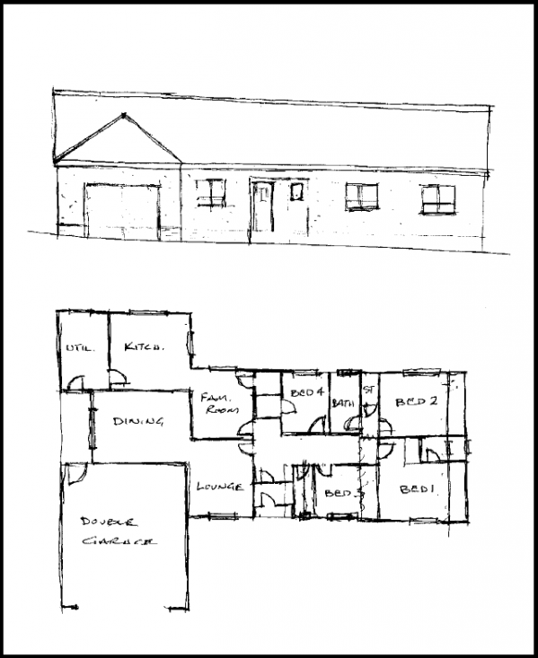
SKETCH

Answer

- Referring to Q76. compose an email to the client, providing an estimate of the additional labour hours/costs and material quantities/costs that have resulted from the their request.

Answer

