Construction
Management Plan

for
BHC CURWEN TERRACE

BHC 2 – 8 Curwen terrace Chermside – Community Housing
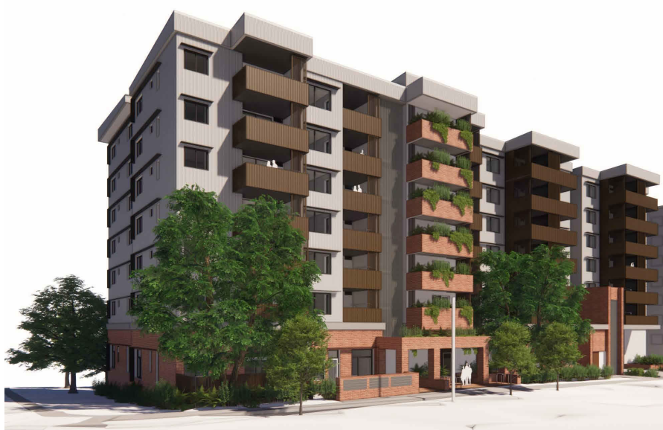

Rev | Date | Revision Description |  |  | Prepared |  | Reviewed |  | Approved
0 | 10.10.23 | Made project specific/Council submission |  |  | Oliver Olsen |  | Colin Heironymus |  | Andrew Lamond

Table of Contents
1. PROJECT SUMMARY 5
Development Approval 5
Office Location 5
Project Personnel 5
Scope of Works 5
Project Duration 6
Hours of Operation 6
Staging and Programming of Works 6
2. TRAFFIC MANAGEMENT 7
Local Haulage Routes 7
Temporary Vehicular Access 8
Temporary Closures 8
Loading/Unloading 8
Pedestrian Movement 8
Construction Parking 9
Emergency Exit Routes 9
Materials Plant and equipment 9
Waste Management 9
3. SITE ESTABLISHMENT 10
Site Amenities 10
External Hoardings & Gantries 10
Plant, Machinery, and Materials Storage 11
4. COUNCIL ASSETS 11
Parking Meters & Spaces 11
Street Trees 11
Traffic Signals 11
Street Furniture 11
Sewer & Stormwater 11
5. AUTHORITY CONNECTIONS 12
Electrical/Telecommunications Infrastructure 12
Potable & Fire Water Service 12
Wastewater Service 12
6. ADJOINING & NEIGHBOURING OWNERS 12
Communication 12
Complaints Response Process 13
7. ENVIRONMENT 13
8. NOISE MANAGEMENT 14
Appendix 1 – Traffic Management Analysis 15
Appendix 2- TGS’ Relevant to Project 16
Appendix 3 – Site Logistics Plan & Storage Plan 17
Appendix 4 - ESC Plans 18
Appendix 5 – Energex Stamped PMT Drawings 19
Appendix 6 – Health & Safety Management Plan 20

PROJECT SUMMARY
McNab Developments QLD Pty Ltd has been awarded the Design & Construct works for BHC CURWEN TERRACE, located Lots 26-28 on RP85139& 29 on RP82137 CURWEN TERRACE Chermside
This Construction Management Plan has been developed to advise how McNab intends to reduce impacts to the surrounding community during construction.

Development Approval
This Construction Management Plan has been compiled in accordance with:
DA Number: A006052317
Condition Number: 30(a)

Office Location
Street Address: Level 2, 10 Browning Street, West End QLD 4101
Postal Address: PO Box 5054, West End QLD 4101
Phone Number: 07 3252 6900
Facsimile: 07 3846 7555
Email: info@mcnab.net.au

Project Personnel
Managing Director: Michael McNab
Construction Manager: Luke Martin
Project Manager: Michael Taylor
Design Manager: Callum Bell
HSEQ Manager: Nick Economidis

Scope of Works
The proposed development is a multi-residential development comprising of:
- Basement - 2 below ground levels of carparking for visitors and residents.
- Structure – 6 storeys above ground structure, consisting of the following.
  - Ground Level - Containing a building foyer, basement entry, four residential units, office/meeting room areas, amenities, visitor, and resident bike parking.
  - Levels 2-6 - Containing the remaining 88 units consisting of studios, 1-bedrooms, and 2-bedrooms.
  - Roof Terrace & Upper roof containing a communal space for residents.

Project Duration
Anticipated Construction Commencement Date: November 2023
Anticipated Construction Completion Date: July 2025

Hours of Operation
Normal working hours for the project will be Monday to Saturday from 6.30am to 6.30pm in accordance with the Development Approval.
If any works are to take place outside these hours, approvals will be obtained from the relevant authority/s.

Staging and Programming of Works
Works on site shall be programmed and staged in line with our construction programme. There are four defined stages of works with a brief description outlining main tasks are noted below.
- Stage 1 – Site establishment, temporary sheds, and fencing
- Stage 1a – Civil works, retention systems and foundation piling
- Stage 2 – In ground services, pad footings, foundations, and Tower Crane erection
- Stage 3 – Concrete Structure and Roofing
- Stage 4 – Internal fit out and external landscape
A letter drop shall be issued at key milestones within the project to keep neighbouring stakeholders informed as to the logistics and construction of the project.

TRAFFIC MANAGEMENT
The management of traffic within the surrounding area will be undertaken in accordance with the attached Traffic Management Analysis – Refer Appendix 1.
The Traffic Management Analysis describes how McNab proposes to manage the safe and orderly passage of motorists, pedestrian traffic, emergency vehicles and other road users through and around the site during the construction.

Local Haulage Routes
Local haulage routes will be in accordance with the below mark up.
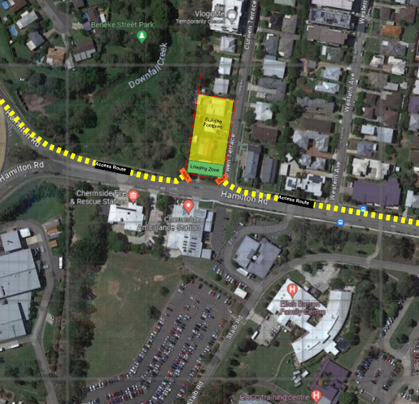

McNab will advise trucks and construction vehicles of the accepted entry and exit routes to the site via Hamilton Road. Delivery routes and access route will utilize the loading zone within site boundary to ensure no queuing on Hamilton road and have taken into consideration of the traffic volumes and requirements of a safe and effective flow of traffic within the area
Construction vehicles are not to queue in any of the surrounding streets.

Temporary Vehicular Access
Vehicle access to site shall enter via Hamilton Road exiting out of the loading zone back onto Hamilton Road to minimise impact on Curwen Terrace.
Accredited & Queensland Transport licensed traffic controllers shall be used to direct traffic when considered necessary by site management or as demanded under the conditions of any Permit. All traffic will be stopped or diverted in accordance with the methods set out in the Manual of Uniform Traffic Control Devices (MUTCD).

Temporary Closures
During construction there will be instances where McNab will be required to partially or fully close a road, footpath and/or car spaces to safely undertake the works. Where any road, footpath or car space closures are required, approvals/permits must be obtained from the relevant authority/s.
The Traffic Guidance Scheme TGS # CC03622­S1­1A demonstrates the closure of footpaths for the purpose of construction activities & maintenance of Hamilton Road traffic during the project.

Loading/Unloading
Deliveries must be registered each day with the site team during the Pre-Start Meeting. The Site Manager will ensure that impact on the local traffic is minimised. Unloading and loading will be performed within the noted zones using the crane, materials hoists, and forklift or by hand.
No unloading or loading will be permitted on the footpath without an approved Traffic Management Plan in place and approved by the relevant authority/s. The frequency of deliveries will be in line with the construction programming. In order to limit deliveries, the Contract Administrator will ensure a system of Just in Time ordering is implemented.
The impact of deliveries on surrounding streets will be assessed based on quantitative and time criteria. In the case of large deliveries, additional traffic management may be utilised to assist truck movements.

Pedestrian Movement
A Construction Loading Zone within the front of site will facilitate deliveries, materials will be unloaded by Tower Crane directly into site.
Pedestrians using the footpath at the front of site will be directed along the pedestrian corridor during working hours. This zone will be monitored at all times during deliveries and unloading by site management, and this zone shall be reopened once site is closed at 6.30pm.
Cyclists will travel with vehicle traffic as per existing conditions or have the option to dismount and walk the Pedestrian route provided. Pedestrian access along Curwen Terrace will be closed on the construction zone and pedestrians managed in accordance with the TMP

Construction Parking
During peak construction periods there will be upwards of 100 personnel onsite. McNab are considerate of the impact which increased vehicle access will have on the community. McNab will endeavour to contain and control the parking of subcontractors as this will be a fluid situation within the precinct.
Management & Subcontractors will use the following methods of transport to attend work.
- Surrounding spaces – McNab is currently looking to secure a vacant site that has recently been cleared on Curwen Terrance for construction parking. Parking of vehicles in front of driveways is prohibited. There are numerous on road parking in the area which can be utilized in addition to any sites that can be secured.
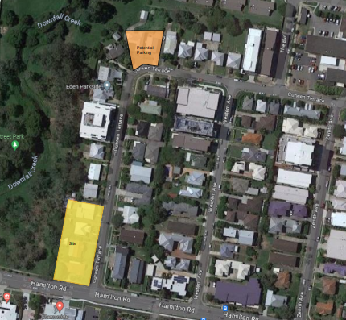

- Public transport - McNab will encourage workers and contractors to catch public transport, carpool, and park off site to reduce the potential for impact of parking on residents and council assets.

Emergency Exit Routes
In the event of an emergency a plan showing exit routes for a safe and functional emergency exit from site shall be placed on the site signage board, the emergency muster point is noted on the site logistics plan showing adjacent park being the emergency muster point, please refer appendix 3.

Materials Plant and equipment
All materials and plant shall be stored within the site boundaries and within the basement of the project. Designated areas have been noted on the attached site logistics plan and areas shall be relocated as the sequence of works progress. Please refer to the attached appendix 3.

Waste Management
It is part of McNab philosophy that a tidy site is a safe site, and this principle will be maintained throughout the construction duration. Skip bins will be provided at strategic positions around the site, where all subcontractors will be required to clear their rubbish as it accumulates. These bins will be brought down the building via the crane / builders’ lifts into the large skips for removal from site. Change overs will occur as required.

All rubbish will be removed from site daily via wheelie bins and deposited in bins/skips which will be provided at strategic positions onsite. Where space permits, McNab will also provide specifically labelled recycling bins for materials such as, cardboard and plasterboard to maximise the amount of material able to be recycled.

In addition, all subcontractors are responsible for removing their own packaging and other re-usable items such as pallets from site. Adopting this policy is multi-beneficial, as it promotes recycling by subcontractors and suppliers, removes unnecessary packaging at the source rather than at site; and reduces the amount of rubbish being sent to land fill.

SITE ESTABLISHMENT

Site Amenities
Site facilities for the construction phases will be located within the site boundary on the Curwen Terrance side of the property. See below site logistics plan showing site amenities onsite - Ref appendix 3 and figure below.
McNab will establish a site compound with offices & amenities on the corner Curwen Terrace, with additional temporary amenities to be provided within the site boundaries & building structure (in line with the numbers of workers on site).
This site setup will be subject to change based on construction requirements.
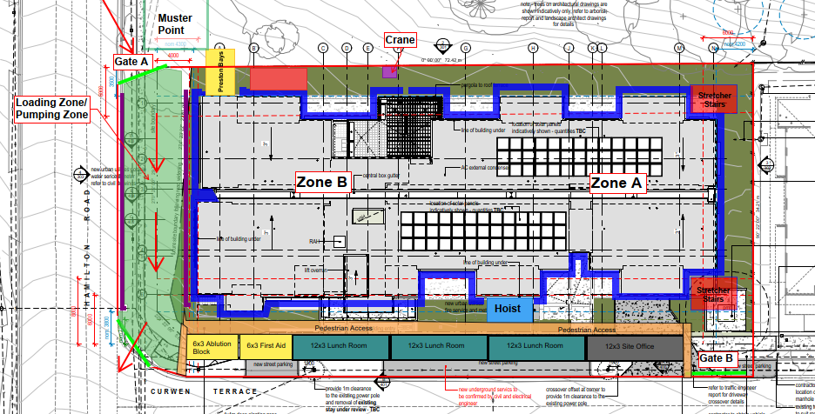

External Hoardings & Gantries
Temporary fencing will be erected to restrict access to the site from members of the public. Temporary fencing will be erected prior to commencement of works, adjusted as required and remain in place until a time where the building itself is secure.

Plant, Machinery, and Materials Storage
All plant, machinery and materials are to be stored within the site boundaries and/or work zones.
The logistics plan shows areas for storage of materials and machinery on site as well as the intended Tower Crane location. Material storage to be within the loading zone on short stay prior to being lifted. All other material storage will be within the building footprint, utilizing basement carpark areas and ground floor carpark areas

COUNCIL ASSETS

Parking Meters & Spaces
As per the proposed Traffic Management Analysis (refer Appendix 1), there are no parking meters or Council parking space along the construction site frontage.

Street Trees
There is three trees as identified on JFP Urban Consultants Arboriculturally Impact Assessment that requires a TPZ
Tree 5 requires the TPZ to be bordering scaffold base and requires arborist supervision and consultation throughout key works in these areas.
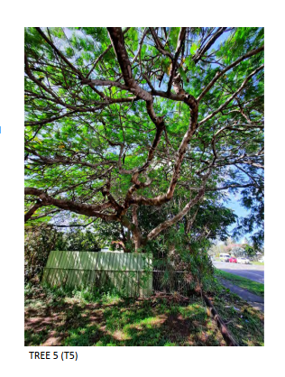

There are two (2) existing trees external to the boundaries of the site, that require protection and coordination during the external civil stormwater works. These works will require vacuum excavation to expose root systems and require arborist supervision and parks permission to work in the areas.
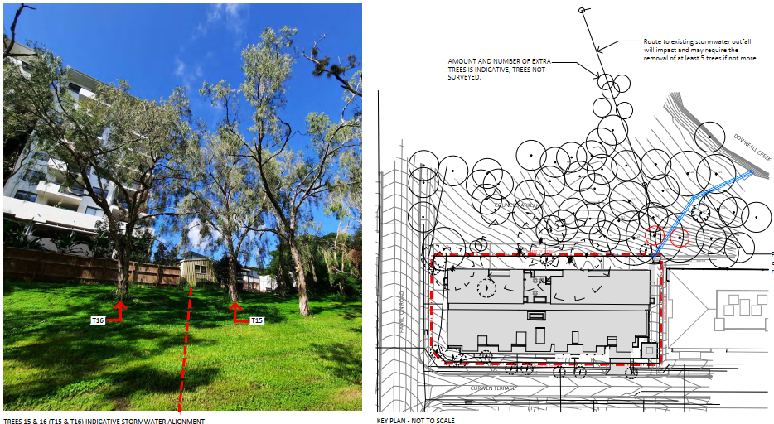

No contractors will be permitted to damage or alter any existing trees outside of the site boundaries at any stage of the works. If a tree is observed to have any damage; and incident report is to be completed and the Project Manager to be notified. Disciplinary action may result.

Traffic Signals
Please refer to the attached traffic management plan with considers the changes to traffic conditions within proximity to the site.

Street Furniture
There is no street furniture in close proximity to site that will be affected by the works.

Sewer & Stormwater
Civil stormwater works include the construction of a new stormwater line through adjacent park area. Protection of two identified trees is required with consultation as per Arboriculturally Impact Assessment
Existing stormwater gullies/pits will be protected in accordance with the Erosion and Sediment Control Plan – Refer Appendix 4.

AUTHORITY CONNECTIONS

Electrical/Telecommunications Infrastructure
The connection of the existing conduits into our site will be completed by an Energex approved contractor.
Energex shall perform their works (PMT installation) in accordance with the documentation provided– refer Appendix 5.
Energex will obtain all necessary approvals/permits from the relevant authority/s prior to the works.
All Authorities will be responsible for temporary closures required to undertake their own works.

Potable & Fire Water Service
Potable & fire water service infrastructure will be installed by McNab within nominated areas of footpath & verge surrounding the site, in accordance with the relevant Urban Utilities Water Approval.

Wastewater Service
Wastewater service infrastructure will be installed by McNab within nominated in accordance with the relevant Urban Utilities Water Approval including the removal of existing services as documented.

ADJOINING & NEIGHBOURING OWNERS

Communication
Prior to commencement of works, McNab will contact the relevant stakeholders and surrounding residents by way of a letter drop. This shall outline the construction sequence, together with an overview of the staging and timing of the works.
To ensure ease of communication between all parties, a protocol will be established to:
- Define lines of communication and appoint two points of contact for neighbours; and
- Clarify the escalation process of any concerns raised by neighbours
It is essential that stakeholders are aware of current and future activities of the project and how these could impact them, including the duration, and mitigation strategies which will be provided by McNab.
Points of contact between McNab’s project team and stakeholders will be agreed for various scenarios, with stakeholders provided with McNab’s contact details.
McNab will endeavour to continually communicate, consult and engage with surrounding stakeholders

Complaints Response Process

The complaints response process for the Project will be controlled by McNab representatives and company procedures for communication with internal and external stakeholders, necessary territory authorities, and the public.
All complaints received are to be forwarded to McNab – BHC Curwen terrace Project Team (contact details below). The initial point of contact for the Project for complaints will be the Project Manager, Michael Taylor. The contact details for these personnel may change between this submission and starting onsite, however the responsibilities and procedures will always remain the same.
Project Manager:
Michael Taylor
0400 330 537
Michael.Taylor@mcnab.net.au

In the event of not being able to contact the above, please call McNab Head Office on (07) 3252 6900

ENVIRONMENT
The management of environmental impacts will be undertaken in accordance with McNab’s Environmental Management Plan and compliance to the Environmental Protection Act 1994.
Construction can have the potential to disturb flora and fauna, generate nuisance air and noise emissions and generate general and hazardous waste. McNab will ensure the below Environmental Procedures are followed to ensure the risk is minimised or eliminated:
- Site Establishment / Prestart Environmental Briefing
- Community Consultation
- Site Management
- Erosion and Sediment Control
- Flora Protection
- Fauna Protection
- Noise and Vibrations
- Air Emissions /Dust suppression
- Waste Minimisation and Management
- Concreting
- Storage of Hazardous Substances
- Contaminated Land
- Acid Sulphate Soils
- Water Quality
- Fire Ants
- Interaction with local community

NOISE MANAGEMENT
McNab will always ensure that plant, equipment and works activities are selected to ensure that noise levels at the Sound Measurement locations identified in the contract do not exceed 100dB during normal work times.
McNab intend to implement several controls which will mitigate the noise exposure to
neighbouring residents. These include the following.
1. Delivery trucks will be discouraged from congregating outside of the site outside of approved
working hours.
2. McNab will display the contact details for the nominated person who is responsible for management
of noise on site, these details will be located on the site fence. This person will be responsible for
managing all noise complaints and ensuring that work does not commence prior to the allowable
times.
3. If complaints arise regarding noise, the complaint will be directed to the 'responsible person', who
will determine the source of the noise and take immediate steps to investigate further or minimise
the noise as required.
4. The 'responsible person' will notify the neighbouring properties on the commencement of works, or
when works are being undertaken which will adversely impact surrounding residents. On the rare
occurrence that works are approved to be undertaken outside of working hours, surrounding
residents will be notified.
5. If a complaint is received which is specific to a piece of plant, the plant shall be inspected for working
condition, with particular attention given to the condition of engine covers or enclosures and exhaust
systems to ensure all are in good working order.

APPENDICES

Appendix 1 – Traffic Management Analysis

Appendix 2- TGS’ Relevant to Project

Appendix 3 – Site Logistics Plan & Storage Plan

Appendix 4 - ESC Plans

Appendix 5 – Energex Stamped PMT Drawings

Appendix 6 – Health & Safety Management Plan

