CPCCBC4006B
Select, procure and store construction materials for low rise projects
ASSESSMENT SUMMARY

The assessment activities for CPCCBC4006B Select, procure and store construction materials for low rise projects cover all aspects of the unit of competency required. To demonstrate competence in this unit, a participant must undertake all tasks and complete them satisfactorily and consistently. For Apprentices and Trainees, this includes employer completion of the Employer Record Book (ERB).

Participants must read all the information given before starting any assessment task. The assessment tasks are intended to be equitable, fair and flexible. If a participant has any questions or requires alternative arrangements to be made such requests should be directed to their Trainer/Assessor, who should note such arrangements in the ‘Assessor Comments’ on the affected assessment. If a participant feels they are not yet ready to be assessed, they should discuss their options with their Trainer/Assessor.

To satisfactorily complete the assessment, the participant is required to answer all questions correctly and demonstrate their skills to industry standards. If a participant does not answer some questions or perform some tasks, they will be deemed ‘Not Satisfactory’ for the task and ‘Not Yet Competent’ for the unit of competency. The Trainer/Assessor is able to provide the participant with additional information on interpreting the assessment outcomes and provide guidance on the participant’s options. Should a participant still be deemed ‘Not Satisfactory’ they will have the opportunity to undertake a supplementary assessment or appeal the result.

By signing the cover page for each assessment item, the participant acknowledges they understand the assessment instructions and requirements and consent to being assessed. The participant also verifies and assures the RTO that the work submitted is their own work.

Participant Name | Lauren Wilson

Task | Assessment Results
Theory Exam | Satisfactory | Not Yet Satisfactory
Practical Assessment | Satisfactory | Not Yet Satisfactory
Outcome for Unit of Competency | Competent | Not Yet Competent

Assessor Name
Assessor Signature | 
Unit Competence Determination Date | Click here to enter a date.

CPCCBC4006B
Select, procure and store construction materials for low rise projects

THEORY EXAM INSTRUCTIONS

- This exam will occur under standard assessment conditions.
  - An oral examination may be allowed under certain circumstances, whereby the Participant’s answers will be documented by a party other than the Participant. This must be acknowledged in writing (e.g. FT001 and Assessor Comments)
- Participants must provide enough detail in their responses to demonstrate their knowledge and skills.
- Please fill in the details below, providing your name, signature and date of assessment.
  - Your signature acknowledges that this is your own work.
- Assessors are to complete marking in pen of a different colour to the Participant.
- If a Participant initially answers a question incorrectly but modifies their response, they must follow the instructions below:
  - If a Participant changes their response in writing, they must put their initials next to the written change.
  - If a Participant changes their response verbally, this must be noted on the exam paper by the assessor.

Participant name | Lauren Wilson
Participant signature | 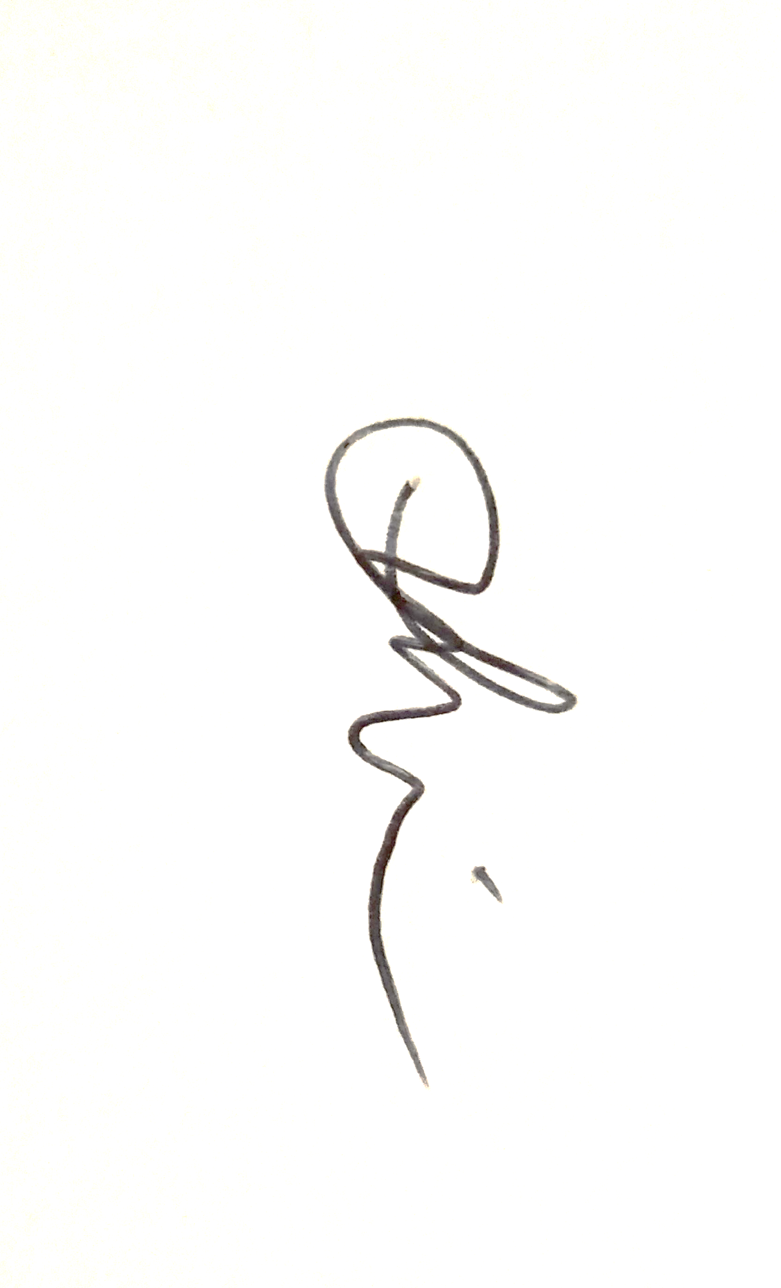
Date | 6/09/2020

Assessor name
Assessor signature
Date | Click here to enter a date.

Number of questions | Number of questions answered correctly | Task outcome (Tick)
44 |  | Satisfactory | Not Yet Satisfactory
ASSESSOR Comments
- Which of the following documents and/or people would you refer to when selecting materials for a building project? Tick all that apply.

Answer | Choice | Possible Answers
 |  | Australian Standards
 |  | Contract
 |  | Drawings
 |  | Manufacturer
 |  | National Construction Code
 |  | Specifications
 |  | Tolerances

- Identify the Volume and Parts of the NCC that relate to suitability of materials for Classes 1 and 10, and Classes 2 to 9.

Answer | Classes 1 and 10 | Classes 2 to 9
 | Part 5A.2 – Evidence of Materials – volumes One and Two | Part 5A.2 – Evidence of Materials – volumes One and Two

- Identify the assessment methods used to verify a performance solution.

Answer | Evidence of Suitability  Expert judgement  Comparison with the Deemed-to-Satisfy provisions  A verification method

- Which of the following solutions for material selection often references the Australian Standards? Tick your response.

Answer | Choice | Possible Answers
 |  | Deemed-to-Satisfy solution
 |  | Performance solution

- Identify five (5) materials commonly used for low rise buildings in your region. For each material, identify the following:
- Its name
- Properties of the material

Answer | # | Material name | Properties
 | 1 | Wood | Very flexible and durable  Strong when compressed vertically  Many different structures can be built in most climates  Various types and species all for different uses
 | 2 | Blocks / bricks | More fire Retardant than wood  Quite cheap to produce  Sound insulation  Can support relatively high loads
 | 3 | Tiles | High strength  Stain free and scratch resistant  Lightweight  Good insulation  Fireproof  High acoustic dampening factor  Easy to lay and ready to live in
 | 4 | Steel | Tough and durable  Weldability  Very strong  Ductility
 | 5 | Glass | Fire resistant  Low thermal conductivity  Hardness and brittleness  Weather resistant  Insulation  Transparency  Many different variaties

- For each of the materials in Q5. identify the following:
- Quality of the material (i.e. durability, serviceability, cost effectiveness)
- Compatibility and non-compatibility of the material (i.e. what it would/would not be suitable for)

Answer | # | Quality | Compatibility
 | 1 | Strength, Durability, Workability, Flexibility, versatility, sustainability, recyclable | Framing, flooring, roof trusses, fencing
 | 2 | Strength, economic, energy efficient, low maintenance, weatherproof, sustainability, various colours | External walls, fencing, internal walls
 | 3 | Fire and heat resistance, easy to clean, versatile, energy efficient, zero allergens, fit for purpose and safe, sustainability, odour free, | Flooring, roofing, walls
 | 4 | Sustainable, prefabrication, value for money, strong, efficient, adaptable and accessible, fire resistant | Framing, reinforcing, structural stabilisation, fencing
 | 5 | Strength, recyclable, energy efficient, transparency | Windows, showers, doors, walls

- Identify five (5) physical characteristics that may be considered when evaluating potential building materials.

Answer | Finish  Aesthetic appeal  Cost effectiveness  Initial costs  Availability  Sustainability

- Match the terms and definitions below by writing the appropriate letter next to each number in the centre column.

Answer | Term |  | Answers | Definition
 | 1 | Carbon footprint | 1 -B | A | The amount of energy required to manufacture a product
 | 2 | CO2e | 2 -E | B | Total GHD emissions produced during manufacture construction and use
 | 3 | Embodied energy | 3 -A | C | Greenhouse gas emissions
 | 4 | Embodied water | 4 -D | D | The amount of water required to manufacture a product
 | 5 | GHG | 5 -C | E | CO2equivalent tonnes emitted into the atmosphere

- Which of the following materials would be considered as ‘low energy content’? Tick all that apply.

Answer | Choice | Possible Answers
 |  | Bricks
 |  | By-products of other industrial processes
 |  | Cement
 |  | Glass
 |  | Metals
 |  | Plastics
 |  | Sand
 |  | Stone
 |  | Timber

- Refer to the table below and identify the wall material type that has the smallest embodied energy and emission impact.



Answer | Walls timber frame fibro clad

- Identify the Volume and Parts of the NCC that relate to energy efficiency of materials for Classes 1 and 10, and Classes 2 to 9.

Answer | Classes 1 and 10 | Classes 2 to 9
 | NCC 2019 Volume 2 – Part 3.12 Energy Efficiency | NCC 2019 Volume 1 – Section J – Energy Efficiency

- Identify the relevant section of the Standards and Tolerances Guide and the associated Australian Standard that addresses residential slabs and footings.

Answer | Standards and Tolerances Guide | Australian Standard
 | 3. Footings, Slabs and Set out – Ref Page 14 | BD-025: Residential Slabs and Footings

- Identify the relevant section of the Standards and Tolerances Guide and the associated Australian Standard that addresses roof tiles.

Answer | Standards and Tolerances Guide | Australian Standard
 | 7.4 – Roof Tiles | BD – 008: Roof Tiles

- Identify the Volume and Parts of the NCC that relate to safety barriers for swimming pools for Classes 1 and 10, and Classes 2 to 9.

Answer | Classes 1 and 10 | Classes 2 to 9
 | NCC – 2019 Volume 2 – AS 1926 – Part 1 – Referenced Documents - Swimming Pool Safety – G1.1, G1.3 | NCC 2019 Volume 1 – AS 1926.0 – referenced documents – Swimming Pool Safety

- In some states, barriers and fences for swimming pools are not entirely regulated by the NCC, as noted in the Ancillary Provisions and State and Territory Variations. Identify the applicable Act and Regulation that regulate safety barriers for swimming pools in your jurisdiction.

Answer | Cairns Regional Council – Pool Safety Standard.  Queensland Development Code Mandatory Part 3.4  QBCC – Pool Safety

- Identify the Australian Standard that relates to safety barriers for swimming pools.

Answer | Australian Standard – AS1926.1 – Swimming pool Safety – part 1 – Safety barriers for swimming pools

- True or False (Tick your response): According to the Standard in Q16. all gates must be fitted with a self-closing device that will return the gate to a closed position from any position without the use of manual force.

Answer |  | True
 |  | False

- Identify the Volume and Parts of the NCC that relate to fire-resistance of building elements for Classes 1 and 10, and Classes 2 to 9.

Answer | Classes 1 and 10 | Classes 2 to 9
 | NCC 2019 – Volume 2 – Schedule 5 – Fire resistance of Building Elements – Page 542 | NCC 2019 Volume 1 – Classes 2 – 9 – Schedule 5 – Fire resistance of building elements

- Identify the Australian Standard that relates to fire-resistance tests for elements of construction.

Answer | AS 1530.4-2005 - Methods for fire tests on building materials, components and structures, Part 4: Fire-resistance test of elements of construction

- For all NCC Classes, where the ground or subfloor space is excessively damp or subject to frequent flooding, which durability class must the subfloor framing must be used where above ground?

Answer | NCC 2019 Building Code of Australia – Volume one - Ref page 242  Durability class 1 or 2 timbers or H3 preservative timbers in accordance with the AS 1684.2, AS 1684

- Identify the Australian Standards that must be observed when meeting the requirements for Q20.

Answer | 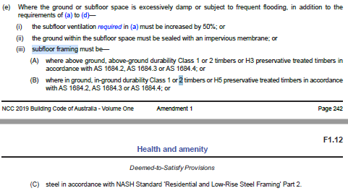

- True or False (Tick your response): Where materials are not used as intended (or without considering NCC requirements), this can make a significant difference to the life or serviceability of the structure.

Answer |  | True
 |  | False

- Explain why durability and serviceability impact on the cost effectiveness of chosen materials.

Answer | Certain factors such as natural elements, location, use of product etc must be considered prior to materials being selected because if the correct materials as per specification are not used for the project, defects will occur in time.

- Provide an example of short term degradation of materials and describe its effects on a building on structure.

Answer | Timber is often prone to short term degradation.  When exposed to natural elements (rain, sunshine) the timber may suffer from weathering causing it to split, crumble and or rot if unprotected.  You must ensure you select and seal the right timber for the project to ensure longjevity

- Provide an example of long term degradation of materials and describe its effects on a building on structure.

Answer | Stone which usually forms a surface skin when exposed to the atmosphere, this acts to protect the stone but in some instances can cause failure – usually associated with acid rain. Depending on the structure of the building and what the stone is used for it would need to be replaced ( roof etc)

- You have spoken to a supplier who has indicated that some of the client’s desired materials are unavailable. When considering alternative building materials what must be taken into consideration (i.e. other than the client’s requirements)?

Answer | After raising a variation from the client had getting there approval other factors must be taken into consideration  - Availability of replacement materials  - Transport costs  - Handling  - Life Cycle costs  - Short- and long-term degradation  - Acoustic properties  - Environmental impacts

- Identify two (2) things that you should look for when receiving a delivery of materials.

Answer | Correct quantities  Condition of the delivery

- If you encounter issues with delivery, what two (2) options do you have?

Answer | - Accept the delivery with “conditions”- take notes / photos of discrepancies  - Reject the entire shipment

- Which of the following should be assessed before shifting materials? Tick all that apply.

Answer | Choice | Possible Answers
 |  | What needs to be relocated (e.g. size, weight)
 |  | The relocation area, site layout and obstacles
 |  | Distance and time to relocate load
 |  | Whether a team is available and/or appropriate
 |  | Whether PPE must be worn (e.g. for hazardous materials)

- What document should you refer to for guidance on how to handle and store hazardous chemicals?

Answer | Safety Data Sheets

- Name three (3) ways you can reduce the risk of injury if a load is too heavy for one person to carry, push or pull.

Answer | Use a mechanical aid  Ask for help from other employees  Take breaks when required and communicate clearly with all involved

- In the diagram below a person is lifting a tool box.
Filling in the table, indicate how each body part should be used/placed.

F. Hands
E. Knees
D. Shoulders
C. Feet
B. Back
A. Neck
Answer | Area of body (Letter) | How it should be placed
 | Shoulders | Level
 | Neck | Upright
 | Hands | Good grip
 | Back | Natural curve
 | Knees | Bent
 | Feet | Flat, facing load

- How should construction materials and components be handled?
Tick all that apply.

Answer | Choice | Possible Answers
 |  | Sorted to suit material type and size, separating hazardous material
 |  | Stacked or stockpiled for ease of identification and retrieval
 |  | Stored in access ways for ease of retrieval
 |  | Stored clear of access ways
 |  | Handled and positioned ready for installation

- Identify the Australian Standard that relates to the storage and handling of LP gas.

Answer | AS/NZS 1596:2014

- List one (1) testing method for each of the building materials listed below.

Answer | Material name | Properties
 | Concrete | Cylinders or cubes are usually tested in a hydraulic press
 | Metals | Repeated loading test, tension test
 | Timber | Visual grading, stress grading machine tests

- What Code gives detailed tables which state the required grade of timber for specific sizes and uses?

Answer | The Australian Timber Framing Code

- Name two (2) ways that defects may be seen in timber.

Answer | Knots, splits, gum veins, pockets of resin, insect damage

- Identify two (2) tests that may be performed to determine the durability of stone.

Answer | Acid immersion and water absorption

- Name two (2) ways that defects may be seen in stone.

Answer | Cracks and fissures

- True or False (Tick your response): Under a contract, builders and other specialist tradespersons are the ones most likely to rectify or remedy problems that arise from incorrect installation, application or placement of materials.

Answer |  | True
 |  | False

- Name two (2) established methods that may be used to preserve timber.

Answer | Brushing or spraying  Dip diffusion or pressure impregnation

- Identify two (2) established methods that may be used to protect ferrous metals.

Answer | Ceramic coating  Salt

- Explain why the corrosion resistance of non-ferrous metals is superior to that of ordinary steel.

Answer | Because of the production method of a ceramic coating of oxide which it protects it from further corrosion however is more expensive than iron or steel.

- When should aluminium be coated with bituminous paint?
Tick all that apply.

Answer | Choice | Possible Answers
 |  | At all times
 |  | When it is buried in soil
 |  | When it comes in contact with chemical materials
 |  | When it is immersed in water
 |  | When it is used on bitumen

CPCCBC4006B
Select, procure and store construction materials for low rise projects

PRACTICAL ASSESSMENT INSTRUCTIONS

- The following practical assessment will require the Participant to complete work related activities.
- The Assessor will conduct observations of the Participant’s work to determine whether they display sufficient practical skills and knowledge.
- Please fill in the details below – providing your name, signature and date of assessment.
  - The Participant’s signature acknowledges that the Assessor provided clear instructions and the Participant understood what was required to complete this assessment.
- The Assessor may substitute a Practical Task with an alternate task of equal value.
  - Alternate tasks must be fully documented by the assessor in the Assessor Comments area.

Participant name | Lauren Wilson
Participant signature
Date | 6/09/2020

Assessor name
Assessor signature
Date | Click here to enter a date.

Task | Task outcome (Tick)
Task | Satisfactory | Not Yet Satisfactory
Task 1 (Occasion 1)
Task 1 (Occasion 2)

Assessor Comments
CPCCBC4006B
Select, procure and store construction materials for low rise projects

Practical Task 1 (2X)
Description of task:
On two (2) occasions, a suitable observer is to verify the participant’s ability to supervise systems through which materials are selected, acquired and stored on site for the following projects:
- Occasion 1: Construction classified as Class 1 and 10 construction
- Occasion 2: Construction classified in Classes 2 to 9 with a gross floor area not exceeding 2000 square metres, not including Type A or Type B construction

The participant is to gather evidence of how they have completed each component of the Practical Task, which is to be submitted with this Practical Assessment sheet. Evidence to be submitted may include:
- Copy of PO sent to site team for materials.
- Email correspondence sighting need for materials, delivery of materials and storage of materials (if relevant).

The observer is to provide detailed comments on the tasks completed by the participant. The assessor is to verify the observer’s comments in the Assessor Comments section, and provide the Practical Assessment outcome on the front cover of this document.
Resources required:
Computer, Building Contract, Drawings, Specifications, Building materials (including timber, and ferrous and non-ferrous metal).
Assessment of task
Name of participant:
Name of observer:
Role of observer
(Confirm suitability to sign)
Email address of observer
Signature of observer:
Date: | Click here to enter a date.
When completing the task, did the participant: |  | Tick if satisfactorily completed.  Provide comments if left unticked.
 |  | 1st  Occasion | 2nd  Occasion
1 Evaluate building materials
- Identify suitability of materials commonly used in the region for low rise buildings.
- Through research and testing, identify properties of different materials, their quality and compatibility and non-compatibility and maintain effective sampling and organisational record-keeping processes.
- Identify the environmental impacts of different materials.
- Identify the impact of allowable tolerances on the conversion of naturally occurring materials.
- Identify and check tolerances for installing and assembling materials with regard to the nature of the work being performed and the requirements of relevant construction industry Australian standards.
2 Material selection
- Select materials structurally adequate and appropriate for the building system specified in the contract, drawings and specifications.
- Select materials after considering:
- Safety
- Required fire resistance rating
- Suitability to the application
- Durability
- Serviceability and cost effectiveness
- Compliance with NCC, legislation, regulations and Australian Standards
- Consider short and long-term degradation of materials in relation to the building’s proposed life cycle.
- Select and evaluate alternative materials, if specified materials were unavailable or unsuitable – justifying decisions to regulatory authorities, as necessary
- Finalise selection of materials in accordance with contractual requirements and in consultation with relevant professionals and the client, compiling results in a report.
- Effectively communicate using the following methods:
- Language/concepts appropriate to cultural differences
- Non-verbal communication
3 Supervising materials on site
- Determine limitations and effects of transportation on material and components, taking action in potentially damaging circumstances.
- Ensure materials were correctly and safely handled on site using appropriate equipment and safe work practices.
- Communicate with manufacturers and suppliers to ensure materials are stored in accordance with specifications and Australian standards.
- Implement processes for inspecting all materials delivered on site for naturally occurring and/or manufactured defects before installation.
- Ensure personnel were aware of actions to be taken in the case of defects caused by incorrect installation, application or placement.
- Preserve and protect timber and ferrous and non-ferrous metal used in the construction process.
The Participant’s performance was: Satisfactory Not Satisfactory

observer Comments

