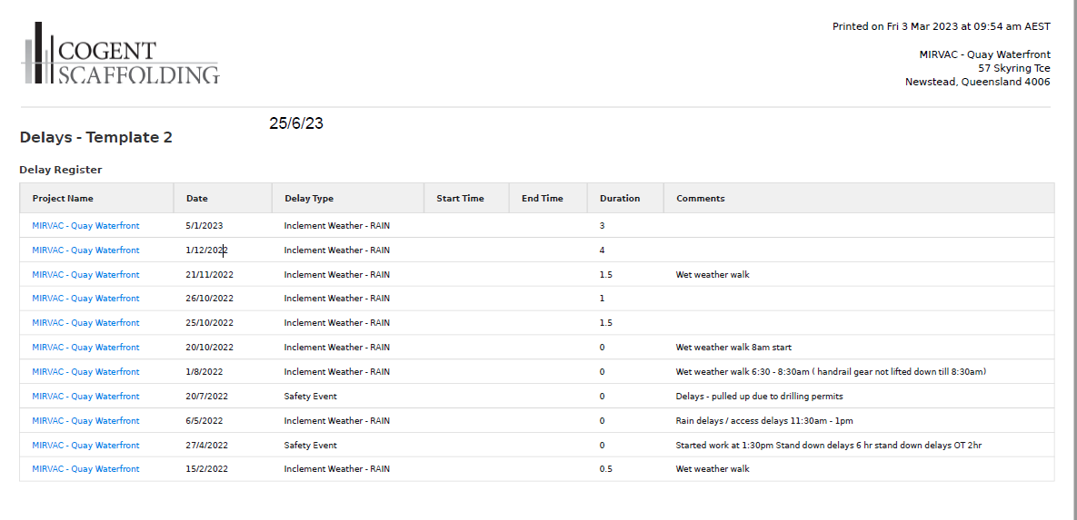
18/6/23
18/6/23
18/6/23
18/6/23
18/6/23
16/6/23
17/6/23
17/6/23
17/6/23
17/6/23
16/6/23

