BSBWHS414
Contribute to WHS risk management
ASSESSMENT SUMMARY

The assessment activities for BSBWHS414 Contribute to WHS risk management cover all aspects of the unit of competency required. To demonstrate competence in this unit, a participant must undertake all tasks and complete them satisfactorily and consistently. For Apprentices and Trainees, this includes employer completion of the Employer Record Book (ERB).

Participants must read all the information given before starting any assessment task. The assessment tasks are intended to be equitable, fair and flexible. If a participant has any questions or requires alternative arrangements to be made such requests should be directed to their Trainer/Assessor, who should note such arrangements in the ‘Assessor Comments’ on the affected assessment. If a participant feels they are not yet ready to be assessed, they should discuss their options with their Trainer/Assessor.

To satisfactorily complete the assessment, the participant is required to answer all questions correctly and demonstrate their skills to industry standards. If a participant does not answer some questions or perform some tasks, they will be deemed ‘Not Satisfactory’ for the task and ‘Not Yet Competent’ for the unit of competency. The Trainer/Assessor is able to provide the participant with additional information on interpreting the assessment outcomes and provide guidance on the participant’s options. Should a participant still be deemed ‘Not Satisfactory’ they will have the opportunity to undertake a supplementary assessment or appeal the result.

By signing the cover page for each assessment item, the participant acknowledges they understand the assessment instructions and requirements and consent to being assessed. The participant also verifies and assures the RTO that the work submitted is their own work.

Participant Name | Matthew minehan

Task | Assessment Results
Workbook | Satisfactory | Not Yet Satisfactory
Quiz | Satisfactory | Not Yet Satisfactory
Practical Assessment | Satisfactory | Not Yet Satisfactory
Outcome for Unit of Competency | Competent | Not Yet Competent

Assessor Name
Assessor Signature | 
Unit Competence Determination Date | Click here to enter a date.

BSBWHS414
Contribute to WHS risk management

WORKBOOK INSTRUCTIONS

- This workbook will occur under standard assessment conditions.
  - An oral assessment may be allowed under certain circumstances, whereby the Participant’s answers will be documented by a party other than the Participant. This must be acknowledged in writing (e.g. FT001 and Assessor Comments)
- Participants must provide enough detail in their responses to demonstrate their knowledge and skills.
- Please fill in the details below, providing your name, signature and date of assessment.
  - Your signature acknowledges that this is your own work.
- Assessors are to complete marking in pen of a different colour to the Participant.
- If a Participant initially answers a question incorrectly but modifies their response, they must follow the instructions below:
  - If a Participant changes their response in writing, they must put their initials next to the written change.
  - If a Participant changes their response verbally, this must be noted on the document by the assessor.

Participant name | Matthew minehan
Participant signature | 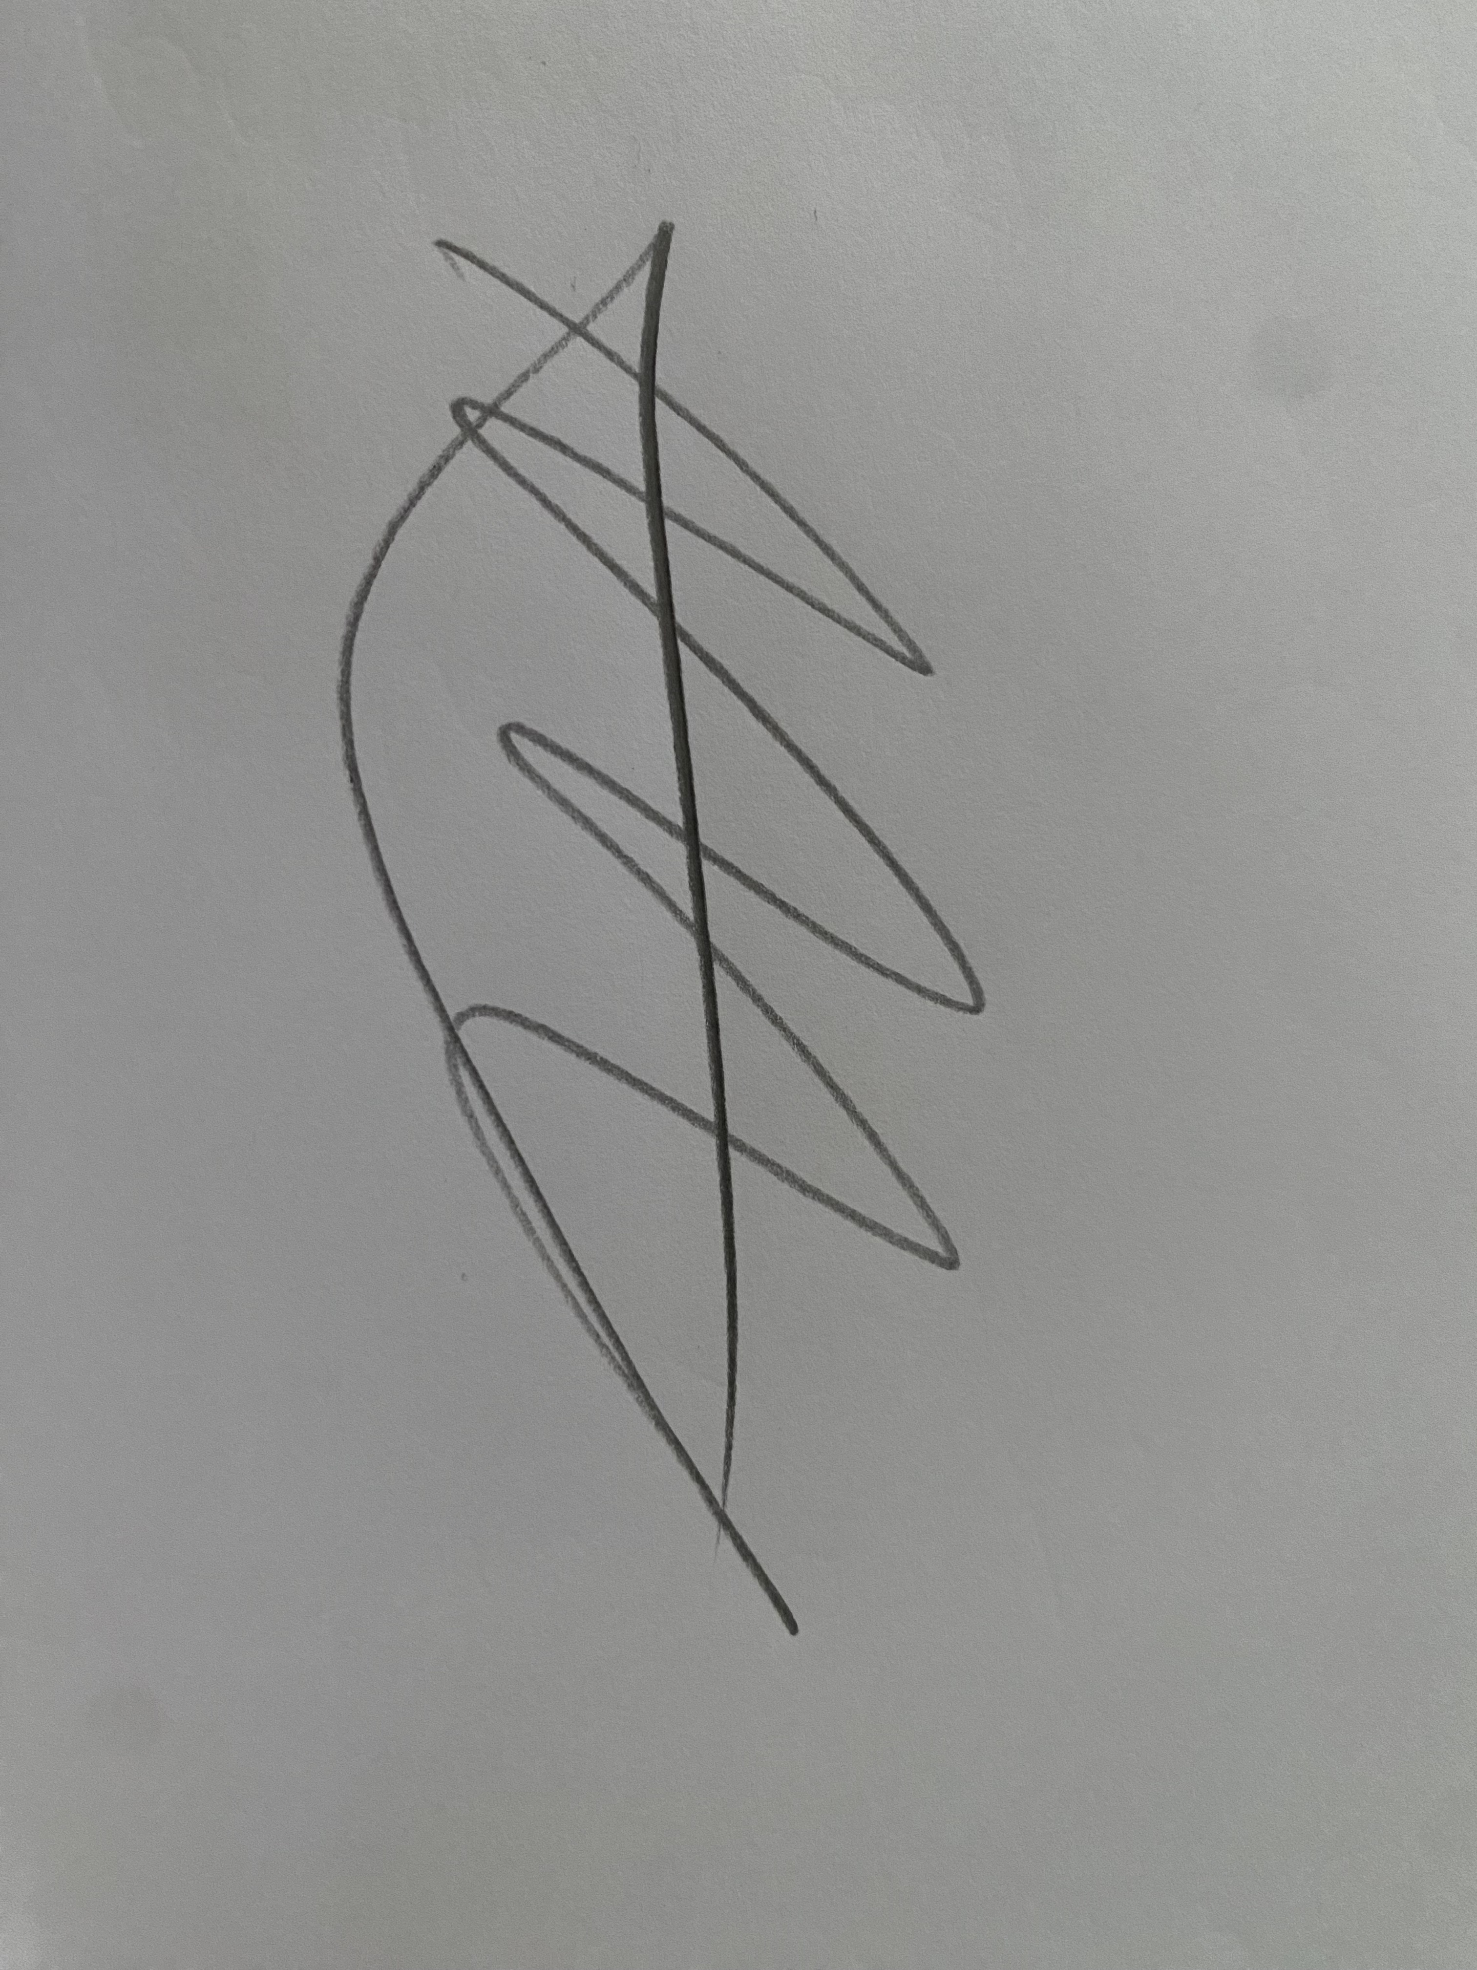
Date | 19/03/2023

Assessor name
Assessor signature
Date | Click here to enter a date.

Number of activities | Number of activities answered correctly | Task outcome (Tick)
4 |  | Satisfactory | Not Yet Satisfactory

ASSESSOR Comments
NOTE

At times, you will be provided with a specific business context to which you must respond, otherwise it is anticipated that you will use a workplace of your choosing (your own, or hypothetical) to provide the context to the task.

At all times, the responses in your assessment must reference Australian (Queensland or Federal) documentation, including legislation, regulations, codes of practice, standards and guidance publications.

For the following activities, name a workplace that you wish to examine.

Name of workplace | Steel fabrication workshop

Identify the duty holders and their range of duties regarding hazard identification, risk assessment and risk control activities by explaining the requirements found in:
- WHS Acts
- WHS Regulations
- Codes of practice
- Guidelines

Explain how you comply with the requirements of these documents.

Hazard identification
WHS Acts
Section 19 (3)(g) of the work health and safety act 2011 outlines that a pcbu must ensure, so far as reasonably practicable, that the health of workers and the conditions at the workplace are monitored for the purpose of preventing illness and injury of workers arising from the conduct of the business or undertaking

Section 28 of the work health and safety act 2011 outlines that workers are to comply, so far as they are reasonably able. With any reasonably instruction given by the pcbu to allow the pcbu to comply with whs laws, and cooperate with any reasonably policy or procedure of the pcbu relating to health or safety at the workplace that has been notified to workers. Eg implement risk controls are specified to the pcbu
WHS Regulations
Section 34 of the work healh and safety regulation 2011 outlines that a pcbu (asa duty holder) must identify reasonably foreseeable hazards that could give risk to risks to health and safety
Codes of practice
Section 3 of the managing noise and preventing hearing loss at work code of practice outlines that you should inspect the workplace and review available information (eg manufacturers details) when identifying hazards
Guidelines
the guide to the work health and safety act 2011 outlines that a pcb must consult with workers when identifying hazards
How you comply
By ensuring that hazards are identified as soon as possible through an ior form so that required monitoring and rectification can occur

Questioning whether noise is unreasonable by referring to noise level expectation levels in manufacturing guidelines

Risk assessment
WHS Acts
Section 18 of the work health and safety act 2011 outlines that reasonable practicability (re duties held by parties) required weighing up the likelihood of the hazard or the risk concerned occurring and the degree of harm that might result from the hazard or risk. This is essentially risk assessment
WHS Regulations
Section 33 of the work health and safety regulations 2011 (qld) outlines that a pcbu (as a duty holder) must follow any specific requirements of the regulations when assessing risk.
Codes of practice
Section 4 of the managing noise and preventing hearing loss at work code of practice outlines that risk assessments should be conducted by a competent person in accordance with as/nzs 1269.1
Guidelines
the guide to the work health and safety act 2011 outlines that risk assessments should consider the likelihood of the hazard or the risk occurring and the degree of harm that would result If the hazard or risk occurred
How you comply
Ensuring that high risk activities have an associated SWMS

Ensuring that any noise assessments are conducted by a person with accurately calibrated noise measuring instruments.

Risk control
WHS Acts
Section 19 (2) of the work health and safety act 2011 (qld) states that a pcbu must ensure, so far as reasonably practicable, that the health and safety of other persons is not put at risk from work carried out as part of the conduct of business or undertaking

Division 3 (sections 20-26) of the act also outlines other instances in which pcbus are required to manage risk.

Part 5 of the act specifies that pcbus are required to consult with other parties when dealing with risk control and hazards.
WHS Regulations
Section 36 of the work health and safety regulations 2011 qld outlines that a pcbu (duty holder) must implement risk control measures
Codes of practice
Section 5 of the managing noise and preventing hearing loss at work code of practice outlines that the hierarchy of control should be worked wthrough in order to choose the control measures that best eliminates or minimises the risk in the circumstances
Guidelines
the guide to the work health and safety act 2011 outlines that a pcbu must consult with workers when making decisions about ways to eliminate or minimise risks.
How you comply
Ensuring that the SWMS and other control methods prescribed by the pcbu are followed.

Ensuring that recommendations are offered when consultation is sought on control options.

Satisfactory Outcome

Explain the requirements of your organisation regarding hazard identification, risk assessment and risk control activities by identifying the requirements found in:
- WHS policy
- WHS procedure
- WHS process
- WHS system

Explain how you comply with the requirements of these documents.

Hazard identification
WHS policy
Taringa steel identifies the potential hazards of the proposed work activities, assess the risks involved and develops controls measures to eliminate, or minimise the risks. The hazard management process is carried out with employees.
WHS procedure
To assist in identifying hazards and risks, taringa steel has considered the use of resources such as codes and standards, industry publications (ie safety alerts; hazard profiles for specific trade groups) workplace experience and consultation.
WHS process
Hierarchy of control, risk matrix, toolbox talks, safety meetings, pre starts
WHS system
Safe work method statements
How you comply
To assist in identifying hazards and risks, taringa steel has considered the use of resources such as codes and standards, industry publications (ie safety alerts; hazard profiles for specific trade groups), workplace experience and consutation ie toolbox talks.

Risk assessment
WHS policy
Taringa steel has identified a risk class/ranking for potential workplace hazards by referring to the categories ranging from high to low in a risk matrix

WHS procedure
taringa steel uses the risk matrix to help control risks. The risk matrix is used to determine the level of danger or seriousness of the risk, how likely it is that this risk will occur and therefore how detailed control measures will need to be to eliminate or minimise the risk.
WHS process
Toolbox talks, pre starts, safety meetings
WHS system
Safe work method statements
How you comply
Taringa steel comply by ensuring their policies, procedures, processes and systems meet requirements in the ACTS and REGS

Risk control
WHS policy
Taringa steel uses the risk matrix to help control risks. The risk matrix is used to determine the level of danger or seriousness of the risk, how likely it is that this risk will occur and therefore how detailed control measures will need to be to eliminate or minimise the risk.
WHS procedure
taringa steel uses the risk matrix to help control risks. The risk matrix is used to determine the level of danger or seriousness of the risk, how likely it is that this risk will occur and therefore how detailed control measures will need to be to eliminate or minimise the risk.
WHS process
Risk matrix, hierarchy of control, risk action plan
WHS system
Safe work method statements
How you comply
Taringa steel comply by ensuring their policies, procedures, processes and systems meet requirements in the ACTS and REGS

Satisfactory Outcome

In meeting the legal and organisational requirements noted in Activities 1 and 2, identify two (2) hazards that may occur in your workplace. For each hazard identified, find information to explain:
- The nature and scope of the hazard
- The range of harms caused by the hazard and how they are caused
- The techniques, tools and processes used to identify each hazard
- Select tools appropriate for the workplace and identify different tools for each hazard
- Describe how you contribute to applying these selected techniques, tools and processes and document the results
- Determine the level of risk for the hazard within your workplace
- How you advise others of this information
- Identify the individuals and parties who should be notified (i.e. because they are at risk or are required to implement controls)
- Consider how best to addresses peoples’ range of abilities and backgrounds
- Be sure to also consider the timeframes in which you should advise others
- Risk controls that may be implemented to address the hazard and risk assessment results
- Consider the hierarchy of control and any legal requirements
- Offer at least two (2) risk controls and justify why one (1) is more appropriate than the other
- Explain the timeframes in which these risk control options should be implemented

Name of Hazard 1
Soft sling failure mid lift.
Nature and scope of hazard
the nature of the hazard is unlikely, but there is a chance of catastrophic harm or death if the hazard did happen.
The range of harms caused and how they are caused
The falling crane loads could cause serious crush hazards. For those under the lifts, also significant property damage if the load hits plant.

Techniques, tools and processes to identify hazard
Visual checks of the slings used pre lifting and the visual checking of the sung load during and after its left the ground.
Determine the level of risk
the level of risk is H, unlikely but death could follow
How you advise others about hazards, harms and associated risk
Pre starts, crane sirens, safety meetings, JHA
Risk controls
Exclusion zones, checking of lifting gear pre lift.

Name of Hazard 2
Dropping of hand tools out of EWP
Nature and scope of hazard
The nature of the scope is dependant on the risk controls in place, without tool tethers the chance of the hazard becomes much higher.
The range of harms caused and how they are caused
The crush damage comes from falling objects, if someone is swinging a hammer and lets go for example, it could cause significant damage to someone walking by.
Techniques, tools and processes to identify hazard
Visual checks to see if worker is using tool tethers and exclusion zones.
Determine the level of risk
the level of risk is H, possible chance of it happening with serious inury as the result.
How you advise others about hazards, harms and associated risk
Pre starts, toolbox talks, swms, safety meetings
Risk controls
Exclusion zones, tool tethers.

Satisfactory Outcome

For the two (2) risks (and associated risk controls) identified in Activity 3:
- Explain how you would contribute to developing and implementing a risk control plan to meet your legal and organisational obligations
- Describe the process you would undertake to evaluate the risk controls that had been implemented

Hazard/Risk 1
Develop and implement risk control plan
Using the hierarchy of control, risk assessment and communication with workers, I would have a safety meeting with all involved. Once the level of risk is achieved control measures would be implemented (eg checking of slings daily. SWMS woud be updated and re signed for relevant workers.
Evaluation of risk control
Visual safety audit on workers would be undertaken to see if control measures were being followed.

Hazard/Risk 2
Develop and implement risk control plan
Using the hierarchy of control, risk assessment and communication with workers, I would have a safety meeting and discuss control measures. For example mandatory tool tethers and exclusion zones around ewps. SWMS would then be updated and re signed by workers
Evaluation of risk control
Visual audits on workers would be undertaken to ensure the risk controls are being followed.

Satisfactory Outcome

BSBWHS414
Contribute to WHS risk management

QUIZ INSTRUCTIONS

- This quiz will occur under standard assessment conditions.
  - An oral assessment may be allowed under certain circumstances, whereby the Participant’s answers will be documented by a party other than the Participant. This must be acknowledged in writing (e.g. FT001 and Assessor Comments)
- Participants must provide enough detail in their responses to demonstrate their knowledge and skills.
- Please fill in the details below, providing your name, signature and date of assessment.
  - Your signature acknowledges that this is your own work.
- Assessors are to complete marking in pen of a different colour to the Participant.
- If a Participant initially answers a question incorrectly but modifies their response, they must follow the instructions below:
  - If a Participant changes their response in writing, they must put their initials next to the written change.
  - If a Participant changes their response verbally, this must be noted on the document by the assessor.

Participant name | Matthew minehan
Participant signature
Date | 13/03/2023

Assessor name
Assessor signature
Date | Click here to enter a date.

Number of questions | Number of questions answered correctly | Task outcome (Tick)
6 |  | Satisfactory | Not Yet Satisfactory

ASSESSOR Comments
- Match the terms and definitions by writing the appropriate letter next to each number in the centre column.

Answer | Terms |  |  | Definitions
 |  | Hazard | 1 - c |  | Taking action to eliminate health and safety risks
 |  | Risk | 2 - b |  | The possibility that harm might occur when exposed to a hazard
 |  | Risk control | 3 - a |  | A situation or thing that has the potential to harm a person

- Which of the following can be causes of workplace hazards?
Tick all that apply.

Answer | Choice | Possible Answers
 | þ | Noise
 | þ | Physical layout of the workplace
 | þ | Temperature
 | þ | Stress

- Which of the following individuals and parties may require information about workplace hazards? Tick all that apply.

Answer | Choice | Possible Answers
 | þ | Health and Safety Committees (HSCs)
 | þ | All members of the public
 | þ | Contractors
 | þ | Workers
 | þ | Managers
 | þ | Technical specialists who can assist with determining control measures

- Which of the following are appropriate techniques, tools and processes for identifying hazards and risks? Tick all that apply.

Answer | Choice | Possible Answers
 | þ | Workplace inspections
 | þ | Compensation claim information
 | þ | Safe Work Method Statements
 | þ | Information issued by WHS regulators

- True or False (Tick your response): Risk control options can come from both internal sources (e.g. policies and procedures) and external sources (e.g. codes of practice and standards).

Answer | þ | True
 |  | False

- Which of the following should be considered when developing a risk control plan? Tick all that apply.

Answer | Choice | Possible Answers
 | þ | How and when controls will be implemented
 | þ | Evaluation processes for implemented controls
 | þ | Consultation with individuals and parties
 | þ | Responsibilities for implementation

BSBWHS414
Contribute to WHS risk management

PRACTICAL ASSESSMENT INSTRUCTIONS

- The following practical assessment will require the Participant to complete work related activities.
- The Assessor will conduct observations of the Participant’s work to determine whether they display sufficient practical skills and knowledge.
- Please fill in the details below – providing your name, signature and date of assessment.
  - The Participant’s signature acknowledges that the Assessor provided clear instructions and the Participant understood what was required to complete this assessment.
- The Assessor may substitute a Practical Task with an alternate task of equal value.
  - Alternate tasks must be fully documented by the assessor in the Assessor Comments area.

Participant name | Matthew minehan
Participant signature
Date | 13/03/2023

Assessor name
Assessor signature
Date | Click here to enter a date.

Task | Task outcome (Tick)
Task | Satisfactory | Not Yet Satisfactory
Task 1

Assessor Comments
BSBWHS414
Contribute to WHS risk management

Practical Task 1
Description of task:
The participant is to identify two (2) different WHS hazards, assess and control the risk relating to those identified hazards. For each hazard, the participant is required to:
- Apply legal and organisational requirements when selecting and applying techniques, tools and processes for hazard identification, risk assessment and risk control
- Document the processes undertaken in the form of a presentation, for delivery to workers, contract workers, managers and PCBU (e.g. PowerPoint presentation slides with accompanying face-to-face delivery or real-time video, as arranged with your assessor)
- Identify the responsibilities of your audience with regards to their legal duties in controlling the identified risks

The participant is to submit the following evidence with this Practical Assessment sheet. There should be two (2) of each of the following documents submitted (i.e. one for each hazard):
- Workplace checklists for monitoring effectiveness of risk control measures
- Presentation materials with included graphics (e.g. PowerPoint)

The assessor is to provide detailed comments on the tasks completed by the participant. Detail should be recorded in the Assessor’s Comments (e.g. questions asked by assessor during presentation).
Resources required:
Computer.
Assessment of task
Name of participant: | Matthew minehan
Name of assessor:
Location:
Date:
When completing the task, did the participant: |  | Tick if satisfactorily completed.  Provide comments if left unticked.
1 Hazard identification
- Confirm and apply legal and organisational requirements with regards to hazard identification.
- Select and apply hazard identification tools and techniques.
- Analyse information and data to determine each hazard’s nature and scope.
2 Risk assessment
- Confirm and apply legal and organisational requirements with regards to risk assessment.
- Analyse information and data when conducting risk assessments.
- Select and apply tools, techniques and processes to assess risk – determining those affected, as well as the nature, severity and likelihood of potential harm.
3 Risk management and controls
- Confirm and apply legal and organisational requirements with regards to risk controls.
- Analyse information and data when identifying, evaluating and selecting risk control options.
- Identify potential risk controls according to the hierarchy of control and evaluate most appropriate options for action.
- For each hazard, develop a checklist to enable evaluation of effectiveness of risk controls.
4 Presenting findings
- Develop and deliver presentation (in person/via live stream video).
- Review processes undertaken, including:
- Tools used for hazard identification, risk assessment and risk control processes
- Hazard identification results – including two (2) workplace hazards and the harms they may cause
- Risk assessment results – including those affected and the nature, severity and likelihood of potential harm
- Risk management plan – including the selected risk controls and activities requiring joint responsibility and accountability (considering time and resource constraints)
- Identify duty holders and their roles and responsibilities according to risk management requirements including:
- Explaining legal and organisational requirements
- Identifying requirements to ensure effectiveness of risk controls
- Outline plan for monitoring effectiveness of risk controls (i.e. using checklist)
The Participant’s performance was: Satisfactory Not Satisfactory

