CPCCBC4008B
Conduct on-site supervision of building and construction project

THEORY EXAM INSTRUCTIONS

- This exam will occur under standard assessment conditions.
  - An oral examination may be allowed under certain circumstances.
Answers will be documented and FT003 (Oral examination declaration form) must be completed.
- Participants must provide enough detail in their responses to demonstrate their knowledge and skills.
- Please fill in the details below, providing your name, signature and date of assessment.
  - Your signature acknowledges that this is your own work.
- If a participant initially answers a question incorrectly but modifies their response, they must follow the instructions below:
  - If a participant changes their response in writing, they must put their initials next to the written change.
  - If a participant changes their response verbally, this must be noted on the exam paper by the assessor.

Participant name | Karl Kain
Participant signature | 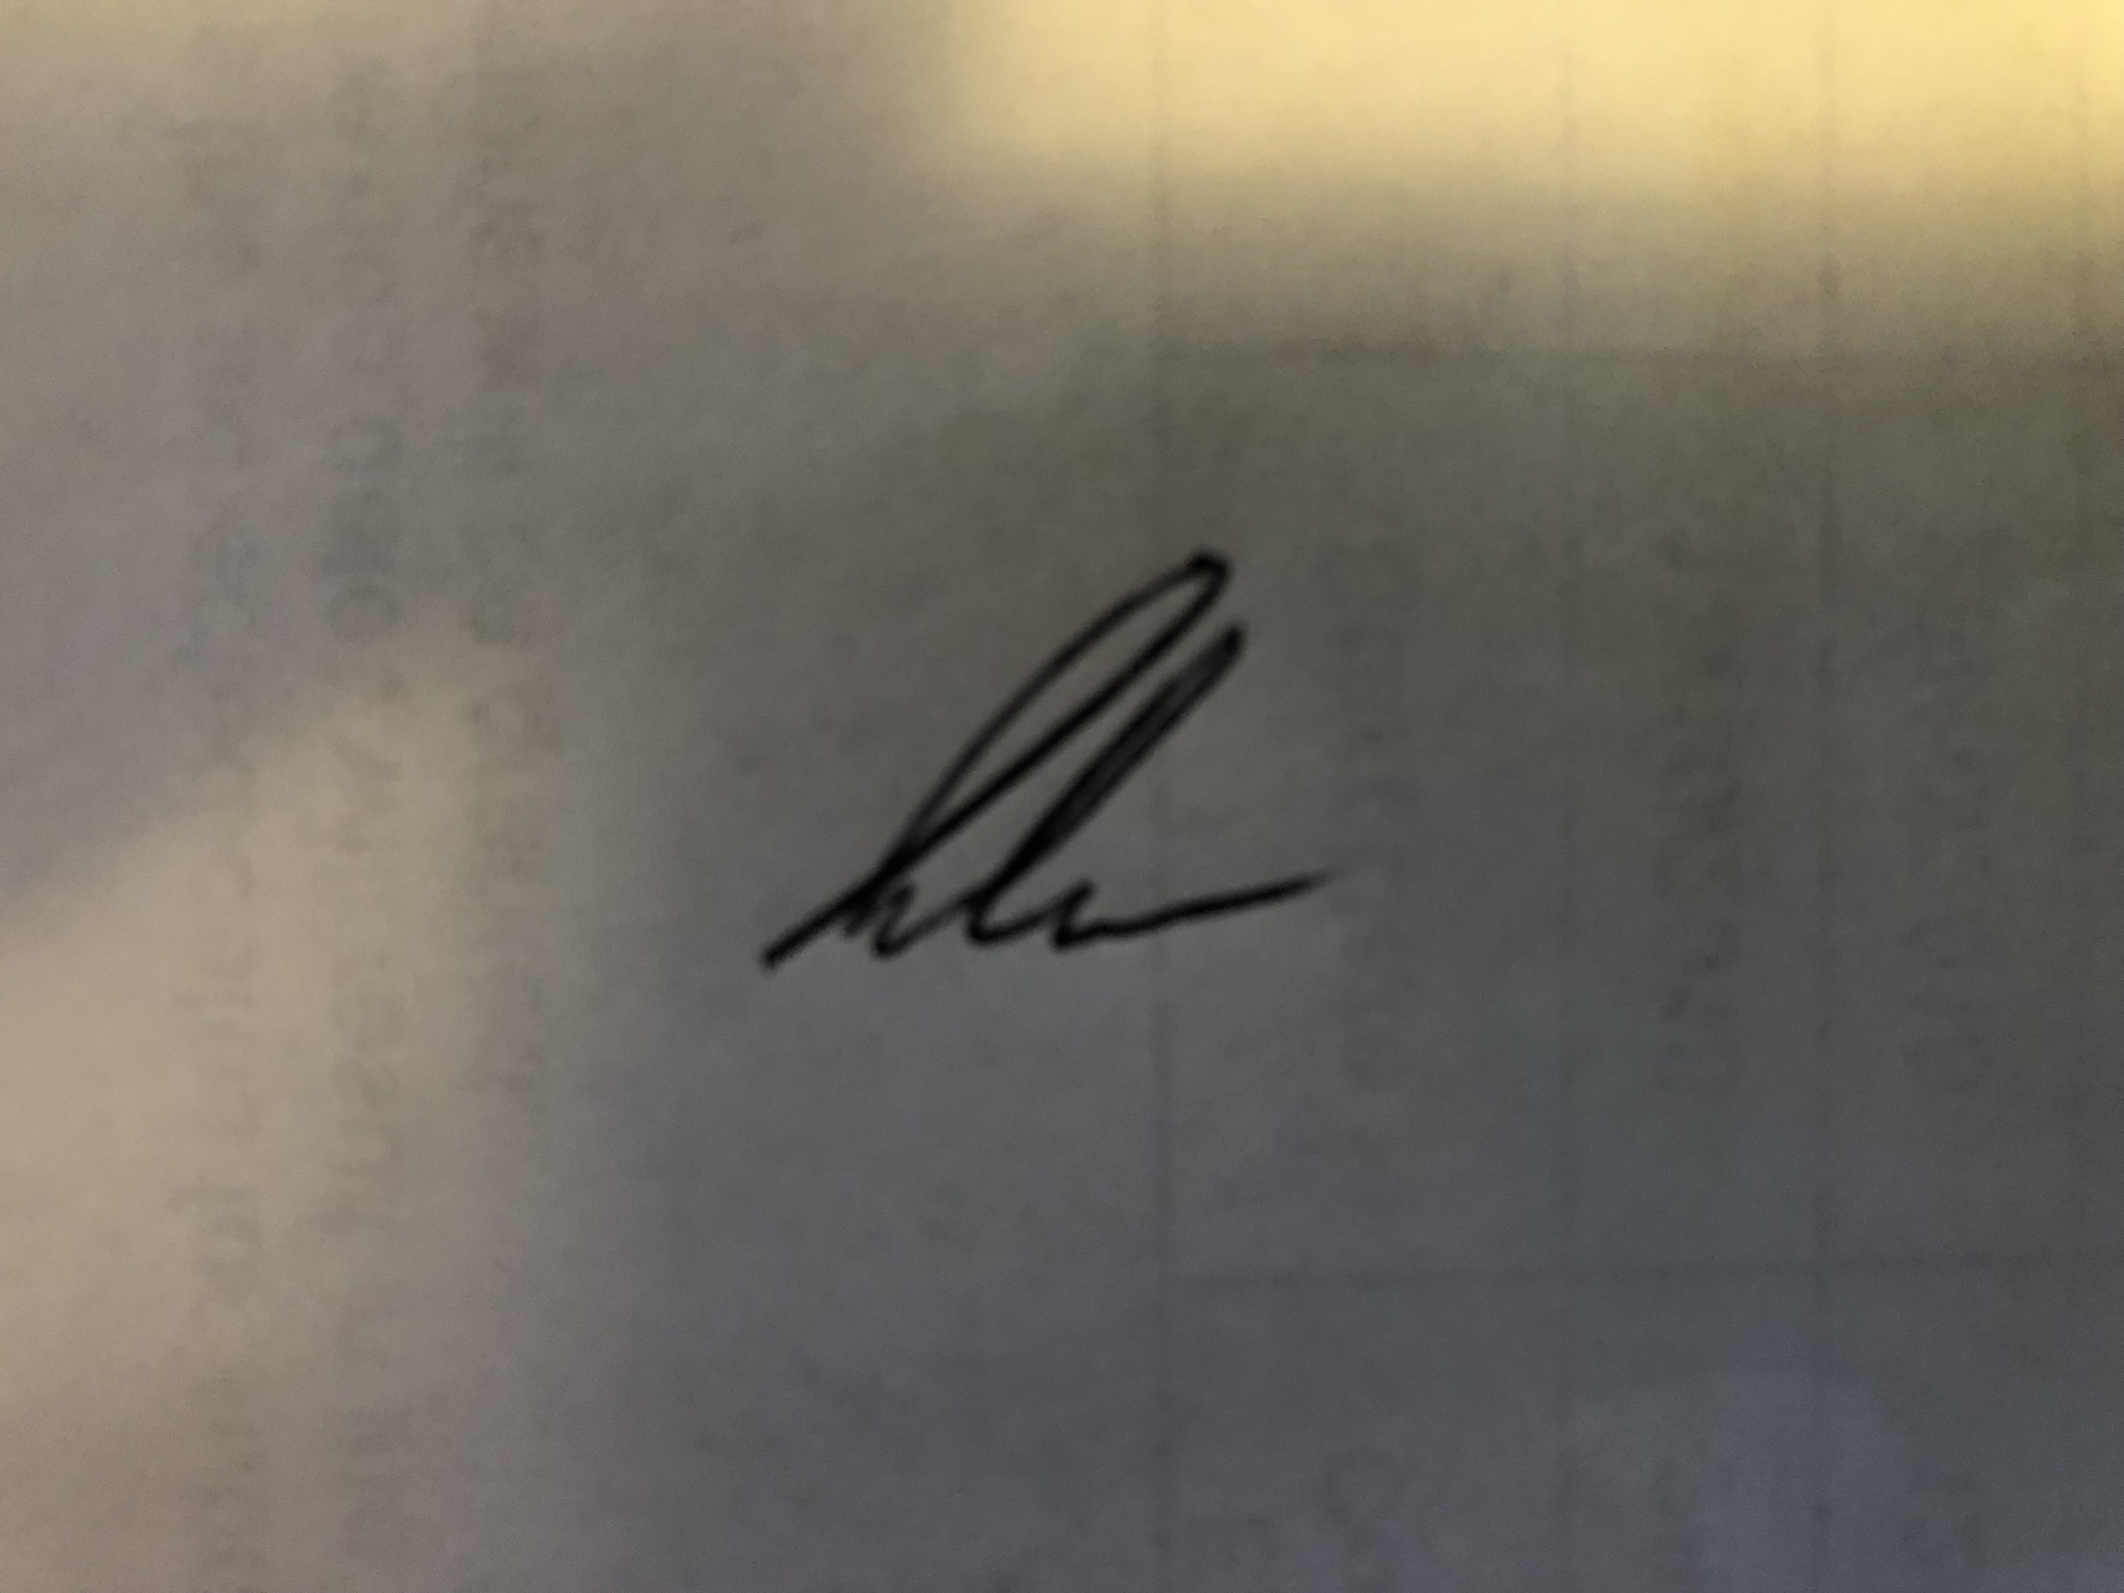

Assessor name
Assessor signature | 

Date | 26/05/2019

Number of questions | Number of questions answered correctly | Satisfactory?
46 |  | Yes | No
Assessor Comments
- Name the Act and identify the section that addresses the amount of progress payments. Briefly describe the requirements.

Answer | Section of Act | Requirements
 | Queensland Building and Construction Commission Act 1991  Schedule 1B  Division 2 Payments relating to contracts | 34 Progress payments for regulated contracts  (1) The building contractor under a regulated contract must not  claim an amount under the contract, other than a deposit,  unless the amount—  (a) is directly related to the progress of carrying out the  subject work at the building site; and  (b) is proportionate to the value of the subject work that  relates to the claim, or less than that value.  Example for paragraph (b)—  The claimed amount is for half of the contract price for a  regulated contract, less a 5% deposit, and is demanded after the  completion of half of the subject work.  Maximum penalty—50 penalty units.  (2) A regulation may prescribe when an amount is proportionate  to the value of subject work under a regulated contract.  (3) For subsection (1), a building contractor is taken to claim an  amount if the contractor demands or receives the amount.  (4) In this section—  building site, for a regulated contract, does not include a place  where the subject work has been, is being, or is to be, carried  out if the work is required to later be installed or constructed  at another place under the contract.  deposit, for a regulated contract, means the deposit permitted  for the contract under schedule section 33(1).

- Name the Regulation and identify the section that identifies the types of dispute resolution processes for progress payments. Briefly describe the requirements.

Answer | Section of Regulation | Requirements
 | Building Industry Fairness (Security of Payment) Regulation 2018 (Qld)  8 Dispute resolution process—Act, s 36 | (1) For the Act, section 36(10), definition dispute resolution  process, the following processes are prescribed  (a) a proceeding in a court or tribunal;  (b) an adjudication of a payment claim under the Building  and Construction Industry Payments Act 2004.  (2) For the Act, section 36(10), definition dispute resolution  process, arbitration as required by, or conducted in accordance  with, a subcontract is also prescribed for that subcontract.

- List three (3) different documents you might refer to when making contract payments.

Answer | Ensure that your contract payments are made in accordance with:  The contract allowance  Relevant material supply purchase orders  Invoices

- Identify two (2) types of construction allowances, using examples.

Answer | There are two types of allowances:  Material allowance amounts: The amount of money allocated to cover the cost of material(s) and any applicable taxes only, excluding the labour to install the specified material(s), overhead and profit not included.  Installed allowance amounts: The amount of money allocated to cover the cost of both material and labour to install the specified material(s) and any applicable taxes, overhead and profit not included.

- To avoid misunderstanding between the builder and client regarding construction allowances, describe one (1) organisational policy/procedure that might be implemented.

Answer | Builders should provide a work order for the allowance immediately upon completion of the work or purchase of material. Customers should insist on seeing work orders for every project when allowances come into play.  Builders should insist that changes, as pertaining to cost allowances, are approved by the client before they lay out any money for the new materials or labour. Customers should request that the builder secure approval before spending additional funds for materials or labour costs.

- True or False (Tick your response): Any changes to the original contract (time and/or work) must be in writing.

Answer |  | True
 |  | False

- Who must sign a contract variation (time and/or work)?
Tick all that apply.

Answer | Choice | Possible Answers
 |  | All subcontractors
 |  | All suppliers
 |  | Builder
 |  | Client

- Fill in the blanks: Once a variation is signed, the builder must provide a copy to the client within __________ days.
5

Answer

- True or False (Tick your response): Subcontractors should be given time to rectify issues before a back-charge is incurred.

Answer |  | True
 |  | False

- Identify one (1) document you might supply to a subcontractor to justify a back-charge.

Answer | Documentation: Include as much detail as possible when sending notice of defective work. If the subcontractor does not remedy the defects, keep the invoices and timesheets regarding the back-charges separately to show they link back to the subcontractor.  On the flip side, the subcontractor should also document all phases of the work performed as well. As a general rule, when courts analyse back charges, they look to see if the incurred fees fall ‘within the scope of the contract’.

- True or False (Tick your response): Invoices should correspond with delivery notes.

Answer |  | True
 |  | False

- Identify two (2) controls for ensuring that invoice payments are appropriately authorised.

Answer | Numbering documents sequentially to avoid duplication  Comparisons between budgeted amounts and actual figures

- What type of insurance should you take out for site loss or damage?

Answer | Contract Works Insurance (sometimes referred to as ‘Construction All Risks Insurance’) protects the construction-related activities of a construction project – including accidental risks of physical loss or physical damage to the contract works during construction as well as third party liabilities and the advance loss of profits.

- Identify three (3) written records you might supply to support an insurance claim.

Answer | The following are supportive to a claim: Receipts, Police reports, Product make/model/serial numbers, Photographs

- Name the document that outlines the timeframes for processing insurance claims.

Answer | Under the General Insurance Code of Practice, insurance companies promise to respond to your claim within 10 business days and tell you whether they will accept or deny your claim based on the information you have provided. If the insurance company needs more detailed information before making a decision, it will let you know what information it needs from you within 10 business days of receiving your claim.  The insurance company might decide to appoint a loss assessor, loss adjuster or an investigator to get more information. If so, the insurance company will give you an estimate of how long it will take to make a decision about your claim. It will also notify you within five business days of appointing that person and it will let you know, every 20 business days, about the progress of your claim.

- You should record communications with which of the following parties? Tick all that apply.

Answer | Choice | Possible Answers
 |  | Clients
 |  | Contractors
 |  | Inspectors
 |  | Suppliers
 |  | Unions

- You have participated in on-site communication for the following matters. Which of the listed communications should you record in your site diary? Tick all that apply.

Answer | Choice | Possible Answers
 |  | Allocating and managing human resources
 |  | Communicating with regulatory authorities to ensure compliance
 |  | Facilitating dispute prevention and resolution
 |  | Maintaining environmental controls and obligations
 |  | Managing expenditure
 |  | Participation in on-site meetings
 |  | Placing orders for supplies or equipment
 |  | Scheduling of plant and equipment

- True or False (Tick your response): A file note should be used to document important interactions between the builder and client.

Answer |  | True
 |  | False

- True or False (Tick your response): File notes are regularly referred to.

Answer |  | True
 |  | False

- Which of the following details should be on a site report?
Tick all that apply.

Answer | Choice | Possible Answers
 |  | Conditions (e.g. weather)
 |  | Observation date and time
 |  | Project details
 |  | Safety observations
 |  | Sign-off by observer
 |  | Site activities

- Briefly describe the purpose of a site report.

Answer | A site observation report is the report which documents the general and detailed observations a supervisor makes on site - on a particular day and at a particular time.  The idea behind conducting observations and creating observation reports is to step back and make a conscious and objective assessment of project progress, as well as general site activity, safety or environmental findings and evidence of anything out of the ordinary.  The point of reporting being that the findings will be made actionable, either by the observing party or other workers and teams.

- When can a notice for unsatisfactory work be issued by the client?
Tick all that apply.

Answer | Choice | Possible Answers
 |  | Before work commences
 |  | Before work completes
 |  | Upon completion of work

- True or False (Tick your response): A notice of unsatisfactory work should be communicated in writing.

Answer |  | True
 |  | False

- Identify three (3) quality control procedures that may be implemented.

Answer | Types of procedures include:  Checking materials supplied to site  Comparing materials against specifications  Quality/Site Checklists  Regular on-site progress and quality checks  Reviews of building work against the plans and specifications with clients

- True or False (Tick your response): Site checklists should be maintained for all stages of the building project.

Answer |  | True
 |  | False

- True or False (Tick your response): Site checklists may be used as a reminder for workers and during inspections.

Answer |  | True
 |  | False

- What is the purpose of an organisational quality manual and who might refer to this document?

Answer | Once you have identified the types of procedures that will assist you in managing your building project quality (such as checklists, quality checks and on-site reviews) you can then transfer these procedures into written form within a Quality Manual.  This practice ensures your business maintains its quality systems and continuously improves those systems. The builder many refer to these threw the build process. AS/NZS 4505

- Identify the Volume and Parts of the NCC that relate to the quality requirements for garage doors for Classes 1 and 10, and Classes 2 to 9.

Answer | Classes 1 and 10 | Classes 2 to 9
 | NCC Vol 2  3.0.4 Determination of structural resistance of materials and forms of construction  (p)  Garage doors and other large access doors in openings not more than 3 m in height in Open link in same pageexternal walls of buildings determined as being located in wind region C or D in accordance with Open link in same pageFigure 3.0.1: AS/NZS 4505. | NCC Vol 1  B1.4 Determination of structural resistance of materials and forms of construction  (l)  Garage doors and other large access doors in openings not more than 3 m in height in Open link in same pageexternal walls of buildings determined as being located in wind region C or D in accordance with AS/NZS 1170.2: AS/NZS 4505.

- Which Australian Standard is referenced in the NCC with regards to the quality requirements for garage doors?

Answer | AS/NZS 4505:2012  AS/NZS 1170.2

- True or False (Tick your response): Building approvals/inspections must be carried out by Council building certifiers.

Answer |  | True
 |  | False

- Name the Regulation and identify the section that identifies the mandatory stages requiring inspection for a single detached Class 1a building. Briefly describe the requirements.

Answer | Section of Act | Requirements
 | Building Regulation 2006  Section 24 What is a stage of  assessable building work | For a single detached class 1a building, a notice for inspection must  be given by the builder to the building certifier for the following stages  of assessable building work:  • the foundation and excavation stage—before the footings are  poured. Aspects of this stage include boundary clearances, footing  excavation, reinforcement etc.  • the slab stage—before the concrete is poured. Aspects of this stage  include floor level check, termite treatment etc.  • the frame stage—before the cladding or lining is fixed (after if the  cladding forms part of the bracing) or, for reinforced masonry  construction, before the wall cavities are filled. Aspects of this stage  include sub-floor framing, lower wall framing etc.  • the final stage. Aspects of this stage include site works, drainage,  fire safety, energy and water efficiency etc

- True or False (Tick your response): A supervisor must watch over the work as it is happening.

Answer |  | True
 |  | False

- Identify three (3) checks that may occur to verify painting work meets the required standard.

Answer | Pre paint inspection carried out to ensure adequate surface  Correct paint type used for internal and external environment  Selected finish accords with contract documents,

- True or False (Tick your response): Specific requirements for quality and finish should be included in the contract, so the builder knows the standard required to be met.

Answer |  | True
 |  | False

- List three (3) implied standards for building work, as per the Australian Consumer Law.

Answer | In addition to specified requirements, under Australian Consumer Law there are a number of implied expectations for the work undertaken:  The builder will carry out the work in a proper and workmanlike manner and in accordance with the plans and specifications set out in the contract  The materials to be supplied by the builder will be good and suitable for the purpose for which they are used and, unless otherwise stated, those materials will be new  The work will be carried out in accordance with, and will comply with, all laws and legal requirements  The work will be carried out with reasonable care and skill and will be completed by the date specified by the contract  The work will be suitable for occupation; and  If the contract states a particular purpose for the work, the work and the materials used will be reasonably fit for the purpose

- For each of the following topics, identify an organisational policy that may be in place.

Answer | Topic | Policy
 | Pre-handover inspection | Arrange an on-site inspection with the client perhaps a week before the date nominated for handover. This gives you a final opportunity to address any remaining issues prior to handover
 | Final payment | Organise final payment of the project at practical completion and not at handover

- True or False (Tick your response): Final payment is to be made prior to practical completion.

Answer |  | True
 |  | False

- True or False (Tick your response): The contract may specify that certificates of inspection are required prior to receiving final payment.

Answer |  | True
 |  | False

- List five (5) aspects that may be checked as part of the final inspection.

Answer | The final inspection will cover aspects such as:  The control and discharge of stormwater  The height of the floor above ground  Support of any earthworks necessary to protect the building and other property  Protection against water penetration  Fire safety issues such as smoke alarms  Room ventilation  Toilet door swing  Vermin proofing  Sub-floor ventilation  Termite protection and re-treatment notice  Stairs, handrails and balustrades  Swimming pool fencing

- True or False (Tick your response): The building certifier’s certificate indicates that all inspections and approvals required by the legislation have been satisfactorily completed.

Answer |  | True
 |  | False

- What documents should be provided to the client on handover day?

Answer | during handover give the client/s:  Certificates of inspection  Product warranties for appliances installed  reports, notices or other documentation issued by service providers (e.g. electricity, gas, telephone, water or sewerage)  Provide a Practical Completion Certificate to the client where this is required under the contract  (Note: Form 7 is the Certificate of Practical Completion required under the QBCC New Home Construction Contract)

- Identify two (2) items that might be found on a defects item document.

Answer | List the minor defects and minor omissions that both you and the homeowner agree to  State when you’ll attend to the matters  Separately list minor defects or minor omissions that only the home owner believes exist, and  Be signed by the homeowner and yourself (or if you’ve signed it you need to make reasonable efforts to have the owner sign it).

- True or False (Tick your response): The builder and client must agree to all items listed on a defects document.

Answer |  | True
 |  | False

- Fill in the blanks: Defects noted at handover should be rectified within __________ months after completion of the work.
6

Answer

- True or False (Tick your response): The client must sign-off once defects have been rectified.

Answer |  | True
 |  | False

- Identify two (2) reasons why you should implement a site safety policy.

Answer | Demonstrate that your business is addressing its health and safety obligations.  Show that your business is committed to working within a set of health and safety principles.  Clarify functions and responsibilities in your business.  Ensure that safe systems of work are recorded, communicated to workers and implemented in a consistent way throughout your business.  Guide the future actions of workers in a formal way.  Help your business to manage staff more effectively by defining acceptable and unacceptable behaviour in the workplace.  Save time by allowing health and safety matters to be handled quickly through an existing procedure, rather than staff dealing with problems as they occur or responding differently each time the same issues arise.

