Practical Task 1 (2X)
Description of task:
On two (2) occasions, a suitable observer is to verify the participant’s ability to apply legal requirements to building and construction projects:
- Occasion 1: Residential buildings
- Occasion 2: Low rise commercial buildings (Class 1 and 10 construction and Classes 2 to 9 with a gross floor area not exceeding 2000 square metres, not including Type A or Type B construction)

The participant is to gather evidence of how they have completed each component of the Practical Task, which is to be submitted with this Practical Assessment sheet. Evidence to be submitted may include:
- Copies of any licences
- Business insurance Certificates of Currency
- A copy of a WHS Policy
- A copy of an Environmental Policy
- If an employer - copies of employee records, apprenticeship papers
- Sub-contractor agreements or a copy of a sub-contract
- A copy of a Business Activity Statement
- A copy of a business tax invoice that references relevant legislation
- A copy of a Dispute Resolution Procedure or documentary evidence of a dispute

The observer is to provide detailed comments on the tasks completed by the participant. The assessor is to verify the observer’s comments in the Assessor Comments section, and provide the Practical Assessment outcome on the front cover of this document.

Below are copies of business licenses, insurances, employee licenses, licenses register, company policies and subcontracts.
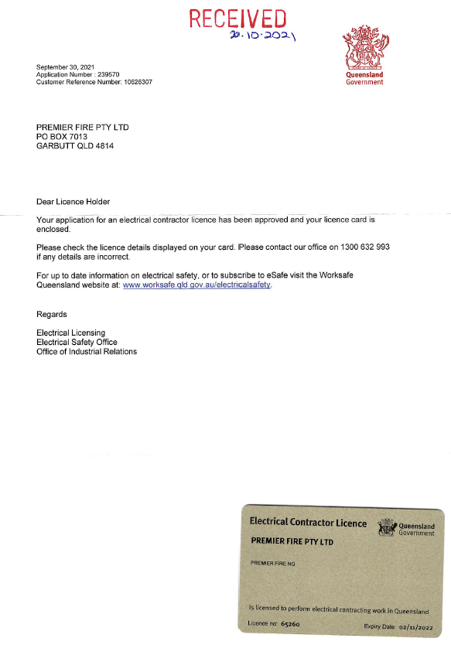

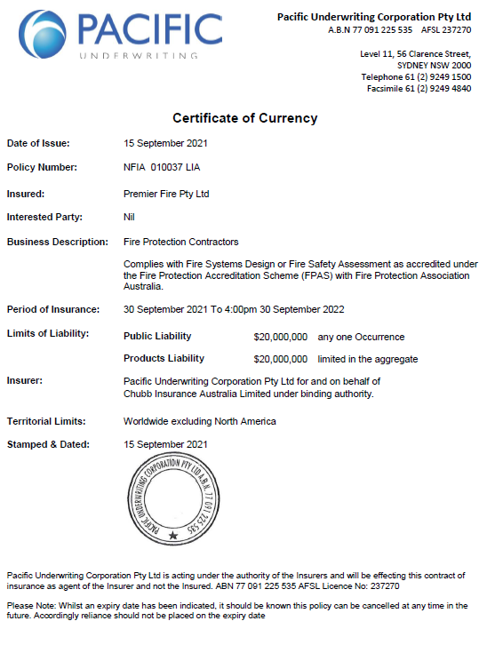

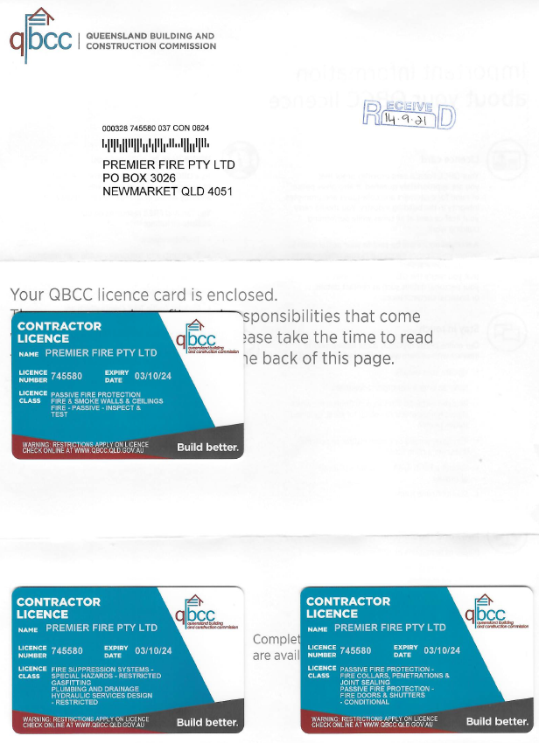

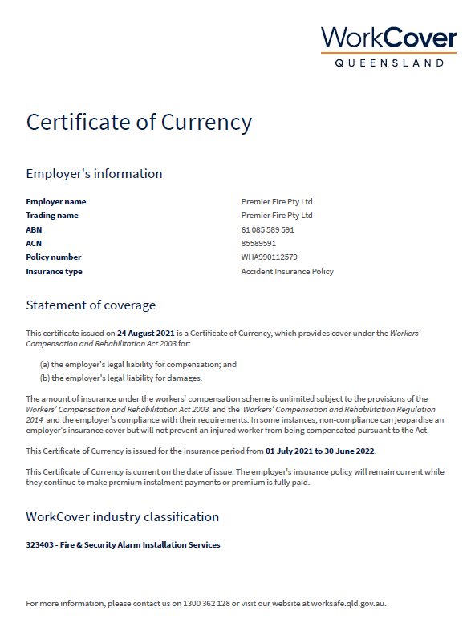

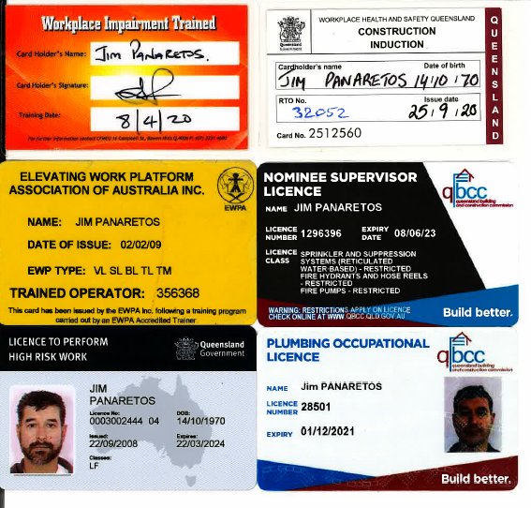

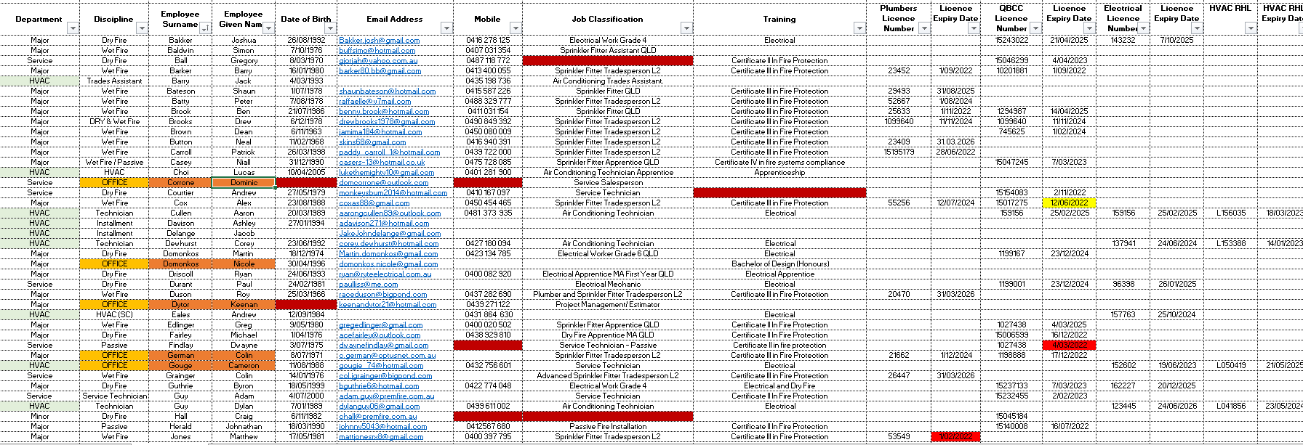

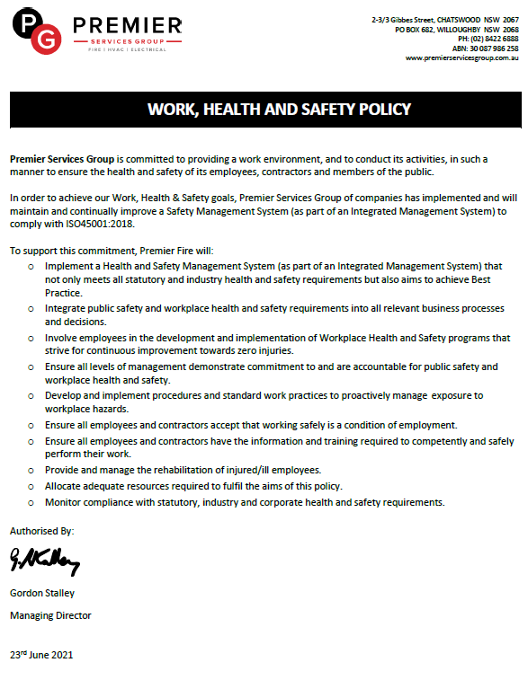

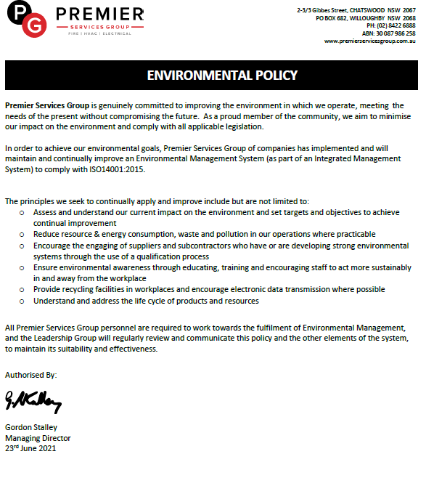

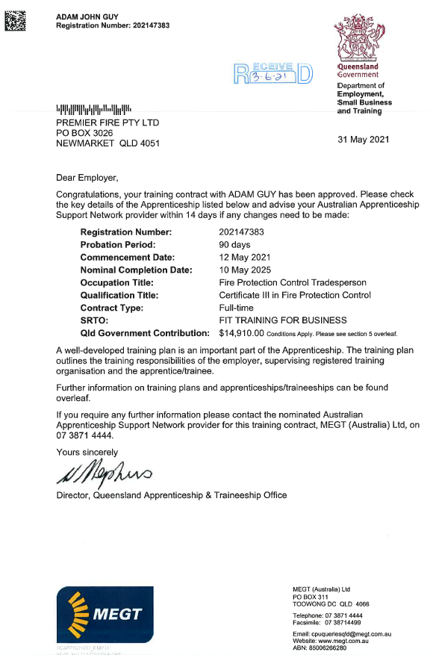

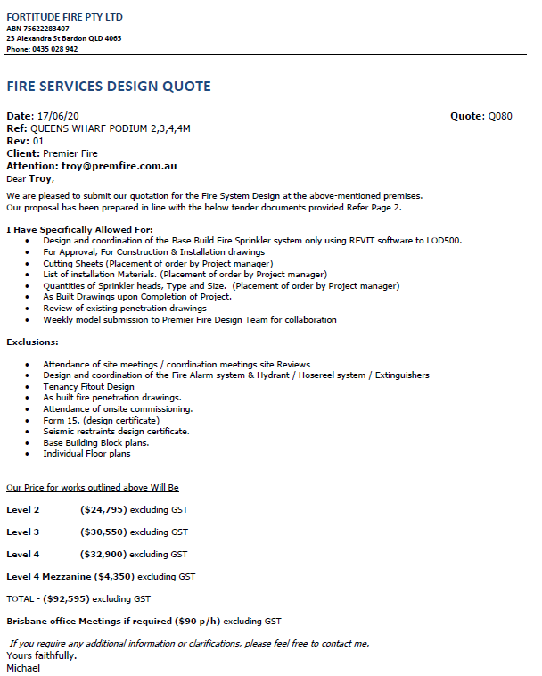

Disputes in relation to defects


