
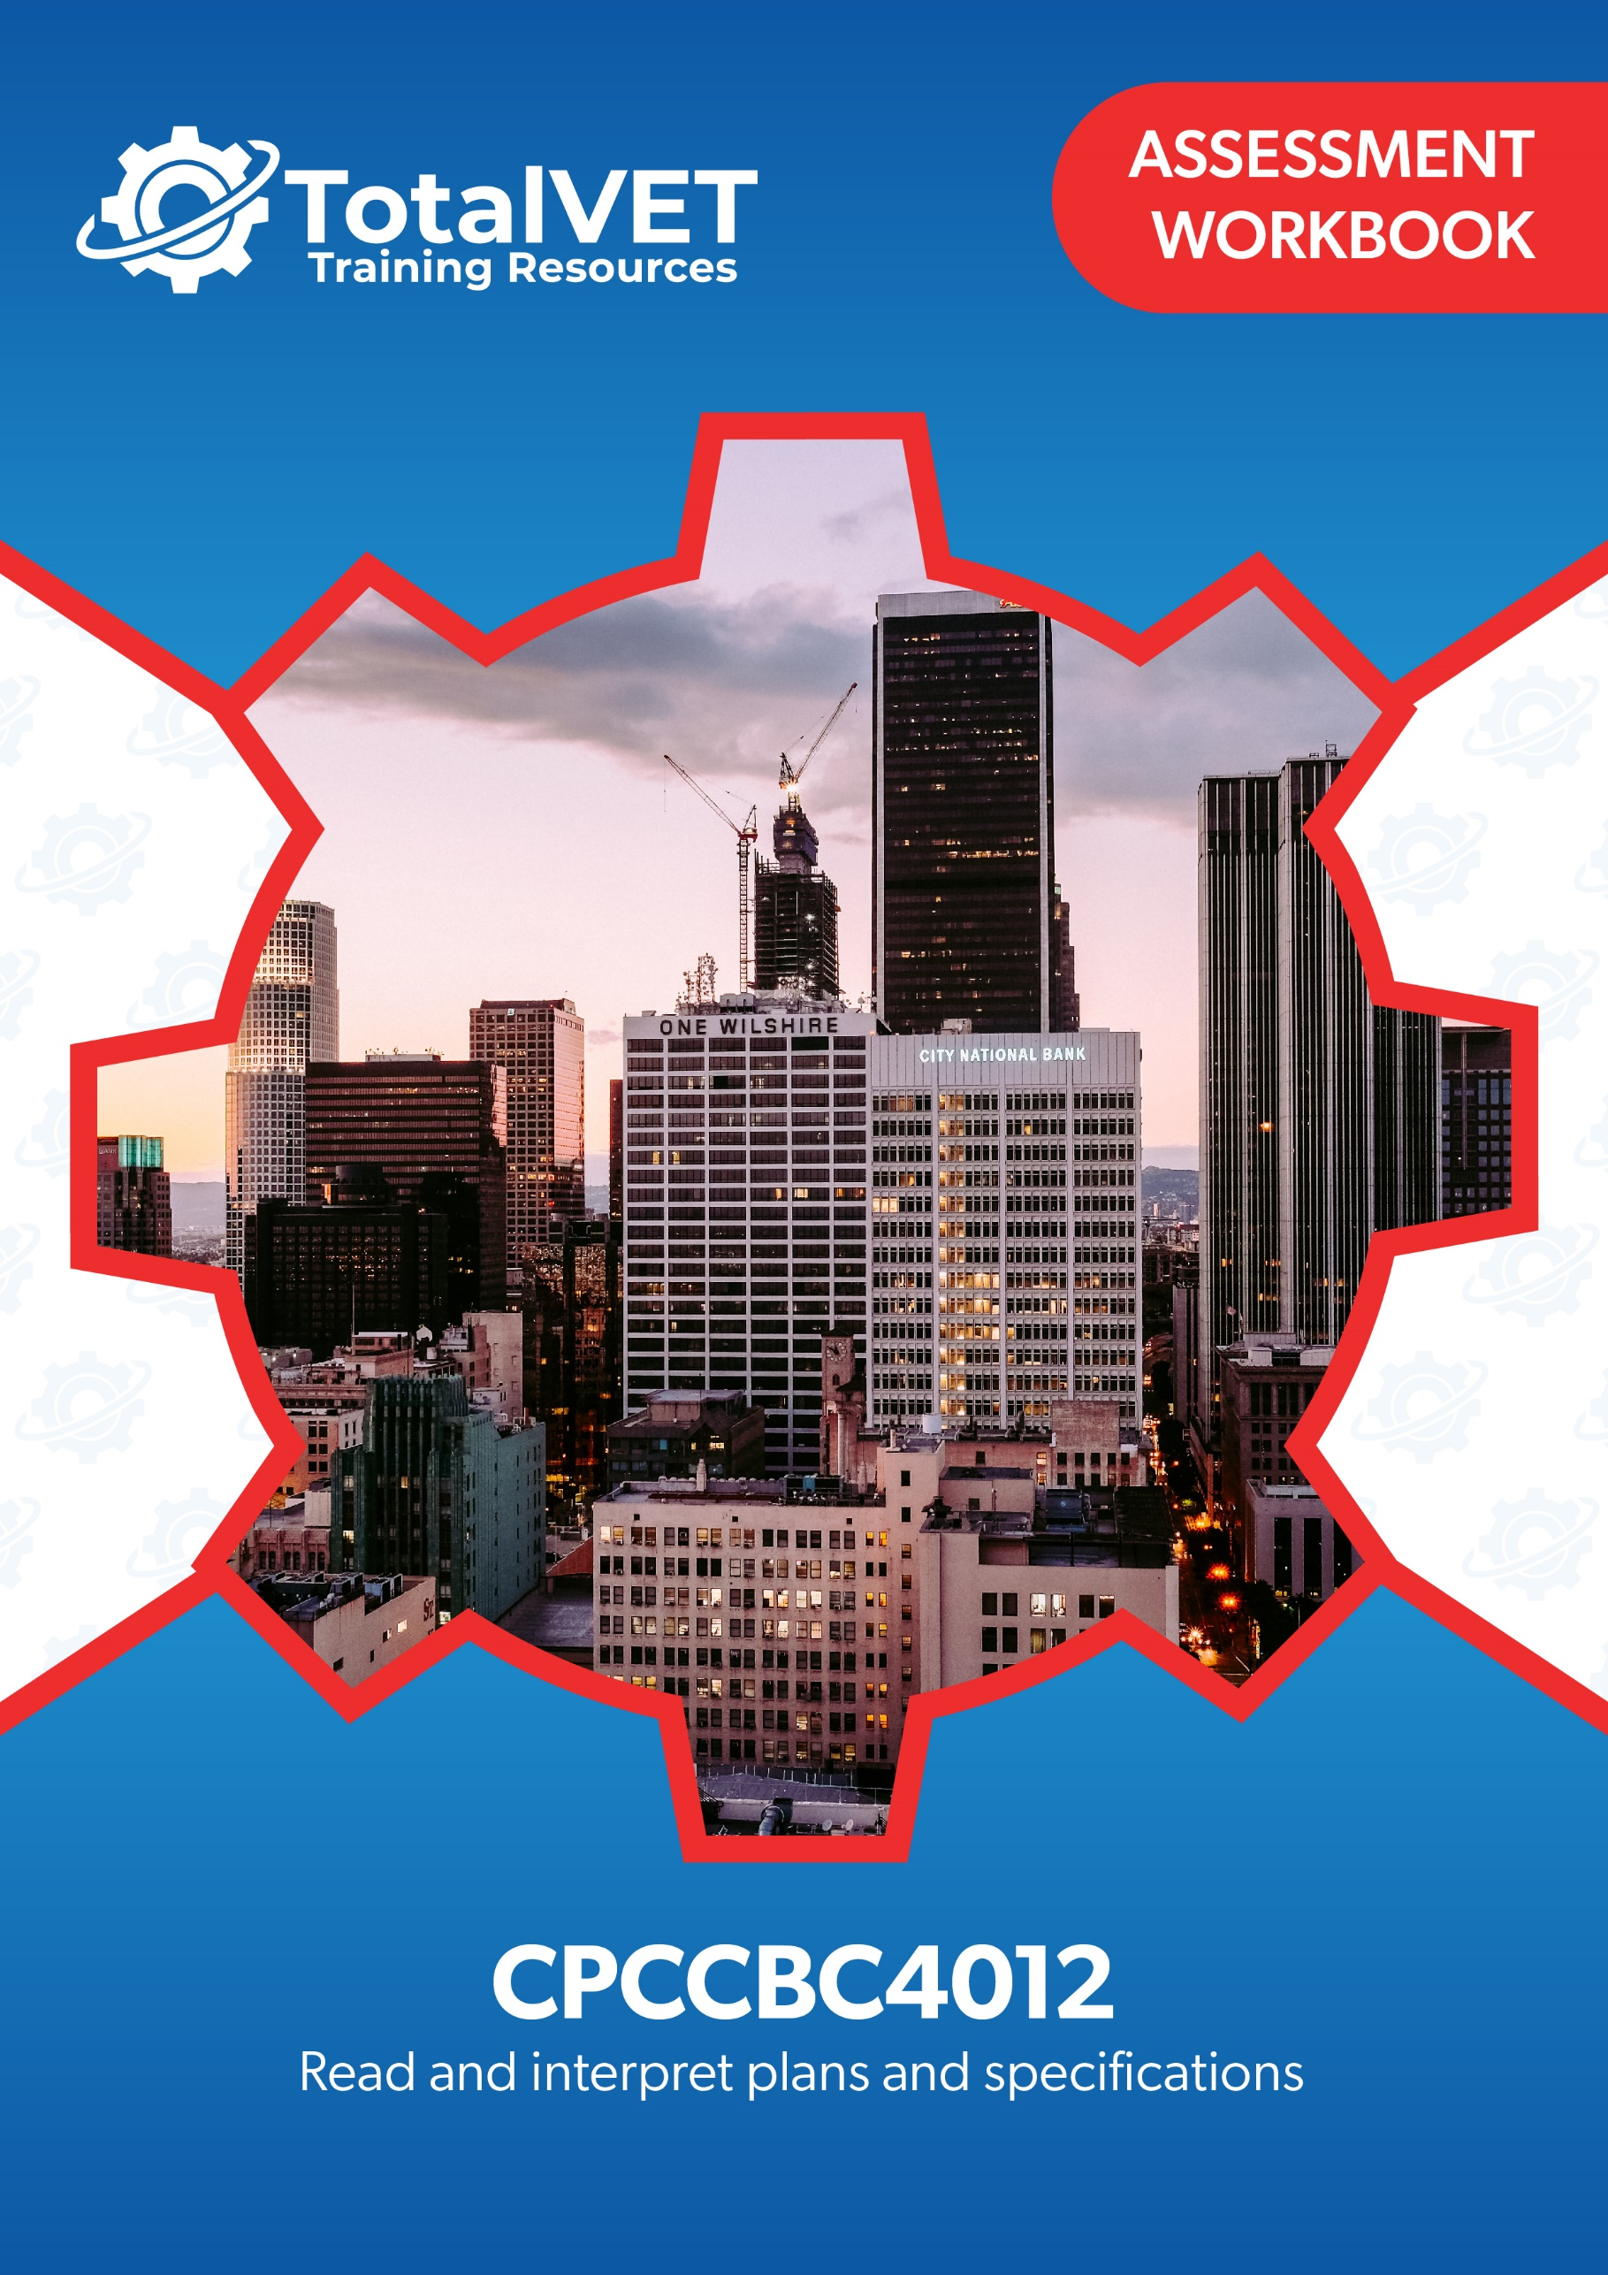
Copyright
This document was developed by TotalVET Training Resources.
© 2021 TotalVET Training Resources.
All rights reserved.
No part of this publication may be reproduced, stored in a retrieval system, or transmitted in any form or by any means, electronic, mechanical, photocopying, recording, or otherwise without the prior written permission of TotalVET Training Resources.

Version Control & Document History
Date | Summary of Modifications | Version
9 February 2021 | Version 1.0 released for publishing | 1.0
28 October 2022 | Revision of Practical Assignment, Workplace Assessment and Practical Plans Assignment | 1.1

Table of Contents
Table of Contents 3
Introduction 5
Competency-Based Assessments 6
Assessing Nationally-Recognised Training 7
Dimensions of Competency 8
Reasonable Adjustment 9
The Unit of Competency 10
The Context of Assessment 10
Assessment Methods 11
Resources Required for Assessment 12
Assessment Workbook Cover Sheet 13
Knowledge Assessment 14
Practical Assessment 35
Candidate Instructions 35
Preliminary Assessment Information 36
Practical Assignment 37
Overview 37
Workplace Assessment 41
Overview 41
Task 1 Confirm Currency of Plans, Specifications, and Amendments 42
Task 2 Confirm Details on Plans Comply with the Specifications 44
Task 3 Examine Detail Drawings to Determine Sizes and Thickness 48
Task 4 Discuss Details During the Planning Phase 50
Practical Plans Assignment 52
Overview 52
Task 1 Types of Plans and Aspects 54
Task 2 Construction Plans 57
Task 3 Materials from Specifications 61
Task 4 Concrete Footing and Slab 62
Task 5 Load Bearing Points 63
Task 6 Load Bearing Information 65
Task 7 Wind Bracing and Tie-Down Requirements 67
Task 8 Wind Bracing Materials and Tie-Down Methods 68
Task 9 Provisional Sum and Prime Cost Items 69
Task 10 Installation and Connection Points of Services 70
Task 11 Location of Fixtures 72
Task 12 Details of Finishes 74
Assessment Workbook Checklist 75
Record of Assessment (Assessor’s Use Only) 79

Introduction
The assessments in this workbook are divided into three categories: Knowledge Assessment and Practical Assessment.
The Knowledge Assessment is a set of general and workplace questions testing your knowledge and understanding of the general theory behind the unit.
You must answer all Knowledge Assessment Questions using your own words. However, you may refer to your Learner Guide and other relevant resources and learning materials to complete this assessment.
Some questions cover processes you would likely encounter in a workplace. Ideally, you should be able to answer these questions based on the processes that are currently in place in your workplace. However, if you do not currently have access to a workplace, then answer the questions based on processes that should be implemented in a typical workplace setting.
The Practical Assessment is made up of the Practical Assignment, Workplace Assessment, and Practical Plans Assignment. This assessment tests your practical skills with respect to the requirements of the unit of competency relevant in this workbook.
The Practical Assessment requires you to complete and submit workplace documents and other documentation relevant to the unit of competency.
The evidence you submit must be your own work except where due reference is made and where you are required to submit supplementary workplace documents such as policies and procedures.
When completing the assessments included in this workbook:
- Read the instructions provided in each task carefully before attempting to complete the task. The instructions will guide you on how to answer the question or complete the task satisfactorily.
- Follow the steps provided in each task.
  - If the question instructs you to describe, provide a description as your response. If the question instructs you to list, provide a list as your response.
  - Where there is a number of required responses, provide the required number of responses. For example, if you are asked to list three responses, provide three responses.
- Ensure that all your submissions for this assessment indicate your first and last name and that these submissions have been named according to the file naming convention prescribed in each task.

Competency-Based Assessments
Definition of Competency
Assessment in this context can be defined as the fair, valid, reliable, and flexible gathering and recording of evidence to support the judgement on whether competency has been achieved. Skills and knowledge (developed in a structured learning situation, at work, or in some other context) are assessed against national standards of competence required by industry, rather than compared with the skills and knowledge of other candidates.

The features of a competency-based assessment system are:
- It is focused on what candidates can do and whether it meets the criteria specified by the industry as competency standards.
- Assessment should mirror the environment the candidate will encounter in the workplace.
- Assessment criteria should be clearly stated to the candidate at the beginning of the learning process.
- Assessment should be holistic. That is, it aims to assess as many elements and/or units of competency as is feasible at one time.
- In competency assessment, a candidate receives one of only two outcomes – ‘competent’ or ‘not yet competent.’
- The basis of assessment is in applying knowledge for some purpose. In a competency system, knowledge for the sake of knowledge is seen to be ineffectual unless it assists a person in performing a task to the level required in the workplace.
- The emphasis in assessment is on assessable outcomes that are clearly stated for the trainer and candidate. Assessable outcomes are tied to the relevant industry competency standards where these exist. Where such competencies do not exist, the outcomes are based upon those identified in a training needs analysis.

Assessing Nationally-Recognised Training
Developing and conducting assessment, in an Australian Vocational Education and Training (VET) context, is founded on the Principles of Assessment and the Rules of Evidence:
Principles of Assessment
- Assessment must be valid
  - Assessment must include the full range of skills and knowledge needed to demonstrate competency.
  - Assessment must include the combination of knowledge and skills with their practical application.
  - Assessment, where possible, must include judgements based on evidence drawn from a number of occasions and across a number of contexts.
- Assessment must be reliable
  - Assessment must be reliable and must be regularly reviewed to ensure that assessors are making decisions in a consistent manner.
  - Assessors must be trained in national competency standards for assessors to ensure reliability.
- Assessment must be flexible
  - Assessment, where possible, must cover both the on- and off-the-job components of training within a course.
  - Assessment must provide for the recognition of knowledge, skills, and attitudes regardless of how they have been acquired.
  - Assessment must be made accessible to candidates through a variety of delivery modes, so they can proceed through modularised training packages to gain competencies.
  - Assessment must be mutually developed and agreed upon between assessor and the assessed.
  - Assessment must be able to be challenged. Appropriate mechanisms must be made for reassessment as a result of challenge.
- Assessment must be fair
  - Assessment process must consider the individual needs of the candidate.
  - Assessment must provide for reasonable adjustments, where appropriate, to consider the individual candidate’s needs.
(Source: Standards for RTOs 2015, Clauses 1.8 – 1.12)

Rules of Evidence
When collecting evidence, certain rules apply to that evidence. All evidence must be valid, sufficient, authentic, and current:
- Valid
Evidence gathered should meet the requirements of the unit of competency. This evidence should match, or at least reflect, the type of performance that is to be assessed, whether it covers knowledge, skills, or attitudes.
- Sufficient
This rule relates to the amount of evidence gathered. Enough evidence must be gathered to satisfy the requirements that the candidate be competent in all aspects of the unit of competency.
- Authentic
When evidence is gathered, the assessor must be satisfied that evidence is the candidate’s own work.
- Current
This relates to the recency of the evidence and whether the evidence relates to current abilities.
(Source: Training in Australia by M Tovey, D Lawlor)

Dimensions of Competency
The national concept of competency includes all aspects of work performance and not only narrow task skills. The four dimensions of competency are:
- Task skills
- Task management skills
- Contingency management skills
- Job or role environment skills

Reasonable Adjustment
‘Reasonable adjustment’ in VET is the term applied to modifying the learning environment or making changes to the training delivered to assist a candidate with a disability. A reasonable adjustment can be as simple as changing classrooms to be closer to amenities or installing a particular type of software on a computer for a person with vision impairment.
Why make a reasonable adjustment?
We make reasonable adjustments in VET to make sure that candidates with a disability have:
- The same learning opportunities as candidates without a disability, and
- The same opportunity to perform and complete assessments as those without a disability.
Reasonable adjustment applied to participation in teaching, learning, and assessment activities can include:
- Customising resources and assessment activities within the training package or accredited course
- Modifying the presentation medium
- Learner support
- Use of assistive/adaptive technologies
- Making information accessible both before enrolment and during the course
- Monitoring the adjustments to ensure candidate needs continue to be met
Assistive/Adaptive Technologies
Assistive/Adaptive technology means ‘software or hardware that has been specifically designed to assist people with disabilities in carrying out daily activities’ (World Wide Web Consortium - W3C). It includes screen readers, magnifiers, voice recognition software, alternative keyboards, devices for grasping, visual alert systems, digital note-takers.
(Adapted Reasonable Adjustment in teaching, learning and assessment for learners with a disability - November 2010 - Prepared by - Queensland VET Development Centre)
IMPORTANT:
Reasonable adjustment made for collecting candidate assessment evidence must not impact on the standard expected by the workplace, as expressed by the relevant unit(s) of competency. For example, if the assessment were gathering evidence of the candidate’s competency in writing, allowing the candidate to complete the assessment verbally would not be a valid assessment method. The method of assessment used by any reasonable adjustment must still meet the competency requirements.

The Unit of Competency
The units of competency specify the standards of performance required in the workplace.
This assessment addresses the following unit of competency:
CPCCBC4012 – Read and interpret plans and specifications (Release 1.0)
- Identify types of plans
- Read and interpret the plan
- Identify structural details
- Identify non-structural details
A complete copy of the above unit of competency can be downloaded from the TGA website:
https://training.gov.au/Training/Details/CPCCBC4012

The Context of Assessment
To complete the assessments in this workbook, students need to have access to their learning materials and the Internet. The Knowledge Assessment may be completed wholly at the candidate’s home or chosen place of study. The Practical Assessment must be completed in a workplace or a simulated environment.

Assessment Methods
This workbook uses the following assessment method/s:
- Knowledge Assessment
A set of general and workplace questions testing the candidate’s general knowledge and understanding of the general theory behind the unit.
- Practical Assignment
A series of written practical tests assessing the candidate’s practical knowledge and understanding of the unit of competency.
- Workplace Assessment
A set of tasks or activities completed according to set instructions and guidelines to meet the requirements of the relevant unit. These tasks and activities require you to have access to a workplace or a similar environment.
- Practical Plans Assignment
A series of assessment tasks testing the candidate’s practical knowledge and understanding of the unit of competency. The candidate needs to provide their responses to these assessment tasks, sometimes working with an appropriately experienced person in your workplace.

Resources Required for Assessment
The Training Organisation to provide/organise candidate with access to:
- Assessor to supervise and observe candidate as they complete assessments, where required.
- Workplace, or a similar environment, where the candidate can complete the assessments, and that will allow them access to:
  - Building and construction project
  - Relevant construction personnel whom the candidate will be verifying details on the construction plans and specifications with.
  - Construction plans
  - Construction specifications
  - Detail drawings
  - Documentation templates, including:
    - Construction Plan Details Verification Checklist
    - Material Quantity Takeoff Form
  - Relevant government building and construction and contract legislation
  - Current building and construction codes and standards
  - The National Construction Code (NCC)
  - Computers, applications and software to access CAD.

The candidate will need access to:
- Computer with Internet, email access, and a working web browser
- Installed software: MS Word, Adobe Acrobat Reader

Assessment Workbook Cover Sheet
To the candidate: Print this cover sheet and complete it by filling in all the required information and signing in the space provided. Your signature must be handwritten. Scan the completed cover sheet and submit it along with your evidence submissions. Use the filename: CPCCBC4012 Cover Sheet
Workbook | CPCCBC4012
Title | Read and interpret plans and specifications (Release 1.0)
First and Last Name | Jessica Jones
Phone | 0427 916 930
Email | Jessica.jones@advancedbuildings.com.au

Please read the Candidate Declaration below and if you agree to the terms of the declaration, sign and indicate the date in the spaces provided.
By submitting this work, I declare that:
- I have been advised of the assessment requirements, have been made aware of my rights and responsibilities as an assessment candidate, and choose to be assessed at this time.
- I am aware that there is a limit to the number of submissions that I can make for each assessment, and I am submitting all documents required to complete this Assessment Workbook.
- I have organised and named the files I am submitting according to the instructions provided. I am aware that my assessor will not assess work that cannot be identified and may request the work be resubmitted according to the correct process.
- This work is my own and contains no material written by another person except where due reference is made. I am aware that a false declaration may lead to the withdrawal of qualification or statement of attainment.
- I am aware that there is a policy of checking the validity of qualifications that I submit as evidence as well as the qualifications/evidence of parties who verify my performance or observable skills. I give my consent to contact these parties for verification purposes.
Name: | Signature: | Date signed:

Knowledge Assessment
- Answer the following questions about concept drawing/sketches.
- What is the significance of concept drawing/sketches?
Concept drawings and sketches are simple drawings used for presenting preliminary ideas regarding a project
- What are sketch plans?
Scaled drawings showing proportions of building and components
- How do you create presentation drawings?
Presentation drawings are created using computer program to formally present the project to an audience.

- Answer the following questions about architectural plans.
- What is an architectural plan?
Drawings used to obtain details about architectural aspect of a building and how various elements are integrated into the building.
- List down four details contained in an architectural plan.
- Site Plan
- Floor Plan
- Elevations
- Window & Door Schedules

- Answer the following questions about structural plans.
- What is a structural plan?
Drawings used to obtain information about structural aspects of a building

- How is a structural plan different from an architectural plan?
Structural Plans focus on elements that make a building secure and stable whereas architectural plans focus on the aesthetic and function of the building.

- List four details that can be found in a structural plan.
- Foundation Plan
- Material schedules
- Structural Floor Plan
- Connection details

- Answer the following questions about civil plans.
- What is a civil plan?
Civil Plans are drawings provided to engineer showing overview of all construction site elements. Generally, contains an integration of the architectural and structural plans.
- List two details contained in a civil plan that can be found in an architectural plan.
- Landscape contours
- Site Plan/Layout
- List two details contained in a civil plan that can be found in a structural plan.
- Foundation Plan
- Schedule of materials

- Answer the following questions about mechanical plans.
- What is a mechanical plan?
Drawings containing layout and specifications of Mechanical equipment
- List down two types of equipment included in a mechanical plan.
- Air Conditioning Units
- Escalators
- List down three details that are included in a mechanical plan.
- HVAC layout
- Thermostat location
- Ducting layout

- Answer the following questions about electrical plans.
- What is an electrical plan?
Drawings used to show information in relation to electrical systems
- List down three details contained in an electrical plan.
- Power wiring layout
- Lighting wiring layout
- Panel and switch locations

- Answer the following questions about plumbing and drainage plans.
- What is a plumbing and drainage plan?
Drawings providing visual representations of plumbing elements

- What is the purpose of a plumbing and drainage plan?
Used as a guide for the installation of water supply and drainage components

- What are the two primary concerns addressed by a plumbing and drainage plan?
- Water supply system
- Details in relation to drainage system
- List down two details contained in a plumbing and drainage plan that are related to water supply system.
- Quantity of pumps
- Sizes of water supply pipes
- List down two details contained in a plumbing and drainage plan that are related to drainage system.
- Location of sanitary fixtures
- Septic tank layout

- Answer the following questions about parts of a plan.
- What is a site plan?
A drawing that provides an overview of the entire property and gives an idea of the entire scope of works
- List five key features of a site plan.
- Block Identification
- Boundary lines
- Location of power connection
- Proposed building
- North Point
- What is a floor plan?
A graphical representation of a building section’s top view
- What information can be acquired from a floor plan? List five.
- Wall layouts
- Width of windows and doors
- Location of appliances
- Furniture arrangement
- Width of stairs
- What are two key differences between elevation view and section view?
- Elevation view shows the exterior of the building
- Section view shows a cross section of the interior
- List three types of information that can be found in an elevation view.
- Roof height
- Floor to ceiling height
- Exterior wall finishes
- List three types of information that can be found in a section view.
- Dimensions of doors and windows
- Floor to ceiling height
- Dimensions of fixtures
- What is the purpose of detail views?
Provides large scale views of components of a building to examine intricate details

- Answer the following questions about datum and reduced levels (RL).
- What is the purpose of a datum in construction?
Provides a horizontal point of reference from which all vertical dimensions are measured
- List two ways of how datum can be established in construction drawings.
- Datum can be set at ground floor of building
- Can be set at a location found outside the project site for larger projects
- What are reduced levels (RL)?
Reduced Levels are the vertical measurements made from the Datum point
- List two ways of establishing reduced levels in construction drawings.
- Using + or – symbols to indicate whether the point is above or below the Datum which has been set
- Stating if a RL is above or below the Datum point

- Answer the following questions about title blocks.
- What is a title block?
Section of drawing which provides general information about the drawings and specific information about the drawing being viewed.
- Where is a title block usually located?
Generally located at the bottom portion of the drawing
- List five types of information that can be obtained from the title block.
- Site address
- Scale
- Project Title
- Date of publication
- Amendments

- Answer the following questions about scale and dimension drawing conventions.
- What are scale drawings used for?
Scaled drawings are used for accurate illustration of building components, can be measured with a scale ruler to determine actual size based on ratio dictated
- Describe each ratio of standard scale ranges below.
Ratio | Description
- 1:100 | Real sized object is 100 times bigger than one unit on the drawing
- 1:2 | Real sized object is 2 times bigger than one unit on the drawing
- 1:1000 | Real sized object is 1000 times bigger than one unit on the drawing
- 1:50 | Real sized object is 50 times bigger than one unit on the drawing

- What is the importance of dimensions in construction drawings?
Dimensions in construction drawings define the seize and measurements of an object (length, width, height etc)

- What system of measurement is used for dimensions in Australian construction drawings?
Australian Construction Drawings use the metric system unless otherwise stated on the drawing.

- List three ways of how dimensions can be displayed in construction drawings.
- Using decimal points
- Using comma or spaces as a separator for thousands
- Using dimension terminators (dots, arrows, slash etc) to indicate point of measurement start or end.

- Listed below are the different types of plans. Identify the corresponding terminologies used and the equivalent abbreviation for the type of plan indicated.
Type of Plan | Building and construction terminology | Abbreviation
- Architectural | Downpipe | DP
- Architectural | Plasterboard | PB
- Structural | Wall Tile | WT
- Structural | Universal Beam | UB
- Mechanical | Air Conditioning Unit | ACU
- Mechanical | Access Panel | A/P
- Electrical | Main Switch Board | MSB
- Electrical | General Power Outlet | GPO
- Plumbing and drainage | Water Closet | WC
- Plumbing and drainage | Urinal | U

- Answer the following questions about utilities and services plans and specifications.
- What is the difference between a utilities plan and a services plan in the context of building construction?
Utilities plan provides information about the supply for electricity and water, lifts, gas supply, sewage, for the construction phase. Services plan is concerned with systems necessary for the smooth flow of construction operations, including fire safety detection and protection, lighting, and security and alarm
- What is the importance of utilities specifications?
Provide information about utilities which cannot be represented completely in the utilities drawings.
- What is the importance of services specifications?
Provides information about services which cannot be fully detailed in the services drawings.

- Describe the aspects of drawings provided below.
Aspects of Drawings | Description
- Isometric drawings | 3D drawings where same scale is used for all axes. Used for viewing a 3D image with the scaled dimensions of an object.
- Oblique drawings | 2D projections of a 3D drawing that shows true shape and form of an object based on a point of view.
- Perspective drawings | 3D drawings that provide an approximate representation of an object.
- Orthographic drawings | 3D images which generally provide 3 views (top, front, side) eg Floor Plan and Elevation views

- Answer the following questions about CAD drawings.
- What does CAD stands for?
Computer-Aided Design

- What are CAD drawings?
Drawings created and edited using computer software rather than being hand drawn.

- How is CAD used in building and construction?
CAD is used to create precise 2D and 3D drawings to assist in design of project and provide visualisation of the project

- Provide a brief description of the given classes of buildings according to the National Construction Code.
Building Class | Description
- Class 1a building | One or more buildings forming a single dwelling
- Class 1b building | One or more buildings which form a guest house, hostel or similar which does not accommodate more than 12 people or is four or more dwellings in one allotment used for short-term accommodation
- Class 2 building | Contains two or more sole-occupancy units
- Class 3 building | Class 3 buildings are residential buildings other than Class 1 or 2. These are long-term or transient living accommodations for unrelated people
- Class 4 building | The only dwelling or residence within any Class 5, 6, 7, 8 or 9 buildings
- Class 5 building | An office building used for professional or commercial purposes, except for buildings of Class 6, 7, 8 or 9
- Class 6 building | Buildings that directly sell goods by retail or supply services to the public
Building Class | Description
- Class 7a building | A building that is a Carpark
- Class 7b building | Warehouses, storage buildings, buildings used to display or produce wholesale goods
- Class 8 building | Process Type Buildings:  - buildings used for production, assembling, altering, repairing, finishing, packing or cleaning of goods or produce  - laboratories (classified as such because of their high potential for fire hazard)
- Class 9a building | Healthcare building where occupants are undergoing or have undergone medical treatment or are in need of physical assistance in evacuation during emergencies
- Class 9b building | Assembly buildings used for social, theatrical, political, religious or civil purposes
- Class 9c building | An aged care building
- Class 10a building | Non-habitable Building – Private garage, carport or shed

Building Class | Description
- Class 10b building | Non-habitable structures such as pool, retaining wall, fence etc
- Class 10c building | A private bushfire shelter

- The Building Code of Australia is divided into three volumes. Briefly describe the scope of each volume.
Volume | Description
- Volume One | contains technical design and construction requirements for all Classes 2 to 9 buildings
- Volume Two | contains technical design and construction requirements for certain residential and non-habitable buildings and structures, specifically Class 1 and Class 10 buildings.
- Volume Three | contains technical requirements for the design and construction for plumbing and drainage systems in new and existing buildings.

- Explain how the Building Code of Australia is relevant to construction drawings.
The BCA sets out the technical provisions for design, construction, and performance of buildings & plumbing and drainage systems. During planning stage drawings must reflect BCA requirements (must show that relevant Performance Requirements are met)

- Answer the following questions about NCC requirements.
- Explain what the General Requirements of buildings are.
Contains the rules and instructions for using and complying with the BCA/NCC
- Explain what the Performance Requirements of buildings are.
Requirements that state the minimum level of performance for buildings, as well as plumbing and drainage installations.
- Explain the relationship between a building’s Performance Requirements and compliance options (e.g. performance solutions, deemed-to-satisfy solutions).
Compliance options are the basis for determining that the Performance Requirements of a building have been met. The Performance Requirements can be satisfied by a Performance Solution, a Deemed-to-Satisfy Solution or a combination of the two.

- Answer the following questions about standards applicable to building and construction projects.
- Explain the importance of complying with standards during a building and construction project.
Standards serve as examples of best practices that can be used to model requirements in a building and construction product. Standards provide a minimum threshold that project must meet in order to achieve safety, sustainability and functionality. Referring to these requirements during construction provides a greater chance of passing the assessments on completion of project.

- List two current standards relevant to the specification and interpretation of engineering drawings.
- AS1684.1 Basis for calculating timber sizes and forces to be resisted by Tie-down and bracing
- AS4100 1.6.2 Design details

- Specify your state/territory, and:
  - Identify three building and construction regulations that apply in your state/territory.
  - Summarise the regulatory requirements relevant to building drawings and sketches under each regulation you identified.
  - Provide a URL where you sourced your responses.
State/territory | Queensland

Regulations | Regulatory requirements | URL/Source
- QLD Building & Construction Act 1991 | The act is intended to ensure maintenance of proper standards within the industry and provides a reasonable balance between the interests of both the building contractors and the consumers. | https://www.legislation.qld.gov.au/view/html/inforce/current/act-1991-098
- Building Fire Safety Regulation 2008 | Ensure prescribed fire safety installations for building are maintained and ensure persons can safely and quickly evacuate a building in an emergency situation | https://www.legislation.qld.gov.au/view/html/inforce/current/sl-2008-0160
- Work Health and Safety Regulation 2001 | Provides a nationally consistent framework to secure the health and safety or workers and workplaces | https://www.legislation.qld.gov.au/view/html/inforce/current/sl-2011-0240

- Answer the following questions about building information modelling (BIM).
- What is building information and modelling (BIM)?
A 3D model-based process that enables creation of digital representation of characteristics of structures or buildings.
- What is BIM used for?
Used to design and document building and infrastructure designs. Used more for real-time collaboration among different construction personnel (ie architectural and plumbing)

- Listed in the table below are common building and construction methods you usually encounter when reading and interpreting plans. Briefly describe each method.
Building and construction methods | Description
- Paintworks | Refers to the application of painting or coating materials
- Tilework | Application of tiling elements
- Steelworks | Methos relating to the construction of steel building elements
- Concrete works | Methods related to the construction of concrete building elements

Practical Assessment

Candidate Instructions
The Practical Assessment is a set of tasks that must be completed in a workplace, or in an environment with conditions similar to that of a real workplace.
This assessment will help you demonstrate skill requirements relevant to reading and interpreting plans and specifications.
The Practical Assessment includes the following:
- Practical Assignment
A series of written practical tests assessing the candidate’s practical knowledge and understanding of the unit of competency.
- Workplace Assessment
A set of tasks or activities completed according to set instructions and guidelines to meet the requirements of the relevant unit. These tasks and activities require you to have access to a workplace or a similar environment.
- Practical Plans Assignment
A series of assessment tasks testing the candidate’s practical knowledge and understanding of the unit of competency. The candidate needs to provide their responses to these assessment tasks, sometimes working with an appropriately experienced person in your workplace.

Preliminary Assessment Information
The tasks in this practical assessment must be completed in a workplace (or a similar environment) and in the context of a building and construction project which you are currently a part of.
E.g. You are a builder, a site manager in training, foreperson, or an apprentice in this project, etc.
Before starting the practical assessment, record the following information for your assessor’s reference.
When completing the tasks in this practical assessment ensure that your responses and performance must align with the information you have provided below.
For example (but not limited to):
- If the task asks you to refer to building and construction legislation and regulatory requirements, refer to the requirements that apply to the state/territory where your nominated building and construction project is undertaken.
- If the task requires you to follow organisational policies and procedures, refer to the policies and procedures in your nominated organisation/workplace.
Work role/title | Contract Administrator
Organisation/workplace | Advanced Buildings
Building and construction project | Cedar Creek State School
Project overview | Refurbishment of existing school hall
Building classification | 9B
Project site address | 1368 Beaudesert Beenleigh Road, Cedar Creek QLD 4207
State/territory where this project is being undertaken | Queensland

Practical Assignment

Overview
The goal of this assessment is to assess your practical knowledge of:
- Workplace safety requirements
- Workplace processes
- Environmental requirements
This assessment has three tasks:
- Task 1 – Workplace Safety Requirements
- Task 2 – Workplace Processes
- Task 3 – Environmental Requirements
This task must be completed in the context of the workplace you have nominated in the “Preliminary Assessment Information” section.
You are required to:
- Review your workplace’s safety requirements relevant to safety when preparing for building and construction
- Review and briefly explain your workplace’s processes for accessing the latest copies of building construction plans
- Review the task instructions included in this Practical Assignment.
- Record your response as required in the instructions.
Resources required for assessment
- Workplace documents:
  - Workplace safety requirements in planning building and construction

- Review your workplace’s safety requirements relevant to building and construction and answer the following questions.
- List three (3) local and/or state/territory safety requirements that your workplace must meet to conduct building and construction work.
- QBCC Required Site Safety Sign to be installed visible at main access point/roadway
- Risk assessment to be provided for all tasks to comply with WHSA & Reg 2011
- SWMs to be provided for all High Risk Works as per the Code of Practice, eg Working at Heights, excavation works
- Explain your workplace’s processes when plans outline tasks that require high risk work (e.g. scaffolding, rigging etc.)
Risk assessments, pre-starts and fortnightly toolbox meetings are conducted with Weekly Safety Inspections by inhouse Safety Advisors must be completed on all larger/High Risk projects. SWMs are provided by trades before entering site and these are reviewed by Site Manager to ensure risks and appropriate controls are noted.

- Review your workplace’s processes for implementing building construction plans and answer the following questions.
- What types of building construction documents does your workplace implement?
Document Transmittal Register to be update as updated drawings/plans are received.
- Summarise below your workplace’s processes for receiving and confirming building construction plans, including drawings and sketches.
Plans are received via email and reviewed by the Project admin/CA. These are then saved into the project folder and uploaded to our Project Management System. These are then issued to the Project Manager and Site Manager for review and to confirm the plans are consistent with the scope of works and then issued to individual trades and consultants.

- List three (3) local and or state/territory environmental requirements that your workplace must meet to conduct building and construction work.
- Control of Noise Emissions – works completed within approved hours eg 7am to 4pm
- Spill control for re-fuelling/maintenance of equipment on site eg Bobcat, excavator etc
- Control/Monitoring of dust emissions eg due to excavation works and at site laydown area in the event area is not sealed.

Workplace Assessment

Overview
The goal of this assessment is to assess your practical knowledge and skills in:
- Identifying types of plans
- Reading and interpreting the plan
This workplace assessment is made up of five workplace tasks:
Task 1 – Confirm Currency of Plans, Specifications, and Amendments
Task 2 – Confirm Details on Plans Comply with the Specifications
Task 3 – Examine Detail Drawings to Determine Sizes and Thickness
Task 4 – Discuss Details During the Planning Phase
You are required to:
- Review the instructions in each task.
- Identify types of plans.
- Read and interpret the plan.
- Perform the workplace task according to the instructions provided
- Complete and submit any required documentation.
Resources required for assessment:
To complete this assessment, you will need access to the following:
- A workplace or a similar environment that will allow you access to:
  - Building and construction project
  - Relevant construction personnel whom the candidate will be verifying details on the construction plans and specifications with.
  - Construction plans
  - Construction specifications
  - Detail drawings
  - Relevant government building and construction and contract legislation
  - Current building and construction codes and standards
  - The National Construction Code (NCC)
  - Computers, applications and software to access CAD.

Task 1 Confirm Currency of Plans, Specifications, and Amendments
Through an email confirmation with relevant construction personnel, confirm the currency of plans, specifications and amendments. The construction personnel to be consulted with must have suitable experience (e.g. supervisor):
You will be assessed on:
- Practical knowledge of building and construction plans
- Practical skills in confirming the currency of plans, specifications and amendments with relevant construction personnel
Before starting this task, review the Workplace Assessment Task 1 – Assessor Checklist provided along with this workbook. This form lists all the practical skills you need to demonstrate while completing this task.
After completing this task, submit the following to your assessor:
- Email evidence of your discussion with relevant construction personnel

Insert email screenshot below
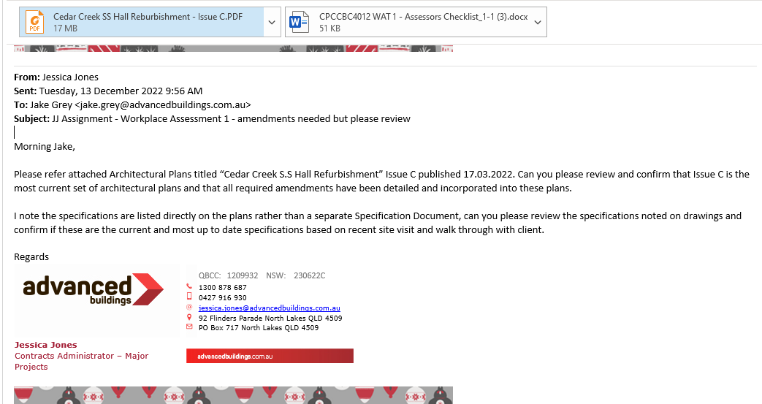

Task 2 Confirm Details on Plans Comply with the Specifications
Use Construction Plan Details Verification Checklist below to verify whether details on the construction plans comply with the specifications.
You will be assessed on:
- Practical knowledge of building and construction plans and specifications
- Practical skills in confirming the compliance of the details specified in construction plans with the construction specifications
Before starting this task, review the Workplace Assessment Task 2 – Assessor’s Checklist provided along with this workbook. This form lists the criteria your Construction Plan Details Verification Checklist submission must address to complete this task satisfactorily.
After completing this task, submit the following to your assessor:
- Three (3) examples of how the plans refer to and confirm the specifications.

Example 1
Provide excerpt (screenshot) of plans | 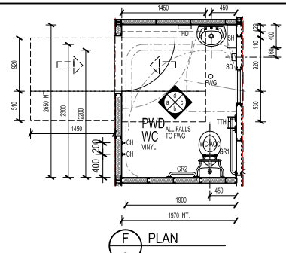
Provide excerpt (screenshot) of specifications | 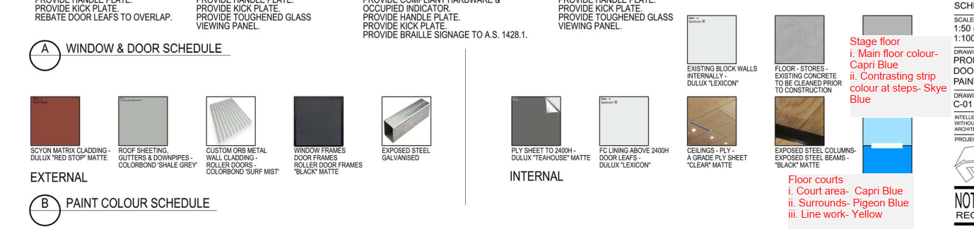
Confirm that plans comply with specifications | YES  NO (Explain why): No Vinyl selection noted on the internal schedule drawing C-01

Example 2
Provide excerpt (screenshot) of plans | 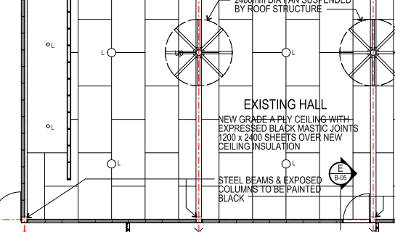
Provide excerpt (screenshot) of specifications
Confirm that plans comply with specifications | YES Internal schedule notes Ceilings to be A Grade Ply Sheet  NO (Explain why):

Example 3
Provide excerpt (screenshot) of plans | 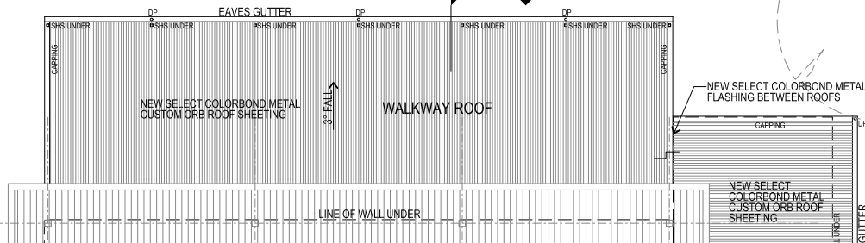
Provide excerpt (screenshot) of specifications
Confirm that plans comply with specifications | YES Colorbond Metal Roof Sheeting noted in external specs, colour to be ‘Shale Grey’  NO (Explain why):

Task 3 Examine Detail Drawings to Determine Sizes and Thickness
Record the sizes, thickness, and quantity of the three (3) different materials listed on the detail drawings used on the building and construction project.
You will be assessed on:
- Practical knowledge of the sizes, thickness and quantity of construction items
- Practical skills in examining detail drawings to determine sizes and thickness
- Practical skills in interpreting two-dimensional and three-dimensional drawings and applying to estimation
Before starting this task, review the Workplace Assessment Task 3 – Assessor’s Checklist provided along with this workbook. This form lists the criteria your Material Quantity Takeoff Form submission must address to complete this task satisfactorily.
After completing this task, submit the following to your assessor:
- Completed Material Quantity Takeoff Form
- Detail drawings you used as basis in determining the sizes, thickness and quantity of materials

Material Quantity Takeoff Form

Completed by | Jessica Jones
Date completed | 15/12/2022

Items | Size |  | Thickness (mm) | Quantity (pcs)
Items | Height (mm) | Width (mm) | Thickness (mm) | Quantity (pcs)
1. Colorbond ‘Surf Mist’ Roller doors | 2400 | 4800 |  | 2
2. A Grade Ply sheeting ‘Clear’ Matte (Hall Ceiling) | 2400 | 1200 |  | 73
3. Hardies Scyon Matric Ext Wall Cladding | 600 | 2400 | 19 | 85

Task 4 Discuss Details During the Planning Phase
In the role of a supervisor, email the details of your estimates from Workplace Assessment Task 3 to subordinate construction personnel to order materials.
You will be assessed on:
- Practical knowledge of two-dimensional and three-dimensional drawings
- Practical skills in interpreting two-dimensional and three-dimensional drawings and applying to planning
Before starting this task, review the Workplace Assessment Task 4 – Assessor Checklist provided along with this workbook. This form lists all the practical skills you need to demonstrate while completing this task.
After completing this task, submit the following to your assessor:
- Email to those requiring your direction with regards to ordering materials

Insert email screenshot below
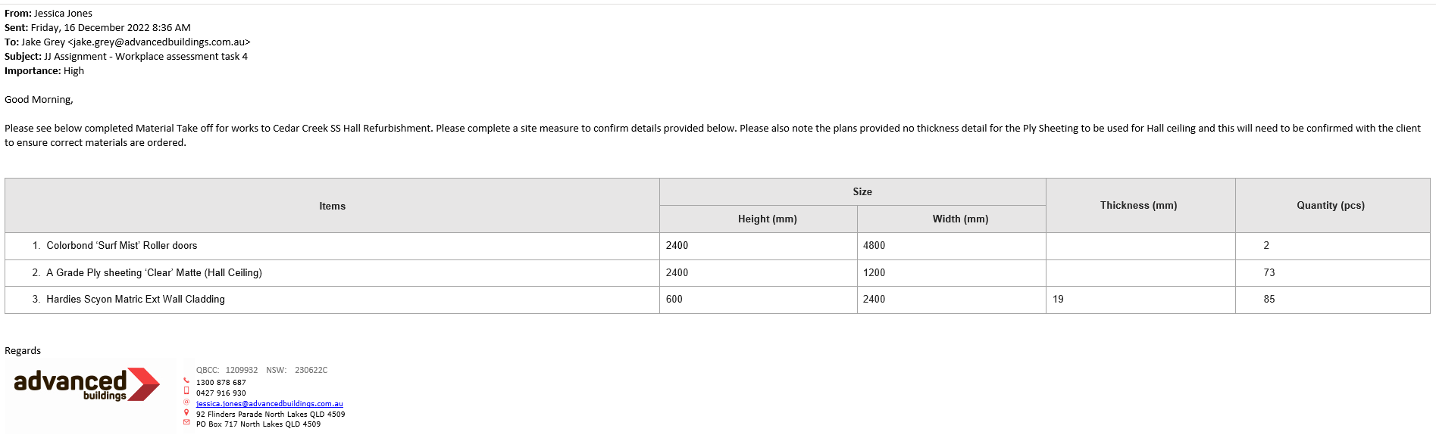

Practical Plans Assignment

Overview
The goal of this assessment is to assess your practical knowledge and skills in:
- Identifying types of plans
- Reading and interpreting plans
- Identifying structural details
- Identifying non-structural details
This assessment is divided into 12 assessment tasks.
Task 1 – Types of Plans and Aspects
Task 2 – Construction Plans
Task 3 – Materials from Specifications
Task 4 – Concrete Footing and Slab
Task 5 – Load Bearing Points
Task 6 – Load Bearing Information
Task 7 – Wind Bracing and Tie-Down Requirements
Task 8 – Wind Bracing Materials and Tie-Down Methods
Task 9 – Provisional Sum and Prime Cost Items
Task 10 – Installation and Connection Points of Services
Task 11 – Location of Fixtures
Task 12 – Details of Finishes
The assessment items included in this assessment will require you to demonstrate your knowledge and skills relevant to reading and interpreting plans.
You will record your responses in this workbook when completing the assessments.
Resources required for assessment:
To complete this assessment, you will need access to the following:
- Construction plans, including:
  - Site plan
  - Floor plan
  - Detail drawings
  - Structural drawings
- Construction specifications
- Wind bracing table
- Construction contract

Task 1 Types of Plans and Aspects
Provide examples of three (3) of the listed types of construction plans and briefly identify what they contain.
Record your responses in the spaces provided in each item.
You will be assessed on:
- Practical knowledge of the types of plans and aspects of drawings
- Practical skills in identifying the types of plans and aspects of drawings specific for the intended purpose

- Provide examples of three (3) of the listed types of construction plans and briefly explain their purpose:
  - Concept drawing/sketches
  - Architectural plans
  - Structural plans
  - Civil plans
  - Mechanical plans
  - Electrical plans
  - Plumbing and drainage plans

Type of Plan |  | Purpose
1 | List type of plan and file name of submitted example | Plumbing & Drainage Plan  Filename – Hydraulic Sanitary Drainage  Provide the location of existing and required sanitary drainage in the works area as well as the pipe lengths and fittings sizes
2 | List type of plan and file name of submitted example | Structural Plan  Filename – Structural Roof Wall Frame  Provides the layout of roof and wall framing required as well as the structural requirements such as materials and their sizes
3 | List type of plan and file name of submitted example | Architectural  Filename - Arch Prop Roof Plan  Provides the layout of Roof in works area and highlights the remaining/existing roof and the new works required. Provides the required Fall of roof and downpipe locations

- Provide examples of three (3) of the listed aspects of drawings and briefly explain their purpose:
  - Site plan
  - Floor plan
  - Elevations
  - Sections
  - Details
  - Isometric drawings
  - Oblique drawings
  - Perspective drawings
  - Orthographic drawings

Aspects of Drawings |  | Purpose
1 | List aspect of drawing and file name of submitted example | Elevations  Filename – Elevations  Provides an external view of building and works required, provides floor to ceiling heights
2 | List aspect of drawing and file name of submitted example | Sections  Filename - Elev & Section  Section shows the internal cross section of the building, provides measurements for doors and windows
3 | List aspect of drawing and file name of submitted example | Site Plan  Filename - HYD Site Plan  Provides an overview of the property on which works are to be conducted, also provides the North Point and Lot/Plan details

Task 2 Construction Plans
Review the construction plans for the project you are undertaking for this assessment.
You will be assessed on:
- Practical knowledge of the construction plans
- Practical skills in reading and interpreting the plans

- Identify one key feature for each of the plans you identified in Task 1:
Explain how each indicated key feature distinguishes the plan from other types of plans.

Type of Plan |  | Key Feature | How does this key feature distinguish the plan from the other types of plans?
1 | Plumbing & Drainage Plan  Filename – Hydraulic Sanitary Drainage | Sizes of pipes | Plumbing and Drainage plans are concerned with the Hydraulics and layout on site and provide the required sizes for pipes and fittings for the connection of water services, pipe sizes are not provided in other types of plans
2 | Structural Plan  Filename – Structural Roof Wall Frame | Framing Member Schedule | Provides the structural materials and connection required to ensure the construction is secure
3 | Architectural  Filename - Arch Prop Roof Plan | Floor/Roof Plan | Provides the architectural aspects of the works to area of constructions such as materials required, layout and roof pitch

- Refer to an example of a site plan and outline the detail requested below. Ensure you supply the plan with your submission.

Questions | Candidate Responses
What is the address of the building project? | Not listed on site plan received
What is the block number of the land where the building is to be constructed? | Not listed on site plan received
What is the name of the road adjacent to the block of land? | Not listed on site plan received
Based on the north point, describe the orientation of:
- The proposed building | Proposed Building is to the South East
- The road used to access the entrance of the property | Access Road not shown on Site Plan receiveed
What is the elevation of the datum? | Not listed on Site Plan
What are the elevations (reduced levels) of the site contours? | 105.5 – 109.5
Describe the contour of the land based on the site contour. | Land is uniformly sloping upwards from the north to the south

Questions | Candidate Responses
What are the site features to be removed? | Partial wall behind stage to be removed, roofing/wall cladding to external of building to be removed and replaced
What are the site features to be retained? | Stage within hall to remain, flooring/slab to existing structure to remain

- Refer to an example of a floor plan and outline the detail requested below. Ensure you supply the plan with your submission.

Questions | Candidate Responses
Describe the shape of the layout of the building. | Overall Rectangular Shape
Identify all the building spaces in the floor plan and their corresponding dimensions. | Building Space: Existing Hall  Dimensions: 19000 x 12000
Building Space: PWD
Dimensions: 2700 x 2000
Building Space: Store 1
Dimensions: 8900 x 2000
Building Space: Store 2
Dimensions: 8200 x 2000
Building Space: OSH
Dimensions: 7700 x 4800
Building Space: Office
Dimensions: 2000 x 3500
- Refer to an example of a plan outlining details about internal linings, external cladding and roof materials and outline the detail requested below. Ensure you supply the plan with your submission.

Questions | Candidate Responses
What materials are used for the internal linings of the building? | Dulux Ply Sheeting
 | FC Lining
What materials are used for the external cladding of the building? | Custom Orb Metal Wall Cladding
 | Scyon Matrix Cladding Dulux ‘Red Stop” matte
What are the different roof materials used in the building project? | Colorbond Sheeting“Shale Grey”

- Refer to an example of detail drawings and outline the detail requested below. Ensure you supply the drawings with your submission.

76mm steel studs
New concrete hob 200mm under wall between existing walls scabble back existing slab.
Waterproof membrane between sheeting & Hob
New timber roof frame to Structural Engineers design

Task 3 Materials from Specifications
Refer to an example of specifications and outline the detail requested below. Ensure you supply the specifications with your submission.
You will be assessed on:
- Practical knowledge of the specifications document
- Practical skills in identifying materials from the specifications document

Questions | Candidate Responses
What materials are used for the internal linings of the building? | Dulux Ply Sheeting
 | FC Lining
What materials are used for the external cladding of the building? | Custom Orb Metal Wall Cladding
 | Scyon Matrix Cladding Dulux ‘Red Stop” matte
What are the different roof materials used in the building project? |  | Colorbond Sheeting“Shale Grey”

Task 4 Concrete Footing and Slab
Refer to an example of plan addressing footings, slabs and reinforcing and outline the detail requested below. Ensure you supply the plan with your submission. Alternatively, refer to:
    - Practical Plans Assignment Task 4 Footing and Ground Floor Slab Plan – 1
    - Practical Plans Assignment Task 4 Footing and Ground Floor Slab Plan – 2

- Describe the position of one (1) footing and slab-on-ground in the plans.
- Identify the following:
  - Size of footing
  - Size of slab-on-ground
  - The type of reinforcing applied
You will be assessed on:
- Practical knowledge of concrete footing and slab sizes and position and type of reinforcing
- Practical skills in identifying the concrete footing and slab sizes and position and type of reinforcing

Footing
Position | Size | Type of reinforcing
SF1 – Warehouse | 800 x 300 DP | L8TM Top & Bottom

Slab-on-ground
Position | Size | Type of reinforcing
Office | 100mm thick | SL62 Mesh Top

Task 5 Load Bearing Points
Refer to an example of a plan which identifies load bearing points (or columns). Alternatively, refer to Practical Plans Assignment Task 5.
Provide three (3) screenshots from the plans that identify load bearing points.
You will be assessed on:
- Practical knowledge of the load bearing points of the building
- Practical skills in identifying the load bearing points of the building

Load bearing points (or columns)
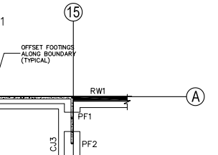
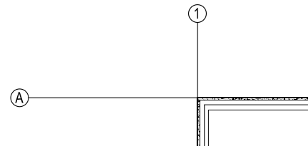
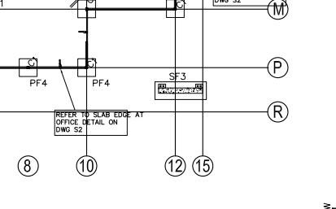

Task 6 Load Bearing Information
Refer to an example of structural drawings of structural members (e.g. columns, beams) and outline the detail requested below. Ensure you supply the plan with your submission.
Ensure to:
- Identify the strength of steel and concrete from the structural drawings.
- Indicate whether the strength of steel and concrete identified from the structural drawings are consistent with the information in the project specifications.
If your answer is NO, explain why the information in the structural drawings are not consistent with the specifications.
You will be assessed on:
- Practical knowledge of load bearing information from plans and specifications
- Practical skills in identifying structural load bearing information of the building and comparing information from specifications

Strength of Steel: | 300
Is the strength of steel specified in the structural drawings, consistent with the information in the project specifications?
YES NO
Explanation (Candidate to explain if their response is no)
No project specifications provided. Main Architectural drawings note to refer to Structural drawings. Steel strength not listed on individual drawings but noted on General Notes page of drawing set

Strength of Concrete: | 25 MPa
Is the strength of concrete specified in the structural drawings, consistent with the information in the project specifications?
YES NO
Explanation (Candidate to explain if their response is no)
No project specifications document provided for this project. All information noted direct on drawings only. Specifications for Concrete strength are included in the general notes of the Structural Drawing Set provided

Task 7 Wind Bracing and Tie-Down Requirements
Refer to an example of plans and specifications which outline wind bracing and tie-down requirements and outline the detail requested below. Ensure you supply the plans and specifications with your submission.
You will be assessed on:
- Practical knowledge of wind bracing and tie-down requirements
- Practical skills in identifying wind bracing and tie-down requirements

What are the wind bracing requirements?
BR2 – Cross Brace – 30mm x 0.8mm to be installed at 30-60 degress max from the horizontal for the length of wall indicated. Some walls require multiple set.

What are the tie-down requirements?
BR2 – Wrap over top and bottom plate and provide 3 No 12 Teks to each end. Provide 1 No 12 Tek to each passing stud, provide additional 30mm x 08mm looped strap to top and bottom of studs closest to diagonal strap ends.

Task 8 Wind Bracing Materials and Tie-Down Methods
Confirm whether the wind bracing materials and tie-down methods found in the plans and specifications from Practical Assessment Task 7 are accurate against the wind bracing table.
You will be assessed on:
- Practical knowledge of wind bracing and tie-down requirements
- Practical skills in identifying wind bracing and tie-down requirements

Wind bracing materials  (Student to list wind bracing materials below) | Candidate’s confirmation to whether the wind bracing material is accurate against the wind bracing table
30 x 0.8mm galvanised diagonal brace | yes
e.g. galvanised metal angle (18 x 16 x 1.2 mm)
e.g. 30 x 0.8 mm tensioned metal brace

Tie-down methods  (Student to list tie-down methods below.) | Candidate’s confirmation to whether the tie-down method is accurate against the wind bracing table
3/No 12 Teks to each end | yes
1/No 12 Tek to each passing stud | yes
e.g. 1/30 x 2.8 mm Ø nail driven to fix brace to studs

Task 9 Provisional Sum and Prime Cost Items
Refer to an example of a construction contract and outline the detail requested below. Ensure you supply the extract of the construction contract with your submission.
Identify the following based on the documents you reviewed:
- Provisional sum (PS) items
- Prime cost (PC) items
You will be assessed on:
- Practical knowledge of provisional sum and prime cost items
- Practical skills in identifying provisional sum and prime cost items

What are the prime cost items?
PC Sum for supply and install of new commercial vanity and top to Girls Bathroom
PC Allowance for supply of Ceramic Tiles to Main Area Bathroom. 9sqm
3. PC Allowance for fittings and fixtures to Licensee Office kitchenette
What are the provisional sums items?
Provisional Sum to remove and replace feature nib wall with mirrored uprights to main waiting area

Task 10 Installation and Connection Points of Services
Provide screenshots from construction plans to:
- Locate the installation points of services
- Locate the connection points of services
You will be assessed on:
- Practical knowledge of the installation and connection points of building services
- Practical skills in locating the installation and connection points of building services

Installation Points of Services
(Student to provide a screenshot example of three (3) installation points of services, such as gas supply, air conditioning)
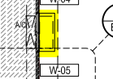
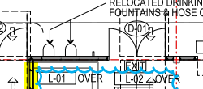
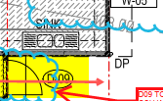

Connection Points of Services
(Student to provide a screenshot example of three (3) connection points of services, such as sewer connection, water supply connection point)
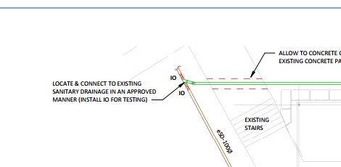
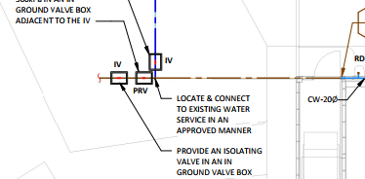
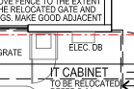

Task 11 Location of Fixtures
Provide screenshots of examples from plans which locate three (3) fixtures in plans.
You will be assessed on:
- Practical knowledge of fixtures
- Practical skills in identifying the location of fixtures from plans

Fixtures
(Student to provide a screenshot example of three (3) fixtures, such as toilet, ceiling fan, sprinkler system)
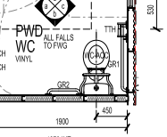
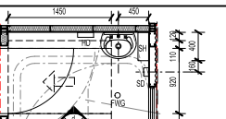
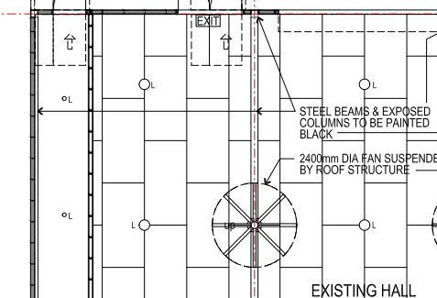

Task 12 Details of Finishes
Provide screenshots of examples from specifications which identify the details of three (3) finishes.
You will be assessed on:
- Practical knowledge of details of fixtures
- Practical skills in identifying details of fixtures

Finishes | Details of finishes from the specifications
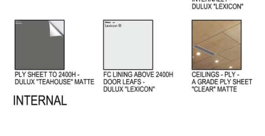 | Internal Ceilings – A Grade Ply Sheet “Clear” matte
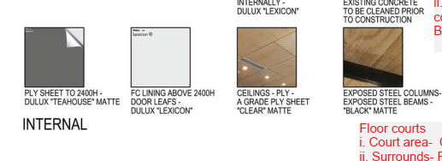 | Exposed Steel Columns/Exposed Steel Beams – “Black” Matte
 | External – Scyon Matrix Cladding – Dulux ‘Red Stop’ Matte

Assessment Workbook Checklist
TO THE CANDIDATE
When you have completed this assessment workbook, review your work, and ensure that:
- You have completed all the Knowledge Assessments Questions.
- You have completed the Practical Assessments in this workbook
- Practical Assignment
- Workplace Safety Requirements
- Workplace Processes
- Environmental Requirements
- Workplace Assessment
- Confirm Currency of Plans, Specifications, and Amendments
- Confirm Details on Plans Comply with the Specifications
- Examine Detail Drawings to Determine Sizes and Thickness
- Discuss Details During the Planning Phase
- Practical Plans Assignment
- Types of Plans and Aspects
- Construction Plans
- Materials from Specifications
- Concrete Footing and Slab
- Load Bearing Points
- Load Bearing Information
- Wind Bracing and Tie-Down Requirements
- Wind Bracing Materials and Tie-Down Methods
- Provisional Sum and Prime Cost Items
- Installation and Connection Points of Services
- Location of Fixtures
- Details of Finishes
- You have saved and submitted the following evidence:
- This completed workbook
- Assessment Workbook Cover Sheet signed and scanned
- Plans used for Practical Plans Assignment Tasks 1, 2, 3, 4, 5, 6, 7 and 9

IMPORTANT:
You must achieve a satisfactory result in ALL assessment tasks to be deemed COMPETENT for the unit/s relevant to this workbook.
To be deemed competent in the unit/s of competency relevant to this workbook, you must successfully complete all the requirements listed above according to the prescribed benchmarks provided to the assessor.

TO THE ASSESSOR
When you have completed assessing the assessment workbook, review the candidate’s submission against the checklist below:
- The candidate has completed all the Knowledge Assessments Questions.
- The candidate has completed the Practical Assessments in this workbook
- Practical Assignment
- Workplace Safety Requirements
- Workplace Processes
- Environmental Requirements
- Workplace Assessment
- Confirm Currency of Plans, Specifications, and Amendments
- Confirm Details on Plans Comply with the Specifications
- Examine Detail Drawings to Determine Sizes and Thickness
- Discuss Details During the Planning Phase
- Practical Plans Assignment
- Types of Plans and Aspects
- Construction Plans
- Materials from Specifications
- Concrete Footing and Slab
- Load Bearing Points
- Load Bearing Information
- Wind Bracing and Tie-Down Requirements
- Wind Bracing Materials and Tie-Down Methods
- Provisional Sum and Prime Cost Items
- Installation and Connection Points of Services
- Location of Fixtures
- Details of Finishes
- The candidate has saved and submitted the following evidence:
- This completed workbook
- Assessment Workbook Cover Sheet signed and scanned
- Plans used for Practical Plans Assignment Tasks 1, 2, 3, 4, 5, 6, 7 and 9

IMPORTANT:
The candidate must achieve a satisfactory result in ALL assessment tasks to be deemed COMPETENT for the unit/s relevant to this workbook.
To be deemed competent in the unit/s of competency relevant to this workbook, the candidate must successfully complete all the requirements listed above according to the prescribed benchmarks.

Record of Assessment (Assessor’s Use Only)
RECORD OF ASSESSMENT
Candidate’s Name
RTO Name
RTO Contact Number
RTO Email Address
Assessor’s Name
Unit of Competency | CPCCBC4012 - Read and interpret plans and specifications (Release 1.0)

Knowledge Assessment | S | NYS
Question 1
Question 2
Question 3
Question 4
Question 5
Question 6
Question 7
Question 8
Question 9
Question 10
Question 11
Question 12
Question 13
Question 14
Question 15
Question 16
Question 17
Question 18
Question 19
Question 20
Question 21
Question 22
Question 23

Practical Assessment
Practical Assignment | S | NYS
Task 1
Task 2
Task 3
Workplace Assessment | S | NYS
Task 1
Task 2
Task 3
Task 4
Practical Plans Assignment | S | NYS
Task 1
Task 2
Task 3
Task 4
Task 5
Task 6
Task 7
Task 8
Task 9
Task 10
Task 11
Task 12

Rules of Evidence | S | NYS
All knowledge and skills evidence submissions are valid
All knowledge and skills evidence submissions are authentic
All knowledge and skills evidence submissions are sufficient
All knowledge and skills evidence submissions are current

Signature Authentication Checklist
This checklist will guide you in authenticating the signatures provided by the candidate in their assessment workbook and evidence submissions.
Read each checklist item and tick the box only if you confirm that the item is a true and accurate reflection of the signature authentication you have conducted.
Checklist | Completed
I have checked the signature provided by the candidate in the Assessment Workbook Cover Sheet against the signature they provided to the Training Provider.
I confirm the signature provided by the candidate in the Assessment Workbook Cover Sheet matches the signature they provided to the Training Provider.
I confirm ALL signatures provided by the candidate in their evidence submissions match with the signature they provided to the Training Provider.

Third-Party Verification Log
Instructions for the Assessor:
You are required to contact all third-party personnel involved in the candidate’s assessment to verify the candidate’s performance and evidence submissions and to confirm with them whether the candidate’s evidence submissions are true and accurate.
Complete this Third-Party Verification Log to document your completion of this process. When completing this log, provide all of the following required information for each third-party personnel:
- Name of third-party personnel contacted
- Role in the candidate’s assessment (e.g. workplace supervisor, observer, or candidate)
- Contact details (phone number or email address)
- Date contacted
You must also confirm that third-party personnel have verified the candidate’s evidence submissions are true and accurate.

Name of Third-party Contacted | Role in the Candidate’s Assessment | Contact Details (Phone number or email address) | Date contacted | Third-Party verifies evidence submissions of the candidate are true and accurate?
Yes No
Assessor’s Notes

Yes No
Assessor’s Notes

Yes No
Assessor’s Notes

Yes No
Assessor’s Notes

Overall Result for this Workbook | S | NYS
Overall Result

Assessor’s comments/feedback

Assessor Declaration
I declare that the results recorded in this Record of Assessment are true and accurate.
Assessor’s name | Assessor’s signature
Date signed | Assessor’s signature
End of Record of Assessment (For the Assessor’s Use Only)

End of Document

