CHCECE019
Facilitate compliance in an education and care service
Learner Guide


Table of Contents

Unit of Competency 4
Application 4
Performance Criteria 5
Foundation Skills 6
Assessment Requirements 7
1. Interpret the National Quality Framework 9
1.1 – Analyse the components of the National Quality Framework (NQF) and their relevance to the service 10
National Quality Framework for Early Childhood Education and Care (NQF) 10
National Quality Standard 11
Analysing standards 12
Activity 1A 14
1.2 – Seek advice from a higher authority if clarification is required on interpretation of any aspect of the Framework 15
How can higher authorities help? 15
Activity 1B 17
1.3 – Confirm staff understanding of the NQF and other legislation and regulations relevant to the service 18
What are the national laws and regulations? 18
Guide to the Education and Care Services National Law and the Education and Care Services National Regulations 2011 19
Confirming staff understanding 23
Activity 1C 24
1.4 – Clarify details and requirements of the assessment and rating process and share information with all staff in the service 25
Clarifying the details and requirements 25
The national quality standards assessment and ratings process 25
Sharing information with all staff 27
Activity 1D 28
2. Facilitate an organisation self- assessment 29
2.1 – Determine ways to collect information from staff, children, families and the community to inform self- assessment on a regular ongoing basis 30
Collecting information 30
Activity 2A 35
2.2 – Share ideas with colleagues and involve them in the collection of information to inform the self-assessment 36
Quality improvement plan and self-assessment 36
Activity 2B 38
2.3 – Record the information collected during the self-assessment process against the standards and elements in the NQF 39
Recording information against the standards 39
Activity 2C 41
2.4 – Ensure the self-assessment is available at the service to inform discussion of the assessment and rating process 42
Ensure self-assessment is available 42
Activity 2D 44
3. Facilitate the development of a quality improvement plan 45
3.1 – Use the information gathered in the self-assessment process to inform the creation of the quality improvement plan 46
Use information gathered in the self-assessment 46
46
Quality improvement plan 47
Activity 3A 49
3.2 – Collaborate with others to decide upon the strengths and the key improvements sought within the service 50
Collaborating with others to decide upon the strengths and the key improvements sought within the service 50
Activity 3B 52
3.3 – Work in collaboration with others to focus on how the key improvements sought will be reflected in the improvement plan 53
Key improvements 53
Activity 3C 54
3.4 – Record all of the required information in the plan 55
Recording information in the plan 55
Activity 3D 56
3.5 – Plan to collaborate with others on a regular basis to review the quality improvement plan 57
Reviewing the quality improvement plan 57
Activity 3E 59
4. Coordinate the service for a site visit 60
4.1 – Inform all stakeholders that the service has been selected for assessment and rating and that the assessment and rating process has commenced 61
Who are your stakeholders? 61
Activity 4A 63
4.2 – Schedule meetings with stakeholders and staff where appropriate 64
Schedule meetings with stakeholders and staff 64
Activity 4B 65
4.3 – Check for accuracy and completion of all documentation required for examination 66
Checking accuracy 66
Activity 4C 67
4.4 – Ensure all staff understand what may be required of them during the assessment visit 68
What might be required of staff during the visit? 68
Activity 4D 69
Summative Assessments 70
References 71

Unit of Competency

Application

This unit describes the skills and knowledge required to facilitate legislative, regulatory and National Quality Framework compliance within an education and care service.

This unit applies to educators working in a range of education and care services.

The skills in this unit must be applied in accordance with Commonwealth and State/Territory legislation, Australian/New Zealand standards and industry codes of practice.

Unit Mapping Information

No equivalent unit.

Performance Criteria
Element  Elements describe the essential outcomes. | Performance Criteria  Performance criteria describe the performance needed to demonstrate achievement of the element.
- Interpret the National Quality Framework | - Analyse the components of the National Quality Framework (NQF) and their relevance to the service  - Seek advice from a higher authority if clarification is required on interpretation of any aspect of the Framework  - Confirm staff understanding of the NQF and other legislation and regulations relevant to the service  - Clarify details and requirements of the assessment and rating process and share information with all staff in the service
- Facilitate an organisation self-assessment | - Determine ways to collect information from staff, children, families and the community to inform self- assessment on a regular ongoing basis  - Share ideas with colleagues and involve them in the collection of information to inform the self-assessment  - Record the information collected during the self-assessment process against the standards and elements in the NQF  - Ensure the self-assessment is available at the service to inform discussion of the assessment and rating process
- Facilitate the development of a quality improvement plan | - Use the information gathered in the self-assessment process to inform the creation of the quality improvement plan  - Collaborate with others to decide upon the strengths and the key improvements sought within the service  - Work in collaboration with others to focus on how the key improvements sought will be reflected in the improvement plan  - Record all of the required information in the plan  - Plan to collaborate with others on a regular basis to review the quality improvement plan
- Coordinate the service for a site visit | - Inform all stakeholders that the service has been selected for assessment and rating and that the assessment and rating process has commenced  - Schedule meetings with stakeholders and staff where appropriate  - Check for accuracy and completion of all documentation required for examination  - Ensure all staff understand what may be required of them during the assessment visit

Foundation Skills
The Foundation Skills describe those required skills (language, literacy, numeracy and employment skills) that are essential to performance.

- Reading – in order to analyse and apply applicable legislative and regulatory requirements, including the National Quality Standards, relevant to the service.

The remaining foundation skills essential to performance are explicit in the performance criteria of this unit.

Assessment Requirements
Performance Evidence

The candidate must show evidence of the ability to complete tasks outlined in elements and performance criteria of this unit, manage tasks and manage contingencies in the context of the job role.

There must be demonstrated evidence that the candidate has completed the following tasks at least once:

- Checked and maintained compliance in an education and care service, including:
- interpreting and applying the requirements outlined in the National Quality Framework in at least one education and care service
- facilitating a self-assessment process in at least one education and care service
- Developed at least one quality improvement plan, including:
- documenting and checking information for accuracy and completeness
- consulting with at least one other educator or service coordinator to review the plan
- Performed the activities outlined in the performance criteria of this unit during a period of at least 120 hours of work in at least one regulated education and care service.

Knowledge Evidence

The candidate must be able to demonstrate essential knowledge required to effectively do the task outlined in elements and performance criteria of this unit, manage the task and manage contingencies in the context of the identified work role.

These include knowledge of:

- How to access:
- the National Quality Framework
- the National Quality Standards
- the relevant approved learning framework
- How to interpret the relevance of framework and standards documents in guiding work in this unit of competency
- Other legislation, standards and regulations relevant to the children’s services industry
- Processes for engaging stakeholders in the planning and consultation stages of quality assurance
- Support systems, including government and non-government consultants, resources and personnel
- Best-practice principles and emerging trends in service delivery area.

Assessment Conditions

Skills must be demonstrated in a regulated education and care service.

In addition, simulations and scenarios must be used where the full range of contexts and situations cannot be provided in the workplace or may occur only rarely. These are situations relating to emergency or unplanned procedures where assessment in these circumstances would be unsafe or is impractical.

Simulated assessment environments must simulate the real-life working environment where these skills and knowledge would be performed, with all the relevant equipment and resources of that working environment.

Assessment must ensure use of:

- National Quality Framework for Early Childhood Education and Care
- The relevant approved learning framework under the National Quality Framework for Early Childhood Education and Care.

Assessors must satisfy the Standards for Registered Training Organisations (RTOs) 2015/AQTF mandatory competency requirements for assessors.

Links

Companion volumes are available from the CS&HISC website - http://www.cshisc.com.au/
Companion Volume implementation guides are found in VETNet - https://vetnet.education.gov.au/Pages/TrainingDocs.aspx?q=5e0c25cc-3d9d-4b43-80d3-bd22cc4f1e53

1. Interpret the National Quality Framework
1.1. Analyse the components of the National Quality Framework (NQF) and their relevance to the service
1.2. Seek advice from a higher authority if clarification is required on interpretation of any aspect of the Framework
1.3. Confirm staff understanding of the NQF and other legislation and regulations relevant to the service
1.4. Clarify details and requirements of the assessment and rating process and share information with all staff in the service


1.1 – Analyse the components of the National Quality Framework (NQF) and their relevance to the service

By the end of this chapter, the learner should be able to:
- Analyse the components of the National Quality Framework (NQF) and their relevance to the service.

National Quality Framework for Early Childhood Education and Care (NQF)
The NQF was founded in 2012 by the government, as a measure to raise the quality and standards of early childhood education and care across the whole of the Commonwealth by introducing consistency in the regulation and assessment of Australian education and care services.

The NQF applies to most of the following services:
- Long day care
- Family day care
- Preschool/kindergarten
- Outside school hours care.
The need for a national approach is to ensure that all children in the early stages of childhood access quality education and care in their formative years, in order to give them the best possible start in development and learning. Research shows that the higher the quality of education and care in these early years, the higher the quality of health, educational attainment, and employment in later life.
The NQF focuses on the belief that all children need quality care that is tailored to meet their individual and specific needs.
It aims to raise the quality of education and care services via two methods:
- Improved caregiver qualifications – the higher the qualification of the caregiver, the more in-depth their knowledge and understanding of the development and learning of children. These higher qualifications improve the effectiveness of the educator, as they take a holistic approach to the education of the whole child
- Lower educator to child ratios – fewer children in an educator’s care allows the educator to spend more time with each child, focusing on their individual learning and development needs and promotes the establishment and reinforcement of positive relationships. Happy children who feel safe are more likely to engage in learning, taking risks to think for themselves and trying new skills without the fear of failure or embarrassment.
The NQF is comprised of three elements:
- National Quality Standard – determines the benchmark for the quality of education and care services across Australia
- National legislative framework – provides a consistent approach to the regulation and assessment of education and child care services
- National quality rating and assessment process – rates education and care providers against the National Quality Standard.
The NQF is overseen by The Australian Children’s Education and Care Quality Authority (ACECQA), which works in conjunction with the regulatory authorities of each state/territory.
More information on the NQF can be found on the government’s website for education and training at https://www.education.gov.au/national-quality-framework-early-childhood-education-and-care-1.

National Quality Standard
The NQS is the benchmark for quality in early years education and childcare provision. The plan is that every early year’s education and care service throughout Australia will be assessed against this standard and rated accordingly. The ratings will then be placed on a national register that can be viewed by all.
Each provider will be assessed in seven different areas and also given an overall rating.
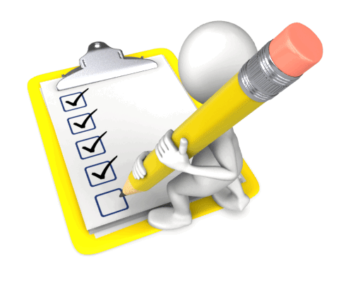
The seven areas of assessment are:
- Educational program and practice
- Children’s health and safety
- Physical environment
- Staffing arrangements
- Relationships with children
- Collaborative partnerships with families and communities
- Governance and leadership.
The assessment criteria of the NQS are intrinsically linked to the two national learning frameworks:
- Belonging, Being and Becoming: The Early Years Learning Framework for Australia – this framework outlines the principles, practices and outcomes for successful development and learning of a child from birth to five years old and includes the transition to school. All education and child care services are expected to use this framework to develop and implement their own provision
- My Time, Our Place: Framework for School Age Care in Australia – this framework supports the continued development of learning and development of children during school age using best practices of learning through play and leisure based activities that are appropriate to the individual’s needs, abilities and interests.
Belonging, Being and Becoming can be found at https://www.education.gov.au/early-years-learning-framework-0

My Time, Our Place can be found at http://education.gov.au/my-time-our-place-framework-school-age-care-australia

Analysing standards
The following table gives a breakdown of standard 6; ‘collaborative partnerships with families and communities’.
Standard 6.1 | Respectful relationships with families are developed and maintained, and families are supported in their parenting role
 | Element 6.1.1 | Families are supported from enrolment to be involved in the service and contribute to service decisions.
 | Element 6.1.2 | The expertise, culture, values and beliefs of families are respected, and families share in decision-making about their child’s learning and wellbeing.
 | Element 6.1.3 | Current information is available to families about the service and relevant community services and resources to support parenting and family well-being.
Standard 6.2 | Collaborative partnerships enhance children’s inclusion, learning and wellbeing
 | Element 6.2.1 | Continuity of learning and transitions for each child are supported by sharing information and clarifying responsibilities.
 | Element 6.2.2 | Effective partnerships support children's access, inclusion and participation in the program.
 | Element 6.2.3 | The service builds relationships and engages with its community.

You will need to analyse each element carefully to understand what is required of you and your organisation. Next, you will need to think of how you can implement practices to meet them.
For example, to meet 6.1.1 and provide an effective enrollment and orientation process for families, you can:
- Create an office area with an appropriate computer or filing system (this can also help you to keep track of ratios)
- Conduct home visits so children can have time to get to know staff in the comfort and security of their own home
- Provide introductory sessions that slowly stagger hours spent at the setting – for example;
  - first, visit 30 minutes with a parent or carer
  - second visit 30 minutes with a parent or carer and 30 minutes without a parent or carer
  - third visit two-hour stay without carer
- Have key workers who will work with a child in the early days/weeks/months.
Note: Sometimes, you will find that ideas will double up for other standards – for example, an office would also help with providing space to consult with parents in order to facilitate access.
For more information see page 104 of the Guide to the Education and Care Services National Law and the Education and Care Services National Regulations 2011 and the whole document can be found at http://files.acecqa.gov.au/files/National-Quality-Framework-Resources-Kit/NQF-Resource-02-Guide-to-ECS-Law-Regs.pdf


Activity 1A

1.2 – Seek advice from a higher authority if clarification is required on interpretation of any aspect of the Framework

By the end of this chapter, the learner should be able to:
- Seek advice from a higher authority if clarification is required on interpretation of any aspect of the Framework.

How can higher authorities help?
The framework for early years is just that; a framework. It is not rigid and does not state what we need to do to achieve the various elements within it. Educators will need to think about how they can put into practice the strategies, principles, practices and learning outcomes that make up the framework.
If you need help or advice about something related to the framework, you can ask for clarification from a higher authority.
Supervisors and managers

A higher authority may simply mean a supervisor or manager – someone that is in a higher position than you are.
They may be able to:
- Answer your questions
- Provide demonstrations
- Provide you with additional information or contacts.
External authorities
It could also mean looking for clarification from outside authorities – for example, the Australian Children’s Education and Care Quality Authority (ACECQA) or regulatory authorities.
Their website is: http://acecqa.gov.au/
It has information about the National Quality Framework including:
- Templates and education resources
- An FAQ page where answers are provided to some of the questions that you may have about the framework or its assessment
- NQF video resources that cover a wide-range of topics including:
  - why has the NQF been introduced?
  - the main changes that have been introduced
  - how services are assessed
  - what the ratings mean for services
  - the seven quality standards
  - examples from excellently rated schools.
There are Regulatory Authorities in each state and territory. Regulatory Authorities can give you information on:
- Information about assessments and ratings
- Certifying and approving supervisors
- Submitting application and notification forms.

Activity 1B

1.3 – Confirm staff understanding of the NQF and other legislation and regulations relevant to the service

By the end of this chapter, the learner should be able to:
- Confirm staff understanding of the NQF and other legislation and regulations relevant to the service.

What are the national laws and regulations?
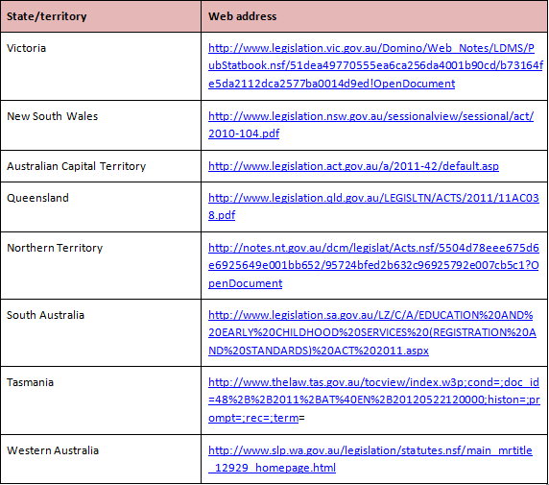
The National Quality Framework is governed by a combination of the Education and Care Services National Law and the Education and Care Services National Regulations. The legislation and regulations vary in each state/territory. To find out more information about the legislation in your region visit the links below:

Guide to the Education and Care Services National Law and the Education and Care Services National Regulations 2011
The following information is taken directly from the official government Guide to the Education and Care Services National Law and the Education and Care Services National Regulations 2011 – the whole document can be found at http://files.acecqa.gov.au/files/National-Quality-Framework-Resources-Kit/NQF-Resource-02-Guide-to-ECS-Law-Regs.pdf
The objectives of the NQF under section 3(2) of the National Law are to:
- Ensure the safety, health and well-being of children attending education and care services
- Improve the educational and developmental outcomes for children attending education and care services
- Promote continuous improvement in the provision of quality education and care services
- Establish a system of national integration and shared responsibility between participating jurisdictions and the Commonwealth in the administration of the national quality framework
- Improve public knowledge, and access to information, about the quality of education and care services
- Reduce the regulatory and administrative burden for education and care services by enabling information to be shared between participating jurisdictions and the Commonwealth.
The following guiding principles under section 3(3) of the National Law should be applied when making decisions about the operation of education and care services:

- The rights and best interests of the child are paramount
- Children are successful, competent and capable learners
- The principles of equity, inclusion and diversity underpin the national law
- That Australia’s Aboriginal and Torres Strait Islander cultures are valued
- That the role of parents and families is respected and supported
- That best practice is expected in the provision of education and care services.
The National Law sets out:
- Approval processes for the operation of education and care services
- The assessment and rating system
- Key operational requirements
- Compliance, monitoring and enforcement powers
- Review of decisions made by regulatory authorities

- The functions and powers of the Standing Council
- The functions and powers of the Australian Children’s Education and Care Quality Authority (ACECQA)—the national body that oversees the system
- The functions and powers of regulatory authorities in each jurisdiction
- Creation of a nationally consistent freedom of information and privacy framework to apply to ACECQA and regulatory authorities
- Publication of information, including registers
- Key transitional arrangements.
Services covered by the National Quality Framework
Section 5 of the National Law states that NQF covers the majority of long day care, family day care, preschool (kindergarten) and outside school hours care services. In Western Australia, the NQF also covers home-based care.
Given that the NQF was only introduced in 2012, not all service providers are covered. It has commenced its assessment and quality rating of the services that provide for the largest number of children, but the intention is to extend it to all providers of education and care over the forthcoming years.
Services excluded from the NQF under National Law include:
- A school providing full-time education to children, including children in the year before Grade 1, but not including a preschool program delivered in a school or a preschool that is registered as a school (as these are within scope)
- A preschool program delivered in a school if the program is delivered in a class or classes where a full-time education program is also being delivered to school children and the program is delivered to fewer than six children in the school (a composite class)
- A personal arrangement
- A service principally conducted to provide instruction in a particular activity (for example, a language class or ballet class)
- A service providing education and care to patients in a hospital or patients of a medical or therapeutic care service
- Care provided under a child protection law of a participating jurisdiction.
These excluded services are not likely to be brought into the scope of the NQF in the future.
Services excluded from the NFQ under National Regulations include:
- Disability services defined under state or territory law, and early childhood intervention services for children with additional needs
- Except in WA, education and care in a residence, other than as part of a family day care service
- Occasional care services (for example, offered at short notice or on a casual basis)
- Education and care provided by a hotel or resort to children of short-term guests at the hotel or resort
- Education and care that is provided on an ad hoc basis to children of a guest, visitor or patron where the person who is responsible for the children is readily available at all times
- Education and care where it is primarily provided or shared by parents or family members
- Education and care provided at a secondary school to a child of a student attending the school, where the parent retains responsibility for the child

- Mobile services
- Services that provide education and care for no more than four weeks per calendar year during school holidays
- Transition to school programs provided by a school to orient children to that school
- Budget based funded services, other than where they receive Child Care Benefit
- Playschools licensed in the Australian Capital Territory
- Stand-alone services in Queensland
- Play centres in South Australia
- Services licensed as centre-based Class 4 or 5 services under the Child Care Act 2001 in Tasmania
- Licensed limited hours or short-term services in Queensland or Victoria
- Government-funded services under the Children and Community Services Act 2004 of Western Australia.
Services excluded under the National Regulations may become an inclusive part of the NQF in the future.
Educational program
The National Law and Regulations determine that all approved services provide an educational program that:
- Is based on an approved learning framework:
  - the two nationally approved learning frameworks:
    - Belonging, Being and Becoming—The Early Years Learning Framework for Australia
    - My Time, Our Place—Framework for School Age Care in Australia
  - jurisdiction specific approved learning frameworks:
    - Australian Capital Territory: Every Chance to Learn—Curriculum Framework for ACT Schools Preschool to Year 10
    - Victoria: Victorian Early Years Learning and Development Framework, Department of Education and Victorian Curriculum and Assessment Authority
    - Western Australia: Curriculum Framework for Kindergarten to Year 12 Education in Western Australia

    - Tasmania: Tasmanian Curriculum, Department of Education of Tasmania, 2008
- Is delivered in accordance with that framework
- Is based on the developmental needs, interests and experiences of each child
- Takes into account the individuality of each child.
The educational program must make a contribution to each of the following outcomes:
- Children have a strong sense of identity
- Children are connected with and contribute to his or her world
- Children have a strong sense of wellbeing
- Children are confident and involved learners
- Children are effective communicators.

Confirming staff understanding
You should inform all staff of relevant legislation and where to find this, when they first arrive at the setting. This information should also be regularly reviewed and updated, and staff should be informed of any changes.
You can provide staff (and stakeholders) with information about legislation through:

- Training or induction guides
- Posters
- Workshops
- Meetings
- Links and information on organisational website
- Newsletters.
Confirming that staff understanding of NQF and other relevant legislation can be achieved in a number of ways.
For example through:
- Observations of staff
- Team meetings
- One-to-one reviews
- Professional development opportunities.

Activity 1C

1.4 – Clarify details and requirements of the assessment and rating process and share information with all staff in the service

By the end of this chapter, the learner should be able to:
- Clarify details and requirements of the assessment and rating process and share information with all staff in the service.

Clarifying the details and requirements
Every early year’s education and care service throughout Australia will be assessed against a set of standards and rated accordingly. The ratings will then be placed on a national register that can be viewed by all.
Each provider will be assessed in seven different areas and also given an overall rating. This means that staff will need to know the seven areas of assessment and how they are assessed.
The seven areas of assessment are:
- Educational program and practice
- Children’s health and safety
- Physical environment
- Staffing arrangements
- Relationships with children
- Collaborative partnerships with families and communities
- Leadership and service management.
Each quality area will be rated with one of the five following levels defined by the NQS:

- Excellent rating – awarded by ACECQA
- Exceeding National Quality Standard
- Meeting National Quality Standard
- Working Towards National Quality Standard
- Significant Improvement Required.
Source – ACECQA website at http://acecqa.gov.au/national-quality-framework/the-national-quality-standard

The national quality standards assessment and ratings process
Ensuring staff are aware of the assessment and ratings process will encourage a reflective approach to caring for children that will improve childcare services.
A good way to do this is to provide staff with an approximate timeline for the assessment, with the different steps and processes involved.
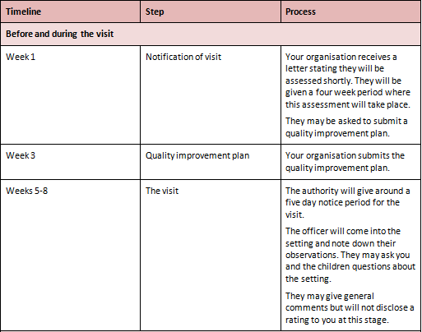
See the following table for an example (timeframes are approximations):
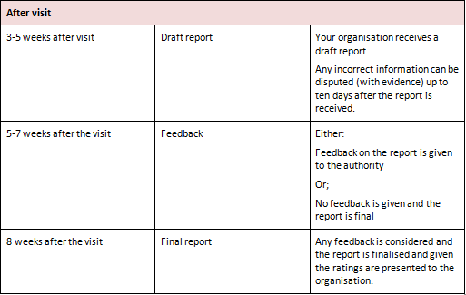

Sharing information with all staff
Sharing information with all members of staff is important, some staff may be anxious about the inspection. Talking things through with them and helping them to prepare will help relieve this anxiety.

Colleagues you should share information with at the setting:
- Nursery nurses
- Supervisors or managers
- Teachers
- Cleaners
- Administration support
- Students
- Volunteers.
Note: you should also inform parents or carers about the inspection and provide them with a date.
To help prepare staff for the inspection, you can:
- Encourage staff to review mission statements legislation and standards
- Regularly host meetings and be available to talk to staff about their concerns
- Check that you have up-to-date contact details for all parents/carers
- Encourage staff to reflect on their own work practices
- Collaborate together and carry out a self-assessment as a practice
- Remind all staff to be cooperative – smile, answer and ask questions, be polite, etc.

Activity 1D

2. Facilitate an organisation self- assessment
2.1. Determine ways to collect information from staff, children, families and the community to inform
self- assessment on a regular ongoing basis
2.2. Share ideas with colleagues and involve them in the collection of information to inform the self-
assessment
2.3. Record the information collected during the self-assessment process against the standards and
elements in the NQF
2.4. Ensure the self-assessment is available at the service to inform discussion of the assessment and
rating process

2.1 – Determine ways to collect information from staff, children, families and the community to inform self- assessment on a regular ongoing basis

By the end of this chapter, the learner should be able to:
- Determine ways to collect information from staff, children, families and the community to inform self-assessment on a regular ongoing basis.

Collecting information
When collecting information from others, you will be in contact with many different types of people and will need to look at various approaches to determine how best to conduct your communications.

You should be aware of:
- Language difficulties
- Literacy issues
- Developmental issues
- Cultural differences
- Social differences
- Uncooperative parents.
Try to use the forms of communication that best suit the individuals.
Collecting information from staff
Staff are a vital resource that can provide insights into the running of the child education service on a day-to-day basis. They have hands-on experience of putting policies and procedures into practice and working with the children and their families.
Information that will be useful to collect from staff may include:
- Safety issues
- The use of resources and equipment
- Areas of weakness in provision and own capabilities
- Things they are doing to improve services
- Issues with policies and procedures
- General communication about the children including observations.
You can collect information from staff in many ways. The type of communication will alter to some extent depending on the purpose.
Ways to collect information from staff include:
- Communication diary
- Staff surveys
- Regular meetings
- Accident or illness forms
- Open-door policies.
Collecting information from children
This can be difficult with very young children as they may not understand or struggle verbalising their thoughts.
Some children will respond to basic questions such as;
- ‘Do you like nursery?’
- ‘Is there anything you don’t like here?’
- ‘Who are your friends?’
- ‘What are you good at?’
You can also use structured/unstructured observations and assessments – for example:
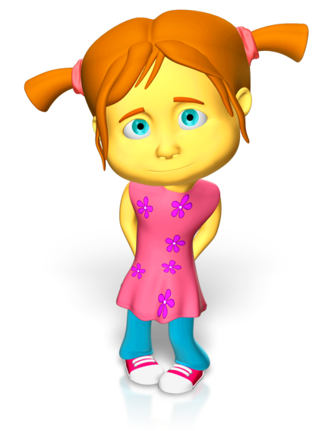
- Entry assessments
- Baseline assessments
- Checklists
- Event samples
- Time samples
- Sociograms
- Target child observations.
Collecting information from families
You should think about how you can overcome any barriers to communication with families. Different families will pose different challenges. You should have plans in place that enable you to deal with these issues if they arise.
- You may be able to get written communication translated for families whose first language is not English.
- You may be able to employ specialists to talk to families from different cultures or those with hearing impairments
- You may find that sending written correspondence proves unsuccessful for some people and you receive a better response when discussing needs
- You might be able to send home written tick sheets or multiple choice surveys for families who you do not see to talk to. Questions can reflect the standards for example:
  - do you feel that you have a good relationship with the setting?
  - are you well informed about your child’s progress?
  - do you feel your child is safe at the setting?
  - how far are your values and beliefs about childrearing respected?
- You could use suggestion boxes to collect information from parents or carers if they wish to remain anonymous
- Look at any complaints that you have had recently – have these been rectified or resolved?
- Use scrapbooks/home-books/communication books to send home with child with space for families to write a contribution about interests, concerns or other comments.
Remember to thank families for their contributions no matter how small – this ensures families feel appreciated.
Collecting information from community members
Members of the community and community workers that work with you in partnership may have relevant information that needs collecting.
Community members/workers may include:

- Club/playscheme worker
- Nurse
- Doctor
- Health visitor
- Counsellor
- Social worker
- Safeguarding officer
- Behavioural support worker
- Speech therapists
- Child psychiatrists
- Educational psychologists
- Play therapists.

Example assessment of learning outcomes templates:
These templates are used when all necessary information has been collected from all sources over a period of time. Information is included here after many observations and input from other professionals (if needed). Templates like these are good for planning opportunities to ensure that the learning outcomes are met.
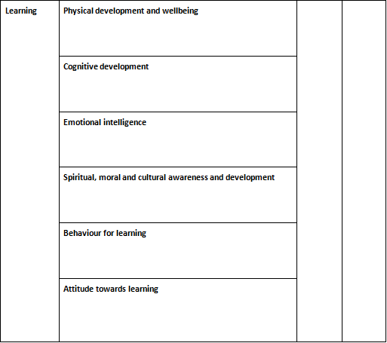
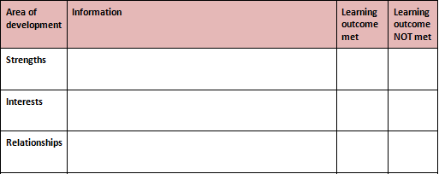

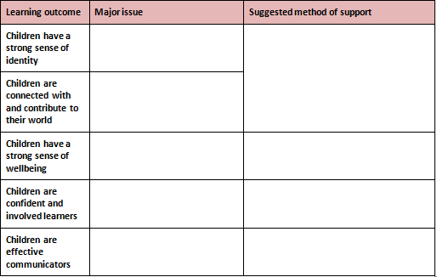

Activity 2A

2.2 – Share ideas with colleagues and involve them in the collection of information to inform the self-assessment

By the end of this chapter, the learner should be able to:
- Share ideas with colleagues and involve them in the collection of information to inform the self-assessment.

Quality improvement plan and self-assessment
A copy of your organisation’s quality improvement plan should be sent when requested by the childcare authority. This will act as a self-assessment of the standard of care and education that your organisation provides.
Your quality improvement plan should include:
- A statement about the organisation’s philosophy
- An assessment of own practices and how they match up to the National Regulations and National Quality Standard
- Areas that you think may need improvement.
Sharing ideas
You will need to share your thoughts and ask colleagues to collect and share their ideas to help contribute to the quality improvement plan.
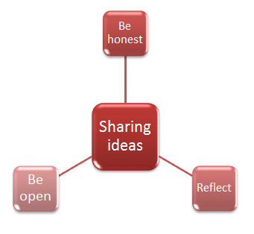

Staff can collect information through:
- Speaking with parents/carers
- Carrying out and recording surveys
- Observing each other working with the children and documenting findings – a checklist could be used for practices demonstrated
- Performance reviews with managers
- Writing and sending requests of information out to parents/carers, members of the community or other professionals that are involved in the child’s care
- Gathering information known about the child, e.g. notes and assessments of development
- Ensuring communication and scrapbooks are up-to-date – staff may need to take additional photographs or link the experiences documented with appropriate standards and practices
- Ensuring child’s file and all other documentation is complete.
Hopefully, after you have completed some of the above, you will have an idea of where your provisions strengths and weaknesses are. These can then be identified as issues.

Do not worry about covering all 18 standards and 58 elements of the National Quality Standards in your improvement plan. Instead, education providers should focus on the seven quality areas, and then prioritise the areas for improvement.
A reminder of the seven quality areas:
- Educational program and practice
- Children’s health and safety
- Physical environment
- Staffing arrangements
- Relationships with children
- Collaborative partnerships with families and communities
- Governance and leadership.

Activity 2B

2.3 – Record the information collected during the self-assessment process against the standards and elements in the NQF

By the end of this chapter, the learner should be able to:
- Record the information collected during the self-assessment process against the standards and elements in the NQF.

Recording information against the standards
Quality Area 1: Educational program and practice includes the following standards:
- Standard 1:1 – the educational program enhances each child’s learning and development.
- Standard 1:2 – educators facilitate and extend each child’s learning and development.
- Standard 1.3 – educators and co-ordinators take a planned and reflective approach to implementing the program for each child.
You should think about how this is achieved at your organisation. To do this, you can ask yourself and your colleagues several questions to ensure that you meet this quality area.
For example:
- How do we gain knowledge and understanding about the learning framework?
- How do we ensure higher learning outcomes for all ages?
- How are we able to learn about children – their abilities, interests and strengths?
- How do we ensure children’s experiences are focused on the child and not the adult?

- How do we help children to participate?
- How do we make decisions and who is involved?
- How do we show children that we value their thoughts and ideas?
- How do we assess development of children through ongoing planning, documenting and evaluation?
- Do we scaffold learning?
- Do we intentionally teach?
- Do we reflect regularly on children’s development – both as a group and as individuals?
You can get staff together to discuss these questions as well as looking at physical evidence of planning, reflection and evaluation through records held on site.
If you cannot answer key questions about a standard, then you should prioritise the area for improvement. You will need to then rank the areas that need to improve in order of urgency. To do this, first prioritise safety – is there anything that you are not doing, or doing, that could potentially cause harm? After this, look at how many questions you have not been able to answer in each area. Now you can make a record of the identified issues for improvement.

Activity 2C

2.4 – Ensure the self-assessment is available at the service to inform discussion of the assessment and rating process

By the end of this chapter, the learner should be able to:
- Ensure the self-assessment is available at the service to inform discussion of the assessment and rating process.

Ensure self-assessment is available
Your organisation’s self-assessment should be available to view so that it can inform the discussion surrounding the assessment and rating process.
You may have electronic, or hard copies of your organisation’s self-assessment and it may be held on a computer or filed away. Staff should be aware of where it is kept, so it is on hand for any meetings or research that they undertake. It may be possible to give staff copies of the self-assessment to ensure that it is available when needed. You should check with your organisational procedures or authorities to ensure that this is appropriate.
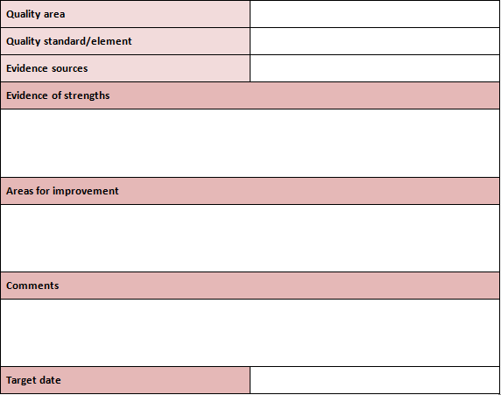
It may be useful to structure your self-assessment similar to the following:

Grade this aspect:
- Excellent – 6 points
- Very good – 5 points
- Good – 4 points
- Satisfactory – 3 points
- Weak – 2 points
- Unsatisfactory – 1 point.

Activity 2D

3. Facilitate the development of a quality improvement plan
3.1. Use the information gathered in the self-assessment process to inform the creation of the quality improvement plan
3.2. Collaborate with others to decide upon the strengths and the key improvements sought within the service
3.3. Work in collaboration with others to focus on how the key improvements sought will be reflected in the improvement plan
3.4. Record all of the required information in the plan
3.5. Plan to collaborate with others on a regular basis to review the quality improvement plan

3.1 – Use the information gathered in the self-assessment process to inform the creation of the quality improvement plan

By the end of this chapter, the learner should be able to:
- Use the information gathered in the self-assessment process to inform the creation of the quality improvement plan.

Use information gathered in the self-assessment
Your self-assessment will help inform your quality improvement plan. You and your colleagues should aim to think objectively and work together when creating the quality improvement plan.
An example self-assessment:
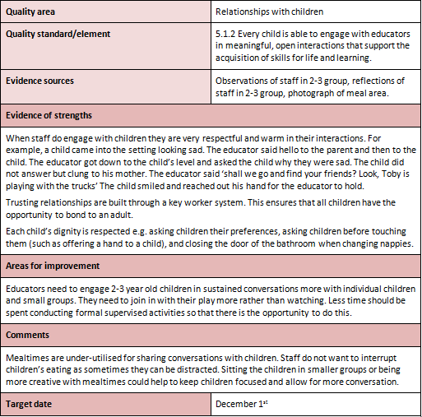

Quality improvement plan
By this stage, you may have a found a few issues that you will need to address in order to improve. Even if you provide excellent care and education services, there will always be ways you can go further.
You will need to identify:
- The issue identified
- The related area, standard or element
- The outcome you hope to achieve
- The level of priority – high, medium, low
- How you will know if you are successful
- When do you aim to have resolved the issue?
- What progress have you made with this issue already?
Example:
Issue: In the 2-3-year-old group, there is a focus on whole group conversations rather than small group, or individual conversations. Educators tend to be directive and supervisory instead of getting involved and engaging children while they play.
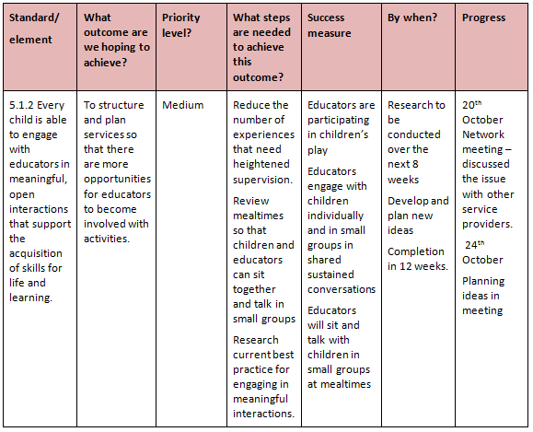
A template, such as the table above, can be used to structure the quality improvement plan making it easier to implement strategies that are appropriate to address the issue. The example above would be used to inform and spark discussion about the issues to be addressed.
For example, the mealtime area is currently small tables pushed together. This needs to be altered so that children sit in small groups and it is easier for educators to talk to them. Educators may decide it would be better to pull the tables out and seat the children around them in groups of four.

Activity 3A

3.2 – Collaborate with others to decide upon the strengths and the key improvements sought within the service

By the end of this chapter, the learner should be able to:
- Collaborate with others to decide upon the strengths and the key improvements sought within the service.

Collaborating with others to decide upon the strengths and the key improvements sought within the service
If you are to create an effective quality improvement plan, it is vital to collaborate with others both internal and external to your service. Together, you should decide upon the strengths and improvements you want to develop and make through the service.

Specifically, you may collaborate with:
- Colleagues
- Clients
- Managers and supervisors
- Teachers, professors, trainers and other educators
- Care workers
- Regulators
- Lawyers.
When collaborating with others, you should:
- Adopt and maintain a proactive active and positive attitude
- Be patient and diplomatic at all times
- Be prepared to compromise
- Respect other peoples’ point of view
- Mediate in disputes if necessary
- Ask for frequent expansion on points that you do not understand.
The strengths and key improvements you decide to develop and make may relate to:
- Educational program and practice
- Children’s health and safety
- Physical environment
- Staffing arrangements
- Relationships with children
- Collaborative partnerships with families and communities
- Leadership and service management.
The importance of teamwork is crucial when it comes to facilitating the development of a quality improvement plan. With the help, ideas and support of others with specific expertise, you will always achieve more than you can by working alone.

Activity 3B

3.3 – Work in collaboration with others to focus on how the key improvements sought will be reflected in the improvement plan

By the end of this chapter, the learner should be able to:
- Work in collaboration with others to focus on how the key improvements sought will be reflected in the improvement plan.

Key improvements
You will need to come up with ideas about how to tackle key improvements. What can you change to improve? For each key improvement, you should be able to think of specific ways you can improve and put these into practice.
Using the example from chapter 3.1, the key improvements would be to:
- Reduce the number of experiences that need heightened supervision:
  - certain craft activities that use glue or scissors
  - marble run

  - home corner (because it is popular and gets overcrowded) – could add to this area (maybe include a grocers or hairdressers)
  - stagger outside time so that children can go out in smaller groups, making them easier to supervise and therefore give the opportunity to engage children in sustained conversations
- Review mealtimes so that children and educators can sit together and talk in small groups:
  - separate tables and chairs so that there are four seats at one table
  - create a covered seating area outside
  - have pretend BBQs and teddy bear picnics where children and educators sit on mats and eat
- Research current best practice for engaging in meaningful interactions:
  - internet and book research
  - training courses
  - networking groups.

Activity 3C

3.4 – Record all of the required information in the plan

By the end of this chapter, the learner should be able to:
- Record all of the required information in the plan.

Recording information in the plan
Information should be recorded in the quality improvement plan.

This requires searching for the relevant section to record:
- Issues
- Standards and elements
- Proposed outcomes
- Priority levels
- Steps needed to achieve proposed outcome
- Success measures
- Timescales
- Progress.
You should check your organisational guidelines as there may be templates or specific forms for you to use.

Activity 3D

3.5 – Plan to collaborate with others on a regular basis to review the quality improvement plan

By the end of this chapter, the learner should be able to:
- Plan to collaborate with others on a regular basis to review the quality improvement plan.

Reviewing the quality improvement plan
You should schedule times where you review the quality improvement plan with others on a regular basis. This could mean weekly, bi-weekly or monthly reviewing opportunities.
Reviewing the quality improvement plan will help you to:

- Check that practices are being implemented as planned
- Check the progress of each change
- Identify and rectify any issues with new practices
- Ensure everyone is informed of the changes
- Prevent complacency issues
- Update and document practices that have been successfully established
- Keep to the proposed schedule for changes to be implemented.
At the review meetings, you should look at the proposed improvements and question their success and implementation.
For example:
- Are we on timescale?
- How far have we got with making the changes?
- Have there been any amendments to the original plan?
- Have there been any problems, are these ongoing or resolved?
- Are improvements working?
It is your role to act as an intermediary for discussions during a meeting. Think about what information you have been given so far and what else you need to know.
Example conversation:
You: ‘So, last time we were looking in more detail at reducing the number of experiences that need heightened supervision. You came up with some interesting ideas. Have you been able to implement any of them?’

Educator: ‘Yes, we are underway with making changes to the home corner. I got the children involved in thinking about what sort of things we find in a hairdressers. We have sent out letters to parents asking for donations of items we could use in the new hairdressers. Things like rollers, combs, hair magazines, and we have had a really good response. We are just planning how to put it all together.’
You: ‘Have you decided on an area of the room?’
Educator: ‘Yes, we have re-organised the art and craft area so that we can put it next to home corner. We thought that this would be best as it might seem like a street.’
You: ‘So when do you think it will be ready?’
Educator: ‘We have everything ready to go now so by the end of the day – ready to play with for tomorrow’
You: ‘That’s fantastic. Thank you for all your hard work on this’

Activity 3E

4. Coordinate the service for a site visit
4.1. Inform all stakeholders that the service has been selected for assessment and rating and that the assessment and rating process has commenced
4.2. Schedule meetings with stakeholders and staff where appropriate
4.3. Check for accuracy and completion of all documentation required for examination
4.4. Ensure all staff understand what may be required of them during the assessment visit

4.1 – Inform all stakeholders that the service has been selected for assessment and rating and that the assessment and rating process has commenced

By the end of this chapter, the learner should be able to:
- Inform all stakeholders that the service has been selected for assessment and rating and that the assessment and rating process has commenced.

Who are your stakeholders?

The first step is to identify your stakeholders.
Stakeholders may include:
- Owners or managers
- Users of the service, e.g. parents
- Staff members
- Education provider
- Association official or member
- Union representative.
Staff members may already know that the service has been selected, but it is still important to formally send them a letter for their records.
The information contained within the letters may differ slightly depending on the type of recipient. Parents may want to know what the rating process is for example, whereas owners, managers and officials may already know this information.
You should inform everyone of the process that the assessment will follow with important information included, such as the dates and times of the inspection. Stakeholders may wish to know information about the visit and what happens after the visit.

See the table below:
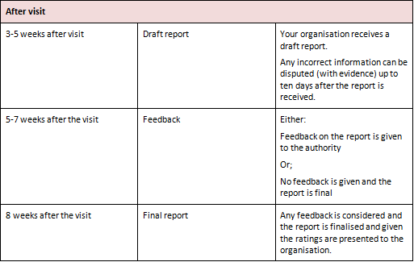
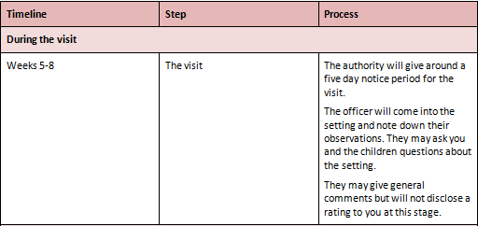

Activity 4A

4.2 – Schedule meetings with stakeholders and staff where appropriate

By the end of this chapter, the learner should be able to:
- Schedule meetings with stakeholders and staff where appropriate.

Schedule meetings with stakeholders and staff
There might be need to schedule meetings with various stakeholders leading up to the assessment and ratings process.
Conducting a meeting
When conducting a meeting, one important factor to consider is the structure. A meeting should have a sensible structure to help team members engage.

Here is an example of how you could structure your meeting:
- Introduction:
  - summary of progress so far
  - topics up for discussion
- Individual responsibilities and accountabilities and feedback
- Teams and departments
- Issues/topics open for discussion in detail
- Conclusion and summary – this enables you to answer any queries and provide a last motivational boost
- Questions and answers.
Presentation methods
You may like to use a couple of different methods to help team members engage and ensure that you have covered all the details.
Remember:
- Small teams may benefit from an informal presentation method, e.g. a group circle
- Slides provide an on-screen method and can sometimes be better than simply speaking as they provide a visual stimulus
- Written communication can help to expand on points in the presentation and give staff something to refer to
- Audio-visual media is a method that uses sound and images, e.g. a video recording. It can be very engaging so you could consider it for communicating with team members during the conclusion to a meeting.

Activity 4B

4.3 – Check for accuracy and completion of all documentation required for examination

By the end of this chapter, the learner should be able to:
- Check for accuracy and completion of all documentation required for examination.

Checking accuracy
It is important to check the accuracy of all the documentation required for examination. If information is not correct, it may impact on your rating. It is important to make a good impression when having an assessment, and the professional completion of all documentation is a good start.
Documentation you need to check includes:
- Policies
- Improvement plan
- Self-evaluation forms.
Your organisation may have procedures to help you with accuracy, but here are some general tips and ideas:

- Read through and check you have all the information in place first
- Next, check if all the information is correct – be careful with dates and facts
- Check spellings and be aware of different spellings, e.g. Stuart and Stewart
- Try to avoid using abbreviations unless everyone is in agreement and has full knowledge of the meanings
- Do not rush – if you rush and make a mistake, it will take longer to rectify in the end.

Activity 4C

4.4 – Ensure all staff understand what may be required of them during the assessment visit

By the end of this chapter, the learner should be able to:
- Ensure all staff understand what may be required of them during the assessment visit.

What might be required of staff during the visit?
You can talk to staff either individually or in a group about the assessment visit. It may be a good idea to send out written information about the assessment visit. If you think that staff might have concerns or worries, be sure to ask them to come and see you to talk about them.

Helping staff to become aware of the assessment procedure is imperative, as it can help them to function well on the day. Staff who do not understand what is required of them may give the wrong impression to inspection authorities.
Staff might be expected to:
- Show representatives around the setting
- Be polite and hospitable
- Co-operate with authorities by answering questions
- Let authorities sit in and observe teaching
- Encourage children to answer questions from representatives
- Inform/remind parents on arrival.

Activity 4D

Summative Assessments
At the end of your Learner Workbook, you will find the Summative Assessments.
This includes:
- Skills Activity
- Knowledge Activity
- Performance Activity.
This holistically assesses your understanding and application of the skills, knowledge and performance requirements for this unit. Once this is completed, you will have finished this unit and be ready to move onto the next one – well done!

References

These suggested references are for further reading and do not necessarily represent the contents of this unit.
Websites
Victoria: http://www.legislation.vic.gov.au/Domino/Web_Notes/LDMS/PubStatbook.nsf/51dea49770555ea6ca256da4001b90cd/b73164fe5da2112dca2577ba0014d9ed!OpenDocument
New South Wales: http://www.legislation.nsw.gov.au/sessionalview/sessional/act/2010-104.pdf
Australian Capital Territory: http://www.legislation.act.gov.au/a/2011-42/default.asp
Queensland: http://www.legislation.qld.gov.au/LEGISLTN/ACTS/2011/11AC038.pdf
Northern Territory: http://notes.nt.gov.au/dcm/legislat/Acts.nsf/5504d78eee675d6e6925649e001bb652/95724bfed2b632c96925792e007cb5c1?OpenDocument
South Australia: http://www.legislation.sa.gov.au/LZ/C/A/EDUCATION%20AND%20EARLY%20CHILDHOOD%20SERVICES%20(REGISTRATION%20AND%20STANDARDS)%20ACT%202011.aspx
Tasmania: http://www.thelaw.tas.gov.au/tocview/index.w3p;cond=;doc_id=48%2B%2B2011%2BAT%40EN%2B20120522120000;histon=;prompt=;rec=;term=
Western Australia: http://www.slp.wa.gov.au/legislation/statutes.nsf/main_mrtitle_12929_homepage.html

