
BSBRSK401 Identify risk and apply risk management processes

HLTWHS001 Participate in workplace health and safety

SISXFAC001 Maintain equipment for activities

Copyright © 2018 CSTC Pty Ltd

All rights reserved. No part of the contents of this publication may be reproduced or used in any form or by any means – graphic, electronic, or mechanical including photocopying, digitising, recording, or information storage-and-retrieval systems – without the written permission of CSTC Pty Ltd.
ASSESSMENT FOR BSBRSK401, HLTWHS001 & SISXFAC001
Student name
Date of assessment submission | Click here to enter a date.

Trainer/Assessor’s name
Date of assessment marking | Click here to enter a date.
Outcome for units | ☐ Competent  ☐ Not Yet Competent

TASK INSTRUCTIONS

- The assessment for these units of competency consists of the following:
  - Case studies: You are required to provide written responses to a series of case study scenarios to demonstrate your knowledge and skills.
  - Practical tasks: You will be required to put your knowledge and skills into practice, through observed tasks and work experience.
- At times, you will be provided with a specific context to which you must respond, otherwise it is anticipated that you will use a scenario of your choosing to provide context to the task.

CASE STUDIES

Examine the picture below.
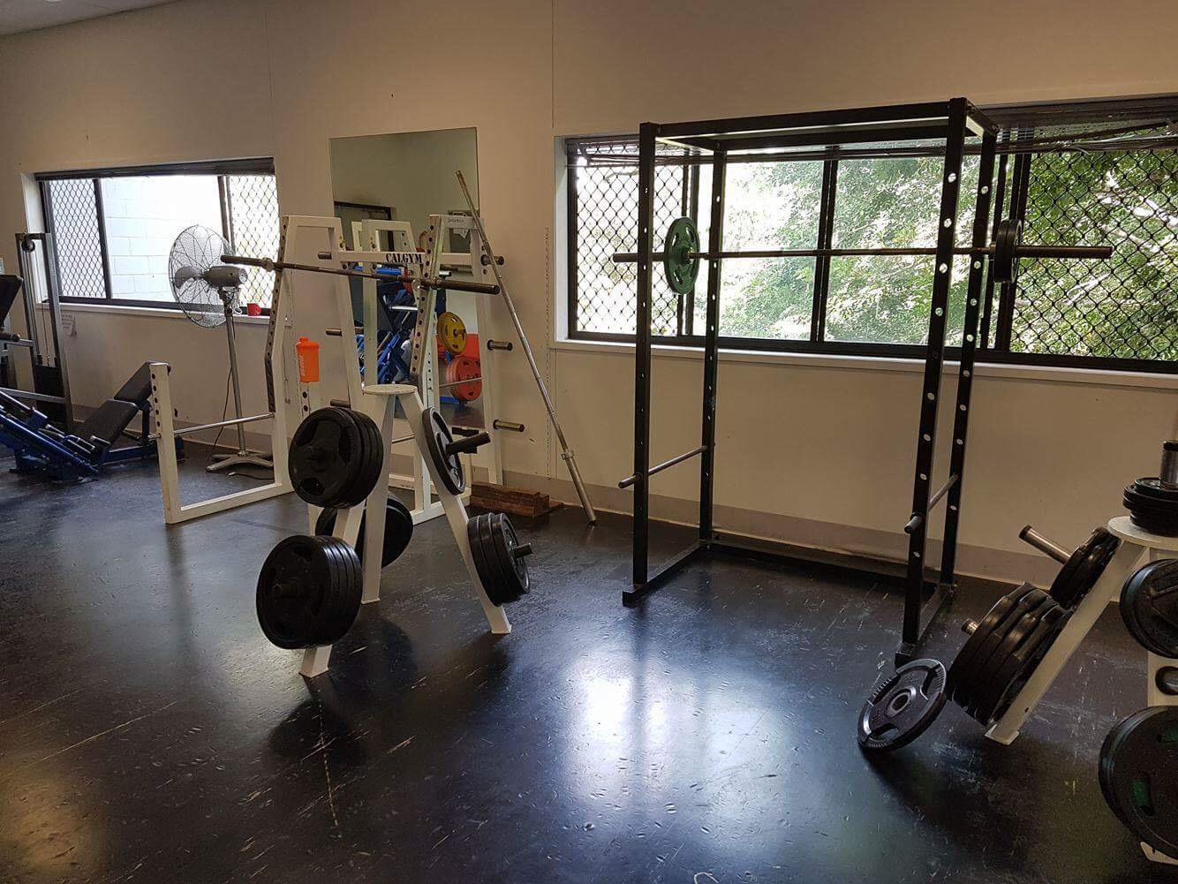

- Identify five (5) hazards present in the picture, completing a risk analysis for each.
- Rank the hazards from 1 to 5 (1 = most serious; 5 = least serious).

EXAMPLE HAZARD
Describe hazard
Dumbbells left on gym floor
Possible consequence(s)
- Trip and fall
- Possible bruising, broken bones, graze, cuts
Control measure(s)
- Erect signs around the gym
- Remind patrons to return weights
- Workers should consistently check gym floor
Determine the level of risk
Matrix | A:  Death or permanent disability | B:  Serious injury | C:  Lost time injury | D:  Casualty Treatment | E:  First Aid
1: Very Likely | E | E | H | H | M
2: Likely | E | H | H | M | M
3: Possible | H | H | M | M | L
4: Unlikely | H | M | M | L | L
5: Very Unlikely | M | M | L | L | L

E: Extreme | H: High | M: Medium | L: Low

Consequence rating: Serious injury (B)
Likelihood rating: Possible (3)
Level of risk: High (H)

HAZARD 1
Describe hazard
Possible consequence(s)
Control measure(s)
Determine the level of risk
Matrix | A:  Death or permanent disability | B:  Serious injury | C:  Lost time injury | D:  Casualty Treatment | E:  First Aid
1: Very Likely | E | E | H | H | M
2: Likely | E | H | H | M | M
3: Possible | H | H | M | M | L
4: Unlikely | H | M | M | L | L
5: Very Unlikely | M | M | L | L | L

E: Extreme | H: High | M: Medium | L: Low

Consequence rating:
Likelihood rating:
Level of risk:

HAZARD 2
Describe hazard
Possible consequence(s)
Control measure(s)
Determine the level of risk
Matrix | A:  Death or permanent disability | B:  Serious injury | C:  Lost time injury | D:  Casualty Treatment | E:  First Aid
1: Very Likely | E | E | H | H | M
2: Likely | E | H | H | M | M
3: Possible | H | H | M | M | L
4: Unlikely | H | M | M | L | L
5: Very Unlikely | M | M | L | L | L

E: Extreme | H: High | M: Medium | L: Low

Consequence rating:
Likelihood rating:
Level of risk:

HAZARD 3
Describe hazard
Possible consequence(s)
Control measure(s)
Determine the level of risk
Matrix | A:  Death or permanent disability | B:  Serious injury | C:  Lost time injury | D:  Casualty Treatment | E:  First Aid
1: Very Likely | E | E | H | H | M
2: Likely | E | H | H | M | M
3: Possible | H | H | M | M | L
4: Unlikely | H | M | M | L | L
5: Very Unlikely | M | M | L | L | L

E: Extreme | H: High | M: Medium | L: Low

Consequence rating:
Likelihood rating:
Level of risk:

HAZARD 4
Describe hazard
Possible consequence(s)
Control measure(s)
Determine the level of risk
Matrix | A:  Death or permanent disability | B:  Serious injury | C:  Lost time injury | D:  Casualty Treatment | E:  First Aid
1: Very Likely | E | E | H | H | M
2: Likely | E | H | H | M | M
3: Possible | H | H | M | M | L
4: Unlikely | H | M | M | L | L
5: Very Unlikely | M | M | L | L | L

E: Extreme | H: High | M: Medium | L: Low

Consequence rating:
Likelihood rating:
Level of risk:

HAZARD 5
Describe hazard
Possible consequence(s)
Control measure(s)
Determine the level of risk
Matrix | A:  Death or permanent disability | B:  Serious injury | C:  Lost time injury | D:  Casualty Treatment | E:  First Aid
1: Very Likely | E | E | H | H | M
2: Likely | E | H | H | M | M
3: Possible | H | H | M | M | L
4: Unlikely | H | M | M | L | L
5: Very Unlikely | M | M | L | L | L

E: Extreme | H: High | M: Medium | L: Low

Consequence rating:
Likelihood rating:
Level of risk:

RANK HAZARDS (1 = most serious; 5 = least serious)
Hazard 1
Hazard 2
Hazard 3
Hazard 4
Hazard 5

Outcome for Case Study 1 | ☐ Satisfactory  ☐ Not satisfactory
Trainer/Assessor comments

It is important to maintain items in the gym environment to maintain a safe environment.
  - Create a maintenance schedule for four (4) items regularly seen in a gym environment – one from each of the following categories:
- Gym floor
- Resistance training equipment item
- Cardiovascular machine
- Gym environment
Include daily, weekly and monthly functions, as well as maintenance/repair procedures that may only take place a limited number of times per year.
  - Locate two (2) instruction booklets for common items in a gym. Within each booklet, identify two (2) points with regards to safety and minimising risk for gym patrons.
  - What should an employee do if they cannot repair a piece of gym equipment?
- Who should they report the matter to?
  - Identify three (3) pieces of equipment that are essential to the safety of patrons in an emergency situation.
- For each equipment item, describe the procedures required to check the currency of their servicing history.

Example:
Name equipment item |  | Lat pulldown
Maintenance requirements
Daily | Weekly |  | Monthly | 6+ months | Other
- Check cleanliness  - Ensure security of safety clips  - Wipe down with anti-bacterial | - Ensure pin is safely secured to stack  - Check seats for tearing |  | - Check plate stack for smooth function  - Check smooth rotation of pulleys  - Check cable for signs of fraying | - Check pulleys and cables for major wear and tear | Nil

ITEM 1: GYM FLOOR ITEM
Name equipment item
Maintenance requirements
Daily | Weekly |  | Monthly | 6+ months | Other

ITEM 2: RESISTANCE TRAINING EQUIPMENT ITEM
Name equipment item
Maintenance requirements
Daily | Weekly |  | Monthly | 6+ months | Other

ITEM 3: CARDIOVASCULAR MACHINE
Name equipment item
Maintenance requirements
Daily | Weekly |  | Monthly | 6+ months | Other

ITEM 4: GYM ENVIRONMENT ITEM
Name equipment item
Maintenance requirements
Daily | Weekly |  | Monthly | 6+ months | Other

INSTRUCTION BOOKLET 1
Name equipment item
Instruction booklet requirements

INSTRUCTION BOOKLET 2
Name equipment item
Instruction booklet requirements

Code of Practice name
Requirements

EMERGENCY EQUIPMENT 1
Name equipment item
Checking servicing currency

EMERGENCY EQUIPMENT 2
Name equipment item
Checking servicing currency

EMERGENCY EQUIPMENT 3
Name equipment item
Checking servicing currency

Outcome for Case Study 2 | ☐ Satisfactory  ☐ Not satisfactory
Trainer/Assessor comments

You have received the following the following client complaint via email:

To whom it may concern,

During the last few sessions at the gym, I have noticed a worrying trend. Of an afternoon, the area around the drink tap is becoming increasingly flooded; it is creating a slippery surface that I have very nearly fallen on at least three times. This leaking tap is a health hazard!

The gym floor workers have acknowledged my complaints, however they are yet to rectify the situation. I fear the next time I go to the gym could result in serious injury. It is disappointing that so far my complaints have fallen on deaf ears. I do not want to go to another gym, but if I continue to feel unheard and unsafe I will begin to look at your competitors.

Please tell me what you are going to do about this.

Regards,
Jim Patron

Respond to this client complaint. Ensure your response meets the following requirements:
- Shows empathy
- Acknowledges recording of the incident
- Discusses the duty of care
- Identifies the relevant chain of command in the resolution and reporting process
- Provides a resolution, including an improvement of organisational policies and procedures to minimise the likelihood of this occurring again

Your response

Outcome for Case Study 3 | ☐ Satisfactory  ☐ Not satisfactory
Trainer/Assessor comments

Consider your safety requirements in a gym environment.
  - Describe ways that the following signs could be used in a gym:
- Dangerous goods classification
- Emergency equipment
- Personal Protective Equipment (PPE)
- Hazard
  - Outline the legal requirements with regards to safety
- Identify the legislation that outlines the safety requirements for a gym
- Identify two (2) legal requirements outlined under safety legislation/regulations
- Identify the regulatory authority who would check that legal requirements are being met
  - In situations where an employee cannot repair a piece of gym equipment, who should they refer the repair task to?
  - What role do clients and staff have in reducing or preventing the spread of infectious diseases?
- How can a gym regulate these practices?
  - What reporting processes can be put in place to ensure injuries are appropriately reported?
  - Describe how an employee may reflect on their own levels of stress and fatigue. Who should employees report to?
  - Explain the best process for undertaking hazardous manual tasks.

Safety signs
Legal requirements
Referring repair tasks
Infectious diseases
Reporting processes
Stress and fatigue
Hazardous manual tasks

Outcome for Case Study 4 | ☐ Satisfactory  ☐ Not satisfactory
Trainer/Assessor comments

PRACTICAL TASKS

You are required to have a suitable observer verify your ability to complete the following tasks. These tasks may be simulated or real.

TASKS | VERIFIED
- Conduct a safety inspection of your work area, completing a risk register:  - Identify hazards and associated risks (including hazardous manual tasks)  - Consult with relevant stakeholders to analyse and evaluate risks  - Identify and evaluate control measures  - Develop and implement treatment plans for your area of responsibility  - Report hazards as per workplace procedures  - Refer hazards that are beyond your own area of responsibility  - Maintain risk management documentation  [Evidence: Risk Register] | ☐
- Respond to a (simulated) fire emergency/drill:  - Provide information needs to emergency response personnel during reporting, arrival and in response to emergency  - Checking and accounting for people during an evacuation  - Debriefing with an appropriate person, as per workplace procedures, to identify personal levels of stress and fatigue | ☐
- Over five (5) service periods, safely conduct six (6) of the following minor maintenance tasks on equipment (i.e. equipment used within the facility, participant/client-specific equipment, emergency equipment, large items requiring lifting and assembly):  - Cleaning  - Lubrication  - Reinflating  - Checking for damage  - Restocking or refilling  - Repairing  - Calibration  - Storage (ensuring entry and exit in the case of an emergency situation)  - Completing maintenance records and forms (e.g. logbook) | ☐

Outcome for Practical Tasks | ☐ Satisfactory  ☐ Not satisfactory
Trainer/Assessor comments

