Introduction of the construction works that were planned:
Sub-contractor Trafflec were awarded to complete some outstanding works remaining within our Maintenance Area here in STWBA ASMTI. Between various phone calls and emails Trafflec were informed of the works required to be completed over the weekend of 11th and 12th February, under supervision of myself. Below I have listed the details of an email sent to Trafflec personnel after the confirmation of dates to start. These dates were aligned with the project precinct roster (10:4) so Laing O’Rourke Supervision had a presence (No sub-contractor can conduct works without LO’R Supervision on site). We have nominated these 2 days for Trafflec to complete these works, however due to other sub-contractor interaction in other locations within the UOLF, Trafflec may continue to complete this works during the start of the following week. Below is the information sent to the sub-contractor listed the works required.
Page 1 – Communications – Drawing # EST00355-AEC-07-IT-DRW-00112
- Core pit 7102 and complete conduit installation (LVL2 security personnel confirmed for Saturday 11th)
- Complete conduit installation to new comms pit installed by Trafflec
- Ensure all conduits have been mandrilled and draw ropes installed

Page 2 – Electrical (Maintenance Area) – Drawing # EST00355-WG-07-EL-DRW-00211
- Core and Install 8 (4P63 & 4P80) conduits from MSB Pit to pit 404.
- Complete 3 x light pole footings
- Complete conduit install to kiosk pit
- Ensure all conduits have been mandrilled and draw ropes installed

Page 3 – Electrical (Composting Toilet) – Drawing EST00355-WG-EL-DRW-00213
- Backfill around pit D6R 600
- Complete coring into pit and install conduits
- Ensure all conduits have been mandrilled and draw ropes installed

Page 4 – Drainage & Landscaping
- Install 900 x 600mm filed inlet pits
- Detail overland flow paths
- Complete landscaping

Miscellaneous
- Complete rectification of pits at the UOLF (Strapping of pits that had been previously rectified)

Prior to the email being sent, I conducted a walkthrough and inspection of all work locations to ensure that no other sub-contractor materials/equipment/tools were in located/situated in the vicinity of these works to reduce obstruction / delays for when the sub-contractor commences works. It was a finding that, one of the locations that required excavations to find a capped conduit had materials within the area (Pallets, Timber, and hard barricading). During these inspections I immediately delegated our onsite labour workforce to ensure these materials were removed and relocated by the end of the day. The pallets were then relocated by our On-Site telehandler to the closest laydown yard, and the timber and barricading were collected and removed also. If works relevant to excavations within the South Maintenance Area are planned, this is brought to the attention of the on-site work personnel during morning pre-start for everyone’s awareness and to ensure no one has the risks of entering the excavation exclusion zone.
Each page has been attached below for visibility; these attachments were included within the Email. Prior to sending out this email, I requested my partner Project engineer to include markups and labels within the drawings to help translate the works in a visual representation. These pages were constructed in a critical path, as each of these steps (Pages) had to be completed in a timely manner due to following trades entering the work area’s the following week.

Note: Plans attached have been reduced in size and plan information blanked black for confidentiality reasons.
additional information of plans can be provided on request

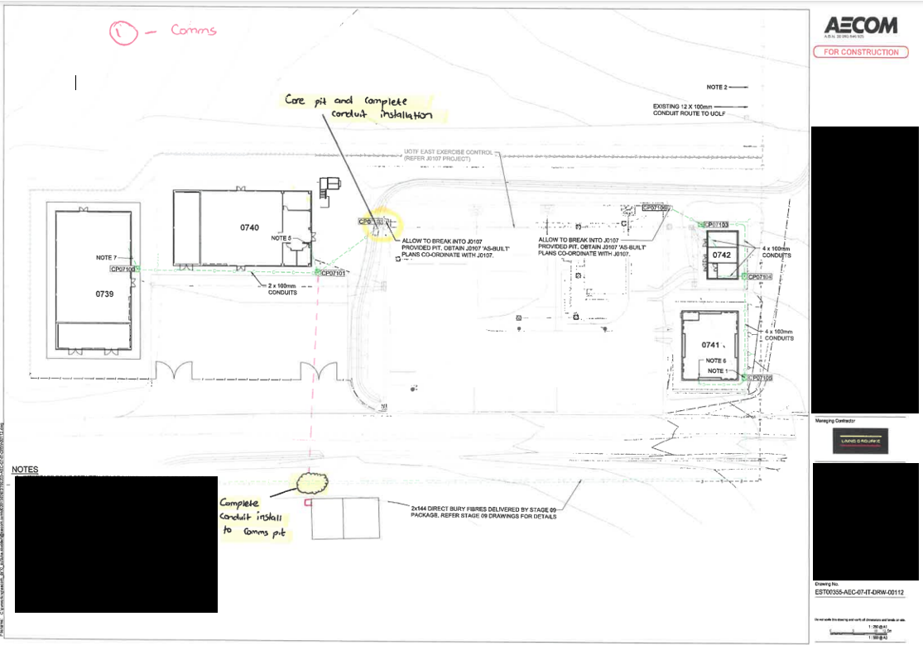
Page 1 Communications Drawing # EST00355-AEC-07-IT-DRW-00112

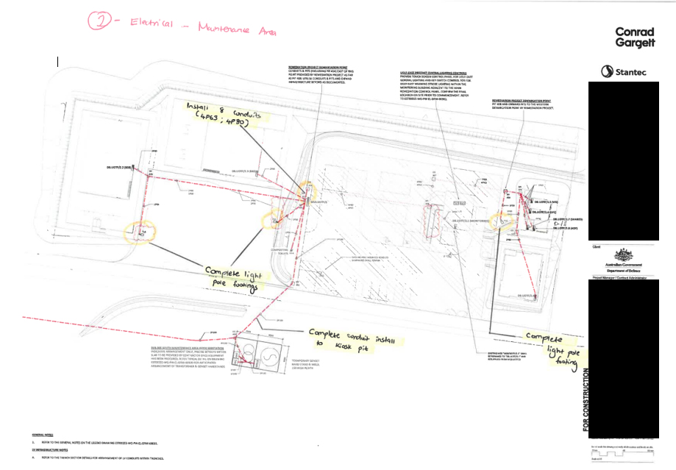
Page 2 Electrical (Maintenance Area) – Drawing #EST00355-WG-07-EL-DRW-00211

Page 3 – Electrical (Composting Toilet) – Drawing EST00355-WG-EL-DRW-00213
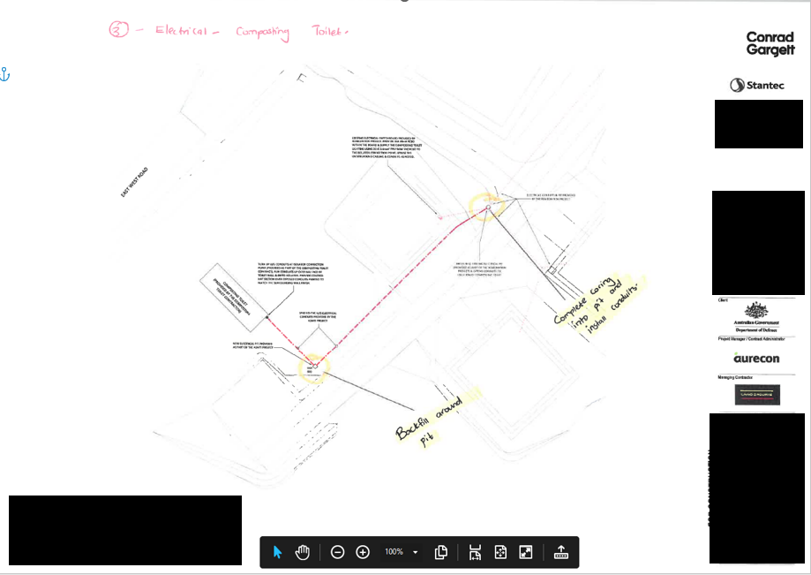

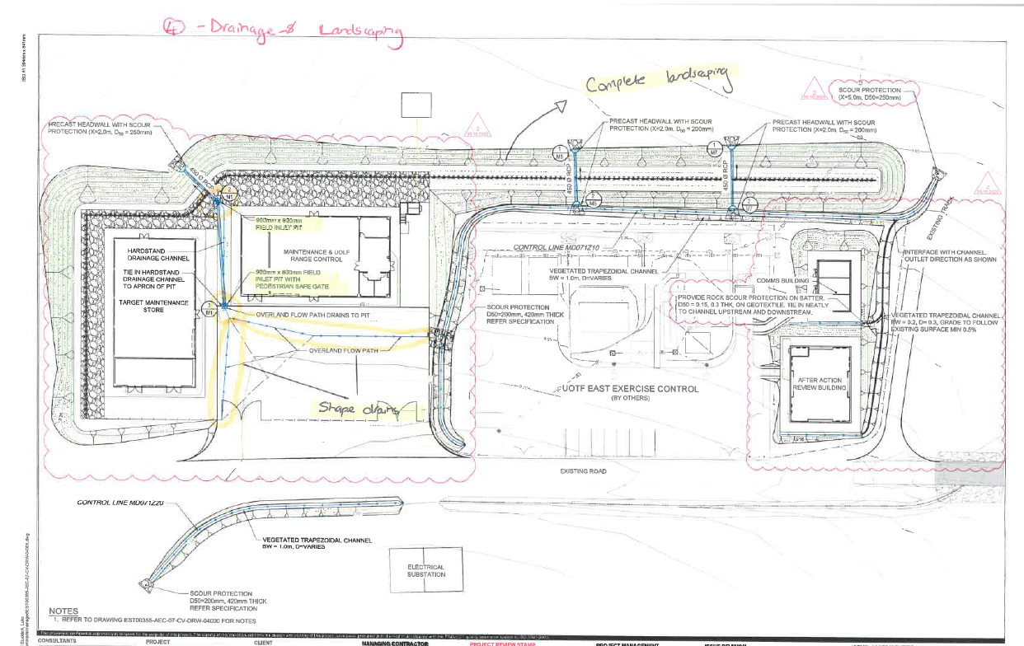
Page 4 – Drainage & Landscaping

Day before the commencement of Trafflec’s work, I conducted an inspection on all qualification documentation was facilitated through a LO’R used system called ‘EIFY’, This system is able to track each sub-contractor’s personnel details, qualifications, and additional relevant information required to attend site. Below is a snippet of the personnel inspected, at this person was the nominated operator for the day of works (Excavator Operator)
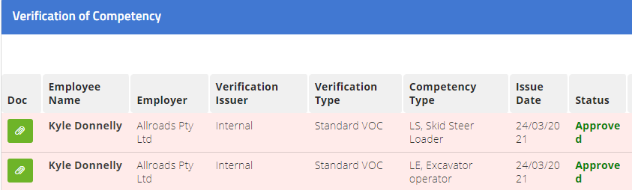
Under Laing O’Rourke requirements, for an operator to undertake plant operations, the operator must have all relevant qualifications uploaded and approved through EIFY – this includes a valid and in date verification of competency as well as the Statement of attainment (Or RII competency)
Kyle **** was solely the operator during this works, and approved to operate the machinery.
As shown within each plan and documentation, several services were captured within and had been made aware to the worksite personnel. Our procedure for reviewing excavation works is filled out within an Excavation permit. The excavation permit must be issued to a certified permit holder after a visual inspection has been completed (Permit holder training appointment letter was also witnessed during the inspections of all required qualification). The day of arrival, Myself and Ashley ***** conducted a visual inspection on all areas of work and any issues he may have. With the excavation permit was attached Azbuilts of the work area to identify all services within in the proximity of the work zone. This pointed out all communication and electrical services in ground already and ensuring that the permit holder (Ashley) as well as the operator are aware of all inground services to avoid any damage/potential risk. Due to the hardcopy of this excavation permit being shredded for confidentiality, and online copy has been closed out and inaccessible, I am unable to attach the documentation – If required, I can see what I can acquire for proof.
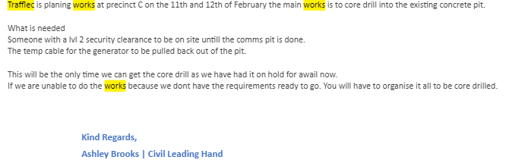
Page 1 – Communication conduit installation works.
Trafflec were required to core pit 7102 and complete conduit installation – Due to this being a LVL2 Security communication pit, a Master key for the communication pit had to be acquired from the Defence range control by a qualified person(s). This person was currently working under our communications sub-contractor (Nielsen’s) who acquired the key through my organisation with Range control and unlocked the pit for the day to complete the works. Prior to arrival Trafflec were informed of the core drilling works through the email details listed above – A small snippet is attached below to show the correspondence of these works.

Page 2 – Electrical conduit and core drilling works.
Shown within the page 2 drawing stipulating the electrical conduit that must be extended, it was made clear to Trafflec that they were required to engage a vac truck, as there was an optic fibre cable running in line with the conduit planned to be installed. Due to that cable being so closed to where the excavation must take place, it was organised that the vac truck is required to slot trench where the cable could potentially be to locate its exact position. Once the cable is located, Trafflec can then continue the excavations / Hand digging back from the cable to locate the conduit to extend. Note: - The optic fibre cable was not live.
During these works, I ensured I was there while the works were being conducted for supervision and a presence to ensure there were no potential risks/hazards in the area or during the works. Prior to this Vac truck commencing, all documentation for vehicle pre-mobilisation was required to be sent through. Due to this Truck and driver being inducted and pre-mobilised on site, another pre-mobilisation checklist was not required before works – However, it was reminded to the driver that a weed and seed declaration form had to be filled and present ready for inspection at our security gate. During excavations, an exclusion zone was constructed with hard barricading and flagging.
Page 3 – Compose toilet works.
Shown within the Page 3 Drawing, Trafflec were needing to backfill material that was left from the previous pit install works, and complete coring works into another pit to install conduits. These works required an excavator, crew truck for tools and equipment and the core drill with labour. During the excavation permit walk around with Ashley, I explained the important of using certain road accesses to this work site, as we had various sub-contractors within the UOLF operating plant. To keep the plant interaction low, they were told to use an alternate route to the job. During the conduction of these works, visual and documented inspections were made, as well as their works being personally entered into my diary for details of the works.
This photograph was taken of the Trafflec crew continuing excavation works while completing the connection of conduits into the pit.
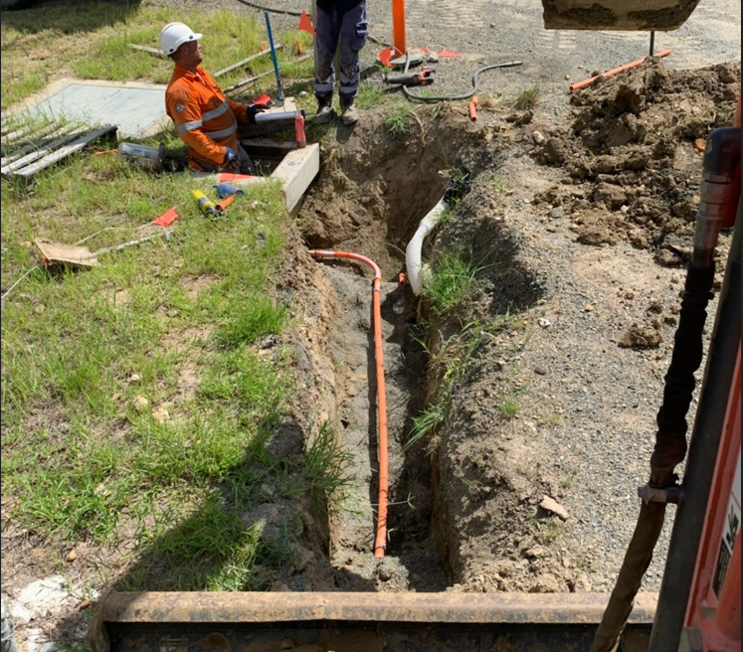
Below I have also attached a distributed fieldview form, showing the documentation of the daily site report while the sub-contractor was on site.

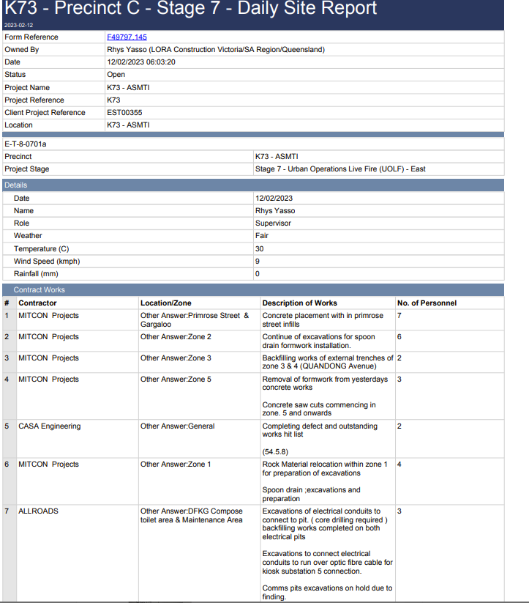

(Trafflec)

The daily site report attached is documentation uploaded within a LOR used system called fieldview – Having this documentation ensures that work date and descriptions can be accessible by project wide personnel for visibility and to ensure that all works have been documented and recorded each day. This includes the number of on-site personnel conducting the works.
Accommodation, on-site labour and start times
On-site we currently assist in facilitating a camp for the workforce to minimise fatigue risk with driving in and out. This camp currently holds up to 150 personnel, accommodating any sub-contractor who meet the requirements to be booked in. Prior to commencement of works Trafflec were informed of the camp and its current capacity, and heavily advised that being booked in within the camp would make the works more efficient and increase productivity as it would minimise the travel time. (This discussion was held over phone call). Due to the late booking request to the on-site camp and rise of workforce presence on site, they were unable to accommodate the crew of 4 as they were at full capacity. Due to having to drive in and out of the work site each day, it was advised that they were to leave Rockhampton at the earliest at 5:00am to arrive at the security gate by 6:00am (Time the security gate opens). To remain within fatigue management hours, Trafflec were told to have left site by 4:30pm to remain in this timeframe.
With the work required it was requested to have the following: -
a. Excavator / Truck Operator
b. General Labourer
c. Leading Hand / Supervisor
d. Core drill operator / Truck Operator / General Labourer.
Having these operators / labourers in place gives them the ability to be flexible with tasks and ensure all personnel on site is qualified and conducting works in a safe and professional manner.

Daily Reports
Below I’ve attached evidence of a few handwritten daily brief reports of trafflec’s works (Digital diary site diaries like above, were also documented each day)
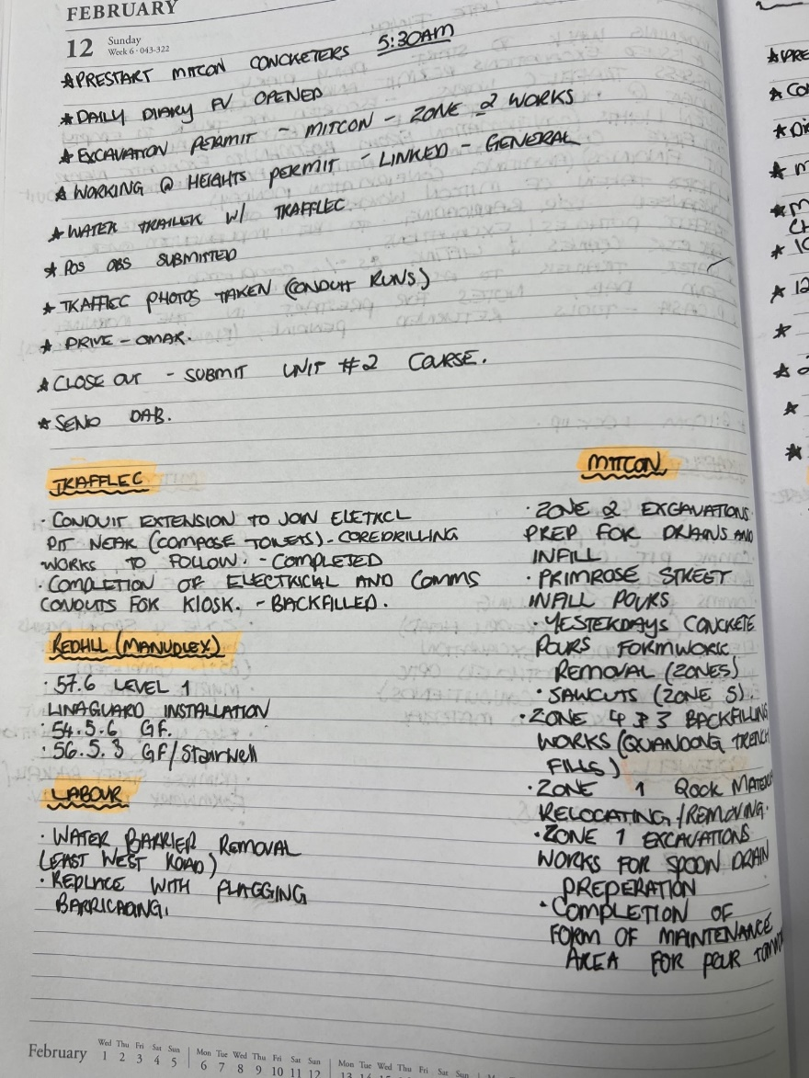
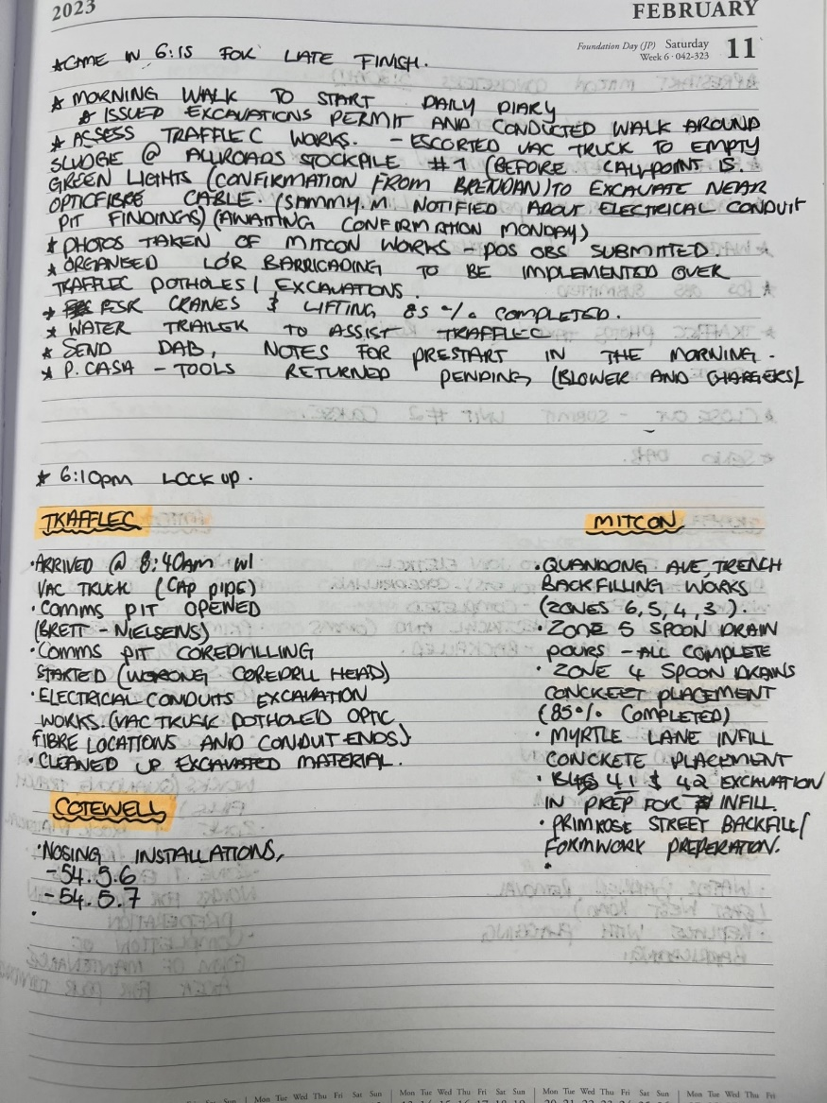

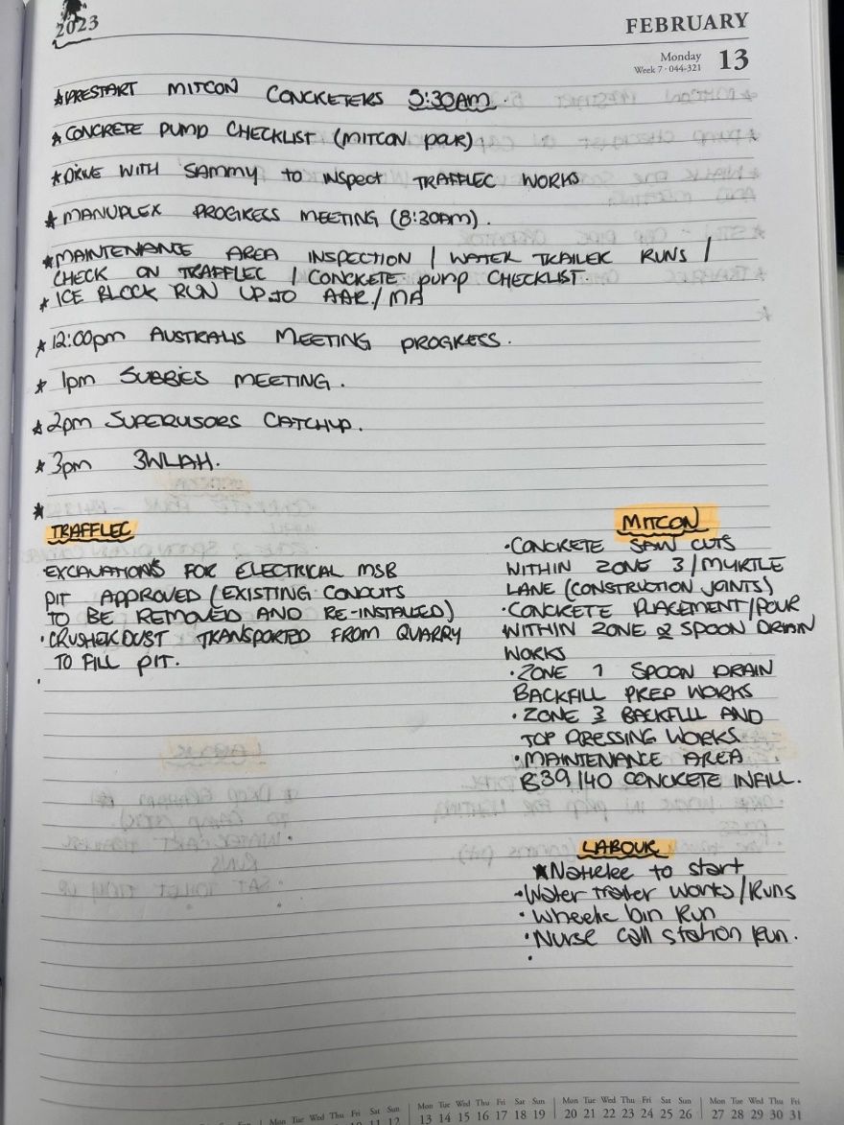
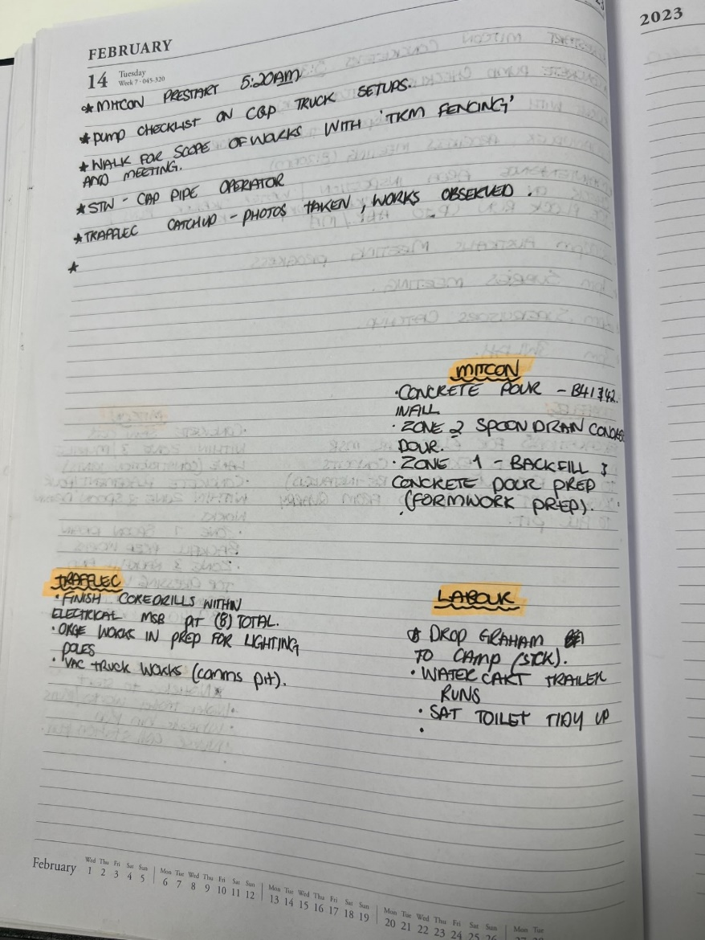

Below I have also attached a few photographs of the works for visibility.
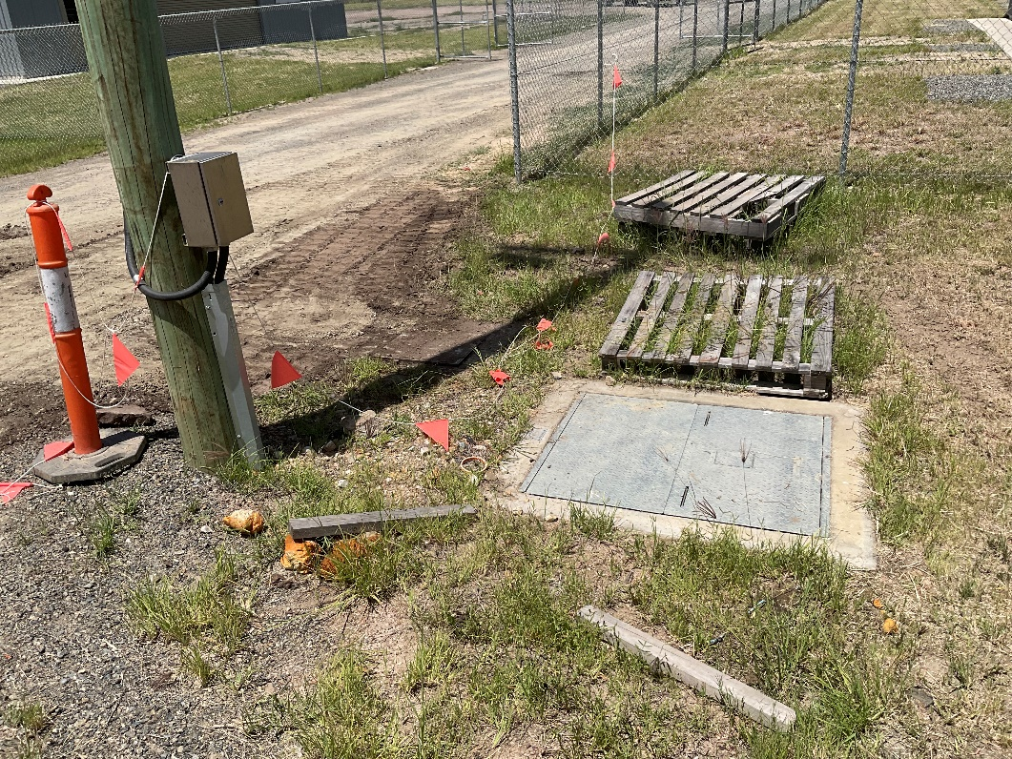
Backfilling works completed after the conduit and core drilling works for the compose toilets.

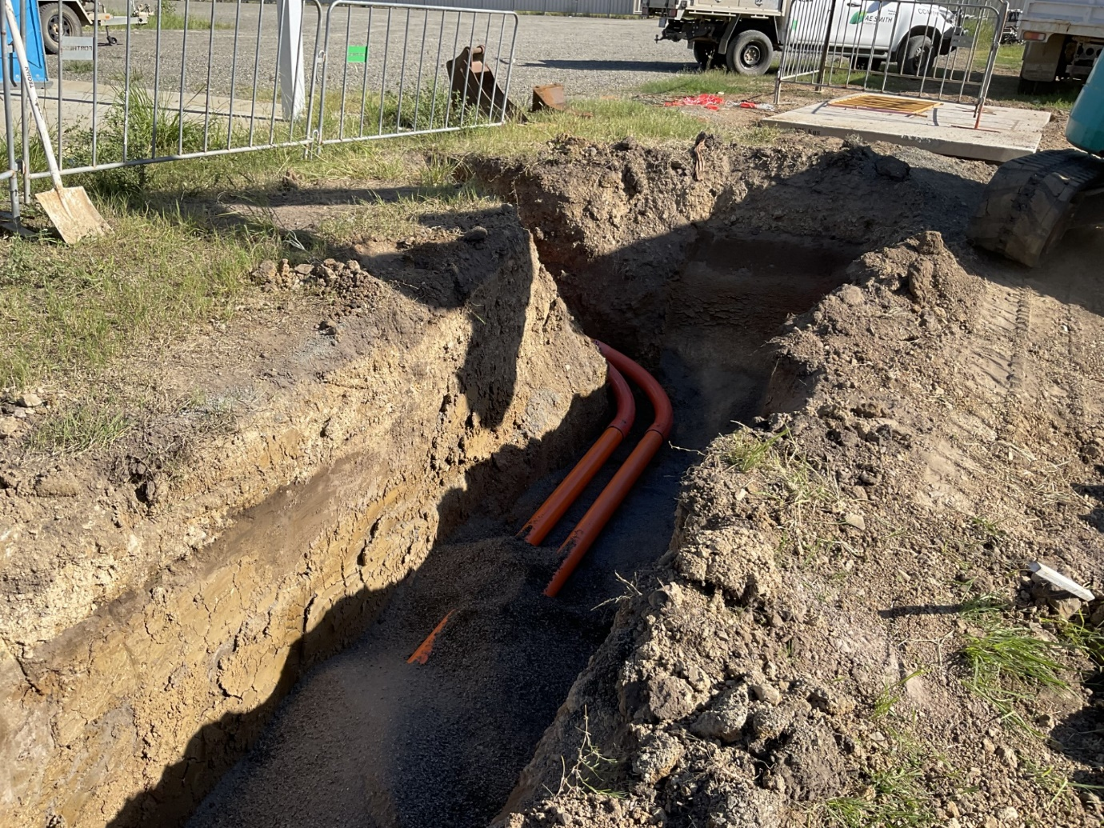
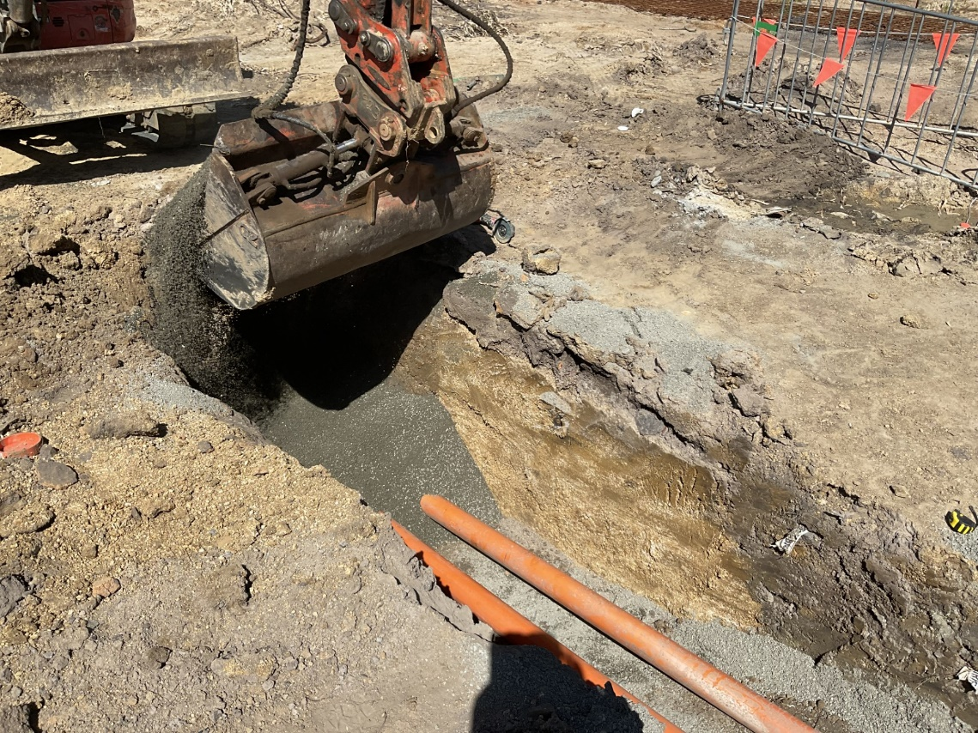
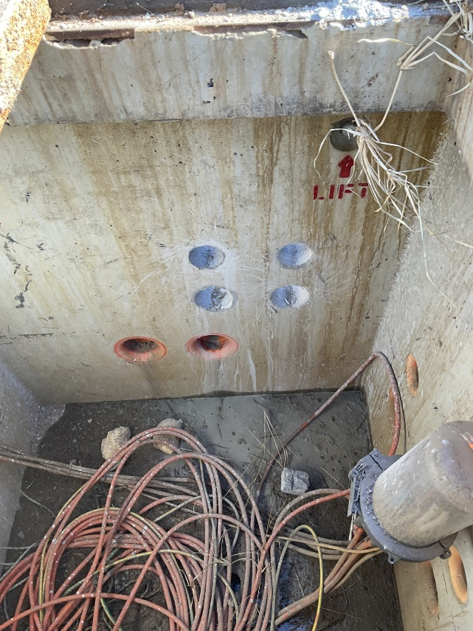
Excavations, Crusher Dust placement and conduit installation running from MSB pit linking to communications pit

Excavations works for conduit installation under optic fibre cable.
Core drilling works within the communication pits.

Further photographs can be sent through upon request.

Upon the completion of works, a final inspection was conducted to ensure all works had been finished in the required timeframe and expectation. In conclusion no incidents, accidents or WH&S incidents happened, and all works were signed off to be finished. Through my personnel comments to the sub-contractor, it was great to see this contractor supplying all the correct and required documentation prior to arriving to site to ensure no delays or disruptions were present, and all operator’s and labourers worked within a safe and professional manner.

