CHCECE009
Use an approved framework to guide practice
Learner Workbook



Table of Contents

Table of Contents 2
Candidate Details 3
Assessment – CHCECE009 Use an approved framework to guide practice 3
Competency Record to be completed by Assessor 4
Activities 7
Activity 1.1.1 – 1.2.1 7
Activity 1.3.1 8
Activity 2.1.1 – 2.2.1 9
Activity 2.3.1 – 2.4.1 10
Activity 2.5.1 11
Skills and Knowledge Activity 12
Major Activity 14

Candidate Details

Assessment – CHCECE009 Use an approved framework to guide practice
Please complete the following activities and hand in to your trainer for marking. This forms part of your assessment for CHCECE009 Use an approved framework to guide practice.
Name: _____________________________________________________________
Address: _____________________________________________________________
_____________________________________________________________
Email: _____________________________________________________________
Employer: _____________________________________________________________
Declaration
I declare that no part of this assessment has been copied from another person’s work with the exception of where I have listed or referenced documents or work and that no part of this assessment has been written for me by another person.
Signed: ____________________________________________________________
Date: ____________________________________________________________
If activities have been completed as part of a small group or in pairs, details of the learners involved should be provided below:
This activity workbook has been completed by the following persons and we acknowledge that it was a fair team effort where everyone contributed equally to the work completed. We declare that no part of this assessment has been copied from another person’s work with the exception of where we have listed or referenced documents or work and that no part of this assessment has been written for us by another person.
Learner 1: ____________________________________________________________
Signed: ____________________________________________________________
Learner 2: ____________________________________________________________
Signed: ____________________________________________________________
Learner 3: ____________________________________________________________
Signed: ____________________________________________________________

Competency Record to be completed by Assessor
Learner Name: _______________________________________________________
Date of Assessment: _______________________________________________________
The learner has been assessed as competent in the elements and performance criteria and the evidence has been presented as:
Assessor Initials
Authentic
Valid
Reliable
Current
Sufficient

Learner is deemed: COMPETENT NOT YET COMPETENT (Please circle)

If not yet competent, date for re-assessment: ____________________________________

Comments from Trainer / Assessor:
__________________________________________________________________________________________________________________________________________________________________________________________________________________________________________________________________________________________________________________________________________________________________________________________________________________________
Assessor Signature: ________________________________________________________
Observation/Demonstration

Throughout this unit, you will be expected to show your competency of the elements through observations or demonstrations. Your instructor will have a list of demonstrations you must complete or tasks to be observed. The observations and demonstrations will be completed as well as the activities found in this workbook. An explanation of demonstrations and observations:
Demonstration is off-the-job
A demonstration will require:
- Performing a skill or task that is asked of you
- Undertaking a simulation exercise
Observation is on-the-job
The observation will usually require:
- Performing a work based skill or task
- Interaction with colleagues and/or customers
Your instructor will inform you of which one of the above they would like you to do. The demonstration/observation will cover one of the unit’s elements.
The observation/demonstration will take place either in the workplace or the training environment, depending on the task to be undertaken and whether it is an observation or demonstration. Your instructor will ensure you are provided with the correct equipment and/or materials to complete the task. They will also inform you of how long you have to complete the task.
Learner should be able to demonstrate they can:
- Identify learning frameworks
- Apply the learning framework
They will also need to show:
- Reading skills
- That they Worked collaboratively with at least one other educator to implement an approved learning framework within an approved education and care service, including:
  - Investigating and documenting at least two examples of how the learning framework is demonstrated in the service
  - Researching and documenting at least one example of how each principle of the learning framework is reflected in the service
  - Working closely with others and under supervision to help implement the framework
  - Reflecting on and discussing practice with supervisor and others
  - Investigated and documented their own involvement in at least three examples of pedagogical practices in the service
It is not a requirement to have all of the tasks witnessed in succession.

Activities

Activity 1.1.1 – 1.2.1
Estimated Time | 30 Minutes
Objective | To provide you with an opportunity to investigate different approved learning frameworks and identify the framework relevant to the service, and recognise differences between the relevant framework and other approved frameworks.
Activity | Individually, in pairs or in groups, complete the following:  Download the following three documents and come up with 2 examples of how each one is relevant to your setting:  - National Quality Standard  - Early Years Learning Framework  - My Time, Our Place Framework  Investigate one of the other relevant frameworks – or if your setting uses a different one, use that for this activity, and outline the differences.  - The national framework offers a vision for a new Australia where:  - All children are equal, and get an equal start  - There is mutual respect for each individual and the part they play  - All children are considered to play an equal part in the future of Australia  - The goal of the national framework is to close the gap in educational achievements between indigenous and non-indigenous people.  - The relevant framework is different in that it is more unified in its approach. It can be used to complement, supplement or replace the other frameworks mentioned.  - The other approved frameworks are specific to their region.

Activity 1.3.1
Estimated Time | 45 Minutes
Objective | To provide you with an opportunity to clarify the relevance of the framework with educators and others to identify its relationship to other aspects of relevant law and regulations.
Activity | Individually, in pairs or in groups, complete the following:  Locate your state/territory legislation relevant to early childhood education and care, and outline relevant parts to the EYLF framework.  Then, get into a group of 2-3 people and discuss and summarise your findings.
  Region | Legislation
  Australian Capital Territory | Education and Care Services National Law (ACT) Act 2011
  New South Wales | Children (Education and Care Services National LAW Application Act) 2010
  Northern Territory | Education and Care Services (National Uniform Legislation) Act 2011
  Queensland | Education and Care Services National Law (Queensland) Act 2011
  South Australia | Education and Early Childhood Services (Registration and Standards) Act 2011
  Tasmania | Education and Care Services (National Law) Application) Act 2011
  Victoria | Education and Care Services National Law Act 2010
  Western Australia | Education and Care Services National Law (WA) Act 2012

Activity 2.1.1 – 2.2.1
Estimated Time | 30 Minutes
Objective | To provide you with an opportunity to investigate how the framework is applied to support children’s learning and explore and develop an understanding of the principles and practices of the relevant framework.
Activity | Individually, in pairs or in groups, complete the following;  Locate the EYLF and summarise the principles and practices.  - Is delivered in accordance with that framework  - Is based on the developmental needs, interests and experiences of each child  - Takes into account the individuality of each child.  Provide an example of how your service upholds each of the 5 principles.  Secure, respectful and reciprocal relationships – we always greet each child and welcome them into the room in a respectful way taking into account their individuality e.g. their age and personality.  Some children will enjoy a ‘boo’ or high five and others may need a cuddle or a simple hello.  - Secure, respectful and reciprocal relationships  - Partnerships with families  - High expectations and equity  - Respect for diversity  - Ongoing learning and reflective practice.  Provide three examples of how your service applies the practices.  Learning through play – we always ensure we have a variety of toys to help children learn and practice skills appropriate for their developmental stage e.g. shape sorters, puzzles with 6, 9 12, 24 pieces, slides, dolls, dress-up clothes, books etc.  - Holistic approaches  - Responsiveness to children  - Learning through play  - Intentional teaching  - Learning environments  - Cultural competence  - Continuity of learning and transitions  - Assessment for learning.  How does your service use the framework to support children’s learning?  Examples:  - Learning through play  - Intentional teaching  - Continuity of learning and transitions  - Assessment for learning

Activity 2.3.1 – 2.4.1
Estimated Time | 30 Minutes
Objective | To provide you with an opportunity to work in collaboration with others to apply the principles and practices of the learning framework to all aspects of the educator role and work in collaboration with others to implement framework learning outcomes.
Activity | Individually, in pairs or in groups, complete the following;  Outline three ways you can initiate collaboration with other educators or community members with the goal of applying and implementing the principles, practices and learning outcomes of the learning framework.  - Lead a staff meeting with the goal of determining specific principles, practices and learning outcomes that my service needs to focus on  - Invite parents to a family night to present the learning framework. Organise a few games and activities to make it interesting and fun and to help them understand the framework, and how it relates to them.  - Organise an after school meeting with network members or another service in the area. Chose one or two of the principles, practices and learning outcomes to focus on and share ideas and strategies about ways to support children’s learning.  Include a list of the key participants in the implementation of the learning framework.  - Educators  - Families  - Children  - Community members  - Network members

Activity 2.5.1
Estimated Time | 30 Minutes
Objective | To provide you with an opportunity to reflect on own practices in the workplace and discuss with supervisor.
Activity | Individually, in pairs or in groups, complete the following;  Write a reflection on your own work practices.  - Journaling  - Reviewing observations and identifying reasons as to why things are working or not, and what else could be tried  - Thinking about issues and situations after they occur  - Talking about issues and situations with other educators  - Reading about current trends and issues  - Asking questions  Next, set up a meeting with your supervisor and discuss your reflection, asking for feedback.  - Inviting them to observe after a time of sharing with them  Then, summarise the meeting.  - Listen to what is being said and try to remain focused on the issue  - Not personalise the feedback  - Ask questions to clarify if you do not understand what is being said  - Try not to be defensive or to justify your behaviour  - Stay calm  - Consider what has been said and be honest with yourself and your own self-reflection of the situation and performance  - Make changes to your practice/behaviour if you see that as appropriate

Skills and Knowledge Activity
Estimated Time | 60 Minutes
Objective | To provide you with an opportunity to demonstrate your knowledge of the required skills, knowledge and critical aspects of assessment.
Activity | Complete the following individually and attach your completed work to your workbook.  The answers to the following questions will enable you to demonstrate your knowledge of:  - Working collaboratively with at least one other educator to implement an approved learning framework within an approved education and care service, including:  - Investigating and documenting at least two examples of how the learning framework is demonstrated in the service  - Researching and documenting at least one example of how each principle of the learning framework is reflected in the service  - Working closely with others and under supervision to help implement the framework  - Reflecting on and discussing practice with supervisor and others  - Investigated and documented their own involvement in at least three examples of pedagogical practices in the service  Answer each question in as much detail as possible, considering your organisational requirements for each one.  - National Framework and Standards. Locate and use the following documents:  - Belonging, Being and Becoming: The Early Years Learning Framework for Australia  - My Time, Our Place: Framework for School Age Care in Australia  - Or the relevant approved learning framework used in the service if different from those above  - United Nations Convention on the Rights of the Child  - Your organisation’s standards, policies, procedures and guidelines  Outline what each of these frameworks/documents specifically say about providing children with opportunities to maximise their potential and develop a foundation for future success.  The documents can be accessed at:  - http://www.education.nt.gov.au/__data/assets/pdf_file/0018/20538/BelongingBeing-Becoming.pdf  - hhttp://www.unicef.org/crc/  ttp://www.mytimeourplace.com.au/  - Investigate three examples of pedagogical practices in the service and document your own involvement in each. For example:  - Play-based learning  - Experiential learning  - Intentional teaching  Childhood pedagogy that focuses on play-based learning and emphasises the acquisition of language, literacy and numeracy, communication skills and social and emotional development.  - Play-based learning  This is the opportunity to allow children to experiment and be creative in their own ways. At our centre we have boxes, paint, creative art equipment available for the children to play with.  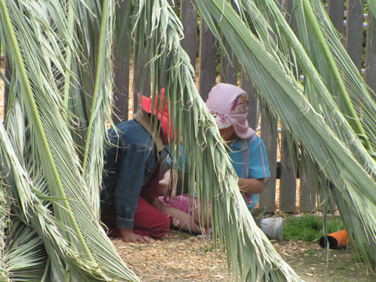  Play based learning is teaching the children as they like to learn – through play.    Play based learning does not mean that the children just do what they like all day. We arrange for the children to come together as a group where they learn to listen to each other, share information, follow rules and partake in group activities. Play based activities don’t replace intentional teaching, rather complement and enhance it!  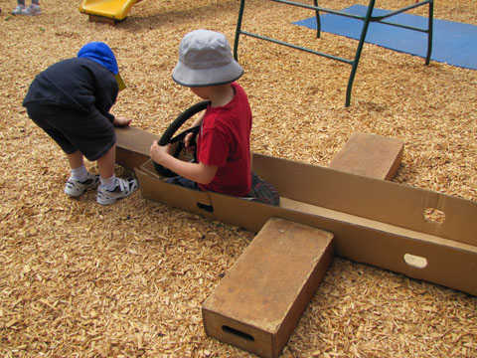  At our centre we provide children with long periods of uninterrupted play time. They have the opportunity to follow their own interests. They are encouraged to initiate activities and be self-directed with the support of their teachers. They learn to take ownership of their work. They are gently moulded into independent children with initiative and the confidence to take risks, knowing that there is no right or wrong way.  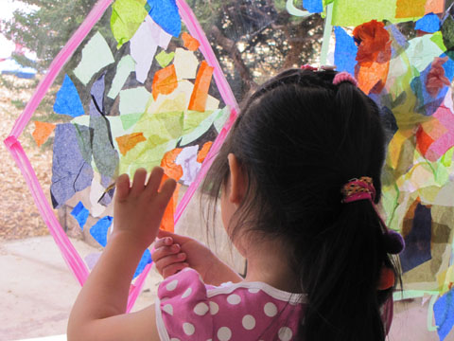  Open ended play based learning focuses on the process not the product. It is the learning that is taking place that is the important factor.  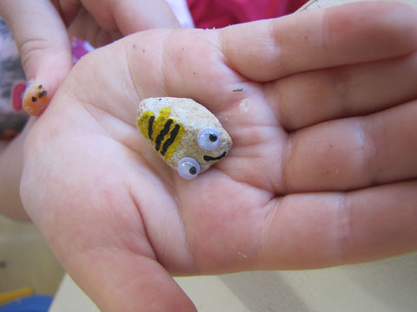  At our centre we are now choosing to run indoor/outdoor programs and free snack times to enable and enhance the long stretches of uninterrupted play times..  Experiential learning  There are three basic steps involved:  - Planning stage  - Doing stage and  - Reviewing stage  During the planning stage I sat down with the children and we discussed a few ideas about what we would do. As we had been reading some books on gardening and growing vegetables we decided to go ahead and plant some seedlings.  We began to collect the required materials by asking the parents to become involved and getting them to donate seedlings, compost, fertilizer etc. I then guided the children in planting the seedlings in the garden by using the materials and tools. I allowed the children to plant the seedlings with their own efforts and didn’t interfere with their work.  I gave them practical suggestions and input as well as guiding them through the process of planting.  By planting the seedlings, the children felt very proud and gained immense confidence and developed positive attitudes.  Once I had helped them plant and after they had finished, I sat down with them to review the entire process of planting right from the start to finish. Reviewing allows the children to solidify their experiences and skills.  Intentional teaching  ‘solving everyday dilemmas with intentions in mind’  We had a safety problem at our centre—children racing around the bike track with trucks. We could have solved this by just putting the trucks away or by talking about rules, or by staggering outside play times however we wanted the children to have the trucks but to use them in a more constructive way  Children remembered we had originally ‘set up’ the trucks in the ‘island’ area in the yard that already had undulations, bark and trees, so we talked about this with the children and decided together to create ‘a four-wheel drive park’ as many of the children related to this experience  We discussed what else we might need to create a park like the one they described—‘fallen logs, rocks and a tent’ —children offered many other ideas such as somewhere for the baby, the dog.  Stones were delivered and staff and children spent three days moving them into place. Staff and children solved a problem together.

Major Activity
Estimated Time | 60 Minutes
Objective | To provide you with an opportunity to demonstrate your knowledge of the entire unit.
Activity | This is a major activity – your instructor will let you know whether you will complete it during class or in your own time.  You must individually, answer the following questions in full to show your competency of each element:  - Identify learning frameworks  - Apply the learning framework  - Create an action plan, using the learning framework that outlines how your service will provide children with opportunities to maximise their potential and develop a foundation for future success. Collaborate with your supervisor or lead educator. Use the principles, practices and outcomes table to guide your action plan:  Principles  - Secure, respectful and reciprocal relationships  - Partnerships  - High expectations and equity  - Respect for diversity  - Ongoing learning and reflective practice  Practices  - Holistic approaches  - Responsiveness to children  - Learning through play  - Intentional teaching  - Learning environments  - Cultural competence  - Continuity of learning and transitions  - Assessment for learning  Outcomes  - Children have a strong sense of identity  - Children are connected to and contribute to their world  - Children have a strong sense of wellbeing  - Children are confident and involved learners  - Children are effective communicators

