National Quality Standards 2018

Table of Contents

Quality Area 1 – Educational program and practice 2
Quality Area 2 – Children's health and safety 3
Quality Area 3 – Physical environment 4
Quality Area 4 – Staffing arrangements 5
Quality Area 5 – Relationships with children 6
Quality Area 6 – Collaborative partnerships with families and communities 7
Quality Area 7 – Governance and leadership 8
Further Reading 9
References 12

Quality Area 1 – Educational program and practice
Educational program and practice of educators are child-centred, stimulating and maximise opportunities for enhancing and extending each child’s learning and development.
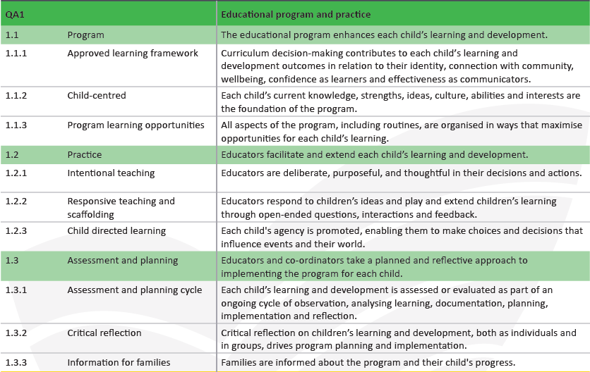
The aim of Quality Area 1 of the National Quality Standard is to ensure that the educational program and practice is stimulating and engaging, and enhances children’s learning and development. In school age care services, the program nurtures the development of life skills and complements children’s experiences, opportunities and relationships at school, at home and in the community.

Quality Area 2 – Children's health and safety
Children have the right to experience quality education and care in an environment that safeguards and promotes their health, safety and wellbeing.
The aim of Quality Area 2 under the National Quality Standard is to safeguard and promote children’s health and safety, minimise risks and protect children from harm, injury and infection.
All children have the right to experience quality education and care in an environment that provides for their physical and psychological wellbeing and provides support for each child’s growing competence, confidence and independence.
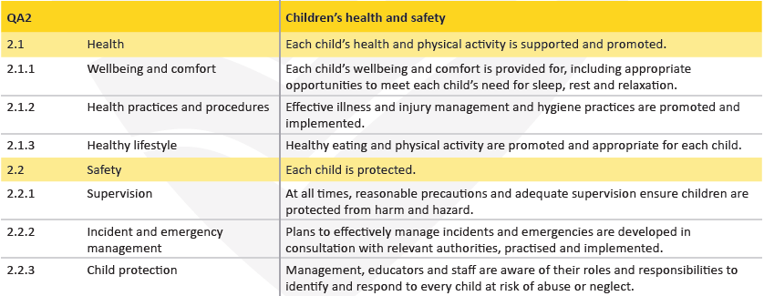

Quality Area 3 – Physical environment
Physical environment is safe, suitable and provides a rich and diverse range of experiences that promote children’s learning and development.
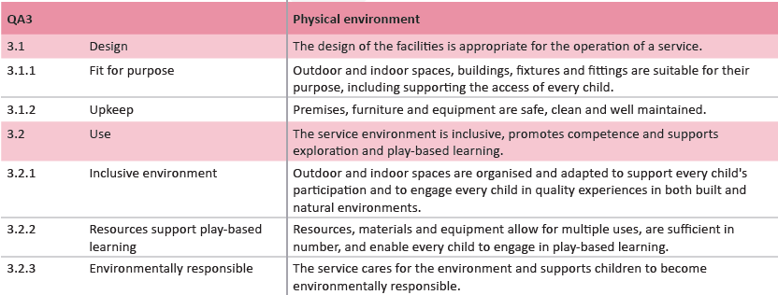

Quality Area 4 – Staffing arrangements
Qualified and experienced educators, who develop warm, respectful relationships with children, create predictable environments and encourage children’s active engagement in the learning program.
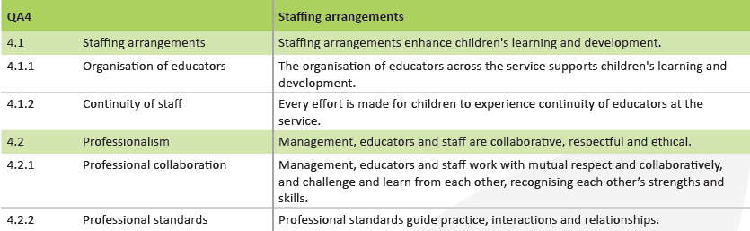

Quality Area 5 – Relationships with children
Relationships with children are responsive, respectful and promote children’s sense of security and belonging.
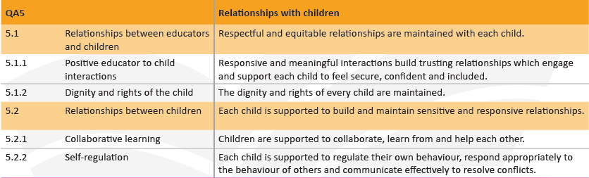

Quality Area 6 – Collaborative partnerships with families and communities
Collaborative relationships with families are fundamental to achieving quality outcomes for children, and community partnerships based on active communication, consultation and collaboration are essential.
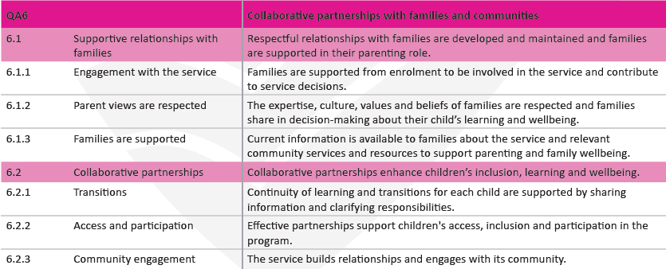

Quality Area 7 – Governance and leadership
Effective leadership and governance of the service contributes to quality environments for children’s learning and development. Effective leaders establish shared values for the service and set clear direction for the service’s continuous improvement.
The aim of Quality Area 7 under the National Quality Standard is to support effective leadership and management of the service that contributes to quality environments for children’s learning and development. Well-documented policies and procedures, well-maintained records, shared values, clear direction and reflective practices enable the service to function as a learning community.
An ongoing cycle of planning and review, including engagement with families, creates a setting for continuous improvement.
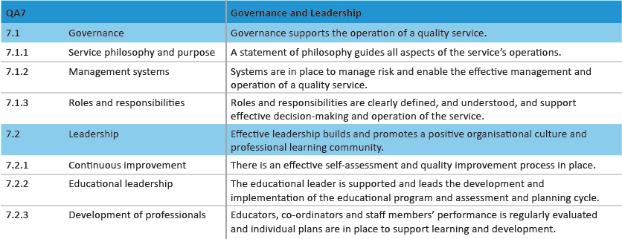

Further Reading

Belonging, Being and Becoming: The Early Years Leaning Framework for Australia | http://files.acecqa.gov.au/files/National-Quality-Framework-Resources-Kit/belonging_being_and_becoming_the_early_years_learning_framework_for_australia.pdf
My Time, Our Place: Framework for School Age Care in Australia | https://www.acecqa.gov.au/media/24641
Educators Guide Belonging, Being, Becoming | https://www.acecqa.gov.au/sites/default/files/acecqa/files/National-Quality-Framework-Resources-Kit/educators_guide_to_the_early_years_learning_framework_for_australia.pdf
Educators Guide My Time, Our Place | https://www.acecqa.gov.au/sites/default/files/acecqa/files/National-Quality-Framework-Resources-Kit/educators_my_time_our_place.pdf
Developmental Milestones and the EYLF | https://www.acecqa.gov.au/sites/default/files/acecqa/files/QualityInformationSheets/QualityArea1/DevelopmentalMilestonesEYLFandNQS.pdf
Guide to Physical Health and Wellbeing | https://det.qld.gov.au/earlychildhood/news/Documents/pdf/aedc-health.pdf
ACECQA Information Sheet: Quality Area 2 – Toileting and nappy changing principles and practice | https://www.acecqa.gov.au/sites/default/files/acecqa/files/QualityInformationSheets/QualityArea2/EffectiveToiletingandNappyChangingProcedure.pdf
Sustainability and intentional teaching in early childhood | http://www.earlychildhoodaustralia.org.au/our-publications/every-child-magazine/every-child-index/every-child-vol-18-3-2012/sustainability-intentional-teaching-early-childhood-free-article/
Talking about practice: environments for learning | http://www.ecrh.edu.au/resources/detail/index/talking-about-practice-environments-for-learning

Developing inclusive relationships among early childhood staff | https://www.google.com.au/url?sa=t&rct=j&q=&esrc=s&source=web&cd=1&cad=rja&uact=8&ved=0ahUKEwjcnbyGq_fPAhUBKpQKHco8DtMQFggbMAA&url=http%3A%2F%2Fwww.earlychildhoodaustralia.org.au%2Four-publications%2Fevery-child-magazine%2Fevery-child-index%2Fevery-child-vol-16-1-2010%2Fdeveloping-inclusive-relationships-among-early-childhood-staff-free-article%2F&usg=AFQjCNFIxnzKCtKhchFFNoSgCOu-djaXrw
Working with people who challenge us | http://www.ecrh.edu.au/resources/detail/index/working-with-people-who-challenge-us-self-guided-learning-package
A fine balance: understanding the roles educators and children play as intentional teachers and intentional learners within the EYLF | http://nova.newcastle.edu.au/vital/access/manager/Repository/uon:23256?f1=sm_creator%3A%22Ford%2C+Margot%22
ECA Code of Ethics | http://www.earlychildhoodaustralia.org.au/our-publications/eca-code-ethics/
Supporting self-regulation | https://www.kidsmatter.edu.au/early-childhood/resources-support-childrens-mental-health/about-emotions/self-regulation
Children’s mental health | http://www.rch.org.au/uploadedFiles/Main/Content/ccch/Policy_Brief_24_web.pdf
Self regulation: a foundation for wellbeing and involved learning | http://www.ecrh.edu.au/docs/default-source/resources/ipsp/self-regulation-a-foundation-for-wellbeing-and-involved-learning.pdf?sfvrsn=8
High expectations for every child | http://www.education.vic.gov.au/Documents/childhood/providers/edcare/highexpect.pdf
Building partnerships between families and early childhood staff | http://www.startingblocks.gov.au/media/1105/kmec_c4_201205_03_building-partnerships.pdf
Engaging marginalised and vulnerable families | http://www.rch.org.au/uploadedFiles/Main/Content/ccch/PB18_Vulnerable_families.pdf
Engaging with Aboriginal Communities – where do we start? | https://www.acecqa.gov.au/sites/default/files/acecqa/files/NEL/engaging-with-aboriginal-communities1.pdf
Continuity of Learning | https://docs.education.gov.au/documents/continuity-learning-resource-support-effective-transition-school-and-school-age-care

Transitions: Moving in, Moving up and Moving On | http://www.ecrh.edu.au/docs/default-source/resources/nqs-plp-e-newsletters/nqs-plp-e-newsletter-no-70-2013-transitions-moving-in-moving-up-and-moving-on.pdf?sfvrsn=4
Creating an organisational culture of your dreams | https://www.kidsmatter.edu.au/early-childhood/blog/creating-organisational-culture-your-dreams
Talking about practice: The quality improvement process | http://www.ecrh.edu.au/resources/detail/index/talking-about-practice-the-quality-improvement-process
NQS PLP – The educational leader | https://www.google.com.au/url?sa=t&rct=j&q=&esrc=s&source=web&cd=1&cad=rja&uact=8&ved=0ahUKEwi_jKeEsPfPAhWJHZQKHZRSAioQFggbMAA&url=http%3A%2F%2Fwww.earlychildhoodaustralia.org.au%2Fnqsplp%2Fwp-content%2Fuploads%2F2012%2F05%2FNQS_PLP_E-Newsletter_No33.pdf&usg=AFQjCNHEgd0G5JitBAXft27QLa0ZtJCZ4Q
The dark side of leadership: troubling times at the top | http://www.conference.co.nz/files/docs/darksideofleadership2.pdf
How to develop and update policies successfully | http://www.ecrh.edu.au/docs/default-source/resources/ipsp/how-to-develop-and-update-policies-successfully-(without-the-stress).pdf?sfvrsn=6

All links accessed and correct as of 06.02.18.

References

The above images have been retrieved from ACECQA’s publication: 2018 National Quality Standard (A4 Poster).
https://www.acecqa.gov.au/sites/default/files/acecqa/files/NQF/RevisedNQSHandoutA4_2.pdf (Access date 06/02/18)

