BSBITU302
Create electronic presentations
Learner Guide



BSBITU302
Create electronic presentations

Table of Contents

Table of Contents 3
Unit of Competency 6
Performance Criteria 7
Foundation Skills 8
Assessment Requirements 9
Housekeeping Items 10
Objectives 10
1. Prepare to create presentation 11
1.1 – Organise personal work environment in accordance with ergonomic requirements 12
Examples of workplace policy requirements 14
Activity 1A 15
Using a mouse 19
Keyboard equipment and radiation 19
Keyboard and telephone operations 19
Posture during typing 19
Typing technique 19
1.2 – Determine purpose, audience and mode of presentation in consultation with content author or presenter 22
What is a content author? 22
Determine purpose, audience and mode of presentation 22
Determine the purpose 22
Check list 23
Audience Characteristics 24
Presentation format and delivery methods may include: 26
Mode 27
Style 27
Special Considerations 27
1.3 – Identify presentation requirements in terms of supporting documents and equipment 28
Enhancing the audience understanding of key concepts and central ideas 29
Resources – choosing your method 29
Use of audio visual presentation aids 29
Presentation aids quick evaluation: 31
Resources and methods quick evaluation: 31
1.4 – Apply work organisation strategies and energy and resource conservation techniques to plan work activities 32
Apply work organisation strategies to plan work activities 32
Activity 1B 35
2. Create presentation 36
2.1 – Design slides, notes and handout masters to incorporate organisational and task requirements in relation to image and preferred style, avoiding distractions 37
Design slides, notes and hand-out masters 38
Design the master slide 38
What about corporate template images? 39
Notes and hand-outs 40
Create notes pages 40
Previewing your hand-out 41
Hand-out master 42
Avoiding distractions 42
Using storyboards may help you plan your presentation 42
Types of Storyboard 43
2.2 – Use software functions for consistency of design and layout, to meet identified presentation requirements 44
2.3 – Balance presentation features for visual impact and emphasis 45
Visual impact and emphasis 45
Speelling Spelling!! 45
Don’t hide behind your visual impact and emphasis 46
2.4 – Use advanced software features to streamline and customise presentation for different audiences 47
What are Advanced Features? 47
Presentation for different audiences 47
Create a custom slide show 47
On-the-spot customisation 47
Using advanced software may require advanced skills? 48
2.5 – Prepare presentation within designated timeline 50
Activity 2A 51
3. Finalise presentation 52
3.1 – Use manuals, user documentation and online help to overcome problems with design and production 53
Read the manual 53
User documentation quality checklist 54
Overcome some problems with design and production help 55
Online help 56
Outsourcing technical documentation and help 56
Help Desks 56
Try a tutorial: 57
Activity 3A 58
3.2 – Check presentation for spelling and consistency in presentation features and style, in accordance with task requirements 59
3.3 – Print presentation materials in accordance with presenter or audience requirements 59
Establish what you want to do 59
PowerPoint 2010 59
Check spelling 60
60
Consistency in presentation features 60
Activity 3B 62
3.4 – Store presentation, in accordance with organisational requirements and exit application without information loss or damage 63
Storage integrity 63
Costs of storage 64
Saving your presentation is quite easy 64
What are your organisations requirements? 64
Storage on hard/floppy disk drives, Thumb Drives, CD-ROM, tape back-up and other devices 65
Exit the application without information loss or damage 65
Loss or damage 65
Possible solutions – no guarantees! 66
Activity 3C 67
Skills and Knowledge Activity 68
Major Activity – An opportunity to revise the unit 69
References 71

Unit of Competency

Application
This unit describes the skills and knowledge required to design and produce electronic presentations for speakers, for self access and online access.

It applies to individuals employed in a range of work environments who design electronic presentations. They may work as individuals providing administrative support within an enterprise, or may be responsible for production of their own electronic presentations.

No licensing, legislative or certification requirements apply to this unit at the time of publication.

Unit Sector
Information and Communications Technology – IT Use

Performance Criteria
Element  Elements describe the essential outcomes. | Performance Criteria  Performance criteria describe the performance needed to demonstrate achievement of the element.
- Prepare to create presentation | - Organise personal work environment in accordance with ergonomic requirements  - Determine purpose, audience and mode of presentation in consultation with content author or presenter  - Identify presentation requirements in terms of supporting documents and equipment  - Apply work organisation strategies and energy and resource conservation techniques to plan work activities
- Create presentation | - Design slides, notes and handout masters to incorporate organisational and task requirements in relation to image and preferred style, avoiding distractions  - Use software functions for consistency of design and layout, to meet identified presentation requirements  - Balance presentation features for visual impact and emphasis  - Use advanced software features to streamline and customise presentation for different audiences  - Prepare presentation within designated timeline
- Finalise presentation | - Use manuals, user documentation and online help to overcome problems with design and production  - Check presentation for spelling and consistency in presentation features and style, in accordance with task requirements  - Print presentation materials in accordance with presenter or audience requirements  - Store presentation, in accordance with organisational requirements and exit application without information loss or damage

Foundation Skills
This section describes language, literacy, numeracy and employment skills incorporated in the performance criteria that are required for competent performance.

Skill | Performance  Criteria | Description
Reading | 1.3, 3.1, 3.2, 3.4 | - Evaluates and integrates information and ideas to construct meaning in an effort to design and create a presentation
Writing | 2.1, 2.3-2.5 | - Communicates relationships between ideas and information in a style appropriate to audience and purpose in accordance with organisational and task requirements
Oral Communication | 1.2 | - Listens to discussions and participates in exchange of information to choose appropriate actions to create presentation
Navigate the world of work | 1.1-1.4, 2.1, 2.2, 2.5, 3.2-3.4 | - Recognises and follows explicit and implicit protocols and meets expectations associated with own role
Interact with others | 1.2 | - Collaborates with others to achieve joint outcomes
Get the work done | 1.4, 2.1-2.5, 3.1-3.4 | - Uses advanced features within applications to address routine and complex work tasks  - Plans and implements routine tasks and workload making limited decisions on sequencing and timing

Assessment Requirements
Performance Evidence

Evidence of the ability to:

- Adhere to organisational requirements and strategies when creating electronic presentations including:
  - ergonomic requirements
  - energy and resource requirements
- Adhere closely to task requirements:
  - following designated timelines
  - achieving consistency of design and layout
  - ensuring correct editing and style requirements
- Use advanced software features
- Communicate effectively with personnel
- Print and store presentation

Note: If a specific volume or frequency is not stated, then evidence must be provided at least once.

Knowledge Evidence

To complete the unit requirements safely and effectively, the individual must:

- Outline key provisions of relevant legislation, standards and codes that affect aspects of business operations
- Explain how design features affect the readability and appearance of electronic presentations

Assessment Conditions

Assessment must be conducted in a safe environment where evidence gathered demonstrates consistent performance of typical activities experienced in the information and communications technology – IT use field of work and include access to:

- Office equipment and materials
- Relevant software applications
- Examples of electronic presentations
- Style guides

Assessors must satisfy NVR/AQTF assessor requirements.

Links

Companion volumes available from the IBSA website: http://www.ibsa.org.au/companion_volumes

Housekeeping Items
Your trainer will inform you of the following;
- Where the toilets and fire exits are located, what the emergency procedures are and where the breakout and refreshment areas are.
- Any rules, for example asking that all mobile phones are set to silent and of any security issues they need to be aware of.
- What times the breaks will be held and what the smoking policy is.
- That this is an interactive course and you should ask questions.
- That to get the most out of this workshop, we must all work together, listen to each other, explore new ideas, and make mistakes. After all, that’s how we learn.
- Ground rules for participation;
  - Smile
  - Support and encourage other participants
  - When someone is contributing everyone else is quiet
  - Be patient with others who may not be grasping the ideas
  - Be on time
  - Focus discussion on the topic
  - Speak to the trainer if you have any concerns

Objectives
- Discover how to prepare to create presentation
- Learn how to create a presentation
- Know how to finalise a presentation
- Gain skills and knowledge required for this unit

1. Prepare to create presentation
1.1 Organise personal work environment in accordance with ergonomic requirements
1.2 Determine purpose, audience and mode of presentation in consultation with content author or presenter
1.3 Identify presentation requirements in terms of supporting documents and equipment
1.4 Apply work organisation strategies and energy and resource conservation techniques to plan work activities


1.1 – Organise personal work environment in accordance with ergonomic requirements
Ergonomic requirements may include:
- Avoiding radiation from computer screens
- Chair height, seat and back adjustment
- Document holder

- Footrest
- Keyboard and mouse position
- Lighting
- Noise minimisation
- Posture
- Screen position
- Workstation height and layout.
Any assessment of ergonomic conditions that exists in the workplace would normally be handled through the Human Resource (HR) department under a Risk Assessment as part of Workplace Health and Safety (WHS) or by a system that evaluates risk potential to employees.
Some of the areas suggested in the Range Statement would be more suitably handled by employees as part of a daily or periodic self-check of equipment, the workstation and work area before work commences and during work.
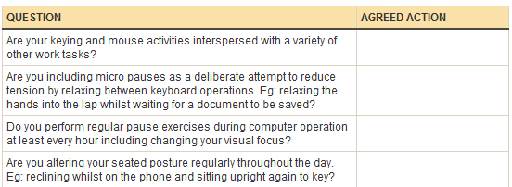
For areas that may be covered under WPH&S and awards or Human Resource policies, responsibility of the employer to provide a safe workspace would be documented and form part of regular risk management checks.
- Supervisors, managers, team leaders etc. are generally designated WHS officers so that there is a standard and policy driven culture present to the checks.
- Responsibilities include hazard reporting procedures, job procedures and safe work instructions, emergency procedures, accident and near miss reporting and recording procedures, consultation on WHS issues, correct selection, use & storage and maintenance procedures for use of personal protective equipment, control of risks under direct supervision.
- Awareness of relevant legislation from all levels of government (State or Federal) which affect business operation, especially in regard to WHS and environmental issues, equal opportunity, industrial relations, anti-discrimination and diversity.
- Compliance to behaviour that contributes to a safe working environment, identifying and reporting risks or hazards, using business equipment according to guidelines, listening to the ideas and opinions of others in the team, sharing opinions, views, knowledge and skills.
- Formal and informal health and safety meetings, meetings called by health and safety representatives, suggestions, requests, reports and concerns put forward to management.
- Workstation height and layout, chair height, seat and back adjustment, footrest, screen position, keyboard and mouse position, document holder, posture, avoiding radiation from computer screens, noise minimisation.
- Mix of repetitive and other activities, rest periods, exercise breaks, VDU eye testing.
- A range of environmental conditions including: noise, light, gas, smoke, odour, vapour, liquids/solids, particles and fumes.
If a particular office layout design is needed this would be a matter of personal and working circumstances.
For example:
- Does the workspace provide acoustical privacy (for example, can people talk in privacy, according to the level of confidentiality required; do noises and conversations interfere with their concentration; do noises or conversations make it difficult to hear or understand speech if much of their work involves using the telephone?)

- Are the walls permanent (i.e., fixed) or is the workspace in an open office environment?
- Does the workspace provide visual privacy?
- Can an employee personalise his or her individual work space?
- Is there access to natural light or only artificial lighting?
- Is the workplace layout designed to facilitate interpersonal contact?

Examples of workplace policy requirements

- Maintain work areas in a safe, uncluttered and organised manner according to policy and procedures.
- Carry out all procedures safely, effectively and efficiently with minimum inconvenience to staff according to policy.
- Apply policy and procedures for tidying work areas and placing items in designated areas.
Clean work area.
- Apply policy and procedures for personal hygiene.
- Apply policy and procedures for cleaning of work area.
- Sort, recycle, remove and dispose of waste promptly according to policy requirements.
- Safely remove and clean spills of food, waste or other potential hazards in compliance with WHS requirements and policy.
- Maintain equipment and consumable materials and store correctly after use.
- Use and clean equipment according to manufacturer instructions and policy requirements.


Activity 1A

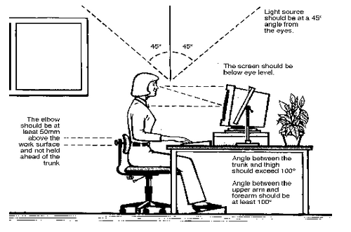
Consideration should be given to:
- The accessories required to operate properly
- The layout of equipment on the desk
- The location of furniture in the room
Work surface height
- Adjust the height of the work surface and/or the height of the chair so that the work surface allows your elbows to be bent at 90 degrees, forearms parallel with the floor, wrist straight, shoulders relaxed.
Chair
- Adjust the seat tilt so that you are comfortable when you are working on the keyboard. Usually, this will be close to horizontal but some people prefer the seat tilted slightly forwards. Your knees should be bent at a comfortable angle and greater than 90 degrees flexion. If this places an uncomfortable strain on the leg muscles or if the feet do not reach the floor then a footrest should be used. The footrest height must allow your knees to be bent at 90 degrees. Therefore the height of the footrest may need to be adjustable. Adjust the backrest so that it supports the lower back when you are sitting upright.


Keyboard placement
- Place the keyboard in a position that allows the forearms to be close to the horizontal and the wrists to be straight. That is, with the hand in line with the forearm. If this causes the elbows to be held far out from the side of the body then re-check the work surface height. Some people prefer to have their wrists supported on a wrist desk or the desk. Be careful not to have the wrist extended or bent in an up position.
Screen placement
- Set the eye to screen distance at the distance that permits you to most easily focus on the screen. Usually this will be within an arm's length. Set the height of the monitor so that the top of the screen is below eye level and the bottom of the screen can be read without a marked inclination of the head. Usually this means that the centre of the screen will need to be near shoulder height. Eyes level with the tool bar. People who wear bifocal or multi focal lenses will need to get a balance between where they see out of their lenses and avoid too much neck flexion.
Desk-top layout
- Place all controls and task materials within a comfortable reach of both hands so that there is no unnecessary twisting of any part of the body. Most people prefer the document holder to be between the keyboard and the monitor. There are many different types of document holders available.
Document holder
- Place this close to the monitor screen in the position that causes the least twisting or inclination of the head.
Posture and environment
- Change posture at frequent intervals to minimise fatigue. Avoid awkward postures at the extremes of the joint range, especially the wrists. Take frequent short rest breaks rather than infrequent longer ones. Avoid sharp increases in work rate. Changes should be gradual enough to ensure that the workload does not result in excessive fatigue. After prolonged absences from work the overall duration of periods of keyboard work should be increased gradually if conditions permit.

Lighting
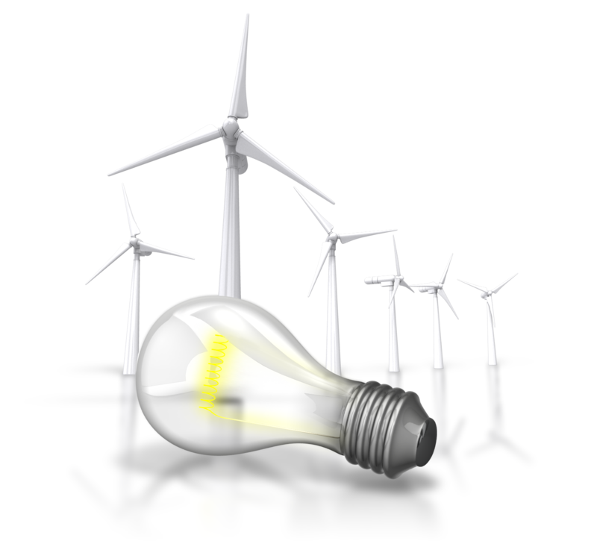
- Place the monitor to the side of the light source/s, not directly underneath. Try to site desks between rows of lights. If the lighting is fluorescent strip lighting, the sides of the desks should be parallel with the lights. Try not to put the screen near a window. If it is unavoidable ensure that neither the screen nor the operator faces the window.
- If the monitor is well away from windows, there are no other sources of bright light and prolonged desk-work is the norm, use a low level of service light of 300 lux. If there are strongly contrasting light levels, then a moderate level of lighting of 400 – 500 lux may be desirable.
Glare and reflection
- It is important to detect the presence of glare and reflection. To determine whether there is glare from overhead lights whilst seated worker should hold an object such as a book above the eyes at eyebrow level and establish whether the screen image becomes clearer in the absence of overhead glare. To detect whether there are reflections from the desk surface, the worker should hold the book above the surface and assess the change in reflected glare from the screen.
A number of ways are available to eliminate or reduce the influence of these reflections:
- Tilt the screen (top part forwards) so that the reflections are directed below eye level.
- Purchase an LCD screen.
- Cover the screen with a light diffusing surface or anti-glare screen.
- Negative contrast screen (dark characters on light background) will reduce the influence of these reflections.
If you experience eye discomfort when using a bright screen you should make the following adjustments:
- Turn the screen brightness down to a comfortable level.
- Look away into the distance in order to rest the eyes for a short while every ten minutes or so.
- Change the text and background colours. Recommended are black characters on white or yellow background, or yellow on black, white on black, white on blue and green on white. Avoid red and green and yellow on white.

Using a mouse
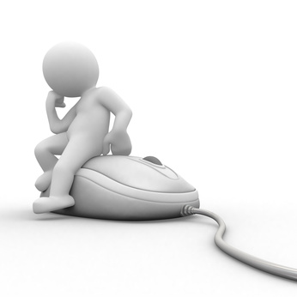
- A well designed mouse should not cause undue pressure on the wrist and forearm muscles. A large bulky mouse may keep the wrist continuously bent at an uncomfortable angle. Pressure can be reduced by releasing the mouse at frequent intervals, by selecting a slim-line, low-profile mouse. Keep the mouse as close as possible to the keyboard, elbow bent and close to the body.

Keyboard equipment and radiation
- Computer screens emit visible light which allows the characters on the screen to be seen. Weak electromagnetic fields and very low levels of other radiation, not visible to the human eye, can be detected by sensitive instruments. Similar emissions are produced by television receivers.
- The levels of most radiations and electromagnetic fields emitted from computers are much less than those from natural sources, such as the sun or even the human body and are well below levels considered to be harmful by responsible expert bodies such as the International Radiation Protection Association (IRPA).

Keyboard and telephone operations
- Avoid cradling the phone between your head and shoulder when answering calls. If needing to access the computer at the same time a headset is recommended. Hands free/speaker phone is another option if the environment is suitable.

Posture during typing
- Good posture is essential for all users of computers. It comprises of a natural and relaxed position, providing opportunity for movement, and from which the operator can assume a number of alternative positions. It is not a single, rigidly defined position.

Typing technique
Typing is a physical activity, and using a keyboard requires skill, hence the need to learn correct typing technique. Unskilled ('hunt and peck') typists are particularly at risk of Occupational Overuse Injury because they:
- Often use only one or two fingers which may overload the finger tendons;
- Are constantly looking from keyboard to screen to keyboard, which may strain neck muscles;
- Often adopt a tense posture (wrists bent back and fingers 'poised to strike').
- The University acknowledges the importance of learning correct typing technique. Departments should ensure that untrained staff receive appropriate training.
Speed of typing

- The efficiency and speed of modern computers make it possible for a skilled operator to type extremely quickly. This capability, reinforced by workload pressures means the potential exists for operators to key at speeds which may cause or contribute to Occupational Overuse Syndrome.
- The role of the repetitive movement in injury is not fully understood, but is believed to interfere with the lubrication capacity of tendons, and the ability of muscles to receive sufficient oxygen supplies.
10,000 – 12,000 keystrokes per hour is considered an acceptable standard.
Length of time on the keyboard
- The maintenance of a fixed posture for long periods is tiring and increases the likelihood of muscular aches and pains. In addition, long periods of repetitive movement and sustained visual attention can also give rise to fatigue-related complaints.
- It is recommended that operators avoid spending more than five hours a day on keyboard duties and no longer than 50 minutes per hour without a postural/stretching break.
- Employees newly engaged in keyboard work, and staff returning from an absence of two or more weeks, need a period of adjustment. The adjustment may be achieved through reduced work rates, or provision of alternate duties with gradual re-introduction to keyboard work.
Jobs should be designed and organised so that either:
- Computer related tasks can be interspersed with non-computer related
- Computer based tasks can be rotated amongst several staff (task/job sharing).
- It is not the change of task per se, but the change to using different movements and postures that is important. The whole purpose of task variety is to give the overloaded structures a necessary break.
Supervisors should ensure that workload controls are exercised using the following strategies:
- Planning ahead to avoid peaks, and rushed jobs
- Delegating fairly to all staff not just the best workers
- Considering the total workload of the individual (often comes from a number of sources)
- Clearly defining each operator's workload
- Implementing systems of prioritisation e.g. Work request forms, waiting lists
- Using relief staff
- Applying strict tests to the use of 'urgent' labels
- Discouraging 'endless' drafts
- Discouraging the use of typed internal minutes and memoranda
- Encouraging authors to have realistic expectations
- Teaching authors keyboard skills
- Teaching operators how to be assertive, and how to prioritise
- Supporting operators when authors impose unrealistic expectations
- Refusing illegible drafts.


1.2 – Determine purpose, audience and mode of presentation in consultation with content author or presenter
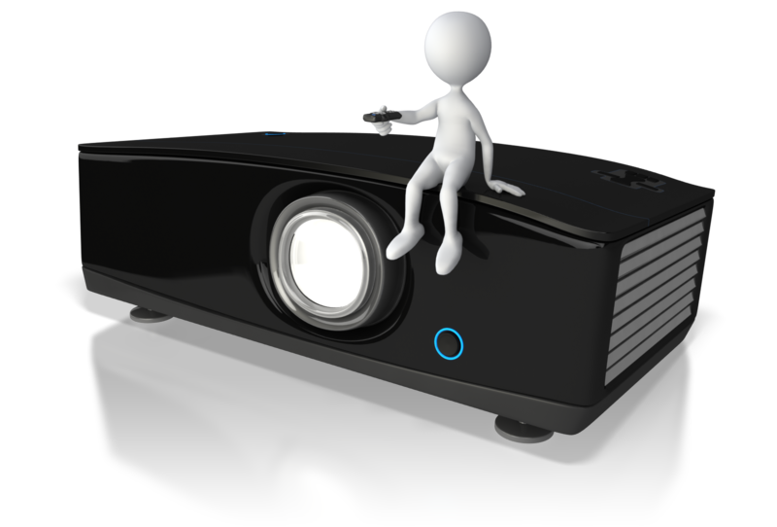
Mode of presentation may include:
- Available for browsing by individuals
- Display on one computer, control from another
- Online, internet, intranet
- Conference presentation
- Self-running presentation
- Speaker
A sound method in helping you determine the purpose and the intended audience of your presentation is to complete a check list of your design or in association with a content author or the presenter.

What is a content author?
A content author can be anyone, anywhere who contributes to content of a subject.
- There are few, if any, prerequisites for such a position and generically, such an individual would be a knowledge worker, and more specifically this is a role and not a title.
- As a content author, you would add content to pages in your website or other knowledge based applications and programs.
- A content author would have skills in assisting with structures such as designing a purpose, audience profile and mode of presentation in the instance of creating an electronic presentation.

Determine purpose, audience and mode of presentation
Establish if you don’t know already:
- Project name and title
- Start date
- Presentation date

Determine the purpose
- Have a clear statement of your goals and objectives
- Take your audience into consideration well before you commence designing the presentation
- Know, if you can, the size of your audience and the length of your presentation, type and location

Check list
Purpose
What is the purpose of the presentation? | Indicate | Comments
Inform

Persuade

Inspire

Motivate

Share

Other (describe)

Purpose
What is the single most important thing you want to communicate?
What is the next most important thing?
What other information do you want to include?

Audience
Who is your audience?

Audience Characteristics
Characteristics of a target audience can include: age, cultural and language differences, gender, physical ability and previous experience linked to your presentation or topic.
Having prior knowledge of your target audience provides focus and insight for you to ensure your presentation is relevant.
Ask yourself:
- Who are they?
- What do they know and expect?
- What do they feel about this presentation or subject?
- How do you think they will be impacted or affected by your topic?
- What is the most appropriate way to approach them with your ideas and concepts?
- What is their organisational status: seniors, middle management or juniors?
How familiar is your audience likely to be with your presentation topic and goals?
 |  | Tick | Comments
Very Familiar
Unfamiliar
Likely to be supportive
Likely to be opposed
Why? (Describe)

Audience type |  |  | Characteristics
A | Experienced |  | - Avoid boring the experts  - Identify unfamiliar terms and jargon  - Be sure to give the experts examples to keep them interested
B | Culturally diverse |  | - Formal or informal  - Do I use audience participation or questions  - Differences in motivation – some cultures value wealth and achievement; others may value work relationships and status in business
C | Aged |  | - Use simple vocabulary  - Does your topic excite or bore them?  - Are they biased before they begin?  - What are their values, attitudes and beliefs?
D | Disabled |  | - Analyse how you would feel about being in the audience  - Be mindful of Audio or Visual restrictions  - Consider audience participation restrictions  - What are their values, attitudes and beliefs
E, F, G etc. | List as needed |  | List as needed

My presentation – strategies for choosing format and delivery methods
TYPE |  | Detail: My preferred method of presentation
B |  | Detail: My preferred method of presentation
Detail: What to look for in this type of audience profile |  | Detail: My preferred method of presentation

Mode and Style (in consultation with content author or presenter)
Communication classifications relevant to the task
- Verbal is the use of words
- Non-verbal is body language, clothing, gestures, facial expressions, eye contact
- Graphic is represented by shapes, diagrams, lines, charts.
The single most important observation is that the objective of communication is not the transmission but the reception.

- Identify the main ideas – stay focused on the main purpose of your presentation as you gather material and ideas. In doing so, you will be contributing a set of well-developed communication skills whilst presenting a range of concepts and ideas. In turn, these ideas would then be used to provoke a response, reaction or critical discussion.

Presentation format and delivery methods may include:
- Advertising copy – generally accepted to be: text of a print, radio, or television advertising message that aims at catching and holding the interest of the prospective buyer. It would likely be included as part of a PowerPoint presentation or used as part of a case study.
- Audio – can be an adjunct to a presentation or, in some instances, used exclusively such as a presentation to Music or Media audiences.
- Direct marketing copy – as the name implies is communication that goes out directly to an individual without the use of other media and usually has more creative text that would include testimonials and action words.
- Individual presentation – can be to an audience but pitched to the individuals in that group, or to a wider format such as a TV or Radio presentation. The presentation itself can take on many forms.
- Public relations copy – technically, it's about directing a message to specific people in an organisation or Government, with a view to gain a form of publicity.
- Scripts – in the context of a format and delivery method, a script will contain text which is created for TV, Radio or other promotional or advertising media and usually follows a plan or direction.
- Storyboards – are graphic illustrations of images displayed in a sequence for the purpose of visualising what an advertisement, animation, motion graphic or interactive media sequence would appear like before production.
- Team presentation – would include more than one person in the presentation to an audience. It could also include debates using multiple participants. Workshops and exercises that are often used in a presentation would include teams.
- Verbal presentation – verbal presentation is the use of words only. A speech is a verbal presentation in the simplest example.
- Video – is often used in a presentation to supplement or emphasise a verbal or other type of format. Video is used generally to gain a high impact to the presentation. An out of date video is the worst thing to use.
- Visuals – can be anything you see. They would likely be included in slides, printed material, signs or other graphics used to supplement your presentation.

Mode
 | Tick | Comments
PowerPoint
Other
Sound
Special effects

Style
 | Tick | Comments
Conference presentation
Formal presentation
Informal
Location
Introduction by whom?

Special Considerations
 | Tick | Comments
Will your presentation be available for browsing by individuals on the website?
Will you display your presentation via a projector using one computer and controlling it remotely or via a separate laptop?
Will the presentation be live online, through the internet or intranet or other?
Will the presentation be recorded by Video?

1.3 – Identify presentation requirements in terms of supporting documents and equipment

Presentation Requirements
May Include:
- Presentation requirements  - 35 mm slides  - Annotation pen  - Computer equipment and peripherals for on-screen presentation  - Data show  - Digital pointer  - Handouts  - Internet access  - Laptop computer | - Network access  - Outlines  - Overhead projector  - Overhead transparencies  - Paper printouts of presentation or slide show  - Slide projector  - Speaker notes  - Video projector/s  - World wide web documents

In addition to these equipment based enhancement techniques, you may also need to consider some of the following that suit the format and purpose of the presentation:
- Evaluate presentation effectiveness though critical evaluation using friends or colleagues
- The use and level of research. Be aware of how you use the research
- One-on-one interviews to use for video or PowerPoint presentations
- Written feedback or testimonials.
And finally, consider these additional presentation aids that may be employed as part of your strategy:
- Case studies
- Demonstration/discussion
- Group and/or pair work
- Questioning
- Simulations and role-play.

Enhancing the audience understanding of key concepts and central ideas
Visual material improves any presentation. It is wise to place this consideration at the top of the list, unless you are designing a specific presentation that may be considered “different” to the norm.

- People receive messages in different ways. As we have discussed, receiving and understanding your message is more important than just delivering it.
- A variety of communications methods will help get your message across.
- This includes reading, seeing, hearing or a mixture of voice and gestures.
Don’t forget to consider all these presentation aids, materials and techniques as part of your budget. Check first before diving in headlong to a commitment that you cannot support either financially or through bad timing.

Resources – choosing your method
- Presentation aids
- Materials/technique that suit the purpose
- Enhance the understanding
- Select appropriate points of emphasis in your presentation
- Develop a useful level of detail
- Choose and prepare appropriate visual aids
- Create a tone that is sensitive to your audience's circumstance.

Use of audio visual presentation aids
Audio Video or PowerPoint will likely be the preferred method of choice for the vast majority of presentations. Let’s consider the issues for this type of presentation before the next session on how to actually use presentation aids and materials.
- When using any form of display, including PowerPoint etc., it must be visible and clearly seen by all in the room. Frustration, boredom and drift will occur with those members of the audience who cannot visually participate.
- When using such things as slides or written displays check font size so that everyone can see and read it clearly. PowerPoint slides are the biggest offender here when a presenter writes it on a PC and it reads clearly, only to fail to transpose that to a room of 40 people from a small projector screen.
- A font size of 28 or above is recommended.
- Don’t clutter slides with fancy background art.
- PowerPoint slides should only contain headings, not the speech.
- PowerPoint slides are a summary of your key points, which you use as prompts. Slides should not be a script for you to follow and constantly look at and read out. Adult education and training is ineffective when using complex text slides.
- The presenter must engage the audience with knowledge, a message or facts delivered as person-to-person rather than just explain what is written on the slides or display boards.
- The use of artwork, cartoons, sketches, maps, diagrams etc. are all useful to enhance your presentation and generally hold interest better than text. Do not use graphics just for the sake of your artistic enjoyment, they must be relevant.


Presentation aids quick evaluation:
Suggested aids | Positive | Negative
Computer simulations and presentations | Up to date technology | Can fail and no back-up style can reduce presentation to a talk fest
Diagrams, charts and posters  Models | Novel, visual and different | Needs presenter to be aware of this style and fully conversant.
Overhead projector  Paper-based materials | OHP is now different, novel and can be engaging. Paper is always used in some form. | OHP is old school, and equipment can be equally old and faulty. Paper is negatively regarded by environmentally conscious audiences.
Video and audio recordings | Enhancement items are good to break the boredom or to engage the audience. | Be aware of using video and audio for the wrong reasons! Relevancy can be the biggest negative.
Whiteboard | Good aid to make instant points or record instant comments from the audience. | Can be dangerous if the presenter cannot write clearly! Old school and comes with, “where are the marker pens”?
Computers and peripherals | Modern, technically impressive and can create almost any type of presentation. | Can fail and no back-up style can reduce presentation to a talk fest

Resources and methods quick evaluation:
Resources & methods | Positive | Negative
Audio CDs / DVDs | Flexible and can be used at any time.  Provides good adjunct imagery and sound to a presentation. | Old technology can be misplaced or damaged.  A computer is more reliable and contains both audio and images.
Online Videos / Online Audios / Website | Can be useful to connect to a current video or international connection. | Like all internet connections, it is unreliable and should not be the main point of a presentation.
PowerPoint or Similar Presentation Software  Flash presentations | The most common therefore generally the most reliable. | Flash in particular is not compatible with all software applications.
Skype | One on one interviews | Very unreliable connections.

1.4 – Apply work organisation strategies and energy and resource conservation techniques to plan work activities
Work organisation strategies may include:
- Exercise breaks
- Mix of repetitive and other activities
- Rest periods
Energy and resource conservation techniques may include:
- Double-sided paper use
- Recycling used and shredded paper
- Re-using paper for rough drafts (observing confidentiality requirements)
- Using power-save options for equipment

Apply work organisation strategies to plan work activities
- Planning your work organisation in a strategic manner makes efficient use of your time when planning or designing a project, such as an electronic presentation.
- A strategic plan for the relevant work activities required will ensure you address all necessary steps for completing the objective.
- Various organisational tools can allow you to track the planning of the activity.
- A suitable organisational plan will facilitate collaboration and information sharing with other staff and management members who play a role in the completion of the presentation or other project.
- If needed, further tweaking of your strategic work method can then allow you to create the most effective system for your future needs.

A step process can be an easy way of addressing this
Step 1
- Identify the scope and goals of the planning process related to the work activity. Determine what you need to accomplish for the success of the activity or project. Identify the employees who will play a role in the task if it is a team project.
Step 2
- Break down the major tasks of the activity into smaller steps that you need to take for completion, essentially creating a to-do list for the project.
- If staff is working on the tasks with you, assign each person a role and specific responsibilities to divide the workload.
Step 3
- Establish the timeline for completing the work activity. Assign each individual task that goes into the activity a completion date to make sure everything is completed in a timely manner. Give yourself enough time to complete all associated tasks before the deadline passes.
Step 4
- Write each due date for the project tasks on your calendar, or set up reminders that pop up on your computer screen as the deadlines approach. Use a Critical Path Schedule (CPS) software program or a simple Excel spreadsheet.
Step 5
- Identify potential problems or barriers you may face for the work activities. Create an action plan to avoid those issues to keep the project on track.
Step 6
- Schedule regular meetings when active participation and feedback is needed from others working on the project. Keep the meetings focused and productive to use the time efficiently.
Step 7
- Send out regular updates and communication to all other employees who are involved in the project. This allows all team and staff members to stay informed and update their to-do lists and timelines as necessary.

Personnel energy and resource conservation techniques
- As previously stated, for areas that may be covered under WPH&S and awards or Human Resource policies, responsibility of the employer to provide a safe workspace would be documented and form part of regular risk management checks.
For example:
- A mix of repetitive and other activities
- Appropriate rest periods
- Suitable and effective exercise breaks
- VDU eye testing.
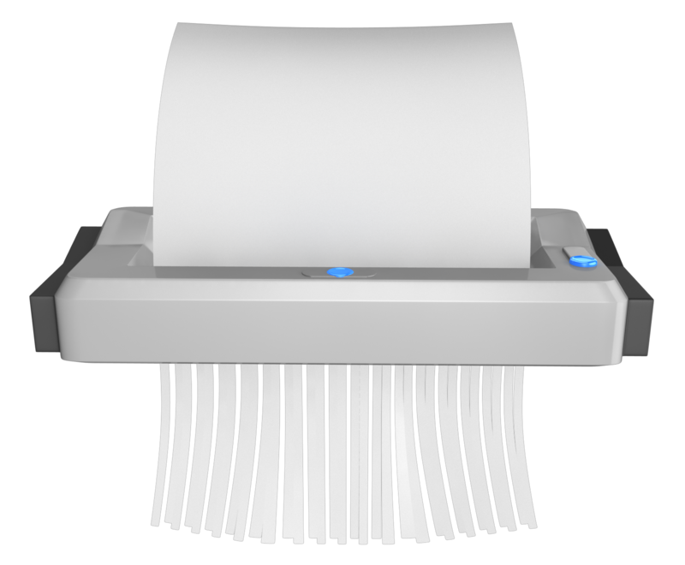

Activity 1B

2. Create presentation
2.1 Design slides, notes and handout masters to incorporate organisational and task requirements in relation to image and preferred style, avoiding distractions
2.2 Use software functions for consistency of design and layout, to meet identified presentation requirements
2.3 Balance presentation features for visual impact and emphasis
2.4 Use advanced software features to streamline and customise presentation for different audiences
2.5 Prepare presentation within designated timeline

2.1 – Design slides, notes and handout masters to incorporate organisational and task requirements in relation to image and preferred style, avoiding distractions

Organisational and task requirements may include:
- Company colour scheme
- Company logo
- Corporate image
- Music
- Organisation name, time, date, occasion etc. In header/footer
- Organisational video clip.
Distractions may include:
- Heavy colour
- Insufficient colour separation (background to text)
- Irrelevant animation
- Multiple transitions
- Overly busy background
- Overuse of sound
- Too many words or pictures per slide
- Too small fonts.
Try to include, observe and incorporate:
- Key phrases about your topic
- Limit punctuation and avoid all capital letters
- Avoid fancy fonts
- Use contrasting colours for text and background
- Use slide designs effectively
- Limit the number of slides
- Use photos, charts and graphs
- Avoid excessive use of slide transitions and animations
- Make sure your presentation can run on any computer.

Design slides, notes and hand-out masters
- When addressing the question of design slides, notes and handout masters the sky is the limit unless you are guided by specific organisational and task requirements.
- Previously we discussed the purpose, the audience and the other various areas of consideration, so it is assumed that has been addressed and the specific organisational and task requirements are in place.
- Whatever those specifics are, you will need to include holistically in relation to any image and preferred style.
The slide master used in PowerPoint
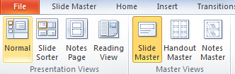
- Using the slide master allows you to change font colours and styles for every slide add a clipart or picture to every slide add a footer or date to every slide.
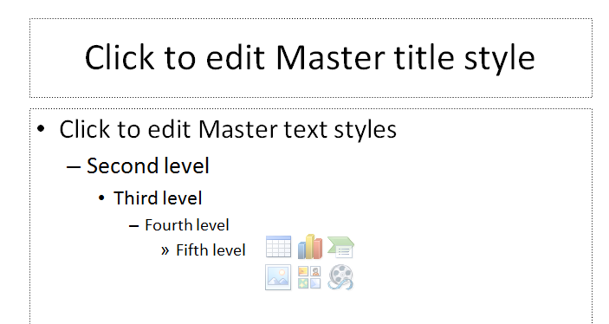

Design the master slide
Important: Before you spend a lot of time creating or customising a master slide, clarify your goal first. If what you are trying to accomplish involves applying a colour scheme, fonts, effects, layouts, or backgrounds, what you likely will need is a theme.
- Some suggest ignoring themes or the provided examples of the PowerPoint design template.
- PowerPoint templates adopt a design element that look more like a document and branded as such.
- Pre-designed templates and themes may add unnecessary clutter and distraction from the intended visual impact of a slide.
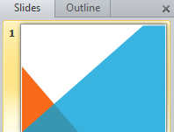
Maybe consider starting from a clean blank slide
- Some templates that are included in the PowerPoint stable are very much overused and are seen almost at every seminar or conference.
- Consider that your slide design is a method of communication and does not need fancy artwork or pretty background colours?
- After all, in most presentations you are only using slides as a text prompt to help focus the audience on what you are saying, not looking at the slides.
- Everything you add to your slides should have a positive impact on the message you are communicating.

- If your presentation is in fact a photo ensemble or montage of visual work, then that is what you would design it around.

What about corporate template images?
- Just about every organisation has a template that you would be required to use as part of incorporating organisational and task requirements in relation to the image and preferred style of your particular presentation.
- Even so, with the right consideration to space for text, the company or organisation logo can still be a feature.
- Consider not using the organisation logo on every slide, but just the opening one or two.
Consider not using the logo because:
- The audience know who you are.
- The audience are not going to forget the company you represent.
- The audience does not need to be reminded on every slide.
- This is especially applicable for internal company presentations.
A company logo featured on every slide of your presentation may look like an infomercial for your company and totally lose the audience.
- Don’t get resistance to your presentation at the outset as this is obviously not the outcome you want.
- Logos take up valuable space.
- If you can get approval...if approval is needed, just use a coloured slide in the company colours!

Notes and hand-outs
- Fortunately, PowerPoint lets you add personal notes to your slide, text that only you get to see.
- This allows you to plan out your presentation and outline what you are actually going to say.
- You can create notes pages as you build your presentation.
- You may want to print them and review them as you deliver your presentation.
A Green Idea... 
However, before printing notes pages, consider viewing your notes in Presenter View. You can view your notes as you deliver your presentation on a second monitor, and this will help to conserve paper and printer ink.

Create notes pages
Use the notes pane in Normal view to write notes about your slides.
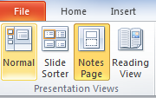 | 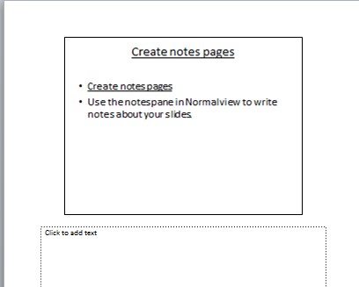

Notes pane in Normal view
- You can type and format your notes as you work in Normal view, but to see how your notes pages will print and to see the full effect of any text formatting, such as font colours, switch to Notes Page view.
- You can also check and change the headers and footers of your notes in Notes Page view.
Each notes page shows a slide thumbnail, along with the notes that go with that slide. In Notes Page view, you can embellish your notes with charts, pictures, tables, or other illustrations.
Hand out notes
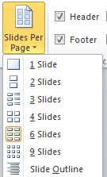
- You can print your presentation in the form of handouts — with one, two, three, four, six, or nine slides on a page — that your audience can use for future reference.
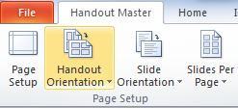

You can select a layout for your handouts from the Ribbon.

Previewing your hand-out
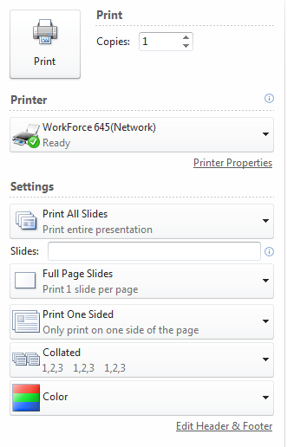
File Tab – The new File tab in the left corner of the ribbon, replaces the Office button. Many of the same features are present and some new features have been added.


Hand-out master
- If you want to change the look, positions, and size of the header and footer text, date, or page number on your handouts, make the changes to the handout master.
- To include a name or logo that should appear on every page of the handout, add it to the master.
- Changes you make to the handout master also appear when you print an outline.

Avoiding distractions
Check your PowerPoint presentation before presenting it
- There are usually several things in many PowerPoint presentations that distract audiences.
These are the obvious culprits:
- Wrong colour combinations
- Wrong or inconsistent fonts

- Overall slide design layout
- Using excessive and sometimes unrelated animation
- Inappropriate and distractive sounds
- Unreadable fonts
- Lengthy text
- Poor slide sequencing

Using storyboards may help you plan your presentation
- A storyboard is a document which specifies the visual elements, text elements, audio elements, interactions and branching (where the system or user will go next) of every screen.
- It is basically used to express our ideas and thoughts.
The storyboard is usually created by a person on your team or by a graphic artist if there are complex illustrations and art to be shown in your presentation.
- For a simple text based presentation it is still useful to look over the plan using a storyboard. This helps you to produce and incorporate organisational and task requirements in relation to image and preferred style and avoiding distractions.
- The storyboard is then usually reviewed by someone else within your organisation or if appropriate, by your client.

Types of Storyboard
Textual approach
- Some prefer to follow the storyboard with textual description, which may be much quicker, but may not be as informative to some people.
Visual approach
- Visual storyboard is common as the picture is considered worth more than the textual description and can be more appealing.
- Creating a storyboard is very similar to simply creating a new slide and working on it.
The preferred outcome in all instances
- Make your media transparent.
- It's easy to lose your presentation's focus if your slides are filled with too many graphic elements, animations, and special effects. Your slides should follow a simple design that keeps you and your audience from being distracted by too much happening on the screen.
- Create a dialog with your audience.
- Think of a presentation as a dialog in which the audience grants you permission to speak first.
- While you deliver the presentation, you are the only one who's speaking.
- You end the presentation when the audience gets to speak too.
- One way to spark a dialog is to focus and refine the story template so that it addresses the audience's concerns directly.

- Make sure that the story template anticipates any questions audience members might have about your reasoning. In this way, you shift the primary function of PowerPoint from a tool that supports the presenter to one that supports the audience.
- Invite further dialog by asking questions throughout your presentation. Your questions will help you connect with your audience, and your conversational tone will relax your audience and encourage them to participate in your dialog.
If you spend the time to plan your presentation carefully, you develop a deep confidence in your story. You are then free to improvise from the slides instead of being chained to just reading bullet points.

2.2 – Use software functions for consistency of design and layout, to meet identified presentation requirements
Software functions may include:
- Backgrounds
- Colour schemes
- Creating templates
- Handout master
- Importing outlines from other applications
- Importing images and graphics
- Notes master
- Placeholders
- Slide master.

Addressed In
2.1

2.3 – Balance presentation features for visual impact and emphasis
A complete PowerPoint presentation includes some basic components:
- An intro
- Table of contents
- Multiple presentation slides

- Conclusion
- Closing slide that opens the floor for questions and comments
- Make sure the audience can read each slide easily.

Visual impact and emphasis
- Make sure each slide looks professional
- Professional does not mean fancy
- Professional visual impact is neat and organised.

Speelling Spelling!!
- Professional does mean correct spelling. Nothing is more distracting than presenting a PowerPoint presentation with obvious spelling errors or place names, people names spelt incorrectly.
- Make sure the information on each slide is grammatically accurate.
- Failure to present correct spelling and grammar will immediately question your credibility.
As previously discussed limit the text on slides
- Not a good idea to include information on a slide that isn't covered in your speech.
- Limit the amount of information on each side
- Keep it simple
- A visual aid should make one point, and that's it.

Don’t hide behind your visual impact and emphasis

- In some instances the PowerPoint presentation can create as barrier between the speaker and the audience.
- An effective and professional speaker needs to create a sense of dialogue with the audience, and you can't do that if you hide in a corner and let your slides speak for you.
- Stand in full view of your audience and make eye contact with them throughout the presentation.
Don't read the slides word for word. This is very unprofessional and looks as if you are reading someone else’s slides!
- Make sure the technology is working.
If anything is going to fail first it will be the technology.
- Leave plenty of time to make sure the PowerPoint setup is functioning properly.
- Test it and retest it if you have the time.
- Make sure you know how to fix immediate and simple AV errors if there is no technical person nearby.
- Have a backup plan in case the technology fails you totally.
- Pre-print your sides ahead of time and be prepared to use them as the alternative if necessary.
- Don’t rely on transparencies as a backup, as this is very, very old technology and OHP are becoming obsolete.

2.4 – Use advanced software features to streamline and customise presentation for different audiences

What are Advanced Features?

- Advanced Features are not used all the time and are not essential to the basic program.
- Advanced Features allow you to fine tune and control your work.
- Advanced features can be found by using alternative software applications to that which is generally regarded as industry standard, e.g., Microsoft PowerPoint.

Presentation for different audiences
- Delivering the same presentation to different audiences.
- You can select slides from an existing presentation that are more appropriate for a particular audience.

Create a custom slide show
- When you need to deliver a presentation for a particular audience from an existing presentation choose a custom slide show from a list in PowerPoint.
- Many of the slides could be the same for both groups, or you can select a subset of the slides suitable for the particular audience.

On-the-spot customisation
- Sometimes you need to make an on-the-spot decision on showing slides during a presentation
- You can give yourself this flexibility by hiding the slide so that you can skip over it if its information doesn't seem useful to a particular audience.
- If you decide to include the slide's information in the presentation, you can display it by pressing the letter H or by using the Go To Slide command in PowerPoint.
Other examples of advanced software features may include:
- Animations and Transitions in PowerPoint
- Photos, Graphics, Clipart in PowerPoint
- PowerPoint Custom Shows. Making a custom show in PowerPoint is a method of playing only a few select slides from a much larger presentation.
- Sound – Music – Narration in PowerPoint
- YouTube Videos in PowerPoint. The use of videos already created on YouTube can save you lots of time. Link to or embed them in your PowerPoint presentations.
- Movies or Videos in PowerPoint. Short movie or video clips can be added into PowerPoint presentations similar to YouTube.
- Running your presentation in a loop.
- Changing slide transition.

Using advanced software may require advanced skills?
- Advanced skills will hopefully give you fine-tuning ability and control over designing and presenting your presentation, especially if you are responsible for the entire project.
- Relying on a technical person may not always be an option.
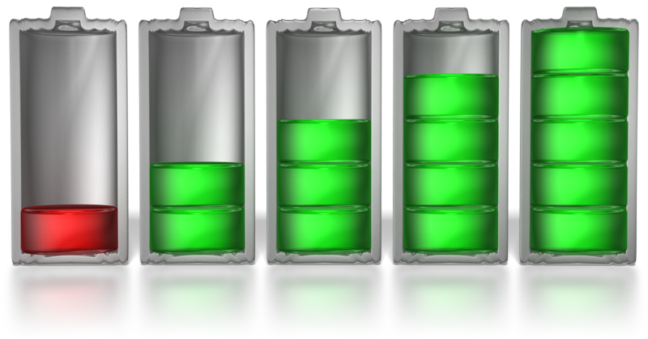
These include:
- Customisation
- Enhancing text and objects
- Working with other applications
- Managing slide shows
Working with other applications
- Using advanced software features to streamline and customise the presentation for different audiences you have options for alternative software to get the job done.
- Even if PowerPoint is regarded as industry standard, you don’t have to use Microsoft PowerPoint if you wish to explore advanced or alternative features.
- Many people would argue there are better tools for the job.
Apple’s Keynote
- Apple’s Keynote can be purchased as a stand-alone product, or as part of a suite.
- It’s probably one of the most intuitive, easy-to-use and template-heavy presentation applications around.
Google Docs
- Google Docs’ presentations module has been recently updated to make it more compatible with those who are moving from using Microsoft Office, or for those who want a more robust presentations tool.
- Google Docs offers a wealth of templates and presentation creation tools that are easy get started with, animations and slide transitions to make your presentation interesting to watch, and even collaborative presentation editing with other people on your team.

Prezi
- Prezi takes presentations in a different direction than static slides on a screen or projector with text on them.
- Even the animations and transitions available in other slideshow applications pale in comparison to Prezi’s zooming user interface, which puts entire slides in motion and focuses heavily on images, graphics and motion to draw attention to text.
- To some, it’s all too overwhelming and distracting from the core message of the presentation.
- Using Prezi in a school student environment is great for students to quickly put together a presentation.



2.5 – Prepare presentation within designated timeline
It is vital that presentations are prepared within designated timelines as to not stall the progression of the subject being presented whether this be a project or a new policy.
Designated timelines may include:
- Organisational timeline e.g. conference deadline requirements
- Timeline agreed with internal or external client
- Timeline agreed with supervisor or person requiring presentation.


Activity 2A

3. Finalise presentation
3.1 Use manuals, user documentation and online help to overcome problems with design and production
3.2 Check presentation for spelling and consistency in presentation features and style, in accordance with task requirements
3.3 Print presentation materials in accordance with presenter or audience requirements
3.4 Store presentation, in accordance with organisational requirements and exit application without information loss or damage

3.1 – Use manuals, user documentation and online help to overcome problems with design and production
PowerPoint is presentation software that can be used to create slide shows for printing, on-screen projection, or Web-based display.

Read the manual
- Manuals will vary according to the application or system, e.g., Microsoft PowerPoint or any number of other presentation programs, some of which have been discussed earlier in this element.
- They may not always address specific functionality or technique questions, but as a starting point in overcoming problems they are most useful.
- A program manual, help files or user guides also can be useful learning tools.

Most applications for creating electronic presentations will have a form of user manual for reference.
Manuals are found:
- Online
- On your computer
- A website
- Hard copy in a box or folder
- On a CD or DVD.
The function and applicability of a manual is usually directly related to the skills or attitude of the user.
- Many users will not refer to manuals, user documentation and online help as a matter of pride, others find that manuals and help services online are incredibly hard to navigate to the question you want answered.
- Most manuals and information guides will not speak your exact language so some form of pre-investigation and assessment is the best option.
- Learn how your specific electronic presentations software relates to the manual as the terminology and instructions are not holistic.
- Look for useful charts and images that will help you with understanding production explanations for some of the more obscure functionality.
- Understand the basic features and some technical advice.


The sections of a user manual often include:
- A cover page
- A title page and possibly a copyright page
- A preface, containing details of related documents and information on how to navigate the user guide
- A contents page
- A guide on how to use at least the main functions of the system
- A troubleshooting section detailing possible errors or problems that may occur, along with how to fix them
- A FAQ (Frequently Asked Questions)
- Where to find further help, and contact details
- A glossary and, for larger documents, an index.
User manuals and user guides for most professional software applications are book-like documents with contents similar to the above list.
Buy a book
- Most major electronic presentation programs have a variety of third-party books that teach both beginner and advanced users of the program.
- These books may include hands-on exercises and supporting material on a CD-ROM.
- It can be helpful to have multiple books on a single program, such as a getting started overview and an in-depth reference manual.

User documentation quality checklist
One element of evaluation for software is the quality of the user documentation supplied.
User documentation may be provided as a user manual, a handbook, online or on a CD or DVD, as a paper insertion in the box, or in the form of an online help service.
Sample Checklist
- Does the documentation reflect the technical architecture of the product?
- Does the document contain decipherable lists of errors and production hints?
- How close and how efficient is the integration of online documentation with the software?
- Are there clear instructions that address users directly?

Identify the exact need
The term guide is often applied to a document that addresses a specific aspect of a software product.
- Some guide usages are installation guide, getting started guide, and various how to guides.
- In some presentation applications, where groups of users have access to only a sub-set of the application's full functionality, a user guide may be prepared for each group.
- An example would be a user guide or manual document, which contains separate administrator guides, user guides, and production guides.
- These types of guides are a valuable tool for on-the-job training.

Sample PowerPoint typical user manual headings with design and production
- Slide show
- Contextual menus and tabs
- Slide layouts/slide types
- Design themes
- Slide transitions
- Animations.

Overcome some problems with design and production help
- Format text around an image. PowerPoint can’t handle pictures and text as well as Microsoft Word does.
- Write it in Word. The single best thing you can do to improve your presentation is to spend more time writing your presentation, rather than fiddling with the look of your slides, transitions, fonts, and graphics.
- When you want to bring the audience's attention from your slides back to you, use some of PowerPoint's keyboard shortcuts. For example, while you are expanding on a point, press the B key to make the screen go black, or press the W key for a white screen. Press the same key again to continue.
- Always be ready to present. Presentations are about informing and persuading others, but these days, you never know when you might get the opportunity to make your case. Use PowerPoint's integration with iPhoto to carry your presentations with you everywhere on your iPhone, iPod or iPad. All you need to do is export the presentation as an iPhoto album.

Online help
Online help is usually topic-oriented, procedural or reference information delivered through computer software.
- It is a form of user assistance.
- Most online help is designed to give assistance in the use of a software application or operating system, but can also be used to present information on a broad range of subjects.
- When online help is linked to the state of the application (what the user is doing), it is called context-sensitive help.
- A help and support centre is an electronic reference manual, for example, on Microsoft Access the support centre tries to answer queried problems while troubleshooting.

Outsourcing technical documentation and help
- The rates charged for an external documentation service provider may be high.
- However, you only have to pay for time that was actually spent on the request.
- An external help or user guide service contractor will have to learn a lot about all products whereas using a single manual for one application can narrow down the issues.

Advantages:
- Quality
- Service
- Time saved
- Expertise
- Flexibility
- Training.

Help Desks
There are two common types of help desks
- Information and assistance provided by an external service that assists a caller with troubleshooting problems with computers or applications such as PowerPoint.
- An in-house help desk software program designed for internal use by employees only.

Try a tutorial:
PowerPoint 2010 Tutorial  Introduction  PowerPoint Basics  Adding & Editing Content  Inserting Text  Inserting Notes, Headers & Footers  Formatting Text & Lists  Working With Design  Design Themes  Backgrounds & Colour Schemes  Slide Masters  Design Tips | Working With Graphics  Downloading & Inserting Images  Editing Images  Image Resources for Health & Life Sciences  Drawing & Editing Objects  Working With Animation  Animating Text & Images  Slide Transitions  Sound & Video  Adding Sounds, Narration, & Music  Adding Videos | Charts & SmartArt  Working With Charts  Working With SmartArt  PowerPoint Online  Hyperlinks & Action Buttons  Putting a Presentation on the Web  Printing & Presenting  Printing Options  Running a Slide Show  Links  Do’s and Don’ts

Activity 3A

3.2 – Check presentation for spelling and consistency in presentation features and style, in accordance with task requirements

3.3 – Print presentation materials in accordance with presenter or audience requirements
Check presentation for spelling
- As mentioned previously, spelling and grammar mistakes can distract from the work that you put into your presentation, so you obviously want to eliminate these mistakes.
- You probably have your own methods and preferences for how to help you do this.
- You might prefer to check spelling all at once when you finish a presentation, or you might want to use automatic spelling and grammar checking while you are working.

Establish what you want to do
- Display the proofing options in the application
- Select the AutoCorrect options
- Select the spelling correction options that apply
- Change how the spelling checker works in the background
- Improve the spelling checker results by using contextual spelling

PowerPoint 2010
Turn on or off spelling check
- Click the FILE button
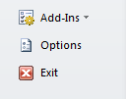
- At the bottom of the FILE menu, click Options

- On the Options menu that appears, click Proofing.
- Under When correcting spelling in PowerPoint, select or clear the Check spelling as you type, or Use contextual spelling, or Hide spelling errors check box.
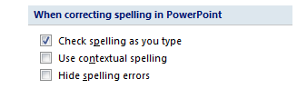

Check spelling
- Open a presentation that needs to be checked.
- On the Review tab, in the Proofing group, click Spelling
- 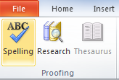
- The Spelling dialog box appears, and the first suggested correction is highlighted.
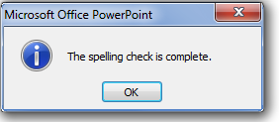
- Use the following buttons to check your spelling:

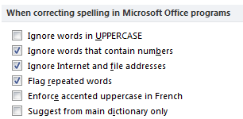

Consistency in presentation features
- As previously addressed, decide if your presentation is meant to entertain, inform, persuade, or sell.
- Is a light-hearted or a more formal approach most appropriate to the subject and your audience?
- Keep colours, clip art, and templates consistent with your main objective.
- Features and style have been covered elsewhere
Avoid info overload:
- If you overload your audience, you shut down the dialogue that is the most important part of any interaction you wish to get from a presentation.
- If there is no intention for feedback, open discussion or dialogue it is best to screen a video or DVD instead.
Practice your delivery:
- A professional presentation can be very captivating and sometimes you may forget about the audience and become absorbed in the talk.
- Practice your delivery over and over until you can be confident about staying on track and the subject even with an exciting audience distraction.

Forget comedy:
- Most organisational based presenters will flirt with the temptation to deliver the stand-up humour.
- Remember your audience didn't come to laugh at you or them especially if it is a business presentation.
- Leave your jokes at home. It's ok to throw in a few natural off the cuff laughs but don't overdo it.
Pick powerful props:
- You don't need a box full of props but a few simple props to demonstrate a point can be memorable in the minds of your target audience.
Minimise you:
- Unless it’s the company Board of Directors, your audience most likely cares little about your company history, as they do about whether you can help them solve the specific problems they face.
- Write a script for your presentation that makes the audience the main character, who face a problem that you will help them solve.
Speak the language:
- A memorable presentation will not work if you leave the audience wondering what the hell you just said!
- It might be tempting to throw in a few big words but are you alienating your audience?
- Always explain terms and acronyms.
- The number of smart executives who are not up on the latest terminology would surprise you.

Activity 3B

3.4 – Store presentation, in accordance with organisational requirements and exit application without information loss or damage
Storing presentations may include:
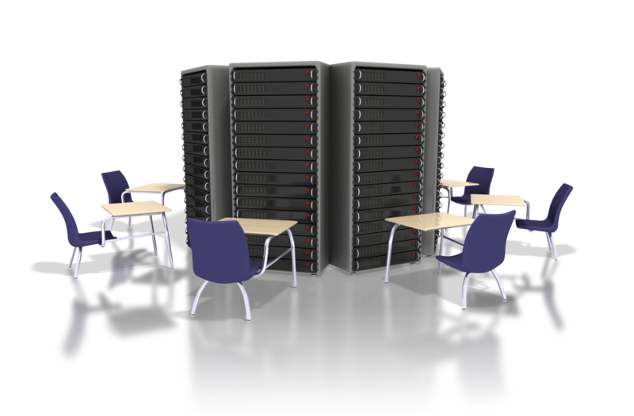
- Authorised access
- Filing locations
- Organisational policy for backing up files
- Organisational policy for filing hard copies
- Security
- Storage in folders or sub-folders
- Storage on disk drives, USB, CD-ROM, backup tapes, server.
The responsibility for records management including storage, access, locations and security of PowerPoint presentations and other organisation files should form part of a manual and policy procedure.
- Your organisation would need to clearly specify how these actions are to be addressed so that all employees are following a common policy and security protocol.
- This is necessary to ensure that the infrastructure, systems, policies and procedures are in place to support the security of digital records over time and with the change of employees.
Maintaining the essential file characteristics for as long as they are required and for audit purposes is critical.

Storage integrity
Storage on disk drives, USB, CD-ROM, backup tapes, servers and such can be particularly vulnerable to obsolescence.
- It is necessary for your organisation to include some form of technology check as part of the operating manual to ensure the technology used for storage is not compromised.
- A regular monitoring of the condition and any faults within the storage systems and subsequent duplication or transfer protocol should be undertaken.

Costs of storage

Plan for the replacement or upgrade of remote servicers and other expensive storage devices.
- Allocate adequate budget resources for all forms of digital storage.
- Costs of digital preservation will vary according to the strategies chosen, past and present controls and the complexity of the digital equipment, size of the organisation etc.
- Careful planning can help you to reduce costs significantly and avoid being left with outdated storage equipment facilities.

Saving your presentation is quite easy
- Simply go to the file menu, click save, and choose a name and place on your hard-drive to save too.
- The resulting PowerPoint file will have either the ".ppt" or “.pptx” extension.
- You can then copy this PowerPoint file onto a CD, thumb drive or any number of external drives and devices for safety and backup.

What are your organisations requirements?
- To save your presentation in the standard format, simply go to the Office Button located at the top left, then choose Save.
- However to save the presentation in other formats, instead of going to save, go to Save as.
- There are multiple formats that the presentation can be saved as.
PowerPoint Presentation
- This is the default format. The presentation will be saved as a PowerPoint 2007 file.
PowerPoint Show
- In this format when the PowerPoint file is launched the presentation will automatically start.
PDF or XPS
- This format is entirely different from PowerPoint meaning that when the save file is launched it will be launched in a PDF/XPS viewer.
- The reason for saving the presentation in this format is to ensure your printed or viewed file keeps the original formatting.


Storage on hard/floppy disk drives, Thumb Drives, CD-ROM, tape back-up and other devices
Develop a Plan
- Before investing in a data storage solution, consult with a trusted IT advisor on which option--or options--will best meet your business's current and future needs. Then create a plan for storage at your organisation and base it on the likely needs you will have and most importantly, when and where it will be needed.
Flash memory thumb drives
- These types of drives are particularly appealing to mobile professionals because they consume little power, are small enough to fit on a keychain and have no moving parts.
External hard drives
- A simple and relatively inexpensive way to add more storage is to connect an external hard disk drive to your computer.
- The danger is that files stored on the external drive but not elsewhere will need to be backed up.
- Remember, you will need to take the external drive with you or remember to copy the required files to a USB thumb drive.
CD or some other storage media
- Not very safe, can easily be damaged or lost.
- Small storage capacity compared to thumb drives, or external drives.

Exit the application without information loss or damage
Clicking the Close button is the easiest way to close a file.
If you’ve made changes since the last time you saved the file, PowerPoint offers to save the changes for you when you close the file.
Click Yes to save the file before closing or click No to abandon any changes.
- Click the Close button.
- Click the Office button and then choose Close.

- Use the keyboard shortcut Ctrl+W.

Loss or damage
- If a PowerPoint presentation displays unusual or weird behaviour after you have closed it and then re-opened, it is likely corrupt.
- The corruption of files impacts on data accessibility, damage or loss.
- The inaccessible data may only be accessed if you have created a backup.
- It may be possible to effectively recovery .ppt or .pptx presentation and retrieve all the data from the presentation.
- The presentation may become corrupt if it is mishandled, or due to improper system shutdown, application malfunction, system crash, virus, etc.

Possible solutions – no guarantees!
Try the following troubleshooting methods to solve the issue:
- Try to open the presentation in Windows Safe mode, since system conflict at times prevents the presentation from opening.
- Try dragging the PowerPoint presentation to the PowerPoint program file.
- Check if the presentation can be opened in Microsoft Windows Explorer.
- Insert the slides into a blank presentation.
- You may be able to open the temporary file by saving the .tmp file (with the same name) as.ppt or .pptx file.
- See if the presentation opens in PowerPoint Viewer.
- Try opening the presentation in another system.
- Try moving the presentation to another disk.
- Use Scan Disk tool.

Activity 3C

Skills and Knowledge Activity

Nearly there...

Major Activity – An opportunity to revise the unit
At the end of your Learner Workbook, you will find an activity titled ‘Major Activity’. This is an opportunity to revise the entire unit and allows your trainer to check your knowledge and understanding of what you have covered. It should take between 1-2 hours to complete and your trainer will let you know whether they wish for you to complete it in your own time or during session. Once this is completed, you will have finished this unit and be ready to move onto the next, well done!

Congratulations!
You have now finished the unit ‘Create electronic presentations’


References

These suggested references are for further reading and do not necessarily represent the contents of this Learner Guide

- Creating a Presentation in Microsoft Office PowerPoint 2007 for Windows: Visual QuickProject Guide [Paperback]
Tom Negrino (Author)
- Beyond Bullet Points: Using Microsoft PowerPoint to Create Presentations That Inform, Motivate, and Inspire (Bpg-Other) [Paperback]
Cliff Atkinson (Author)
- Advanced Presentations by Design: Creating Communication that Drives Action [Paperback]
Andrew Abela (Author)
- PowerPoint 2007: The Missing Manual [Paperback]
E. A. Vander Veer (Author)

