BSBITU304
Produce spreadsheets
Learner Guide



BSBITU304
Produce spreadsheets

Table of Contents

Table of Contents 3
Unit of Competency 7
Performance Criteria 8
Foundation Skills 9
Assessment Requirements 10
Housekeeping Items 11
Objectives 11
1. Select and prepare resources 12
1.1 – Adhere to ergonomic, work organisation and work health and safety requirements 13
Ergonomic requirements may include: 13
Work organisation requirements may include: 13
Work health and safety requirements may include: 13
Examples of workplace policy requirements 15
Activity 1A 16
Using a mouse 20
Keyboard equipment and radiation 20
Keyboard and telephone operations 20
Posture during Keying 20
Typing technique 20
Work health and safety requirements 22
Common law duties 22
Duties of employees and contractors 23
Other issues 23
Management should: 23
1.2 – Use energy and resource conservation techniques to minimise wastage 25
Conservation techniques may include: 25
Energy and resource conservation in the workplace 25
What are your energy efficiency priorities? 25
A plan in simple terms means: 26
Activity 1B 27
1.3 – Identify spreadsheet task requirements in relation to data entry, storage, output and presentation 28
Identify the task? 28
Organisational task requirements 28
Spreadsheet specifications 28
Data entry, storage, output, reporting and presentation requirements 29
Storage 29
Output 29
Presentation 30
Activity 1C 31
2. Plan spreadsheet design 32
2.1 – Ensure spreadsheet design suits purpose, audience and information requirements of task 33
Spreadsheet design may include: 33
Activity 2A 34
2.2 – Ensure spreadsheet design enhances readability and appearance, and meets organisational and task requirements for style and layout 37
Spreadsheet design principles 37
2.3. Use style sheets and automatic functions to ensure consistency of design and layout 40
Excel 2010 41
Background styles 43
Create a macro by using Microsoft Visual Basic 46
Activity 2B 48
3. Create spreadsheet 49
3.1 – Ensure data is entered, checked and amended to maintain consistency of design and layout, in accordance with organisational and task requirements 50
Data may include: 50
Checking data may include: 50
Ensure data is entered, checked and amended to maintain consistency 50
Checking data may include: 51
Accuracy of data 51
Accuracy of formulae with calculator 52
Proofreading 55
Use text-to-speech commands in Microsoft office 2010 55
3.2 – Format spreadsheet using software functions to adjust page and cell layout to meet information requirements, in accordance with organisational style and presentation requirements 57
Formatting may include: 57
Software functions may include: 57
Activity 3A 58
3.3 – Ensure formulae are tested and used to confirm output meets task requirements, in consultation with appropriate personnel as required 59
Formulae may include: 59
Use cell or sheet AUDITING feature to check formulae. 59
3.4 – Use manuals, user documentation and online help to overcome problems with spreadsheet design and production 61
Activity 3B 63
4. Produce simple charts 64
4.1 – Select chart type and design that enables valid representation of numerical data, and meets organisational and task requirements 65
4.2 – Create charts using appropriate data range in spreadsheet 65
Examples of numerical placement in a Chart 67
Activity 4A 68
4.3 – Modify chart type and layout using formatting features 69
Change the layout of chart elements manually 69
Select a predefined chart style 70
Select a predefined chart layout 70
Activity 4B 71
5. Finalise spreadsheets 72
5.1 – Preview, adjust and print spreadsheet and any accompanying charts, in accordance with task requirements 73
Preview 73
Printing may include: 73
Adjust and print spreadsheet 73
Set page options for a chart 74
Print a chart with worksheet data 74
Printing 75
Prints the whole worksheet 75
Activity 5A 77
5.2 – Ensure data input meets designated timelines and organisational requirements for speed and accuracy 78
Designated timelines may include: 78
Designated timelines may be: 78
Activity 5B 79
5.3 – Name and store spreadsheet in accordance with organisational requirements and exit application without data loss/damage 80
What are your storage needs? 81
Activity 5C 83
Skills and Knowledge Activity 84
Major Activity – An opportunity to revise the unit 85
References 87

Unit of Competency

Application
This unit describes the skills and knowledge required to develop spreadsheets through the use of spreadsheet software.

It applies to individuals employed in a range of environments who tend to be personally responsible for designing and working with spreadsheets under minimal supervision.

No licensing, legislative or certification requirements apply to this unit at the time of publication.

Unit Sector
Information and Communications Technology – IT Use

Performance Criteria
Element  Elements describe the essential outcomes. | Performance Criteria  Performance criteria describe the performance needed to demonstrate achievement of the element.
- Select and prepare resources | - Adhere to ergonomic, work organisation and occupational health and safety requirements  - Use energy and resource conservation techniques to minimise wastage  - Identify spreadsheet task requirements in relation to data entry, storage, output and presentation
- Plan spreadsheet design | - Ensure spreadsheet design suits purpose, audience and information requirements of task  - Ensure spreadsheet design enhances readability and appearance, and meets organisational and task requirements for style and layout  - Use style sheets and automatic functions to ensure consistency of design and layout
- Create spreadsheet | - Ensure data is entered, checked and amended to maintain consistency of design and layout, in accordance with organisational and task requirements  - Format spreadsheet using software functions to adjust page and cell layout to meet information requirements, in accordance with organisational style and presentation requirements  - Ensure formulae are tested and used to confirm output meets task requirements, in consultation with appropriate personnel as required  - Use manuals, user documentation and online help to overcome problems with spreadsheet design and production
- Produce simple charts | - Select chart type and design that enables valid representation of numerical data, and meets organisational and task requirements  - Create charts using appropriate data range in spreadsheet  - Modify chart type and layout using formatting features
- Finalise spreadsheets | - Preview, adjust and print spreadsheet and any accompanying charts, in accordance with task requirements  - Ensure data input meets designated timelines and organisational requirements for speed and accuracy  - Name and store spreadsheet in accordance with organisational requirements and exit application without data loss/damage

Foundation Skills
This section describes language, literacy, numeracy and employment skills incorporated in the performance criteria that are required for competent performance.

Skill | Performance  Criteria | Description
Reading | 2.2, 3.1-3.4, 5.1 | - Recognises and interprets numerical and textual information to determine organisational and task requirements
Writing | 2.1, 3.1-3.3, 4.2, 4.3, 5.1-5.3 | - Inputs numerical and key reporting information when creating and finalising spreadsheets and uses format, layout, style guides and standard naming conventions to organise data according to purpose and audience
Oral communication | 3.3 | - Participates in exchange of information to determine whether formulae utilised produce result required
Numeracy | 4.1, 4.2 | - Uses mathematical equations to create simple formulae and validate numerical data
Navigate the world of work | 1.1-1.3, 2.1-2.3, 3.1-3.3, 4.1, 5.1-5.3 | - Recognises and follows explicit and implicit protocols and meets expectations associated with own role
Interact with others | 3.3 | - Collaborates with others to achieve joint outcomes
Get the work done | 2.1-2.3, 3.1-3.4, 4.1-4.3, 5.1-5.3 | - Uses advanced features within applications to address routine and complex work tasks

Assessment Requirements
Performance Evidence

Evidence of the ability to:

- Design spreadsheets that address a range of data and organisational requirements
- Use software functions, graphics and support materials to create spreadsheets
- Apply knowledge of formatting requirements for workplace documents

Note: If a specific volume or frequency is not stated, then evidence must be provided at least once.

Knowledge Evidence

To complete the unit requirements safely and effectively, the individual must:

- Describe formatting requirements of workplace documents
- Identify organisational guidelines on spreadsheet design and use
- Explain organisational requirements for ergonomic standards, work periods and breaks, and conservation techniques

Assessment Conditions

Assessment must be conducted in a safe environment where evidence gathered demonstrates consistent performance of typical activities experienced in the information and communications technology – IT use field of work and include access to:

- Industry software packages
- Computer user information
- Relevant legislation and codes of practice
- Organisational policies and procedures
- Relevant workplace documentation and resources

Assessors must satisfy NVR/AQTF assessor requirements.

Links

Companion volumes available from the IBSA website: http://www.ibsa.org.au/companion_volumes

Housekeeping Items
Your trainer will inform you of the following;
- Where the toilets and fire exits are located, what the emergency procedures are and where the breakout and refreshment areas are.
- Any rules, for example asking that all mobile phones are set to silent and of any security issues they need to be aware of.
- What times the breaks will be held and what the smoking policy is.
- That this is an interactive course and you should ask questions.
- That to get the most out of this workshop, we must all work together, listen to each other, explore new ideas, and make mistakes. After all, that’s how we learn.
- Ground rules for participation;
  - Smile
  - Support and encourage other participants
  - When someone is contributing everyone else is quiet
  - Be patient with others who may not be grasping the ideas
  - Be on time
  - Focus discussion on the topic
  - Speak to the trainer if you have any concerns

Objectives
- Learn how to select and prepare resources
- Understand how to plan spreadsheet design
- Discover how to create spreadsheet
- Identify how to produce simple charts
- Know how to finalise spreadsheets
- Gain skills and knowledge required for this unit

1. Select and prepare resources

1.1. Adhere to ergonomic, work organisation and work health and safety requirements
1.2. Use energy and resource conservation techniques to minimise wastage
1.3. Identify spreadsheet task requirements in relation to data entry, storage, output and presentation



1.1 – Adhere to ergonomic, work organisation and work health and safety requirements

Ergonomic requirements may include:

- Avoiding radiation from computer screens
- Chair height, seat and back adjustment
- Document holder
- Footrest
- Keyboard and mouse position
- Lighting
- Noise minimisation
- Posture
- Screen position
- Workstation height and layout.

Work organisation requirements may include:
- Exercise breaks
- Mix of repetitive and other activities
- Rest periods.

Work health and safety requirements may include:
- Inspections
- Organisational procedures regarding incidents, accidents, fire and emergencies
- Workplace meetings
- Workplace safety procedures
- Other consultative activities.
Any assessment of ergonomic conditions that exists in the workplace would normally be handled through the HR (Human Resource) department under a Risk Assessment as part of OH&S (Workl Health and Safety) or by a system that evaluates risk potential to employees.
Some of the areas suggested in the Range Statement would be more suitably handled by employees as part of a daily or periodic self-check of equipment, the workstation and work area before work commences and during work.
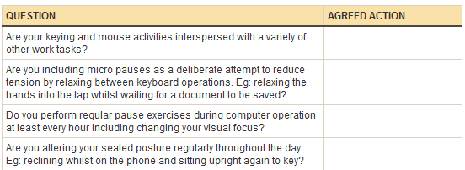
For areas that may be covered under OH&S and awards or Human Resource policies, responsibility of the employer to provide a safe workspace would be documented and form part of regular risk management checks.
- Supervisors, managers, team leaders etc. are generally designated OH&S officers so that there is a standard and policy driven culture present to the checks.
- Responsibilities include hazard reporting procedures, job procedures and safe work instructions, emergency procedures, accident and near miss reporting and recording procedures, consultation on WHS issues, correct selection, use & storage and maintenance procedures for use of personal protective equipment, control of risks under direct supervision.
- Awareness of relevant legislation from all levels of government (State or Federal) which affect business operation, especially in regard to OH&S and environmental issues, equal opportunity, industrial relations, anti-discrimination and diversity.
- Compliance to behaviour that contributes to a safe working environment, identifying and reporting risks or hazards, using business equipment according to guidelines, listening to the ideas and opinions of others in the team, sharing opinions, views, knowledge and skills.
- Formal and informal health and safety meetings, meetings called by health and safety representatives, suggestions, requests, reports and concerns put forward to management.
- Workstation height and layout, chair height, seat and back adjustment, footrest, screen position, keyboard and mouse position, document holder, posture, avoiding radiation from computer screens, noise minimisation.
- Mix of repetitive and other activities, rest periods, exercise breaks, VDU eye testing.
- A range of environmental conditions including: noise, light, gas, smoke, odour, vapour, liquids/solids, particles and fumes.
If a particular office layout design is needed this would be a matter of personal and working circumstances.
For example:

- Does the workspace provide acoustical privacy (for example, can people talk in privacy, according to the level of confidentiality required; do noises and conversations interfere with their concentration; do noises or conversations make it difficult to hear or understand speech if much of their work involves using the telephone?)
- Are the walls permanent (i.e., fixed) or is the workspace in an open office environment?
- Does the workspace provide visual privacy?
- Can an employee personalise his or her individual work space?
- Is there access to natural light or only artificial lighting?
- Is the workplace layout designed to facilitate interpersonal contact?

Examples of workplace policy requirements
- Maintain work areas in a safe, uncluttered and organised manner according to policy and procedures.
- Carry out all procedures safely, effectively and efficiently with minimum inconvenience to staff according to policy.
- Apply policy and procedures for tidying work areas and placing items in designated areas.
Clean work area.
- Apply policy and procedures for personal hygiene.
- Apply policy and procedures for cleaning of work area.
- Sort, recycle, remove and dispose of waste promptly according to policy requirements.
- Safely remove and clean spills of food, waste or other potential hazards in compliance with WHS requirements and policy.
- Maintain equipment and consumable materials and store correctly after use.
- Use and clean equipment according to manufacturer instructions and policy requirements.

Activities

Activity 1A
Estimated Time | 30 Minutes
Objective | To provide you with an opportunity to adhere to ergonomic, work organisation and occupational health and safety requirements.
Activity | - Take time to review the Australian Standard AS 3590 as it relates to workplace ergonomic requirements  - What does this standard specify?  - What are the guidelines aimed at achieving?

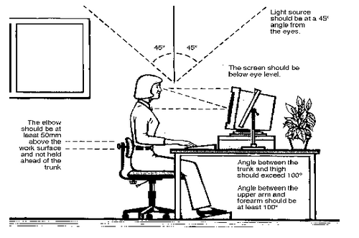
Consideration should be given to:
- The accessories required to operate properly
- The layout of equipment on the desk
- The location of furniture in the room.
Work surface height
- Adjust the height of the work surface and/or the height of the chair so that the work surface allows your elbows to be bent at 90 degrees, forearms parallel with the floor, wrist straight, shoulders relaxed.
Chair
- Adjust the seat tilt so that you are comfortable when you are working on the keyboard. Usually, this will be close to horizontal but some people prefer the seat tilted slightly forwards. Your knees should be bent at a comfortable angle and greater than 90 degrees flexion. If this places an uncomfortable strain on the leg muscles or if the feet do not reach the floor then a footrest should be used. The footrest height must allow your knees to be bent at 90 degrees. Therefore the height of the footrest may need to be adjustable. Adjust the backrest so that it supports the lower back when you are sitting upright.


Keyboard placement
- Place the keyboard in a position that allows the forearms to be close to the horizontal and the wrists to be straight. That is, with the hand in line with the forearm. If this causes the elbows to be held far out from the side of the body then re-check the work surface height. Some people prefer to have their wrists supported on a wrist desk or the desk. Be careful not to have the wrist extended or bent in an up position.
Screen placement
- Set the eye to screen distance at the distance that permits you to most easily focus on the screen. Usually this will be within an arm's length. Set the height of the monitor so that the top of the screen is below eye level and the bottom of the screen can be read without a marked inclination of the head. Usually this means that the centre of the screen will need to be near shoulder height. Eyes level with the tool bar. People who wear bifocal or multi focal lenses will need to get a balance between where they see out of their lenses and avoid too much neck flexion.
Desk-top layout
- Place all controls and task materials within a comfortable reach of both hands so that there is no unnecessary twisting of any part of the body. Most people prefer the document holder to be between the keyboard and the monitor. There are many different types of document holders available.
Document holder
- Place this close to the monitor screen in the position that causes the least twisting or inclination of the head.
Posture and environment
- Change posture at frequent intervals to minimise fatigue. Avoid awkward postures at the extremes of the joint range, especially the wrists. Take frequent short rest breaks rather than infrequent longer ones. Avoid sharp increases in work rate. Changes should be gradual enough to ensure that the workload does not result in excessive fatigue. After prolonged absences from work the overall duration of periods of keyboard work should be increased gradually if conditions permit.

Lighting

- Place the monitor to the side of the light source/s, not directly underneath. Try to site desks between rows of lights. If the lighting is fluorescent strip lighting, the sides of the desks should be parallel with the lights. Try not to put the screen near a window. If it is unavoidable ensure that neither the screen nor the operator faces the window.
- If the monitor is well away from windows, there are no other sources of bright light and prolonged desk-work is the norm, use a low level of service light of 300 lux. If there are strongly contrasting light levels, then a moderate level of lighting of 400 – 500 lux may be desirable.
Glare and reflection
- It is important to detect the presence of glare and reflection. To determine whether there is glare from overhead lights whilst seated worker should hold an object such as a book above the eyes at eyebrow level and establish whether the screen image becomes clearer in the absence of overhead glare. To detect whether there are reflections from the desk surface, the worker should hold the book above the surface and assess the change in reflected glare from the screen.
A number of ways are available to eliminate or reduce the influence of these reflections:
- Tilt the screen (top part forwards) so that the reflections are directed below eye level.
- Purchase an LCD screen.
- Cover the screen with a light diffusing surface or anti-glare screen.
- Negative contrast screen (dark characters on light background) will reduce the influence of these reflections.
If you experience eye discomfort when using a bright screen you should make the following adjustments:
- Turn the screen brightness down to a comfortable level.
- Look away into the distance in order to rest the eyes for a short while every ten minutes or so.
- Change the text and background colours. Recommended are black characters on white or yellow background, or yellow on black, white on black, white on blue and green on white. Avoid red and green and yellow on white.

Using a mouse

- A well designed mouse should not cause undue pressure on the wrist and forearm muscles. A large bulky mouse may keep the wrist continuously bent at an uncomfortable angle. Pressure can be reduced by releasing the mouse at frequent intervals, by selecting a slim-line, low-profile mouse. Keep the mouse as close as possible to the keyboard, elbow bent and close to the body.

Keyboard equipment and radiation
- Computer screens emit visible light which allows the characters on the screen to be seen. Weak electromagnetic fields and very low levels of other radiation, not visible to the human eye, can be detected by sensitive instruments. Similar emissions are produced by television receivers.
- The levels of most radiations and electromagnetic fields emitted from computers are much less than those from natural sources, such as the sun or even the human body and are well below levels considered to be harmful by responsible expert bodies such as the International Radiation Protection Association (IRPA).

Keyboard and telephone operations
- Avoid cradling the phone between your head and shoulder when answering calls. If needing to access the computer at the same time a headset is recommended. Hands free/speaker phone is another option if the environment is suitable.

Posture during Keying
- Good posture is essential for all users of computers. It comprises of a natural and relaxed position, providing opportunity for movement, and from which the operator can assume a number of alternative positions. It is not a single, rigidly defined position.

Typing technique
Typing is a physical activity, and using a keyboard requires skill, hence the need to learn correct typing technique. Unskilled ('hunt and peck') typists are particularly at risk of Occupational Overuse Injury because they:
- often use only one or two fingers which may overload the finger tendons;
- are constantly looking from keyboard to screen to keyboard, which may strain neck muscles;
- often adopt a tense posture (wrists bent back and fingers 'poised to strike').
- The University acknowledges the importance of learning correct typing technique. Departments should ensure that untrained staff receive appropriate training.
Speed of keying

- The efficiency and speed of modern computers makes it possible for a skilled operator to type extremely quickly. This capability, reinforced by workload pressures means the potential exists for operators to key at speeds which may cause or contribute to Occupational Overuse Syndrome.
- The role of the repetitive movement in injury is not fully understood, but is believed to interfere with the lubrication capacity of tendons, and the ability of muscles to receive sufficient oxygen supplies.
10,000 – 12,000 keystrokes per hour is considered an acceptable standard.
Length of time on the keyboard
- The maintenance of a fixed posture for long periods is tiring and increases the likelihood of muscular aches and pains. In addition, long periods of repetitive movement and sustained visual attention can also give rise to fatigue-related complaints.
- It is recommended that operators avoid spending more than five hours a day on keyboard duties and no longer than 50 minutes per hour without a postural/stretching break.
- Employees newly engaged in keyboard work, and staff returning from an absence of two or more weeks, need a period of adjustment. The adjustment may be achieved through reduced work rates, or provision of alternate duties with gradual re-introduction to keyboard work.
Jobs should be designed and organised so that either:
- Computer related tasks can be interspersed with non-computer related, or
- Computer based tasks can be rotated amongst several staff (task/job sharing).
- It is not the change of task per se, but the change to using different movements and postures that is important. The whole purpose of task variety is to give the overloaded structures a necessary break.
Supervisors should ensure that workload controls are exercised using the following strategies:
- Planning ahead to avoid peaks, and rushed jobs
- Delegating fairly to all staff not just the best workers
- Considering the total workload of the individual (often comes from a number of sources)
- Clearly defining each operator's workload
- Implementing systems of prioritisation e.g. Work request forms, waiting lists
- Using relief staff
- Applying strict tests to the use of 'urgent' labels
- Discouraging 'endless' drafts
- Discouraging the use of typed internal minutes and memoranda
- Encouraging authors to have realistic expectations
- Teaching authors keyboard skills
- Teaching operators how to be assertive, and how to prioritise
- Supporting operators when authors impose unrealistic expectations
- Refusing illegible drafts.

Work health and safety requirements

Given that Work Health and Safety (WHS) legislation exists at State, Territory and FEDERAL levels and in private sector businesses covered by State or Territory Acts, the content of the legislation is comprehensive, and each Act has individual differences, but their basic provisions tend to be similar in each case.
As well as the legislative requirements, employers have a common law duty to manage all foreseeable risks of injury at work and to provide:

Common law duties
- Competent staff (which means attention to training them and ensuring they have permits/certificates to use certain equipment or machinery where they are required);
- Sufficient workers to perform the work safely;
- A safe place to work and safe work systems/methods; and
- Proper and safe work plant, equipment and resources

Duties of employees and contractors
- Not all WHS responsibilities rest with the employer. The legislation requires employees to take reasonable care of their own safety and health (and that of others), to work safely and follow safety procedures and rules, to report any WHS hazards or other problems to the employer, and to cooperate with WHS inspections, investigations and training.
- Contractors have WHS responsibilities to their own employees, but some cases have held that the ‘host’ employer (i.e. In charge of the workplace where contractors were working) can be liable for injuries to contractors, even if the contractor had caused them.
- It is therefore good practice to at least inform contractors of your WHS practices and requirements, and better still to actively include them in WHS activities such as training.

Other issues

Generally, compliance with an employer's obligation to employees and others will also include:
- Proper training of employees and labour hire staff
- Adequate supervision
- Identifying, assessing and controlling (by removal, isolation, substitution or risk reduction) all potential hazards and risks at the workplace – this includes work processes and work systems and is widely referred to as ‘risk management’
- Safe and appropriate work equipment
- Developing and issuing WHS policies that promote safe practices generally and encourage a ‘safety culture’ at work
- Regular inspections and audits of the workplace, preferably in consultation with employees
Penalties against employers for breaches of WHS legislation have tended to increase sharply in recent years and the maximum fines are now very high.

Management should:
- Implement safe work systems
- Actively encourage the reporting of incidents
- Look for opportunities to improve
- Value staff contributions by acknowledging and involving them in the decision making process
- Providing safe and effective support to complete their roles safely
Designated person | Role / responsibility
Health and safety officers | Health and safety officers are appointed by:  - An employer for the employers workplace or  - A principal contractor  Workplace health and safety officers provide expert advice to employers to help them meet their obligations under the workplace health and safety act in the appropriate state.
Health and safety representatives | Health and safety representatives and their deputies represent staff within a designated work group.  They should be consulted on:  - Proposed changes in the workplace or to materials, equipment or procedures  - Risk assessment of materials, equipment or procedures  - Development of WHS policy and procedures  - Investigation of WHS hazards and incidents  - Training, instruction and information on WHS
Supervisors | - Supervisors are positioned within the organisation for employees to respond to needs, problems and safety.  - Supervisors are the direct link between management and the work force and can be most effective in developing job training, safety policies, safe working methods and identifying unsafe acts and conditions.
Managers | Managers must take the responsibility for the safety of their employees under the terms of the relevant health and safety act.  Additional duties for health and safety managers would include the continual review and updating of policies as necessary, carrying out risk assessments and site audits.  Health and safety managers are responsible for reviewing and updating training, carrying out accident investigations, ensuring that the organisation is continually kept updated on any changes within legislation.
Team leaders | - Team leaders work to ensure the work systems are safe and do not risk the health of employees within their team or group.  - Team leaders monitor procedures for the health and safety of employees for whom they are responsible and encourage their teams to discuss any Work health and safety problems.
Other authorised persons | - Work undertaken for an organisation by a contractor is usually covered by a legal contract.  - It would be a requirement to include references for health and safety in such a contract, specifically if a contractor has a designated role in the health and safety policy.  - However, health and safety responsibilities are defined by the law and cannot be passed on from one party to another by a contract.  - In any client/contractor relationship, both parties will have duties under the relevant health and safety act.

1.2 – Use energy and resource conservation techniques to minimise wastage

Conservation techniques may include:
- Double-sided paper use
- Recycling used and shredded paper
- Re-using paper for rough drafts (observing confidentiality requirements)

- Utilising power-save options for equipment

Energy and resource conservation in the workplace
In Australia, on July 1st, 2012 a carbon pricing system (tax) was introduced.
This will see power price hikes in most parts of Australia.
There are practical solutions to the energy costs that all businesses will incur.
- Energy is part fixed cost and part variable cost and all organisations can exercise control over the amount of energy they use.
- It comes down to looking at ways to reduce your energy consumption while maintaining suitable and ongoing conditions in your building or your office.
- Consider engaging a consultant to conduct an audit and produce a report designed to your organisations energy needs.
- Do not engage in an audit that is not specifically targeted to your needs otherwise you will end up with a giant list to choose from!
- Don’t be surprised how bad things are as a result of an energy audit, as in Australia most organisations have experienced very cheap energy costs where bad energy wasting habits have been left unchecked.

What are your energy efficiency priorities?
- After completing an energy audit and having addressed the report, you will need to implement an energy management plan.
- You may already have one...and the audit will allow you a new approach to viewing the plan and prepare for carbon pricing system (tax) increases.
- If nothing else, prioritise which ones you can do NOW.

What is an energy management plan?

A plan in simple terms means:
- Designing with your employees and suppliers a critical management tool that clearly articulates the measures that can and will be deployed by each department or team or individual to reduce energy usage.
- The scope and coverage of your energy management plan can be developed for individual organisations, corporate entities or just for a single small operation.
- Decide on the different priorities and ‘levels’ of energy management each requires such as the size and complexity of the workplace.
The audit results, as discussed above, can then be incorporated into your plan
- Where, how and why is the energy being consumed?

- What specific measures can you introduce to reduce consumption and how will they be implemented in the short, medium and longer terms?
- How will these measures be resourced and funded?
- What are the direct benefits and what are the associated risks?
- What are the advantages and disadvantages?
- Will the energy consumption reduction measures impact on your product or service delivery?
- What new roles and responsibilities will employees have within the organisation?
- How will relevant information and data be recorded and reported?

Activities

Activity 1B
Estimated Time | 45 Minutes
Objective | To provide you with an opportunity to use energy and resource conservation techniques to minimise wastage.
Activity | - What are the advantages and disadvantages of each of the suggested energy conservation techniques listed below, as they may apply to your WORKPLACE?
  Suggested area | Advantages | Disadvantages
  Turn off the lights
  Remove yourself from junk mail lists
  Send your monitor to sleep

1.3 – Identify spreadsheet task requirements in relation to data entry, storage, output and presentation

- Data entry
- Storage
- Output
- Presentation.

Identify the task?
Use spreadsheets to list and maintain groups of numerically based data | most general purpose information projects can be implemented with either a spreadsheet or a relational database
You can automatically create charts out of spreadsheet data, which you can then print or easily import into presentation applications. | Ease of Use: In fact, some would say that this is in fact the problem with spreadsheets! It is just too easy to knock together a new report without having to think about the big picture.
A spreadsheet can also be handy for simple data entry, because you can press the Tab key to easily advance from cell to cell, and the data are simply laid out in rows and columns. | The latest versions of Excel have stunning presentation facilities and they also connect very easily to Word or PowerPoint.

Organisational task requirements
- As the task and any organisational requirement in this instance may be hypothetical, it can be assumed that the challenge here is to firstly assume that we are talking about recording and evaluating data that a spreadsheet would likely serve as your number one choice as described above.
- In reality, however, there may be several other more suitable application options within your organisation such as word docs, major data base applications and other computerised formats for recording, storage, generating output, reporting and subsequent presentation requirements.

Spreadsheet specifications
- The structure of tables, as one example, is determined by different kinds of cells and their relationships. For example, the cells of a table can be distinguished according to their content into header, data, and computation cells. Moreover, some rows or columns of a table are ﬁxed, like header and footer rows and columns, while other rows and columns are duplicated if new data is to be added.

Data entry, storage, output, reporting and presentation requirements
Data entry
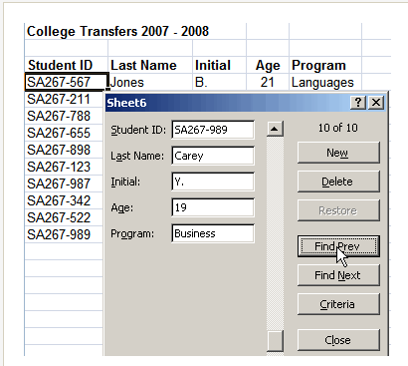
Using a form for data entry in excel

Storage
- Spreadsheet applications can appear somewhat intimidating to uninitiated users, and this overwhelming initial appearance can lead users to use the applications for unintended purposes.
- Users should employ spreadsheet applications only for purposes of short-term data compilation and analysis, not for the long-term data storage that many users may attempt.
- Specific data bases are best used for longer and more sophisticated storage needs.

Output
- Spreadsheets are very handy tools in data output as they can help the user to do simple computations and checks on the data input.
- Simple statistical analysis and statistical parameters like mean, median, mode and range, etc. can be easily found using spreadsheet formulas.
- Data output is a process by which data can be studied under different circumstances and manipulated as required by the user.
- Any statistical analysis produces an output data that needs to be studied. This data needs to be modified in a presentable form so that further conclusions and inferences can be drawn by the team and other parties.
- As more software is developed there are many programs that help with data output. These tools can be used by the team to present the findings in different formats and also helps to do the required calculations on the data.

Presentation
- Spreadsheets are designed to record, sort, calculate and store data. There are, however, times when you need to add graphics in order to communicate the information more effectively.
- You might, for example, like to add graphics, photos or other enhancements to add to the “presentation” format of a report or spreadsheet on a PC.
- It’s often not realised that graphics can be substituted for the vertical bars in a column chart.
- Perhaps the best way to enhance spreadsheet style is to project a spreadsheet on a screen and invite discussion about how its readability may be improved.
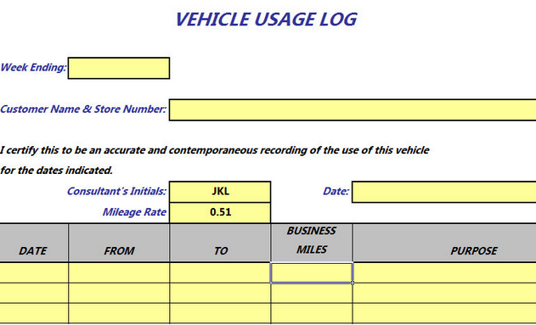

2. Plan spreadsheet design

2.1. Ensure spreadsheet design suits purpose, audience and information requirements of task
2.2. Ensure spreadsheet design enhances readability and appearance, and meets organisational and task requirements for style and layout
2.3. Use style sheets and automatic functions to ensure consistency of design and layout

2.1 – Ensure spreadsheet design suits purpose, audience and information requirements of task

Spreadsheet design may include:

- Appropriateness to required tasks
- Basic analysis
- Charts
- Formatting and reformatting
- Formulae
- Functions
- Headers and footers
- Headings.
Ensure spreadsheet design suits YOUR purpose
A good design for your spreadsheet should make it easy for you:
- To read the data
- To understand the point of the spreadsheet
- To use the spreadsheet's information
- To update the spreadsheet
- To spot the important parts quickly
- Good design does not have to be pretty or colourful, with lots of charts or images.
- A well-designed sheet will ideally be comfortable to work with and makes it easy to answer the questions you want to ask.
How can you tell if a worksheet has a good design?

Bad or incomplete spreadsheet design would be:
- No titles to tell you what the spreadsheet is about
- No column labels to explain what the data within is about or represents, e.g., dollars or numbers
- Not sufficient labelling or information to indicate what the data results are, e.g., multiplication or addition
- Poor layout such as not lining up the decimal points in data with figures.
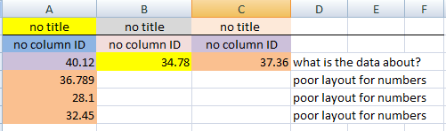
Adding some simple titles and labels makes the spreadsheet much more understandable.
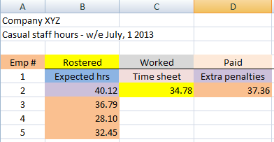

Additional clarity can be achieved if it is required by adding or expanding on labels and titles.
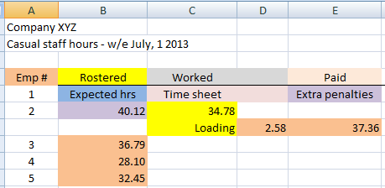
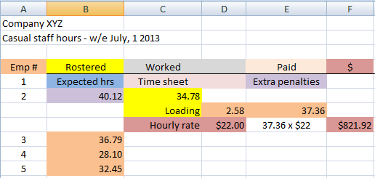

2.2 – Ensure spreadsheet design enhances readability and appearance, and meets organisational and task requirements for style and layout

Spreadsheet design principles
- From the examples above and your own organisational requirements, design and style of spreadsheets can match the data you are placing into it.
Choose fonts which are easy to read:
Choose fonts which are easy to read
Choose fonts which are easy to read
Choose fonts which are easy to read
Choose fonts which are easy to read
Choose fonts which are easy to read
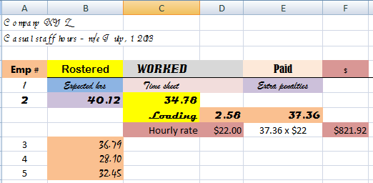
Use backgrounds and colours for good contrast and easy reading.
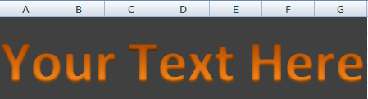
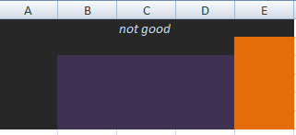
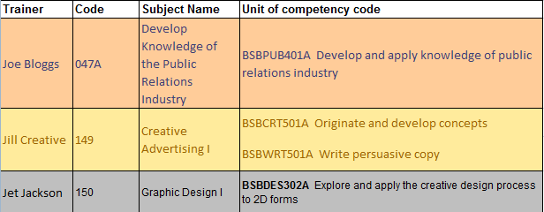
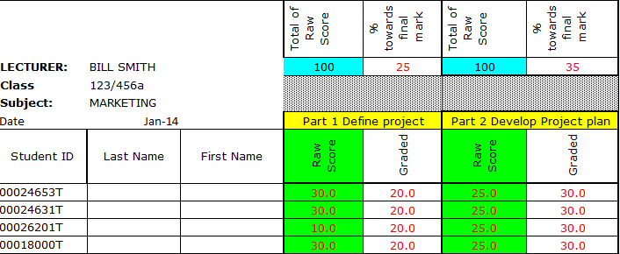
Consider how the sheet will look in print as well as on the screen.
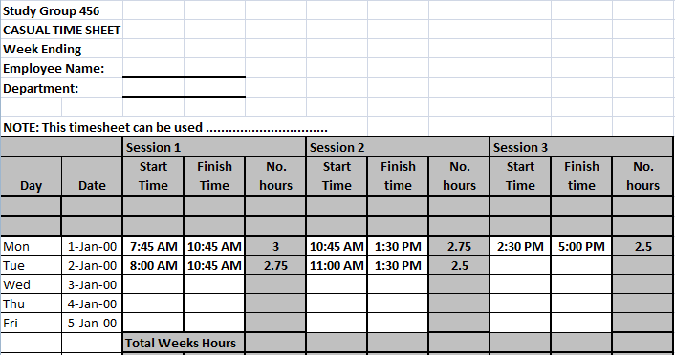
Create helpful labels and titles that make the purpose and function of the sheet clear.
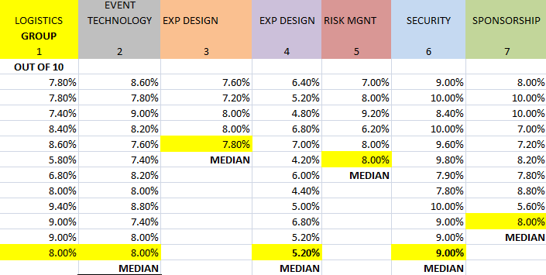
Position and format the key values, like totals, to make them stand out from the crowd of data

2.3. Use style sheets and automatic functions to ensure consistency of design and layout

Automatic functions may include: | Consistency of design and layout may include:
- Auto date  - Auto correct  - Auto format  - Auto text  - Default settings  - Headers and footers  - Page numbering  - Styles  - Table headings | - Borders  - Bullet/number lists  - Captions  - Consistency with other business documents  - Page numbers  - Spacing's  - Typeface styles and point size

A cell style is a defined set of formatting characteristics, such as fonts and font sizes, number formats, cell borders, and cell shading.
- To prevent others from changing specific cells, you can also use a cell style that locks cells. To keep an area of a worksheet visible while you scroll to another area of the worksheet, you can either lock specific rows or columns in one area by freezing panes, or create multiple worksheet areas that can scroll separately from each other by splitting panes.
- You can also modify or duplicate a cell style to create your own custom cell style.
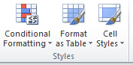
- Cell styles are based on the document theme that is applied to an entire workbook to ensure consistency of design and layout

- When you switch to another theme, the cell styles are updated to match the new theme.
- Built-in cell styles are aware of theme fonts, but many are not theme colour aware.
None of the cell styles are related to theme effects.

Excel 2010
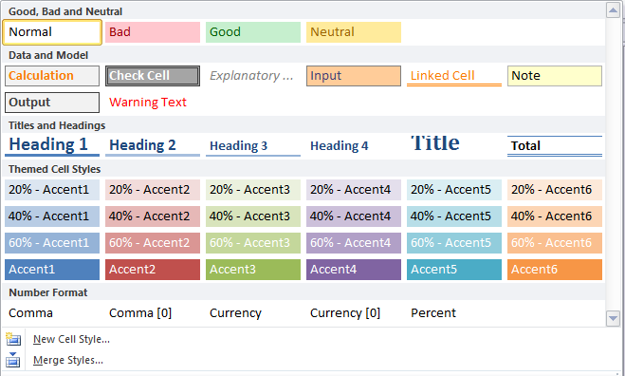
Automatic functions
Auto date | The DATE function returns the sequential serial number that represents a particular date. For example, the formula  =DATE(2010,11,12) 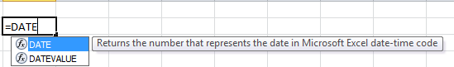  The DATE function is most useful in situations where the year, month, and day are supplied by formulas or cell references. For example, you might have a worksheet that contains dates in a format that Excel does not recognize, such as YYYYMMDD. You can use the DATE function in conjunction with other functions to convert the dates to a serial number that Excel recognises
Auto correct | Excel 2010  - Click the Button, and then click Excel Options.  - In the dialog box, click, and then select AutoCorrect Options.  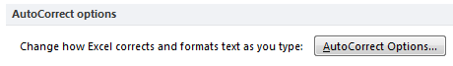

Auto format | Excel 2010  - Click the Button, and then click Excel Options.  - In the dialog box, click, and then select AutoCorrect Options.  - Click the AutoFormat As You Type tab.  - Select or clear the check boxes for the options that you want to enable or disable.  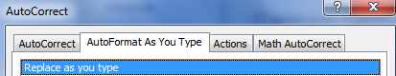
Auto text | Excel 2010  - If you have a list of data, when you type a new value, Excel will initiate auto text on its own.  - You could also use Autocorrect (see auto format instructions) to make a set of keystrokes that mean something else, e.g., a text line or words.
Default settings | Excel 2010  DEFAULT WHAT? There are ‘dozens’ of default settings?  - Change the Default Font in Excel 2010  - Set new formatting defaults for a shape or text box  - Change the default theme  - How to change default settings of Pivot tables in excel 2010  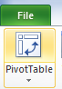  - Making changes to default excel templates
Headers and footers | Excel 2010  - You can add headers or footers at the top or bottom of a printed worksheet.  - Headers and footers are not displayed on the worksheet in Normal view — they are only displayed in Page Layout view and on the printed pages.  - You can insert headers or footers in Page Layout view where you can see them, or you can use the Page Setup dialog box if you want to insert headers or footers for more than one worksheet at the same time.  - For other sheet types, such as chart sheets, you can only insert headers and footers by using the Page Setup dialog box.
Page numbering | Excel 2010  - You can insert page numbers in the headers or footers of the worksheet pages.  - Page numbers that you insert are not displayed on the worksheet in Normal view — they are only displayed in Page Layout view and on the printed pages.  - You can insert page numbers for a worksheet in Page Layout view where you can see them, or you can use the Page Setup dialog box if you want to insert page numbers for more than one worksheet at the same time.  - For other sheet types, such as chart sheets, you can only insert page numbers by using the Page Setup dialog box.
Table headings | Excel 2010  - When you create a Microsoft Office Excel table on a worksheet, table headers are automatically added and displayed by default.  - Table headers either display default names that you can change on the worksheet, or you can specify that they display the header data that is on your worksheet.  - In a long table, table headers replace the worksheet column headings so that they stay visible when you scroll the table data.  - If you do not want to view the table headers, you can turn them off.
Styles | Excel 2010  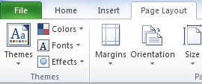  - For built-in themes, the light colours are always visible over the dark colours and vice versa, such as when dark colour text is used over a light background.  - And there are six accent colours that look good over any of the four possible background colours in the built-in themes.  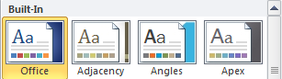

Background styles
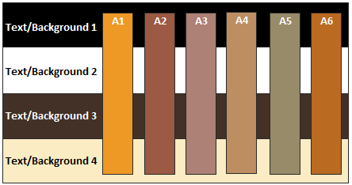

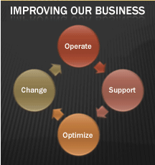


How to create consistent looking excel spreadsheets
- Consistency in your documentation, including Excel spreadsheets, presents a polished, professional image to your customers and your organisation.
- Consistency with spreadsheets also provides a common internal style and ease of understanding for fellow employees and management who may use these spreadsheets on a regular basis.
Use consistent colours and schemes
- Excel 2007> has the ability to define a set of formats as a style that can be applied to cells much easier to get at than earlier versions.
- The major benefit of predefined styles is that if you change an element within a style, the change is applied to all the cells using that named style automatically, which is a huge time-saver on large workbooks.
- Each style sheet contains a range of formats associated with a specific purpose.
- For example, the "Heading and Title" style sheet has a set of formats for different header levels and the title of a document. The "Data and Model" style set has formats for different types of data entry cells.
- Select the style you want to apply to the selected cell.
- Click on the sample style in the drop-down menu to apply the style to the selected cell.
Colour schemes | It is recommended that you select a muted colour scheme in an attempt to reduce the glare, whilst retaining enough contrast between the text and the background. A recommended colour background is off-white (bgcolor="#FFFFFC"). Do not use patterned or tiled backgrounds.
Bullet/number lists | To quickly add a bullet symbol to a cell, double click in the cell where you want to add your bullet symbol, and then press ALT+7 or ALT+9 using the numeric keypad on your keyboard. Or, in excel 2010, click Symbols. In the Symbol dialog box, on the Symbols tab, in the Font box, click the font that you want to use.  In the Symbol box, use the scroll bar to locate the bullet symbol that you want to insert.  Although there is not a command to insert sequence numbers in Excel, you can insert sequence numbers in contiguous cells with clicking and dragging mouse.  Step 1: Enter 1 in a cell, and enter 2 in a cell beside the first cell.  Step 2: Select the both cells, and drag the fill handle across the range that you want to fill.
Lists | It is recommended to use lists (bullets and numbers) rather than continuous prose. The use of numbered lists is preferable to bulleted lists.
Borders | By using predefined border styles, you can quickly add a border around cells or ranges of cells. If predefined cell borders do not meet your needs, you can create a custom border.  Note Cell borders that you apply appear on printed pages.  If you do not use cell borders but want worksheet gridline borders to be visible on printed pages, you can display the gridlines.
Text | It is recommended that you use a single font type throughout the spreadsheet. If you have to emphasise text then don't emphasise too much, while also use bold as opposed to underline or italics. The following are recommended typefaces:  - Calibri (12)  - Verdana  - Arial (14)  - Tahoma  - Trebuchet  The font size should be approximately 12pt-14pt, and use lower case wherever possible
Paragraphs | All paragraphs should be left-aligned, with approximately 6-8 sentences a paragraph, and 40-65 characters per sentence. Try to use white space, both left and right, and above and below. It is also good practice to use boxes to emphasise or highlight important text. Paragraph text is difficult in spreadsheets. An alternative is to include a word document (insert object) for large amounts of text.
Captions | 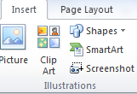  Click the spreadsheet that contains the SmartArt graphic that you want to add a caption to. On the Insert tab, in the Illustrations group, click Shapes.  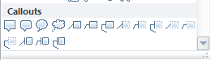  Under Callouts, click the shape that you want, click anywhere on your SmartArt  Graphic, and then drag to draw and place the shape.  To enter text, type in the shape.
Writing style | It is important to try to write in short simple sentences. Where ever possible, use short words and try to keep the sentence length between 15 to 20 words. It is important to clearly state the aims and the instructions at the start of each page.
Images | The use images should be encouraged. This is because they break up the text into smaller chunks and provide a visual stimulus / memory trigger.
Overall | Try to maintain a consistent look and feel throughout your material. This will help create a resource where the individual quickly becomes familiar with your style.

Create or delete a macro? Here’s how it works.
- To automate a repetitive task, you can quickly record a macro in Office Excel.
- You can also create a macro by using the Visual Basic Editor in Microsoft Visual Basic to write your own macro script, or to copy all or part of a macro to a new macro.
- After you create a macro, you can assign it to an object (such as a toolbar button, graphic, or control) so that you can run it by clicking the object. If you no longer use a macro, you can delete it.
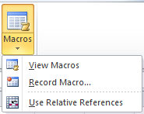

Create a macro by using Microsoft Visual Basic
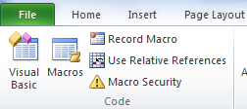
If your organisation uses Excel spreadsheets on a regular basis, the use of Macros can help make that ‘consistency’ task easier.
If you frequently produce Excel spreadsheet on regular topics you can create a macro to make consistent headers and footers and other commands.
To set the security level temporarily to enable all macros, do the following:
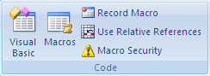
- On the Developer tab, in the Code group, click Macro Security

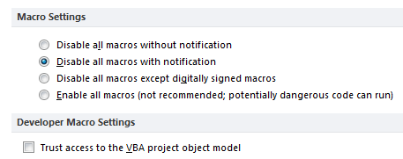
- Under Macro Settings, click Enable all macros (not recommended, potentially dangerous code can run), and then click OK.
- On the Developer tab, in the Code group, click Visual Basic.
If needed, in the Visual Basic Editor, on the Insert menu, click Module.
In the code window of the module, type or copy the macro code that you want to use.
To run the macro from the module window, press F5.
In the Visual Basic Editor, on the File menu, click Close and Return to Microsoft Excel when you finish writing the macro.
Simpler macros can be created using the Excel macro recorder. The macro recorder works by recording all keystrokes and clicks of the mouse.

3. Create spreadsheet

3.1. Ensure data is entered, checked and amended to maintain consistency of design and layout, in accordance with organisational and task requirements
3.2. Format spreadsheet using software functions to adjust page and cell layout to meet information requirements, in accordance with organisational style and presentation requirements
3.3. Ensure formulae are tested and used to confirm output meets task requirements, in consultation with appropriate personnel as required
3.4. Use manuals, user documentation and online help to overcome problems with spreadsheet design and production

3.1 – Ensure data is entered, checked and amended to maintain consistency of design and layout, in accordance with organisational and task requirements

Data may include:
- Numbers
- Text

Checking data may include:
- Accuracy of data
- Accuracy of formulae with calculator
- Ensuring instructions with regard to content and format have been followed
- Proofreading
- Spelling, electronically and manually

Ensure data is entered, checked and amended to maintain consistency
- Depending on your WORKPLACE needs, the creation of a spreadsheet by inserting data, be it TEXT or NUMBERS will require some degree of checking for accuracy, consistency or whatever the requirement of your organisation has in place.
For example...in the previous session where the DESIGN was the focus, the activity now is to concentrate on the DATA being entered.


Checking data may include:
- Accuracy of data
- Accuracy of formulae with calculator
- Ensuring instructions with regard to content and format have been followed
- Proofreading
- Spelling, electronically and manually

Accuracy of data
- Sometimes you may not want data to repeat itself.
- On an order form or an inventory sheet, for instance, you may not want a part number entered in one cell to repeat in another cell.
- You can use Excel's Data Validation to prevent a value from appearing more than once in a range.
You use data validation to control the type of data or the values that users enter into a cell.
For example:
- You may want to restrict data entry to a certain range of dates, limit choices by using a list, or make sure that only positive whole numbers are entered
- Among other things, you can use data validation to restrict data to predefined items in a list such as types of departments to Sales, Finance, R&D, and IT.
- Similarly, you can create a list of values from a range of cells elsewhere in the worksheet
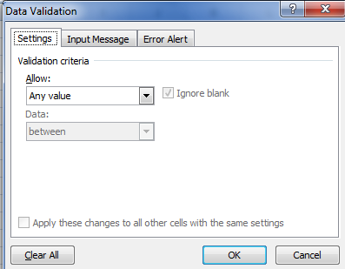

Accuracy of formulae with calculator
NOTE: The plural of formula in English is Formulae.
Calculation in Excel is the process of computing a formula and then displaying the result as a value in the cell that contain that formula.
- To avoid unnecessary calculations, Microsoft Office Excel automatically recalculates formulas only when the cells that the formula depends on have changed.
- This is the default behaviour when you first open a workbook and when you are editing a workbook. However, you can control when and how Excel recalculates formulas.
Iteration in Excel is the repeated recalculation of a worksheet until a specific numeric condition is met.
- Excel cannot automatically calculate a formula that refers to the cell — either directly or indirectly — that contains the formula.
- This is called a circular reference. If a formula refers back to one of its own cells, you must determine how many times the formula should recalculate.
- Circular references can iterate indefinitely. However, you can control the maximum number of iterations and the amount of acceptable change.
Precision in Excel is a measure of the degree of accuracy for a calculation.
- Excel stores and calculates with 15 significant digits of precision.
- However, you can change the precision of calculations so that Excel uses the displayed value instead of the stored value when it recalculates formulas.
Basic mathematical operations such as addition, subtraction, or multiplication
- Use the following arithmetic operators.
Formula | Looks like
=SUM | 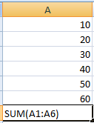 | 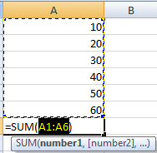
= A1+A2 | 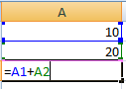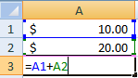
Subtraction – minus sign ( – )
Addition – plus sign ( + )
Division – forward slash ( / )
Multiplication – asterisk ( * )
Exponentiation – caret ( ^ ) (The operation of raising one quantity to the power of another)
Excel Order of Operations
If more than one operator is used in a formula, there is a specific order that Excel will follow to perform these mathematical operations. This order of operations can be changed by adding brackets to the equation. An easy way to remember the order of operations is to use the acronym:
BEDMAS
The Order of Operations is:
- Brackets
- Exponents
- Division
- Multiplication
- Addition
- Subtraction

Ensuring instructions with regard to content and format have been followed
Depending on the “instructions”, there could be several requirements to follow content and format protocols.
Content
To display the contents of a worksheet cell in a shape, text box, or chart element, you can link the shape, text box, or chart element to the cell that contains the data that you want to display.
Using the Camera command, you can also display the contents of a cell range by linking the cell range to a picture.
You can split the contents of one or more cells in a column and distribute those contents as individual parts across other cells in adjacent columns.
For example, your worksheet contains a column of full names that you want to split into separate first name and last name columns.
Select the cell, range, or entire column that contains the text values that you want to split.

Format
You can save a Microsoft Excel 2010 file in another file format by clicking the File tab, and then clicking Save As. The file formats that are available in the Save As dialog box vary, depending on what type of sheet is active (a worksheet, chart sheet, or other type of sheet).
In Excel 2010, you can open a file that was created in another file format, either in an earlier version of Excel or in another program, by clicking the File tab, and then clicking Open. If you open an Excel 97-2003 workbook, it automatically opens in Compatibility Mode. To take advantage of the new features of Excel 2010, you can save the workbook to an Excel 2010 file format. However, you also have the option to continue to work in Compatibility Mode, which retains the original file format for backward compatibility.
Format | Extension | Description
Excel Workbook | .xlsx | The default XML-based file format for Excel 2010 and Excel 2007. Cannot store Microsoft Visual Basic for Applications (VBA) macro code or Microsoft Office Excel 4.0 macro sheets (.xlm).
Excel 97- Excel 2003 Workbook | .xls | The Excel 97 – Excel 2003 Binary file format (BIFF8).
XML Spreadsheet 2003 | xml | XML Spreadsheet 2003 file format (XMLSS).
Other formatting requirements
- You can add content or apply formatting to two or more of the sheets on a multi-sheet worksheet by "grouping" the sheets together.
- When you group multiple sheets, any content or formatting that you add to one sheet also gets added to all the other sheets, so you can add a row of headers to one sheet and have it automatically appear on all the sheets that are grouped together with it.
- To group all the sheets in a worksheet, right-click on any of the tabs in the lower left of the window, and click Select All Sheets.
- If you only want to select two or more individual sheets, hold down the Ctrl key and click on the tabs of the sheets that you want to format or edit at the same time.
- When two or more sheets are grouped, Excel adds the word "[Group]" (in square brackets) after the sheet's name in the title bar.

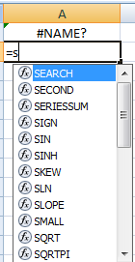
Proofreading
- In order to have Excel assist with proofreading type your function names in small case letters.
- When you hit enter Excel will capitalize the letters of all functions it recognises.
- When proofreading you immediately know that all the function names capitalised are not the problem.
- Concentrate on items still in small case letters.

Use text-to-speech commands in Microsoft office 2010
- Next to the Quick Access Toolbar, click Customize Quick Access Toolbar
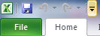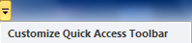
- Click More Commands.
- In the Choose commands from list, select All Commands.
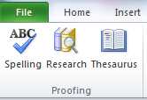
- Scroll down, and for each text-to-speech command that you want to use, click the Speak Cells command, and then click Add.
- Click OK.
- When you want to use a text-to-speech command, click it on the Quick Access Toolbar.

Spelling, electronically and manually
Microsoft Office Excel 2010 includes a built-in spell checker that can catch and get rid of spelling errors and typos in your worksheets.
Excel spell checker normally looks for misspellings only in the current worksheet.
If you have a multiple-sheet workbook, you can select the sheets you want to check before you start the spell checker.
Also, you can check the spelling of just a particular group of entries by selecting the cells first.

To check the spelling in a worksheet, follow these steps:
Click the Spelling command button in the Proofing group of the Review tab (or press F7).
Excel begins checking the spelling of text entries in the worksheet. When the program comes across an unknown word, it displays the Spelling dialog box.
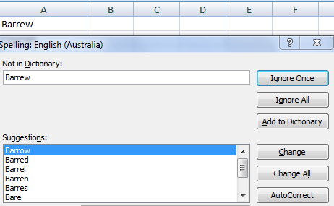
Excel suggests replacements for the unknown word shown in the Not in Dictionary text box with a likely replacement in the Suggestions list box. If that replacement is incorrect, you can scroll through the Suggestions list and click the correct replacement.
Select one or more of the following dialog box options:
- Ignore Once or Ignore All: When Excel’s spell check comes across a word its dictionary finds suspicious but you know is viable, click the Ignore Once button. If you don’t want the spell checker to query you about this word again, click Ignore All.
- Add to Dictionary: Click this button to add the unknown word — such as your name — to a custom dictionary so that Excel won’t flag it again.
- Change: Click this button to replace the word listed in the Not in Dictionary text box with the selected word in the Suggestions list box.
- Change All: Click this button to change all occurrences of this misspelled word in the worksheet to the selected word in the Suggestions list box.
- AutoCorrect: Click this button to have Excel automatically correct this spelling error with the selected suggestion in the Suggestions list box (by adding the misspelling and suggestion to the AutoCorrect dialog box).

3.2 – Format spreadsheet using software functions to adjust page and cell layout to meet information requirements, in accordance with organisational style and presentation requirements

Formatting may include:
- Alignment on page
- Efficiency of formulae
- Enhancements to format – borders, patterns and colours
- Enhancements to text
- Headers/footers

- Use of absolute and relative cell addresses
- Use of cell addresses in formulae.

Software functions may include:
- Adding/deleting columns/rows
- Formatting cells
- Formatting text
- Headers/footers
- Sizing columns/rows
- Using macros
- Utilising shortcuts.
Many of these essential formatting and software functions suggested above have already been covered in different areas including designing and ensuring data is entered correctly using an Excel spreadsheet.
The practical application of all of these functions will depend on the WORKPLACE situation, the individual needs of the application and the context of the organisation need, e.g., records, lists comparative charts etc.

Activities

Activity 3A
Estimated Time | 40 Minutes
Objective | To provide you with an opportunity to ensure data is entered, checked and amended to maintain consistency of design and layout, in accordance with organisational and task requirements; and format spreadsheet using software functions to adjust page and cell layout to meet information requirements, in accordance with organisational style and presentation requirements.
Activity | - In your WORKPLACE create a spreadsheet using the practical application of the two Elements detailed below.  - Complete the online tutorial (https://www.youtube.com/watch?v=8L1OVkw2ZQ8) OR select a spreadsheet function from within your WORKPLACE that is either current or perhaps a new project.
  Workplace Activity
  Describe the spreadsheet requirement:
  Select a format to save your Excel Spreadsheet
  - Ensure the data is entered, checked and amended to maintain consistency using the details discussed in that element.
  - Format the spreadsheet using software functions to adjust page and cell layout to meet information requirements REFERENCING the list of examples provided above.

3.3 – Ensure formulae are tested and used to confirm output meets task requirements, in consultation with appropriate personnel as required


Formulae may include:
- Average
- Division
- Multiplication
- Percentage
- Subtraction
- Sum
- Combinations of above

Use cell or sheet AUDITING feature to check formulae.

Normal View | Auditing View
  AUSTRALIS WATCH
  300 | 250
  120 | 100
  30 | 25
  39 | 32
  17 | 14
  206 | 171
  AUSTRALIS WATCH
  300 | 250
  =B32*F33 | =C32*F33
  =B32*F34 | =C32*F34
  =B32*F35 | =C32*F35
  =B32*F36 | =C32*F36
  =SUM(B33:B36) | 171.428571428571

Normal View
member standard | non member standard
37% of $1800 | 37% of $2138 | 37% is historical
$666 | $791
 |  | 0.00 |  | 0.00 | 0.00
 |  | 0.00 |  | 0.00 | 0.00
$0 |  | 0.00 |  | 0.00 | 0.00
 | $0 | 0.00 |  | 0.00 | 0.00
 |  | 0.00 |  | 0.00 | 0.00

Auditing View
member standard | non member standard
37% of $1800 | 37% of $2138 | 37% is historical
666 | 791
 |  | =J75
 |  | =J76
=C77*A74 |  | =J77
 | =C78*B74 | =J78
 |  | =SUM(C75:C78)

3.4 – Use manuals, user documentation and online help to overcome problems with spreadsheet design and production

Manuals | Provide a complete how to instruction in ‘manual’ format!  - Getting Started  - Definitions  - Ribbon  - Navigating Cells  - Data  - Entering Data/Text  - Editing Data/Text  - Autofill  - Controlling Your View of Data  - Sorting and Filtering  - Formulae  - Cell References Autofill with Formulae  - AutoSum  - Functions  - AutoCalculate  - Name Manager  - Charts  - Pivot table  - Trouble-shooting  - Printing
User documentation | Resources  For more information about Office Excel 2010, please visit:  Office Excel 2010  http://www.microsoft.com/office/excel
Online help | 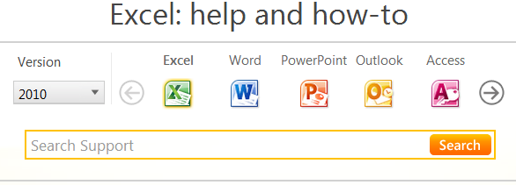

Didn't find what you were looking for here?
Search the Microsoft Answers forum to get help from others in the Office community.


Activities

Activity 3B
Estimated Time | 40 Minutes
Objective | To provide you with an opportunity to ensure formulae are tested and used to confirm output meets task requirements, in consultation with appropriate personnel as required; and use manuals, user documentation and online help to overcome problems with spreadsheet design and production.
Activity | Create spreadsheet  Select a spreadsheet function from within your WORKPLACE either currently in place or a new project.
  Workplace Activity
  Demonstrate, using your previous Activity excel example or project, your understanding and knowledge of:
  - Testing Excel formulas and detail how this technique confirms output AND meets the task requirements of your organisation.
  - Detail what manuals, online help or user documentation you have used or currently use to overcome problems with spreadsheet design and production

4. Produce simple charts

4.1. Select chart type and design that enables valid representation of numerical data, and meets organisational and task requirements
4.2. Create charts using appropriate data range in spreadsheet
4.3. Modify chart type and layout using formatting features

4.1 – Select chart type and design that enables valid representation of numerical data, and meets organisational and task requirements

4.2 – Create charts using appropriate data range in spreadsheet
- Selecting the most effective chart type will make your data clearer, stronger, and more informative.
- Microsoft Office Excel offers a wide variety of chart types and simple methods for selecting and previewing them.
Select chart type and design that enables valid representation of numerical data
- Selecting the most effective chart type will make your data clearer, stronger, and more informative.
- Microsoft Office Excel offers a wide variety of chart types and simple methods for selecting and previewing them.
- There are many ways to enhance a chart to emphasise the point or purpose and to improve readability.
- Usually, Graphs and Charts are used for representing and organising a set of numerical data with a graphical representation such as pie chart, line charts, bar graphs and many more.
- With so many chart types available, how do you know which is best for you? Keep in mind, the point is to get your message across in the most effective way.
Meeting your organisational and task requirements will require the instructor to detail what that actually represents.
- Different chart types can deliver different messages about the same data.
- It's like several versions of a single story.
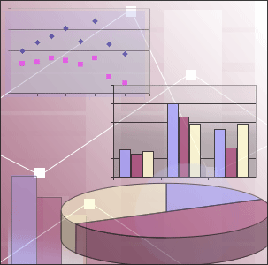 | 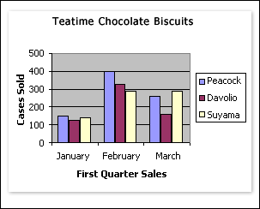

In Excel, there is a selection of chart options.
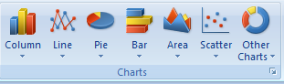
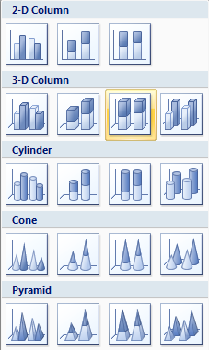 | A Column chart is a good type for comparing values directly, and you want to compare how many cases each salesperson sold, so it's a good fit.  When choosing a chart type, it's often wise to keep it simple, so that your message comes across clearly.  As you can see in the chart above, Peacock sold the most cases in January and February, but Suyama pulled ahead in March. The sizes and colours of the columns tell the story at a glance.
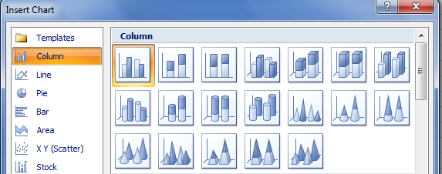

Examples of numerical placement in a Chart
Data used in this example:
 |  |  |  | Sales (in $000)
Product Code | 2010 | 2011 | 2012 | 2013 | 2014
Excel | $ 175 | $ 200 | $ 250 | $ 300 | $ 350
Power Point | $ 100 | $ 125 | $ 170 | $ 200 | $ 275
Word | $ 300 | $ 350 | $ 400 | $ 450 | $ 525
Outlook | $ 275 | $ 250 | $ 350 | $ 325 | $ 375

Activities

Activity 4A and B
Estimated Time | 40 Minutes
Objective | To provide you with an opportunity to select chart type and design that enables valid representation of numerical data, and meets organisational and task requirements; and create charts using appropriate data range in spreadsheet.
Activity | Create a chart using appropriate data range in the spreadsheet  Demonstrate, using your previous Activity Excel example OR use WORKPLACE examples for preference.

4.3 – Modify chart type and layout using formatting features

- After you create a chart, you can instantly change its look.
- Instead of manually adding or changing chart elements or formatting the chart, you can quickly apply a predefined layout and style to your chart.
- Microsoft Office Excel provides a variety of useful predefined layouts and styles (or quick layouts and quick styles) that you can select from.
- You can do more with your data than create one chart. You can make your chart compare data another way by clicking a button to switch the chart view from one view to another.
- However, you can customize a layout or style of a chart further by manually changing the layout and style of the individual chart elements that are used in the chart.
- You cannot save a custom layout or format, but if you want to use the same layout or format again, you can save the chart as a chart template.

Change the layout of chart elements manually
- Click the chart element for which you want to change the layout, or do the following to select it from a list of chart elements.
- Click anywhere in the chart to display the Chart Tools.
- On the Format tab, in the Current Selection group, click the arrow in the Chart Elements box, and then click the chart element that you want
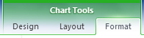
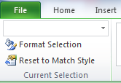
- On the Layout tab, in the Labels, Axes, or Background group, click the chart element button that corresponds with the chart element that you selected, and then click the layout option that you want.
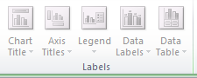
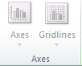
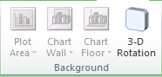

Note: The layout options that you select are applied to the chart element that you have selected. For example, if you have the entire chart selected will be applied to all data series. If you have a single data point selected, data labels will only be applied to the selected data series or data point.

Select a predefined chart style
- Click the chart that you want to format.
TIP This displays the Chart Tools, adding the Design, Layout, and Format tabs.
- On the Design tab, in the Chart Styles group, click the chart style that you want to use.
TIP To see all predefined chart styles, click More
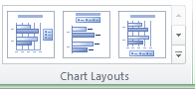
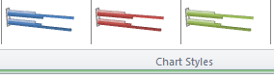
NOTE When the Excel window is reduced in size, chart styles will be available in the Chart Quick Styles gallery in the Chart Styles group.
TIP Chart styles use the colours of the current document theme that is applied to the workbook. You can change the colours by switching to a different document theme. You can also customize a document them to display a chart in the exact colours that you want.

Select a predefined chart layout
- Click the chart that you want to format.
TIP This displays the Chart Tools, adding the Design, Layout, and Format tabs.
- On the Design tab, in the Chart Layouts group, click the chart layout that you want to use.
NOTE When the Excel window is reduced in size, chart layouts will be available in the Quick Layout gallery in the Chart Layouts group.
TIP To see all available layouts, click More

5. Finalise spreadsheets

5.1. Preview, adjust and print spreadsheet and any accompanying charts, in accordance with task requirements
5.2. Ensure data input meets designated timelines and organisational requirements for speed and accuracy
5.3. Name and store spreadsheet in accordance with organisational requirements and exit application without data loss/damage

5.1 – Preview, adjust and print spreadsheet and any accompanying charts, in accordance with task requirements

Preview
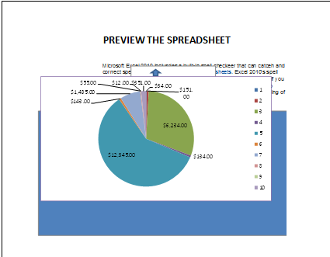
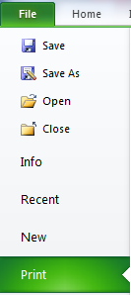

Printing may include:
- Charts
- Entire workbooks
- Selected data within a worksheet
- Worksheets

Printing may include:
- Charts
- Entire workbooks
- Selected data within a worksheet
- Worksheets
.
- Click the Excel 2010 Button, and then click Print 
By default, the selected chart is displayed to see how the chart will look on the printed page.
NOTE You cannot scale a chart before you print it. Instead, you can move and size the chart area of the chart to adjust is as needed.

Set page options for a chart
- On the Page Layout tab, in the Page Setup group, click the Dialog Box Launcher
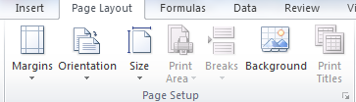
- Do one or more of the following:
- On the Page tab, specify the orientation, paper size, print quality, and the page number of the first page.
NOTE You cannot adjust the scaling of a chart.

Print a chart with worksheet data
- Click the worksheet that contains the chart that you want to print.
- On the View tab, in the Workbook Views group, click Page Layout or Page Break Preview.
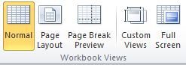
- To move the chart, drag it to a preferred location on the page that you want to print.
- To resize the chart:
- Click the chart, and then drag the sizing handles to the size that you want.
TIP If a worksheet contains more than one chart, you may be able to print the charts on one page by reducing the size of the charts.
- Click the worksheet.
- Click the Excel 2010 Button, and then click Print
NOTE By default, cell gridlines are not printed on a worksheet. To print the worksheet with cell gridlines displayed, see Print with or without cell gridlines

Printing
- By default, Excel prints worksheets in portrait orientation (taller than wide).
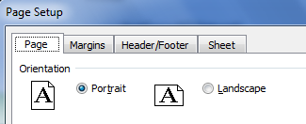
- You can change the page orientation to landscape (wider than tall) on a worksheet-by-worksheet basis.
- If you always want to print worksheets in landscape orientation, you can create a template, change the page orientation from portrait to landscape, and then use that template as the basis for all future workbooks.
NOTE Because you can set page orientation on a worksheet-by-worksheet basis, it is possible to print some worksheets in a workbook in one orientation (such as portrait orientation) and other worksheets in the same workbook in the opposite orientation (such as landscape orientation).
Simply set the orientation for each worksheet as appropriate, and then print the entire workbook.

Prints the whole worksheet
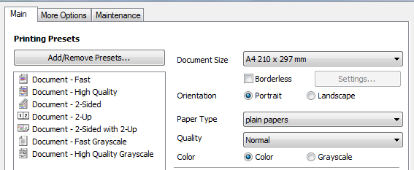

Print a partial or entire worksheet or workbook
- Do one of the following:
- To print a partial worksheet, click the worksheet, and then select the range of data that you want to print.
- To print the entire worksheet, click the worksheet to activate it.
- To print a workbook, click any of its worksheets.
- Click the Excel 2010 Button, and then click Print
Keyboard shortcut: You can also press CTRL+P.
- Under Print what, select an option to print the selection, the active sheet or sheets, or the entire workbook.


5.2 – Ensure data input meets designated timelines and organisational requirements for speed and accuracy

Designated timelines may include:
- Organisational timeline e.g. Financial requirements
- Timeline agreed with internal/external client

- Timeline agreed with supervisor/person requiring spreadsheet.

Designated timelines may be:
- By month end
- Monthly
- Within agreed period
- Within organisational deadline.
It would be clearer to students conducting this element to have the instructor clarify what are the designated timelines in place within the organisation where this class is being conducted for such an example, before proceeding.
General administration timelines can be met if you observe common sense principles:
- Determine when the task must be accomplished by you.
- This becomes your end point on the timeline.
- Calculate how long you have from the current date until the deadline arrives.
- Write down specifically what needs to be done by the deadline.
For example, determine exactly the data input needs that are drawn from a range of sources either within your organisation or from external providers.
- Divide the goal into smaller logical steps.
- Think about what individual actions you need to take in order to get to the end result you defined.
- Estimate how much time each step will take to complete. Use prior experience or your knowledge of the amount of work involved in processing the data.
- Add up your time estimates to determine if the total time needed fits within the actual amount of time you have left or what has been determined as organisational requirements for speed and accuracy.
- If not, adjust the time lengths for each step as necessary to fit the timeline.
- Monitor your progress on each smaller step and toward the end goal at regular intervals. Make any adjustments to the timeline as necessary if you fall behind or get ahead of the estimated due dates.

5.3 – Name and store spreadsheet in accordance with organisational requirements and exit application without data loss/damage

Naming and storing spreadsheet may include:
- Authorised access
- File naming conventions
- Filing locations
- Organisational policy for backing up files
- Organisational policy for filing hard copies of spreadsheets
- Security
- Storage in electronic folders/sub-folders
- Storage on CD-ROM, USB, tape back-up, server.
It would be clearer to students conducting this element to have the instructor clarify what are the organisational requirements in place within the organisation where this class is being conducted for such an example, before proceeding.
Naming and storing spreadsheet may include
File naming conventions
The Open XML file formats and their extensions are used by Microsoft Word 2010, Microsoft Excel 2010, and Microsoft PowerPoint 2010.
Excel 2010 or Office
Excel Workbook. xlsx The default Excel file format. Cannot store VBA macro code or Microsoft Excel 4.0 macro sheets (.xlm files in Excel 4.0).
Excel Macro-Enabled Workbook. .xlsm. Uses the same basic XML format as the Excel Workbook, but can store VBA macro code. Users saving an Excel workbook that has VBA code or Excel 4.0 macro sheets (.xlm files in Excel 4.0) are prompted to use this file format.EXCEL
XML FILE TYPE | EXTENSION
Workbook | .xlsx
Macro-enabled workbook | .xlsm
Template | .xltx
Macro-enabled template | .xltm
Non-XML binary workbook | .xlsb
Macro-enabled add-in | .xlam

Filing locations
You can keep track of when records in a table are last modified, by using a form with a macro. When the form is used to modify a record, the macro stores the date and time in the table. Only the most recent modification date and time are stored.

The My Places bar is on the left side of some dialog boxes, such as Save As, Open, and Insert Picture, that allows you to specify a folder where you want to store your files. You can use the My Places bar to help save time getting to your folders and help make it easier to access your files in your various folders. After you update the My Places bar in one dialog box, the changes are available in the other dialog boxes with the My Places bar.
Security
Viruses, worms, Trojan horses, phishing, and spyware are security threats to your computer and data.
- Virus Software (or code) written with the express intention of replicating itself. A virus attempts to spread from computer to computer by attaching itself to another file or program.
- Worm Software that replicates independently by sending itself to other systems through network connections.
- Trojan horse Software that appears to be useful or harmless but that contains hidden code designed to exploit or damage the system on which it is run.
- Spyware Software that can display advertisements (such as pop-up ads), collect information about you, or change settings on your computer, generally without appropriately obtaining your consent. You usually download spyware without knowing it by visiting untrustworthy Web sites.
- Phishing A way of extracting personal information from you such as bank or credit card details, normally done via e-mail. There are also some phishing schemes designed to put spyware on your computer. The good news is that Outlook 2010 has new anti-phishing features.

What are your storage needs?

- All organisations, large and small, need more space for data storage.
- Documentation in the form of e-mails, word documents, presentations, databases, graphics, audio files and excel spreadsheets is the lifeblood of most organisations.
- As the applications that run and protect your business require more and more memory and space so does the growth of storage options and storage protocols.
- The protocols and procedures for saving files, storing and backup are usually part of an operating policy so the organisation can minimise loss of data.
- Assess your storage needs associated with each application, the data it is producing and how and where you will access that data.

Exit the application without data loss/damage
- You can close each of these workbook windows one at a time, or you can close the whole workbook (including all of its workbook windows). To close all workbooks that are open, you can close the Excel window or exit Excel.
Close the active workbook window
- Click the workbook window that you want to close.
- In the upper-right corner of the workbook window, click Close Window.
NOTE If the window is the only open window of the workbook, the whole workbook is closed. If there are more workbook windows of the same workbook, only the active workbook window is closed.
Close a workbook
- Activate the workbook that you want to close.
- Click the Excel 2010 Button
- Click the Button.
Close all workbooks and exit Excel without data loss/damage
Do one of the following:
- In the upper-right corner of the Excel window, click Close Window
- Click the Excel 2010 Button
- Click the Button.
Prevent data loss:
- Never store your documents on the same drive as your operating system
- Back up your files regularly, no matter where they're stored
- Beware of email attachments
- Beware of user error
- Keep hardcopies of your documents

Activities

Activity 5C
Estimated Time | 30 Minutes
Objective | To provide you with an opportunity to name and store spreadsheet in accordance with organisational requirements and exit application without data loss/damage.
Activity | - What are your organisations requirements?
  Workplace activity
  Authorised access | What are your organisations requirements?
  Organisational policy for backing up files | What are your organisations requirements?
  Organisational policy for filing hard copies of spreadsheets | What are your organisations requirements?
  Storage in electronic folders/sub-folders | What are your organisations requirements?
  Storage on CD-ROM, USB, tape back-up, server | What are your organisations requirements?


Skills and Knowledge Activity

Nearly there...

Major Activity – An opportunity to revise the unit

At the end of your Learner Workbook, you will find an activity titled ‘Major Activity’. This is an opportunity to revise the entire unit and allows your trainer to check your knowledge and understanding of what you have covered. It should take between 1-2 hours to complete and your trainer will let you know whether they wish for you to complete it in your own time or during the sessions. Once this is completed, you will have finished this unit and be ready to move onto the next, well done!

Congratulations!
You have now finished the unit ‘Produce spreadsheets’


References

These suggested references are for further reading and do not necessarily represent the contents of this Learner Guide

- Excel 2010 Bible [Paperback]
John Walkenbach (Author)

- Excel 2010 Formulas (Mr. Spreadsheet's Bookshelf) [Paperback]
John Walkenbach (Author)

- Learn Excel 2010 Essential Skills with The Smart Method: Courseware Tutorial for Self-Instruction to Beginner and Intermediate Level [Paperback]
Mike Smart (Author)

- Microsoft Excel 2010 Step by Step (Step by Step (Microsoft)) [Paperback]
Curtis Frye (Author)

