BSBFIA301
Maintain financial records
Learner Guide



BSBFIA301
Maintain financial records

Table of Contents

Table of Contents 2
Unit of Competency 4
Performance Criteria 5
Foundation Skills 6
Assessment Requirements 7
Housekeeping Items 8
Objectives 8
1. Maintain daily financial records 9
1.1 – Correctly maintain daily financial records and in accordance with organisational and legislative requirements for accounting purposes 10
Daily financial records 10
Designated timelines 10
Guidelines for reconciling journals 10
Procedures for totalling adjusted journals 12
Resolution procedures 13
Security procedures 13
1.2 – Identify and rectify or refer discrepancies or errors in documentation or transactions to designated persons in accordance with organisational and legislative requirements 16
Identifying discrepancies 16
Activity 1B 18
1.3 – Accurately credit and debit transactions and promptly enter into journals in accordance with organisational and legislative requirements 19
Journal entries 19
Assets 20
Liabilities 20
Equity 20
Revenue 20
Expenses 20
Activity 1C 21
2. Maintain general ledger 22
2.1 – Maintain general ledger in accordance with organisational and legislative requirements 23
Maintaining the general ledger 23
Balance sheet accounts 24
Activity 2A 26
2.2 – Post transactions into general ledger in accordance with organisational and legislative reporting requirements 27
Posting transactions 27
Transactions may include: 29
Activity 2B 30
2.3 – Reconcile systems for accounts payable and receivable with general ledger 31
Reconciling systems 31
Activity 2C 34
2.4 – Accurately prepare trial balance from general ledger in accordance with organisational and legislative requirements 35
Activity 2D 37
3. Monitor cash control 38
3.1 – Ensure cash flow is accurately accounted for in accordance with organisational and legislative requirements 39
Cash flow 39
Cash inflow 39
Cash outflow 39
Activity 3A 43
3.2 – Make and receive payments in accordance with organisational and legislative requirements 44
Payments 44
Organisational and legislative requirements 45
Activity 3B 47
3.3 – Collect or follow up outstanding accounts within designated timelines 48
Outstanding accounts 48
Activity 3C 50
3.4 – Check payment documentation for accuracy of information and despatch to creditors within designated timeline 51
Checking documentation 51
Activity 3D 52
Skills and Knowledge Activity 53
Major Activity – An opportunity to revise the unit 54
References 56

Unit of Competency

Application

This unit describes the skills and knowledge required to maintain daily financial records such as reconciling debtors’ and creditors’ systems, preparing and maintaining a general ledger and trial balance and includes activities associated with monitoring cash control for accounting purposes.

It applies to individuals who are skilled operators and apply a broad range of competencies in various work contexts and may exercise discretion and judgement using appropriate theoretical knowledge of financial records.

No licensing, legislative or certification requirements apply to this unit at the time of publication.

Unit Sector

Finance – Financial Administration

Performance Criteria
Element  Elements describe the essential outcomes. | Performance Criteria  Performance criteria describe the performance needed to demonstrate achievement of the element.
- Maintain daily financial records | - Correctly maintain daily financial records in accordance with organisational and legislative requirements for accounting purposes  - Identify and rectify or refer discrepancies or errors in documentation or transactions to designated persons in accordance with organisational and legislative requirements  - Accurately credit and debit transactions and promptly enter into journals in accordance with organisational and legislative requirements
- Maintain general ledger | - Maintain general ledger in accordance with organisational and legislative requirements  - Post transactions into general ledger in accordance with organisational and legislative reporting requirements  - Reconcile systems for accounts payable and receivable with general ledger  - Accurately prepare trial balance from general ledger in accordance with organisational and legislative requirements
- Monitor cash control | - Ensure cash flow is accurately accounted for in accordance with organisational and legislative requirements  - Make and receive payments in accordance with organisational and legislative requirements  - Collect or follow up outstanding accounts within designated timelines  - Check payment documentation for accuracy of information and despatch to creditors within designated timeline

Foundation Skills
This section describes language, literacy, numeracy and employment skills incorporated in the performance criteria that are required for competent performance.

Skill | Performance  Criteria | Description
Reading | 1.1-1.3, 2.1-2.4, 3.1-3.4 | - Recognises and interprets numerical and textual information to determine and complete required activities
Writing | 1.3, 2.1-2.4, 3.1-3.4 | - Integrates data from different sources and records numerical information in a format appropriate to context and purpose of material  - Prepares clear and detailed information and instructions using format, structure and tone suitable to audience
Oral Communication | 1.2, 3.2, 3.3 | - Explains financial issues and requirements clearly, using facts and examples, and uses listening and questioning techniques to obtain sequenced instructions
Numeracy | 1.1-1.3, 2.1-2.4, 3.1-3.4 | - Uses a limited range of mathematical calculations to reconcile amounts using whole numbers and decimals and arrange/compare numerical information
Navigate the world of work | 1.1-1.3, 2.1-2.4, 3.1-3.3 | - Recognises, understands and monitors adherence to legislative and organisational requirements in undertaking own work
Interact with others | 3.3, 3.4 | - Understands the importance of using appropriate practices and protocols when handling confidential information
Get the work done | 1.1-1.3, 2.1-2.4, 3.1-3.4 | - Takes responsibility for own workload and monitors adherence to specified goals and timelines  - Uses digital technologies to access, record, store, organise and compile data as required

Assessment Requirements
Performance Evidence

Evidence of the ability to:

- Maintain daily transactions and identify and respond to discrepancies and errors
- Transfer and record financial data accurately
- Reconcile expenditures and revenue in a timely manner.

Note: If a specific volume or frequency is not stated, then evidence must be provided at least once.

Knowledge Evidence

To complete the unit requirements safely and effectively, the individual must:

- Identify the key provisions of relevant legislation, codes of practice and national standards that may affect financial record keeping
- Discuss organisational policies and procedures relating to maintaining financial records
- Define credits/creditors and debits/debtors
- Describe principles of double entry bookkeeping and accrual accounting
- Identify methods of presenting financial data.

Assessment Conditions

Assessment must be conducted in a safe environment where evidence gathered demonstrates consistent performance of typical activities experienced in the financial administration field of work and include access to:

- Office equipment and resources
- Computer equipment and relevant software
- Examples of source documents relating to financial record keeping
- Case studies and, where possible, real situations.

Assessors must satisfy NVR/AQTF assessor requirements.

Links

Companion volumes available from the IBSA website: http://www.ibsa.org.au/companion_volumes - http://www.ibsa.org.au/companion_volumes

Housekeeping Items
Your trainer will inform you of the following:
- Where the toilets and fire exits are located, what the emergency procedures are and where the breakout and refreshment areas are.
- Any rules, for example asking that all mobile phones are set to silent and of any security issues they need to be aware of.
- What times the breaks will be held and what the smoking policy is.
- That this is an interactive course and you should ask questions.
- That to get the most out of this workshop, we must all work together, listen to each other, explore new ideas, and make mistakes. After all, that’s how we learn.
- Ground rules for participation:
  - Smile
  - Support and encourage other participants
  - When someone is contributing everyone else is quiet
  - Be patient with others who may not be grasping the ideas
  - Be on time
  - Focus discussion on the topic
  - Speak to the trainer if you have any concerns

Objectives
- Discover how to maintain daily financial records
- Know how to maintain general ledger
- Learn how to monitor cash control
- Gain skills and knowledge required for this unit

1. Maintain daily financial records

  - Correctly maintain daily financial records and in accordance with organisational and legislative requirements for accounting purposes

  - Identify and rectify or refer discrepancies or errors in documentation or transactions to designated persons in accordance with organisational and legislative requirements

1.3. Accurately credit and debit transactions and promptly enter into journals in accordance with organisational and legislative requirements



1.1 – Correctly maintain daily financial records and in accordance with organisational and legislative requirements for accounting purposes

Daily financial records
Developing a system to keep on top of the daily financial records of your organisation is advisable. It is accomplished easily through tracking the organisation’s expenses. This can be done using software or simple bookkeeping. A large portion of the task is simply recording the money coming in and the money going out. An example of a daily record you may come across is reconciling debtors' and creditors' systems. The customer/supplier relationship is often referred to as the debtor/creditor relationship within accounting. By reconciling the debtors’ and creditors’ systems, it essentially evens out the organisation’s figures by making sure all money owed to the organisation is paid.
The process of maintaining the financial records needs to be carried out in accordance with organisational and legislative requirements for accounting purposes.
Organisational and legislative requirements may include:

Designated timelines
A range of designated timelines that organisations must comply with are outlined by the Australian Taxation Office (ATO) and include:
- The date the PAYG Withholding must be paid
- The date by which Payment Summaries must be completed and issued
- Superannuation reporting and lodgement dates.
The reconciliation, authorisation and processing of the payroll within an organisation will have its own internal timeline. These timelines will differ between organisations. Detailed information on timelines that are relevant to the current financial year can be found at the ATO website. By providing relevant data within the designated timelines, it will ensure that your employees are paid on time and in full, as well as meeting other deadlines and key dates.

Guidelines for reconciling journals
Journals; in other words, your accounting records, reflect the balance of your bank and can often differ to your bank statement’s balance. Trying to reconcile these balances can be very time consuming; however, it is a very important function. Consistency and accuracy between the organisation’s financial records is ensured through the reconciliation process.
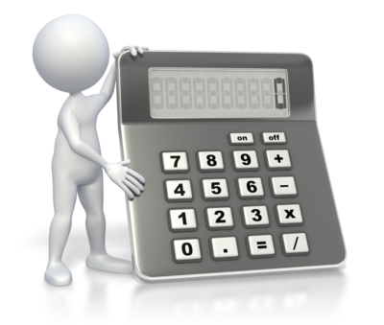
A difference between your bank balance and the balance on your bank statement will often be because something is showing up on your bank statement that is not yet on the books. Examples of these things include:
- A bank service charge
- Printing charges
- Fees for returned cheques
- Interest
- Loan payments.
Legal and organisational and legislative policies, guidelines and requirements
Often, the length you will need to keep your records for will be determined by the laws that apply to your business. If the ATO requests to see your organisation’s financial records that are stored electronically, then you must be able to provide a hard copy. The financial records for your organisation must be kept for 7 years along with employee records and all records of fringe benefits and capital gains.
For your organisation to meet the basic legal requirements, it must keep the following:
- A cash book or financial accounting program
- Employment records
- Bank accounts
- Sales records
- Proof or purchases
- Occupational training records.
When it comes to meeting the legal requirements regarding the end of financial year records, your organisation must keep the following:

- Details of stock on hand
- Capital gains details
- A list of debtors and creditors
- Expense records
- Depreciation details
- Basic accounting records
- Staff and wages details
- Agreements
- Basic accounting records.
Again, the ATO website can help you to decipher which records you should keep.
OHS policies, procedures and programs
Occupational Health and Safety (OHS) records and statistics must be kept appropriately organised on file and should be easily available for reference.
These can include:
- First aid treatments
- Incident investigations
- Training activities.
Keeping records on health and safety within your organisation may provide you with valuable statistics, including how much workplace injuries cost the organisation per year.

Procedures for totalling adjusted journals
All transactions start as journal entries. The adjusting process is necessary in order for an organisation’s financial statements to be complete. When a trial balance is prepared by an organisation, a list of necessary adjusting journals will be developed.
Types of adjusting entries:

- Accrued revenues
- Accrued expenses
- Deferred revenues
- Deferred expenses
- Depreciation expense.
Steps for recording adjusting entries:
- The two or more accounts involved must be identified
- The amounts for the adjusting entries must be calculated
- Both of the accounts and the adjustment must be entered in the general journal
- The account that will be debited and the account that will be credited must be designated.
Quality assurance and/or procedures manuals
The variety of policies and procedures that assist an organisation to manage its money are brought together in one document called a financial procedures manual. It helps to control the finances of an organisation, ensuring accuracy, timeliness and completeness of financial data. The procedures manual will be dependent on the needs and structure of your organisation; there is no one model.
Within a procedures manual, the typical content headings include:
- Controls on expenditure
- Exercising budgetary control
- Trustees’ financial responsibilities
- Controls on financial assets
- Controls on physical assets
- Controls on human resources.
When maintaining daily financial records in accordance with quality assurance, there are two primary aspects to consider:
- Do the records do exactly what they should do? Do they function correctly?
- Are any mistakes present? How can these be rectified?

Resolution procedures
If an organisation hasn’t lodged a financial report with the Australian Securities & Investments Commission (ASIC) within the year running up to the review date, a couple of months after the review date, the organisation must pass a solvency resolution. Within finance, solvency is concerned with an organisation meeting its long-term expenses and accomplishing its expansion and growth. It looks at the degree to which the current assets of an organisation exceed the current liabilities of that organisation.
The two possible outcomes of this process are:
- Positive: there are reasonable grounds to believe that the organisation will be able to pay its debts when they need to do so
- Negative: there are not reasonable grounds to believe that the organisation will be able to pay its debts when they need to do so.

Security procedures
Keeping the financial records of your organisation is extremely important and many of these are stored digitally.

Popular ways to store financial records include:
- Web-based storage services
- USB flash drives
- External hard drives
- CD-Rs and CD-RWs
- Network-attached storage hard drives.
Although these ways of storing financial documents will allow for large amounts to be stored together and make them less likely to get lost, there are problems that may arise.
These include:
- Technology failing
- Devices being stolen or damaged
- Privacy issues.
Before taking on the task of keeping daily financial records, as we have seen, there are plenty of things to consider. It can all be extremely daunting and confusing. If you have any worries; seek expert advice.

Activities

Activity 1A
Estimated Time | 20 Minutes
Objective | To provide you with an opportunity to correctly maintain daily financial records and in accordance with organisational and legislative requirements for accounting purposes
Activity | - What are the basic records that need to be kept?  - Define debtors/creditors.  - What is gained by reconciling the debtors’ and creditors’ systems?  - Give examples of the organisational and legislative requirements that financial records should be kept in accordance with.

1.2 – Identify and rectify or refer discrepancies or errors in documentation or transactions to designated persons in accordance with organisational and legislative requirements

Identifying discrepancies
A discrepancy within financial records is an unintentional error that leaves the figures within your organisation’s accounts unmatched, often having significant repercussions. Once identified, these discrepancies should be rectified.
Discrepancies may relate to:
- Bank charges
- Dishonoured cheques
- Errors in transporting between source documents and journals
- Interest.
Discrepancies can often occur in the following documentation:
- Purchase credit notes
- Purchase invoices
- Sales credit notes
- Sales invoices.

The method needed to correct any discrepancies found within your organisation’s financial records will depend on the type of discrepancy, the number of financial periods that it affects and whether it is counterbalancing.
The following questions should be considered:
- What type of discrepancy is it?
- How can it be fixed?
- Do the financial records need to be revised?
In some cases, after identifying the discrepancies within your organisation’s financial records, it may be that you need to pass these on to the designated persons in accordance with organisational and legislative requirements.
Designated persons may include your:
- Bank
- Line management

- Organisation’s authorisations department
- Statutory body
- Supervisor.
To minimise the chance of discrepancies occurring, ensure you compare your organisation’s bank statements to the accounts on a regular basis. This will aid you in finding any errors much quicker. You need to ensure that identifying, rectifying or referring any discrepancies found is done within the organisational and legislative requirements. For example, they need to be found and corrected within the designated timelines.

1.3 – Accurately credit and debit transactions and promptly enter into journals in accordance with organisational and legislative requirements

Journal entries
The posting of credit and debit transactions is traditionally called bookkeeping, but can often be referred to as accounting. Whenever an accounting transaction is recorded, one account is debited and another account is credited. The amount of debit and credit must be equal. This is known as double-entry bookkeeping. The performance and position of a company can be measured by recognising economic events regardless of when cash transactions occur. This accounting method is known as accrual accounting.
What’s the difference between credit and debit?
Credit is subtracting from an account, whereas debit is adding to an account when looking at it from a mathematical perspective. Within accounting, the terms debit record (DR) and credit record (CR) are often used to indicate a credit or a debit. You must remember to think of credit and debit from your organisation’s perspective; when you credit cash, you subtract from it and when you debit cash, you add to it.
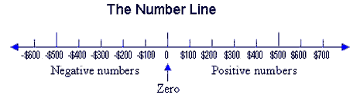
Positive and negative

A simpler way of looking at credit and debit is to use this number line. It can be found at www.keynotesupport.com/accounting/accounting-basics-debits-credits.
When an account is debited; a positive number is added to it, moving you to the right of the number line.
For example, if your balance is at $300 and you deposit (debit) $100, you will move to the right on the number line to $400.
When an account is credited; a negative number is added to it, moving you to left of the number line.
For example, if your balance is at $300 and you write a cheque (credit) for $100, you will move to the left on the number line to $200.
These credit and debit transactions then need to be promptly entered into journals, according to the organisational and legislative requirements. This is also known as journalising. A complete entry consists of the accounts and amounts to be debited and credited, a brief explanation of the transaction and the date of the transaction.
Transactions are initially recorded chronologically in an accounting record know as a journal before being transferred to the accounts. The journal shows the debit and credit effects for each transaction. Journals can be described as the basic day-to-day record of transactions.
Journals may include:
- Cash payments
- Cash receipts
- Purchases and purchase returns
- Sales and sales returns.
In order to fully understand how to record transactions, it must be understood that all accounts fit into one of five categories.

Assets
Assets are the things your organisation owns of value. These include cash, furniture and vehicles.

Liabilities
The things that your organisation owes out are known as liabilities, including loans.

Equity
Equity is your organisation’s net worth. Assets minus liabilities equal your organisation’s equity.

Revenue
Revenue is the money that your organisation is earning.

Expenses

Expenses include what money the organisation is spending.

Activities

Activity 1C
Estimated Time | 10 Minutes
Objective | To provide you with an opportunity to accurately credit and debit transactions and promptly enter into journals in accordance with organisational and legislative requirements
Activity | - What is double-entry bookkeeping?  - Outline the difference between credit and debit transactions.  - Your organisation’s account balance is currently at $1000.  - If you were to debit $700, what would the end balance be?  - If you were to credit $700, what would the end balance be?

2. Maintain general ledger

2.1. Maintain general ledger in accordance with organisational and legislative requirements

2.2. Post transactions into general ledger in accordance with organisational and legislative reporting requirements

2.3. Reconcile systems for accounts payable and receivable with general ledger

2.4. Accurately prepare trial balance from general ledger in accordance with organisational and legislative requirements

2.1 – Maintain general ledger in accordance with organisational and legislative requirements

Maintaining the general ledger
The financial transactions throughout the life of an organisation are collected within one complete record known as the general ledger. It is thought of as a master set of accounts that summarise all transactions. A general ledger contains all the assets, liabilities and stockholders’ equity accounts and your organisation’s financial statements will be built from this. Due to the advance in technological development, a general ledger no longer has an easily identifiable physical form.
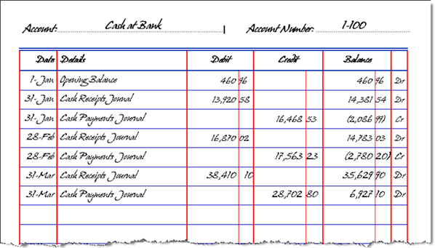

The image above outlines the format of the general ledger and can be found at www.leoisaac.com/fin/fin049. Summarised information from the journals is transferred to the general ledger on a monthly basis. By summarising all of the monthly journal postings, the general ledger then provides a final balance for each account at the end of the financial year. The journals that general ledger will summarise include the sales and cash receipts journal and the cash disbursements journal. Remember, the ultimate purpose of the whole accounting process is to ensure that the financial transactions occurring throughout the year can be easily summarised, recorded and understood.
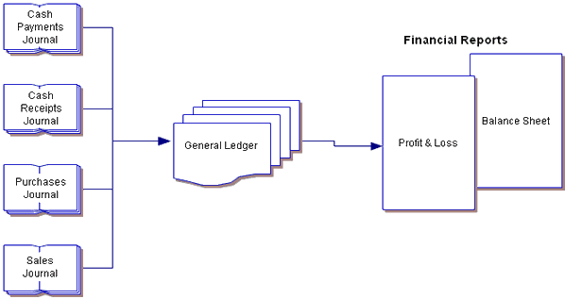

It may be easier to use the diagram above, found at www.leoisaac.com/fin/fin049, to understand the use and process of the general ledger. In most organisations, the general ledger will exist in the form of an electronic database. However, for the purpose of explaining the process, the previous paper-based format has been looked at.
Maintaining your general ledger should be one of your top priorities. Within the general ledger, there will be several general ledger accounts. These will include each account title shown on the sales and cash receipts journal columns and your cash disbursements journal columns. For miscellaneous items that don’t have their own column in the journals, separate general ledger accounts are used.
The individual entries in your organisation’s general ledger should always be from the total columns of the supporting journals. An ending balance can be reached when all journal entries have been posted and the sum of the debit and credit balances are the same.
Common general ledger accounts include:

Balance sheet accounts
- Assets
  - Petty cash
  - Office supplies
  - Investments
  - Buildings/land.
- Liabilities
  - Accounts payable
  - Accrued wages

  - Unearned revenue
  - Accrued income taxes.
- Capital accounts
  - Owner’s equity
  - Common stock
  - Preferred stock
  - Retained earnings.

Income statement accounts
- Income
  - Sales
  - Revenues
  - Sales discounts
  - Investment income.
- Expenses
  - Purchases
  - Bank charges
  - Insurance
  - Advertising.
The general ledger accounts that are used will depend on the type of organisation. Ensure you use the applicable headings. When maintaining the general ledger, be sure to do so in accordance with the organisational and legislative requirements discussed in Chapter 1.1.
To recap, the organisational and legislative requirements are:
- Designated timelines
- Guidelines for reconciling journals
- Legal and organisational and legislative policies, guidelines and requirements
- OHS policies, procedures and programs
- Procedures for totalling adjusted journals
- Quality assurance and/or procedures manuals

- Resolution procedures
- Security procedures.

Activities

Activity 2A
Estimated Time | 30 Minutes
Objective | To provide you with an opportunity to maintain general ledger in accordance with organisational and legislative requirements
Activity | - Briefly outline what a general ledger is.  - Give examples of common general ledger accounts you may come across.  - Draw up an example of how a general ledger may look for your organisation.

2.2 – Post transactions into general ledger in accordance with organisational and legislative reporting requirements

Posting transactions
Posting is the procedure of transferring journal entry amounts into the ledger accounts. Once the entries you need for the general ledger are developed, these entries are then posted into the general ledger accounts. To ensure a transaction can be tracked at a later date, these posts should include transaction dollar amounts and references as to where the material was originally entered into the books.
The following example, found at www.netmba.com/accounting/fin/process/ledger/ illustrates the posting of transactions into the general ledger.
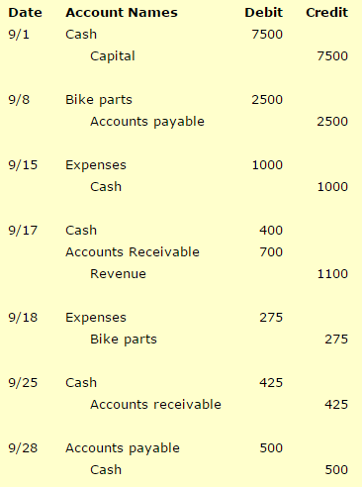

The journal entries illustrated above then need to be posted to the T-accounts of the general ledger. For example:

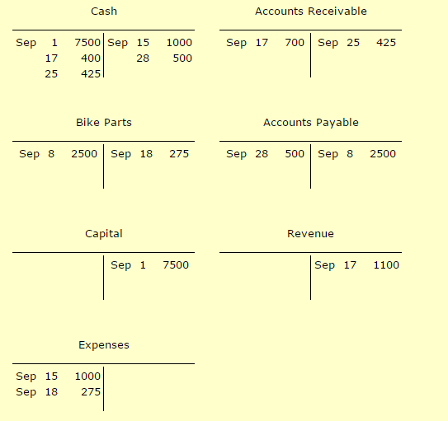

Despite the fact the transactions are already recorded in the general journal, they still need to be posted in the general ledger. This ensures that the activity and balance of each account can be looked at quickly and efficiently. Posting transactions into the ledger is easily performed as it is simply a rearrangement of information and needs no additional decisions. The posting process will be performed by the accounting software your organisation uses at the end of the day, the end of the week or as soon as the journal entry is created. Although the examples of T-accounts given show two columns; three or four columns may be used to show the running account balance and whether that balance if a net debit or credit.
Most organisations use a more informative and structured spreadsheet layout, rather than the basic T-accounts. Within this account, there are typically six columns: date, explanation, reference, debit, credit and balance.
The journal page that contains the transaction is identified in the reference column and the balance after each transaction is shown in the balance column. A transaction’s first line item should be posted to the correct ledger account and each column should be completed. Also, the account’s new balance should be calculated and the account’s reference number should be entered into the journal. This sequence of steps should be repeated for every account that is listed in the journal entry. The following diagram helps to demonstrate the process and can be found at http://www.cliffsnotes.com/more-subjects/accounting/accounting-principles-i/analyzing-and-recording-transactions/the-general-ledger.
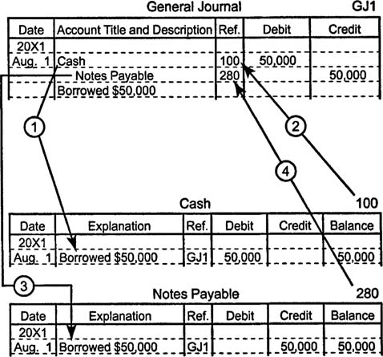

Transactions may include:

- Commencing business entries
- Correction of posting errors
- Interest expense
- Interest receivable
- Non-cash transactions (e.g. Writing-off depreciation, stock losses)
- Purchase of a fixed asset on credit
- Sale of a fixed asset on credit
- Withdrawal of stock/assets by owner
- Write-off a bad debt.

After all of the ledger entries are posted, the details as to where the transactions are posted need to be recorded on the journal pages.

2.3 – Reconcile systems for accounts payable and receivable with general ledger

Reconciling systems
The reconciliation process leads to more accurate financial statements. When reconciling an account, the aim is to prove that the balance is correct and that the transactions that add up to the end balance are correct. Using accounting software makes the whole process much easier and cuts down on the work required. However, it can be done manually. It is likely that there is a way to reconcile near enough any accounts but two common accounts are: accounts receivable and accounts payable.
Reconciling systems for accounts payable and receivable may include:
- Checking accuracy of creditor account balances (e.g. Cash payments journal, purchases journal, purchases returns journal, general journal)
- Checking accuracy of debtor account balances (e.g. Cash receipts journal, sales return journal, general journal)
- Checking cash payments and receipt journals against bank statement
- Checking the total of the creditor's schedule equals the balance of the creditor's control account
- Checking the total of the debtor's schedule equals the balance of the debtor's control account.
What is accounts payable?
Accounts payable is the money owed by an organisation to its suppliers. On the organisation’s balance sheet, it is shown as a liability.
Reconciling accounts payable with the general ledger
The payables account balance stated in the general ledger must match the detailed total of all accounts payable that are outstanding before closing the books.
The process includes the following steps:

- Checking that the ending accounts payable account balance in the general ledger matches the aged accounts payable detail report. These should be taken from the current period. If they don’t match, earlier periods may need to be reconciled before tackling the current period.
- Look at the accounts payable general ledger account and see if any journal entries were made to the account during the current period. If so, these items need to be recorded in a reconciliation spreadsheet.
- The ending aged accounts payable report for the current period should be printed. The total amount outstanding from this report should be entered into the reconciliation spreadsheet.
This should mean that the reconciliation process is complete. However, if there is still a variance these additional steps should be followed:
- Verify that the aged accounts payable report was printed after all posting was completed
- Verify that the accounts payable journal was properly posted to the general ledger
- Verify that the general ledger is set to the correct reporting period.
When it is being performed for the first time, this process can be difficult. Once the errors have been identified and the corrections have been made, it is normally easy to update the document in following reporting periods.
What is accounts receivable?
Accounts receivable is a claim for payment from an organisation to its customer for the goods that have been supplied. Usually, these are in the form of an invoice and are shown as an asset within a balance sheet. Accounts receivable is an accounting transaction that deals with the billing of goods that have been ordered by the customer.
Reconciling accounts receivable with the general ledger
The matching of detailed amounts of unpaid customer billings to the accounts receivable total stated in the general ledger is the process of reconciling accounts receivable. The process is important as it proves that the general ledger figure for receivables is justified.
The information sources for this reconciliation are:
General ledger
Within the general ledger, there is normally an account that is specifically designated for the sole compilation of all receivables related to customers. These are also known as trade receivables. The resulting ending balance in the receivables account is the summary total that will be verified through the reconciliation process. This happens once all of the transactions have been recorded and the subsidiary ledger balances have been posted to the general ledger.
Receivables detail

The detailed listing of unpaid customer billings is usually recorded in a subsidiary sales ledger. This should match the ending balance in the general ledger. By printing the aged accounts receivable report, the required information can be extracted for reconciliation purposes. The totals on the report need to be compared to the receivable total in the general ledger.

If there is a difference when the reconciliation is conducted it could be because:
- A journal entry was made to the general ledger account that was missed out by the subsidiary sales ledger.
- A billing was accidentally posted to somewhere other than the trade receivables account.
- The aged receivables report was run as of different date than that used to obtain the ledger balance.


Activities

Activity 2C
Estimated Time | 20 Minutes
Objective | To provide you with an opportunity to reconcile systems for accounts payable and receivable with general ledger
Activity | - Why is reconciliation necessary?  - Outline the process of reconciling accounts payable with the general ledger

2.4 – Accurately prepare trial balance from general ledger in accordance with organisational and legislative requirements

What is a trial balance?
Within the ledger of an organisation, there is a list of all the general ledger accounts. This list is known as the trial balance and it contains the name of the nominal ledger account and its value.
What is the purpose of a trial balance?
The trial balance is the first step in the preparation of financial statements. The purpose of the trial balance is to prove the mathematical equality of debits and credits after posting. It ensures that a corresponding credit entry is recorded for each debit entry that is recorded. This is completed in accordance with the double entry concept of accounting. The trial balance is useful in ensuring that the account balances are accurately extracted from the accounting ledgers. It may also uncover errors within the journalising and posting process and it can be useful in the preparation of the organisation’s financial statements. As it used to assist in the drafting of financial statements, the trial balance is usually prepared at the end of an accounting period. The balances of the ledger are divided into debit balances and credit balances.
For example:
Account Title | Debit ($) | Credit ($)
Debtors | 4,000
Creditor |  | 6,000
Sales |  | 12,000
Cash | 1,500
Cost of sales | 5,000
Administration expense | 1,000
Share capital |  | 8,500
Building | 15,000
Total | 26,500 | 26,500
The debit side of the trial balance includes:
- Assets accounts
- Expense accounts.
The credit side of the trial balance includes:
- Liabilities accounts
- Capital accounts
- Income accounts.
If all the ledger balances are accurately extracted and all the accounting entries are recorded correctly, the total of the debit balances displayed in the trial balance must be the same as then sum of all credit balances. Note: this is shown in the example above.
Preparing a trial balance
- At the end of an accounting period, all ledger accounts are closed.
- Ledger balances are posted into the trial balance.
- Errors are identified as the trial balance is conducted.
- In order to agree the trial balance totals temporarily until any corrections are accounted for, a suspense account is created.
- By posting corrective entries, the errors that were identified earlier are rectified.
- Any adjustments needed at the period end that have not been previously accounted for are incorporated into the trial balance.
Developing a trial balance
- A worksheet with three columns needs to be prepared
  - Account titles

  - Debits
  - Credits
- These columns need to be filled in
- The debit and credit columns need to be totalled
- The totals need to be compared.
Limitations of a trial balance
It is only confirmed by the trial balance that the total of all debit balances simply matches the total of all credit balances. Even if these match, there could be errors present.
For example:
- It is possible that an incorrect debit entry could be restored with an incorrect credit entry equal to this amount.
- Any transactions not recorded at all would not be identified by a trial balance because both the debit and credit sides would be left out.

3. Monitor cash control

3.1. Ensure cash flow is accurately accounted for in accordance with organisational and legislative requirements
3.2. Make and receive payments in accordance with organisational and legislative requirements
3.3. Collect or follow up outstanding accounts within designated timelines
3.4. Check payment documentation for accuracy of information and despatch to creditors within designated timeline

3.1 – Ensure cash flow is accurately accounted for in accordance with organisational and legislative requirements

Cash flow
The movement of money into or out of an organisation is known as cash flow. Usually, it is measured during a specific period of time. It is a revenue or expense stream that changes a cash account over a given period. The operating activities of your organisation are represented by the incoming and outgoings of cash.

Cash inflow
These normally arise from one of the following activities:
- Financing
- Operations
- Investing.

Cash outflow
These are usually the result of either of the following:
- Expenses
- Investments.
Cash flow, within accounting, is the difference between the opening balance and the closing balance of particular period of time. A positive cash flow is when the closing balance is larger than the opening balance. Cash flow can be increased if:
- More goods are sold
- An asset is sold

- Costs are reduced
- The selling price is increased
- Money is collected faster
- Money is paid slower
- More equity is brought in
- A loan is taken out.
Remember, high levels of cash flow do not indicate good performance or profit.
Cash flow statements
One of the most important financial statements for your organisation is the cash flow statement; these can range from a simple analysis to a more complicated analysis. This more complicated analysis needs a central statement that receives information from several schedules. The cash flows that occurred during the past accounting period are listed within a cash flow statement. As well as the amount of the cash flow, the cash flow statement is also concerned with the timing of these flows. From a cash flow statement, you can make a prediction about future cash flows. This is known as cash flow budget.
The cash flow statement consists of three sections:
- Cash flow from operations
- Cash flow from investing activities
- Cash flow from financing activities.
The cash flow from operations section is often deemed the most important section as it shows whether the organisation was able to generate cash from its operating activities. Typically, it consists of two sub-sections:
- The first subsection adds back to/minus from net income all non-cash operating items that were subtracted/added in arriving at net income
- In the second section, the net change in the working capital is calculated and added back to the net income.
Preparing a cash flow statement
You’ll need:
- The most recent balance sheet
- The prior balance sheet
- The most recent income statement
- Any additional notes about transactions within the relevant period.
Then:

- Record any non-cash charges that were applied against revenue (depreciation)
- Record any non-cash income that was added to revenue (profit from sale of fixed assets)
- Compare the two balance sheets
- Divide the balance sheets into the three sections previously discussed
- Excluding cash, deduct line items on prior balance sheet from the similar line item on the recent balance sheet.

Rules with changes in assets, liabilities and equity:
- Increase in an asset – use of cash
- Decrease in an asset – source of cash
- Increase in liability – source of cash
- Decrease in liability – use of cash
- Increase in equity – source of cash
- Decrease in equity – use of cash.
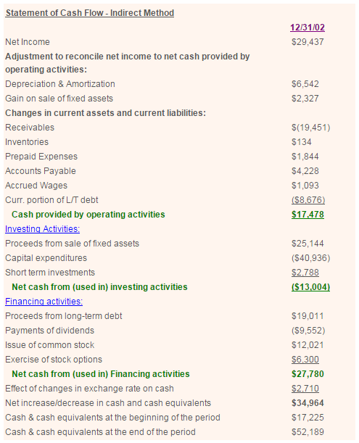
To the opening cash balance, add the change in cash; this should equal the most recent balance sheet’s cash balance. The following example of a cash flow statement can be found at: www.accountingbase.com/CashFlow.

When conducting a cash flow statement, the organisational and legislative requirements discussed in Chapter 1.1 should be considered.
For example:
Designated timelines
A cash flow statement needs to be carried out at the appropriate time, ensuring any deadlines are met.
Legal policies
Consider how long a cash flow statement will need to be kept in accordance to legal guidelines.

Quality assurance
What should a successful cash flow statement show?
Security procedures
Where the cash flow statements will be stored is something that needs to be considered. What is the most appropriate method?

Activities

Activity 3A
Estimated Time | 20 Minutes
Objective | To provide you with an opportunity to ensure cash flow is accurately accounted for in accordance with organisational and legislative requirements
Activity | - What documents are needed before a cash flow statement is carried out?  - In relation to your organisation, draw a brief example of a cash flow statement.  - Choose an organisational and legislative requirement. Outline how it relates to cash flow.

3.2 – Make and receive payments in accordance with organisational and legislative requirements

Payments
Payments can include:
Cash
Although cash payments are still important, they are being used less and less.
Cheque
A cheque is written out to instruct an organisation’s bank to make a payment on their behalf. Although it is a relatively safe way to make a payment, cheques take three to four days to clear. For organisation’s using cheque, this can be harmful to their cash flow.
Credit card
A credit card allows the cardholder to pay for goods based on the promise they will pay for them.
Electronic funds
Transferring funds electronically enables payments to be made very quickly. By using automated computer systems, electronic transfers are used by organisations to pay large numbers of employees or suppliers. These electronic transfers can be easily tied into an organisation’s accounting system and are easily traced.
Direct debit
If regular payments are being made to an organisation, a direct debit or standing order may be appropriate. When a direct debit or standing order is created, the bank of an organisation is instructed to pay a regular sum on a regular date until the arrangement is altered. A direct debit is slightly different as the receiver has the power to alter the amount that is paid.
Cheque payments and electronic fund transfers are typical methods used when an organisation makes a payment.
Making cash payments

The running of an organisation relies on other goods and services that will need to be paid for. Ideally, an organisation should use the organisation’s account for business purchases, not a private account. Petty cash can be used to pay for small purchases, for example: parking or stamps. When making cash payments, receipts or invoices should be kept as proof of purchase. Also, these payments should be recorded for accounting purposes.
Receiving cash payments
Receiving cash is a highly regimented process. Handling cash payments within your organisation can lead to many risks. For example:
- Theft
- Destruction of accounting records
- Failure to create initial records.
Things to consider:
- During non-business hours, keep cash locked away
- Cash should be accessed only by employees that need to do so
- During business hours, cash should be locked in drawers or tills
- Secure areas that store cash with alarms.
Making a cheque payment
When using a cheque as a method of payment, the funds must be in the corresponding account already. After filling in the recipient’s name and the amount needed to be paid, the process will not start until it is paid into their account. Once this is done, it usually takes around three days to complete the process.
Receiving a cheque payment
An organisation should be wary when accepting high-value cheques as there is no way to be sure that money is theirs until a few days after paying it into the accounts.

Records of any payments made or received are essential to an organisation’s accounts. Records that need to be kept will vary between organisations but may include:
- Credit card statements
- Sales receipts or invoices
- Bank account statements
- Stocktaking sheets
- List of debtors and creditors
- Motor vehicle expenses.
For more information, go to http://www.fairwork.gov.au/about-us/policies-and-guides/fact-sheets/rights-and-obligations/record-keeping-pay-slips to view information on payment requirements.

Organisational and legislative requirements
Be aware of the relevant organisational and legislative requirements for making and receiving payments.
These may include:
- Maintaining confidentiality of customer information in accordance with the Privacy act 1988
- Compliance with Fair Work Act 2009
- Make and keep records of payments in and out of organisation
- Issuing pay slips for employees
- Keep records for seven years
- Not altering records unless correcting a mistake
- Not including false information
- Ensuring the organisation has the funds to fund outgoing payments before making them
- Including extra relevant information (e.g. tax deductions or additions).
Privacy laws
You need to be able to protect client data and respect the relationships you have – if you fail to do this, they can likely move to your competitors.
Privacy is governed by the Privacy Act 1988 (Privacy Act), which regulates the handling of personal information.
As of March 2014, the following privacy legislation amendments came into effect:
- Privacy Amendment (Enhancing Privacy Protection) Act 2012
- Privacy Regulation 2013
- Credit Reporting Privacy Code.
You can read more about the privacy law reform at: www.oaic.gov.au/privacy/privacy-act/privacy-law-reform
There are 13 Australian Privacy Principles that apply to the handling of personal information, contained in Schedule 1 of the Privacy Act:

- Open and transparent management of personal information
- Anonymity and pseudonymity
- Collection of solicited personal information
- Dealing with unsolicited personal information
- Notification of the collection of personal information
- Use or disclosure of personal information
- Direct marketing
- Cross-border disclosure of personal information
- Adoption, use or disclosure of government related identifiers
- Quality of personal information
- Security of personal information
- Access to personal information
- Correction of personal information.
Full information on the Privacy Act and its terms can be found at www.oaic.gov.au/privacy/privacy-act/the-privacy-act.

3.3 – Collect or follow up outstanding accounts within designated timelines

Outstanding accounts
For an organisation, not getting paid on time is actually very common. Ideally, these payments should be made before designated timelines. Although designated timelines will vary between organisations, they may include:
- By month end
- Monthly
- Within agreed period
- Within organisational and legislative deadline.
Keeping outstanding accounts within the designated time frames
Ensure:
- The payment terms are outlined clearly within a policy
- A firm credit policy is set up
- Regular follow ups
- Invoices are sent quickly
- Large orders are taken with caution
- Accounts are monitored for customer history.

How to minimise the chances of not getting paid:
- Have contracts with clear guidelines
- Establish a process for following invoices up
- Be disciplined – start early
- Understand why a payment could be late
- Do it face-to-face.
Collecting outstanding accounts
Timing, accuracy and repetition are crucial in a collection strategy. An organisation should deal with collecting outstanding accounts in a standardised manner. The stages of the process will be dependent on the organisation itself and the status of each invoice. The following steps are a general overview of the stages that may be used in the collection of outstanding accounts and is not a conclusive list:
- Assign overdue invoices
- Verify allowed deductions
- Issue letters

- Initiate direct contact
- Settle payment arrangements
- Adjust the credit limit
- Monitor payments
- Refer to collection agency
- Sue the customer
- Write of the remaining balance
- Conduct a post mortem.

3.4 – Check payment documentation for accuracy of information and despatch to creditors within designated timeline

Checking documentation
Payment documentation needs to be checked for accuracy and then sent to creditors within a designated timeline. These designated timelines will vary between organisations.
To recap, they may include:
- By month end
- Monthly
- Within agreed period
- Within organisational and legislative deadline.
Check payment documentation:
- The invoices received from the creditor for any supplies purchased
- The organisation’s statement that validates the purchase
- The extensions and calculations of the prices and discounts of that purchase
- Quality and quantity of purchase matches that on the order specifications.
Process of sending payment documentation:
- The accurate details are entered into the organisation’s accounts payable system
- Each payment request needs to have the appropriate documentation
- A signature from the relevant person is required.
Remember:
- All accounts payable procedures need to be documented
- Any payments made are only on original invoices
- Stamp the original invoice once the payment is made
- Payments over a certain amount may need to be handled by the manager.
This checking and paying process should be completed within the organisation’s relevant designated timeline.

Skills and Knowledge Activity


Nearly there...

Major Activity – An opportunity to revise the unit

At the end of your Learner Workbook, you will find an activity titled ‘Major Activity’. This is an opportunity to revise the entire unit and allows your trainer to check your knowledge and understanding of what you have covered. It should take between and 1-2 hours to complete and your trainer will let you know whether they wish for you to complete it in your own time or during session. Once this is completed, you will have finished this unit and be ready to move onto the next, well done!

Congratulations!
You have now finished the unit ‘Maintain financial records'


References

These suggested references are for further reading and do not necessarily represent the contents of this Learner Guide.

The ATO website www.ato.gov.au (Accessed 19/11/2014)
http://www.keynotesupport.com/accounting/accounting-basics-debits-credits.shtml (Accessed 19/11/2014)
http://www.leoisaac.com/fin/fin049.htm (Accessed 19/11/2014)
http://quizlet.com/52428449/chapter-3-accounting-flash-cards/ (Accessed 20/11/2014)
http://www.netmba.com/accounting/fin/process/ledger/ (Accessed 20/11/2014)
http://www.cliffsnotes.com/more-subjects/accounting/accounting-principles-i/analyzing-and-recording-transactions/the-general-ledger (Accessed 20/11/2014)
http://www.accountingbase.com/CashFlow.html (Accessed 21/11/2014)

