

BSBINM301
Organise workplace information
Learner Guide

BSBINM301
Organise workplace information

Table of Contents

Table of Contents 2
Unit of Competency 4
Performance Criteria 5
Foundation Skills 6
Assessment Requirements 7
Housekeeping Items 8
Objectives 8
Collect and assess information 9
1.1 – Access product and service information in accordance with organisational requirements 10
Computer databases 10
Correspondence 11
Organisational requirements 11
Activity 1A 13
1.2 – Ensure methods of collecting information are reliable and make efficient use of available time and resources 14
1.3 – Assess information for clarity, accuracy, currency and relevance to intended tasks 14
Methods of collecting information may include 14
Recordkeeping requirements 15
Activity 1B 17
1.4 – Use interpersonal skills to access relevant information from teams and individuals 18
Interpersonal skills 18
Using appropriate body language 19
Activity 1C 20
2. Organise information 21
2.1 – Organise information in a format suitable for analysis, interpretation and dissemination in accordance with organisational requirements 22
Formats 22
Activity 2A 24
2.2 – Use appropriate technology/systems to maintain information in accordance with organisational requirements 25
Technology 25
Activity 2B 27
2.3 – Collate information and materials and communicate to relevant designated persons 28
Collating information 28
Activity 2C 29
2.4 – Identify difficulties organising and accessing information and solve collaboratively with individuals and team members 30
Potential difficulties 30
Activity 2D 32
2.5 – Update and store information in accordance with organisational requirements and systems 33
Activity 2E 35
3. Review information needs 36
3.1 – Actively seek feedback on clarity, accuracy and sufficiency of information to ensure relevance of information and system 37
3.2 – Review the contribution of information to decision making and implement appropriate modifications to collection processes 37
Feedback 37
Clarity, accuracy and sufficiency of information 38
Evaluating the contribution of information to decision making 38
Decision making 38
Activity 3A 39
3.3 – Identify future information needs and incorporate modifications to collection processes 40
3.4 – Document future information needs and incorporate in modifications to reporting processes 40
Information resources that can aid in performance management 40
Factors to consider when collecting or modifying further information 41
Information needs analysis 42
Activity 3B 43
Skills and Knowledge Activity 44
Major Activity – An opportunity to revise the unit 45
References 47

Unit of Competency

Application

This unit describes the skills and knowledge required to gather, organise and apply workplace information in the context of an organisations’ work processes and knowledge management systems.

It applies to individuals who perform a defined range of skilled operations in various work contexts. They may exercise discretion and judgement using appropriate knowledge of information management to provide technical advice and support to a team.

No licensing, legislative or certification requirements apply to this unit at the time of publication.

Unit Sector

Knowledge Management – Information Management

Performance Criteria
Element  Elements describe the essential outcomes. | Performance Criteria  Performance criteria describe the performance needed to demonstrate achievement of the element.
- Collect and assess information | - Access product and service information in accordance with organisational requirements  - Ensure methods of collecting information are reliable and make efficient use of available time and resources  - Assess information for clarity, accuracy, currency and relevance to intended tasks  - Use interpersonal skills to access relevant information from teams and individuals
- Organise information | - Organise information in a format suitable for analysis, interpretation and dissemination in accordance with organisational requirements  - Use appropriate technology/systems to maintain information in accordance with organisational requirements  - Collate information and materials and communicate to relevant designated persons  - Identify difficulties organising and accessing information and solve collaboratively with individuals and team members  - Update and store information in accordance with organisational requirements and systems
- Review information needs | - Actively seek feedback on clarity, accuracy and sufficiency of information to ensure relevance of information and system  - Review the contribution of information to decision making and implement appropriate modifications to collection processes  - Identify future information needs and incorporate modifications to collection processes  - Document future information needs and incorporate in modifications to reporting processes

Foundation Skills
This section describes language, literacy, numeracy and employment skills incorporated in the performance criteria that are required for competent performance.

Skill | Performance  Criteria | Description
Reading | 1.1-1.3, 2.1-2.3, 2.5, 3.2 | - Recognises and assesses textual information to complete tasks according to requirements
Writing | 2.1, 2.2, 2.3, 2.5, 3.1, 3.4 | - Completes workplace records, forms and documentation accurately using correct format, accurate spelling and grammar and terminology specific to requirements
Oral communication | 1.4, 2.3, 2.4, 3.1 | - Elicits the view and opinions of others and obtains information by listening and questioning  - Participates in a verbal exchange of ideas/solutions using clear language to contribute information and convey issues
Navigate the world of work | 1.1, 2.1, 2.5 | - Understands rights and responsibilities and complies with explicit policies and procedures and legal and regulatory requirements
Interact with others | 1.4, 2.3, 2.4, 3.1 | - Identifies and follows accepted communication practices and protocols  - Complies with work instructions and contributes to work group discussions using accepted conventions
Get the work done | 1.1, 1.2, 2.1, 2.2, 2.4, 3.2, 3.3 | - Plans and implements routine tasks and workload making decisions about sequencing and timing  - Makes low impact decisions within familiar situations, based on a range of predefined or routine solutions, and evaluates the effectiveness of the outcome  - Uses digital technology to access and record information and to communicate with others

Assessment Requirements
Performance Evidence

Evidence of the ability to:

- Efficiently and effectively gather, assess, organise and use workplace information as part of own job role
- Provide accurate information for defined purposes
- Maintain and handle data and documents systematically
- Use business technology to manage information
- Communicate with colleagues and clients using effective interpersonal skills to obtain and check workplace information
- Apply relevant legislation and regulations to workplace information
- Monitor, review and modify information processes

Note: If a specific volume or frequency is not stated, then evidence must be provided at least once

Knowledge Evidence

To complete the unit requirements safely and effectively, the individual must:

- Explain how legislation and regulations may affect the gathering, organising and distribution of workplace information
- Describe methods for checking validity of information and its sources
- Describe organisational recordkeeping and filing systems, security procedures and safe recording practices
- Identify workplace policies and procedures relating to workplace information

Assessment Conditions

Assessment must be conducted in a safe environment where evidence gathered demonstrates consistent performance of typical activities experienced in the knowledge management – information management field of work and include access to:

- Business technology
- Workplace policies and procedures
- Relevant legislation and codes of practice
- Office equipment and resources
- Examples of information documents found in the workplace
- Interaction with others

Assessors must satisfy NVR/AQTF assessor requirements.

Links

Companion volumes available from the IBSA website: http://www.ibsa.org.au/companion_volumes

Housekeeping Items
Your trainer will inform you of the following:
- Where the toilets and fire exits are located, what the emergency procedures are and where the breakout and refreshment areas are.
- Any rules, for example asking that all mobile phones are set to silent and of any security issues they need to be aware of.
- What times the breaks will be held and what the smoking policy is.
- That this is an interactive course and you should ask questions.
- That to get the most out of this workshop, we must all work together, listen to each other, explore new ideas, and make mistakes. After all, that’s how we learn.
- Ground rules for participation:
  - Smile
  - Support and encourage other participants
  - When someone is contributing everyone else is quiet
  - Be patient with others who may not be grasping the ideas
  - Be on time
  - Focus discussion on the topic
  - Speak to the trainer if you have any concerns

Objectives
- Discover how to collect and assess information
- Learn how to organise information
- Know how to review information needs
- Gain skills and knowledge required for this unit

Collect and assess information
1.1. Access product and service information in accordance with organisational requirements
1.2. Ensure methods of collecting information are reliable and make efficient use of available time and resources
1.3. Assess information for clarity, accuracy, currency and relevance to intended tasks
1.4. Use interpersonal skills to access relevant information from teams and individuals


1.1 – Access product and service information in accordance with organisational requirements
In order to complete designated tasks in the workplace, information needs to be accessed first, before being able to organise information and respond to a requirement. Depending on the information you need to access, there may be restrictions on what you are able to access and how to do so. Becoming more familiar with the types of information available will help you to effectively access the information you are looking for.
Information will come in a variety of forms, including:
- Computer databases (e.g. library catalogue, customer records)
- Computer files (e.g. letters, memos and other documents)
- Correspondence (e.g. faxes, memos, letters, email)
- Financial figures
- Forms (e.g. insurance forms, membership forms)
- Invoices (e.g. from suppliers, to debtors)
- Personnel records (e.g. personal details, salary rates)
- Production targets
- Sales records (e.g. monthly forecasts, targets achieved).

Computer databases
A computer database is a collection of data records stored in a particular file or number of files. Text retrieval and information management is made easier through the use of systems that help businesses access specific information within a wide range of data. These systems can include software for information and storage retrieval, text information management systems, document retrieval systems and document management systems.

The process may be as follows:
- User searches the interface
- Search engine completes a task
- The database is examined
- A file will be identified containing the required information.

Correspondence
‘Correspondence’ refers to letters, memos, faxes etc. that have been sent to the workplace, by persons such as clients, colleagues or employees. With all information in the workplace, documentation should be clearly protected by workplace policies.
Correspondence could include a detailed conversation between two parties which needs to be handled carefully. Therefore, accurate records should be kept so that information can be scrutinised if necessary.
This information must also be stored for further reference. If this is a common source of information in your workplace, you may need to ask your supervisor to explain the policies that are implemented regarding information storage. Your employer should keep copies of correspondence in case of any legal proceedings.
Legal information
‘Appropriate correspondence to workplace participants can demonstrate an employer's attempts to comply with the law.

For example, it may allow an employer to take appropriate action against a workplace participant who acts without regard for the safety of their fellow workplace participants or the business, where appropriate correspondence evidences a series of warnings in relation to the employee’s performance and/or conduct.’

http://hradvance.com.au/information/how-to-use-correspondence#key

Organisational requirements
Organisational requirements may include:
Code of conduct/code of ethics
A code of conduct aims to promote the standards of business practices and policies that employees are to follow. They are guidelines for safe and fair communications between the parties involved in your business or organisation and can be mandatory or voluntary. It is possible to establish a code of practice for individual businesses so ask your supervisor about the code of practice governing your industry. For example, in the accommodation and food services industry, the Competition and Consumer Act 2010 is a legislative document that influences business operations in this industry. You can see which documents influence your industry by accessing www.business.gov.au
Information protocols
Information protocols are guidelines about information sharing and can regulate the information that is shared between organisations

Legal and organisational policies, guidelines and requirements
Australian citizens must abide by the legislation set out for businesses. The Office of the Australian Information Commissioner (OAIC) regulates how information is collected, accessed and stored. There are specific rules relating to each industry; for example, medical employees must acknowledge the legislation surrounding medical records. Australian states and territories will have different laws that will apply in the workplace. For more information on privacy laws, please see the OAIC website: www.oaic.gov.au
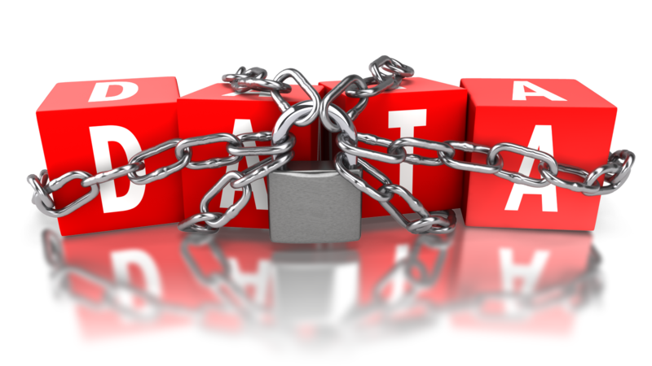
Management and accountability channels
Your business or organisation could employ a range of information management strategies depending on specific business needs. Accountability refers to relationships where one person is responsible to the other (sometimes vice versa) for their actions and consequences. In the same way, management structures work in a hierarchical way to ensure that business protocol including information management is conducted according to organisational requirements
WHS policies, procedures and programs
Each commonwealth, state and territory holds responsibility for enforcing Workplace Health and Safety (WHS) laws. For example, in South Australia, SafeWork SA provides a range of services involving workplace safety. Ask a designated person for information regarding the WHS regulations for your business.
Other organisational requirements may include:
- Procedures for updating records
- Quality assurance and/or procedures manuals
- Security and confidentiality requirements.


Activity 1A

1.2 – Ensure methods of collecting information are reliable and make efficient use of available time and resources


1.3 – Assess information for clarity, accuracy, currency and relevance to intended tasks
If you are relying on others for your sources of information, this could prove more unproductive if you are not thinking critically. Ensure that the information collected is from a credible source as you may find that a colleague has had a very different experience to you in a particular area. Wherever possible, double check your information either with another person, or use multiple methods to ensure reliability.

Methods of collecting information may include
Methods of collecting information may include:
- Checking research provided by others
- Checking written material including referrals and client files
- Individual research
- Information from other organisations
- Interviews with colleagues/customers
  - Interviews can allow you to get a full range of information as well as building relationships with those in the workplace. This sort of method can be flexible and can offer insights into the processes and workplace information.
- Observation and listening
  - Observation enables you to gather accurate information about how a program operates including its processes. An observer can view operations as they are occurring.
- Previous file records
- Questioning (in person or indirect)
  - Questionnaires can be a quick way of receiving feedback and can produce statistics that are easy to assimilate. You can make comparisons and draw conclusions that will cause action to be taken in the workplace. However, they can be expensive and can involve a lot of paperwork. The responses may be rather shallow but you may not have the opportunity to follow up the responses.
- Recruitment applications and other forms

- Classification tools
  - In order for a business to manage their documents effectively, classification tools may be used to develop business conduct. Options for record classification range from folder structure to electronic applications
  - Classification tools serve as a way to manage records effectively. Each organisation will have their own recordkeeping requirements based on the evidence needed, how it is presented, recordkeeping timings and access to this evidence.
  - Types of classification may include: alphabetic, numeric, subject, key word and perhaps more.

Recordkeeping requirements
Recordkeeping requirements may include:
- The information that is recorded
- Time allocation for the storage of records
- Requirements for the disposal of information
- The form of information recorded
- There may be other regulations, depending on your workplace or organisation.
Reliability

Whatever information you are collecting, you will need to make sure that the method is reliable and will complement the data collected. If you repeat the procedure and the results are the same, then this is a good indication that your method is consistent and trustworthy. In general, data/statistics/information is checked three times in order to test reliability.
Time and resources
Your organisation may use particular resources to analyse information. For example, if databases contain significant information, an electronic process that includes graphs and charts may be the best way to analyse information.
In order to be efficient with your time, make sure that you ask a designated member of staff if you need assistance. Sometimes it is helpful to consult another person when interpreting data anyway, as it strengthens the credibility of your results.
What are you trying to find?
Once you have identifies the information required, analyse whether it clearly relates to the task you are completing.
Once the information has been organised, you can conduct the analysis. Ensure that your information has been scrutinised for reliability and then you can begin drawing conclusions.
Processing/analysing information
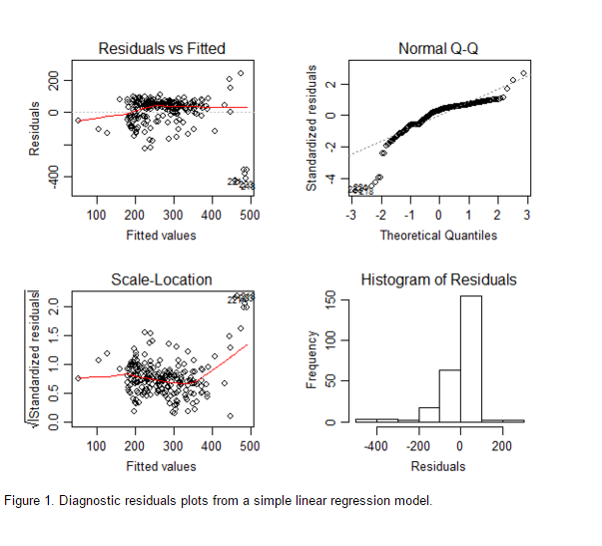
Data Analysis Australia provides a few different ways to produce superior data, using more sophisticated methods. One way to analyse data through mapping involves standard diagnostic plots which enable the person to quickly assess the data and whether assumptions were correct.

Source: http://www.daa.com.au/analytical-ideas/mapping-diagnostics/

Activity 1B

1.4 – Use interpersonal skills to access relevant information from teams and individuals
Interpersonal skills are important as they help to form effective working relationships within the work environment. Not only do they help you to develop better relationships with colleagues, but they ensure that communication with customers, clients and others is as calm and efficient as possible. Interpersonal skills include patience, respect, kindness, empathy, compassion and the ability to diffuse potentially difficult emotional situations. Showing an awareness of these skills and their importance can help you develop them.

Interpersonal skills
Interpersonal skills may include:
- Consultation methods, techniques and protocols
- Networking
- Seeking feedback from group members to confirm understanding
- Summarising and paraphrasing
- Using appropriate body language.
Consultation
This involves talking to people (colleagues, clients etc.) and explaining an issue, before working together to share views and ideas. In order to access accurate information, you will need to collaborate effectively.
Further consultation information:
- Clarify the issue or topic to be discussed in order to avoid trivial and unnecessary conversation
- If this is a major topic within the organisation, you may need to consult management so that they can agree on the issues to be discussed
- Some consultative committees may be established so that management and their employees can work together in order to understand issues and overcome common problems in the workplace.

Summarising and paraphrasing
This involves receiving information from others and taking the most important parts of the correspondence in order to take away the most concise and effective information. After a long conversation you may need to summarise in order to remember a key piece of advice, perhaps for the purpose of passing it on to others.
This skill will enable you to retain and transfer important information and work with others in order to access relevant information from those around you.

Using appropriate body language
The way you hold/position yourself can have positive or negative effects on others. When body language is properly adopted, it can aid in developing professional relationships and help you to have more credibility within the workplace.
Examples of positive body language:
- Keep an upright, confident posture. Standing up straight immediately makes you appear more confident and assured of yourself, as opposed to slouching and looking lazy or under confident.
- Eye contact is absolutely vital when working collaboratively. It is important that you show you are attentive and that you want to engage in the conversation. You show another person that you are listening by looking directly at them. Looking at the space in between someone’s eyes is a good place to aim for if you are unsure of how to maintain eye contact.
- Open your body up. Show that you are warm, welcoming and confident by keeping your arms open, by your side and keeps your hands open.
- Smile and be aware of the way your expressions convey what you are feeling. If you want to learn something from another person, they are more likely to share information if you show that you are interested in hearing from them. Nodding and responding to their comments through supportive utterances such as ‘mmm’ and ‘yeah’ can often be simple ways of showing support to the other person.


Activity 1C

2. Organise information
2.1 Organise information in a format suitable for analysis, interpretation and dissemination in accordance with organisational requirements
2.2 Use appropriate technology/systems to maintain information in accordance with organisational requirements
2.3 Collate information and materials and communicate to relevant designated persons
2.4 Identify difficulties organising and accessing information and solve collaboratively with individuals and team members
2.5 Update and store information in accordance with organisational requirements and systems

2.1 – Organise information in a format suitable for analysis, interpretation and dissemination in accordance with organisational requirements

Formats
Formats may include:
- Adding headers and footers
  - This may signpost the document and outline what is being addressed as well as displaying information in a formal way
- Incorporating graphics and pictures
  - Images may help colleagues, or whoever is exposed to the information, to see information in a concise way. Sometimes it will convey the information far more effectively than describing data
- Inserting symbols
  - This may signpost the reader to particular elements of the analysis. Symbols may represent particular parts of the document that could be cross-referenced, and again, keeps it simple
- Using legends
  - Legends can be used to provide more information alongside a chart
- Using a particular software application
  - The software application will depend on your organisation, however plenty of applications are available that can help you organise information. A generic application will allow you to select information, format the data into graphs and charts etc
  - Applications may include Microsoft Word, Excel and PowerPoint.

- Using tables and charts
  - As aforementioned, this can be an easy way of displaying data. They are easy to use on the above applications and can be displayed in a variety of ways

Analysis | Interpretation | Dissemination
- Information can be analysed using computerised or manual methods.  - You should be able to inspect information in order to make conclusions, draw comparisons or complete the task you have been given. The organisation of your information should be clear enough to analyse.  - Ensure accuracy through using software you are familiar with.  - You may have to transfer this data into another form, so keep it clear and concise. | - Consider how you present your findings: it needs to be relevant to your audience and clearly signpost how you have collected, analysed and interpreted information.  - This is the time to consider reliability of information. If your research is current, it should be accurate however be aware of data that is dated and misleading.  - Allow the data to guide your conclusions. | - The way that you share this information, on a broad scale, will depend on the audience you want to reach.  - If the information has been collected for the purposes of increasing sales, then dissemination on a large scale would promote the business or organisation.  - Dissemination methods may include sales reports or other published documents or through a presentation – perhaps at a conference or a smaller scale business meeting or seminar.

If you are not familiar with your organisation’s specific requirements regarding the organisation of data, please check with a designated person.

Activity 2A

2.2 – Use appropriate technology/systems to maintain information in accordance with organisational requirements

Technology
Technology may include:
Answering machine
An answering machine serves as a record of correspondence. If an organisation uses landline telephones, this provides a way of maintaining verbal information and can be passed on if necessary.
Computer

Computers are the most widely used and can keep up to date with the fast-moving systems of information management. Software that runs on a computer provides an efficient way of storing a large amount of information.
Your organisation will have policies in place for responding to unforeseen circumstances, including the area of confidentiality. The technology used should be checked regularly to avoid becoming inoperable.
Email
Anyone using email for data management should use information protocols, encryption and authentication measures.
For example, in the healthcare sector, therapists must ensure that if they communicate with clients via email and store any records electronically that it must be safe. They must ensure that computers are password protected, have virus protection, backup systems and encryption in order to maintain information security.
Fax machine
Using a fax machine has become less popular although they can still be a useful way to transfer paper documents between parties. Information can be sent quickly, easily and cost-effectively through a machine, avoiding the physical transfer.
Internet
The internet is a connection that allows the sharing of information. It connects files which are stored on servers to others’ computers. In terms of maintaining information, protection is important therefore measures should be taken to ensure this. Encryption, passwords and cloud services can help keep personal information safe.
Extranet
The extranet is an extension of the intranet that allows other businesses to access the intranet. It provides controlled access to business information and knowledge. It can aid communication and information transfer between parties.

Intranet
The intranet is an internal network that is accessible to people within a business or organisation. Security measures such as firewalls keep others from accessing information within this network. The intranet can be a useful measure with regard to knowledge management as it can enhance communication and knowledge sharing.
Photocopier
A photocopier can be used to reproduce information but these machines can store the data it reproduces. Digital copiers contain a hard disk drive to manage tasks, so you must take steps to protect this data from being stolen.
Shredder
A shredder safely destroys documentation and is often used when official documents are no longer needed. This is an easy way of keeping records and files free from unnecessary clutter.
Telephone
A telephone call is a quick, effective an interactive method of information transferral. Some businesses monitor phone conversations for training purposes although many calls are confidential.
Systems may include:
Information management systems | An Information Management System (IMS) is a broad term used to define any software that facilitates the storage, organisation and collection of information.
Knowledge management systems | Knowledge management systems refer to any kind of IT system that stores, shares, develops and retrieves organisational knowledge.
Record management systems | Often computerised and known as an Electronic Records Management (ERM) system. This software manages the creation and upkeep of records.

Activity 2B

2.3 – Collate information and materials and communicate to relevant designated persons

Collating information
Collating information, in the context of business, is when you bring documentation together from a range of sources and compare, arrange and organise the documents.
The International Fund for Agricultural Development (IFAD) website contains information on dealing with organisational information. They outline a three-step process describing the ‘journey’ of data. Initially, material, research and statistics are gathered to form data. Once analysis occurs, this data has significance and can be labelled as information. Finally, knowledge transpires when this information is compared and explained.
Consider your workplace or organisation. What data has been transferred and how does it add value to the workplace?
For more information, see www.ifad.org
Depending on your level of authority within your organisation, and the industry, you may have to communicate sales records. This involves categorising the data and input it into a relevant system, before consulting a designated person. Depending on the task, you will need to consider who you communicate any information with.
Designated persons may include:
- Clients
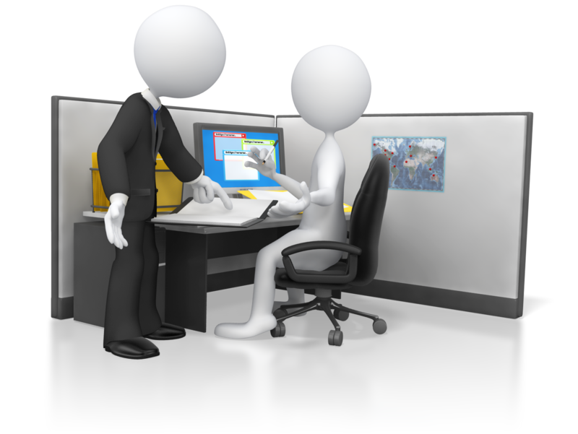
- Colleagues
- Committee
- External agencies
- Line management
- Statutory bodies
- Supervisor.

Activity 2C

2.4 – Identify difficulties organising and accessing information and solve collaboratively with individuals and team members

Potential difficulties
If your company uses a particular system for collecting and maintaining information, then these systems will need to be maintained which can be time consuming
Some information management systems can fail because they are too complex and it can be too difficult to get results and converting the data can be difficult. The ideal situation is to be able to interpret data with ease and efficiency
When a large businesses processes lots of information, any additional tasks can overload the system
Where data is shared across organisations, security measures can restrict access to data. In addition to this, computer systems may be incompatible across locations therefore restricting the sharing of information
You may encounter difficulties when organising information. If you are not competent using applications, it is best to ask a supervisor or someone with the skills and knowledge to help.

Solving collaboratively
Collaboration is a form of integration that can improve business protocol.
CADRE outlines steps for effective collaboration:
- Share perspectives
  - This involves discussing opinions and perspectives on the task or situation and will require interpersonal skills
- Define the issues
  - Clarify the main area for discussion
- Identify the interests
  - Share the different perspectives in order to reach a conclusion, whilst aiming to reach a mutual understanding
- Generate options
  - Come up with multiple methods for solution
- Develop a fair standard or objective criteria for deciding
  - Decide the criteria for solution and narrow the options for problem solving
- Evaluate options and reach agreement.
These steps are identified on the CADRE website: http://www.directionservice.org/cadre/section5.cfm#STEPSINTHECOLLABORATIVEPROCESSS

As previously outlined, designated persons may include all members of staff across the hierarchical levels. Being part of a business or organisation, you should be confident in working with others to handle problems with information and work collaboratively.

Activity 2D

2.5 – Update and store information in accordance with organisational requirements and systems
Each organisation will implement systems in order to keep information accessible and up to date. This could be electronically, manually or both.
A centralised filing system is one that stores all records in the same place. A non-centralised system is where each department within an organisation have the responsibility to update and store their own records.

Most companies will train employees to use their information management system so that all staff are consistent with organisational requirements.
Information can come from:
- Websites
- Magazines
- Presentations
- Emails
- Colleagues
- Blogs
- Databases and spreadsheets.
The variables that may alter the way organisations store information could depend on:
- The size of the company
- The level of technological sophistication. For example, an IT company will use specific applications and software to complete tasks and manage information. A company that is less up-to-date with such software will operate much differently, therefore the system will be different
- The nature of the information will affect storage procedures. If a company deals with personal details or sensitive information, then high security measures will be put in place to maintain limited access to information
- The frequency of access to information will affect the systems in place. If an organisation functions through accessing information rather than producing, for example, then an electronic system may be in place so that employees can access information at any point.

Examples of manual information storage may include:
- Folders (ring binders, lever arch files)
- Shelving
- Filing cabinets
- Full length secure storage units.
Examples of electronic storage may include:
- Databases
- Emails
- Computer files
- Cloud storage systems.



Activity 2E

3. Review information needs
3.1 Actively seek feedback on clarity, accuracy and sufficiency of information to ensure relevance of information and system
3.2 Review the contribution of information to decision making and implement appropriate modifications to collection processes
3.3 Identify future information needs and incorporate modifications to collection processes
3.4 Document future information needs and incorporate in modifications to reporting processes

3.1 – Actively seek feedback on clarity, accuracy and sufficiency of information to ensure relevance of information and system

3.2 – Review the contribution of information to decision making and implement appropriate modifications to collection processes
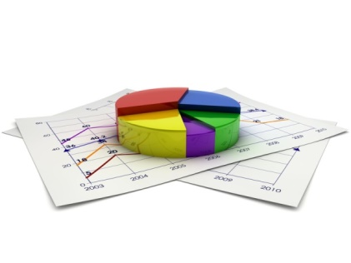
To maintain effective organisation of workplace information, it is helpful to gain feedback on the information collected and organised. Not only will it benefit your role, but it will aid in your organisations’ improvement of the management of information. There are a variety of ways in which you can gain this feedback.

Feedback
Audit documentation and reports
Australian auditing standards outline the requirements for keeping records for the planning and performance of work.
Comments from clients and colleagues
Although this method does require effort from colleagues (as effective feedback must be specific) it has the potential to give accurate insights into business performance. If you want to seek feedback from clients and colleagues, make sure that your questions are also specific as this will lead to more valuable responses. This is a good way to test the clarity of information, as you can gauge other people’s responses to see whether or not they are like-minded.
Customer satisfaction questionnaires
Gaining an insight into the views of your customers is a great way to gauge the success of your business. It allows you to understand the perspective of those outside the ‘bubble’ and can often be more accurate than asking colleagues. The responses may highlight issues you may not have picked up on, so that you can respond and ultimately gain more business from improving customer experiences.
Quality assurance data
Quality assurance is a conducted review of business procedures. This is often a non-biased way to assess the standards of the business and improvements needed.
Returned goods
This is an easy way of determining whether products (this may not apply to all businesses) are of the highest quality. By monitoring the amount of returned goods, you will be able to gauge whether there has been a decline in customer satisfaction. From there, you will need to troubleshoot the issue in order to improve the product, service etc. and ultimately make the experience better for the client or customer. If it is not within your realm of responsibility, seek the help of a more experienced individual to deal with these situations.
The aforementioned sources of feedback may directly or indirectly provide the opportunity for your business or organisation to make improvements. It is important to value feedback as it offers multiple perspectives of business performance. Some forms of feedback may not apply to your business or organisation so ensure that you are assessing the relevance of any feedback given and whether or not it could bring clarity to areas of improvement.

Clarity, accuracy and sufficiency of information
How is the information presented? You may wish to discuss the documents containing your information and assess whether or not they are clear and precise. Do they achieve what they set out to achieve?
Accuracy ensures that minor errors don’t cause major effects. For example, if a document contains spelling mistakes and grammatical errors, or the structure of the document is hard to follow, information may not have the desired impact. Your information should be as simple as possible to ensure that others can follow it.
Sufficiency refers to the measure of quantity. If you have not provided enough information, you could mislead another person or provide material that isn’t appropriate to the purpose.

Evaluating the contribution of information to decision making
Question whether the quality and appropriateness of information was relevant to your organisation. Just because information is credible, doesn’t mean it has value in your context

Assess whether the decision making was impacted directly by the information. If so, how can this inform future decisions in business, as you could seek helpful information in the next instance?
The impact of this information on decision making will vary depending on who is assessing the information. For example, a manager of a business has the authority to implement change as a result of these evaluations. Leaders of a business may get together to discuss the possibilities of change as a result of the information presented. It is the responsibility of those who know the finer details such as time, money, feasibility and other aspects to weigh up whether further action is required.
In most workplace tasks, information is collected, organised and assessed. Dealing with clients and colleagues as well as emailing, researching and organising information is an opportunity to manage information.
These processes will help you in your ability to deal with information and make decisions based on what you are presented with.

Decision making
Decision making involves identifying alternative decisions and selecting the best option. When handling information you will need to take actions such as deciding to store information, to use/manipulate/transfer information, to process and pass it on or perhaps you will just discard it. Either way, you will need to consider what is best for the task you are setting out to achieve.

Activity 3A

3.3 – Identify future information needs and incorporate modifications to collection processes

3.4 – Document future information needs and incorporate in modifications to reporting processes
Once an assessment of the contribution of information to decision making has been conducted, potential modifications to the collection processes can be discussed. Future information needs will be based on different factors, depending on your organisation, the tasks and people involved and whether improvements need to be made.

Information resources that can aid in performance management

Businesses rely on information in order to identify the standard of current performance as well as planning for future progress.
Types of information resources may include:
- Internal information that contributes data such as sales reports and customer feedback. This information often comes from reputable sources and can provide a reliable insight into the areas that will improve customer satisfaction.
- Networking information from other organisations can help build relationships between companies in the same industry. This can help staff to become aware of who else is providing the same product, service (whatever it may be) and combine data to identify patterns and tips for building the business.
- Internet information can also provide an insight into what other businesses are doing, giving them ideas for improvement. This could identify future information needs and get companies involved in social media, for example, that would be an effective way of promoting business or even provide another collection method.
- Legislation is an important factor that needs to be considered when identifying information needs. When a business is aware of what they need to adhere to, they can operate effectively and will maintain credibility with the government. This in turn builds the reputation in the eyes of clients and customers. As legislation changes, companies also need to be aware that this could change business protocol.

Factors to consider when collecting or modifying further information
The user

The person responsible for managing information and documenting information needs will need to know about the business and of the procedures used to analyse information. You could also consider whether the user will change, as others may need access to documentation and security measures may restrict this.
Information management
The systems in place will affect how information is modified. If necessary, ask your supervisor about knowledge systems and how they work.
Environment
The size of the institution and the ways that information is managed will vary. For example, a high-tech organisation may have complex information management systems and clear locations for storage.
IT system needs
More technology in a workplace can make things easier, faster and can reduce the stress of tasks but they also increase standardisation and repetition of procedures. Digital continuity addresses the requirements and how they may change over time. The retention period for information may alter so it’s good to be aware of this – you can redefine requirements and change accordingly.
Management system
The supervisor may decide on the uses of information and how it can be used to solve a problem, therefore governing your actions. Ensure that you are aware of the responsibilities you and other members of staff have so that you abide by organisational requirements.
Information needs can range vastly because of minor factors i.e. the industry, the economic system of the organisation, the background and the analysis resources available. Just as the requirements for information may change, the way you need to work with the information may also alter. In this way, documenting information on an electronic system will enable the information to be editable and accessible to others if necessary.

Information needs analysis
To make decisions about future needs, you will need to consider information from previous experience and information you are presently dealing with. Conducting an information needs analysis aims to identify information to act on. This standard process assists in looking at future developments and can occur within common situations such as meetings with departments in your organisation. Your company may choose particular ways to conduct an analysis but methods such as brainstorms or group questioning can be effective ways of gathering a range of information.
Changes to information may include:
- The information itself
- Information management system
- Technological systems in place
- Business requirements.


Activity 3B

Skills and Knowledge Activity

Nearly there...

Major Activity – An opportunity to revise the unit

At the end of your Learner Workbook, you will find an activity titled ‘Major Activity’. This is an opportunity to revise the entire unit and allows your trainer to check your knowledge and understanding of what you have covered. It should take between and 1-2 hours to complete and your trainer will let you know whether they wish for you to complete it in your own time or during the sessions. Once this is completed, you will have finished this unit and be ready to move onto the next, well done!

Congratulations!
You have now finished the unit 'Organise workplace information'.


References

These suggested references are for further reading and do not necessarily represent the contents of this Learner Guide.

IFAD: www.ifad.org
Australian Government Business website: www.business.gov.au
Office of the Australian Information Commissioner: www.oaic.gov.au
NSW HSC: http://www.hsc.csu.edu.au/business_services/services_120/maintain/4194/maintain.htm
Chron: http://smallbusiness.chron.com/types-information-resources-business-usually-need-4753.html

All references accessed on and correct as of 23/09/2015, unless other otherwise stated

