BSBITU301
Create and use databases
Learner Guide



BSBITU301
Create and use databases

Table of Contents

Table of Contents 3
Unit of Competency 6
Performance Criteria 7
Foundation Skills 8
Assessment Requirements 9
Housekeeping Items 10
Objectives 10
1. Create a simple database 11
1.1 – Design a simple database, with at least two tables, using a database application, basic design principles, software functions and simple formulae 12
Databases 12
Design principles 12
Formulas 15
Relational databases 16
Activity 1A 19
1.2 – Develop a table with fields and attributes according to database usage, as well as data considerations and user requirements 20
Database fields 20
Attribute 22
Activity 1B 23
1.3 – Create a primary key for each table 24
Primary key 24
AutoNumber 25
1.4 – Modify table layout and field attributes as required 26
Table layout 26
1.5 – Create a relationship between the two tables 27
Relationship between tables 27
Types of relationships 28
Activity 1C 30
1.6 – Check and amend data entered, in accordance with organisational and task requirements 31
Check and amend data 31
Activity 1D 32
2. Create reports and queries 33
2.1 – Determine information output, database tables to be used and report layout to meet task requirements 34
2.2 – Determine data groupings, search and sort criteria to meet task requirements 34
Reports 34
Data groups 35
2.3 – Run reports and queries to check results and formulae provide the required data 36
2.4 – Modify reports to include or exclude additional requirements 36
Running a query 36
Running a report 36
Modifying the layout 36
Activity 2A 38
3. Use database 39
3.1 – Ensure data input meets designated timelines and organisational requirements for speed and accuracy 40
Deadlines 40
Reviewing the data 41
Organisational requirements 41
Activity 3A 42
3.2 – Use manuals, user documentation and online help to overcome problems with database design and production 43
Overcoming problems 43
Activity 3B 46
3.3 – Preview, adjust and print database reports or forms in accordance with organisational and task requirements 47
Database reports 47
Activity 3C 49
3.4 – Name and store databases, in accordance with organisational requirements, and exit application without data loss or damage 50
Naming databases 50
Storing databases 52
Activity 3D 54
3.5 – Prepare and distribute reports to appropriate person in a suitable format 55
Distributing reports 55
Activity 3E 57
Skills and Knowledge Activity 58
Major Activity – An opportunity to revise the unit 59
References 61

Unit of Competency

Application

This unit describes the skills and knowledge required to create simple two-table relational databases with reports and queries, for storage and retrieval of information.

It applies to individuals that may provide administrative support within an enterprise, or may be independently responsible for storage and retrieval of data relating to their own work roles.

No licensing, legislative or certification requirements apply to this unit at the time of publication.

Unit Sector

Information and communications Technology – IT use

Performance Criteria
Element  Elements describe the essential outcomes. | Performance Criteria  Performance criteria describe the performance needed to demonstrate achievement of the element.
- Create a simple database | - Design a simple database, with at least two tables, using a database application, basic design principles, software functions and simple formulae  - Develop a table with fields and attributes according to database usage, as well as data considerations and user requirements  - Create a primary key for each table  - Modify table layout and field attributes as required  - Create a relationship between the two tables  - Check and amend data entered, in accordance with organisational and task requirements
- Create reports and queries | - Determine information output, database tables to be used and report layout to meet task requirements  - Determine data groupings, search and sort criteria to meet task requirements  - Run reports and queries to check results and formulae provide the required data  - Modify reports to include or exclude additional requirements
- Use database | - Ensure data input meets designated timelines and organisational requirements for speed and accuracy  - Use manuals, user documentation and online help to overcome problems with database design and production  - Preview, adjust and print database reports or forms in accordance with organisational and task requirements  - Name and store databases, in accordance with organisational requirements, and exit application without data loss or damage  - Prepare and distribute reports to appropriate person in a suitable format

Foundation Skills
This section describes language, literacy, numeracy and employment skills incorporated in the performance criteria that are required for competent performance.

Skill | Performance  Criteria | Description
Reading | 1.1-1.6, 2.1-2.4, 3.1-3.5 | - Recognises and interprets textual and numerical information to determine and confirm tasks are completed as per requirements
Writing | 1.1-1.6, 2.1-2.4, 3.1-3.4 | - Inputs numerical and key reporting information when creating and querying databases, and uses standard naming conventions and format to organise data
Numeracy | 1.1, 1.2, 1.6, 2.1-2.4 | - Uses mathematical equations to create simple database queries and formulae
Navigate the world of work | 1.2, 1.4, 1.6, 2.1-2.3, 3.1, 3.3, 3.4 | - Recognises and follows explicit and implicit protocols and meets expectations associated with own role
Get the work done | 1.1-1.6, 2.1-2.4, 3.1-3.5 | - Plans, organises and competes tasks to meet organisational requirements  - Utilises a broad range of features within applications in performing routine and complex tasks

Assessment Requirements
Performance Evidence

Evidence of the ability to:

- Adhere to organisational requirements when inputting, amending and storing data including:
  - correct naming conventions
- Adhere closely to task requirements including:
  - following designated timelines
  - achieving speed and accuracy
- Create simple databases including:
  - reports and queries
- Follow designated timelines
- Correctly name and store data
- Distribute reports to appropriate personnel

Note: If a specific volume or frequency is not stated, then evidence must be provided at least once.

Knowledge Evidence

To complete the unit requirements safely and effectively, the individual must:

- Outline key provisions of relevant legislation, standards and codes that may affect aspects of business operations
- Describe organisational requirements relating to data entry, storage and presentation

Assessment Conditions

Assessment must be conducted in a safe environment where evidence gathered demonstrates consistent performance of typical activities experienced in the information and communications technology – IT use field of work and include access to:

- Business technology
- Workplace documentation and resources
- Industry database software applications

Assessors must satisfy NVR/AQTF assessor requirements.

Links

Companion volumes available from the IBSA website: http://www.ibsa.org.au/companion_volumes

Housekeeping Items
Your trainer will inform you of the following:
- Where the toilets and fire exits are located, what the emergency procedures are and where the breakout and refreshment areas are?
- Any rules, for example asking that all mobile phones are set to silent and of any security issues they need to be aware of.
- What times the breaks will be held and what the smoking policy is.
- That this is an interactive course and you should ask questions.
- That to get the most out of this workshop, we must all work together, listen to each other, explore new ideas, and make mistakes. After all, that’s how we learn.
- Ground rules for participation:
  - Smile
  - Support and encourage other participants
  - When someone is contributing everyone else is quiet
  - Be patient with others who may not be grasping the ideas
  - Be on time
  - Focus discussion on the topic
  - Speak to the trainer if you have any concerns

Objectives
- Discover how to create a simple database
- Learn how to create reports and queries
- Know how to use a database
- Gain skills and knowledge required for this unit

1. Create a simple database

1.1. Design a simple database, with at least two tables, using a database application, basic design principles, software functions and simple formulae
1.2. Develop a table with fields and attributes according to database usage, as well as data considerations and user requirements
1.3. Create a primary key for each table
1.4. Modify table layout and field attributes as required
1.5. Create a relationship between the two tables
1.6. Check and amend data entered, in accordance with organisational and task requirements


1.1 – Design a simple database, with at least two tables, using a database application, basic design principles, software functions and simple formulae

Databases
A database is a collection of data that can be viewed, changed and updated. Databases can be used to record and track a wide variety of information such as sales, customers, products and finances. However, the purpose will vary depending on the organisation using it.
Databases are used in most organisations to track the company’s resources and business activities, and ensure they are effective. Reports may be created from the information held in the database in order to judge whether this has happened or not.
Microsoft Access is a software programme that is purpose-built to create databases, and all the examples in this unit will be assuming you are using it. However, other databases will have similar principles. Microsoft Excel is also a popular software choice as it requires fewer skills to use.
Databases may be used to:
- Record customer information
- Track orders and purchases
- Manage relationships with customers
- Analyse past and future trends
- Record personnel information.

Design principles
Formatting the database may require design changes such as naming, data layout and formatting. Cell sizes can be changed by moving the mouse to the top or side of the page where columns start, known as field names, and clicking and dragging.
Microsoft Access can be used in a range of views:

- Datasheet view
- Design view
- Layout view
- PivotChart view
- PivotTable view.
The different purposes of these will be explained throughout the unit. To switch between them, choose from the icons in the bottom-right hand corner of the screen when a table is open. Hovering over them will show which icon is which.
Objects can be added to a database to record or analyse data. These include tables, forms and reports.
Tables
Large amounts of information quickly get confusing, so they are arranged in tables to make them easier to understand. Before you start building a database, you should plan which tables will be contained within it, and whether they will need to relate to each other. This will prevent you from deleting redundant tables or creating additional ones later. In a Microsoft Access table, columns are known as fields (or sometimes attributes) and rows are records.
To create a table, open a blank database, choose a file name for it and click Create. You also import external data to create a table by selecting the Import and Link button under the External Data tab. This will allow you import data from an Excel spreadsheet, another database or an XML file.
Each table has properties which can be edited to change how the data is stored within it. The properties can be accessed by opening the Design View, clicking Show in the Design tab, and selecting General. A box will appear with options relating to the display, behaviour and appearance of the database.
Forms
Also known as ‘data entry screens’, forms are used to view, enter and edit data in the table. It is possible to work without them by editing data directly on the table datasheets, but most people find a former easier and less confusing to use. It is likely to be one of your tasks to enter data into forms before producing a report with it.
Each table will probably have a different form with different data entry requirements. For example, an ‘Order Form’ would allow you to record information about a particular purchase a customer has made, which would then enter into the system. To ensure that data is entered correctly, you can format the form so that only certain boxes can be written in, or that certain requirements must be fulfilled before it is completed.
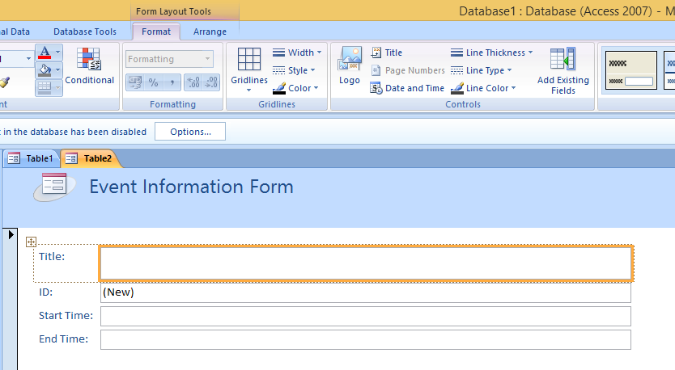
Creating a form can be done in several ways. The simplest way is to select the table you want to enter data into, choose the Create tab and click Form.
To create a blank form not belonging to any table, click Blank Form instead. You can then select fields as data entry points by double-clicking or dragging them.
Queries
Queries are essentially requests for information from the database, which allow you to perform many functions such as adding, changing, reviewing or deleting data. They can also filter or summarise it. They are useful in that they can pull together information from multiple tables. You will be required to have a strong grasp of queries when working with databases.
There are several main types of queries:
Query name | Function
Action queries | Add, change or delete data
Select queries | Retrieve data or make calculations
Append queries | Adds new records
Delete queries | Delete whole records from database

One of the most common uses of queries is to review subsets of data within a table. To do this, select the Create tab and click Query Design. On the Tables tab, select the table that the data you want is contained within. Then double click the fields you want to analyse. To run the result, open the Design tab and click Run. This will return your information which you can analyse.
To review data from multiple tables, start the Query design as normal. Once you have selected one field, select the other table and add the field from that. Repeat this process as many times as necessary. You can also set criteria (for example, in product type you may only want it to return ‘electronics’.) To do this, click on the appropriate column and type your specification in the Criteria row. This will allow you to produce more complex queries.
Some queries are ‘updatable’ meaning editing the data in the query sheet will update the original data. Be aware of this when assembling the report.
Reports
Reports are a way to summarise information in databases that you may have obtained either from tables or queries. These can provide broad summaries of multiple tables or detailed breakdowns of individual records. The purpose of a report is usually to present data in a clearer way which may. Creating reports will be explained in more detail later in the unit.

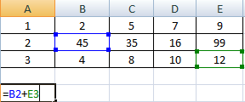
Formulas
Formulas are used to perform calculations automatically. They are known as expressions in Access. They are particularly useful when information may change as they will be continuously calculated; when the original information changes, so will the answer.
Excel formulas
Formulas in excel are written directly into the cells. Every formula starts with an = signs. You can perform calculations such as averaging, addition, multiplication and counting. For example, if you wanted the cell to have the total of cell B2 and E3 added together, it would be written: =B2+E3.
Function | Formula
Multiplication | = A1*A2.  Several cells can be multiplied together, such as: =A1*A2*A3. If there are a lot of numbers in the range, it may be quicker to write it as =PRODUCT(A1:A3).  To multiply the answer by other numbers, you can also write =PRODUCT(A1:A3,2).
Average | The mean average is calculated by adding the numbers together and dividing by the number of pieces of information.  =AVERAGE(A1:A3)
Division | =A1/A2
Maximum and minimum | These return the largest or smallest pieces of data from the selected range.  =MAX(A1:15) or =MIN(A1:A5)
Count | To workout the number of cells that contain numbers within a given range, use =COUNT(A1:A5)
Sum | To add together numbers, such as whole columns or rows, use =SUM(A1:A4).
Subtraction | =A3-A2

Access expressions
In Microsoft Access, expressions are used to produce a logical or mathematical outcome in forms and reports. They can calculate values or check data for values. Like Excel, each expression starts with an = sign.
To enter them, have the report or form open in Design view and right click the text box where the expression will be, then click Properties. In the pop-up box, type the expression you want in the Control Source box.
Expression | Result
=Avg([Order]) | This expression will find the average value in the order field.
=Count([Order]) | This expression counts the number of pieces of data in a particular field and displays it as a number.
=Sum([ShippingCost]) | The sum function adds the pieces of data together. This would produce the total of all shipping costs.
=[FirstName] & “ “ & [LastName] | This expression will display the results for the two fields in square brackets, in this case someone’s first and last name. The space in quotation marks ensures there is a space between the fields.
=[Page] | Used in headers and footers to automatically display the page number.
=[ProductTotal] + [ShippingTotal] | This performs a mathematical equation by adding together the two values, assuming they are correctly formatted. It should display the result as currency.
=[ProductPrice]*[Quantity] | This expression multiplies one field by the other, in this case to produce an overall price. Fields can also be multiplied by numbers.
=[TotalPrice]/[Quantity] | The / symbol acts as a division symbol, which would produce the average price per product in this case.

Expressions can also refer to fields in other forms or reports by writing it as: =Forms![Personnel]![Personnel]. This will return the value for that field.

Relational databases
Relational databases are ones that are connected through a relationship between pieces of data.
Often in tables, there will be excess information that is redundant for the purpose. Relational tables divide these into smaller, connected tables that only contain the relevant information. This is referred to as normalisation.
Databases with all the information recorded in just one table are flat file databases. They cause problems when trying to edit or delete information. For example, this database records employees who work at a company, along with their employee number and department.
Employee no. | Name | Department
101 | Ben | Marketing
102 | Mark | Sales
103 | Allison | IT
104 | Aaron | Sales
105 | Ken | IT
106 | Beth | Sales
107 | Helen | Marketing

Imagine the Sales department changes its name to Commercial. To change this in the database, each individual cell with that word would have to be changed. This could be made more efficient if the table was relational with another one.
Employee no. | Name | Department code
101 | Ben | 10
102 | Mark | 20
103 | Allison | 30
104 | Aaron | 20
105 | Ken | 30
106 | Beth | 20
107 | Helen | 10

Department code | Department
10 | Marketing
20 | Sales
30 | IT

Now the department name could be changed simply by adjusting the name in the Department Code table. For example, you can now see Allison works in department 30. Cross-referencing this reveals that department 30 is IT. The data is now structured more efficiently and is easier to edit. The method of creating relationships will vary depend on the programme the database is stored in.


Activity 1A


1.2 – Develop a table with fields and attributes according to database usage, as well as data considerations and user requirements

Database fields
A database field is the name for a column. The data could be a name, date or a monetary value. Each of those is a different type of data.
Columns in an Excel database are also known as fields. Headings (called field names) are used to identify the data contained below. For example, the field names from the table in Chapter 1.1 were:
Employee number | Name | Department

Using these ensures the correct data is always recorded in the same column.
Data fields can be formatted to hold different pieces of data, which affects the overall size of the database. To change the data type, open the Datasheet view, click on the column and then use the drop down menu to select the correct type. Often Access will correctly determine the type of data, but may get confused between time and currency, for example.
Different types of field include:

- Text fields
They can hold any type of characters and up to 255 characters of text. To improve the database’s speed, limit this to a reasonable amount. For example, surnames are very unlikely to exceed 20 characters.
- Numeric fields
They can only hold numbers which aren’t monetary, which may be either positive or negative. Whenever you will use the data to perform a calculation, record it as a number field. If the numbers will always be whole integers, format the field to remove ‘floating’ decimal points at the end.
- Date and time fields
These are used to store dates and times, although the exact format can vary, e.g. 1st January 2015 and 1/1/2015. It is important to be consistent to ensure no errors are made. A range of predefined formats are available to record long, medium or short versions of both dates and times.
- Currency fields
This is used for calculations relating to money, and allow up to four decimal places to the right to ensure it is accurately recorded.
- Hyperlink fields
Hyperlink fields are used to store email addresses or Internet URLS.
- OLE fields
These fields attach OLE (object linking and embedding) objects such as Excel spreadsheets. However, only one object may be attached to each record.
- Yes/No fields
They fields require an answer that must be either yes/no, on/off or true/false. These answers are known as Boolean data.
It is also important to be consistent when entering data. For example, entering numbers as both letters and numbers (ten and 10) will produce incorrect results. Choose beforehand which you will use.
If you are unsure which field is appropriate, use the smallest and simplest field which will hold the data. For example, dates can be held by the data fields so there is no need to use a numeric field, which will take up more space. Similarly, use a numeric field for numbers rather than a text field. This will save space in the database, which may be important if it becomes quite large.
Other ways to improve database performance are:
- Normalising the database wherever possible to only record data one
- Limit primary keys to one field
- Delete subdatasheets that are created between related tables
- Don’t add unnecessary indexes, just enough to create primary keys.
As you use more functions of a database, other ways to improve database performance may also become relevant: https://msdn.microsoft.com/en-us/library/dd942824(v=office.12).aspx


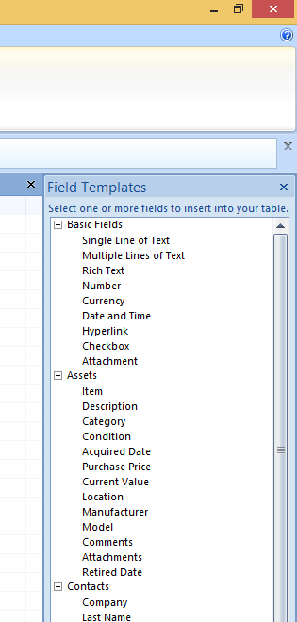
Attribute
An attribute can refer to two things:
- A single component such as a table or database field
- A characteristic of table that affects its behaviour.
You can add more database fields to an existing table. If you want to enter the data by hand, click on the Add New Field button to the right of the table and begin entering information. You can edit the field’s name to reflect the information.
You may also choose to choose from a pre-defined list of fields beforehand, as many databases share similarities. Choose the one that fits your needs most closely. To choose from the list, have the table open in Datasheet View open and press New Field in the Fields & Columns group. Select the fields that you want and drag them onto the table.
For example, under the Events tab are field names such as:
- Title
- Start time
- End time
- Location
- Description.
If you have never created a database before, these will give you an idea of the information you will need to record. You can remove or add fields to customise it, or rename columns by right clicking on the heading.
You can also add fields from other tables. Open the table you are working with in Datasheet view. In the Datasheet tab, click Add Existing Fields. This will display the possible fields, which you can drag onto the table like in the previous example. Note that this may create new relationships between tables. Be cautious of this if the two tables are unconnected.

Activity 1B

1.3 – Create a primary key for each table

Primary key
A primary key is a unique piece of information for a record. It acts as an index, giving each record a unique number. For example, there may be several John Smiths in an organisation, but if they were each given a unique Employee number, they would be easily recognised in a database.
It is important to remember that there can only be one primary key in a table. It may be generated specifically to identify records, or it may be a normal attribute that is always unique for administration purposes.
A primary key in one table can be used to create a relationship with another table, where it is called a foreign key. This connects the tables together to share data. A table can have any number of foreign keys.
A common example in business is customer databases. There is usually a database of customers, each with their own unique ID number, which is the primary key. This ID number is then used to create a relationship with the Orders table, where it is considered a foreign key. If orders were recorded by the customer name, items risk being delivered to the wrong customer with a different name. When using unique primary keys, there is never any doubt.
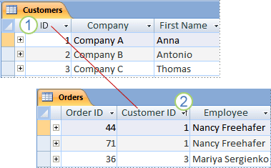
Foreign keys are different from primary keys in that a table can contain more than one and they are not necessarily unique. They cannot always identify a record either; for example, you wouldn’t be able to tell which record is which by looking at the customer ID number in the Orders table. This would require you to cross reference it with the previous table.
To create a primary key in Access 2010:
- Select the database that needs a primary key
- Find the Navigation Panel. (If you can’t see it, press F11)
- Right click the relevant table and click Design View
- Choose the field that will be the primary key. (To choose more than one, hold CTRL and click the appropriate fields)
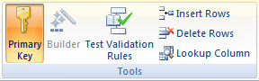

AutoNumber
AutoNumber can be used as a type of primary key in Access 2010 and other programmes. For example, the employee numbers in Chapter 1.1 may have been generated by using the AutoNumber feature.
Only one AutoNumber field is allowed per table. It is useful when generating large amounts of numbers instantly, for example, for every customer in the organisation database. This would be a laborious task by hand.
To create AutoNumber:
- Open the appropriate database
- Find the Navigation Panel. (If you can’t see it, press F11)
- Right click the relevant table and click Design View
- Click on the first empty row
- Type a name for the AutoNumber in the Field Name field, e.g. Customer ID, PIN, Order Number
- Click the arrow up the Data Type field and press AutoNumber
- Click New Values then Field Properties and click:
  - Increment to use incremental numbers (e.g. going up by one each time)
  - Random to use random numbers.
Your choice of incremental or random numbers will depend on the purpose of the database. For example, incremental numbers will help you to track back through it easier, although random numbers might be better for customer protection reasons.
A table will automatically be created with a primary key. However, you may change or remove it. To change it, select the fields in Design View, open the Design tab and click Primary Key.
To see the relationships within a table, click on the Database Tools tab, and then Relationships. This will display which tables are connected. You can delete them from here by clicking on a line between two tables and pressing Delete.

1.4 – Modify table layout and field attributes as required

Table layout
You may be required to edit the table layout in order to make information clearer or edit information. It affects not just the presentation of the table, making it more visually appealing, but the functions as well.
Modifying it may include:
- Setting gridlines on or off
- Adding columns or rows to table to add additional information
- Deleting columns or rows
- Aligning the content in a table (e.g. left, right, centre)
- Changing the spacing in a table
- Modifying the font or size used for text
- Changing the background colour.
The method of modifying tables will vary depending on the programme you are using.
In Microsoft Access, right clicking on a field name in Datasheet view will allow you to delete, rename, hide or inset the field. You can also change the width to ensure all information is visible through a pop-up box. The Font Pane, under the Home tab, will allow you to adjust the writing colour, size and font. The symbol beneath the font size menu will also allow you to set the gridlines on, off or any mixture of the two.

You may need to create columns and fields to contain details such as:
- Customer details (e.g. names and addresses)
- Financial information such as:
  - balances
  - card numbers
  - invoices
  - prices
  - dates
  - paid or unpaid information.
Modify the table to ensure you have the correct number of fields and records, and they can correctly display the information you are required to show.

1.5 – Create a relationship between the two tables

Relationship between tables
Database systems like Microsoft Access can easily establish relationships between tables.
To create relationship between tables:
- Click on the Database Tools tab and then Relationships
- The Show Table box will appear if you haven’t defined any relationships yet. You can filter it to view tables, queries or both. For this exercise, click Tables
- Select two or more tables, then click Close
- Select the field you want to become the primary key. Drag it to foreign field in the other table
- An Edit Relationships box will appear. Confirm that the field names are the ones that you want to create a relationship between (e.g. ID in the Customers table and Customer ID in the Orders table)
- Confirm that the field names are correct. If they aren’t, click on the field to edit it and chose the correct one
- If you want each value to transfer exactly over (as in this case), check the Enforce Referential Integrity box. Otherwise, leave it unchecked
- Click Create to establish the relationship.
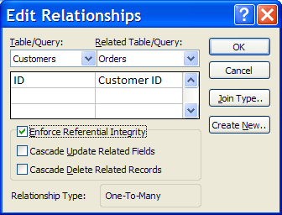
Referential integrity
Referential integrity ensures that related tables are consistent. It prevents to addition of a record in a table with foreign key that doesn’t appear in the table with the primary value. This is important so that Employee ID numbers or order numbers can’t be mistyped.
To maintain consistency, some referential integrity rules cause deleting a record in one table to delete it in the other. This is known as cascading delete. The same applies with cascading modification, where changing one record causes all linked records to be changed.
Table A  (Primary key) |  | Table B  (Foreign key)
1 |  | 1
2 |  | 2
3 |  | 5

For example, 1 and 2 are acceptable in Table B because they appear in Table A. However, 5 isn’t a valid because it doesn’t appear in the primary key.

Types of relationships
One-to-one
In the tables above, there was one primary key and one foreign key in the tables. This is known as one-to-one relationship. It occurs when there is exactly one matching record for each table.
This type of relationship isn’t commonly used as it can be combined into a single table unless it creates redundant information. However, it may be relevant when a table with many fields is divided for security reasons or ease of use.
One-to-many
In this case, one primary key relates to multiple foreign keys in the related tables. Therefore, changing information in the primary key will produce multiple changes. The field on the primary must be unique. When editing the Indexed property for this field, set it to ‘Yes (No duplicates)’. The field on the foreign key side should not have a unique index; the Indexed property should be set to ‘No’ or ‘Yes (Duplicates OK)’. This will allow Access to create a one-to-many relationship.
These may occur in customer order tables; the customer order number will be unique in one table, but they can place multiple orders that will make duplicates acceptable in the connected table.
Table A (Primary key) |  | Table B (Foreign key)
1 |  | 1
2 |  | 1
3 |  | 4

Many-to-many
Records in both tables relate to multiple records in the other table. Both sides must not have a unique index, which requires setting the Indexed Property to ‘No’ or ‘Yes (Duplicates OK)’.
These require an associate table (also known as a junction or a linking table) to allow them to function correctly. This will contain the primary key from each table to establish them, effectively making two one-to-many relationships.

A relationship like this may occur in a complex set of databases such as a Product and Order database. Each product may be contained within any number of orders, and each order may have any combination of products.

Activity 1C

1.6 – Check and amend data entered, in accordance with organisational and task requirements

Check and amend data
After data is entered into a database, you will need to check its accuracy and amend it where appropriate. Be aware of the aims of the task you are performing what correct data will look like.
Checking data involves:
- Checking the accuracy of data
It will be necessary to ensure the data you have entered reflects the information you were provided with. Confirm it against paper records or earlier databases. When data is entered manually, mistakes always occur, no matter how carefully it is done.
- Checking the formatting
Ensure that data is entered in the correct format. For example, numbers should always be written numerically, while there are several different ways of writing dates. Look at the Database Fields discussed in Chapter 1.2 to determine the correct one.
- Proofreading
Check text for spelling and grammatical errors. Spell-check functions can be useful, however make sure you read it to confirm.
- Checking the accuracy of formulas
You can’t always trust the accuracy of formulas. Confirm them with a calculator to make sure they are producing the desired answers; if not, check the data you have entered and mistakes in the writing of the formulas, such as the cell names.
Data produced by databases is always inaccurate if the data that is put in isn’t accurate; therefore it is important to be as careful as possible when inputting data. Follow any relevant organisational procedures to help improve your accuracy.

If you find inaccurate data, amend it and check similar pieces of data to ensure it wasn’t a recurring mistake.
When inputting data for long periods of time, ensure you are set up to work properly, such as sitting comfortably at your desk with no distractions. This will help you achieve the highest possible accuracy. Research whether there are any organisational requirements relating to this to achieve the company’s desired standards of accuracy.

Activity 1D

2. Create reports and queries

2.1. Determine information output, database tables to be used and report layout to meet task requirements
2.2. Determine data groupings, search and sort criteria to meet task requirements
2.3. Run reports and queries to check results and formulae provide the required data
2.4. Modify reports to include or exclude additional requirements

2.1 – Determine information output, database tables to be used and report layout to meet task requirements

2.2 – Determine data groupings, search and sort criteria to meet task requirements

Reports
Reports are a common way of producing information from a database query. They can present the results clearly, often with visual representations like graphs, and can be printed off, exported to another programme or used in presentations to educate the listeners. They are often used to inform decisions.
When you are preparing a report, it is important to determine what information is needed and which database you will need to access it, known as the source. Before running the query, you may need to change the layout or contents of database.
Queries may answer questions such as:
- How are sales performing this year?
- Where are our customers located?
- How has this product performed?
Determine exactly what question you need to ask and the information you will need to answer it. Whether it is straight forward, such as a list of customers, or complex, such as a detailed breakdown of sales, you must first locate the data.
Microsoft Access contains a feature called Report Wizard which can walk you through creating a report by asking questions to determine the result you want. You can select how the data will be organised and displayed.
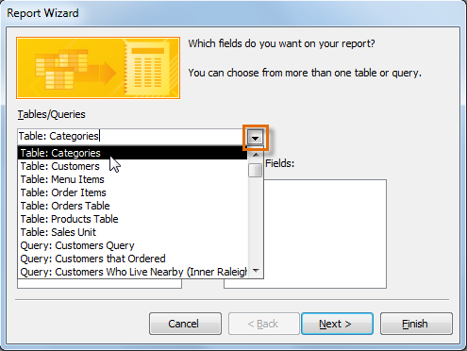
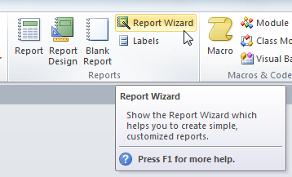

Data groups
Microsoft Access can perform reports to group data by values. The groups are editable, so if you choose to group customers by age, you would be able to select the groups you wanted (e.g. 16-25, 26-35, 36-50, 51 and over.) This allows you more flexibility in defining the groups.
It is important to select groups that will provide the data you need for the report. If the report is about sales in a certain city, make sure to exclude all data that doesn’t relate to that city.
To sort through the data, click ‘Add a sort.’ Select a field from the list, and the Layout view will allow you to review the changes. You can continue adding grouping levels and sorting requirements until you are happy with the appearance of the data. This often makes it simpler and easier to understand than in its raw form.
When adding multiple sorts, records are sorted from the outmost field (the one on the left) to the innermost field (the one of the right). You can adjust this order to choose which field should be given priority.

Tables, queries and forms can also be sorted. Right click on the innermost field and click on the relevant sorting, which will depend on the data type. For example, text could be sorted alphabetically, numbers could be sorted by size and dates could be sorted oldest to newest or vice versa. Repeat the steps moving up towards the outermost field.
Records can be sorted by:
- Customer’s name
- Product ordered
- Value of order
- Date of order placed
- Delivery destination
- Product category.
This allows you to thoroughly sort through the data before running a report or query. If you choose to remove a sort order, find the Sort & Filter group and click Clear All Sorts.

2.3 – Run reports and queries to check results and formulae provide the required data

2.4 – Modify reports to include or exclude additional requirements

Running a query
To run a query, click on the Create Tab and then Query Design. In the pop-up box, open the Tables tab and select the field you want to draw data from. Once you have closed the box, you can click on Field Names to add them to the query. When you are ready, click Run in the Design tab.
You can add parameters to narrow the data in existing queries by editing the criteria of them. This can be done by opening them in Design View and clicking Parameters in the Design Tab. Add a value for each parameter you want to match to. For example, if you are looking for employees with the last name Smith, you would type that in the LastName field.

Running a report
To create a report in Microsoft Access, you should:

- Choose a record source such as a table or a query
- Choose the tool to create it. You can choose from:
  - Report, which opens a simple report containing the fields
  - Report Design, which allows you to add extra fields and controls
  - Blank Report, which creates a blank report in layout view to allow further editing
  - Report Wizard, which walks you through to process of specifying fields and layout
- Click Create to produce the report. Navigate through the Wizard if you selected that and press Finish.

Modifying the layout
You can modify reports to change the presentation by:
- Adjusting the size of fields and labels
- Moving a field to a new location
- Spitting, merging or deleting fields.
You can modify reports through either Layout or Design view. Although both are usable, some tasks are easier in one than the other.
Layout view is useful for rearranging the fields, changing their sizes or any other task that requires an overall view of the report. It is also useful for applying custom styles. In Layout view, it is also possible to see the data while you make design changes. Also, only Layout view can be used to make changes to the table layout of web forms using HTML. In addition, the view allows you to split columns and cells like you would tables, which makes rearranging them easier.
Design view allows you to more easily format each area of the report, such as adding, positioning, formatting, and manipulating the fields. This includes adding text boxes of the date the report was run, which is useful when dealing with rapidly changing data.
It is important to be familiar with both layouts and change between them when necessary. You may receive a message when trying to perform certain functions telling you that you need to switch views.
You can switch between views by:
- Right-clicking on the report’s document tab and selecting the appropriate view from the menu
- Right-clicking on the report in the Navigation panel and selecting the view from the menu
- Clicking on the View button in the Home tab, and switching between available views. (Note: clicking the arrow under View will drop down a list of available views.)


Activity 2A

3. Use database

3.1. Ensure data input meets designated timelines and organisational requirements for speed and accuracy
3.2. Use manuals, user documentation and online help to overcome problems with database design and production
3.3. Preview, adjust and print database reports or forms in accordance with organisational and task requirements
3.4. Name and store databases, in accordance with organisational requirements, and exit application without data loss or damage
3.5. Prepare and distribute reports to appropriate person in a suitable format

3.1 – Ensure data input meets designated timelines and organisational requirements for speed and accuracy

Deadlines
It is likely that you will have to work towards a deadline when using databases and creating reports. It is important that you know when this deadline is and leave sufficient time to complete it even if the work takes longer than expected.
Deadlines may be:
- Organisational deadlines, such as a meeting
- Informal deadlines agreed with colleagues
- Formal deadlines required by customers or clients.
Check with a supervisor to see if your organisation has any relevant policies regarding deadlines.

Deadline policy example
Reports of marketing data must be created within five working days of the end of each month. This will provide staff with sufficient time to process the data accurately and produce a report up to the company standards. If for any reason the marketing data is late in being received, a reasonable extension can be agreed with the relevant staffs’ supervisor.

Be aware of relevant deadlines. If they will impact on others in the organisation, (for example, if you will be unable to work on a team project on a specific day), you should inform your colleagues beforehand.
Ensure that you understand what is required of you by the deadline. While most months this will be consistent, sometimes your workload may fluctuate due to seasonal variations, activities or events. Investigate this beforehand to ensure you leave enough time to finish before the deadline. If you are unsure how long an assignment will take, it is better to start it early.
Be aware how much time you can be delayed by before you will miss your deadline. If you don’t believe you will be able to meet a deadline for whatever reason, it is important to explain this to your supervisor as soon as possible. An alternative deadline may be arranged, or you may have to show what you have completed by that date. Informing others will allow people to work around you.
Raise issues speedily if you encounter technical problems. Developing your own skills will also enable you to tackle these problems yourself and increase your data inputting speed.

Reviewing the data
Once you have inputted the data, take time to review it to match sure it matches what you would expect. Consider whether there appears to be more or less than you thought there would be, whether any information is duplicated or if it is in the correct format.
If there are any problems, you should attempt to solve them now before you proceed further with the database. Double check the information you have inputted against the hard copy to look for mistakes.
If you find that you are constantly making large mistakes, consider whether your working practices are preventing you from achieving your potential.
You may have to look at:
- Your working environment
- Your concentration levels
- Any distractions such as people within your workplace.

Organisational requirements
Be aware that organisational requirements will vary from company to company. Try to take note of any company goals which may affect your deadlines. For example, if an important trading period is approaching, you may be required to meet deadlines sooner than usual.
Take into consideration the company’s level of technology. Newer software may increase your work speed, while older technology will reduce it. If you don’t believe you have the necessary technology, inform the company.



Activity 3A

3.2 – Use manuals, user documentation and online help to overcome problems with database design and production

Overcoming problems
From time to time, you may experience problems with databases, such as inadequate software, malfunctions or lack of knowledge, which will affect your ability to complete your work. You should try to use various methods to overcome them and meet your deadlines on time.
These methods may include:
- Manuals
- User documentation
- Online help
- Colleagues’ help.
Manuals
Most software and equipment will come with manuals, either in paper, digital or CD form. Whenever you receive one, you should read it even if you believe you are already familiar with the software or equipment.
Store this manual in a safe place once you are finished so you can consult it when problems arise. The manual may include a list of common problems and how to solve them, as well as an installation guide. Online manuals will also include more recent bugs and fixes, which you can find by visiting to the manufacturer’s website.
Manuals are a useful starting point when trying to solve a problem in database software. However, the effectiveness of a manual is usually directly related to the competency of the user, and may be out of date if it is on paper.

Third-party user manuals are also available for many pieces of software. These are tailored to both beginners and advanced level, so you can purchase one that is applicable to you. Also books serve different purposes, so don’t assume just one book on a programme will be sufficient. For example, to adequately solve problems, you need separate books on getting started, troubleshooting problems and understanding the software’s advanced features.

User documentation
User documentation describes what the product is capable of, such as its features and functions. It may also offer tutorials to educate the user on them. Once again, it will often arrive with a product or be available online later.
Consult it if you are unsure whether the software you are using will be suitable for your purpose, or if you wish to fully understand a new feature.
Effective user documentation should include:
- Current terminology
- A list of applicable error codes
- Descriptions of all toolbars, options and menus
- Images and diagrams, if necessary
- Lists of functions
- An explanation of acronyms or abbreviations.
The organisation may also provide user guides explaining the specific functions you will need to understand in order to perform the role correctly. These documents are important for on-the-job training. They will likely not go into depth about functions that aren’t relevant, so in the event of a problem, you may have to refer to another source of help.
Online help
Online help can be available in several forms, and is usually sorted by topic or problem.
Help may include:
- Manufacturer’s websites
- Software help functions

- Web chats
- Help forums.
These may be of varying reliability. For example, checking relevant information on the manufacturers’ website or chatting with an employee should provide you with accurate information; however, when using help forums, you are relying on the guidance of strangers. Treat advice with caution and do not follow it if you believe it may harm your computer or software.

However, you may also receive advice that would be unavailable from the manufacturer, and may get a quicker reply.

Software help functions may also have information on your problem. For example, Microsoft Access has a help function for common problems. To use it, press the question mark icon in the top-right corner of the screen or press F1 while the programme is open. This will open a window in which you can search keywords relating to your problem. It will then provide tutorials and links to helpful information.
Colleagues’ help
If you’re working with colleagues who perform similar roles, you may be able to ask their advice and use their expertise. Once again, the accuracy will vary depending on their level of experience and knowledge.
To ensure you can receive help whenever needed, try to reciprocate if they encounter a problem they can’t solve. This exchange of knowledge will make the workplace more efficient.
In addition, your company may have an in-house IT department that will offer help free of charge. If so, they will offer help as soon as possible, although they are not guaranteed to have expertise in the programme you are working with.
Outsourcing technical help
In extreme cases, you may consider outsourcing problems to an external IT company. These are only used as a last resort due to the high fees. You will have to pay for the time spent on your request which could be expensive if the problem turns out to be complex. However, in most cases they will provide quality service, saving the organisation time.

Activity 3B

3.3 – Preview, adjust and print database reports or forms in accordance with organisational and task requirements

Database reports
As mentioned in earlier chapters, you can use either the Layout or Design views to make changes to a report. Layout view is most effective when changing the visual presentation of the report, such as rearranging and adjusting the size of fields. You can also apply pre-made styles from this view.
Design view, by contact, offers more control over the functional aspects of the report, such as the structure. While you can’t see the data, you can see the header and footer sections. Editing text boxes, labels and images is easier in this view. You should change between the views whenever necessary to make full use of the functions of Microsoft Access.
There are a variety of ways to preview a report before printing in Microsoft Access:
- From any view, press the File button in the top left hand corner and select Print Preview
- Right click the document tab and select Print Preview
- If the report isn’t already open, scroll to the Navigation Panel, right click the document name and select Print Preview.
This will allow you to see how the report will look when printed as opposed to on the screen. It will help you to judge the overall look and feel, which may cause you to make changes. Consider whether the information is spaced appropriately, the correct font size is used and all of the information is visible. Always preview a report before printing it to verify the accuracy of the data and the report.
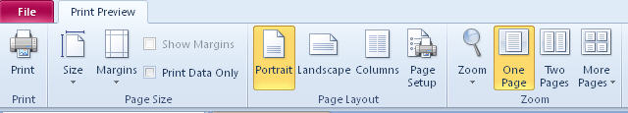
You can also use the Print Preview view to adjust the layout of the report, such as changing the size, margins and orientation of the page. You can adjust to settings to view more than one page at a time, which may be helpful if you are working with a report which goes over multiple pages. From this panel, you can also export the data into another report.
Some companies may suggest or require the company logo to be on all reports. To add this, open the report in Layout View and click Logo in the design tab. Use the pop-up box to find the saved image on your hard drive or serve and press Open. It will be added to the relevant pages of the report.
When you are happy to print the document:
- Click File at the top left of the screen
- From the drop down menu, select Print (or if you don’t want to change properties, click Quick Print)
- Ensure the correct printer is selected, along with the number of copies. (You may also have options about single or double sided sheets)
- Once you are satisfied with the options, press OK.
Your organisation may have relevant policies about printing reports, such as whether or not you should use colour and whether reports should be double sided in order to save paper. Also consider how many copies you will need; if you are presenting them in a meeting, you may need a copy for every person attending, or if that is impractical, enough so that all people can see at least one copy.
Themes
Themes provide formatting options for reports and forms to provide a consistent experience. This makes them more visually impressive when printed out. They are customisable and can be shared with others. This can allow a company to create a trademark theme, and since themes are available on all Microsoft Office products, they can be applied it to all documents it creates.
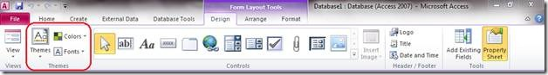
Normally, themes are applied across a document. To apply if to one object in it, right click the theme in the menu.
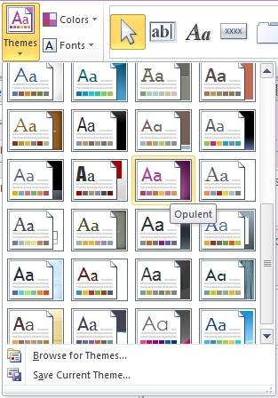
Themes are located in the Design View. On the Design tab, click Fonts, then Create New Theme Fonts to customise your own design. To save it for later, click Choose Themes and then Save Current Theme. It will be saved as .thmx file inside the Application Data folder.

Activity 3C

3.4 – Name and store databases, in accordance with organisational requirements, and exit application without data loss or damage

Naming databases
You should have named and saved your database while creating it in case of a sudden loss. Important documents may also warrant a backup that is updated regularly.
Your company may have requirements about naming documents, especially if they are to be shared with other staff or costumers.
You should try to:
- Be clear about the report’s role (e.g. End of Q1 Analysis)
- Differentiate it from similar reports, for example adding the date to it
- Use a version number when it is an updated copy of an older report
- Use a code it if you have been given one.
Correct naming procedures will allow you to find the report easily in the future. It will also inform other people what it is, which may prevent it getting accidently deleted. Simply calling it ‘Database 1’ sounds unimportant and doesn’t provide any information on it.
Some companies may follow established guidelines, such as the Leszynski/Reddick Guidelines for Access. This suggests that all databases should have a descriptive tag at the start.
For example:
- A form about imports becomes ‘frmImport’
- A report about customers becomes ‘rptCustomer’

- A table about sales becomes ‘tblSales’. This allows consistent naming. A full list of Leszynski/Reddick naming conventions is available here: http://access.mvps.org/access/general/gen0012.htm
However, even if your company don’t use an officially recognised naming convention, you should use a convention. Use one that makes sense and is effective within your organisation.

File extensions
When you create a file, it will automatically be given an extension. This will determine how the file is saved and which programmes it can be opened by.
For example, saving a file in Microsoft Access 2010 will give it an .accdb extension. This will prevent it from being read or opened by earlier versions of Microsoft Access. If you wish to use it with earlier versions of Access, you should save it with an older extension.
Earlier versions use a .mdb file extension. These can be opened in Microsoft Access 2010 but you cannot use new features that require .accdb extension.
File extension | Type of file
.accda | Microsoft Access 2007/2010 add-in file
.accdb | Microsoft Access 2007/2010 database file
.accdc | Microsoft Access 2007/2010 digitally signed database file
.accde | Microsoft Access 2007/2010 compiled execute-only file
.accdp | Microsoft Access 2007/2010 project file
.accdr | Microsoft Access 2007/2010 runtime mode database file
.accdt | Microsoft Access 2007/2010 database template file
.accdu | Microsoft Access 2007/2010 database wizard file

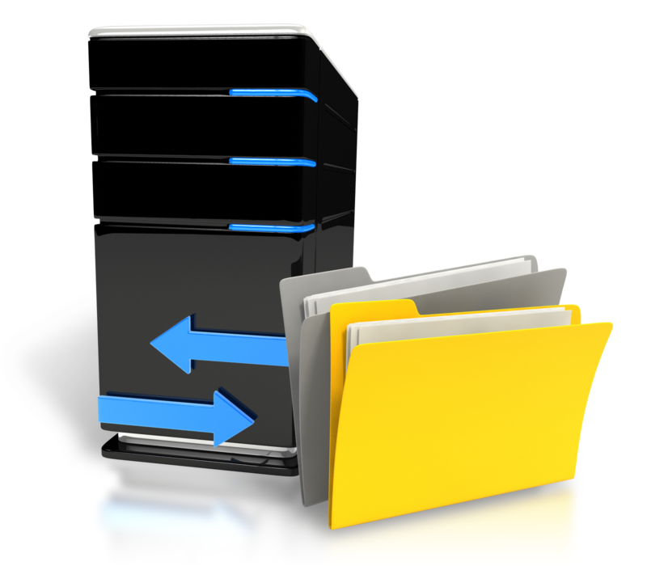

Storing databases
When preparing to store a database, consider:
- Any security precautions needed
- The organisation’s policy for creating backup files and hard copies
- Who is authorised to access it
- How sensitive the information contained is
- Whether physical copies should be made on CDs in case of computer problems
- Which specific folders it should be saved in

- How big the file is.
Choose a location that is appropriate for the level of security the database needs. For example, if it includes information that is freely accessible within the company and needs to be accessed by several people regularly, saving it to the organisation server may be appropriate. However, if it is a larger file or shouldn’t be freely accessed, organisational requirements by suggest saving it to a single computer, a memory stick or a CD.
Ensure there is always a backup somewhere so lost files can be recovered. Backups are also useful to restore a database to an earlier version. Remember to update backup files whenever you make changes. This will allow you to restore an entire database or selected objects. Some products may automatically create backups to improve efficiency.
Managing backups is important for the smooth running of a company. If the list of backups grows too much, consider archiving the older, less relevant ones to save space and make it easier for employees to find the one they are looking for.
To backup a database:
- Have the database open
- Click File or the Microsoft Office button in newer versions
- Click Manage, then Manage this Database, then Back Up Database
- Enter the name you wish to save it as. The default name will record the name of the original file and the date of the backup, which would be helpful to remember it
- Chose the location you want to save it to. This could be on your computer, a network, a memory stick or CD
- Click Save.
Physical storage
It is always advisable to store backups on the database in a physical location, such as a memory stick, thumb drive, CD-ROM or external hard drives. This way, if the organisation’s computer network experiences severe problems or the database is accidently deleted, the backup will be unaffected.
When planning this, consider talking to an IT expert who will be able to advise you the best way to do this for your organisation. For example, if you produce a large amount of data on a regular basis, investing in external hard drives may be more cost efficient than dozens of memory sticks. Ask for advice on compressing databases so they can be stored easily.

Also take into account where the physical backups are going to be kept. Memory sticks and thumb drives are small and easily lost or mixed up. If your organisation chooses to use them, a labelling and cataloguing system might be required to record where they are at all times. CDs are also easily scratched or broken unless they are stored correctly, and CD drives are seen as less essential in computers nowadays. Therefore, they may not be as future-proof as other methods.
Remember that backups are a method of last resort when the original is no longer accessible. If you create a backup, do not assume you can delete the original as you then have no insurance if the backup fails. Keep at least two copies safe at all times.
Splitting a database
If a database is shared over a network, splitting it can make it easier to maintain. It will prevent corruption or unwanted changes by other people working on it.
Splitting it will produce two files:
- The backend file that stores data in the tables
- The front end file that stores the reports and forms.
These can both be worked on separately. Splitting a database will enable you to store them in different locations or on different networks. It is still advisable to back both files up.
This method is useful when many people are working with the same data. By saving the backend to the company network and giving users access to the front end, many people can use the same data without fear of overwriting each other’s work. It also allows a new front end file to be created without modifying the entire database.

Activity 3D

3.5 – Prepare and distribute reports to appropriate person in a suitable format

Distributing reports
Once you have finished, saved and printed the report, consider how you will distribute it to the appropriate people. This will depend on the setting, the amount of people and the use for it afterwards.
For example, if the report will only be seen by your supervisor, consider which format will benefit him or her most. It may be that they would like a digital copy to be emailed to them. Alternatively, some people prefer paper copies to make notes on and annotate. Learn people’s preferences and ask what format they would like if you are not sure.
Formal presentations may require numerous copies of the report to distribute. Find out how many will be needed and prepare them beforehand. You may wish to email the databases to anybody who requests them after the meeting.
When printing reports out, take care that the finished product reflects the work that has gone into it. Hours of work and preparation may be undone if the paper copies look creased with the printing smudged or blurred. Presentation is important, so ensure it meets your organisation’s standards. This will be particularly important with members of management or external clients and customers. If the report goes over several pages, consider stapling them neatly together to keep them in order.
If you aren’t sure about the format for reports to be distributed in, check your organisational policies or consult your supervisor.
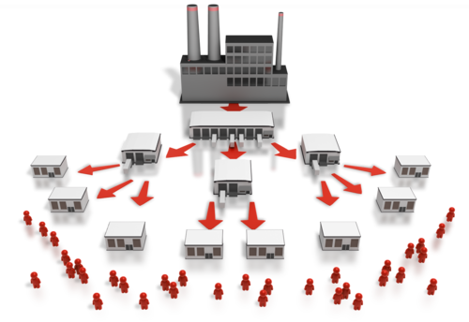
Highlighting points
Seeing the report on paper, you may decide to make changes to draw the audience’s attention to important points. Conditional formatting is a useful way of highlighting values based on certain conditions.
For example, you could condition data to become red when it goes below zero, or bold when it exceeds a certain amount. The specifics will depend on the requirements of the report and what you wish to highlight. These will only affect how data is displayed and not how it is stored.
To do this, click on the object you want to apply the formatting to, holding down the CTRL key if there are multiple objects. On the Format tab, click Conditional. This will open a pop-up box which will allow you to set the type of formatting you want and which conditions you require to meet it. You can add multiple conditions as long as they don’t conflict with one another.
You could also use data bars which show visual information at a glance. Length of bars will immediately show the values of the data which can help comprehension and identify trends that weren’t immediately obvious before.
If you decide to implement these changes, you will need to go back into the database and repeat the printing process.



Activity 3E

Skills and Knowledge Activity

Nearly there...

Major Activity – An opportunity to revise the unit
At the end of your Learner Workbook, you will find an activity titled ‘Major Activity’. This is an opportunity to revise the entire unit and allows your trainer to check your knowledge and understanding of what you have covered. It should take between 1-2 hours to complete and your trainer will let you know whether they wish for you to complete it in your own time or during session. Once this is completed, you will have finished this unit and be ready to move onto the next, well done!

Congratulations!
You have now finished the unit ‘Create and use databases’.


References

These suggested references are for further reading and do not necessarily represent the contents of this Learner Guide

- Access 2007: The Missing Manual [Paperback]
Matthew MacDonald (Author)

- Microsoft® Office Access(TM) 2007 Inside Out (Microsoft Office Access Inside Out) [Paperback]
John Viescas (Author), Jeff Conrad (Author)

- Microsoft Office Access 2007 Step by Step Book/CD Package (Step by Step (Microsoft)) [Paperback]
Joan Lambert (Author)

- Database Systems: The Complete Book (GOAL Series) [Hardcover]
Hector Garcia-Molina (Author), Jeffrey D. Ullman (Author), Jennifer D. Widom (Author)

- Fundamentals of Database Systems (5th Edition) [Hardcover]
Ramez Elmasri (Author), Shamkant B. Navathe (Author)

Websites:
Relationship types: http://www.techrepublic.com/article/relational-databases-defining-relationships-between-database-tables
Database basics: https://support.office.com/en-za/article/Database-basics-a849ac16-07c7-4a31-9948-3c8c94a7c204#bmreports
Creating a report: https://support.office.com/en-us/article/Introduction-to-reports-in-Access-e0869f59-7536-4d19-8e05-7158dcd3681c
Layout and design view: https://support.office.com/en-gb/article/Which-view-should-I-use-Layout-view-or-Design-view-6a67e214-56fe-47bb-ae73-0f1d1aa6f378
Naming conventions: http://access.mvps.org/access/general/gen0012.htm
Data bars: https://support.office.com/en-us/article/Display-comparative-data-visually-with-data-bars-1329c412-b6ce-427b-a5af-c49890667513
Tables: https://support.office.com/en-us/article/Create-a-table-8fdc65f9-8d40-4ff5-9212-80e6545e8d87#bmaddfield
Forms: https://support.office.com/en-za/article/Create-a-form-in-Access-5d550a3d-92e1-4f38-9772-7e7e21e80c6b?ui=en-US&rs=en-ZA&ad=ZA
Queries: https://support.office.com/en-us/article/Introduction-to-queries-d85e4893-0ed7-4118-8297-785a01357516
Database performance: https://msdn.microsoft.com/en-us/library/dd942824(v=office.12).aspx

All references accessed on and correct as of 4/9/15, unless other otherwise stated.

