CHCECE004
Promote and provide healthy food and drinks
Learner Guide

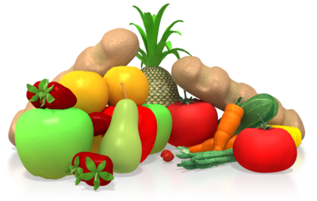

CHCECE004
Promote and provide healthy food and drinks

Table of Contents

Table of Contents 3
Unit Description 6
Performance Criteria 7
Skills and Knowledge 8
Assessment conditions 9
Housekeeping Items 10
Objectives 10
1. Promote healthy eating 11
1.1 – Engage children in experiences, conversations and routines that promote relaxed and enjoyable mealtimes and promote healthy lifestyles and good nutrition 12
1.2 – Model, reinforce and implement healthy eating and nutrition practices with children during mealtimes 12
Mealtimes 12
Learning Activity One 17
Learner Workbook Activity 1.1.1 – 1.2.1 18
1.3 – Support and guide children to eat healthy food 19
Why is it important to support and guide children to eat healthily? 19
How can you guide children to eat healthy food? 19
Learning Activity Two 23
Learner Workbook Activity 1.3.1 24
1.4 – Check that children have ready access to water and are offered healthy food and drinks regularly throughout the day 25
Keep children hydrated throughout the day 25
Learning Activity Three 27
Learner Workbook Activity 1.4.1 28
1.5 – Assist in ensuring that furniture and utensils are suitable to encourage children to be positively involved in and enjoy mealtimes 29
Set children up for success 29
Learning Activity Four 31
Learner Workbook Activity 1.5.1 32
2. Plan food and drinks that are nutritious and appropriate for each child 33
2.1 – Within scope of own work, ensure children are provided with food and drink consistent with the guidelines for healthy eating 34
Planning healthy food 34
Learning Activity Five 38
List 3 reasons why it is important to provide children with food and drink consistent with the guidelines for healthy eating. 38
Learner Workbook Activity 2.1.1 39
2.2 – Assist in ensuring children’s individual needs are consistent with advice provided by families about their child’s dietary requirements, likes, dislikes and any cultural or other requirements families have regarding their child’s nutrition 40
Keeping families informed 40
Allergies and Intolerances 40
Preferences 42
Learning Activity Six 44
Learner Workbook Activity 2.2.1 45
2.3 – Read and interpret food labels and other information about food contents 46
Understanding food labels 46
The Nutrition Information Panel 46
Learning Activity Seven 49
List 4 healthy things you should look for when reading food labels: 49
List 4 unhealthy things you should look for when reading food labels: 49
Learner Workbook Activity 2.3.1 50
2.4 – Assist in providing education and support to families around healthy eating 51
Engaging families 51
Learning Activity Eight 53
Learner Workbook Activity 2.4.1 54
2.5 – Assist to develop and display a cycle of written menus detailing the food that is provided to children 55
Cycle of menus 55
Learning Activity Nine 58
Learner Workbook Activity 2.5.1 59
3. Maintain food safety while carrying out food-handling activities 60
3.1 – Assist in developing and maintaining food safety procedures according to relevant guidelines 61
Food safety 61
Germ Prevention 62
Learning Activity Ten 65
Learner Workbook Activity 3.1.1 66
3.2 – Within scope of own work role, carry out food-handling, preparation and storage according to service policies and procedures and regulatory requirements 67
3.3 – Follow food safety procedures when preparing food 67
Preparing and storing food 67
Learning Activity Eleven 71
Learner Workbook Activity 3.2.1 – 3.3.1 72
Skills and Knowledge Activity 73
Major Activity – An opportunity to revise the unit 74

Unit Description

Application of Unit
This unit describes the skills and knowledge required to promote healthy eating and ensure that food and drinks provided are nutritious, appropriate for each child and prepared in a safe and hygienic manner.

This unit applies to educators working in a range of education and care services.

No licensing, legislative or certification requirements apply to this unit at the time of publication.

Performance Criteria
Element | Performance criteria
1. Promote healthy eating | 1.1. Engage children in experiences, conversations and routines that promote relaxed and enjoyable mealtimes and promote healthy lifestyles and good nutrition  1.2 Model, reinforce and implement healthy eating and nutrition practices with children during mealtimes  1.3 Support and guide children to eat healthy food  1.4 Check that children have ready access to water and are offered healthy food and drinks regularly throughout the day  1.5 Assist in ensuring that furniture and utensils are suitable to encourage children to be positively involved in and enjoy mealtimes
2. Plan food and drinks that are nutritious and appropriate for each child | 2.1. Within scope of own work, ensure children are provided with food and drink consistent with the guidelines for healthy eating  2.2 Assist in ensuring children’s individual needs are consistent with advice provided by families about their child’s dietary requirements, likes, dislikes and any cultural or other requirements families have regarding their child’s nutrition  2.3 Read and interpret food labels and other information about food contents  2.4 Assist in providing education and support to families around healthy eating  2.5 Assist to develop and display a cycle of written menus detailing the food that is provided to children
3. Maintain food safety while carrying out food-handling activities | 3.1. Assist in developing and maintaining food safety procedures according to relevant guidelines  3.2 Within scope of own work role, carry out food-handling, preparation and storage according to service policies and procedures and regulatory requirements.  3.3 Follow food safety procedures when preparing food

Skills and Knowledge
This section describes the skills and knowledge required for this unit.
Foundation skills
The foundation skills described those required skills (language, literacy and numeracy) that are essential to performance.
- Reading – in order to accurately read and interpret food labels and dietary requirements.
The remaining foundation skills essential to performance are explicit in the performance criteria of this unit.
Knowledge Evidence
The candidate must be able to demonstrate essential knowledge required to effectively do the task outlined in elements and performance criteria of this unit, manage the task and manage contingencies in the context of the work role. These include knowledge of:
- How to access:
- The National Quality Framework
- The National Quality Standards
- The relevant approved learning framework
- How to navigate through framework and standards documents to find areas relevant to this unit of competency
- United nations convention on the rights of the child
- Code of ethics
- Food allergies, food intolerances, contamination and/or allergic reactions in meal preparation and possible reactions, including anaphylaxis
- Infant feeding requirements and guidelines
- Recommendations for healthy eating – Dietary Guidelines for Children and Adolescents in Australia and the Australian Guide to Healthy Eating, including Get Up and Grow: Healthy Eating and Physical Activity for Early Childhood resources
- Implications of poor diet including tooth decay, deficiencies, poor concentration, out of character behaviour
- Food-handling requirements, preventing microorganism contamination and/or allergic reactions
- Importance of addressing individual dietary needs and preferences with particular reference to specific cultural, religious or health requirements
- Organisational standards, policies and procedures.
Performance Evidence
The candidate must show evidence of the ability to complete tasks outlined in elements and performance criteria of this unit, manage tasks and manage contingencies in the context of the job role. There must be demonstrated evidence that the candidate has completed the following tasks:
- Planned and provided food and drink for children on at least three occasions, including:
- Identifying and responding to requirements related to food allergies, medical conditions and cultural and religious requirements
- Role-modelling healthy eating habits for children
- Ensuring safe handling, preparation and storage of food and drinks
- Creating a positive, relaxed environment during mealtimes
- Engaged children by involving them in menu planning and assisting in meal preparation
- Read and interpreted food labels to identify ingredients of concern and nutrition content.

Assessment conditions
Skills must be demonstrated in a regulated education and care service.

In addition, simulations and scenarios must be used where the full range of contexts and situations cannot be provided in the workplace or may occur only rarely. These are situations relating to emergency or unplanned procedures where assessment in these circumstances would be unsafe or is impractical.

Simulated assessment environments must simulate the real-life working environment where these skills and knowledge would be performed, with all the relevant equipment and resources of that working environment.
Assessment must ensure use of:
- National Quality Framework for Early Childhood Education and Care
- The relevant approved learning framework under the National Quality Framework for Early Childhood Education and Care.

Assessors must satisfy the NVR/AQTF mandatory competency requirements for assessors.

Links
Companion volumes are available from the CS&HISC website - http://www.cshisc.com.au/

Housekeeping Items
Your trainer will inform you of the following;
- Where the toilets and fire exits are located, what the emergency procedures are and where the breakout and refreshment areas are.
- Any rules, for example asking that all mobile phones are set to silent and of any security issues they need to be aware of.
- What times the breaks will be held and what the smoking policy is.
- That this is an interactive course and you should ask questions.
- That to get the most out of this workshop, we must all work together, listen to each other, explore new ideas, and make mistakes. After all, that’s how we learn.
- Ground rules for participation;
- Smile
- Support and encourage other participants
- When someone is contributing everyone else is quiet
- Be patient with others who may not be grasping the ideas
- Be on time
- Focus discussion on the topic
- Speak to the trainer if you have any concerns

Objectives
- Discover how to promote healthy eating
- Understand how to plan food and drinks that are nutritious and appropriate for each child
- Develop skills to maintain food safety while carrying out food-handling activities
- Gain the essential skills and knowledge required for this unit

1. Promote healthy eating
1.1. Engage children in experiences, conversations and routines that promote relaxed and enjoyable mealtimes and promote healthy lifestyles and good nutrition
1.2. Model, reinforce and implement healthy eating and nutrition practices with children during mealtimes
1.3. Support and guide children to eat healthy food
1.4. Check that children have ready access to water and are offered healthy food and drinks regularly throughout the day
1.5. Assist in ensuring that furniture and utensils are suitable to encourage children to be positively involved in and enjoy mealtimes



1.1 – Engage children in experiences, conversations and routines that promote relaxed and enjoyable mealtimes and promote healthy lifestyles and good nutrition

1.2 – Model, reinforce and implement healthy eating and nutrition practices with children during mealtimes

Mealtimes
Mealtimes are an excellent opportunity for educators to nurture their relationships with children and to support developing peer relationships. Eating together contributes to a sense of community and allows educators to help develop safe and healthy eating habits.
Educators should supervise and engage with children during meals to:
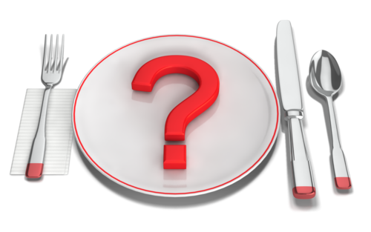
- Ensure safe and hygienic eating
- Model and teach table manners
- Increase socialisation and foster peer relationships
- Build self-help skills
- Ensure healthy eating habits
Safe and Hygienic Eating
Supervising meals promotes safe and hygienic eating by ensuring children:
- Wash their hands with soap and water and dry them thoroughly with a paper towel
- Eat appropriate sized bites to avoid choking
- Do not touch or take each other’s food
- Turn away from the table to sneeze of cough (and wash their hands again)
- Use appropriate utensils to serve themselves (from shared plates)
Table Manners
Children are naturally geared to play with food; it is developmentally appropriate to explore textures, flavours, temperatures and colours. It is important to tolerate accidental messes and small amounts of experimentation, but discourage children from making a mess for the sake of it. Regularly remind children that food is for eating not playing and ask them to clear their plates or lunchboxes when they are finished to discourage playing with their food out of boredom.
Table manners begin to develop around two years-of-age, but they happen gradually and they need consistent encouragement. Children learn table manners by watching others so it is recommended that educators sit with children during meals to model appropriate table behaviour. Instead of always explaining the expectations for table manners, model them, e.g., use your napkin, ask politely for something to be passed to you, demonstrate using a fork properly.
Use mealtimes as an opportunity to teach and model good table manners in a positive and supportive way. Remind children to:
- Sit at the table and try to remain still for the duration of the meal
- Wait until everyone is seated to start eating
- Use ‘please’ and ‘thank you’
- Use a napkin
- Chew with their mouths closed
- Politely ask for help
- Not make comments about other children’s food
- Not to throw or spit out food
- Use utensils safely and correctly
- Finish chewing before they talk
- Wait to leave the table until everyone is finished
- Clear their plate or lunchbox when they are finished
- Help clean up the table
You will need to remind children to do these things every mealtime. Most children won’t master their table manners until they are much older. Come up with a signal for certain things so you don’t need to call a particular child out, e.g., use your own napkin to mimic wiping your mouth
Encourage parents to eat together as a family whenever they can to help their child with table manners.
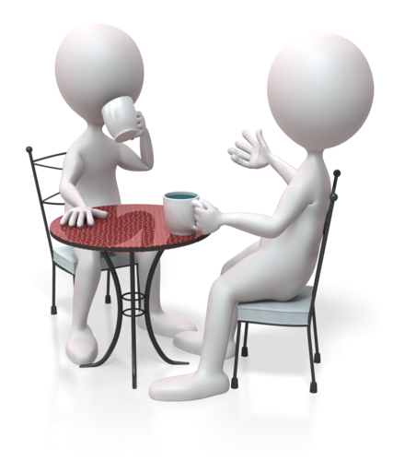
Social Skills
Sitting and talking with children during meals encourages socialisation. Educators can use this time to help direct conversations, ensure that everyone is included and observe friendship patterns.
Young children learn important social skills when they eat together. They learn to:
- Use soft, pleasant voices during meals
- Listen to others
- Wait their turn (to talk, to ask for more, etc.)
- Share in conversation
- Develop a sense of community
- Show each other respect
- Interact with others in a respectful way
- Build healthy friendships
Some centres allow children to share food during meals because they believe this to be a good way to encourage socialisation and reinforce sharing behaviours. Sharing food may also increase the variety of foods children are exposed to. However, given the concerns around food safety and hygiene, and the increase of food allergies, this is a divisive issue. Parents may prefer that their child eat what they pack so they know exactly what they ate while in care.
Food sharing is an issue to be decided by the centre and parents and must take into account the needs of each individual child. Check with your centre’s policy on food sharing or ask your nominated supervisor if you are unsure.
Self-help skills
When children are old enough to feed themselves they gain valuable self-help skills. Educators can facilitate this by supervising and engaging with children during meals.
Encourage children to help prepare meals, or if children bring their own lunch, have them help set up and clean up. If your centre provides food for children, put serving plates on the table and allow children to serve themselves. Supervise and monitor portion control and talk with children about taking enough and why it’s important to share and take turns.
Self-help skills children learn at mealtimes:
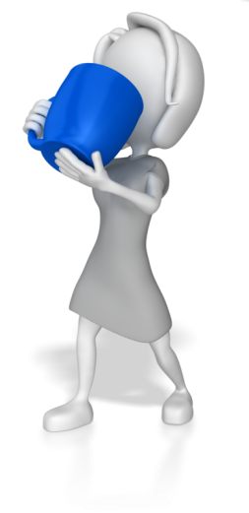
- Preparing food
- Pouring water from a jug
- Scraping plates/trays into the bin
- Wiping the table clean
- Offering food and help to others
- Using utensils
- Responsibility
- Cleaning up after themselves
Healthy Eating Habits
The eating behaviours children practice early in life affect their health and nutrition as they grow. Educators who engage with children during mealtimes can help them learn about and practice healthy eating. Healthy eating is not just about eating healthy foods; it is also about developing a positive attitude towards food.

Educators can influence children’s healthy eating habits by:
- Providing a safe and nurturing eating environment
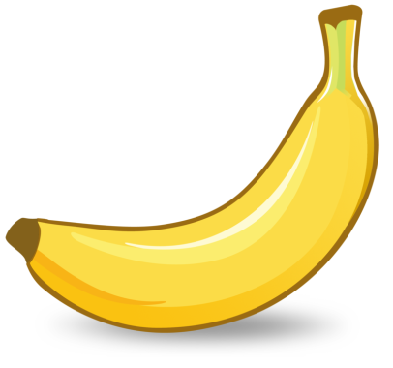
- Encouraging them to help prepare meals and snacks
- Giving them choices
- Defining limits
- Encouraging them to try new foods
- Reacting and interacting responsively
- Displaying your own healthy eating habits
- Integrating healthy eating into the classroom curriculum
Educators can reinforce healthy attitudes towards food by encouraging children to help prepare food. This is an opportunity to talk about different foods and why they are important to being healthy. If you centre does not provide food, you can use meal times to talk about the different foods that each child brings in. Encourage the children to ask questions about the different foods, but remind them not to say anything negative about foods that are new to them.
It is important for educators to have a positive attitude towards food and mealtimes in the classroom. Children will follow your lead if you express a negative attitude about food. If your centre provides meals, eat the same food the children are eating and engage them in a positive conversation about the meal. Only talk about food being eaten in a positive manner. For example, if you don’t like baked beans, you should not react negatively if baked beans are on the menu.
When siting down to eat with children, educators should aim to:
- Set a relaxed tone that promotes socialisation
- Allow time for exploration and experimentation
- Discourage sharing food
- Have everything they need to avoid getting up from the table too often and leaving the children unsupervised
- Vary the environment for meals and snacks. For example, occasionally sit outside in an informal setting
- Use verbal praise an alternative to food rewards
- Create a routine for clean up

National Quality Standards
Quality Area and Standards included in this section:

The Early Years Learning Framework
The principles, practices and outcomes included in this section:

Learning Activity One
- List three benefits of engaging with children during meals.

- How can you influence children’s healthy eating habits?

Learner Workbook Activity 1.1.1 – 1.2.1


1.3 – Support and guide children to eat healthy food

Why is it important to support and guide children to eat healthily?
It is important to support and guide children to eat healthy food for many reasons. The habits children develop at a young age are the habits they will continue over a lifetime. Children who have healthy eating habits get the most nutrition from their food, which leads to healthy, happier children who are ready to learn. Children who have healthy eating habits tend to concentrate more, and are ensuring proper growth and development. Healthy eating habits can prevent mood swings, tiredness, illness, as well as some diseases.
Examples of healthy food and drinks:
- Water
- 100% fruit or vegetable juices in limited amounts - avoid juices that have added sugars or are made from concentrate
- Fresh fruit
- Dried Fruits without sugar added
- Fresh vegetables for snacking (broccoli, carrots, capsicum, cauliflower, cherry tomatoes, etc.
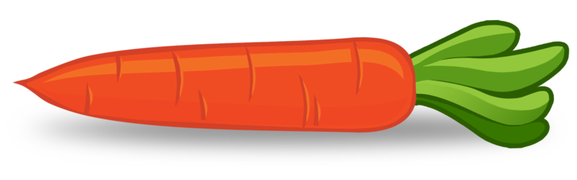
- Cheese
- Eggs
- Nuts and nut butters if not allergic
- Lean proteins
- Yogurt, with no added sugar
It is best to avoid processed foods, regardless of their convenience. When possible, whole foods should always be the first choice. If other foods are chosen, aim for foods with as little additives and sugar as possible and ones made of whole grains.

How can you guide children to eat healthy food?
There are many ways educators can support and guide children to make healthy choices when it comes to food. Start by educating them about what healthy choices are. You can do this through intentional teaching, modelling and by providing healthy snacks and meals when appropriate.
Ways to guide children to eat healthy food:
- Read books and talk about healthy choices
- Conduct structured activities, e.g., gardening, cooking, craft projects, etc.
- Lead by example and bring your healthy foods in for snacks and meals
- Expose them to a variety of healthy foods during snack and meal times
- Provide them with healthy pretend foods for play (if you have a play kitchen)
- Involve them in preparing snacks for each other, or bringing in a healthy snack
- For special occasions bring in healthy alternatives and encourage parents to do the same
- Educate parents on what you are trying to instil in the children
- Create a healthy food policy for your centre – see sample below
Sample Nutrition Policy
Purpose | For the service to provide healthy and varied food choices to encourage healthy eating habits in all children attending the service.
Procedures
- Provision of healthy and varied food choices
  - Staff to access information about healthy food choices from recognised authorities e.g. Dietary Guidelines for Children and Adolescents in Australia.
  - Menus will be based on the Dietary Guidelines for Children and Adolescents in Australia
  - Healthy and varied food choices will be provided for all meals.
  - Drinking water will be accessible to children at all times.
  - Menus to be planned on a weekly basis.
  - If a child has special food needs, the service will work together with the family to develop a plan to meet the child’s needs.

- The eating environment
  - Snack times will be social events where children and staff relax and enjoy food.
  - Staff will demonstrate healthy eating habits to children.
  - Food will never be used as punishment or reward.

- Involving children
  - Children, staff and families are encouraged to contribute ideas for the menu.
  - Children will be encouraged to be involved in the preparation and serving of food.
  - Staff will discuss healthy food choices with children as part of the overall program.

- Communication with families
  - Meals are planned in advance and menus are displayed for parents and children.
  - If parents provide food for their child, the service will encourage healthy food and drink choices.
  - The service will provide relevant nutrition information for parents.

- Diverse cultural experiences
  - Foods that are provided will include, where appropriate, foods from a range of cultures especially those represented in the service and local community.
  - Children’s food awareness activities are chosen from a variety of cultures.

- Professional development
Staff are encouraged to keep up to date with food and nutrition related issues through attendance at professional development events, Internet research, networks.

If children bring food from home, you will need to include this information in the policy. Encourage parents or guardians to send in healthy whole foods, and limit sugary processed foods that are of little nutritional value.
Food choices can come from many sources, including, culture, economic status, family preferences and dietary restrictions. Because of these factors, it is important to consider the following:
- Be aware of food allergies – make sure everyone is aware of any allergies in the centre.
- Children can be picky eaters – it frequently takes many tries of a food before likeness can be established.
- Encourage children not to share lunches that are provided from home as allergies or parental food choices need to be respected.
- Behavioural problems can frequently arise from poor nutrition – if you suspect this, take the time to tactfully educate the parents through brochures and other forms of literature and discussion, as well as be consistent with your established policy. You can send home copies of your policies as well as reminders.
- Remember to be respectful of different cultures and their food choices.



National Quality Standards
Quality Area and Standards included in this section:

The Early Years Learning Framework
The principles, practices and outcomes included in this section:

Learning Activity Two
- How do you encourage children to eat/drink an appropriate amount of food and drink?

- What is healthy eating?

- How can childcare centre staff teach children about healthy eating habits?

Learner Workbook Activity 1.3.1

1.4 – Check that children have ready access to water and are offered healthy food and drinks regularly throughout the day

Keep children hydrated throughout the day
It is essential that children be well hydrated and nourished in order to optimise their time in the learning environment. Children must learn to regulate their own bodies for thirst and hunger so that they may learn to be independent in caring for themselves. When children are hydrated and fully nourished they are more likely to concentrate on the activities at hand and to perform optimally. They are better listeners, less moody and have the energy they need to make it through the day.
There are lots of ways we can ensure that children have ready access to water and are offered healthy food throughout the day. It is essential to provide water for children during both indoor and outdoor activities, so that they can stay hydrated while being active in the sun. This is particularly essential during the summer months.
Some ideas to ensure children have access to water and healthy foods include but are not limited to:
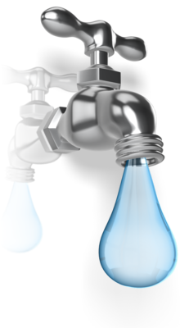
- Encourage children (parents) to bring water bottles from home and keep them in a designated area for ready access, e.g., a bucket, basket or shelf.
- Provide a water dispenser with small cups for mealtimes.
- Bring children’s water bottles outside and set them in a specified place.
- Provide morning or afternoon snacks that include a variety of fresh fruit and vegetables for the children to try (these foods have a high water content and keep children hydrated).
- Invite the children to help you prepare snacks.
- Assign a child and their family to bring in a special healthy snack once a week – rotate through the children so they each get one or two turns.
- Have typical snacks from different places around the world and use this as an opportunity to learn about a variety of cultures.
You want children to be able to quench their thirst and hunger as needed. Children are constantly growing and their appetites are changing as well. The more freedom you can allow for them to meet their own needs and listen to their own bodies, the better. When educators do this, it fosters an independence that is essential for human survival.
Be careful not to let snack times turn into a free-for-all. It is important that their day is not centred on food. Setting schedules for snacks can help, but you have to remember to be flexible with policies and to accommodate for those children whose needs are changing. When a child starts to develop a pattern of using your flexibility to avoid work, then you may have to be firmer in your limits or adjust the amount they are allowed for snack.

National Quality Standards
Quality Area and Standards included in this section:

The Early Years Learning Framework
The principles, practices and outcomes included in this section:

Learning Activity Three
List 5 ways you can ensure that children have ready access to water and are offered healthy food throughout the day.

Learner Workbook Activity 1.4.1

1.5 – Assist in ensuring that furniture and utensils are suitable to encourage children to be positively involved in and enjoy mealtimes

Set children up for success
It is essential to set children up for success in all areas of the early childhood setting, and this includes eating times. Educators can promote optimal development and ensure that children are successful by providing them with properly sized tables and chairs, utensils, plates, cups. Child size sinks for hand washing and food preparation are also important.
It is important to provide these things for the following reasons:
- The children can set the tables using mats, utensils, cups.
- Children can be involved in rinsing used dishes, packing up, cleaning up..
- Children can get their own drinks when they are thirsty.
- Proper furniture and utensils limit frustrations – children want to do what adults do, but if you give them an adult-sized fork to use at mealtime, they are likely to struggle and become frustrated.
- Good manners develop from an early age when children are seated and using utensils.
- Children are likely to be more focussed on eating and enjoying their food when they are not frustrated.
- Without frustration, children can learn to eat and socialise during meals.
- Appropriate furniture and utensils encourage the development of fine motor skills.
- Children feel respected, understood and cared for.
- Children are more successful in meeting their nutritional needs when they don’t struggle at mealtimes.
- As a result of getting proper nutrition, children are happier, and ready to focus when it comes to other learning opportunities throughout the day.

Children are able to be more independent when the furniture and utensils are the appropriate size; they can wash their own hands, feed themselves, move a chair to a different location, etc. With child sized items educators can help children help themselves.
Remember, that utensils need to fit small hands and be sharp or pointy enough without being dangerous or hazardous. Children need to be able to use utensils properly; if they begin to play with them, they should be redirected.

National Quality Standards
Quality Area and Standards included in this section:

The Early Years Learning Framework
The principles, practices and outcomes included in this section:

Learning Activity Four
Provide 5 reasons why it is important to use properly sized tables and chairs, utensils, plates and cups during mealtimes with children.

Learner Workbook Activity 1.5.1

2. Plan food and drinks that are nutritious and appropriate for each child
2.1. Within scope of own work, ensure children are provided with food and drink consistent with the guidelines for healthy eating
2.2. Assist in ensuring children’s individual needs are consistent with advice provided by families about their child’s dietary requirements, likes, dislikes and any cultural or other requirements families have regarding their child’s nutrition
2.3. Read and interpret food labels and other information about food contents
2.4. Assist in providing education and support to families around healthy eating
2.5. Assist to develop and display a cycle of written menus detailing the food that is provided to children

2.1 – Within scope of own work, ensure children are provided with food and drink consistent with the guidelines for healthy eating

Planning healthy food
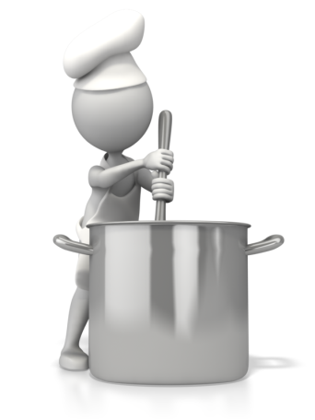
It is important to plan food and drinks that are nutritious and appropriate for each child for a variety of reasons. What the children eat now, will set the stage for a lifetime of healthy habits. It is also an opportunity to teach them, and expose them to a variety of healthy foods and drinks. You can expose the children to common foods and drinks from around the world to accentuate other lessons or learning opportunities about other cultures. When educators provide children with nutritious food and drinks, they are ensuring a well-balanced diet that leads to optimum nutrition which then results in optimal learning.
When planning food for children offer a variety of attractively presented food that lies within the preferences of the child. Make the food look appetising and be creative, e.g., cut sandwiches and fruit into fun shapes. It is also important to explain to children the value of healthy eating habits. You and the children together can design healthy food charts, grow a vegetable garden, visit appropriate food places, e.g., a cheese factory, bakery, farm.
The early years are a critical period for establishing healthy eating and physical activity behaviours in children. Nutritious food and regular physical activity supports the normal growth and development of children and reduces the risk of developing chronic lifestyle diseases including obesity.
Parents are responsible for providing a range of healthy food that contains the appropriate daily nutrients for the general health, wellbeing and continuous growth of their children. Early childhood education centres will either provide meals, snacks, formulas etc., or they will ask parents to supply them.
Healthy Eating and Physical Activity Guidelines for Early Childhood Settings
The Get Up & Grow: Healthy Eating and Physical Activity for Early Childhood Settings Guidelines were developed to respond to the increasing rates of childhood obesity. The guidelines provide evidence based, practical information and advice to support and promote healthy eating and physical activity in children attending early childhood settings including centre-based care, family day care and preschools.
The guidelines are consistent with the Australian Dietary Guidelines and the Physical Activity Recommendations for children 0-5 years, support the Early Years Learning Framework for Australia and are linked to the new National Quality Framework for Early Childhood Education and Care developed by the Council of Australia Governments (Queensland Health, 2013).
Healthy Eating Guidelines for Children
Healthy eating guideline 1 | Exclusive breastfeeding is recommended, with positive support, for babies up to six months. Continued breastfeeding is recommended for at least 12 months and longer if the mother and baby wish.
Healthy eating guideline 2 | If an infant is not breastfed, is partially breastfed, or if breastfeeding is discontinued, use an infant formula until 12 months of age.
Healthy eating guideline 3 | Introduce suitable solids at around six months.
Healthy eating guideline 4 | Make sure that food offered to children is appropriate to the child’s age and development, and includes a wide variety of nutritious foods consistent with the Dietary Guidelines for Children and Adolescents in Australia.
Healthy eating guideline 5 | Provide water in addition to age-appropriate milk drinks. Infants under the age of six months who are not exclusively breastfed can be offered cooled boiled water in addition to infant formula.
Healthy eating guideline 6 | Plan mealtimes to be positive, relaxed and social.
Healthy eating guideline 7 | Encourage children to try different food types and textures in a positive eating environment.
Healthy eating guideline 8 | Offer an appropriate amount of food, but allow children to decide themselves how much they will actually eat.
Healthy eating guideline 9 | Offer meals and snacks at regular and predictable intervals.
Healthy eating guideline 10 | Ensure that food is safely prepared for children to eat from the preparation stages to consumption.
(Queensland Health 2014)

The following chart provides an overview of what is required for a balanced diet.
Nutrients | The body uses them for | Examples of where they come from
Proteins | Growing muscles, skin, hair, healthy blood | Lean red meats, chicken, fish, cheese, milk, nuts beans e.g. baked beans
Carbohydrates | Energy | Pasta, cereals, bread, rice, potatoes, corn,
Fat | Energy and vitamins | Oils, milk, butter, cream, yoghurt, margarine, fried food such as fish and chips, take-away foods
Vitamins | Helps us t heal i.e. cuts or sores on our skin, grow, aids digestion | Vegies, fruit, wholemeal breads, pasta, rice, legumes, fat and milk, milk products
Minerals | Building strong teeth, bones, blood, nervous system | From most healthy foods such as meat, fish, chicken, fruit, vegies, bread, wholemeal pasta and rice
Fibre / roughage | Healthy digestion, including regular bowel movements | Products made from brown flour, apricots, prunes, broccoli

National Quality Standards
Quality Area and Standards included in this section:

The Early Years Learning Framework
The principles, practices and outcomes included in this section:

Learning Activity Five

List 3 reasons why it is important to provide children with food and drink consistent with the guidelines for healthy eating.

What can you do to encourage children to make healthy food choices?

Learner Workbook Activity 2.1.1

2.2 – Assist in ensuring children’s individual needs are consistent with advice provided by families about their child’s dietary requirements, likes, dislikes and any cultural or other requirements families have regarding their child’s nutrition

Keeping families informed
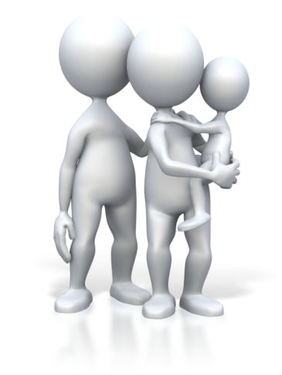
Families like to know that their children’s individual food preferences are respected while in childcare. They like to know what their children have eaten during the day, how much and what they liked/disliked. This is particularly important for maintaining consistency between home and the early childhood education and care setting, especially for babies and toddlers.
At enrolment, parents are asked for details of their child’s food preferences, cultural requirements and any allergies the child may have. This information is then recorded on the child's enrolment records. Some parents may not have determined these things, and you will need to work together as they become clear.
Frequent communication with parents will help you both meet the children’s food requirements. Most centres include a food section in the daily log for each child. Record any food issues that come up during the day, e.g., intolerances, preferences, new favourites, etc. to keep parents informed about their child’s eating.
You can also talk with parents at the end of the day to let them know what their child ate and how you helped support their preferences and needs. When a child has been sick or has developed a food intolerance or allergy, parents will need to share this information with you as soon as possible. It is important that you ask questions after an illness or when a child displays signs of intolerance and allergy.

Allergies and Intolerances
True food allergies are very rare and are usually very serious. Food intolerances are more common. The following are common signs and symptoms that can be caused by food intolerance:
- Watery eyes
- Sneezing/wheezing, or runny nose
- Coughing
- Lethargy and/or headaches
- Behaviour concerns
- Dark circles under the eyes
- Frequent colds and/or middle ear infections
- Intestinal gas
- Frequent skin rashes e.g., hives
- Diarrhoea, stomach pains
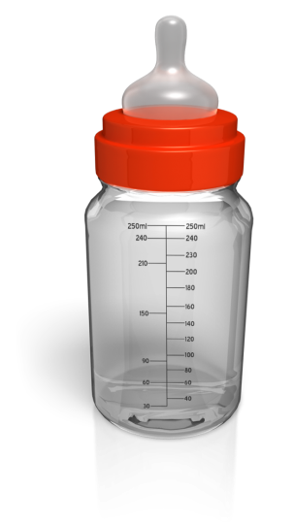
These symptoms may also have other causes so it is important to check with a medical practitioner.
It is reported that the following may assist with preventing the development of food allergies and intolerances:
- Breastfeeding for at least the first twelve months.
- Introducing solid foods when the child shows definite signs of readiness, this is usually about six months of age.
- Making sure the solids introduced are less allergenic e.g., cereal, fruits and vegetables.
- Introducing foods one at a time to test for a reaction.
Allergies are triggered by the immune system, while food intolerances are abnormal responses to food that do not involve the immune system. Usually, food allergies are more medically serious and may be life threatening in some cases. People with a food allergy are usually advised to avoid the food altogether. Food intolerances can often be managed by lowering the intake of the food that causes the problem.
Some children have severe allergic reactions to certain foods. Some of these reactions are life threatening, e.g. peanuts. Children who are allergic to peanuts can react if they as much as smell peanut butter. Some centres have initiated a ‘nut free’ policy to address the increasing number of children with nut allergies.
It can take weeks and even months to track the exact food to which the child is allergic or intolerant or exactly how much a child can eat of the allergenic food before a reaction occurs. This must always be done in consultation with a doctor or dietician. If you suspect that a child has a food intolerance or allergy, speak to your nominated supervisor and the parents.
Food allergies should not be taken lightly, as serious situations can develop very quickly when a child has an allergic reaction to food or drink.

Follow these guidelines at all times:
- Parents of children just starting to eat solids will be asked to provide a list of foods their child has already experienced. When the centre menu is introducing a new food the parent should will be contacted and given the choice of introducing the food item at home first.
- Ask parents to provide doctor's advice on details of the intolerance or allergy and any suitable substitutions.
- Make sure the list of children with food allergies is displayed clearly to all staff preparing or serving snacks and/or meals.
- Check that you have written authorisation to administer medications where required.
- Encourage the child to take responsibility for their food selections. They need to develop life skills that will assist them as they get older.
- Don't isolate the child who has an allergy. It is important to include foods in the menu that everyone can eat.
- Become familiar with the foods/drinks that potentially contain allergens.

Preferences
It is important to appreciate that every child is different. Even if two children have an allergy to the same food, there will be some very distinct individual differences. For this reason, it is necessary for early education and care centres to receive as much information as possible from the child's parents, doctor and dietician.
If a child has coeliac disease, the bowel is damaged by gluten. Gluten is the protein in wheat, barley, rye, oats and triticale. Foods containing these products should be avoided, e.g., breakfast cereals, pasta, breads, cakes and biscuits. Again, work with the family to ensure the child’s needs are met.
As an early childhood educator, you would have a duty of care to observe the food requirements of children who are on a strict diet based on doctor’s advice. Detailed written instructions must be sought from the parents. Notices, including the child’s photo, should be posted in the food preparation area to remind staff, and especially relief staff, of the child’s special dietary needs. You need to know what the child must not eat, and also what the child can eat. If you are not sure of special dietary needs, or you think a child has a problem with a particular food, consult the parents.
Vegetarianism is a fairly common food practice in many cultures including Australian. It may be chosen for a range of reasons including potential health benefits, not wanting to exploit other species, distaste in consuming animal flesh or religious beliefs.
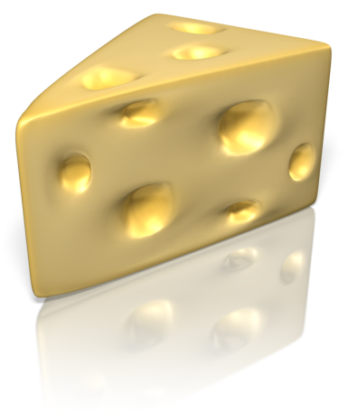
There are several different levels of vegetarianism:
- Not eating red meat but including fish and chicken and all plant foods
- Not eating any red meat, fish or chicken but including dairy foods and all plant foods (lacto-ovo vegetarian).
- Not eating any meat, fish, chicken or eggs, but including dairy foods and all plant foods (lacto vegetarian).
- Not eating any animal products at all, but including all plant foods (vegan).
It is important that early education and care centres work closely with parents to ensure the child gets sufficient nutrients for healthy growth and development.
National Quality Standards
Quality Area and Standards included in this section:

The Early Years Learning Framework
The principles, practices and outcomes included in this section:

Learning Activity Six
List all the things you need to take into consideration regarding children’s nutrition at your centre.

Learner Workbook Activity 2.2.1

2.3 – Read and interpret food labels and other information about food contents

Understanding food labels
It is important to understand food labels and other information about the food you are serving to children. When you provide and teach young children about healthy foods and drinks you are laying a foundation for a lifetime of healthy habits. Educators are in the perfect position to teach children how to pay attention to what is in the food they eat by reading labels and looking to avoid certain ingredients. By taking the time to read and interpret food labels, you can ensure healthy choices for children, and protect those who have food allergies.
Foods should be low in sugar, minimally processed, not too salty and include whole ingredients. When buying pre-packaged food look for things that don’t have too many ingredients. Food manufactures are required to meet strict guidelines on their packaging. This includes specific information for people with food allergies, food additive listings and food storage instructions.
Examples of labels you are likely to see:
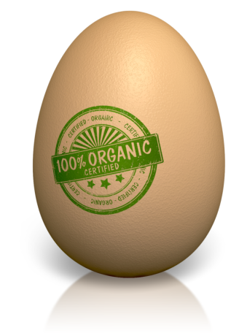
- Fat free
- Low fat
- Low sugar
- All natural
- No hydrogenated oils
- Whole grain
- Organic

The Nutrition Information Panel
Food labels can be difficult to understand, but the important information is included in the Nutrition Information Panel, which can be found on the back of packages or side of boxes. The Nutrition Information Panel provides a simple and easy way to choose foods with less saturated fat, salt (sodium), added sugars and kilojoules. It can also be used to determine portions and serving sizes, which are especially important for ensuring young children, get the nutrition they need without over-eating.
How to use the nutrition panel
- Use the Australian Guide to Healthy Eating to decide whether a food belongs in the five food groups and is an ‘everyday’ food for eating regularly, or a discretionary food best eaten only sometimes or in small amounts.
- Use the Nutrition Information Panel to compare similar packaged foods and to decide which product provides less saturated fat, salt (sodium), added sugars and kilojoules per 100gm and more fibre per serve.

Sometimes, food labels will include nutrition content claims like ‘low fat’, ‘reduced salt’ or ‘high fibre’. These claims can only be used if the food meets certain criteria. For example, with a ‘good source of calcium’ claim, the food must contain more than a set amount of calcium. While nutrition content claims can generally guide you to healthier choices, it is important to check the claim by looking at the Nutrition Information Panel. For example, products carrying ‘low fat’ claims may not be low in total energy (kilojoules) when compared with similar products.
Source: National Health and Medical Research Council
Don’t fall for labels; look closer. For example, low fat and non-fat is not always the healthier option. Frequently, these foods contain more synthetic ingredients that are not whole or natural. Certain natural fats are actually essential for optimum brain development and are good for children. Fats in nuts, meats and eggs are an excellent choice for growing children.
Research is showing that what children eat directly impacts all aspects of their development and behaviour. If you have a child who is challenging, looking at their diet is a good place to start. See what kinds of foods they gravitate towards. Really work to eliminate sugars and processed foods for these children. Their issues may be the result of food intolerance.
Important things to note when interpreting food labels:
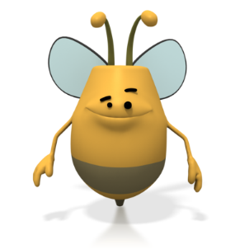
- All natural can be a hoax – marketing experts are taking advantage of people’s food consciousness.
- Research is showing hydrogenated oils are not a good choice. Choose products with non-hydrogenated oils.
- If possible choose organic foods, or vigorously wash non organic fruits and vegetables.
- Honey is easier to digest for humans, if allergies allow use this for a sweetener when necessary.
National Quality Standards
Quality Area and Standards included in this section:
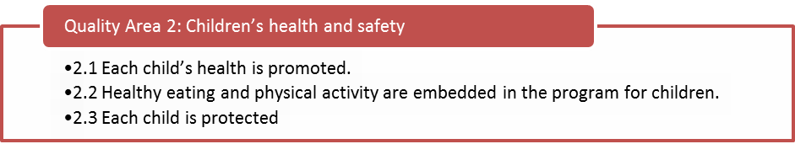

The Early Years Learning Framework
The principles, practices and outcomes included in this section:

Learning Activity Seven

List 4 healthy things you should look for when reading food labels:

List 4 unhealthy things you should look for when reading food labels:

Learner Workbook Activity 2.3.1

2.4 – Assist in providing education and support to families around healthy eating

Engaging families
Engaging with families regarding nutrition and healthy eating builds a connection between home and the early education and care service, and ensures the children feel supported in making healthy choices. Many families are busy with both parents working or they are single parents who don’t have time to prepare and serve balanced meals every day. Many families resort to quick and easy foods without realising how this might impact aspects of their child’s development.
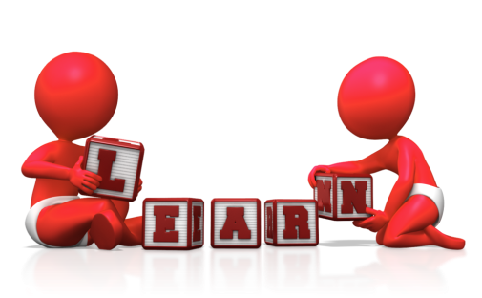
By sending home information through flyers, brochures or other literature about healthy foods and nutritious and easy snacks, you can help parents see how easy it can be. Provide families with facts and figures about the benefits of nutritious meals. Educate them about your centre’s policy for providing healthy snacks and meals while at school to ensure optimal learning takes place. Parents are busy and lengthy brochures or too much information is often times left unread. Keep the information that goes home short and sweet.
Strategies to help educate families
- Send home brochures, pamphlets, or other literature with ideas for healthy snacks and lunches, as well as with information about the benefits of proper nutrition.
- Invite families to take turns bringing in different healthy snacks.
- On occasion, have families volunteer to work with a small group of children to make healthy meals for the group.
- Assign families activities, tasks or challenges regarding nutrition on a semi-regular basis. For example you might create a weekly ‘Healthy Habit Challenge” for the group to do outside of the centre. Parents can sign that they have completed the challenge and return it with the child. A challenge might be to eat a new vegetable every day.
- When having all school functions create a sign-up sheet with healthy food choices and have parents sign up accordingly. When you create the list, it avoids an overload of sweet or otherwise unhealthy treats.
- Organise a parent night about providing healthy food. Or just how you do it at the centre, in case families are interested or would like to get in sync with the centre’s policies.
- Post information and posters on the bulletin boards around the centre.
- If your centre provides meals, distribute menus to families ahead of time – include nutritional information for each item.
- Encourage families to have fun with food.
It is important to be respectful and understanding when talking with families about food choices. Some families have poor eating habits and may be reluctant to change. It is important to have a policy surrounding the foods that are prepared in the centre to ensure that children are getting balanced nutrition in one environment.
Children may also be reluctant to change. Be patient and consistent and they will adjust. Picky eaters will remain picky unless they are continuously exposed to new choices. When dealing with picky eaters, you can reward them with a favourite food after they try a new food; for example, encourage a child to eat their carrots by reminding them that there will milk arrowroots for snack. Eventually the reward isn’t needed. Remember, it can take up to 20 times of trying a food before a taste for it is established.
National Quality Standards
Quality Area and Standards included in this section:

The Early Years Learning Framework
The principles, practices and outcomes included in this section:

Learning Activity Eight
What strategies does your centre use to help educate and support families around healthy eating? Do they work?

Learner Workbook Activity 2.4.1

2.5 – Assist to develop and display a cycle of written menus detailing the food that is provided to children

Cycle of menus

Some early childhood education and care centres provide meals for children, while others require that children bring their own meals in, but morning and afternoon tea is provided. Centres that provide food of any kind must develop a carefully planned menu that is based on the Australian Healthy Guidelines.
Menus should be planned in advance and should be displayed for families, the children and staff to see. Apart from being a good way to communicate with families about nutrition it is a requirement of the ‘Childcare Regulation 2003’ (Section 63) under the heading of ‘Food and Nutrition’:
2) If the food offered to children is supplied as part of a child care service -
- The food must be adequate and nutritious.
- The types of food must be chosen having regard to the child’s age, health, dietary needs, culture and religion.
- A menu of the food must be displayed where it can be seen by parents and guardians
Displaying the menu
- Prepares children for the day’s meal and snacks.
- Informs parents of the kinds of healthy choices that are being provided.
- Educates families about what a nutritious meal encompasses.
- Informs parents of upcoming meals so they can opt-out if their child is allergic or sensitive to certain ingredients.
When planning menus, it is necessary to consider food allergies and illnesses, religious and cultural requirements, and the effect of food additives.

Sample menus can be in calendar form where each meal and snack is outlined in its entirety.
For example:
 | Monday | Tuesday | Wednesday | Thursday | Friday
Morning Tea | Vegemite Saos and fruit | Fruit salad and custard | Fruit and cheese platter | Rice cakes and fruit | Vegemite Saos and fruit
Lunch | Teriyaki chicken with vegies and rice | Pumpkin soup and salad | Spaghetti and meatballs | Ham and cheese sandwiches with cherry tomatoes | Grilled chicken strips, mashed potato and carrots
Afternoon Tea | Fruit and cheese platter | Rice cakes and fruit | Milk Arrowroots and fruit | Fruit salad and custard | Blueberry muffins
Other ideas include but are not limited to:
- Nut butters (if no allergies)
- Toasted cheese sandwiches on whole grain bread
- Grilled or roasted meat served with a vegetable
- Hard boiled eggs
- Frittatas
- Yogurt
- English muffin pizzas
It is recommended to provide a lean protein with vegetable for lunch and save fruit for snacks. Fruit is easier to digest on its own. Always provide water and/or milk with meals and snacks, but avoid fruit juices, as they are high in sugar and are not considered a healthy choice on a regular basis.

It is not necessary to provide a lot of choices for each meal. Children have small stomachs and don’t eat very much. Food is often wasted when you serve too much food or too many choices. It is better to expose children to a variety of food over the course of the week. Adults tend to limit what they offer children because they think children only like certain kinds of foods. This is inaccurate; children will eat what you expose them to.
It is important not to get into the habit of offering desert with meals; children will come to expect it. Save treats for special occasions, like birthdays, excursions, special guests, completing a group project.
National Quality Standards
Quality Area and Standards included in this section:

The Early Years Learning Framework
The principles, practices and outcomes included in this section:

Learning Activity Nine
Why is it important to plan and display menus detailing the food that is provided for children?

Learner Workbook Activity 2.5.1

3. Maintain food safety while carrying out food-handling activities
3.1. Assist in developing and maintaining food safety procedures according to relevant guidelines
3.2. Within scope of own work role, carry out food-handling, preparation and storage according to service policies and procedures and regulatory requirements.
3.3. Follow food safety procedures when preparing food

3.1 – Assist in developing and maintaining food safety procedures according to relevant guidelines

Food safety
Australian states and territories may have specific food safety regulations for early childhood education and care services and it is recommended that you locate the guidelines relevant to your area.

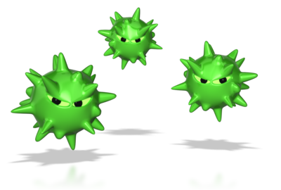
Children are more susceptible to food borne illness making it necessary for early education and care services to implement adequate health and hygiene practices. Safe practices for handling, storing, preparing and heating breast milk/formula and foods must be employed to minimise risks to children.
Early childhood education and care services must prepare and provide food in a way that is safe for the children in their care, to reduce the risk of spreading infectious diseases through food. Standard 3.3.1 of the Australia New Zealand Food Standards Code states that your service must have a documented food safety program (ComLaw, 2011).
Maintaining food safety procedures:
- Prevents spread of illnesses that are currently in the community.
- Prevents cross-contamination of possible allergens (you don’t want to use a spoon with nut butter and then stir some nut free soup).
- Ensures that food is cooked properly and tastes its best, while avoiding food borne illnesses or unnecessary dislike for a food.
- Sets the stage for safe food handling procedures in the future if children are involved in helping.
Food safety procedures include but are not limited to:
- Washing hands before and after preparing or handling food.
- Wearing a hairnet or hair pulled back.
- Not tasting food with a spoon or finger and placing it back into a dish.
- Cooking all meat to specified temperatures.
- Thawing frozen meats in a refrigerator and using thawed meats in a timely manner.
- Keeping certain foods refrigerated.
- Not serving thawed meats that have not been stored at appropriate temperature.
- Not wearing loose clothing or accessories while preparing and serving food
- Using potholders.
- Storing knives safely.
- Coughing or sneezing away from food into arm and then rewashing hands.
- Ensuring no foods or drinks are past their use-by date.
- Not thawing and refreezing meats.
- Ensuring food preparation utensils and cookware are clean before using (they are best cleaned in a dishwasher or sanitiser machine after each use).
- Ensuring ensure that raw meat juices do not cross contaminate.
- Storing meats in sealed bags and cleaning up surfaces properly.
- Checking thermometers of refrigerators and freezers often.

As part of your role in the early childhood education and care setting, you will be assisting to develop and/or maintain food safety procedures according to food safety standards. This will require a detailed knowledge of the food requirements of children in your room, as these procedures will need to be modified as different children join the group.

Ensure the following recommendations are included in your food safety procedures, and that they are reviewed on a regular basis.

Germ Prevention
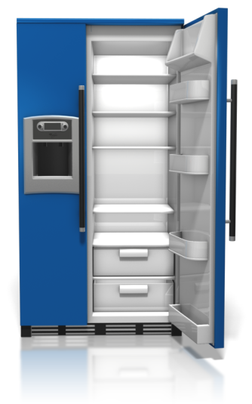
Food is an excellent place for germs to grow. If food is not prepared or stored properly, bacteria can double every 30 minutes.
Preventing the spread of disease and illness through food requires:
- Effective, regular hand washing
- Not sharing food, plates or utensils
- Preparing and storing food properly
- Keeping food preparation areas clean – disinfectants are not routinely needed in food preparation areas if surfaces are thoroughly cleaned with detergent in hot water and allowed to dry.
Food preparation areas should be far away from areas where children play, as well as changing areas and bathrooms. Early childhood education and care services where educators change nappies and prepare or serve food on the same day, have more than three times as many cases of diarrhoea as settings in which educators and other staff do not do both these jobs on the same day. For this reason, the person who prepares and serves food should, wherever possible, not be the person who changes nappies or helps children go to the toilet on that day.
Always wash and dry your hands before handling food. Even if you are required to wear gloves, you must wash your hands prior to putting them on. Gloves are not a substitute for clean hands.
Education and care services must have a hand basin (separate from the kitchen sink), soap and disposable towels in the kitchen so that educators and other staff who are preparing food can easily wash their hands. Check your state or territory’s food safety legislation for any other requirements.
Heating and Cooling Food
Australia’s food safety standards state that reheated food should reach 60°C. Heating to this temperature will destroy germs that may have grown in the food since it was cooked. However, it is recommended that food is reheated until it reaches 70 °C, and should stay at this temperature for 2 minutes.
The 4-hour/2-hour rule provides guidelines regarding the safety of food when it has not been stored under 5°C or over 60°C. Ready-to-eat food that has been at temperatures between 5°C and 60°C for a total of less than 2 hours, must be refrigerated or used immediately (do not reheat milk/formula).
Ready-to-eat food that has been at temperatures between 5°C and 60°C for a total of longer than 2 hours but less than 4 hours, must be used immediately. Food that has been at temperatures between 5°C and 60°C for a total of 4 hours or longer must be thrown out.
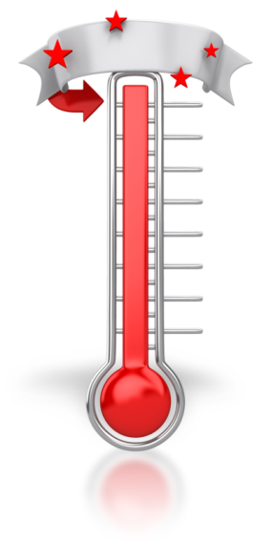
Heating and cooling requirements include:
- Using a food thermometer to ensure that cooked or reheated food reaches the correct temperature.
- Keeping a non-mercury thermometer in the fridge so that you can check that the temperature is below 5°C.
- Checking that the food has cooled before giving it to children.
- Throwing out all leftovers. Tell parents what food their child left, but do not return the leftover food to the parents. (This rule may vary between centres as some policies may require that parents see the food their child, or didn’t eat. Check with your nominated supervisor if you are unsure).

Serving Food
If children are sharing food from a common bowl or plate, make sure they understand that they need to use tongs, spoons or other appropriate utensils to serve themselves. Remind them that they cannot touch food that is being shared because this can spread germs that might make them or other children sick.
During meals:
- Do not allow children to share individual eating or drinking utensils, or take food from other children’s plates or bowls.
- Teach children to turn away from food when they cough or sneeze, and then to wash their hands.
- Use a separate spoon for each infant you feed.
- If you are interrupted to care for another child while preparing food or spoon-feeding an infant, be sure to wash your hands again before you continue.
Keep your food safety knowledge up to date and talk to your nominated supervisor if you have any concerns.

National Quality Standards
Quality Area and Standards included in this section:

The Early Years Learning Framework
The principles, practices and outcomes included in this section:

Learning Activity Ten
What does maintaining food safety include?

Why is it important?

Learner Workbook Activity 3.1.1

3.2 – Within scope of own work role, carry out food-handling, preparation and storage according to service policies and procedures and regulatory requirements

3.3 – Follow food safety procedures when preparing food

Preparing and storing food
Preparing and storing food appropriately, and according to policies, procedures and regulatory requirements prevents the children and staff from getting sick and protects you from liability if a child or children get sick from food borne illnesses while in your care. It is also important to educate children about basic food handling, storage and why it’s so important to wash their hands before eating.
Food preparation
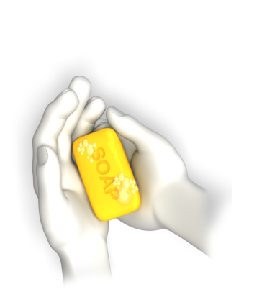
Food preparation and handling duties include:
- Washing hands effectively in designated area
- Opening containers carefully and with clean hands or clean utensils
- Washing fruits and vegetables thoroughly
- Thawing food properly
- Not letting children share meals that are brought from home
- Ensuring your hands are washed before handling a child’s food or utensils
- Ensuring hot food is served hot and cold food is served cold
- Preventing cross contamination by keeping non-food items separate from food
- Ensuring eating surfaces are cleaned properly before and after eating
- Washing utensils and dishes in a dishwasher
- Being aware of freshness dates when purchasing food
- Using clean utensils and tools when preparing food
- Using safety procedures when handling sharp or hot objects
- Follow specific procedures when preparing breast milk. List procedures in the area where bottles are prepared or stored.

Educators who handle and prepare food and formulas must implement basic food hygiene regimes in their preparations. This will include:
- Cleaning and sanitising food preparation areas regularly.
- Only using these areas for the purpose of preparing food and formula.
- Keeping kitchen areas free of flies and other vermin.
- Wearing disposable gloves when preparing food, if required.
- Avoiding cross contamination by using coloured coded chopping boards - one chopping board for cooked food and another chopping board for raw food.
- Covering any broken skin on their hands.
- Washing and drying your hands thoroughly before preparing or serving food and bottles.
- Wearing a clean apron and hairnet.
- Correctly sterilising and washing utensils and bottles before use or storage.
- Disposing of unfinished breast milk or formula.
- Checking that all children have washed and dried their hands before they eat or drink.
Food storage
Food storage guidelines:
- Make sure families know if you provide refrigeration or a source for heating lunches and ensure that they send lunches accordingly.
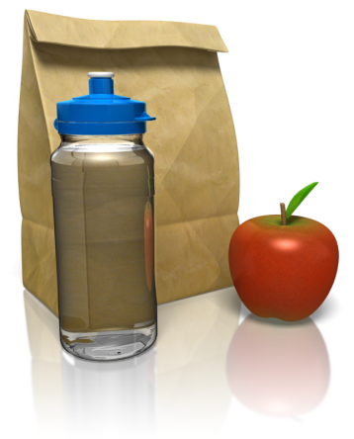
- Ensure food is properly sealed in containers or bags and at correct temperatures, whether in the fridge or in their lunch boxes.
- Ensure that children’s food is labelled with their name and date and stored in a fridge (if used).
- Be especially careful with breast milk. Ensure it is stored and prepared at safe temperatures and labelled with child’s name and date. Do not reheat, and do not share amongst children.
- Store food and bottles at the correct temperature in a clean and well-maintained refrigerator.
- Store chemicals and other toxins in a separate environment from food.

Food safety procedures
Health and safety procedures to remember:
- Keep food hot (over 60°C) or cold (5°C or less); otherwise don’t keep it at all.
- Clean the eating tables before and after eating.
- Wash your hands before food preparations, after any interruptions during food preparation, and before feeding babies.
- Babies must all have their own spoon, plate and cups and bottles.
- Ensure children wash their hands before they eat or drink.
- Teach children to turn away from the food when they cough or sneeze.
- Supervise children to ensure they do not contaminate food by touching it.
- Do not allow children to share food, plates or utensils.
- Do not allow children to feed from the same bowl, e.g., a big bowl of chopped fruit for all to share encourages the spread of germs from all the different hands going into the bowl.
- Keep raw and cooked foods separate in the fridge.
- Use different chopping boards and utensils for raw and cooked food.
- Heat food and bottles once and once only.
- Dispose of unused formula or breast-milk.
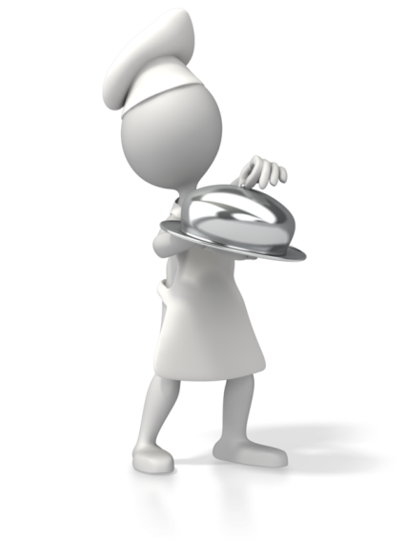
- Be very careful when using microwave ovens, food can heat to dangerously high levels.
- Do not heat breast milk or formula in the microwave.
- When preparing food keep hair tied back away from face, wear a suitable cap; make sure hands, nails and aprons are clean.
- Staff members who prepare food should not be responsible for changing nappies.
- Be careful not to cross contaminate when you have children with allergies.
- Keep a list of children and food allergies in the kitchen, reference it frequently.
- Ensure children do not share food with one another due to allergies or special diets.

National Quality Standards
Quality Area and Standards included in this section:

The Early Years Learning Framework
The principles, practices and outcomes included in this section:

Learning Activity Eleven
How are foods prepared and stored safely?

What are 4 basic food hygiene routines used when preparing and storing food?

Learner Workbook Activity 3.2.1 – 3.3.1

Skills and Knowledge Activity

Nearly there...

Major Activity – An opportunity to revise the unit
At the end of your Learner Workbook, you will find an activity titled ‘Major Activity’. This is an opportunity to revise the entire unit and allows your trainer to check your knowledge and understanding of what you have covered. It should take between and 1-2 hours to complete and your trainer will let you know whether they wish for you to complete it in your own time or during session. Once this is completed, you will have finished this unit and be ready to move onto the next, well done!

Congratulations!
You have now finished the unit ‘Promote and provide healthy food and drinks’



