BSBINM301
Organise workplace information
Learner Guide



BSBINM301
Organise workplace information

Table of Contents
Table of Contents 3
Unit of Competency 6
Performance Criteria 7
Foundation Skills 8
Assessment Requirements 9
Housekeeping Items 10
Objectives 10
1. Collect and assess information 11
1.1 – Access product and service information in accordance with organisational requirements 12
Databases 13
A policy 13
A standard 14
Activity 1A 15
1.2 – Ensure methods of collecting information are reliable and make efficient use of available time and resources 16
1.3 – Assess information for clarity, accuracy, currency and relevance to intended tasks 16
Electronic Publishing 17
Data Harvesting 17
Digitisation 17
Benefits of Digitisation: 18
Pooled Data Analysis 18
Assess information for clarity, accuracy, currency and relevance to intended tasks 19
The value of information 20
Activity 1B 21
1.4 – Use interpersonal skills to access relevant information from teams and individuals 22
Consultation methods, techniques and protocols 22
Activity 1C 25
2. Organise information 26
2.1 – Organise information in a format suitable for analysis, interpretation and dissemination in accordance with organisational requirements 27
Calculations and summarising information 29
Graphs 29
Adding headers and footers 29
Incorporating graphics and pictures 29
Inserting symbols 30
Using legends 30
Using a particular software application 30
Using tables and charts 31
Activity 2A 32
2.2 – Use appropriate technology/systems to maintain information in accordance with organisational requirements 33
Computer 34
Record management devices 34
Activity 2B 37
2.3 – Collate information and materials and communicate to relevant designated persons 38
Activity 2C 39
2.4 – Identify difficulties organising and accessing information and solve collaboratively with individuals and team members 40
2.5 – Update and store information in accordance with organisational requirements and systems 40
Activity 2D 41
3. Review information needs 42
3.1 – Actively seek feedback on clarity, accuracy and sufficiency of information to ensure relevance of information and system 43
Reviewing feedback 44
Discuss in class 45
Activity 3A 47
3.2 – Review the contribution of information to decision making and implement appropriate modifications to collection processes 48
Assessing the contribution of information to decision making 48
Role and importance of information 48
There are several kinds of decisions 49
Those preparing the information 51
Those receiving the information 51
Activity 3B 53
3.3 – Identify future information needs and incorporate modifications to collection processes 54
3.4 – Document future information needs and incorporate in modifications to reporting processes 54
Activity 3C 55
Consider conducting an information needs analysis 56
A needs analysis address two main areas: 57
Activity 3D 58
Skills and Knowledge Activity 59
Major Activity – An opportunity to revise the unit 60
References 62

Unit of Competency

Application
This unit describes the skills and knowledge required to gather, organise and apply workplace information in the context of an organisation’s work processes and knowledge management systems.

It applies to individuals who perform a defined range of skilled operations in various work contexts. They may exercise discretion and judgement using appropriate knowledge of information management to provide technical advice and support to a team.

No licensing, legislative or certification requirements apply to this unit at the time of publication.

Unit Sector
Knowledge Management – Information Management

Performance Criteria
Element  Elements describe the essential outcomes. | Performance Criteria  Performance criteria describe the performance needed to demonstrate achievement of the element.
- Collect and assess information | - Access product and service information in accordance with organisational requirements  - Ensure methods of collecting information are reliable and make efficient use of available time and resources  - Assess information for clarity, accuracy, currency and relevance to intended tasks  - Use interpersonal skills to access relevant information from teams and individuals
- Organise information | - Organise information in a format suitable for analysis, interpretation and dissemination in accordance with organisational requirements  - Use appropriate technology/systems to maintain information in accordance with organisational requirements  - Collate information and materials and communicate to relevant designated persons  - Identify difficulties organising and accessing information and solve collaboratively with individuals and team members  - Update and store information in accordance with organisational requirements and systems
- Review information needs | - Actively seek feedback on clarity, accuracy and sufficiency of information to ensure relevance of information and system  - Review the contribution of information to decision making and implement appropriate modifications to collection processes  - Identify future information needs and incorporate modifications to collection processes  - Document future information needs and incorporate in modifications to reporting processes

Foundation Skills
This section describes language, literacy, numeracy and employment skills incorporated in the performance criteria that are required for competent performance.

Skill | Performance  Criteria | Description
Reading | 1.1-1.3, 2.1-2.3, 2.5, 3.2 | - Recognises and assesses textual information to complete tasks according to requirements
Writing | 2.1, 2.2, 2.3, 2.5, 3.1, 3.4 | - Completes workplace records, forms and documentation accurately using correct format, accurate spelling and grammar and terminology specific to requirements
Oral communication | 1.4, 2.3, 2.4, 3.1 | - Elicits the view and opinions of others and obtains information by listening and questioning  - Participates in a verbal exchange of ideas/solutions using clear language to contribute information and convey issues
Navigate the world of work | 1.1, 2.1, 2.5 | - Understands rights and responsibilities and complies with explicit policies and procedures and legal and regulatory requirements
Interact with others | 1.4, 2.3, 2.4, 3.1 | - Identifies and follows accepted communication practices and protocols  - Complies with work instructions and contributes to work group discussions using accepted conventions
Get the work done | 1.1, 1.2, 2.1, 2.2, 2.4, 3.2, 3.3 | - Plans and implements routine tasks and workload making decisions about sequencing and timing  - Makes low impact decisions within familiar situations, based on a range of predefined or routine solutions, and evaluates the effectiveness of the outcome  - Uses digital technology to access and record information and to communicate with others

Assessment Requirements
Performance Evidence

Evidence of the ability to:

- Efficiently and effectively gather, assess, organise and use workplace information as part of own job role
- Provide accurate information for defined purposes
- Maintain and handle data and documents systematically
- Use business technology to manage information
- Communicate with colleagues and clients using effective interpersonal skills to obtain and check workplace information
- Apply relevant legislation and regulations to workplace information
- Monitor, review and modify information processes

Note: If a specific volume or frequency is not stated, then evidence must be provided at least once.

Knowledge Evidence

To complete the unit requirements safely and effectively, the individual must:

- Explain how legislation and regulations may affect the gathering, organising and distribution of workplace information
- Describe methods for checking validity of information and its sources
- Describe organisational recordkeeping and filing systems, security procedures and safe recording practices
- Identify workplace policies and procedures relating to workplace information

Assessment Conditions

Assessment must be conducted in a safe environment where evidence gathered demonstrates consistent performance of typical activities experienced in the knowledge management – information management field of work and include access to:

- Business technology
- Workplace policies and procedures
- Relevant legislation and codes of practice
- Office equipment and resources
- Examples of information documents found in the workplace
- Interaction with others

Assessors must satisfy NVR/AQTF assessor requirements.

Links

Companion volumes available from the IBSA website: http://www.ibsa.org.au/companion_volumes

Housekeeping Items
Your trainer will inform you of the following;
- Where the toilets and fire exits are located, what the emergency procedures are and where the breakout and refreshment areas are.
- Any rules, for example asking that all mobile phones are set to silent and of any security issues they need to be aware of.
- What times the breaks will be held and what the smoking policy is.
- That this is an interactive course and you should ask questions.
- That to get the most out of this workshop, we must all work together, listen to each other, explore new ideas, and make mistakes. After all, that’s how we learn.
- Ground rules for participation;
  - Smile
  - Support and encourage other participants
  - When someone is contributing everyone else is quiet
  - Be patient with others who may not be grasping the ideas
  - Be on time
  - Focus discussion on the topic
  - Speak to the trainer if you have any concerns

Objectives
- Discover how to collect and assess information
- Learn how to organise information
- Know how to review information needs
- Gain skills and knowledge required for this unit

1. Collect and assess information
1.1 Access product and service information in accordance with organisational requirements
1.2 Ensure methods of collecting information are reliable and make efficient use of available time and resources
1.3 Assess information for clarity, accuracy, currency and relevance to intended tasks
1.4 Use interpersonal skills to access relevant information from teams and individuals



1.1 – Access product and service information in accordance with organisational requirements
Information may include:
- Computer databases (e.g. Library catalogue, customer records)
- Computer files (e.g. Letters, memos and other documents)
- Correspondence (e.g. Faxes, memos, letters, email)
- Financial figures

- Forms (e.g. Insurance forms, membership forms)
- Invoices (e.g. From suppliers, to debtors)
- Personnel records (e.g. Personal details, salary rates)
- Production targets
- Sales records (e.g. Monthly forecasts, targets achieved)
Organisational requirements may include:
- Code of conduct/code of ethics
- Information protocols
- Legal and organisational policies, guidelines and requirements
- Management and accountability channels
- WHS policies, procedures and programs
- Procedures for updating records
- Quality assurance and/or procedures manuals
- Security and confidentiality requirements
- Access product and service information
- Obtain, examine, or retrieve (data or a file)

Databases
- The database is one of the cornerstones of information technology and its ability to organise, process and manage information in a structured and controlled manner is key to accessing and gathering product and service information.
- Information will normally grow naturally into company Databases.
- A database is a collection of data which has been organised so that a computer program can quickly select desired items.
- Database tools and applications are designed to help you store and manage data in a controlled and structured manner.
This could be something as straightforward as a list of names in alphabetical order or a list of numeric codes.
- The secret to the successful use of database technology is the way in which data or information is structured to enable efficient searching, access, retrieval and processing.

- Databases are a great tool for further study or reference to support the initial information access.
A "Database" in this context is used in the very broad sense of an accessible collection
- To be fully accessible it would need to be without password and not behind security walls.
- It could be that the Database is on a website and freely available.
- Participants can use it at their discretion.
What is meant by “in accordance with organisational requirements” would therefore determine the protocols and security access requirements to access data. Employees accessing data would likely need to observe requirements of confidentiality and privacy, comply with protection and control procedures, and accurately present the data in any form of use.
Many organisations will have either a policy or a set of standards to guide employees who may need to access information on products and services.
Access product and service information in accordance with organisational requirements

A policy
- A policy is typically a document that outlines specific requirements or rules that must be met.
- In the information data access reference it may be as simple as an “acceptable use" policy which would cover the rules and regulations for appropriate use of the product and services information.

A standard

- A standard is typically a collection of company requirements that must be met by everyone.
- You might have a standard that describes how to treat certain data on products or services such as distribution.
- Employees must follow this standard and it is linked to the policy and likely work agreements if the data is sensitive.
Guideline are also usually in place to assist employees in the treatment, distribution or other uses of information should there be approvals to do this. They are sometimes not formal but are strongly recommended.
Effective security policies make frequent references to standards and guidelines that exist within an organisation, for example:
- Procedures for updating records
- Quality assurance and/or procedures manuals
- Security and confidentiality requirements
The value of data increases if it gains widespread use.

Activities

Activity 1A
Estimated Time | 45 Minutes
Objective | To provide you with an opportunity to access product and service information in accordance with organisational requirements.
Activity | - Complete the following columns to indicate what you understand within your organisation/workplace where you would likely ACCESS these information items. If you do not have a workplace think of a workplace in general terms.
  Information may INCLUDE digital text, graphics, images, sound or video. | What are your comments on accessing these types of information | YOUR  Organisation standards for accessing such material
  Computer databases e.g. Library catalogue, customer records
  Computer files e.g. Letters, memos and other documents
  Correspondence e.g. Faxes, memos, letters, email

1.2 – Ensure methods of collecting information are reliable and make efficient use of available time and resources

1.3 – Assess information for clarity, accuracy, currency and relevance to intended tasks
Methods of collecting information may include:
- Checking research provided by others
- Checking written material including referrals and client files

- Classification tools
- Individual research
- Information from other organisations
- Interviews with colleagues/customers
- Observation and listening
- Previous file records
- Questioning (in person or indirect)
- Recruitment applications and other forms
Methods of collecting information – are they reliable?
Reliability is a measure of the quality of measurement
- Information collection is reliable if the measurement procedure used indicates the same results if applied repeatedly.
- The most commonly used technique for determining this is to apply THREE (3) different sources to obtain data that can be compared for similarity.
- There are many individual areas that need validation of reliability which could include accuracy or completeness, propaganda, balance, self-interest of a writer or publisher.
Decide what the information tells you before using it
- Avoid conducting any analysis until your collection process is finished. This ensures you do not jump to the wrong conclusion.
- When appropriate, involve others in interpreting the collected information. Different viewpoints strengthen analysis of the results and help you recognise your own personal biases.
- Sort the information into manageable pieces that can be understood by others.
- Use suitable tools and methods to analyse the results. Don't hesitate to seek assistance from those who are experienced with data interpretation techniques and tools.
Methods of collecting information and the efficient use of available time and resources

Electronic Publishing
Electronic publishing or e-Publishing includes the digital publication of e-books and electronic articles, and the development of digital libraries and catalogues.
With the proliferation of Web publishing software e-publishing is frequently listed via websites making the sharing and distribution of the final product relatively easy.
- Gathering data
- Collecting information
- Ensuring information is in a format suitable for analysis
- Analyse information to identify and report relevant trends
....can all be accessed via e-publishing techniques giving added access to an international and global database.
- Blogs and similar social or professional networks are also a way of sharing information gathering from those who also share similar research gathering objectives.
- Validation is vital in open source shared Blogs etc as “wild” unfounded statement can be made at any time in such forums.

Data Harvesting
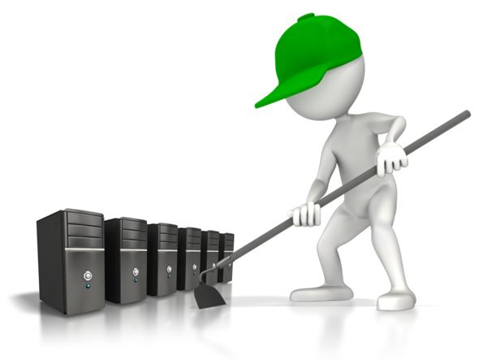
Data gathering services can be employed and outsourced:
- Data capturing service from the web
- Catalogue / database management
- Internet research, email mining and customized list making
- Portal management support
- E-newsletters / e-clippings
- Secondary research / market intelligence
- Digitization

Digitisation
Digitisation is the conversion of images, characters, or sounds to digital codes so that the information may be processed or stored by a computer system.
- This format of presenting data for Teams can be very useful in terms of presentation and understanding.
- Digitizing can be done in-house or outsourced.
- The detail and sophistication will dictate the design of your data gathering project.
The digital technology revolution has given libraries, archives and cultural institutions the ability to reproduce their assets, so that research for information is far more “graphic” and broad in its relevancy.

Benefits of Digitisation:

- Long term and safe preservation of documents
- Orderly archiving of documents
- Easy & customized access to information
- Easy information dissemination through images, text, CD’S, DVD’S, internet, intranets and extranets (an extranet is a computer network that allows controlled access from the outside)
- Allows for a paperless environment
- Easy maintenance and retrieval
- Documents/drawings can be integrated with the teams or clients software environment

Pooled Data Analysis
Data from multiple sites is pooled and combined for numeric and/or pattern analysis.
This is a natural extension of database creations when the data pooled needs to be analysed and results of this analysis shared.
In its simplest form, e.g., a survey, the results could be shared.
In terms of gathering information and reporting the findings to all participants pooled data can be shared with many.
Gathering data from other direct and indirect sources
- Observations
- Questionnaires
- Interviews
- Experiments

Assess information for clarity, accuracy, currency and relevance to intended tasks
Ensure information is in a format suitable for analysis
Take time to carefully assess all of the information you have collected from your research and ensure it is in a format suitable for further analysis.
- Use charts and graphs to help you assess the information
- Did you get the information you had expected?
- What did you find out from your research?
- Was there additional information beyond that which was requested that you feel important?
Format for information analysis
- Assessing business information needs a formatted plan of action
- The entire process should be systematic
- There should be a standard set of principles and procedures followed in assessing a particular situation and making appropriate recommendations
Define the requests for gathering information
- Establish the objectives
- Formulate alternatives (using reasonable and out-of-box thinking)
- Analyse the alternatives (using pros & cons and in a reasonable criteria scheme)
- Recommend a solution (considering the original problems and objectives)
- Create a plan for implementation (maximising feasibility and minimizing cons of the choice)
Competitive Analysis
- It is important to understand the competitive forces of the information you are gathering, especially if that information is being used in a competitive sense.

- Maybe it is for supporting discussion on where does your company stand relative to the suppliers, customers, and competition?
- Is the information linked to changes that are occurring in the industry?
- What changes are likely to occur if this information is accessed?

Environmental Analysis
- In addition to the company, customers, and competition, you may be asked to assess or gather information on the external environment of your company.
- Are there any changes taking place, or expected to take place in the political, legal, social, technological, or economic environment that may affect your organisation?
- Look for environmental threats as well as environmental opportunities in any SWOT or similar analysis.

- Realise that what at first may appear to be a threat may actually be a great opportunity for the organisation.
Processing your data for interpretation numerically and or verbally
- Statistics
- Themes or perspectives
- Graphs
Dissemination of findings
- Written reports
- Presentations
- Seminars
- Supply to media

The value of information
Information can be useful, but what determines its real value to the organisation?
In general, the value of information is determined by:
- The ability and willingness to act on the information
- The accuracy of the information
- The level of indecisiveness that would exist without the information
- The amount of variation in the possible results
- The level of risk aversion
- The reaction of competitors to any decision improved by the information
- The cost of the information in terms of the efficient use of available time and resources

1.4 – Use interpersonal skills to access relevant information from teams and individuals
Interpersonal skills may include:
- Consultation methods, techniques and protocols
- Networking
- Seeking feedback from group members to confirm understanding
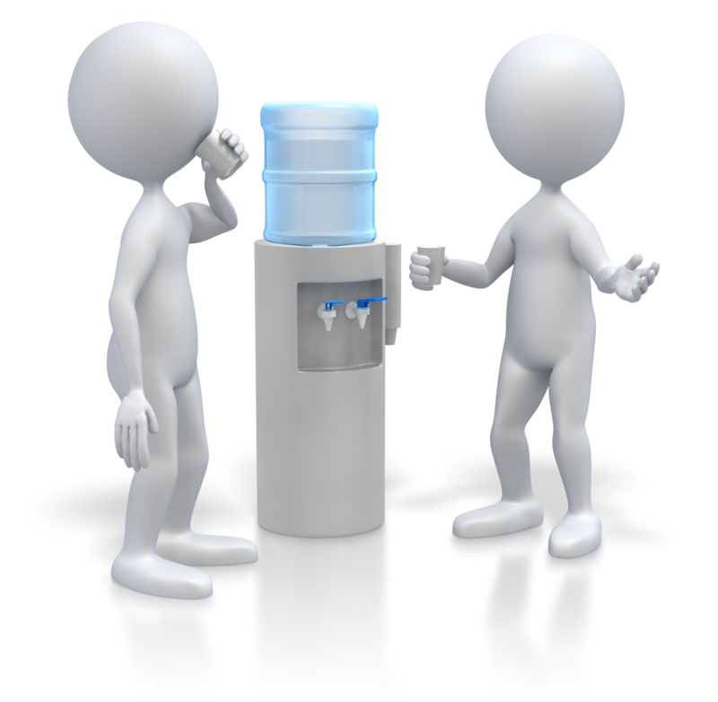
- Summarising and paraphrasing
- Using appropriate body language
Interpersonal skills are the life skills we use every day to communicate and interact with other people, individually and in groups.
Interpersonal skills include not only how we communicate with others, but also our confidence, and our ability to listen and understand, a most important benefit in seeking information.
Problem solving, decision making and personal stress management are also considered interpersonal skills.
People with strong interpersonal skills are usually more successful in both their professional and personal lives. They are perceived as more calm, confident and charismatic, qualities that are often endearing or appealing to others.
Being more aware of your interpersonal skills can help you improve and develop them.

Consultation methods, techniques and protocols
- Consultation provides opportunities to develop two-way relationships between people, teams or groups.
- Government and citizens or community groups are examples of where consultation is used extensively.
- Consultation processes may run parallel with other information gathering strategies. It may be used as part of a strategic process using 3 or 4 techniques.
- You may use a consultative mechanism in order to explore a wider range of opinions to your initial information gathering.
A variety of consultation techniques are available
- Informal discussion groups and workshops
- Facilitated discussion groups or workshops such as focus groups
Discussion groups tend to involve relatively open-ended dialogue whereas workshops are generally more structured activities which often combine dialogue with other strategies such as information provision.
- A planned action process is needed for these activities
Explain to those involved in the process of information gathering:
- The background and rationale for gathering the information
- How confidentiality will be maintained, if applicable

- How the results will be shared, if applicable
- How the information will be used
When using face to face collection methods:
- Set a positive tone.
- Give people lots of opportunities to ask questions and voice their concerns about the process and use of the information.
- Probe for the information you need with confidence but not arrogance.
- Ask questions that encourage people to describe applicable occurrences and situations.
- Try to write down the words the person is saying, not your own interruption of the words.
- Tell people how and when you may further report findings to them, if appropriate .
- If not appropriate you need to tell them this as an expectation of follow up will likely exist.
Access relevant information from teams and individuals
- Ask only for the information that you need when networking or seeking feedback from group members or individuals.
It can be tempting when seeking information to ‘wander’ off the topic.
Stay with your objective of what you need
- Limit your questions to what you need to know.
- Be mindful of time and use strategic summarising and paraphrasing.
- Follow your brief or your research plan.
- Consider the person you are talking with in terms of resources and their personal commitment.
- If you are using someone else for assistance to your research, be mindful of time and respect for those who may be assisting.
- Be aware of your listening and communication skills.
- Use appropriate body language and non-verbal communication especially when dealing with teams and individuals with cultural or language differences.
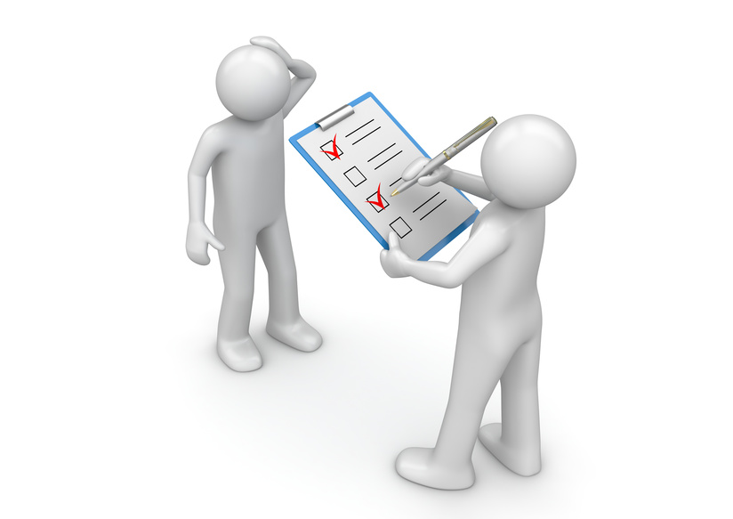
Activities

Activity 1C
Estimated Time | 45 Minutes
Objective | To provide you with an opportunity to use interpersonal skills to access relevant information from teams and individuals.
Activity | - Demonstrate your interpersonal skills by conducting an interview process to seek information on one of the following topics:  - A new type of software to be used in the company  - As a Social Member you are researching where to hold the Company Christmas party  - The process for filing invoices and general administration enquiries  Consider some of the following methods for conducting your interview:  - Direct questioning  - Reports and statistics  - Analysis of responses to case studies and scenarios  - Oral or written questioning to assess knowledge of organisational recordkeeping/filing systems  - Analysis of how information and materials were communicated to relevant people

2. Organise information
2.1 Organise information in a format suitable for analysis, interpretation and dissemination in accordance with organisational requirements
2.2 Use appropriate technology/systems to maintain information in accordance with organisational requirements
2.3 Collate information and materials and communicate to relevant designated persons
2.4 Identify difficulties organising and accessing information and solve collaboratively with individuals and team members
2.5 Update and store information in accordance with organisational requirements and systems

2.1 – Organise information in a format suitable for analysis, interpretation and dissemination in accordance with organisational requirements
Format may include:
- Adding headers and footers
- Incorporating graphics and pictures
- Inserting symbols
- Using legends
- Using a particular software application
- Using tables and charts
In accordance with organisational requirements
NOTE: the instructor will need to clarify to the class exactly what is meant by in accordance with organisational requirements as it refers to the workplace in which the class is being conducted.
If the class is not located within one single workplace then the examples provided above will cover SOME of the generally accepted organisational standards.
Requirements and standards to organise information in a format suitable for analysis, interpretation and dissemination, would likely cover the following:
Information | Notes Only – Requirements And Standards
Analysis format | - Formats such as Excel, PowerPoint, Word or other digital medium would allow separation and ease of analysis in a physical sense.  - Editing and cleaning data is an important step in the preparation of a suitable format. Special care must be taken when editing information so it does not alter or compromise the data.  - Formatting to ensure accuracy for analysis is especially important if it involves information such as graphs, tables or slides.  - Graphs are often an excellent way to display your results for analysis.  - Digital analysis would include cut and paste, reference to the web for further clarification etc.  - MAKE IT SIMPLE... If your information gathering was simply to collect data for your database or teams, you may likely do not need to do anything other than transfer it to a Word doc or Excel doc etc for ease of reading.  - Conversely, if you must transform your raw results into information that will enable the reader to see a clear picture, ensure the formatting is according to needs.  - Calculations, for example, are where a spreadsheet program such as Microsoft Excel may be a good way to present the analysis.
Interpretation formats | - Utilising the same types of digital formats including style of presentation, language and syntax will determine the level of interpretation.  - Formats and language structure aimed at the reader is critical to interpretation.  - The complexity and detail needed to support you conclusions, along with your intended audience, will dictate the format of your report.  - CEOs require a different level of detail than the team members  - Visual reports, such as Microsoft PowerPoint presentation, are best suited for simple levels of interpretation. Graphical reports are best when they are light on text and heavy on graphs and charts.  - This level needs only a quick assessment rather than being studied at length, and most conclusions are obvious, so detailed explanations are seldom required.  - For more complex topics, a detailed report created in Microsoft Word or Adobe Acrobat is often required.  - Reports created using Word often include much more detailed information, report findings that require significant explanation, are extremely text heavy, and are often studied at great length and in significant detail.  - No matter which type of report you use, always remember that information can be more powerfully displayed in a graphic format rather than using text.  - At the beginning of your report, you should review your information gathering objective and the sampling methods used.  - Help the reader understand what the survey was about and reduce the need for further clarification.
Dissemination | - It is important to know to whom the information is going to disseminated to as this would involve knowing the levels of authority, sensitivity, importance and host of possible security measures.  - If the information is an analysis or statement of facts, it may not require any feedback.  - Selective dissemination of information may need to be assessed before the type of method, usually digitally, is used.  - Using computers certain readers may receive your information via a host of secure methods of transmission, according to the organisational policy.  - Some methods of dissemination may include physical copies printed and distributed.  - Others methods can be received through text messages, email, voice mail and RSS feeds.

Calculations and summarising information
- Be sure to label rows and columns--don't forget to include the units of measurement if applicable.
- Summarise calculations consistently such as ratios, percentages and it is better to display your information graphically.
- All units for a measurement analysis should be of the same scale.

Graphs
For any type of graph, e.g., a bar, graph or column:
- Be sure to label the axes of your graph.
- Include the units of measurement consistently.
- If you have more than one set of graphs show each series in a different colour.
- Include a legend with clear labels.

Adding headers and footers
Microsoft Word
- Headers and footers are identifiers that run through the top and bottom of your document, providing important background information about it.
- They can include page numbering, title, author name, chapter number, and date.
- Headers and footers can greatly increase the usability of a long document as well as make it look much more professional.


Incorporating graphics and pictures
There are thousands of reasons why a graphic or a simple picture is preferable in a report or information analysis than a lot of words!

Inserting symbols
- Do the column headings include definitions of symbols used?
 | € | ¥ | Β | Ω | ™ | ≠ | ≤ | ÷ | &?

Using legends
- Legends are symbols and text used to provide additional information about a chart.
- In a multiple series chart, for example columns, the legend typically describes each series to improve understanding.
- You can also define your own legend and style for each item.

Using a particular software application
Your ultimate use of a particular software program or application will likely depend on what is meant by in accordance with organisational requirements.
If this course is conducted in your workplace, then the best way is to identify the software applications in place.
- In a ‘generic’ example a program would usually form part of a database management system that extracts information from one or more files and presents the information in a specified format.
- Report writers, for example, allow you to select records that meet certain conditions and to display selected fields in rows and columns.
- You can also format data into pie charts, bar charts, and other diagrams.
- Once you have created a format for a report, you can save the format specifications in a file and continue reusing it for new data.
Other software applications are:
- Microsoft Word
- Excel
- PowerPoint
- Access
- CRM software
- Websites

Using tables and charts
- In Microsoft applications, tables and charts can be inserted for a variety of analysis formats.

2.2 – Use appropriate technology/systems to maintain information in accordance with organisational requirements
Technology may include:
- Answering machine
- Computer
- Email
- Fax machine

- Internet/extranet/intranet
- Photocopier
- Shredder
- Telephone
Systems may include:
- Information management systems
- Knowledge management systems
- Record management systems
Use appropriate technology/systems
It is important for all organisations to consider what appropriate technology/systems are needed to maintain information.
In the case of a specific organisation, such as this if it is conducted in a workplace, there would be an array of technology and information systems that you could identify.
Using examples provided of technology:
- Answering machine
- Computer
- Email
- Fax machine
- Internet/extranet/intranet
- Photocopier
- Shredder
- Telephone

Computer
Obviously computers are the most current method of using appropriate technology/systems to maintain information and in accordance with organisational requirements.
Software designed specifically for handling the question of information is almost boundless.
With Windows 7, as an example, the concept of Libraries addresses the problem of users storing content all over their PC by allowing them to have full control over their information folder structure.
Users can define which folders to include in the Documents Library.
Information devices associated with computers
- Information management systems
- Knowledge management systems
- Record management systems
Information management systems include many software applications and sub-products.
Software providers have created a wide range of information devices such as:
- Document management system
- Content management system
- Library management system
- Learning management system

Record management devices
- Hard disks – The information is stored on electromagnetically charged surfaces called 'platters'.
- Floppy disks – A floppy disk is a type of magnetic disk memory which consists of a flexible disk with a magnetic coating.
- Optical disks – An optical disc is a storage medium that can be written to and read using a low-powered laser beam.
- CD-R – Compact Disc-Recordable ("CD-R") discs have become a universal data storage medium worldwide.
- CD-RW – Compact Disc-Rewritable (CD-RW) disks are rewritable and can be erased and re-recorded upon over and over again.
- DVD (Digital Versatile Disc or Digital Video Disc) is a high density optical disc with large capacity for storage of data, pictures and sound.
- Apple Time Capsule is a revolutionary backup device that works wirelessly with Time Machine in OS X. It automatically backs up everything, so you never have to worry about losing your important files.
- Cloud computing is the delivery of computing as a service rather than a product, whereby shared resources, software, and information are provided to computers and other devices as a utility (like the electricity grid) over an Internet network.
Things to consider:
- Your organisation, if not already, will need to set plans in place for responding to adverse situations that may occur when using computers for information.
- Such areas as confidentiality and the integrity of the various systems will need to be protected by maintaining an effective information security program.
- Plans such as contingency should information systems go down and computers are inoperable.

- Components of the computer system should be tested regularly to ensure operation and a state of operational readiness.
General technology used in an organisation
- Fax machine
- Photocopier
- Shredder
- Telephone
- Answering machine
The examples provided are but a few of the additional office technology or support systems used in the course of information storage, retrieval and management.
- Items such as those above, are in some cases ‘obsolete’, e.g., fax machines are a dying breed, and others change their form and use constantly, e.g., telephones.
- The use of ‘shredders’ is the end result of information and the photocopier the beginning of some information as it’s duplicated and distributed.
- An answering machine would serve as a record of verbal information in the examples provided and generally serve as a fundamental sub system if the organisation relies only on land line telephones and not the usual use of mobiles?
- Email, is the example provided that would serve as the most used method of communicating information.
- It is not, in itself, a very reliable method of storing information as its tracking is wide and varied, including life on a mobile, iPad and a dozen other mobile devices besides the office email program.
- It requires substantial application to discipline to safely maintain information in accordance with organisational requirements.
- Email protocols are very hard to enforce.
What are your experiences with using those support systems as an appropriate technology/system to maintain information in accordance with organisational requirements?
Suggested Support System | Class Views
Fax machine
Photocopier
Shredder
Telephone
Answering machine
Email
Instructors notes
Conduct this as a class exercise rather than a set activity, given its limited scope.

Activities

Activity 2B
Estimated Time | 30 Minutes
Objective | To provide you with an opportunity to use appropriate technology/systems to maintain information in accordance with organisational requirements.
Activity | In your workplace, ask yourself and others in your workplace the following questions and provide appropriate answers:
  Question | Answer
  On what type of system is YOUR workplace information stored
  Is the storage system appropriate for the type of information you investigated
  How is the information backed up or safeguarded from security breaches
  Is information stored externally to your workplace as well as in the organisation for risk management purposes
  Have advances in technology changed the systems of maintaining information in accordance with your organisational requirements
  Is storing and using technology in your workplace a waste of human resources

2.3 – Collate information and materials and communicate to relevant designated persons
Designated persons may include:
- Clients
- Colleagues
- Committee
- External agencies
- Line management
- Statutory bodies
- Supervisor
When you collect information from different sources and compare them to determine the eventual end use, you collate them.
Even before or after photocopies of sheets of paper they are arranged in some form of order, i.e., they are collated.
- The process of collating information can sometimes get confused between collection and analysis.
- Collation of your information is needed when you are scaling up your information from a smaller unit of analysis to a larger one or when information has been collected from different sources with different methods.
In making a decision on whom your collated information is to be designated to, consider:


2.4 – Identify difficulties organising and accessing information and solve collaboratively with individuals and team members

2.5 – Update and store information in accordance with organisational requirements and systems
The amount of information that hits your computers and other devices every day may cause issues and degrees of difficulty with certain individuals and organisations.
Information that comes from a variety of sources and in many formats as previously discussed, can be overwhelming and cause a re-think of the way you go about these particular tasks.
Information comes via:

- Colleagues
- Websites
- Magazine articles
- Social networking
- Emails
- Texting
- News clippings
- Spreadsheets
- Presentations
Typical areas of difficulty that individuals or teams experience with organising and accessing information
- Information overload
- Too many results
- Computers running certain software can slow a machine down
- Speed of indexing software
- Getting someone who is experienced with this information system or issue, to explain it in a simple and concise fashion.
- Java has built-in methods that allow you to write/read data from a text file.

3. Review information needs
3.1 Actively seek feedback on clarity, accuracy and sufficiency of information to ensure relevance of information and system
3.2 Review the contribution of information to decision making and implement appropriate modifications to collection processes
3.3 Identify future information needs and incorporate modifications to collection processes
3.4 Document future information needs and incorporate in modifications to reporting processes

3.1 – Actively seek feedback on clarity, accuracy and sufficiency of information to ensure relevance of information and system
Feedback may include:
- Audit documentation and reports
- Comments from clients and colleagues
- Customer satisfaction questionnaires
- Quality assurance data
- Returned goods
- By reviewing clarity, accuracy and sufficiency of information to ensure relevance of information and systems in place in your organisation will allow you to streamline, improve or otherwise make changes that benefit all concerned.
You should regularly:
- Review and determine expectations
- Listen to the comments of teams and individuals when making other assessments
- Monitor the relevance of information and systems
- Value feedback as a measure of your service performance

Assessment of information status
A feedback questionnaire can be used to measure relevance and application of the information currently being provided. It will need to be designed according to what feedback you are seeking.
Your check list

What is the main purpose of this questionnaire? _________________

Have you made sure that your questions are relevant to the objective? _________________

Will questions address clarity, accuracy and sufficiency of information? ____________________

How many questionnaires are you planning on distributing? _________________

Are you asking both qualitative and quantitative questions? _________________

Are your questions easy to understand? _________________

Other?

Reviewing feedback
- Feedback can come from many areas depending on the extent by which you seek it and the size of your end user profile.
- Its greatest value is, of course, that if broad enough it offers a different perspective from your own.
- Although it is wise to ‘review’ all feedback, it does not mean that you have to change the way in which you are currently providing information.
If you feel confronted with feedback it may be helpful to ask yourself:
- Am I sure I understand what the feedback is actually saying?

- Do I think the feedback relates to the objective I was seeking comment on?
- Do I actually agree with the feedback?
- If I were to take the feedback seriously, to what extent do I want to follow it?
- If the feedback is on the relevance of information and systems used, why did I do it this way in the first place?
- Is this feedback consistent or isolated?
What do you need to do?
- Measure all of the above, make a decision and incorporate feedback into planning or improvement.
What do these terms mean to you?

Discuss in class
Clarity
- Clarity of information  - Length of sentences  - Good grammar  - Rules of writing  - Document structure  - Acknowledgments  - Numbering tables  - Recommendations | - Table of contents  - Terms of reference  - Executive summary  - Introduction  - Headings/sub-headings  - Headers and footers  - Conclusion  - Referencing
Accuracy
- You check for accuracy and correctness because it makes it easier for someone to understand you.
- Correct spelling helps people know what word you are using.
- Accuracy of your information can help others judge your credibility.
- What claims is this information making?
- What evidence does the information give to support those claims?
- What evidence do I find elsewhere to support this information?
- Accuracy can be controlled to some extent by taking note of your most common mistakes.
Sufficiency of information
- It is essential that you have sufficient information on the topic as sufficiency is a measure of quantity. Appropriateness is a measure of quality of the information.
- Have you considered all sides of the issue or information objective ‘sufficiently’?
- The gauge of sufficient information, if tested, would be the relationship to appropriateness if the test was carried out on a reasonable target sample.

- Sufficiency can draw upon many or less external services such as supporting documents or links?

Activities

Activity 3A
Estimated Time | 45 Minutes
Objective | To provide you with an opportunity to actively seek feedback on clarity, accuracy and sufficiency of information to ensure relevance of information and system.
Activity | - In your workplace, detail the experiences of feedback on clarity, accuracy and sufficiency of information to ensure relevance of information and system through the suggested options.
  Suggested Method | Your Comments
  Surveys
  Questionnaires
  Interviews

3.2 – Review the contribution of information to decision making and implement appropriate modifications to collection processes

Assessing the contribution of information to decision making
“Relevance” of information retrieval is an old concept.
- Assessing the quality and appropriateness of information is a key requirement and skill irrespective of the format of the material provided or its original source.
- Information produced from a highly reputable source can be as irrelevant as that produced from a less reputable group, organisation or individual.
- The key to any assessment should always be the relevance of the information within the context of your needs. In this case, the contribution of information to decision making.

- The critical role information plays in business planning and development should not be underestimated. It drives our decision making and our reactions to a host of options.

Role and importance of information
- Importance of information for communication purposes
- Importance of information for decision making
- Importance of information for understanding and reacting to the organisation environment
Identify the characteristics of valuable information
'Rubbish in equals rubbish out'
All organisations, large and small, spend much of their time in meetings, reading reports, Emails, surfing the web, on phone calls and communicating with other employees, clients and customers.
- These activities are all forms of gathering, processing, and disseminating information.
- Managing the characteristics such information provides to hopefully assist you in various forms of ‘decision making’ is ultimately all about... what to do with it?
- A decision making model is a formal method for making a choice, often involving quantitative and qualitative analysis.
- Other methods are simply disseminating information to employees for their assessment and ultimate decisions.

The handling of information may include:

- Storing it
- Using it
- Passing it on
- Discarding it
Making a decision can imply that there are alternative choices around!
If so, you would not only wish to identify as many options as possible but to ultimately select an option or several that has the highest probability of success and best fits with your objectives.
Decision making is a process of identifying, selecting, and implementing those alternatives. The right information, in the right format and provided at the right time are all elements combined to make that assessment contribution effective in your decision making.
The need for implementing appropriate modifications to the collection processes would, of course, depend on the quality, relevancy, and timing of what you have been provided with to make the assessments.

There are several kinds of decisions
The ‘complexity’ of both your decision or the process to reach it with the information provided to assist you will all play a role and would give you information on the need for implementing appropriate modifications.
Simple decisions include:
- Yes/no, either/or decisions that must be made before you can proceed further with any selection of a further alternative.
- Decisions made by weighing up a pro or con on what you are considering.
Decisions needing a more complex assessment
- These decisions would involve a choice of several alternatives from a set of possibilities, provided in the information.
- These decisions will involve assessment on how well the information provided allows you to measure alternatives or other form of pre-defined criteria.
Decisions contingent on more data or information
- These types of decisions are those that have been placed on hold awaiting more information or possibly modified information to allow a decision to reach a final conclusion or recommendation.

The Information needed to make correct decisions
The information will depend on the requirement for each organisation and the particular information may address a multitude of areas:

- Information about customers
- Competitors
- Employees
- Strategic decisions
- Production capabilities
- Expansion
- Marketing
- Sales etc, etc
Who makes the assessment of information?
The person or team making an assessment of information will also impact on any modifications needed in the collection process as each person or team may have a ‘persona’ view of relevancy, accuracy or presentation of information.
- A manager may decide to alert top executives that a strategic decision needs to be made.
- Top executives would use the information received to identify alternatives for consideration.
- Each alternative would then be evaluated based on feasibility, cost, time to implement, consistency with corporate strategy, and other criteria.
- Finally, the information would be gathered to assess the quality of the decisions that were made and an assessment of the information quality.
This example would have potential information contribution modification impact from at least three groups.

Those preparing the information

Those receiving the information

Is the information in need of modification?
- A critical factor in making an assessment on a decision based on the information collected and provided is that most decisions are made by moving back and forth between the information based on some pre-determined criteria.
- This can mean those making information assessments want their choice to meet their pre-determined choices or values.
- The alternatives that the information you have gathered and presented may influence the criteria others have already placed on what is needed to make their decisions.
- This influence can then be either RIGHT or wrong depending on the degree or level of the already established criteria.

Many decision makers have a tendency to seek more information than required to make a good decision.
- When too much information is either sought or provided several problems may occur.
- Delays may occur because of the volume of information can no longer be managed or assessed appropriately.
- Shortcuts, if you are under pressure, may lead to incorrect assessments that modifications are required post the evaluation or decision making.

- A delay could impact on set timeframes which ultimately affect the effectiveness of the decision or solution.
A major problem caused by too much information is taken the overload into memory rather than strategically make assessments. Some of the information if referenced early on in the assessment will be forgotten or discarded.
Remember...the quality of a decision is not related to its outcome, because a good decision can have either a good or a bad outcome
Therefore, a decision that results in a bad outcome should not necessarily be blamed on insufficient information or a need to make modifications to the collection processes.

Activities

Activity 3B
Estimated Time | 30 Minutes
Objective | To provide you with an opportunity to review the contribution of information to decision making and implement appropriate modifications to collection processes.
Activity | - Review the contribution of information to decision making and implement appropriate modifications to collection processes
  Option 1 – in your workplace
  In your workplace, make the following investigations and report on your findings:
  - the contribution of information to decision making
  - What modifications have been made in your workplace to any collection processes and have they made improvements?

3.3 – Identify future information needs and incorporate modifications to collection processes

3.4 – Document future information needs and incorporate in modifications to reporting processes
To identify ‘future’ information needs to incorporate that into any modification to your collection process, will need to be based on an evaluation process, quite likely based on the workplace Activity 3B where you would have investigated:
- the contribution of information to decision making
- What modifications have been made in your workplace to any collection processes and have they made improvements?
Although the assessment questions for any collection of future information would likely direct the selection of collection techniques, there are a number of factors to consider.
People | Documents | Observations
Target audiences, customers, clients (current and past), support staff, administrators | Records, paper, web-based, digital, prior reports, journals, document analysis, literature review | Interviews, focus group, surveys, face-to-face, behaviours,

To decide on any future needs you should reflect on the current and past information
Identify future information needs and document future information needs

- Use current forms of information reviews and company feedback
- How can you possibly do things differently in the future
- Your organisation may need a change to the manner in which it has been sourcing information
- Is the collection or gathering process too narrow or missing the objective
- Should staff or researchers be drawing on a wider range of sources
Similarly, you may need to incorporate these findings into any scope of modifications to your reporting processes.
Feedback from a variety of sources, as explained above in the activity 3C, may indicate that you need to improve or change techniques.

Consider conducting an information needs analysis
- An information needs analysis identifies the future information needs of an organisation through a standard process
- Conducting an information needs analysis can assist you in pro-actively looking at future planning.
- A needs analysis can be conducted by holding internal meetings with teams and groups within the organisation.
- You can employ several techniques in gathering the information including open brainstorming sessions or focus group ‘style’ meetings where a monitor uses a more structured questioning format.
- You can interview people, customers or teams in an open information gathering process.
- You may also wish to include observation in the workplace or assign individuals to assist in their own area research.

A needs analysis address two main areas:
What information do we have now?
(To decide on any future needs you should reflect on the current and past information)
- What information do we want to have?
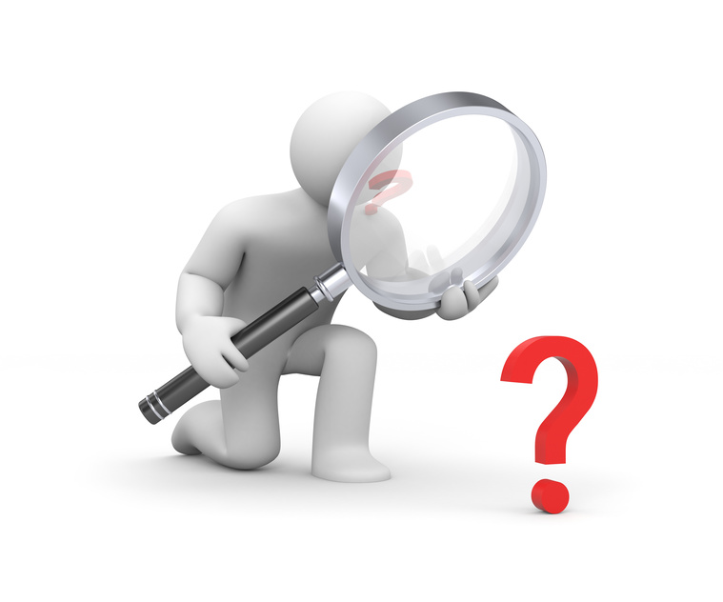
The variances between the two areas of assessment will hopefully give you an insight into the direction you may wish to follow.
In addition, the traditional information needs analysis should aim to seek information or at least give you sufficient information on which to act.

Skills and Knowledge Activity


Nearly there...

Major Activity – An opportunity to revise the unit
At the end of your Learner Workbook, you will find an activity titled ‘Major Activity’. This is an opportunity to revise the entire unit and allows your trainer to check your knowledge and understanding of what you have covered. It should take between 1-2 hours to complete and your trainer will let you know whether they wish for you to complete it in your own time or during session. Once this is completed, you will have finished this unit and be ready to move onto the next, well done!

Congratulations!
You have now finished the unit ‘Organise workplace information’


References

These suggested references are for further reading and do not necessarily represent the contents of this Learner Guide

- Organizing Information: From the Shelf to the Web [Paperback]
G. G. Chowdhury (Author), Sudatta Chowdhury (Author).
- Process and Maintain Workplace Information [Paperback]
Kelly Collison (Author).
- Information Literacy and Workplace Performance [Hardcover]
Tom W. Goad (Author).

